Supplementary Table 1. Cryptococcal uptake and intracellular proliferation rate (IPR) at 24 hour-infection of C. neoformans and C. gattii clinical isolates.
All clinical isolates of Cryptococcus spp. (23 isolates of C. neoformans and 18 isolates of C. gattii) were evaluated for cryptococcal uptake and IPR at 24 h using J774 macrophages. The 4 high-uptake strains (HU, black box) and 4 low-uptake strains (LU, white box) of C. neoformans and the 4 high IPR (HIPR, black circle) and 4 low IPR (LIPR, white circle) of C. gattii were selected for further analyses.
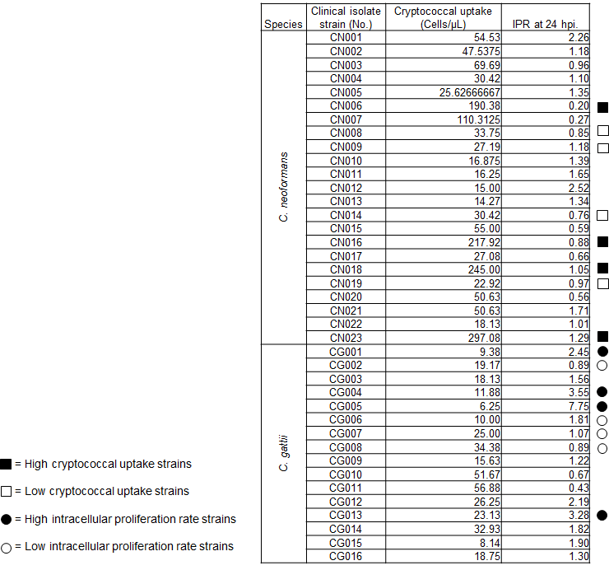

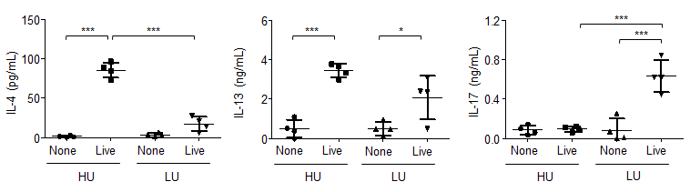

Supplementary Figure 1. Antigen-specific cytokine responses of lung-draining lymph node cells stimulated with live Cryptococcus.
Lung draining lymph node cells prepared from mice infected with the high- (HU) and low- (LU) uptake strains of C. neoformans were plated in a 24-well plate and stimulated with live Cryptococcus (at a ratio of 2:1 Cryptococcus cells to leukocytes). Following 72 hour stimulation at 37°C with 5% CO₂, the culture supernatant was collected and kept at -80°C before analysis of cytokine by ELISA * p <0.05, and *** p <0.001.

