Supplementary information
for
Gene expansion and positive selection as bacterial adaptations to oligotrophic industrial freshwater
Ruben Props^{1,2,3}, Pieter Monsieurs², Peter Vandamme⁴, Natalie Leys², Vincent J. Denef^{3, *} and Nico Boon^{1, *}
¹ Center for Microbial Ecology and Technology (CMET), Ghent University, Coupure Links 653, B-9000 Gent, Belgium
² Belgian Nuclear Research Centre (SCK•CEN), Boeretang 200, B-2400 Mol, Belgium
³ Department of Ecology and Evolutionary Biology, University of Michigan, Ann Arbor, MI, US
⁴ Laboratory of Microbiology, Faculty of Sciences, Ghent University, K. L. Ledeganckstraat 35, B-9000 Ghent, Belgium
* Corresponding authors: Vincent Denef; 830 N. University, Ann Arbor, MI 48109, USA; phone: +1 (734) 764 6481; email: vdenef@umich.edu, Nico Boon, Coupure Links 653; B-9000 Gent, Belgium; phone: +32 (0)9 264 59 76; E-mail: Nico.Boon@UGent.be.

Supplementary materials and methods
Scanning Electron Microscopy (SEM)
Late stationary phase cultures of R. aquaticus LMG 30558^{T} were sampled at the end of the growth experiment after four days for each medium concentration (i.e. 1 mg L⁻¹, 10 mg L⁻¹, and 100 mg L⁻¹ of R2A) (Figure 6). The samples were then concentrated on a Whatman® Nuclepore™ track-etched polycarbonate membrane with 0.1 µm pore diameter (Merck, Belgium). Samples were fixed with solution containing 0.3 M glutaraldehyde and 0.132 M sodium cacodylate for 30 min. Afterwards, excess glutaraldehyde was removed by washing the filter with sodium cacodylate solution (0.150 M) twice. Subsequently, cells were dehydrated using an ascending graded series of ethanol solutions (30%, 50%, 70%, 90%, 95% v/v), followed by a final solution of 100% ethanol which was replaced two times (minimum 10 min between each solution). Drying of the samples was performed with hexamethyldisilazane two times 10 min, followed by air drying for at least one hour. Membranes were finally mounted on a copper stub using carbon conducting tape, and sputter-coated with gold (20 nm) in one cycle of 200s (4 mbar Argon, 50 mA, 1 kV) (Scancoat Six, BOC Edwards B.V., Dongen, The Netherlands). SEM analysis was performed on a Phenom ProX (Phenom-World, The Netherlands), equipped with a backscatter electron detector at a working distance of 20 mm and a 10 or 15 kV acceleration. All images can accessed here: https://dx.doi.org/10.6084/m9.figshare.7472204.

Supplementary figures
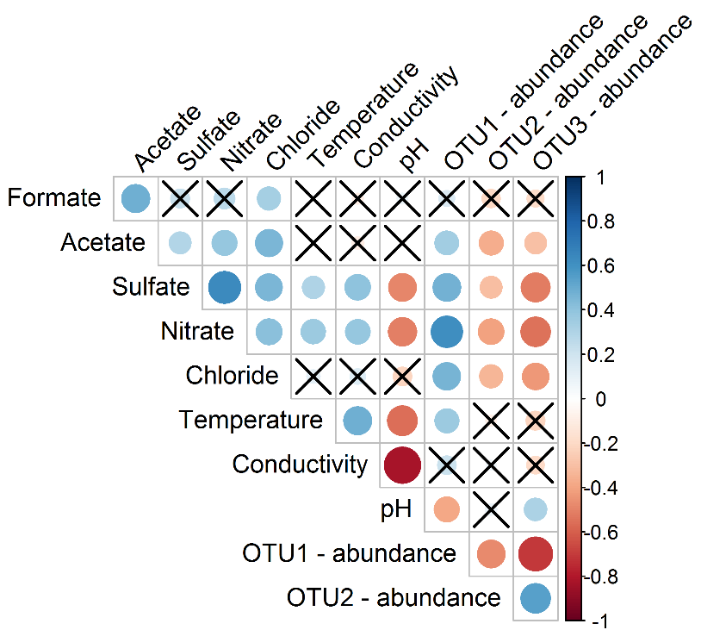
Figure S1: Kendall’s tau-b correlation coefficient (n = 27) between environmental data and the relative abundances of the three most abundant OTUs in the secondary cooling water system. Coefficients that were not significant (p > 0.05) are crossed out.

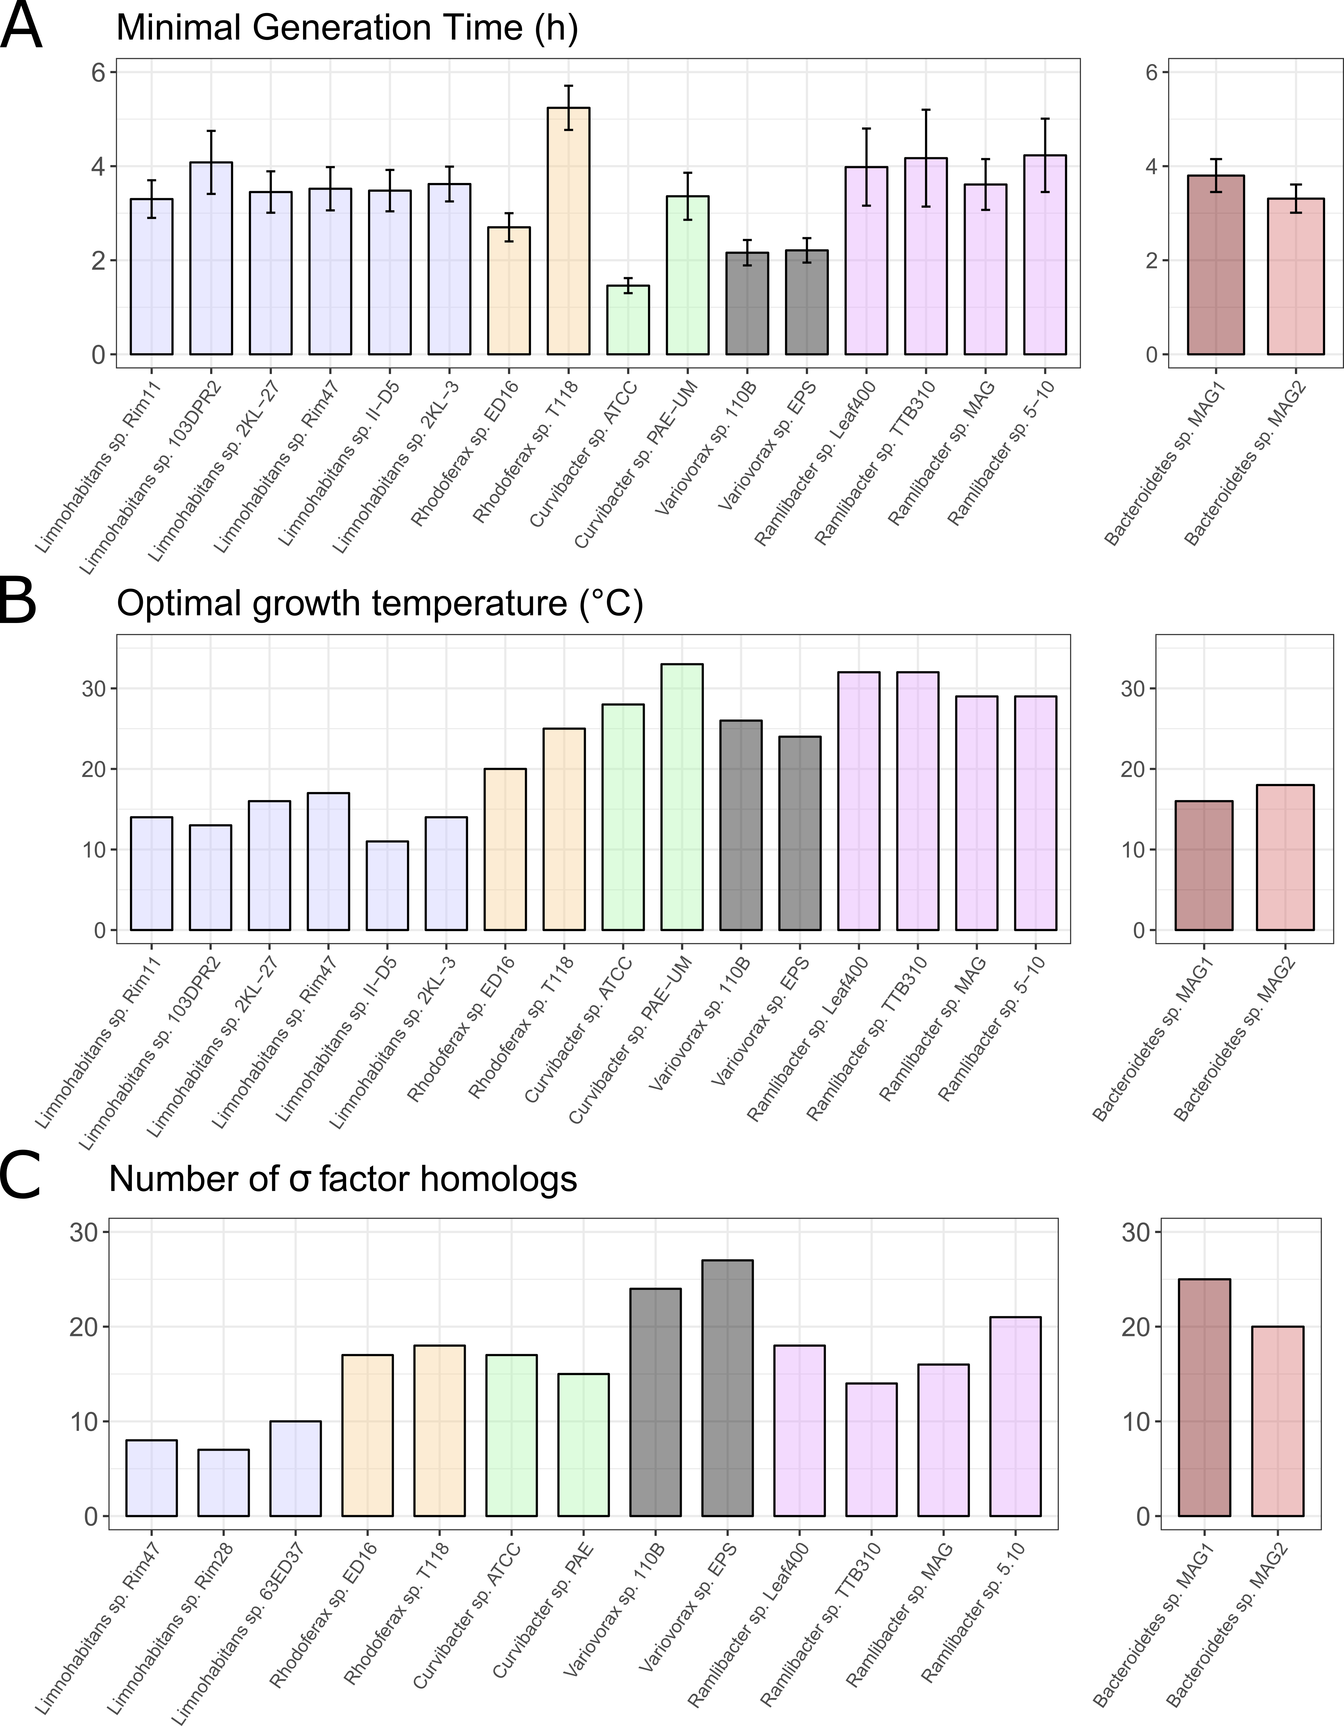
Figure S2: A. Predicted minimal generation time (MGT) for the genomes used in the phylogenomic tree and the Bacteroidetes sp. MAGs. B. Predicted optimal growth temperature (OGT) for the genomes used in the phylogenomic tree and the Bacteroidetes sp. MAGs. C. Number of sigma factor homologs for the genomes used in the phylogenomic analysis based on genes annotated through the IMG annotation pipeline. The Limnohabitans genomes used in the phylogenomic tree were not available through the IMG genome comparison tool and thus we used a set of three other isolate Limnohabitans genomes for comparison.
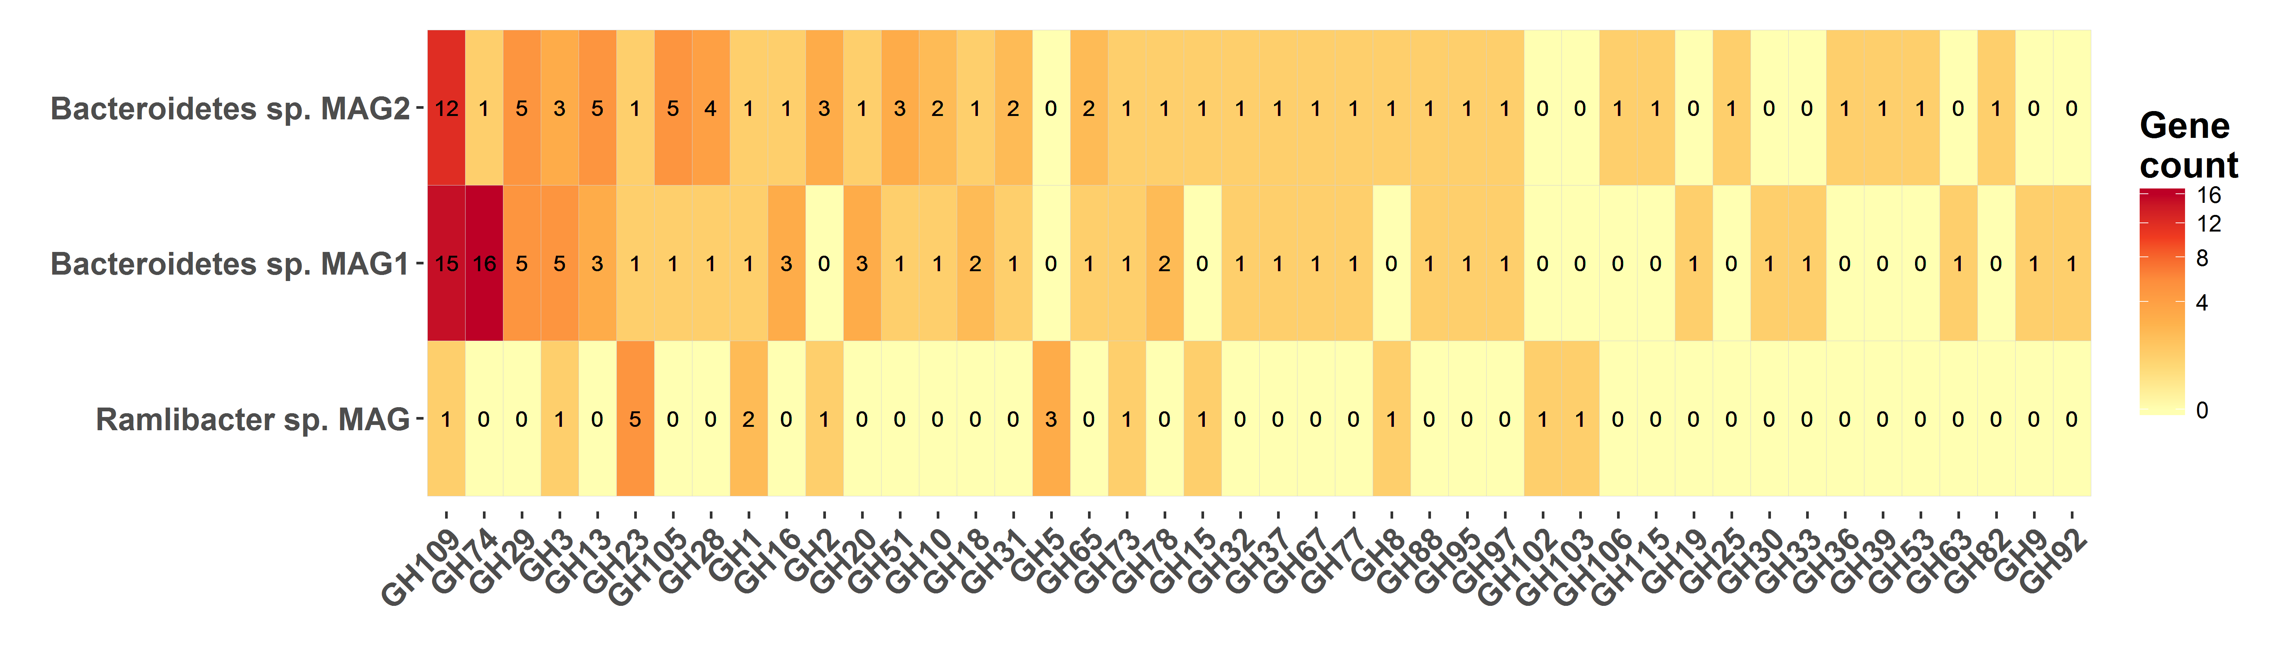
Figure S3: Diversity and abundance of glycoside hydrolases (EC 3.2.1.-) in the Bacteroidetes MAGs and the Ramlibacter sp. MAG. Putative GH109 annotation is error prone as discussed elsewhere, and should be considered uncertain (1).

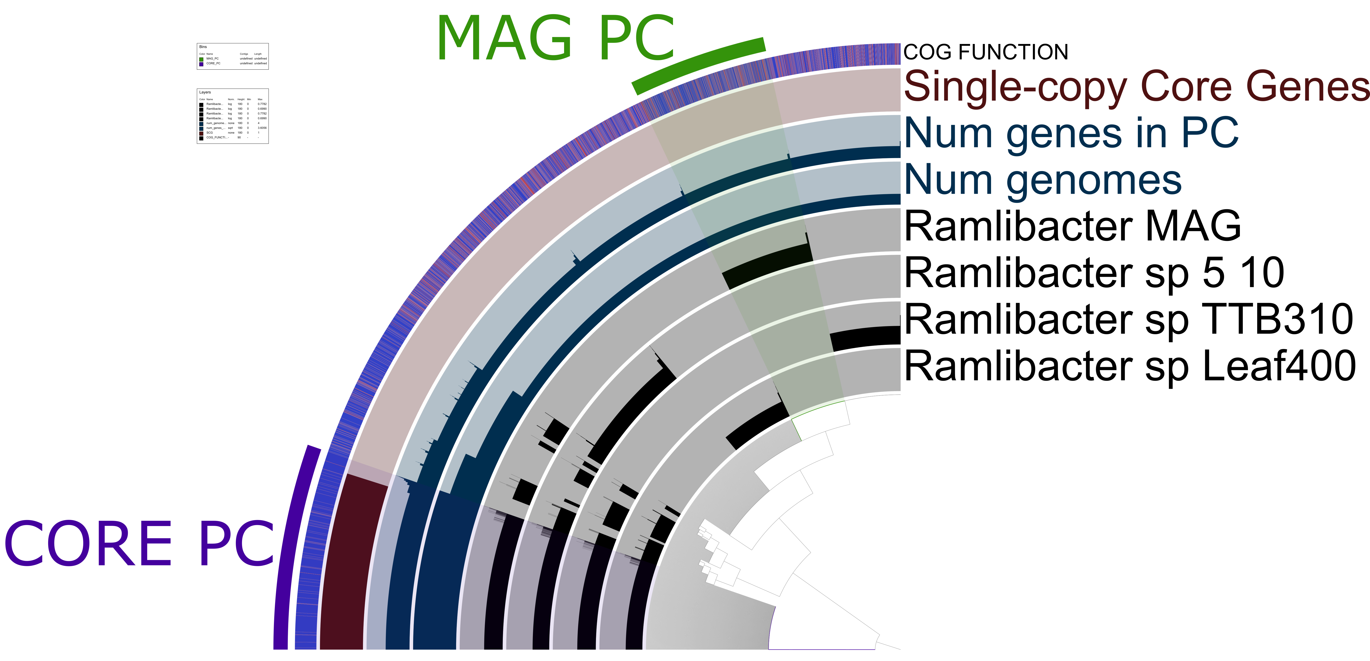
Figure S4: Pangenome analysis of Ramlibacter genomes. Indicated are the core genome (CORE PC, 49% of R. aquaticus LMG 30558^{T} genome) and the Ramlibacter sp. MAG accessory genome (MAG PC, 15% of R. aquaticus LMG 30558^{T} genome).

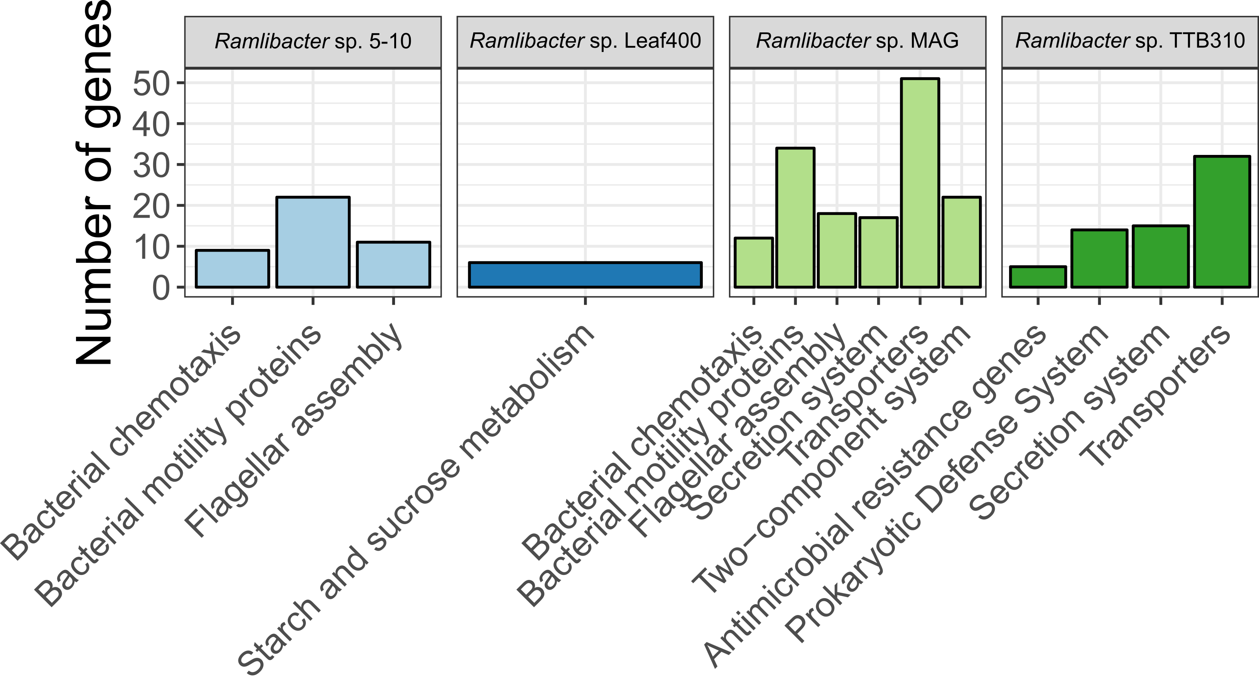
Figure S5: Functional enrichment of the accessory genomes of the four Ramlibacter genomes. Functional groups were considered enriched at an adjusted p-value < 0.05 (Benjamini-Hochberg correction). Genes were allowed to contribute to multiple KEGG subsystem categories.

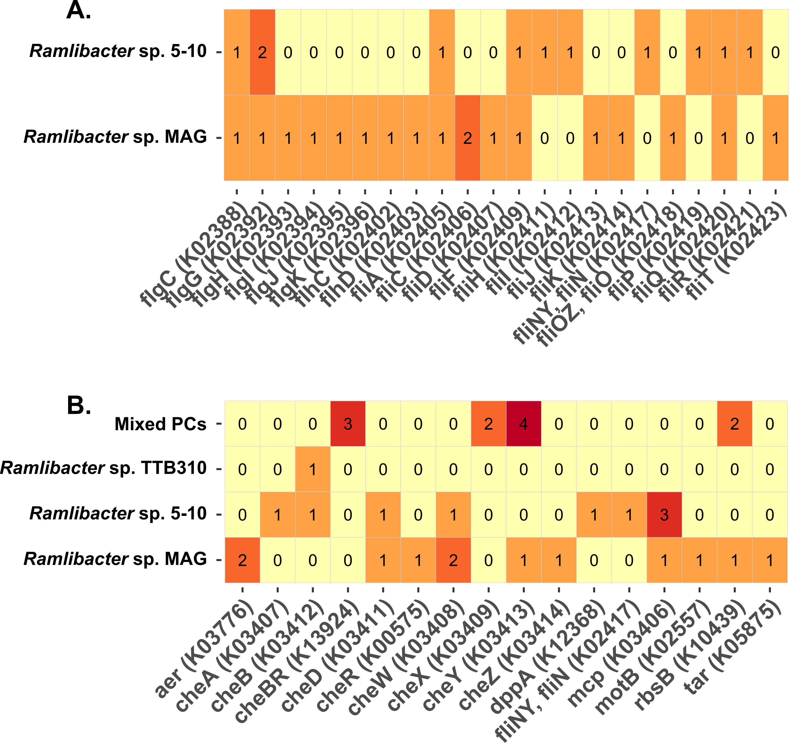
Figure S6: Distribution of unique and shared putative gene functions involved in (A.) flagellar assembly and (B.) chemotaxis in the accessory genomes of Ramlibacter sp.. Mixed PCs indicate gene protein clusters which could not be designated to a single Ramlibacter genome. See materials & methods section for the details of the pangenome analysis.

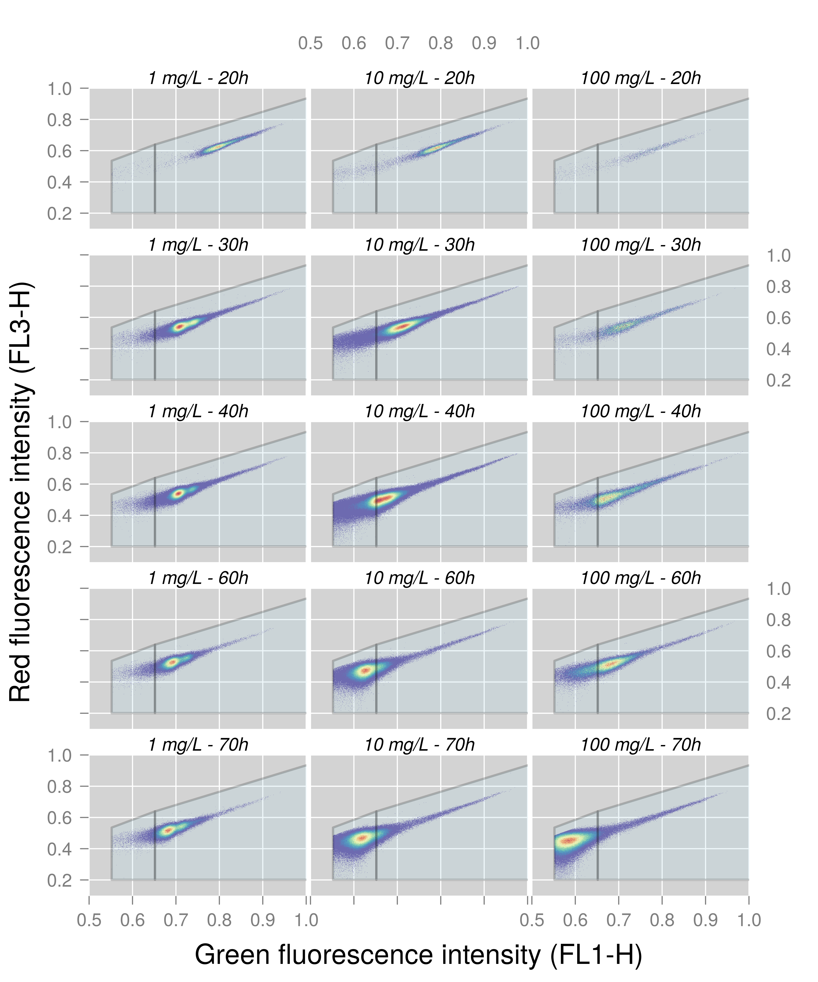
Figure S7: Gating of low nucleic acid (LNA) content cells (left side gate) and high nucleic acid (HNA) content cells (right side gate) of R. aquaticus illustrated for various samples spread across the three growth media concentrations and at different time points.
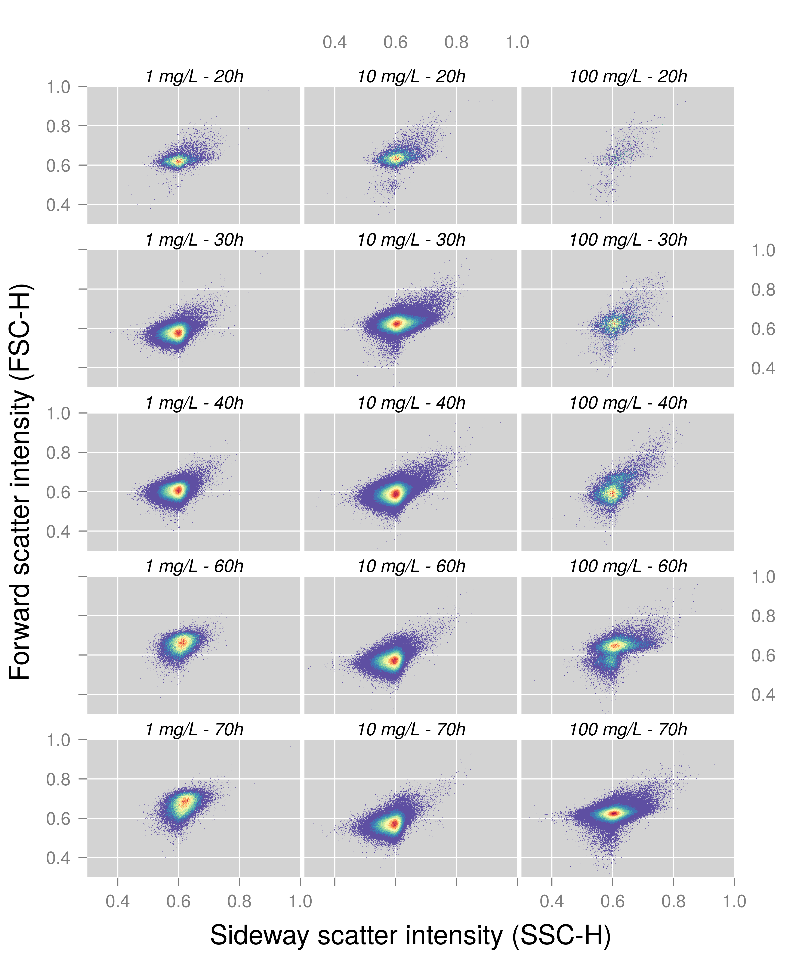
Figure S8: Forward and sideway scatter intensities for the microbial populations of R. aquaticus when grown at various growth medium concentrations and at different time points.

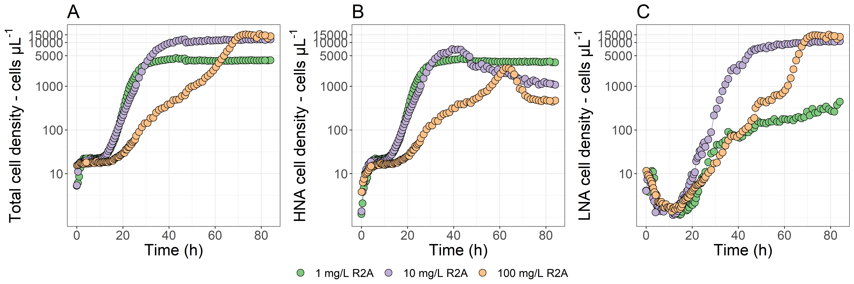
Figure S9: Growth of R. aquaticus LMG 30558^{T} under different growth medium concentrations as assessed through its total cell density (A), HNA cell density (B), and LNA cell density (C).

References
1. He S, Stevens SLR, Chan L-K, Bertilsson S, Glavina del Rio T, Tringe SG, et al. Ecophysiology of Freshwater Verrucomicrobia Inferred from Metagenome-Assembled Genomes. mSphere. 2017;2(5).

