**Supplementary File**

Supplementary Data 1. B-cell epitopes determination by various tools and entropy analysis related with the residue conservation from amino acid sequence of BoNT/A acquired from UniProt. Data are written in the binary form except for the entropy score, whereas 0 means “no” and 1 means “yes”.

|  |  |  |  |  |  |  |  |  |  |  |
| --- | --- | --- | --- | --- | --- | --- | --- | --- | --- | --- |
| Amino acid residue | SVM  TriP Score | imed.  med.  ucm.es | Bepi  Pred  2.0 | ABC  Pred | IEDB-Bepi  Pred | Disco  Tope  2.0 | CB  TOPE | IEDB-Surface accesi  bility | Low  Conse  rved region | Entropy score |
| 1 | 0 | 0 | 0 | 0 | 0 | 0 | 0 | 0 | 0 |  |
| 2 | 0 | 0 | 0 | 0 | 0 | 0 | 0 | 0 | 0 | 0.58 |
| 3 | 0 | 0 | 0 | 0 | 0 | 0 | 0 | 0 | 0 | 1.35 |
| 4 | 0 | 0 | 0 | 0 | 0 | 0 | 0 | 0 | 0 | 1.73 |
| 5 | 0 | 0 | 0 | 0 | 0 | 0 | 0 | 0 | 0 | 0.9 |
| 6 | 0 | 0 | 0 | 0 | 0 | 0 | 0 | 1 | 0 | 1.25 |
| 7 | 0 | 0 | 0 | 0 | 0 | 0 | 0 | 1 | 0 | 1.25 |
| 8 | 0 | 0 | 0 | 0 | 1 | 1 | 0 | 1 | 0 | 0.65 |
| 9 | 0 | 0 | 0 | 0 | 1 | 1 | 0 | 1 | 0 | 0.5 |
| 10 | 0 | 0 | 0 | 0 | 1 | 1 | 0 | 1 | 0 | 0.56 |
| 11 | 0 | 0 | 0 | 0 | 1 | 1 | 0 | 1 | 0 | 1.26 |
| 12 | 0 | 1 | 0 | 0 | 1 | 1 | 0 | 1 | 0 | 0.56 |
| 13 | 0 | 1 | 0 | 1 | 1 | 1 | 0 | 1 | 0 | 0.28 |
| 14 | 0 | 1 | 0 | 1 | 1 | 1 | 0 | 0 | 0 | 0.51 |
| 15 | 0 | 1 | 0 | 1 | 1 | 0 | 0 | 0 | 0 | 0.66 |
| 16 | 0 | 1 | 0 | 1 | 1 | 0 | 0 | 0 | 0 | 0.92 |
| 17 | 0 | 1 | 0 | 1 | 0 | 0 | 0 | 0 | 0 | 1.72 |
| 18 | 0 | 1 | 0 | 1 | 0 | 0 | 0 | 0 | 0 | 1.1 |
| 19 | 0 | 1 | 0 | 1 | 0 | 0 | 0 | 0 | 0 | 0.56 |
| 20 | 0 | 1 | 0 | 1 | 0 | 0 | 0 | 0 | 0 | 1.29 |
| 21 | 0 | 1 | 0 | 1 | 0 | 0 | 0 | 0 | 0 | 1.12 |
| 22 | 0 | 1 | 0 | 1 | 0 | 0 | 0 | 0 | 0 | 1.36 |
| 23 | 0 | 1 | 0 | 1 | 0 | 0 | 0 | 0 | 0 | 1.47 |
| 24 | 0 | 1 | 0 | 1 | 0 | 0 | 0 | 0 | 0 | 1.76 |
| 25 | 0 | 1 | 0 | 1 | 0 | 0 | 0 | 0 | 0 | 1.12 |
| 26 | 0 | 1 | 0 | 1 | 0 | 0 | 0 | 0 | 0 | 2.02 |
| 27 | 0 | 0 | 0 | 1 | 1 | 0 | 0 | 0 | 0 | 1.93 |
| 28 | 0 | 0 | 0 | 1 | 1 | 1 | 0 | 0 | 1 | 1.68 |
| 29 | 0 | 1 | 0 | 0 | 1 | 0 | 0 | 0 | 0 | 2.09 |
| 30 | 0 | 1 | 0 | 0 | 1 | 1 | 0 | 0 | 0 | 1.96 |
| 31 | 0 | 1 | 0 | 0 | 1 | 0 | 0 | 0 | 0 | 1.83 |
| 32 | 0 | 1 | 0 | 0 | 0 | 0 | 0 | 0 | 0 | 1.25 |
| 33 | 0 | 1 | 0 | 0 | 0 | 0 | 0 | 0 | 0 | 1.3 |
| 34 | 0 | 1 | 0 | 0 | 0 | 0 | 0 | 0 | 0 | 0 |
| 35 | 0 | 1 | 0 | 0 | 0 | 0 | 0 | 0 | 0 | 0.5 |
| 36 | 0 | 1 | 0 | 0 | 0 | 0 | 0 | 0 | 0 | 0.05 |
| 37 | 0 | 1 | 0 | 1 | 0 | 0 | 0 | 0 | 0 | 1.67 |
| 38 | 0 | 1 | 0 | 1 | 0 | 0 | 0 | 0 | 0 | 0.55 |
| 39 | 0 | 0 | 0 | 1 | 0 | 0 | 0 | 0 | 0 | 1.56 |
| 40 | 0 | 1 | 0 | 1 | 0 | 0 | 0 | 0 | 0 | 1.9 |
| 41 | 0 | 1 | 0 | 1 | 0 | 0 | 0 | 0 | 0 | 0.84 |
| 42 | 0 | 1 | 0 | 1 | 0 | 0 | 0 | 0 | 0 | 0.59 |
| 43 | 0 | 1 | 0 | 1 | 0 | 0 | 0 | 0 | 0 | 0.05 |
| 44 | 0 | 1 | 0 | 1 | 0 | 0 | 0 | 0 | 0 | 0.69 |
| 45 | 0 | 1 | 0 | 1 | 0 | 0 | 0 | 0 | 0 | 1.08 |
| 46 | 0 | 1 | 0 | 1 | 0 | 0 | 0 | 0 | 0 | 0.05 |
| 47 | 0 | 0 | 0 | 1 | 0 | 0 | 0 | 1 | 0 | 0.3 |
| 48 | 0 | 0 | 0 | 1 | 1 | 0 | 0 | 1 | 0 | 0 |
| 49 | 0 | 0 | 0 | 1 | 1 | 0 | 0 | 1 | 0 | 1.31 |
| 50 | 0 | 0 | 0 | 1 | 1 | 0 | 0 | 1 | 0 | 1.72 |
| 51 | 0 | 0 | 0 | 1 | 1 | 0 | 0 | 1 | 0 | 1.22 |
| 52 | 0 | 0 | 1 | 1 | 1 | 0 | 0 | 1 | 0 | 0.88 |
| 53 | 0 | 0 | 1 | 1 | 1 | 0 | 0 | 1 | 0 | 1.58 |
| 54 | 0 | 0 | 1 | 1 | 1 | 1 | 0 | 1 | 0 | 1.85 |
| 55 | 0 | 0 | 1 | 1 | 1 | 1 | 0 | 1 | 0 | 1.91 |
| 56 | 0 | 0 | 1 | 1 | 1 | 1 | 0 | 1 | 0 | 1.17 |
| 57 | 0 | 0 | 1 | 1 | 1 | 1 | 0 | 1 | 0 | 1.71 |
| 58 | 0 | 0 | 1 | 1 | 1 | 0 | 0 | 1 | 0 | 1.13 |
| 59 | 0 | 0 | 1 | 1 | 1 | 1 | 0 | 1 | 0 | 1.2 |
| 60 | 0 | 0 | 1 | 1 | 1 | 1 | 0 | 1 | 0 | 1.56 |
| 61 | 0 | 0 | 1 | 1 | 1 | 1 | 0 | 1 | 0 | 1.64 |
| 62 | 0 | 0 | 1 | 1 | 1 | 1 | 0 | 1 | 0 | 0.93 |
| 63 | 0 | 1 | 1 | 1 | 1 | 1 | 0 | 1 | 0 | 1.9 |
| 64 | 0 | 1 | 1 | 1 | 1 | 0 | 0 | 1 | 0 | 1.41 |
| 65 | 0 | 1 | 1 | 1 | 1 | 0 | 0 | 1 | 0 | 1.94 |
| 66 | 0 | 1 | 1 | 1 | 1 | 0 | 0 | 1 | 0 | 1.84 |
| 67 | 0 | 1 | 1 | 1 | 1 | 0 | 0 | 0 | 0 | 1.68 |
| 68 | 0 | 1 | 1 | 1 | 1 | 0 | 0 | 0 | 0 | 1.9 |
| 69 | 0 | 1 | 0 | 1 | 1 | 0 | 0 | 0 | 0 | 1.75 |
| 70 | 0 | 1 | 0 | 1 | 1 | 0 | 0 | 0 | 0 | 1.87 |
| 71 | 0 | 1 | 0 | 1 | 1 | 0 | 0 | 1 | 0 | 1.32 |
| 72 | 0 | 1 | 0 | 1 | 1 | 0 | 0 | 1 | 0 | 0.63 |
| 73 | 0 | 1 | 0 | 1 | 1 | 0 | 0 | 1 | 0 | 0.22 |
| 74 | 0 | 1 | 0 | 0 | 0 | 1 | 0 | 1 | 0 | 0 |
| 75 | 0 | 1 | 0 | 0 | 0 | 1 | 0 | 1 | 0 | 0.74 |
| 76 | 0 | 1 | 0 | 0 | 0 | 0 | 0 | 1 | 0 | 1.14 |
| 77 | 0 | 1 | 0 | 0 | 1 | 0 | 0 | 1 | 0 | 0.55 |
| 78 | 0 | 0 | 0 | 0 | 1 | 1 | 0 | 1 | 0 | 0 |
| 79 | 0 | 0 | 0 | 0 | 1 | 1 | 0 | 1 | 0 | 1.47 |
| 80 | 0 | 0 | 0 | 0 | 1 | 1 | 0 | 1 | 0 | 0.74 |
| 81 | 0 | 0 | 0 | 1 | 1 | 1 | 0 | 1 | 0 | 0.53 |
| 82 | 0 | 0 | 0 | 1 | 1 | 0 | 0 | 1 | 0 | 1.79 |
| 83 | 0 | 0 | 0 | 1 | 1 | 0 | 0 | 1 | 0 | 0.82 |
| 84 | 0 | 0 | 0 | 1 | 1 | 0 | 0 | 1 | 0 | 0.19 |
| 85 | 0 | 0 | 0 | 1 | 1 | 0 | 0 | 1 | 0 | 0.63 |
| 86 | 0 | 0 | 0 | 1 | 1 | 0 | 0 | 1 | 0 | 1.71 |
| 87 | 0 | 1 | 0 | 1 | 1 | 0 | 0 | 1 | 0 | 0.59 |
| 88 | 0 | 1 | 0 | 1 | 0 | 0 | 0 | 0 | 0 | 0 |
| 89 | 0 | 1 | 0 | 1 | 0 | 0 | 0 | 0 | 0 | 0.77 |
| 90 | 0 | 1 | 0 | 1 | 0 | 0 | 0 | 0 | 0 | 1.51 |
| 91 | 0 | 1 | 0 | 1 | 0 | 0 | 0 | 0 | 0 | 1.36 |
| 92 | 0 | 1 | 0 | 1 | 0 | 0 | 0 | 0 | 0 | 0.73 |
| 93 | 0 | 1 | 0 | 1 | 0 | 0 | 0 | 0 | 0 | 0.56 |
| 94 | 0 | 1 | 0 | 1 | 0 | 0 | 0 | 0 | 0 | 0.41 |
| 95 | 0 | 1 | 0 | 1 | 0 | 0 | 0 | 0 | 0 | 0.55 |
| 96 | 0 | 1 | 0 | 1 | 0 | 0 | 0 | 0 | 0 | 1.2 |
| 97 | 0 | 1 | 0 | 1 | 0 | 0 | 0 | 0 | 0 | 0 |
| 98 | 0 | 0 | 0 | 1 | 0 | 0 | 0 | 0 | 0 | 0 |
| 99 | 0 | 0 | 0 | 1 | 0 | 0 | 0 | 0 | 0 | 0.71 |
| 100 | 0 | 0 | 0 | 1 | 0 | 0 | 0 | 0 | 0 | 0.99 |
| 101 | 0 | 0 | 0 | 1 | 0 | 0 | 0 | 0 | 0 | 1.27 |
| 102 | 0 | 0 | 0 | 1 | 0 | 0 | 0 | 0 | 0 | 1.8 |
| 103 | 0 | 0 | 0 | 1 | 0 | 0 | 0 | 0 | 0 | 1.63 |
| 104 | 0 | 0 | 0 | 1 | 0 | 0 | 0 | 0 | 0 | 0 |
| 105 | 0 | 0 | 0 | 1 | 0 | 0 | 0 | 0 | 0 | 1.6 |
| 106 | 0 | 0 | 0 | 1 | 0 | 0 | 0 | 0 | 0 | 1.88 |
| 107 | 0 | 1 | 0 | 1 | 0 | 0 | 0 | 0 | 0 | 0 |
| 108 | 0 | 1 | 0 | 1 | 0 | 0 | 0 | 0 | 0 | 0.45 |
| 109 | 0 | 1 | 0 | 0 | 0 | 0 | 0 | 0 | 0 | 1.94 |
| 110 | 0 | 1 | 0 | 0 | 0 | 0 | 0 | 0 | 0 | 1.94 |
| 111 | 0 | 1 | 0 | 0 | 0 | 0 | 0 | 0 | 0 | 0.89 |
| 112 | 0 | 1 | 0 | 0 | 0 | 0 | 0 | 0 | 0 | 1.47 |
| 113 | 0 | 1 | 0 | 0 | 0 | 0 | 0 | 0 | 0 | 1.79 |
| 114 | 0 | 1 | 0 | 0 | 0 | 0 | 0 | 0 | 0 | 0.99 |
| 115 | 0 | 0 | 0 | 0 | 0 | 0 | 0 | 0 | 0 | 1.11 |
| 116 | 0 | 0 | 0 | 0 | 0 | 0 | 0 | 0 | 0 | 0.11 |
| 117 | 0 | 0 | 0 | 0 | 0 | 0 | 0 | 0 | 0 | 0.69 |
| 118 | 0 | 0 | 0 | 0 | 1 | 0 | 0 | 0 | 0 | 1.16 |
| 119 | 0 | 0 | 0 | 0 | 0 | 0 | 0 | 0 | 0 | 0.52 |
| 120 | 0 | 0 | 0 | 0 | 1 | 0 | 0 | 0 | 0 | 1.03 |
| 121 | 0 | 0 | 0 | 0 | 1 | 0 | 0 | 0 | 0 | 1.76 |
| 122 | 0 | 0 | 1 | 0 | 1 | 0 | 0 | 0 | 0 | 0.92 |
| 123 | 0 | 0 | 1 | 0 | 1 | 0 | 0 | 0 | 0 | 1.15 |
| 124 | 0 | 0 | 1 | 0 | 1 | 0 | 0 | 0 | 0 | 1.95 |
| 125 | 0 | 1 | 1 | 0 | 0 | 0 | 0 | 0 | 0 | 1.73 |
| 126 | 0 | 1 | 1 | 0 | 0 | 0 | 0 | 0 | 0 | 1.63 |
| 127 | 0 | 1 | 1 | 0 | 0 | 0 | 0 | 0 | 0 | 0.83 |
| 128 | 0 | 1 | 1 | 0 | 0 | 0 | 0 | 0 | 0 | 1.97 |
| 129 | 0 | 1 | 1 | 0 | 0 | 0 | 0 | 0 | 0 | 1.77 |
| 130 | 0 | 1 | 1 | 0 | 0 | 0 | 0 | 0 | 0 | 1.87 |
| 131 | 0 | 1 | 1 | 0 | 0 | 0 | 0 | 0 | 0 | 1.79 |
| 132 | 0 | 1 | 1 | 0 | 0 | 0 | 0 | 0 | 0 | 1.66 |
| 133 | 0 | 1 | 1 | 0 | 0 | 0 | 0 | 0 | 0 | 1.67 |
| 134 | 0 | 1 | 1 | 1 | 0 | 0 | 0 | 0 | 0 | 1.42 |
| 135 | 0 | 1 | 1 | 1 | 0 | 0 | 1 | 0 | 0 | 1.45 |
| 136 | 0 | 1 | 1 | 1 | 0 | 0 | 1 | 0 | 0 | 1.63 |
| 137 | 0 | 1 | 1 | 1 | 0 | 0 | 1 | 0 | 0 | 1.09 |
| 138 | 0 | 1 | 1 | 1 | 0 | 1 | 1 | 0 | 0 | 1.85 |
| 139 | 0 | 1 | 1 | 1 | 1 | 1 | 1 | 0 | 0 | 1.95 |
| 140 | 0 | 1 | 1 | 1 | 1 | 1 | 1 | 0 | 0 | 1.82 |
| 141 | 1 | 0 | 1 | 1 | 1 | 1 | 1 | 1 | 0 | 1.95 |
| 142 | 1 | 0 | 1 | 1 | 1 | 0 | 1 | 1 | 0 | 1.82 |
| 143 | 1 | 0 | 1 | 1 | 1 | 0 | 1 | 1 | 0 | 1.99 |
| 144 | 1 | 0 | 1 | 1 | 1 | 0 | 1 | 1 | 0 | 1.73 |
| 145 | 1 | 0 | 1 | 1 | 1 | 0 | 1 | 1 | 0 | 1.73 |
| 146 | 1 | 0 | 1 | 1 | 1 | 0 | 1 | 1 | 0 | 1.71 |
| 147 | 1 | 0 | 1 | 1 | 0 | 0 | 1 | 1 | 1 | 1.72 |
| 148 | 1 | 1 | 1 | 1 | 0 | 0 | 1 | 0 | 0 | 2.14 |
| 149 | 1 | 1 | 1 | 1 | 0 | 0 | 1 | 0 | 0 | 1.57 |
| 150 | 1 | 1 | 1 | 1 | 0 | 0 | 1 | 0 | 0 | 0.45 |
| 151 | 1 | 1 | 1 | 1 | 0 | 0 | 1 | 0 | 0 | 0.92 |
| 152 | 1 | 1 | 1 | 1 | 0 | 0 | 0 | 0 | 0 | 1.17 |
| 153 | 1 | 1 | 1 | 1 | 0 | 0 | 0 | 0 | 0 | 0.33 |
| 154 | 1 | 1 | 1 | 1 | 0 | 0 | 0 | 0 | 0 | 1.44 |
| 155 | 1 | 1 | 1 | 1 | 0 | 0 | 0 | 0 | 0 | 0 |
| 156 | 1 | 1 | 1 | 1 | 0 | 0 | 0 | 0 | 0 | 0.47 |
| 157 | 1 | 1 | 1 | 1 | 0 | 0 | 0 | 0 | 0 | 1.15 |
| 158 | 1 | 1 | 1 | 1 | 0 | 0 | 0 | 0 | 0 | 1.22 |
| 159 | 1 | 1 | 1 | 1 | 0 | 0 | 0 | 0 | 0 | 1.04 |
| 160 | 1 | 1 | 1 | 1 | 0 | 0 | 0 | 0 | 0 | 0.65 |
| 161 | 0 | 1 | 1 | 1 | 0 | 0 | 0 | 0 | 0 | 1.84 |
| 162 | 0 | 1 | 1 | 1 | 0 | 0 | 0 | 0 | 0 | 1.36 |
| 163 | 0 | 1 | 1 | 1 | 0 | 0 | 0 | 0 | 0 | 1.6 |
| 164 | 0 | 1 | 1 | 1 | 0 | 0 | 0 | 0 | 0 | 1.88 |
| 165 | 0 | 1 | 1 | 1 | 0 | 0 | 0 | 0 | 1 | 1.45 |
| 166 | 0 | 1 | 1 | 1 | 0 | 0 | 0 | 0 | 1 | 2.23 |
| 167 | 0 | 1 | 1 | 1 | 0 | 0 | 0 | 0 | 1 | 2.15 |
| 168 | 0 | 1 | 1 | 1 | 0 | 0 | 0 | 0 | 0 | 2 |
| 169 | 0 | 1 | 1 | 1 | 0 | 0 | 0 | 0 | 1 | 1.92 |
| 170 | 0 | 1 | 0 | 1 | 0 | 0 | 0 | 0 | 0 | 2.06 |
| 171 | 0 | 1 | 0 | 1 | 0 | 0 | 0 | 0 | 0 | 1.95 |
| 172 | 0 | 1 | 0 | 1 | 0 | 0 | 0 | 0 | 0 | 1.86 |
| 173 | 0 | 1 | 0 | 1 | 0 | 0 | 0 | 0 | 0 | 1.79 |
| 174 | 0 | 1 | 0 | 1 | 0 | 0 | 0 | 0 | 0 | 1.8 |
| 175 | 0 | 0 | 0 | 1 | 0 | 0 | 0 | 0 | 0 | 1.45 |
| 176 | 0 | 0 | 0 | 1 | 0 | 0 | 1 | 0 | 0 | 1.5 |
| 177 | 0 | 0 | 0 | 1 | 0 | 0 | 1 | 0 | 0 | 1.79 |
| 178 | 0 | 0 | 0 | 1 | 1 | 0 | 1 | 0 | 0 | 1.43 |
| 179 | 0 | 0 | 0 | 1 | 1 | 0 | 1 | 0 | 0 | 0 |
| 180 | 0 | 0 | 0 | 1 | 1 | 0 | 1 | 0 | 0 | 0.8 |
| 181 | 0 | 0 | 0 | 1 | 1 | 0 | 1 | 0 | 0 | 0 |
| 182 | 0 | 0 | 0 | 1 | 1 | 0 | 1 | 0 | 0 | 1.21 |
| 183 | 0 | 0 | 0 | 1 | 1 | 0 | 1 | 0 | 0 | 1.46 |
| 184 | 0 | 0 | 0 | 1 | 0 | 0 | 0 | 0 | 0 | 1.82 |
| 185 | 0 | 0 | 0 | 1 | 0 | 0 | 0 | 0 | 0 | 1.71 |
| 186 | 0 | 0 | 0 | 1 | 0 | 0 | 0 | 0 | 1 | 1.16 |
| 187 | 0 | 0 | 0 | 1 | 0 | 0 | 0 | 0 | 0 | 2.1 |
| 188 | 0 | 0 | 0 | 1 | 0 | 0 | 0 | 0 | 0 | 0.57 |
| 189 | 0 | 0 | 0 | 1 | 0 | 0 | 0 | 0 | 0 | 1.22 |
| 190 | 1 | 0 | 0 | 1 | 0 | 0 | 0 | 0 | 0 | 0.17 |
| 191 | 1 | 0 | 0 | 1 | 0 | 0 | 0 | 0 | 0 | 1.52 |
| 192 | 1 | 0 | 0 | 1 | 0 | 0 | 0 | 0 | 0 | 1.28 |
| 193 | 1 | 0 | 0 | 1 | 0 | 0 | 0 | 0 | 0 | 1.76 |
| 194 | 1 | 0 | 0 | 1 | 0 | 0 | 0 | 0 | 0 | 1.95 |
| 195 | 1 | 0 | 0 | 1 | 0 | 0 | 0 | 0 | 0 | 1.78 |
| 196 | 1 | 0 | 0 | 1 | 0 | 0 | 0 | 0 | 0 | 0.63 |
| 197 | 1 | 0 | 0 | 1 | 0 | 0 | 0 | 0 | 0 | 1.36 |
| 198 | 1 | 1 | 0 | 0 | 0 | 0 | 0 | 0 | 0 | 1.82 |
| 199 | 1 | 1 | 1 | 0 | 0 | 0 | 0 | 0 | 0 | 1.3 |
| 200 | 1 | 1 | 1 | 0 | 1 | 0 | 0 | 0 | 0 | 1.55 |
| 201 | 1 | 1 | 1 | 1 | 1 | 0 | 0 | 0 | 0 | 1.38 |
| 202 | 1 | 1 | 1 | 1 | 1 | 0 | 0 | 0 | 1 | 1.36 |
| 203 | 1 | 1 | 1 | 1 | 1 | 0 | 0 | 0 | 0 | 2.08 |
| 204 | 1 | 1 | 1 | 1 | 0 | 0 | 0 | 0 | 0 | 1.73 |
| 205 | 1 | 0 | 1 | 1 | 1 | 0 | 0 | 0 | 0 | 1.51 |
| 206 | 1 | 0 | 1 | 1 | 1 | 0 | 1 | 0 | 0 | 1.82 |
| 207 | 1 | 0 | 1 | 1 | 1 | 0 | 1 | 0 | 0 | 1.86 |
| 208 | 1 | 0 | 1 | 1 | 1 | 0 | 1 | 0 | 0 | 0.91 |
| 209 | 1 | 0 | 1 | 1 | 0 | 0 | 0 | 0 | 0 | 0.97 |
| 210 | 0 | 0 | 0 | 1 | 0 | 0 | 0 | 0 | 0 | 1.07 |
| 211 | 0 | 0 | 0 | 1 | 0 | 0 | 0 | 0 | 0 | 1.68 |
| 212 | 0 | 0 | 0 | 1 | 1 | 0 | 0 | 0 | 0 | 1.99 |
| 213 | 0 | 0 | 0 | 1 | 1 | 0 | 0 | 0 | 0 | 0.5 |
| 214 | 0 | 0 | 0 | 1 | 1 | 0 | 0 | 0 | 1 | 1.57 |
| 215 | 0 | 1 | 0 | 1 | 1 | 0 | 0 | 0 | 0 | 2.02 |
| 216 | 0 | 1 | 0 | 1 | 1 | 0 | 0 | 0 | 0 | 0 |
| 217 | 0 | 1 | 0 | 1 | 1 | 0 | 0 | 0 | 0 | 0 |
| 218 | 0 | 1 | 0 | 1 | 1 | 0 | 0 | 0 | 0 | 0 |
| 219 | 0 | 1 | 0 | 1 | 1 | 0 | 0 | 0 | 0 | 0.67 |
| 220 | 0 | 1 | 0 | 1 | 0 | 0 | 0 | 0 | 0 | 1.07 |
| 221 | 0 | 1 | 0 | 1 | 0 | 0 | 0 | 0 | 0 | 1.7 |
| 222 | 0 | 1 | 0 | 1 | 0 | 0 | 0 | 0 | 0 | 1.1 |
| 223 | 0 | 1 | 0 | 1 | 0 | 0 | 0 | 0 | 0 | 0.63 |
| 224 | 0 | 1 | 0 | 1 | 0 | 0 | 0 | 0 | 0 | 0.55 |
| 225 | 0 | 1 | 0 | 1 | 0 | 0 | 0 | 0 | 0 | 0 |
| 226 | 0 | 1 | 0 | 1 | 0 | 0 | 0 | 0 | 0 | 0.57 |
| 227 | 0 | 1 | 0 | 1 | 0 | 0 | 0 | 0 | 0 | 0.55 |
| 228 | 0 | 1 | 0 | 1 | 0 | 0 | 0 | 0 | 0 | 1.1 |
| 229 | 0 | 1 | 0 | 1 | 0 | 0 | 0 | 0 | 0 | 0.84 |
| 230 | 0 | 1 | 0 | 1 | 0 | 0 | 0 | 0 | 0 | 0.55 |
| 231 | 0 | 1 | 0 | 1 | 0 | 0 | 0 | 0 | 0 | 1.52 |
| 232 | 0 | 1 | 0 | 1 | 0 | 0 | 0 | 0 | 0 | 0 |
| 233 | 0 | 1 | 0 | 1 | 0 | 0 | 0 | 0 | 0 | 0 |
| 234 | 0 | 1 | 0 | 1 | 0 | 0 | 0 | 0 | 0 | 0 |
| 235 | 0 | 1 | 0 | 1 | 0 | 0 | 0 | 0 | 0 | 0.91 |
| 236 | 0 | 0 | 0 | 1 | 0 | 0 | 0 | 0 | 0 | 1.58 |
| 237 | 0 | 0 | 0 | 1 | 0 | 0 | 0 | 0 | 0 | 1.21 |
| 238 | 0 | 0 | 0 | 1 | 0 | 0 | 0 | 0 | 0 | 1.31 |
| 239 | 0 | 0 | 0 | 1 | 0 | 0 | 0 | 0 | 0 | 1.81 |
| 240 | 0 | 0 | 0 | 1 | 0 | 0 | 0 | 0 | 0 | 1.84 |
| 241 | 0 | 0 | 0 | 1 | 0 | 0 | 0 | 0 | 0 | 1.88 |
| 242 | 0 | 0 | 0 | 1 | 0 | 0 | 0 | 0 | 0 | 1.57 |
| 243 | 0 | 0 | 0 | 1 | 0 | 0 | 0 | 0 | 0 | 1.91 |
| 244 | 0 | 0 | 0 | 1 | 0 | 0 | 0 | 0 | 0 | 1.75 |
| 245 | 0 | 0 | 0 | 1 | 0 | 0 | 0 | 0 | 0 | 1.53 |
| 246 | 0 | 0 | 0 | 1 | 0 | 0 | 0 | 0 | 0 | 1.81 |
| 247 | 0 | 0 | 0 | 1 | 0 | 0 | 0 | 0 | 0 | 1.87 |
| 248 | 0 | 0 | 1 | 1 | 0 | 0 | 0 | 0 | 0 | 1.61 |
| 249 | 0 | 0 | 1 | 1 | 0 | 0 | 0 | 0 | 0 | 1.73 |
| 250 | 0 | 0 | 1 | 1 | 0 | 0 | 0 | 0 | 0 | 1.38 |
| 251 | 0 | 0 | 1 | 1 | 0 | 0 | 0 | 0 | 0 | 1.7 |
| 252 | 0 | 0 | 1 | 1 | 0 | 0 | 0 | 0 | 1 | 1.35 |
| 253 | 1 | 0 | 1 | 1 | 0 | 0 | 0 | 0 | 1 | 2.06 |
| 254 | 1 | 1 | 0 | 1 | 0 | 0 | 0 | 0 | 1 | 2.08 |
| 255 | 1 | 1 | 0 | 1 | 0 | 0 | 0 | 0 | 1 | 2.02 |
| 256 | 1 | 1 | 0 | 1 | 0 | 0 | 0 | 0 | 0 | 2.03 |
| 257 | 1 | 1 | 0 | 1 | 0 | 0 | 0 | 0 | 0 | 1.77 |
| 258 | 1 | 1 | 0 | 1 | 0 | 0 | 0 | 0 | 0 | 1.63 |
| 259 | 1 | 1 | 0 | 1 | 0 | 0 | 0 | 0 | 0 | 1.64 |
| 260 | 1 | 1 | 0 | 0 | 0 | 0 | 0 | 0 | 0 | 1.77 |
| 261 | 1 | 0 | 0 | 0 | 0 | 0 | 0 | 0 | 0 | 1.19 |
| 262 | 1 | 0 | 0 | 0 | 0 | 0 | 0 | 0 | 0 | 0.55 |
| 263 | 1 | 0 | 0 | 0 | 0 | 0 | 0 | 0 | 0 | 0.92 |
| 264 | 1 | 0 | 0 | 0 | 0 | 0 | 0 | 0 | 0 | 1.27 |
| 265 | 1 | 0 | 0 | 0 | 0 | 0 | 0 | 0 | 0 | 0.94 |
| 266 | 1 | 0 | 0 | 0 | 1 | 0 | 0 | 0 | 0 | 0.55 |
| 267 | 1 | 0 | 0 | 0 | 1 | 0 | 0 | 0 | 0 | 0 |
| 268 | 1 | 0 | 0 | 0 | 1 | 0 | 0 | 0 | 1 | 0 |
| 269 | 1 | 0 | 0 | 1 | 0 | 0 | 0 | 0 | 0 | 2.15 |
| 270 | 1 | 0 | 0 | 1 | 0 | 0 | 0 | 0 | 0 | 0.41 |
| 271 | 1 | 0 | 0 | 1 | 0 | 0 | 0 | 0 | 0 | 1.81 |
| 272 | 1 | 0 | 0 | 1 | 0 | 0 | 0 | 0 | 0 | 1.48 |
| 273 | 0 | 0 | 0 | 1 | 0 | 0 | 0 | 0 | 0 | 1.43 |
| 274 | 0 | 0 | 0 | 1 | 0 | 0 | 0 | 0 | 0 | 1.48 |
| 275 | 0 | 0 | 0 | 1 | 0 | 0 | 0 | 0 | 0 | 1.59 |
| 276 | 0 | 0 | 0 | 1 | 0 | 0 | 0 | 0 | 0 | 1.75 |
| 277 | 0 | 0 | 0 | 1 | 0 | 0 | 0 | 1 | 0 | 1.73 |
| 278 | 0 | 0 | 0 | 1 | 0 | 0 | 0 | 1 | 0 | 1.73 |
| 279 | 0 | 0 | 0 | 1 | 0 | 0 | 0 | 1 | 0 | 1.81 |
| 280 | 0 | 0 | 0 | 1 | 0 | 0 | 0 | 1 | 0 | 1.79 |
| 281 | 0 | 0 | 0 | 0 | 0 | 0 | 0 | 1 | 0 | 1.99 |
| 282 | 0 | 0 | 0 | 0 | 0 | 0 | 0 | 1 | 0 | 1.06 |
| 283 | 0 | 0 | 0 | 0 | 0 | 0 | 0 | 1 | 0 | 1.11 |
| 284 | 0 | 0 | 0 | 0 | 0 | 0 | 0 | 1 | 0 | 1.68 |
| 285 | 0 | 0 | 0 | 0 | 0 | 0 | 0 | 1 | 0 | 1.17 |
| 286 | 0 | 0 | 0 | 0 | 0 | 0 | 0 | 1 | 0 | 1.67 |
| 287 | 0 | 0 | 0 | 0 | 0 | 0 | 0 | 1 | 0 | 0.94 |
| 288 | 0 | 0 | 0 | 0 | 0 | 0 | 0 | 1 | 0 | 1.78 |
| 289 | 0 | 0 | 0 | 0 | 0 | 0 | 0 | 1 | 0 | 1.5 |
| 290 | 0 | 0 | 0 | 0 | 0 | 0 | 0 | 1 | 0 | 0.69 |
| 291 | 0 | 0 | 0 | 0 | 0 | 0 | 0 | 0 | 0 | 1.88 |
| 292 | 0 | 0 | 0 | 0 | 0 | 0 | 0 | 0 | 0 | 1.57 |
| 293 | 0 | 0 | 0 | 0 | 0 | 0 | 0 | 0 | 0 | 0.93 |
| 294 | 0 | 0 | 0 | 1 | 0 | 0 | 0 | 0 | 0 | 1.07 |
| 295 | 0 | 0 | 0 | 1 | 0 | 0 | 0 | 0 | 0 | 1.42 |
| 296 | 0 | 0 | 0 | 1 | 0 | 0 | 0 | 0 | 0 | 1.45 |
| 297 | 0 | 0 | 0 | 1 | 0 | 0 | 0 | 0 | 0 | 0.55 |
| 298 | 0 | 0 | 0 | 1 | 1 | 0 | 0 | 0 | 0 | 1.16 |
| 299 | 0 | 1 | 0 | 1 | 0 | 0 | 0 | 0 | 0 | 1.52 |
| 300 | 0 | 1 | 0 | 1 | 0 | 0 | 0 | 0 | 0 | 1.48 |
| 301 | 0 | 1 | 0 | 1 | 0 | 0 | 0 | 0 | 0 | 1.7 |
| 302 | 0 | 1 | 1 | 1 | 0 | 0 | 0 | 0 | 0 | 1.44 |
| 303 | 0 | 1 | 1 | 1 | 1 | 0 | 0 | 0 | 0 | 1.39 |
| 304 | 0 | 1 | 1 | 1 | 0 | 0 | 0 | 0 | 0 | 1.61 |
| 305 | 0 | 1 | 1 | 1 | 1 | 0 | 0 | 0 | 0 | 1.56 |
| 306 | 0 | 1 | 0 | 1 | 0 | 0 | 0 | 0 | 0 | 1.59 |
| 307 | 0 | 1 | 0 | 1 | 0 | 0 | 0 | 0 | 0 | 1.88 |
| 308 | 0 | 1 | 0 | 1 | 0 | 0 | 0 | 0 | 0 | 1.69 |
| 309 | 0 | 1 | 0 | 1 | 0 | 0 | 0 | 0 | 0 | 1.52 |
| 310 | 0 | 1 | 0 | 1 | 0 | 0 | 0 | 0 | 0 | 0.83 |
| 311 | 0 | 0 | 0 | 1 | 0 | 0 | 0 | 0 | 0 | 0.66 |
| 312 | 0 | 0 | 0 | 1 | 0 | 0 | 0 | 0 | 0 | 1.92 |
| 313 | 0 | 0 | 0 | 1 | 0 | 0 | 0 | 0 | 0 | 1.07 |
| 314 | 0 | 0 | 0 | 1 | 0 | 0 | 0 | 0 | 0 | 0.37 |
| 315 | 0 | 0 | 0 | 1 | 0 | 0 | 0 | 0 | 0 | 1.36 |
| 316 | 0 | 0 | 0 | 1 | 0 | 0 | 0 | 1 | 0 | 1.55 |
| 317 | 0 | 1 | 0 | 1 | 0 | 0 | 0 | 1 | 0 | 0.77 |
| 318 | 0 | 1 | 0 | 1 | 0 | 0 | 0 | 1 | 1 | 1.49 |
| 319 | 0 | 1 | 0 | 1 | 0 | 0 | 0 | 1 | 0 | 2.19 |
| 320 | 0 | 1 | 0 | 1 | 0 | 0 | 0 | 1 | 0 | 0 |
| 321 | 0 | 1 | 0 | 1 | 0 | 0 | 0 | 1 | 0 | 0 |
| 322 | 0 | 1 | 0 | 1 | 0 | 0 | 0 | 1 | 0 | 1.85 |
| 323 | 0 | 1 | 0 | 1 | 0 | 0 | 0 | 0 | 0 | 0.69 |
| 324 | 0 | 1 | 0 | 1 | 0 | 0 | 0 | 0 | 0 | 1.41 |
| 325 | 0 | 0 | 0 | 1 | 0 | 0 | 0 | 0 | 0 | 1.55 |
| 326 | 0 | 0 | 0 | 0 | 1 | 0 | 0 | 0 | 0 | 1.29 |
| 327 | 0 | 0 | 0 | 0 | 1 | 0 | 0 | 0 | 0 | 1.45 |
| 328 | 0 | 0 | 0 | 0 | 1 | 0 | 0 | 0 | 0 | 1.48 |
| 329 | 0 | 1 | 0 | 0 | 1 | 0 | 0 | 0 | 0 | 0.63 |
| 330 | 0 | 1 | 0 | 0 | 1 | 0 | 0 | 0 | 0 | 1.74 |
| 331 | 0 | 1 | 0 | 0 | 1 | 0 | 0 | 0 | 0 | 1.24 |
| 332 | 0 | 1 | 0 | 0 | 0 | 0 | 0 | 0 | 0 | 1.86 |
| 333 | 0 | 1 | 0 | 0 | 0 | 0 | 0 | 0 | 0 | 0.74 |
| 334 | 0 | 1 | 0 | 0 | 0 | 0 | 0 | 0 | 0 | 0.65 |
| 335 | 0 | 1 | 0 | 0 | 0 | 0 | 0 | 0 | 0 | 1.68 |
| 336 | 0 | 0 | 0 | 0 | 0 | 0 | 0 | 0 | 0 | 1.43 |
| 337 | 0 | 1 | 0 | 0 | 0 | 0 | 0 | 0 | 0 | 0.74 |
| 338 | 0 | 1 | 0 | 0 | 0 | 0 | 0 | 0 | 0 | 0 |
| 339 | 0 | 1 | 0 | 0 | 0 | 0 | 0 | 0 | 0 | 1.61 |
| 340 | 0 | 1 | 0 | 0 | 0 | 0 | 0 | 0 | 0 | 1.63 |
| 341 | 0 | 1 | 0 | 0 | 0 | 0 | 0 | 0 | 0 | 1.13 |
| 342 | 0 | 1 | 0 | 0 | 0 | 0 | 0 | 0 | 0 | 0.63 |
| 343 | 0 | 1 | 0 | 0 | 0 | 0 | 0 | 0 | 0 | 1.39 |
| 344 | 0 | 1 | 0 | 0 | 0 | 0 | 0 | 0 | 0 | 1.78 |
| 345 | 0 | 1 | 0 | 0 | 0 | 0 | 0 | 0 | 0 | 0.41 |
| 346 | 0 | 1 | 0 | 0 | 0 | 0 | 0 | 0 | 0 | 1.24 |
| 347 | 0 | 1 | 0 | 1 | 0 | 0 | 0 | 0 | 0 | 1.75 |
| 348 | 0 | 0 | 0 | 1 | 0 | 0 | 0 | 0 | 0 | 1.25 |
| 349 | 0 | 0 | 0 | 1 | 0 | 0 | 0 | 0 | 0 | 1.08 |
| 350 | 0 | 0 | 0 | 1 | 0 | 0 | 0 | 0 | 0 | 0.94 |
| 351 | 0 | 0 | 0 | 1 | 0 | 0 | 0 | 0 | 1 | 0.55 |
| 352 | 0 | 0 | 0 | 1 | 0 | 0 | 0 | 0 | 0 | 2 |
| 353 | 0 | 0 | 0 | 1 | 0 | 0 | 0 | 0 | 0 | 1.59 |
| 354 | 0 | 1 | 0 | 1 | 0 | 0 | 0 | 0 | 0 | 1.22 |
| 355 | 0 | 1 | 0 | 1 | 0 | 0 | 0 | 0 | 0 | 1.41 |
| 356 | 0 | 1 | 0 | 1 | 0 | 0 | 0 | 0 | 0 | 1.76 |
| 357 | 0 | 1 | 0 | 1 | 0 | 0 | 0 | 0 | 0 | 1.8 |
| 358 | 0 | 1 | 0 | 1 | 0 | 0 | 0 | 0 | 0 | 1.07 |
| 359 | 0 | 1 | 0 | 1 | 0 | 0 | 0 | 0 | 0 | 1.18 |
| 360 | 0 | 1 | 0 | 1 | 0 | 0 | 0 | 0 | 0 | 1.12 |
| 361 | 0 | 1 | 0 | 1 | 0 | 0 | 0 | 1 | 0 | 1.38 |
| 362 | 0 | 1 | 0 | 1 | 0 | 0 | 0 | 1 | 0 | 1.36 |
| 363 | 0 | 1 | 0 | 1 | 0 | 0 | 0 | 1 | 0 | 0.19 |
| 364 | 0 | 0 | 0 | 1 | 0 | 0 | 0 | 1 | 0 | 1.7 |
| 365 | 0 | 0 | 0 | 1 | 0 | 0 | 0 | 1 | 0 | 1.76 |
| 366 | 0 | 0 | 0 | 1 | 0 | 0 | 0 | 1 | 0 | 0 |
| 367 | 0 | 0 | 0 | 0 | 0 | 0 | 0 | 0 | 0 | 1.27 |
| 368 | 0 | 1 | 0 | 0 | 0 | 0 | 0 | 0 | 1 | 1.99 |
| 369 | 0 | 1 | 0 | 0 | 0 | 0 | 0 | 0 | 0 | 2.14 |
| 370 | 0 | 1 | 0 | 0 | 0 | 0 | 0 | 0 | 0 | 1.64 |
| 371 | 0 | 1 | 0 | 0 | 0 | 0 | 0 | 0 | 0 | 1.44 |
| 372 | 0 | 1 | 0 | 0 | 0 | 0 | 0 | 0 | 0 | 1.82 |
| 373 | 0 | 1 | 0 | 0 | 0 | 0 | 0 | 0 | 0 | 1.49 |
| 374 | 0 | 1 | 0 | 0 | 0 | 0 | 0 | 0 | 0 | 1.53 |
| 375 | 0 | 1 | 0 | 0 | 0 | 0 | 0 | 0 | 1 | 1.63 |
| 376 | 0 | 1 | 0 | 0 | 0 | 0 | 0 | 0 | 0 | 2 |
| 377 | 0 | 1 | 0 | 0 | 0 | 0 | 0 | 0 | 0 | 0.66 |
| 378 | 0 | 1 | 0 | 0 | 0 | 0 | 0 | 0 | 0 | 0.67 |
| 379 | 0 | 1 | 0 | 0 | 0 | 0 | 0 | 0 | 0 | 1.21 |
| 380 | 0 | 1 | 0 | 0 | 0 | 0 | 0 | 0 | 0 | 0.76 |
| 381 | 0 | 1 | 0 | 0 | 0 | 0 | 0 | 0 | 0 | 0.75 |
| 382 | 0 | 1 | 0 | 0 | 0 | 0 | 0 | 0 | 0 | 1.97 |
| 383 | 0 | 1 | 0 | 0 | 0 | 0 | 0 | 0 | 0 | 1.1 |
| 384 | 0 | 1 | 0 | 0 | 0 | 0 | 0 | 0 | 0 | 0 |
| 385 | 0 | 0 | 0 | 0 | 0 | 0 | 0 | 0 | 0 | 1.22 |
| 386 | 0 | 0 | 0 | 0 | 0 | 0 | 0 | 0 | 1 | 1.19 |
| 387 | 0 | 0 | 0 | 0 | 0 | 0 | 0 | 0 | 0 | 2.2 |
| 388 | 0 | 0 | 0 | 0 | 0 | 0 | 0 | 0 | 0 | 1 |
| 389 | 0 | 0 | 0 | 0 | 0 | 0 | 0 | 0 | 0 | 0 |
| 390 | 0 | 0 | 0 | 0 | 0 | 0 | 0 | 0 | 0 | 0.33 |
| 391 | 0 | 0 | 1 | 0 | 0 | 0 | 0 | 0 | 0 | 0 |
| 392 | 0 | 0 | 1 | 0 | 0 | 0 | 0 | 0 | 0 | 0.59 |
| 393 | 0 | 0 | 1 | 0 | 0 | 0 | 0 | 0 | 0 | 2.17 |
| 394 | 0 | 0 | 1 | 0 | 0 | 0 | 0 | 0 | 0 | 1.67 |
| 395 | 0 | 0 | 1 | 0 | 0 | 0 | 0 | 0 | 0 | 1.57 |
| 396 | 0 | 0 | 1 | 0 | 0 | 0 | 0 | 0 | 0 | 0.92 |
| 397 | 0 | 0 | 1 | 0 | 0 | 0 | 0 | 0 | 0 | 1 |
| 398 | 0 | 0 | 1 | 0 | 0 | 0 | 0 | 0 | 0 | 1.56 |
| 399 | 0 | 0 | 1 | 0 | 0 | 0 | 0 | 0 | 0 | 1.69 |
| 400 | 0 | 0 | 1 | 0 | 0 | 0 | 0 | 0 | 0 | 1.28 |
| 401 | 0 | 0 | 1 | 0 | 1 | 0 | 0 | 0 | 0 | 1.56 |
| 402 | 0 | 0 | 1 | 0 | 1 | 0 | 0 | 1 | 0 | 1.49 |
| 403 | 0 | 0 | 1 | 0 | 1 | 0 | 0 | 1 | 0 | 0 |
| 404 | 0 | 0 | 1 | 0 | 1 | 0 | 0 | 1 | 0 | 0 |
| 405 | 0 | 0 | 1 | 0 | 1 | 0 | 0 | 1 | 0 | 0.98 |
| 406 | 0 | 0 | 1 | 0 | 1 | 0 | 0 | 1 | 0 | 1.77 |
| 407 | 0 | 0 | 1 | 0 | 1 | 0 | 0 | 1 | 0 | 1.82 |
| 408 | 0 | 0 | 1 | 0 | 1 | 0 | 0 | 0 | 0 | 1.53 |
| 409 | 0 | 0 | 0 | 0 | 0 | 0 | 0 | 0 | 0 | 0.26 |
| 410 | 0 | 0 | 0 | 0 | 0 | 0 | 0 | 0 | 0 | 1.53 |
| 411 | 0 | 0 | 0 | 0 | 0 | 0 | 0 | 0 | 0 | 1.81 |
| 412 | 0 | 0 | 0 | 0 | 0 | 0 | 0 | 0 | 0 | 1.2 |
| 413 | 0 | 0 | 0 | 0 | 0 | 0 | 0 | 0 | 0 | 1.5 |
| 414 | 0 | 0 | 0 | 0 | 0 | 0 | 0 | 0 | 0 | 1.87 |
| 415 | 0 | 0 | 0 | 0 | 0 | 0 | 0 | 0 | 0 | 1.77 |
| 416 | 0 | 0 | 0 | 0 | 0 | 1 | 0 | 0 | 0 | 0.99 |
| 417 | 0 | 0 | 0 | 0 | 0 | 0 | 0 | 0 | 0 | 1.8 |
| 418 | 0 | 0 | 0 | 0 | 0 | 0 | 0 | 0 | 0 | 1.87 |
| 419 | 0 | 0 | 0 | 0 | 0 | 0 | 0 | 0 | 0 | 1.33 |
| 420 | 0 | 0 | 0 | 0 | 0 | 0 | 0 | 0 | 0 | 1.7 |
| 421 | 0 | 1 | 0 | 0 | 0 | 0 | 0 | 0 | 0 | 1.1 |
| 422 | 0 | 1 | 0 | 0 | 0 | 0 | 0 | 0 | 0 | 0.69 |
| 423 | 0 | 1 | 0 | 0 | 0 | 0 | 0 | 0 | 0 | 1.31 |
| 424 | 0 | 1 | 0 | 1 | 0 | 0 | 0 | 0 | 0 | 1.92 |
| 425 | 0 | 1 | 0 | 1 | 0 | 0 | 0 | 0 | 0 | 1.56 |
| 426 | 0 | 1 | 0 | 1 | 0 | 0 | 0 | 0 | 0 | 1.79 |
| 427 | 0 | 1 | 0 | 1 | 0 | 0 | 0 | 0 | 0 | 1.33 |
| 428 | 0 | 1 | 0 | 1 | 0 | 0 | 0 | 0 | 0 | 1.65 |
| 429 | 0 | 1 | 0 | 1 | 0 | 0 | 0 | 0 | 0 | 1.28 |
| 430 | 0 | 1 | 0 | 1 | 0 | 0 | 0 | 0 | 0 | 0 |
| 431 | 0 | 1 | 0 | 1 | 0 | 0 | 0 | 0 | 0 | 1.14 |
| 432 | 0 | 1 | 0 | 1 | 0 | 0 | 0 | 0 | 0 | 1.72 |
| 433 | 0 | 1 | 0 | 1 | 0 | 0 | 0 | 0 | 0 | 1.28 |
| 434 | 0 | 0 | 0 | 1 | 0 | 0 | 0 | 0 | 0 | - |
| 435 | 0 | 0 | 0 | 1 | 0 | 0 | 0 | 0 | 0 | - |
| 436 | 0 | 0 | 1 | 1 | 0 | 0 | 0 | 0 | 0 | - |
| 437 | 0 | 0 | 1 | 1 | 0 | 0 | 0 | 1 | 0 | - |
| 438 | 0 | 0 | 1 | 1 | 0 | 0 | 0 | 1 | 0 | - |
| 439 | 0 | 0 | 1 | 1 | 1 | 0 | 0 | 1 | 0 | - |
| 440 | 0 | 0 | 1 | 1 | 1 | 0 | 0 | 1 | 0 | - |
| 441 | 0 | 0 | 1 | 1 | 1 | 0 | 0 | 1 | 0 | - |
| 442 | 0 | 0 | 1 | 1 | 1 | 0 | 0 | 1 | 0 | - |
| 443 | 0 | 0 | 1 | 1 | 1 | 0 | 0 | 1 | 0 | - |
| 444 | 0 | 0 | 1 | 0 | 1 | 0 | 0 | 1 | 0 | - |
| 445 | 0 | 0 | 1 | 0 | 1 | 0 | 0 | 1 | 0 | - |
| 446 | 0 | 0 | 1 | 0 | 0 | 0 | 0 | 1 | 0 | - |
| 447 | 0 | 0 | 1 | 0 | 1 | 0 | 0 | 0 | 0 | - |
| 448 | 0 | 0 | 1 | 0 | 1 | 0 | 0 | 0 | 0 | - |
| 449 | 0 | 0 | 0 | 0 | 0 | 0 | 0 | 0 | 0 | - |
| 450 | 0 | 1 | 0 | 0 | 0 | 0 | 0 | 0 | 0 | - |
| 451 | 0 | 1 | 0 | 0 | 0 | 0 | 0 | 0 | 0 | 1.128 |
| 452 | 0 | 1 | 0 | 0 | 0 | 0 | 0 | 0 | 0 | 1.74 |
| 453 | 0 | 1 | 0 | 0 | 0 | 0 | 0 | 0 | 0 | 1.28 |
| 454 | 0 | 1 | 0 | 0 | 0 | 0 | 0 | 0 | 0 | 0.61 |
| 455 | 0 | 1 | 0 | 0 | 0 | 0 | 0 | 0 | 1 | 0.62 |
| 456 | 0 | 1 | 0 | 0 | 0 | 0 | 0 | 0 | 0 | 2.02 |
| 457 | 0 | 0 | 0 | 0 | 0 | 0 | 0 | 0 | 0 | 1.25 |
| 458 | 0 | 0 | 0 | 0 | 0 | 0 | 0 | 0 | 0 | 0.78 |
| 459 | 0 | 0 | 0 | 0 | 0 | 0 | 0 | 0 | 1 | 0 |
| 460 | 0 | 0 | 0 | 0 | 0 | 0 | 0 | 0 | 0 | 2.08 |
| 461 | 0 | 0 | 0 | 0 | 0 | 0 | 0 | 0 | 0 | 1.6 |
| 462 | 0 | 0 | 0 | 0 | 0 | 0 | 0 | 0 | 0 | 0 |
| 463 | 0 | 0 | 0 | 0 | 0 | 0 | 0 | 0 | 0 | 1.18 |
| 464 | 0 | 0 | 0 | 1 | 0 | 0 | 0 | 0 | 0 | 1.02 |
| 465 | 0 | 0 | 0 | 1 | 1 | 0 | 0 | 0 | 0 | 1.08 |
| 466 | 0 | 0 | 0 | 1 | 1 | 0 | 0 | 1 | 0 | 0.81 |
| 467 | 0 | 0 | 0 | 1 | 1 | 0 | 0 | 1 | 0 | 1.15 |
| 468 | 0 | 0 | 0 | 1 | 1 | 0 | 0 | 1 | 0 | 0.96 |
| 469 | 0 | 0 | 0 | 1 | 1 | 0 | 0 | 1 | 0 | 1.08 |
| 470 | 0 | 0 | 1 | 1 | 1 | 0 | 0 | 1 | 0 | 0.69 |
| 471 | 0 | 0 | 1 | 1 | 1 | 0 | 0 | 1 | 0 | 1.25 |
| 472 | 0 | 0 | 1 | 1 | 1 | 0 | 0 | 0 | 0 | 1.63 |
| 473 | 0 | 0 | 1 | 1 | 1 | 0 | 0 | 0 | 0 | 1.87 |
| 474 | 0 | 0 | 1 | 1 | 1 | 0 | 0 | 1 | 0 | 0.96 |
| 475 | 0 | 0 | 1 | 1 | 1 | 0 | 0 | 1 | 0 | 1.26 |
| 476 | 0 | 0 | 1 | 1 | 1 | 0 | 0 | 1 | 0 | 1.61 |
| 477 | 0 | 0 | 1 | 1 | 1 | 0 | 0 | 1 | 1 | 1.48 |
| 478 | 0 | 0 | 1 | 1 | 1 | 0 | 0 | 1 | 0 | 2.11 |
| 479 | 0 | 0 | 1 | 1 | 1 | 0 | 0 | 1 | 0 | 0.86 |
| 480 | 0 | 0 | 1 | 1 | 1 | 0 | 0 | 0 | 0 | 1.4 |
| 481 | 0 | 0 | 1 | 1 | 1 | 0 | 0 | 0 | 0 | 0.33 |
| 482 | 0 | 0 | 1 | 1 | 1 | 0 | 0 | 0 | 1 | 1.39 |
| 483 | 0 | 0 | 1 | 1 | 1 | 0 | 0 | 0 | 0 | 2 |
| 484 | 0 | 0 | 1 | 0 | 1 | 0 | 0 | 0 | 0 | 1.37 |
| 485 | 0 | 0 | 1 | 0 | 1 | 0 | 0 | 0 | 0 | 0.99 |
| 486 | 0 | 0 | 1 | 0 | 1 | 0 | 0 | 0 | 0 | 1.73 |
| 487 | 0 | 0 | 1 | 0 | 1 | 0 | 0 | 0 | 0 | 1.8 |
| 488 | 0 | 0 | 1 | 0 | 1 | 0 | 0 | 0 | 0 | 1.49 |
| 489 | 0 | 0 | 1 | 0 | 1 | 0 | 0 | 0 | 0 | 1.65 |
| 490 | 0 | 0 | 1 | 0 | 1 | 0 | 0 | 0 | 1 | 1.8 |
| 491 | 1 | 0 | 1 | 0 | 1 | 0 | 0 | 0 | 0 | 2.02 |
| 492 | 1 | 0 | 1 | 0 | 0 | 0 | 0 | 0 | 0 | 1.82 |
| 493 | 1 | 0 | 0 | 0 | 0 | 0 | 0 | 0 | 0 | 1.04 |
| 494 | 1 | 1 | 0 | 0 | 0 | 0 | 0 | 0 | 0 | 1.28 |
| 495 | 1 | 1 | 0 | 0 | 0 | 0 | 0 | 0 | 0 | 1.19 |
| 496 | 1 | 1 | 0 | 0 | 0 | 0 | 0 | 0 | 0 | 1.56 |
| 497 | 1 | 1 | 0 | 0 | 0 | 0 | 0 | 0 | 0 | 1.07 |
| 498 | 1 | 1 | 0 | 1 | 0 | 0 | 0 | 0 | 0 | 1.66 |
| 499 | 1 | 1 | 0 | 1 | 0 | 0 | 0 | 0 | 0 | 1.67 |
| 500 | 1 | 1 | 0 | 1 | 0 | 0 | 0 | 0 | 0 | 0.96 |
| 501 | 1 | 1 | 0 | 1 | 0 | 0 | 0 | 0 | 0 | 1.2 |
| 502 | 1 | 1 | 0 | 1 | 0 | 0 | 0 | 0 | 0 | 1.53 |
| 503 | 1 | 1 | 0 | 1 | 0 | 0 | 0 | 0 | 0 | 1.11 |
| 504 | 1 | 1 | 0 | 1 | 0 | 0 | 0 | 0 | 0 | 0.98 |
| 505 | 1 | 1 | 0 | 1 | 0 | 0 | 0 | 0 | 0 | 1.77 |
| 506 | 1 | 0 | 0 | 1 | 0 | 0 | 0 | 0 | 0 | 1.9 |
| 507 | 1 | 0 | 0 | 1 | 0 | 0 | 0 | 0 | 1 | 0.81 |
| 508 | 1 | 0 | 0 | 1 | 0 | 0 | 0 | 1 | 0 | 2.24 |
| 509 | 1 | 0 | 1 | 1 | 1 | 0 | 0 | 1 | 0 | 1.66 |
| 510 | 1 | 0 | 1 | 1 | 1 | 0 | 0 | 1 | 1 | 1.59 |
| 511 | 0 | 0 | 1 | 1 | 1 | 0 | 0 | 1 | 0 | 2.24 |
| 512 | 0 | 0 | 1 | 1 | 1 | 0 | 0 | 1 | 0 | 0.132 |
| 513 | 0 | 0 | 1 | 1 | 1 | 0 | 0 | 1 | 0 | 1.03 |
| 514 | 0 | 0 | 1 | 1 | 1 | 0 | 0 | 0 | 0 | 1.45 |
| 515 | 0 | 0 | 1 | 1 | 1 | 0 | 0 | 0 | 0 | 1.44 |
| 516 | 0 | 0 | 1 | 1 | 0 | 0 | 0 | 0 | 0 | 1.07 |
| 517 | 0 | 0 | 1 | 1 | 0 | 0 | 0 | 0 | 0 | 1.39 |
| 518 | 0 | 0 | 1 | 1 | 0 | 0 | 0 | 0 | 0 | 1.56 |
| 519 | 0 | 0 | 1 | 0 | 0 | 0 | 0 | 0 | 0 | 1.78 |
| 520 | 0 | 0 | 1 | 0 | 0 | 0 | 0 | 0 | 0 | 1.75 |
| 521 | 0 | 1 | 1 | 0 | 0 | 0 | 0 | 0 | 0 | 1.63 |
| 522 | 0 | 1 | 1 | 0 | 0 | 0 | 0 | 0 | 0 | 1.84 |
| 523 | 0 | 1 | 1 | 0 | 0 | 0 | 0 | 0 | 0 | 1.96 |
| 524 | 0 | 1 | 1 | 0 | 0 | 0 | 0 | 0 | 0 | 1.04 |
| 525 | 0 | 1 | 1 | 0 | 0 | 0 | 0 | 0 | 0 | 1.36 |
| 526 | 0 | 1 | 1 | 0 | 0 | 0 | 0 | 0 | 0 | 1.48 |
| 527 | 0 | 1 | 1 | 0 | 0 | 0 | 0 | 0 | 0 | 1.29 |
| 528 | 0 | 1 | 1 | 0 | 0 | 0 | 0 | 0 | 0 | 0.65 |
| 529 | 0 | 1 | 1 | 1 | 0 | 0 | 0 | 0 | 0 | 1.88 |
| 530 | 0 | 1 | 1 | 1 | 0 | 0 | 0 | 0 | 0 | 1.49 |
| 531 | 0 | 0 | 1 | 1 | 0 | 0 | 0 | 0 | 0 | 1.76 |
| 532 | 0 | 0 | 1 | 1 | 0 | 1 | 0 | 0 | 0 | 0 |
| 533 | 0 | 0 | 1 | 1 | 0 | 1 | 0 | 1 | 0 | 1.37 |
| 534 | 0 | 0 | 1 | 1 | 0 | 1 | 0 | 1 | 0 | 1.36 |
| 535 | 0 | 0 | 1 | 1 | 1 | 1 | 0 | 1 | 0 | 1.09 |
| 536 | 0 | 0 | 1 | 1 | 1 | 0 | 0 | 1 | 0 | 1.7 |
| 537 | 0 | 0 | 1 | 1 | 1 | 0 | 0 | 1 | 0 | 0.81 |
| 538 | 0 | 0 | 1 | 1 | 1 | 0 | 0 | 1 | 0 | 1.43 |
| 539 | 0 | 0 | 0 | 1 | 1 | 0 | 0 | 1 | 0 | 1.26 |
| 540 | 0 | 0 | 0 | 1 | 1 | 0 | 0 | 1 | 0 | 1.6 |
| 541 | 0 | 0 | 0 | 1 | 1 | 0 | 0 | 1 | 0 | 1.42 |
| 542 | 0 | 0 | 0 | 1 | 1 | 0 | 0 | 1 | 0 | 1.7 |
| 543 | 0 | 0 | 0 | 1 | 1 | 0 | 0 | 1 | 0 | 1.84 |
| 544 | 0 | 0 | 0 | 1 | 1 | 0 | 0 | 1 | 0 | 1.5 |
| 545 | 0 | 0 | 0 | 1 | 0 | 0 | 0 | 1 | 0 | 1.14 |
| 546 | 0 | 0 | 0 | 1 | 0 | 0 | 0 | 1 | 0 | 1.15 |
| 547 | 1 | 0 | 0 | 1 | 0 | 0 | 0 | 1 | 0 | 1.69 |
| 548 | 1 | 0 | 0 | 1 | 0 | 0 | 0 | 1 | 0 | 1.8 |
| 549 | 1 | 1 | 0 | 0 | 0 | 0 | 0 | 1 | 0 | 1.15 |
| 550 | 1 | 1 | 0 | 0 | 0 | 0 | 0 | 0 | 0 | 1.8 |
| 551 | 1 | 1 | 0 | 0 | 0 | 0 | 0 | 0 | 0 | 1.24 |
| 552 | 1 | 1 | 0 | 1 | 0 | 0 | 0 | 0 | 0 | 1.69 |
| 553 | 1 | 1 | 0 | 1 | 0 | 0 | 0 | 0 | 0 | 0 |
| 554 | 1 | 1 | 0 | 1 | 0 | 0 | 0 | 0 | 0 | 0 |
| 555 | 1 | 1 | 0 | 1 | 0 | 0 | 0 | 0 | 0 | 1.68 |
| 556 | 1 | 0 | 0 | 1 | 0 | 0 | 0 | 0 | 0 | 0.6 |
| 557 | 1 | 0 | 0 | 1 | 0 | 0 | 0 | 1 | 0 | 0 |
| 558 | 1 | 0 | 0 | 1 | 0 | 0 | 0 | 1 | 0 | 1.6 |
| 559 | 1 | 0 | 0 | 1 | 1 | 0 | 0 | 1 | 0 | 1.92 |
| 560 | 1 | 0 | 0 | 1 | 1 | 0 | 0 | 1 | 0 | 1.51 |
| 561 | 1 | 0 | 0 | 1 | 1 | 0 | 0 | 1 | 0 | 1.84 |
| 562 | 1 | 0 | 0 | 1 | 1 | 0 | 0 | 1 | 0 | 1.56 |
| 563 | 1 | 1 | 0 | 1 | 0 | 0 | 0 | 1 | 0 | 1.76 |
| 564 | 1 | 1 | 0 | 1 | 0 | 0 | 0 | 0 | 0 | 1.66 |
| 565 | 1 | 1 | 0 | 1 | 0 | 0 | 0 | 0 | 0 | 1.44 |
| 566 | 1 | 1 | 0 | 1 | 0 | 0 | 0 | 0 | 0 | 0.93 |
| 567 | 0 | 1 | 0 | 1 | 0 | 0 | 0 | 0 | 0 | 1.58 |
| 568 | 0 | 1 | 0 | 1 | 0 | 0 | 0 | 0 | 0 | 0.54 |
| 569 | 0 | 1 | 0 | 1 | 0 | 0 | 0 | 0 | 0 | 0.61 |
| 570 | 0 | 0 | 0 | 1 | 0 | 0 | 0 | 0 | 0 | 1.18 |
| 571 | 0 | 0 | 0 | 1 | 0 | 0 | 0 | 0 | 0 | 0.61 |
| 572 | 0 | 1 | 0 | 1 | 0 | 0 | 0 | 0 | 0 | 1.43 |
| 573 | 0 | 1 | 0 | 1 | 0 | 0 | 0 | 0 | 0 | 1.8 |
| 574 | 0 | 1 | 0 | 1 | 0 | 0 | 0 | 0 | 0 | 1.38 |
| 575 | 0 | 1 | 0 | 1 | 0 | 0 | 0 | 0 | 0 | 0.61 |
| 576 | 0 | 1 | 0 | 1 | 0 | 0 | 0 | 0 | 0 | 0.79 |
| 577 | 0 | 1 | 0 | 1 | 0 | 0 | 0 | 0 | 0 | 1.61 |
| 578 | 0 | 1 | 0 | 1 | 0 | 0 | 0 | 0 | 0 | 1.91 |
| 579 | 0 | 1 | 0 | 1 | 0 | 0 | 0 | 0 | 0 | 1.82 |
| 580 | 0 | 1 | 0 | 1 | 0 | 0 | 0 | 0 | 0 | 1.31 |
| 581 | 0 | 1 | 0 | 1 | 0 | 0 | 0 | 0 | 0 | 1.21 |
| 582 | 0 | 1 | 0 | 1 | 0 | 0 | 0 | 0 | 0 | 0.66 |
| 583 | 0 | 1 | 0 | 1 | 0 | 0 | 0 | 0 | 0 | 0 |
| 584 | 0 | 1 | 0 | 1 | 0 | 0 | 0 | 0 | 0 | 0.69 |
| 585 | 0 | 1 | 0 | 0 | 0 | 0 | 0 | 0 | 0 | 0.37 |
| 586 | 0 | 1 | 0 | 0 | 0 | 0 | 0 | 0 | 0 | 0.66 |
| 587 | 0 | 1 | 0 | 0 | 0 | 0 | 0 | 0 | 0 | 1.14 |
| 588 | 0 | 1 | 0 | 0 | 0 | 0 | 0 | 0 | 0 | 1.16 |
| 589 | 0 | 1 | 0 | 0 | 0 | 0 | 0 | 1 | 0 | 1.78 |
| 590 | 0 | 1 | 0 | 0 | 0 | 0 | 0 | 1 | 0 | 1.2 |
| 591 | 0 | 1 | 0 | 0 | 1 | 0 | 0 | 1 | 0 | 1.3 |
| 592 | 0 | 1 | 0 | 0 | 1 | 0 | 0 | 1 | 0 | 1.52 |
| 593 | 0 | 1 | 0 | 0 | 0 | 0 | 0 | 1 | 0 | 1.44 |
| 594 | 0 | 0 | 0 | 1 | 0 | 0 | 0 | 1 | 0 | 0.98 |
| 595 | 0 | 0 | 0 | 0 | 1 | 0 | 0 | 1 | 0 | 0.61 |
| 596 | 0 | 0 | 0 | 0 | 1 | 0 | 0 | 1 | 0 | 1.74 |
| 597 | 0 | 0 | 0 | 0 | 1 | 0 | 0 | 1 | 0 | 1.55 |
| 598 | 0 | 0 | 0 | 0 | 0 | 0 | 0 | 1 | 0 | 1.22 |
| 599 | 0 | 0 | 0 | 0 | 0 | 0 | 0 | 0 | 0 | 1.54 |
| 600 | 0 | 1 | 0 | 0 | 0 | 0 | 0 | 0 | 0 | 0.96 |
| 601 | 0 | 1 | 0 | 0 | 0 | 0 | 0 | 0 | 0 | 1.82 |
| 602 | 0 | 1 | 0 | 1 | 0 | 0 | 0 | 0 | 0 | 1.11 |
| 603 | 1 | 1 | 0 | 0 | 0 | 0 | 0 | 0 | 0 | 0.61 |
| 604 | 1 | 1 | 0 | 0 | 0 | 0 | 1 | 0 | 1 | 1.49 |
| 605 | 1 | 1 | 0 | 0 | 0 | 0 | 1 | 0 | 0 | 2.03 |
| 606 | 1 | 1 | 0 | 0 | 0 | 0 | 0 | 0 | 0 | 0 |
| 607 | 1 | 1 | 0 | 0 | 0 | 0 | 0 | 0 | 0 | 1.38 |
| 608 | 1 | 1 | 0 | 0 | 0 | 0 | 0 | 0 | 0 | 1.67 |
| 609 | 1 | 1 | 0 | 0 | 0 | 0 | 0 | 0 | 0 | 1.77 |
| 610 | 1 | 1 | 0 | 0 | 0 | 0 | 0 | 0 | 0 | 0.97 |
| 611 | 1 | 1 | 0 | 0 | 0 | 0 | 0 | 0 | 0 | 1.23 |
| 612 | 1 | 1 | 0 | 0 | 0 | 0 | 0 | 0 | 0 | 1.54 |
| 613 | 1 | 1 | 0 | 0 | 0 | 0 | 0 | 0 | 0 | 0.61 |
| 614 | 1 | 0 | 0 | 0 | 0 | 0 | 0 | 1 | 0 | 0.14 |
| 615 | 1 | 0 | 0 | 0 | 1 | 0 | 0 | 1 | 0 | 0.84 |
| 616 | 1 | 0 | 0 | 0 | 1 | 0 | 0 | 1 | 0 | 1.18 |
| 617 | 1 | 0 | 0 | 0 | 1 | 0 | 0 | 1 | 0 | 1.01 |
| 618 | 1 | 0 | 1 | 0 | 1 | 0 | 0 | 1 | 0 | 1.31 |
| 619 | 1 | 0 | 1 | 0 | 1 | 0 | 0 | 1 | 0 | 1.83 |
| 620 | 1 | 0 | 1 | 0 | 1 | 0 | 0 | 1 | 0 | 1.23 |
| 621 | 1 | 0 | 1 | 0 | 1 | 0 | 0 | 1 | 0 | 1.17 |
| 622 | 1 | 0 | 1 | 0 | 1 | 0 | 0 | 1 | 0 | 1.27 |
| 623 | 0 | 0 | 1 | 0 | 1 | 0 | 0 | 1 | 1 | 0.46 |
| 624 | 0 | 0 | 1 | 0 | 1 | 0 | 0 | 1 | 0 | 2.19 |
| 625 | 0 | 0 | 0 | 0 | 1 | 0 | 0 | 1 | 0 | 0 |
| 626 | 0 | 0 | 0 | 0 | 1 | 0 | 0 | 1 | 0 | 0 |
| 627 | 0 | 0 | 0 | 0 | 1 | 0 | 0 | 0 | 0 | 0.29 |
| 628 | 0 | 1 | 0 | 0 | 0 | 0 | 0 | 0 | 0 | 1.23 |
| 629 | 0 | 1 | 0 | 0 | 0 | 0 | 0 | 0 | 0 | 0.61 |
| 630 | 0 | 1 | 0 | 0 | 0 | 0 | 0 | 0 | 0 | 0.88 |
| 631 | 0 | 1 | 0 | 0 | 0 | 0 | 0 | 0 | 0 | 0.97 |
| 632 | 0 | 1 | 0 | 1 | 0 | 0 | 0 | 0 | 0 | 1.82 |
| 633 | 0 | 1 | 0 | 1 | 0 | 0 | 0 | 0 | 0 | 0.66 |
| 634 | 0 | 1 | 0 | 1 | 0 | 0 | 0 | 0 | 0 | 0.64 |
| 635 | 0 | 1 | 0 | 1 | 0 | 0 | 0 | 0 | 0 | 0.68 |
| 636 | 0 | 1 | 0 | 1 | 0 | 0 | 0 | 0 | 0 | 0.61 |
| 637 | 0 | 1 | 0 | 1 | 0 | 0 | 0 | 0 | 0 | 1 |
| 638 | 0 | 1 | 0 | 1 | 0 | 0 | 0 | 0 | 0 | 0 |
| 639 | 0 | 1 | 0 | 1 | 0 | 0 | 0 | 0 | 0 | 1.23 |
| 640 | 0 | 1 | 0 | 1 | 0 | 0 | 0 | 0 | 0 | 0 |
| 641 | 0 | 0 | 0 | 1 | 0 | 0 | 0 | 0 | 0 | 0 |
| 642 | 0 | 0 | 0 | 1 | 0 | 0 | 0 | 0 | 0 | 0 |
| 643 | 0 | 0 | 0 | 1 | 0 | 0 | 0 | 0 | 0 | 0.38 |
| 644 | 0 | 0 | 0 | 1 | 0 | 0 | 0 | 0 | 0 | 1.22 |
| 645 | 1 | 0 | 0 | 1 | 0 | 0 | 0 | 0 | 0 | 0.41 |
| 646 | 1 | 0 | 0 | 1 | 0 | 0 | 0 | 0 | 0 | 1.47 |
| 647 | 1 | 0 | 0 | 1 | 0 | 0 | 0 | 0 | 0 | 1.69 |
| 648 | 1 | 0 | 0 | 1 | 0 | 0 | 0 | 0 | 0 | 1.87 |
| 649 | 1 | 1 | 0 | 1 | 0 | 0 | 0 | 0 | 0 | 1.54 |
| 650 | 1 | 1 | 0 | 1 | 0 | 0 | 0 | 0 | 0 | 1.11 |
| 651 | 1 | 1 | 0 | 1 | 0 | 0 | 0 | 0 | 0 | 1.01 |
| 652 | 1 | 1 | 0 | 0 | 0 | 0 | 0 | 0 | 0 | 0 |
| 653 | 1 | 1 | 0 | 0 | 0 | 0 | 0 | 0 | 0 | 1.63 |
| 654 | 1 | 1 | 0 | 0 | 0 | 0 | 0 | 0 | 0 | 1.4 |
| 655 | 1 | 1 | 0 | 0 | 0 | 0 | 0 | 0 | 0 | 0.61 |
| 656 | 1 | 1 | 0 | 0 | 0 | 0 | 0 | 0 | 0 | 1.01 |
| 657 | 1 | 1 | 0 | 0 | 0 | 0 | 0 | 0 | 1 | 1.46 |
| 658 | 1 | 1 | 0 | 0 | 0 | 0 | 0 | 0 | 0 | 2.03 |
| 659 | 1 | 1 | 0 | 0 | 0 | 0 | 0 | 0 | 0 | 1.45 |
| 660 | 1 | 1 | 0 | 0 | 0 | 0 | 0 | 0 | 0 | 0 |
| 661 | 1 | 1 | 0 | 0 | 0 | 0 | 0 | 0 | 0 | 1.02 |
| 662 | 1 | 1 | 0 | 0 | 0 | 0 | 0 | 0 | 0 | 1.71 |
| 663 | 1 | 1 | 0 | 0 | 0 | 0 | 0 | 0 | 0 | 1.37 |
| 664 | 1 | 1 | 0 | 0 | 0 | 0 | 0 | 0 | 0 | 0.17 |
| 665 | 0 | 1 | 0 | 0 | 0 | 0 | 0 | 0 | 0 | 0.87 |
| 666 | 0 | 1 | 0 | 0 | 0 | 0 | 0 | 0 | 0 | 0.77 |
| 667 | 0 | 1 | 0 | 0 | 0 | 0 | 0 | 0 | 0 | 1.46 |
| 668 | 0 | 1 | 0 | 0 | 0 | 0 | 0 | 0 | 0 | 1.49 |
| 669 | 0 | 1 | 0 | 0 | 0 | 0 | 0 | 0 | 0 | 0.8 |
| 670 | 0 | 1 | 0 | 0 | 0 | 0 | 0 | 0 | 0 | 0.61 |
| 671 | 0 | 1 | 0 | 0 | 0 | 0 | 0 | 0 | 0 | 1.14 |
| 672 | 0 | 1 | 0 | 0 | 0 | 0 | 0 | 0 | 0 | 1.6 |
| 673 | 0 | 1 | 0 | 0 | 0 | 0 | 0 | 0 | 0 | 1.26 |
| 674 | 0 | 1 | 0 | 0 | 0 | 0 | 0 | 0 | 0 | 0 |
| 675 | 0 | 1 | 0 | 0 | 0 | 0 | 0 | 0 | 0 | 1.67 |
| 676 | 0 | 1 | 0 | 0 | 0 | 0 | 0 | 0 | 0 | 1.06 |
| 677 | 0 | 1 | 0 | 0 | 0 | 0 | 0 | 0 | 0 | 1.32 |
| 678 | 0 | 1 | 0 | 0 | 0 | 0 | 0 | 0 | 0 | 1.48 |
| 679 | 0 | 1 | 0 | 0 | 0 | 0 | 0 | 0 | 0 | 1.07 |
| 680 | 0 | 1 | 0 | 1 | 0 | 0 | 0 | 0 | 0 | 1.82 |
| 681 | 0 | 1 | 0 | 1 | 0 | 0 | 0 | 0 | 0 | 0.92 |
| 682 | 0 | 1 | 0 | 1 | 0 | 0 | 0 | 0 | 0 | 0.56 |
| 683 | 0 | 1 | 0 | 1 | 0 | 0 | 0 | 0 | 0 | 0.33 |
| 684 | 0 | 1 | 0 | 1 | 0 | 0 | 0 | 0 | 0 | 0.9 |
| 685 | 0 | 1 | 0 | 1 | 0 | 0 | 0 | 0 | 0 | 1.01 |
| 686 | 0 | 1 | 0 | 1 | 0 | 0 | 0 | 0 | 0 | 1.83 |
| 687 | 0 | 1 | 0 | 1 | 0 | 0 | 0 | 0 | 0 | 1.15 |
| 688 | 0 | 1 | 0 | 1 | 0 | 0 | 0 | 0 | 0 | 1.18 |
| 689 | 0 | 1 | 0 | 1 | 0 | 0 | 0 | 0 | 0 | 1.59 |
| 690 | 0 | 1 | 0 | 1 | 0 | 0 | 0 | 0 | 0 | 1.1 |
| 691 | 0 | 1 | 0 | 1 | 0 | 0 | 0 | 0 | 0 | 1.45 |
| 692 | 0 | 1 | 0 | 1 | 0 | 0 | 0 | 0 | 0 | 1.04 |
| 693 | 0 | 1 | 0 | 1 | 0 | 0 | 0 | 0 | 0 | 1.12 |
| 694 | 0 | 1 | 0 | 1 | 0 | 0 | 0 | 0 | 0 | 1.32 |
| 695 | 0 | 1 | 0 | 1 | 0 | 0 | 0 | 0 | 0 | 0.61 |
| 696 | 0 | 1 | 0 | 1 | 0 | 0 | 0 | 0 | 0 | 1.63 |
| 697 | 0 | 1 | 0 | 1 | 0 | 0 | 0 | 0 | 0 | 0.52 |
| 698 | 0 | 0 | 0 | 1 | 0 | 0 | 0 | 1 | 0 | 1.47 |
| 699 | 0 | 0 | 0 | 1 | 1 | 0 | 0 | 1 | 1 | 0.78 |
| 700 | 0 | 0 | 0 | 0 | 1 | 0 | 0 | 1 | 0 | 2.12 |
| 701 | 0 | 0 | 0 | 0 | 1 | 0 | 0 | 1 | 0 | 0.93 |
| 702 | 0 | 0 | 0 | 0 | 1 | 0 | 0 | 1 | 0 | 0.61 |
| 703 | 0 | 0 | 0 | 0 | 1 | 0 | 0 | 1 | 0 | 1.76 |
| 704 | 0 | 0 | 0 | 0 | 1 | 0 | 0 | 1 | 0 | 1.98 |
| 705 | 0 | 0 | 0 | 0 | 1 | 0 | 0 | 1 | 0 | 1 |
| 706 | 0 | 0 | 0 | 0 | 1 | 0 | 0 | 1 | 0 | 0.71 |
| 707 | 0 | 1 | 0 | 0 | 1 | 0 | 0 | 1 | 0 | 1.13 |
| 708 | 0 | 1 | 0 | 0 | 0 | 0 | 0 | 1 | 0 | 1.09 |
| 709 | 0 | 1 | 0 | 0 | 0 | 0 | 0 | 1 | 0 | 1.3 |
| 710 | 0 | 1 | 0 | 0 | 0 | 0 | 0 | 0 | 0 | 0 |
| 711 | 0 | 1 | 0 | 0 | 0 | 0 | 0 | 0 | 0 | 1.89 |
| 712 | 0 | 1 | 0 | 0 | 0 | 0 | 0 | 0 | 0 | 1.76 |
| 713 | 0 | 1 | 0 | 0 | 0 | 0 | 0 | 0 | 0 | 1.34 |
| 714 | 0 | 1 | 0 | 0 | 0 | 0 | 0 | 0 | 0 | 1.15 |
| 715 | 0 | 1 | 0 | 0 | 0 | 0 | 0 | 0 | 0 | 1.47 |
| 716 | 0 | 1 | 0 | 0 | 0 | 0 | 0 | 0 | 0 | 1.12 |
| 717 | 0 | 1 | 0 | 0 | 0 | 0 | 0 | 0 | 0 | 0 |
| 718 | 0 | 1 | 0 | 0 | 0 | 0 | 0 | 0 | 0 | 0.78 |
| 719 | 0 | 1 | 0 | 0 | 0 | 0 | 0 | 0 | 0 | 1.15 |
| 720 | 0 | 1 | 0 | 0 | 0 | 0 | 0 | 0 | 0 | 1.65 |
| 721 | 0 | 1 | 0 | 0 | 0 | 0 | 0 | 0 | 0 | 1.05 |
| 722 | 0 | 1 | 0 | 0 | 0 | 0 | 0 | 0 | 0 | 1.09 |
| 723 | 0 | 1 | 0 | 0 | 0 | 0 | 0 | 0 | 0 | 0.61 |
| 724 | 0 | 1 | 0 | 0 | 0 | 0 | 0 | 0 | 0 | 0 |
| 725 | 0 | 1 | 0 | 0 | 0 | 0 | 0 | 0 | 0 | 0.37 |
| 726 | 0 | 1 | 0 | 0 | 0 | 0 | 0 | 0 | 0 | 1.43 |
| 727 | 0 | 1 | 0 | 0 | 0 | 0 | 0 | 0 | 0 | 1.4 |
| 728 | 0 | 0 | 0 | 0 | 0 | 0 | 0 | 0 | 0 | 0.59 |
| 729 | 0 | 0 | 0 | 0 | 0 | 0 | 0 | 0 | 0 | 1.44 |
| 730 | 0 | 0 | 0 | 0 | 0 | 0 | 0 | 1 | 0 | 1.19 |
| 731 | 0 | 0 | 0 | 0 | 0 | 0 | 0 | 1 | 0 | 1.37 |
| 732 | 0 | 0 | 0 | 0 | 0 | 0 | 0 | 1 | 0 | 0 |
| 733 | 0 | 0 | 0 | 0 | 0 | 0 | 0 | 1 | 0 | 0.79 |
| 734 | 0 | 0 | 0 | 0 | 0 | 0 | 0 | 1 | 0 | 1.57 |
| 735 | 0 | 0 | 0 | 0 | 1 | 0 | 0 | 1 | 0 | 0.69 |
| 736 | 0 | 0 | 0 | 0 | 1 | 0 | 0 | 1 | 0 | 0.8 |
| 737 | 0 | 0 | 0 | 0 | 1 | 0 | 0 | 0 | 0 | 1.54 |
| 738 | 0 | 0 | 0 | 0 | 1 | 0 | 0 | 0 | 0 | 1.09 |
| 739 | 0 | 0 | 0 | 0 | 1 | 0 | 0 | 0 | 0 | 0 |
| 740 | 0 | 0 | 0 | 0 | 1 | 0 | 0 | 0 | 0 | 1.25 |
| 741 | 0 | 0 | 0 | 0 | 1 | 0 | 0 | 0 | 0 | 1.85 |
| 742 | 0 | 1 | 0 | 0 | 1 | 0 | 0 | 0 | 0 | 0.76 |
| 743 | 0 | 1 | 0 | 0 | 0 | 0 | 0 | 0 | 0 | 0.86 |
| 744 | 0 | 1 | 0 | 0 | 0 | 0 | 0 | 0 | 0 | 0.38 |
| 745 | 0 | 1 | 0 | 0 | 0 | 0 | 0 | 0 | 0 | 1.62 |
| 746 | 0 | 1 | 0 | 0 | 0 | 0 | 0 | 0 | 0 | 1 |
| 747 | 0 | 1 | 0 | 0 | 0 | 0 | 0 | 0 | 0 | 0.25 |
| 748 | 0 | 1 | 0 | 0 | 0 | 0 | 0 | 0 | 0 | 1.59 |
| 749 | 0 | 1 | 0 | 0 | 0 | 0 | 0 | 1 | 0 | 1.49 |
| 750 | 0 | 1 | 0 | 0 | 0 | 0 | 0 | 1 | 0 | 1.11 |
| 751 | 0 | 1 | 0 | 0 | 0 | 0 | 0 | 1 | 0 | 0.81 |
| 752 | 0 | 0 | 0 | 0 | 1 | 0 | 0 | 1 | 0 | 1.33 |
| 753 | 0 | 0 | 0 | 0 | 1 | 0 | 0 | 1 | 0 | 1.99 |
| 754 | 0 | 0 | 0 | 0 | 1 | 0 | 0 | 1 | 0 | 0.61 |
| 755 | 0 | 0 | 0 | 1 | 1 | 1 | 0 | 1 | 0 | 1.31 |
| 756 | 0 | 0 | 0 | 1 | 1 | 1 | 0 | 1 | 0 | 1.47 |
| 757 | 0 | 0 | 0 | 1 | 1 | 1 | 0 | 1 | 0 | 1.54 |
| 758 | 0 | 0 | 0 | 1 | 1 | 1 | 0 | 1 | 0 | 0.69 |
| 759 | 0 | 0 | 0 | 1 | 1 | 0 | 0 | 1 | 0 | 0.95 |
| 760 | 0 | 0 | 0 | 1 | 1 | 0 | 0 | 1 | 0 | 1.41 |
| 761 | 0 | 0 | 0 | 1 | 1 | 0 | 0 | 1 | 0 | 1.28 |
| 762 | 0 | 0 | 0 | 1 | 0 | 0 | 0 | 0 | 0 | 0.51 |
| 763 | 0 | 0 | 0 | 1 | 0 | 0 | 0 | 0 | 0 | 1.67 |
| 764 | 0 | 0 | 0 | 1 | 0 | 0 | 0 | 0 | 0 | 1.79 |
| 765 | 0 | 0 | 0 | 1 | 0 | 0 | 0 | 0 | 0 | 1.52 |
| 766 | 0 | 0 | 0 | 1 | 0 | 0 | 0 | 0 | 0 | 1.32 |
| 767 | 0 | 0 | 0 | 1 | 0 | 0 | 0 | 0 | 0 | 1.63 |
| 768 | 0 | 0 | 0 | 1 | 0 | 0 | 0 | 0 | 0 | 0.84 |
| 769 | 0 | 0 | 0 | 1 | 0 | 0 | 0 | 0 | 0 | 0.86 |
| 770 | 0 | 0 | 0 | 1 | 0 | 0 | 0 | 0 | 0 | 1.46 |
| 771 | 0 | 0 | 0 | 1 | 1 | 0 | 0 | 0 | 0 | 1.26 |
| 772 | 0 | 0 | 0 | 1 | 1 | 0 | 0 | 0 | 0 | 1.02 |
| 773 | 0 | 0 | 0 | 1 | 0 | 0 | 0 | 0 | 0 | 0 |
| 774 | 0 | 0 | 0 | 1 | 1 | 0 | 0 | 0 | 0 | 0.84 |
| 775 | 0 | 0 | 0 | 1 | 0 | 0 | 0 | 0 | 0 | 1.27 |
| 776 | 0 | 0 | 0 | 1 | 0 | 0 | 0 | 0 | 0 | 0.9 |
| 777 | 0 | 0 | 0 | 1 | 0 | 0 | 0 | 0 | 0 | 0.96 |
| 778 | 0 | 0 | 0 | 1 | 0 | 0 | 0 | 0 | 0 | 1.09 |
| 779 | 0 | 0 | 0 | 1 | 0 | 0 | 0 | 0 | 0 | 1.64 |
| 780 | 0 | 0 | 0 | 1 | 0 | 0 | 0 | 0 | 0 | 0.16 |
| 781 | 0 | 0 | 0 | 1 | 0 | 0 | 0 | 0 | 0 | 0.48 |
| 782 | 0 | 0 | 0 | 1 | 0 | 0 | 0 | 0 | 0 | 1.29 |
| 783 | 0 | 0 | 0 | 1 | 0 | 0 | 0 | 0 | 0 | 0.16 |
| 784 | 0 | 0 | 0 | 1 | 0 | 0 | 0 | 0 | 0 | 0.54 |
| 785 | 0 | 0 | 0 | 1 | 0 | 0 | 0 | 0 | 0 | 0.96 |
| 786 | 0 | 0 | 0 | 1 | 0 | 0 | 0 | 0 | 0 | 1.68 |
| 787 | 0 | 1 | 0 | 1 | 0 | 0 | 0 | 0 | 0 | 0 |
| 788 | 0 | 1 | 0 | 1 | 0 | 0 | 0 | 0 | 0 | 1.15 |
| 789 | 0 | 1 | 0 | 1 | 0 | 0 | 0 | 0 | 0 | 1.24 |
| 790 | 0 | 1 | 0 | 1 | 0 | 0 | 0 | 0 | 0 | 1.46 |
| 791 | 0 | 1 | 0 | 1 | 0 | 0 | 0 | 0 | 0 | 1.08 |
| 792 | 0 | 1 | 0 | 1 | 0 | 0 | 0 | 0 | 0 | 0.57 |
| 793 | 0 | 1 | 0 | 1 | 0 | 0 | 0 | 0 | 0 | 1.09 |
| 794 | 0 | 1 | 0 | 0 | 0 | 0 | 0 | 0 | 0 | 1.13 |
| 795 | 0 | 1 | 0 | 0 | 0 | 0 | 0 | 0 | 0 | 0.85 |
| 796 | 0 | 0 | 0 | 0 | 0 | 0 | 0 | 0 | 0 | 0.61 |
| 797 | 0 | 0 | 0 | 0 | 0 | 0 | 0 | 0 | 0 | 1.48 |
| 798 | 0 | 0 | 0 | 0 | 0 | 0 | 0 | 0 | 0 | 1.35 |
| 799 | 0 | 0 | 0 | 0 | 0 | 0 | 0 | 0 | 0 | 1.62 |
| 800 | 0 | 0 | 0 | 0 | 0 | 0 | 0 | 0 | 0 | 0.69 |
| 801 | 0 | 1 | 0 | 0 | 0 | 0 | 0 | 0 | 0 | 1.35 |
| 802 | 0 | 1 | 0 | 0 | 0 | 0 | 0 | 0 | 0 | 0.77 |
| 803 | 0 | 1 | 0 | 0 | 0 | 0 | 0 | 0 | 0 | 1.52 |
| 804 | 0 | 1 | 0 | 0 | 0 | 0 | 0 | 0 | 0 | 1.61 |
| 805 | 0 | 1 | 0 | 0 | 0 | 0 | 0 | 0 | 0 | 1.02 |
| 806 | 0 | 1 | 0 | 0 | 0 | 0 | 0 | 0 | 0 | 1.62 |
| 807 | 0 | 1 | 0 | 0 | 0 | 0 | 0 | 0 | 0 | 1.59 |
| 808 | 0 | 0 | 0 | 0 | 0 | 0 | 0 | 0 | 0 | 0.61 |
| 809 | 0 | 0 | 0 | 0 | 0 | 0 | 0 | 0 | 0 | 1.72 |
| 810 | 0 | 0 | 0 | 0 | 0 | 0 | 0 | 0 | 0 | 1.36 |
| 811 | 0 | 0 | 0 | 0 | 0 | 0 | 0 | 0 | 0 | 1.04 |
| 812 | 0 | 1 | 0 | 0 | 0 | 0 | 0 | 0 | 0 | 0.61 |
| 813 | 0 | 1 | 0 | 0 | 1 | 0 | 0 | 0 | 0 | 1.9 |
| 814 | 0 | 1 | 0 | 0 | 0 | 0 | 0 | 0 | 0 | 1.87 |
| 815 | 0 | 1 | 0 | 0 | 0 | 0 | 0 | 0 | 0 | 1.52 |
| 816 | 0 | 1 | 0 | 0 | 0 | 0 | 0 | 0 | 1 | 0.97 |
| 817 | 0 | 1 | 0 | 0 | 0 | 0 | 0 | 0 | 1 | 2.18 |
| 818 | 0 | 1 | 0 | 0 | 0 | 0 | 0 | 0 | 0 | 2.21 |
| 819 | 0 | 1 | 0 | 0 | 0 | 0 | 0 | 0 | 0 | 0.7 |
| 820 | 0 | 1 | 0 | 0 | 0 | 0 | 0 | 0 | 0 | 1.52 |
| 821 | 0 | 1 | 0 | 0 | 0 | 0 | 0 | 0 | 0 | 1.71 |
| 822 | 0 | 1 | 0 | 0 | 0 | 0 | 0 | 0 | 0 | 0.99 |
| 823 | 0 | 0 | 0 | 0 | 0 | 0 | 0 | 0 | 0 | 0 |
| 824 | 0 | 0 | 0 | 0 | 0 | 0 | 0 | 0 | 0 | 1.68 |
| 825 | 0 | 0 | 0 | 0 | 0 | 0 | 0 | 0 | 0 | 1.82 |
| 826 | 0 | 0 | 0 | 0 | 0 | 0 | 0 | 0 | 0 | 1.43 |
| 827 | 0 | 0 | 0 | 0 | 0 | 0 | 0 | 0 | 0 | 1.57 |
| 828 | 0 | 0 | 0 | 0 | 0 | 0 | 0 | 0 | 0 | 1.7 |
| 829 | 0 | 0 | 0 | 0 | 0 | 0 | 0 | 0 | 0 | 1.26 |
| 830 | 0 | 1 | 0 | 0 | 0 | 0 | 0 | 0 | 0 | 0.73 |
| 831 | 0 | 1 | 0 | 0 | 0 | 0 | 0 | 0 | 0 | 1.13 |
| 832 | 0 | 1 | 0 | 0 | 0 | 0 | 0 | 0 | 0 | 1.65 |
| 833 | 0 | 1 | 0 | 0 | 0 | 0 | 0 | 0 | 0 | 1.28 |
| 834 | 0 | 1 | 0 | 0 | 0 | 0 | 0 | 0 | 0 | 1.77 |
| 835 | 0 | 1 | 0 | 0 | 0 | 0 | 0 | 1 | 0 | 1.5 |
| 836 | 0 | 1 | 0 | 0 | 0 | 0 | 0 | 1 | 0 | 1.6 |
| 837 | 0 | 1 | 0 | 0 | 0 | 0 | 0 | 1 | 0 | 0.81 |
| 838 | 0 | 1 | 0 | 0 | 0 | 0 | 0 | 1 | 0 | 1.35 |
| 839 | 0 | 0 | 0 | 0 | 1 | 0 | 0 | 1 | 0 | 1.48 |
| 840 | 0 | 0 | 0 | 0 | 1 | 0 | 0 | 1 | 0 | 1.29 |
| 841 | 0 | 0 | 0 | 0 | 0 | 0 | 0 | 1 | 0 | 1.23 |
| 842 | 0 | 0 | 0 | 0 | 1 | 1 | 0 | 0 | 0 | 1.55 |
| 843 | 0 | 0 | 0 | 0 | 1 | 0 | 0 | 0 | 0 | 1.66 |
| 844 | 0 | 0 | 0 | 0 | 1 | 0 | 0 | 0 | 0 | 1.45 |
| 845 | 0 | 0 | 0 | 0 | 1 | 0 | 0 | 0 | 0 | 0.69 |
| 846 | 0 | 1 | 0 | 0 | 1 | 0 | 0 | 0 | 0 | 1.52 |
| 847 | 0 | 1 | 0 | 0 | 0 | 0 | 0 | 0 | 0 | 1.39 |
| 848 | 0 | 1 | 0 | 0 | 0 | 0 | 0 | 0 | 0 | 1.4 |
| 849 | 0 | 1 | 0 | 0 | 0 | 0 | 0 | 0 | 0 | 0.67 |
| 850 | 0 | 1 | 0 | 0 | 0 | 0 | 0 | 0 | 0 | 0.75 |
| 851 | 0 | 1 | 0 | 0 | 0 | 0 | 0 | 0 | 0 | 0 |
| 852 | 0 | 1 | 0 | 0 | 0 | 0 | 0 | 0 | 0 | 1.66 |
| 853 | 0 | 1 | 0 | 0 | 0 | 0 | 0 | 0 | 0 | 0.71 |
| 854 | 0 | 1 | 0 | 0 | 0 | 0 | 0 | 0 | 0 | 0.79 |
| 855 | 0 | 1 | 0 | 0 | 0 | 0 | 0 | 0 | 0 | 1.8 |
| 856 | 0 | 1 | 0 | 0 | 0 | 0 | 0 | 1 | 0 | 0.85 |
| 857 | 0 | 1 | 0 | 0 | 0 | 0 | 0 | 1 | 0 | 1.18 |
| 858 | 0 | 1 | 0 | 0 | 0 | 0 | 0 | 1 | 0 | 0.87 |
| 859 | 0 | 1 | 0 | 1 | 0 | 0 | 0 | 1 | 0 | 1.08 |
| 860 | 0 | 1 | 0 | 1 | 0 | 0 | 0 | 1 | 0 | 1.57 |
| 861 | 0 | 1 | 0 | 1 | 0 | 0 | 0 | 1 | 0 | 1.83 |
| 862 | 0 | 1 | 0 | 1 | 0 | 0 | 0 | 0 | 0 | 0.9 |
| 863 | 0 | 1 | 0 | 1 | 0 | 0 | 0 | 0 | 0 | 1.17 |
| 864 | 0 | 1 | 0 | 1 | 0 | 0 | 0 | 0 | 0 | 1.86 |
| 865 | 0 | 1 | 0 | 1 | 0 | 0 | 0 | 0 | 0 | 1.86 |
| 866 | 0 | 1 | 0 | 1 | 0 | 0 | 0 | 0 | 0 | 0.86 |
| 867 | 0 | 1 | 0 | 1 | 0 | 0 | 0 | 0 | 0 | 0.9 |
| 868 | 0 | 0 | 0 | 1 | 0 | 0 | 0 | 0 | 0 | 1.47 |
| 869 | 0 | 0 | 0 | 1 | 0 | 0 | 0 | 0 | 0 | 1.4 |
| 870 | 0 | 0 | 0 | 1 | 0 | 0 | 0 | 0 | 0 | 1.72 |
| 871 | 0 | 0 | 0 | 1 | 0 | 0 | 0 | 0 | 1 | 1.81 |
| 872 | 0 | 0 | 0 | 1 | 0 | 0 | 0 | 0 | 0 | 2.03 |
| 873 | 0 | 0 | 0 | 1 | 0 | 0 | 0 | 0 | 0 | 0.79 |
| 874 | 0 | 0 | 0 | 1 | 0 | 0 | 0 | 0 | 0 | 1.91 |
| 875 | 0 | 1 | 0 | 1 | 0 | 0 | 0 | 0 | 0 | 1.53 |
| 876 | 0 | 1 | 0 | 1 | 0 | 0 | 0 | 0 | 0 | 1.22 |
| 877 | 0 | 1 | 0 | 1 | 0 | 0 | 0 | 0 | 0 | 1.69 |
| 878 | 0 | 1 | 0 | 1 | 0 | 0 | 0 | 0 | 0 | 0.25 |
| 879 | 0 | 1 | 0 | 0 | 0 | 0 | 0 | 0 | 0 | 0 |
| 880 | 0 | 1 | 0 | 0 | 0 | 0 | 0 | 0 | 0 | 0.99 |
| 881 | 0 | 1 | 0 | 0 | 0 | 0 | 0 | 0 | 0 | 0.86 |
| 882 | 0 | 0 | 0 | 0 | 0 | 0 | 0 | 0 | 0 | 1.74 |
| 883 | 1 | 1 | 0 | 0 | 0 | 0 | 0 | 0 | 0 | 0.87 |
| 884 | 1 | 1 | 0 | 0 | 0 | 0 | 0 | 0 | 0 | 1.37 |
| 885 | 1 | 1 | 0 | 0 | 0 | 0 | 0 | 0 | 0 | 1.79 |
| 886 | 1 | 1 | 0 | 0 | 0 | 0 | 0 | 0 | 1 | 1.55 |
| 887 | 1 | 1 | 0 | 0 | 0 | 0 | 0 | 0 | 0 | 2.09 |
| 888 | 1 | 1 | 0 | 0 | 0 | 0 | 0 | 0 | 0 | 1.43 |
| 889 | 1 | 1 | 0 | 0 | 0 | 0 | 0 | 0 | 0 | 1.56 |
| 890 | 1 | 1 | 0 | 0 | 0 | 0 | 0 | 0 | 0 | 0.8 |
| 891 | 1 | 1 | 0 | 0 | 0 | 0 | 0 | 0 | 0 | 1.37 |
| 892 | 1 | 1 | 0 | 0 | 0 | 0 | 0 | 0 | 0 | 0.73 |
| 893 | 1 | 1 | 0 | 0 | 0 | 0 | 0 | 0 | 0 | 0.88 |
| 894 | 1 | 1 | 0 | 0 | 0 | 0 | 0 | 0 | 0 | 0.52 |
| 895 | 1 | 0 | 0 | 0 | 0 | 0 | 0 | 0 | 0 | 1.59 |
| 896 | 1 | 0 | 0 | 0 | 0 | 0 | 0 | 0 | 0 | 1.22 |
| 897 | 1 | 0 | 0 | 0 | 0 | 0 | 0 | 0 | 0 | 1.84 |
| 898 | 1 | 0 | 0 | 0 | 0 | 0 | 0 | 0 | 0 | 1.41 |
| 899 | 1 | 0 | 0 | 0 | 0 | 0 | 0 | 0 | 1 | 1.7 |
| 900 | 1 | 0 | 0 | 0 | 0 | 0 | 0 | 0 | 0 | 2.1 |
| 901 | 1 | 0 | 0 | 0 | 0 | 0 | 0 | 0 | 0 | 1.83 |
| 902 | 1 | 0 | 0 | 0 | 0 | 0 | 0 | 0 | 0 | 1.74 |
| 903 | 0 | 0 | 0 | 0 | 0 | 0 | 0 | 0 | 0 | 1.36 |
| 904 | 0 | 0 | 0 | 0 | 0 | 0 | 0 | 0 | 0 | 0.94 |
| 905 | 0 | 0 | 0 | 0 | 1 | 0 | 0 | 0 | 1 | 1.54 |
| 906 | 0 | 0 | 0 | 0 | 1 | 1 | 0 | 0 | 0 | 2 |
| 907 | 0 | 0 | 0 | 0 | 1 | 1 | 0 | 0 | 0 | 1.44 |
| 908 | 0 | 0 | 0 | 0 | 1 | 1 | 0 | 0 | 0 | 1.81 |
| 909 | 0 | 0 | 0 | 0 | 1 | 1 | 0 | 0 | 0 | 1.31 |
| 910 | 0 | 0 | 0 | 0 | 1 | 1 | 0 | 0 | 0 | 1.59 |
| 911 | 0 | 0 | 0 | 0 | 1 | 0 | 0 | 0 | 0 | 1.58 |
| 912 | 0 | 1 | 0 | 0 | 0 | 0 | 0 | 0 | 0 | 0.91 |
| 913 | 0 | 1 | 0 | 0 | 0 | 0 | 0 | 0 | 0 | 1.44 |
| 914 | 0 | 1 | 0 | 0 | 0 | 0 | 0 | 0 | 0 | 1.42 |
| 915 | 0 | 1 | 0 | 0 | 0 | 0 | 0 | 0 | 0 | 1.83 |
| 916 | 0 | 1 | 0 | 0 | 0 | 0 | 1 | 0 | 1 | 0.43 |
| 917 | 0 | 1 | 1 | 0 | 0 | 0 | 1 | 0 | 0 | 2.07 |
| 918 | 0 | 1 | 1 | 0 | 0 | 0 | 1 | 0 | 0 | 1.3 |
| 919 | 0 | 0 | 1 | 0 | 0 | 0 | 1 | 0 | 0 | 1.31 |
| 920 | 0 | 0 | 1 | 0 | 0 | 0 | 1 | 0 | 0 | 1.8 |
| 921 | 0 | 1 | 1 | 0 | 0 | 0 | 1 | 0 | 0 | 1.92 |
| 922 | 0 | 1 | 0 | 0 | 0 | 0 | 1 | 0 | 0 | 0.46 |
| 923 | 0 | 1 | 0 | 0 | 0 | 0 | 1 | 0 | 0 | 1.55 |
| 924 | 0 | 1 | 0 | 0 | 0 | 0 | 1 | 0 | 0 | 1.27 |
| 925 | 1 | 1 | 0 | 0 | 0 | 0 | 0 | 0 | 0 | 1.72 |
| 926 | 1 | 1 | 0 | 0 | 0 | 0 | 0 | 0 | 0 | 0.85 |
| 927 | 1 | 1 | 0 | 0 | 0 | 0 | 0 | 0 | 0 | 1.9 |
| 928 | 1 | 1 | 0 | 1 | 0 | 0 | 0 | 0 | 0 | 1.28 |
| 929 | 1 | 1 | 0 | 1 | 0 | 0 | 0 | 0 | 0 | 1.58 |
| 930 | 1 | 1 | 0 | 1 | 0 | 0 | 0 | 0 | 0 | 1.25 |
| 931 | 1 | 1 | 0 | 1 | 0 | 0 | 0 | 0 | 0 | 1.72 |
| 932 | 1 | 1 | 0 | 1 | 0 | 0 | 0 | 0 | 0 | 1.25 |
| 933 | 1 | 1 | 0 | 1 | 0 | 0 | 0 | 0 | 0 | 1.55 |
| 934 | 1 | 1 | 0 | 1 | 0 | 0 | 0 | 0 | 0 | 1.23 |
| 935 | 1 | 1 | 0 | 1 | 0 | 0 | 0 | 0 | 0 | 0.55 |
| 936 | 1 | 0 | 0 | 1 | 0 | 0 | 0 | 1 | 0 | 1.39 |
| 937 | 1 | 0 | 0 | 1 | 0 | 0 | 0 | 1 | 0 | 1.55 |
| 938 | 1 | 0 | 0 | 1 | 0 | 0 | 0 | 1 | 0 | 1.25 |
| 939 | 1 | 0 | 0 | 1 | 0 | 0 | 0 | 1 | 0 | 1.65 |
| 940 | 1 | 0 | 0 | 1 | 0 | 0 | 0 | 1 | 0 | 1.31 |
| 941 | 1 | 0 | 0 | 1 | 0 | 0 | 0 | 1 | 0 | 0.76 |
| 942 | 1 | 0 | 0 | 1 | 0 | 0 | 0 | 0 | 0 | 0.59 |
| 943 | 1 | 0 | 0 | 1 | 0 | 0 | 0 | 0 | 0 | 1.03 |
| 944 | 1 | 0 | 0 | 1 | 0 | 0 | 0 | 0 | 0 | 1.34 |
| 945 | 0 | 1 | 0 | 1 | 0 | 0 | 0 | 0 | 0 | 0.19 |
| 946 | 0 | 1 | 0 | 1 | 0 | 0 | 0 | 0 | 0 | 0 |
| 947 | 0 | 1 | 0 | 1 | 0 | 0 | 0 | 0 | 0 | 1.1 |
| 948 | 0 | 1 | 0 | 1 | 0 | 0 | 0 | 0 | 0 | 1.08 |
| 949 | 0 | 1 | 0 | 1 | 0 | 0 | 0 | 0 | 0 | 1.88 |
| 950 | 0 | 1 | 0 | 1 | 0 | 0 | 0 | 0 | 0 | 1.47 |
| 951 | 0 | 1 | 1 | 1 | 0 | 0 | 0 | 0 | 1 | 1.64 |
| 952 | 0 | 1 | 1 | 1 | 0 | 0 | 1 | 0 | 0 | 2.14 |
| 953 | 0 | 1 | 1 | 1 | 0 | 0 | 1 | 0 | 0 | 1.62 |
| 954 | 0 | 1 | 1 | 1 | 0 | 1 | 1 | 0 | 1 | 1.58 |
| 955 | 0 | 1 | 1 | 1 | 0 | 0 | 0 | 0 | 0 | 2 |
| 956 | 0 | 0 | 1 | 0 | 0 | 0 | 0 | 0 | 0 | 1.74 |
| 957 | 0 | 0 | 1 | 0 | 0 | 0 | 0 | 0 | 1 | 1.52 |
| 958 | 0 | 0 | 1 | 0 | 0 | 0 | 0 | 0 | 1 | 2.27 |
| 959 | 0 | 0 | 0 | 0 | 0 | 0 | 0 | 0 | 0 | 2.04 |
| 960 | 0 | 0 | 0 | 0 | 0 | 0 | 0 | 0 | 0 | 1.71 |
| 961 | 0 | 0 | 0 | 0 | 0 | 0 | 0 | 0 | 0 | 0.86 |
| 962 | 0 | 0 | 0 | 0 | 0 | 0 | 0 | 0 | 0 | 1.42 |
| 963 | 0 | 0 | 0 | 0 | 0 | 0 | 0 | 0 | 0 | 1.47 |
| 964 | 0 | 0 | 0 | 0 | 0 | 0 | 0 | 0 | 0 | 1.13 |
| 965 | 0 | 0 | 0 | 0 | 0 | 0 | 0 | 0 | 0 | 0.59 |
| 966 | 0 | 0 | 0 | 0 | 0 | 0 | 0 | 0 | 0 | 1.37 |
| 967 | 0 | 0 | 0 | 0 | 0 | 0 | 0 | 0 | 0 | 1.41 |
| 968 | 0 | 0 | 0 | 0 | 0 | 0 | 0 | 0 | 0 | 1.66 |
| 969 | 0 | 0 | 0 | 0 | 0 | 1 | 0 | 0 | 0 | 1.97 |
| 970 | 0 | 0 | 0 | 0 | 0 | 1 | 0 | 0 | 0 | 1.76 |
| 971 | 0 | 0 | 0 | 0 | 1 | 0 | 0 | 0 | 0 | 1.05 |
| 972 | 0 | 0 | 0 | 0 | 1 | 0 | 0 | 0 | 0 | 1.55 |
| 973 | 0 | 0 | 0 | 0 | 1 | 0 | 0 | 0 | 0 | 0.47 |
| 974 | 0 | 1 | 0 | 0 | 0 | 0 | 0 | 0 | 0 | 0.21 |
| 975 | 0 | 1 | 0 | 0 | 0 | 0 | 0 | 0 | 0 | 1.64 |
| 976 | 0 | 1 | 0 | 0 | 0 | 0 | 0 | 0 | 0 | 1.24 |
| 977 | 0 | 1 | 0 | 0 | 0 | 0 | 0 | 0 | 0 | 1.37 |
| 978 | 0 | 1 | 0 | 0 | 0 | 0 | 0 | 0 | 1 | 1.36 |
| 979 | 0 | 1 | 0 | 0 | 0 | 0 | 0 | 0 | 0 | 2.11 |
| 980 | 0 | 1 | 0 | 0 | 0 | 0 | 0 | 0 | 0 | 1.76 |
| 981 | 0 | 0 | 0 | 0 | 0 | 0 | 0 | 0 | 1 | 1.62 |
| 982 | 0 | 0 | 0 | 0 | 0 | 0 | 0 | 0 | 0 | 2.13 |
| 983 | 0 | 0 | 0 | 0 | 0 | 0 | 0 | 0 | 0 | 1.21 |
| 984 | 0 | 0 | 0 | 0 | 0 | 0 | 0 | 0 | 0 | 1.59 |
| 985 | 0 | 0 | 0 | 0 | 0 | 0 | 0 | 0 | 0 | 0.56 |
| 986 | 0 | 0 | 0 | 0 | 0 | 0 | 0 | 0 | 0 | 1.52 |
| 987 | 0 | 0 | 0 | 0 | 0 | 0 | 0 | 0 | 0 | 1.62 |
| 988 | 0 | 0 | 0 | 0 | 0 | 1 | 0 | 0 | 0 | 1.96 |
| 989 | 0 | 0 | 0 | 1 | 0 | 1 | 0 | 1 | 0 | 0.85 |
| 990 | 0 | 0 | 0 | 1 | 1 | 1 | 0 | 1 | 0 | 1.57 |
| 991 | 0 | 0 | 0 | 1 | 1 | 1 | 0 | 1 | 0 | 1.61 |
| 992 | 0 | 0 | 0 | 1 | 1 | 1 | 0 | 1 | 0 | 1.36 |
| 993 | 0 | 0 | 0 | 1 | 1 | 1 | 0 | 1 | 1 | 1.8 |
| 994 | 0 | 0 | 0 | 1 | 0 | 1 | 0 | 1 | 0 | 2.22 |
| 995 | 0 | 0 | 0 | 1 | 0 | 0 | 0 | 0 | 0 | 1.33 |
| 996 | 0 | 0 | 0 | 1 | 0 | 0 | 0 | 0 | 0 | 1.85 |
| 997 | 0 | 0 | 0 | 1 | 0 | 0 | 0 | 0 | 0 | 1.77 |
| 998 | 0 | 0 | 0 | 1 | 0 | 0 | 0 | 0 | 0 | 1.68 |
| 999 | 0 | 0 | 0 | 1 | 0 | 0 | 0 | 0 | 0 | 0.86 |
| 1000 | 0 | 0 | 0 | 1 | 0 | 0 | 0 | 0 | 0 | 1.67 |
| 1001 | 0 | 0 | 0 | 1 | 0 | 0 | 0 | 0 | 1 | 0.83 |
| 1002 | 0 | 0 | 0 | 1 | 0 | 0 | 0 | 0 | 1 | 2.26 |
| 1003 | 0 | 0 | 0 | 1 | 0 | 1 | 0 | 0 | 1 | 2.17 |
| 1004 | 0 | 0 | 0 | 1 | 0 | 1 | 0 | 0 | 1 | 2.03 |
| 1005 | 0 | 0 | 0 | 1 | 0 | 1 | 0 | 0 | 0 | 2.29 |
| 1006 | 0 | 0 | 0 | 1 | 0 | 0 | 0 | 0 | 0 | 1.74 |
| 1007 | 0 | 0 | 0 | 1 | 0 | 0 | 0 | 0 | 0 | 1.44 |
| 1008 | 0 | 0 | 0 | 1 | 0 | 0 | 0 | 0 | 0 | 1.6 |
| 1009 | 0 | 0 | 0 | 0 | 0 | 0 | 0 | 0 | 0 | 1.34 |
| 1010 | 0 | 0 | 0 | 0 | 0 | 0 | 0 | 0 | 0 | 1.12 |
| 1011 | 0 | 0 | 0 | 0 | 0 | 0 | 0 | 0 | 0 | 1.88 |
| 1012 | 0 | 0 | 0 | 0 | 0 | 0 | 0 | 0 | 0 | 0.95 |
| 1013 | 0 | 0 | 0 | 0 | 0 | 0 | 0 | 0 | 0 | 1.54 |
| 1014 | 0 | 0 | 0 | 0 | 0 | 0 | 0 | 0 | 0 | 0 |
| 1015 | 0 | 0 | 0 | 0 | 0 | 0 | 0 | 0 | 0 | 1.64 |
| 1016 | 0 | 0 | 0 | 0 | 0 | 0 | 0 | 0 | 0 | 1.33 |
| 1017 | 0 | 0 | 0 | 0 | 0 | 0 | 0 | 0 | 0 | 0.83 |
| 1018 | 0 | 0 | 0 | 0 | 0 | 0 | 0 | 0 | 0 | 1.14 |
| 1019 | 0 | 0 | 0 | 0 | 0 | 0 | 0 | 0 | 0 | 0.72 |
| 1020 | 0 | 0 | 0 | 0 | 0 | 0 | 0 | 0 | 0 | 1.12 |
| 1021 | 0 | 0 | 0 | 0 | 0 | 1 | 0 | 0 | 0 | 1.21 |
| 1022 | 0 | 0 | 0 | 0 | 0 | 0 | 0 | 0 | 0 | 0.82 |
| 1023 | 0 | 0 | 0 | 0 | 0 | 1 | 0 | 0 | 0 | 0.53 |
| 1024 | 0 | 0 | 0 | 0 | 1 | 1 | 0 | 0 | 0 | 1.72 |
| 1025 | 0 | 0 | 0 | 0 | 0 | 1 | 0 | 0 | 0 | 1.45 |
| 1026 | 0 | 0 | 0 | 0 | 0 | 0 | 0 | 0 | 0 | 1.97 |
| 1027 | 0 | 0 | 0 | 0 | 0 | 0 | 0 | 0 | 0 | 1.76 |
| 1028 | 0 | 0 | 0 | 0 | 0 | 0 | 0 | 0 | 0 | 1.92 |
| 1029 | 0 | 0 | 0 | 0 | 0 | 0 | 0 | 0 | 0 | 1.23 |
| 1030 | 0 | 0 | 0 | 0 | 0 | 0 | 0 | 0 | 0 | 0.59 |
| 1031 | 0 | 0 | 0 | 0 | 0 | 0 | 0 | 0 | 0 | 0.69 |
| 1032 | 0 | 0 | 0 | 0 | 0 | 1 | 0 | 0 | 0 | 0.53 |
| 1033 | 0 | 0 | 0 | 0 | 0 | 1 | 0 | 0 | 0 | 0.56 |
| 1034 | 0 | 0 | 0 | 0 | 0 | 0 | 0 | 0 | 0 | 1.64 |
| 1035 | 0 | 0 | 0 | 0 | 0 | 0 | 0 | 0 | 0 | 1.2 |
| 1036 | 0 | 0 | 0 | 0 | 0 | 0 | 0 | 0 | 1 | 1.79 |
| 1037 | 0 | 0 | 0 | 0 | 0 | 0 | 0 | 0 | 0 | 2.17 |
| 1038 | 0 | 0 | 0 | 0 | 0 | 1 | 0 | 0 | 0 | 1.95 |
| 1039 | 0 | 0 | 0 | 0 | 0 | 1 | 0 | 0 | 0 | 1.79 |
| 1040 | 0 | 0 | 0 | 0 | 1 | 1 | 0 | 0 | 0 | 1.81 |
| 1041 | 0 | 0 | 0 | 0 | 1 | 1 | 0 | 0 | 0 | 0.57 |
| 1042 | 0 | 0 | 0 | 0 | 1 | 1 | 0 | 0 | 0 | 1.9 |
| 1043 | 0 | 0 | 0 | 0 | 0 | 1 | 0 | 0 | 0 | 1.79 |
| 1044 | 0 | 0 | 0 | 1 | 0 | 1 | 0 | 0 | 0 | 1.51 |
| 1045 | 0 | 0 | 0 | 0 | 0 | 1 | 0 | 0 | 0 | 1.84 |
| 1046 | 0 | 0 | 0 | 0 | 0 | 0 | 0 | 0 | 0 | 1.81 |
| 1047 | 0 | 0 | 0 | 0 | 0 | 0 | 0 | 0 | 1 | 1.32 |
| 1048 | 0 | 0 | 0 | 0 | 0 | 0 | 0 | 0 | 0 | 2.29 |
| 1049 | 0 | 0 | 0 | 0 | 0 | 0 | 0 | 0 | 0 | 1.85 |
| 1050 | 0 | 0 | 0 | 0 | 0 | 0 | 0 | 0 | 0 | 1.53 |
| 1051 | 0 | 0 | 0 | 0 | 0 | 0 | 0 | 0 | 0 | 1.38 |
| 1052 | 0 | 0 | 0 | 0 | 0 | 0 | 0 | 0 | 0 | 1.94 |
| 1053 | 0 | 0 | 0 | 0 | 0 | 0 | 0 | 0 | 1 | 0.77 |
| 1054 | 0 | 0 | 0 | 1 | 0 | 0 | 1 | 0 | 0 | 2.02 |
| 1055 | 0 | 0 | 0 | 1 | 0 | 0 | 1 | 0 | 0 | 0.97 |
| 1056 | 0 | 0 | 0 | 1 | 0 | 0 | 1 | 0 | 0 | 1.77 |
| 1057 | 0 | 0 | 0 | 1 | 0 | 0 | 1 | 0 | 0 | 1.61 |
| 1058 | 0 | 0 | 1 | 1 | 0 | 0 | 1 | 0 | 0 | 1.46 |
| 1059 | 0 | 0 | 1 | 1 | 0 | 0 | 1 | 0 | 1 | 1.54 |
| 1060 | 0 | 0 | 1 | 1 | 0 | 0 | 1 | 0 | 0 | 2 |
| 1061 | 0 | 0 | 1 | 1 | 0 | 0 | 1 | 0 | 0 | 1.53 |
| 1062 | 0 | 0 | 1 | 1 | 1 | 1 | 1 | 0 | 1 | 0.95 |
| 1063 | 0 | 0 | 1 | 1 | 0 | 1 | 1 | 0 | 0 | 2.08 |
| 1064 | 0 | 0 | 1 | 1 | 0 | 0 | 1 | 0 | 0 | 1.55 |
| 1065 | 0 | 1 | 0 | 1 | 0 | 0 | 1 | 0 | 1 | 1.87 |
| 1066 | 0 | 1 | 0 | 1 | 0 | 0 | 1 | 0 | 0 | 2.23 |
| 1067 | 0 | 1 | 0 | 1 | 0 | 0 | 1 | 0 | 1 | 1.71 |
| 1068 | 0 | 1 | 0 | 1 | 0 | 0 | 1 | 0 | 0 | 2.18 |
| 1069 | 0 | 1 | 0 | 1 | 0 | 0 | 1 | 0 | 0 | 0.91 |
| 1070 | 0 | 1 | 0 | 1 | 0 | 0 | 1 | 0 | 0 | 1.29 |
| 1071 | 0 | 1 | 0 | 1 | 0 | 0 | 0 | 0 | 0 | 1.64 |
| 1072 | 0 | 1 | 0 | 1 | 0 | 0 | 0 | 0 | 0 | 0.68 |
| 1073 | 0 | 1 | 0 | 1 | 0 | 0 | 0 | 0 | 0 | 1.86 |
| 1074 | 0 | 0 | 0 | 0 | 0 | 0 | 0 | 0 | 0 | 0.57 |
| 1075 | 0 | 0 | 0 | 0 | 0 | 0 | 0 | 0 | 0 | 1.9 |
| 1076 | 0 | 0 | 0 | 0 | 0 | 0 | 0 | 0 | 0 | 1.46 |
| 1077 | 0 | 0 | 0 | 0 | 0 | 0 | 0 | 1 | 0 | 1.3 |
| 1078 | 0 | 0 | 0 | 0 | 0 | 0 | 0 | 1 | 0 | 1.7 |
| 1079 | 0 | 0 | 0 | 0 | 1 | 1 | 0 | 1 | 0 | 0.89 |
| 1080 | 0 | 0 | 0 | 0 | 1 | 1 | 0 | 1 | 1 | 1.52 |
| 1081 | 0 | 0 | 0 | 0 | 1 | 1 | 0 | 1 | 0 | 2.24 |
| 1082 | 0 | 0 | 0 | 0 | 1 | 0 | 0 | 1 | 0 | 1.84 |
| 1083 | 0 | 0 | 0 | 0 | 0 | 0 | 0 | 1 | 0 | 0.63 |
| 1084 | 0 | 0 | 0 | 0 | 0 | 1 | 0 | 1 | 0 | 0.85 |
| 1085 | 0 | 0 | 0 | 0 | 0 | 1 | 0 | 1 | 1 | 1.9 |
| 1086 | 0 | 0 | 0 | 0 | 0 | 0 | 0 | 1 | 0 | 2.23 |
| 1087 | 0 | 0 | 0 | 0 | 1 | 0 | 0 | 1 | 0 | 1.18 |
| 1088 | 0 | 0 | 0 | 0 | 1 | 0 | 0 | 1 | 1 | 0.55 |
| 1089 | 0 | 0 | 0 | 0 | 1 | 0 | 0 | 1 | 1 | 2.25 |
| 1090 | 0 | 0 | 0 | 0 | 1 | 0 | 0 | 1 | 1 | 2 |
| 1091 | 0 | 0 | 0 | 0 | 1 | 1 | 0 | 1 | 0 | 2.11 |
| 1092 | 0 | 0 | 0 | 0 | 1 | 1 | 0 | 1 | 0 | 1.58 |
| 1093 | 0 | 0 | 0 | 0 | 1 | 1 | 0 | 0 | 0 | 1.56 |
| 1094 | 0 | 0 | 0 | 0 | 1 | 1 | 0 | 0 | 0 | 1.78 |
| 1095 | 0 | 0 | 0 | 0 | 1 | 1 | 0 | 0 | 0 | 1.52 |
| 1096 | 0 | 0 | 0 | 0 | 0 | 0 | 0 | 0 | 0 | 1.4 |
| 1097 | 0 | 0 | 0 | 0 | 0 | 1 | 0 | 0 | 0 | 0.95 |
| 1098 | 0 | 0 | 0 | 0 | 0 | 0 | 0 | 0 | 0 | 0.66 |
| 1099 | 0 | 0 | 0 | 0 | 0 | 0 | 0 | 0 | 0 | 0.23 |
| 1100 | 0 | 0 | 0 | 0 | 0 | 1 | 0 | 0 | 0 | 1.24 |
| 1101 | 0 | 1 | 0 | 0 | 0 | 1 | 0 | 0 | 0 | 0.96 |
| 1102 | 0 | 1 | 0 | 0 | 0 | 1 | 0 | 0 | 0 | 0.73 |
| 1103 | 0 | 1 | 0 | 0 | 0 | 1 | 0 | 0 | 0 | 1.07 |
| 1104 | 0 | 1 | 0 | 0 | 0 | 1 | 0 | 1 | 0 | 1.54 |
| 1105 | 0 | 1 | 0 | 0 | 0 | 1 | 0 | 1 | 0 | 0 |
| 1106 | 0 | 1 | 0 | 0 | 1 | 0 | 0 | 1 | 0 | 1.69 |
| 1107 | 0 | 1 | 0 | 0 | 1 | 0 | 0 | 1 | 0 | 0.28 |
| 1108 | 0 | 1 | 0 | 0 | 0 | 0 | 0 | 1 | 0 | 0.68 |
| 1109 | 0 | 1 | 0 | 0 | 0 | 0 | 0 | 1 | 0 | 0.7 |
| 1110 | 0 | 1 | 0 | 0 | 0 | 0 | 0 | 1 | 0 | 1.72 |
| 1111 | 0 | 1 | 0 | 0 | 0 | 0 | 0 | 1 | 0 | 0.02 |
| 1112 | 0 | 1 | 0 | 0 | 0 | 0 | 0 | 1 | 0 | 0.93 |
| 1113 | 0 | 1 | 0 | 0 | 0 | 0 | 0 | 0 | 0 | 0.84 |
| 1114 | 0 | 1 | 0 | 0 | 0 | 0 | 0 | 0 | 0 | 1.5 |
| 1115 | 0 | 1 | 0 | 0 | 0 | 0 | 0 | 0 | 0 | 0.47 |
| 1116 | 0 | 1 | 0 | 0 | 0 | 0 | 0 | 0 | 0 | 1.72 |
| 1117 | 0 | 0 | 0 | 0 | 0 | 0 | 0 | 0 | 0 | 1.73 |
| 1118 | 0 | 1 | 0 | 0 | 0 | 0 | 0 | 0 | 0 | 1.89 |
| 1119 | 0 | 1 | 0 | 0 | 0 | 0 | 0 | 0 | 0 | 1.9 |
| 1120 | 0 | 1 | 0 | 0 | 1 | 0 | 0 | 0 | 0 | 0.89 |
| 1121 | 1 | 1 | 0 | 0 | 1 | 0 | 0 | 0 | 0 | 1.61 |
| 1122 | 1 | 1 | 0 | 0 | 1 | 0 | 0 | 0 | 0 | 1.09 |
| 1123 | 1 | 1 | 0 | 0 | 1 | 0 | 0 | 0 | 0 | 0.9 |
| 1124 | 1 | 1 | 0 | 0 | 1 | 0 | 0 | 0 | 1 | 1.9 |
| 1125 | 1 | 1 | 0 | 0 | 0 | 0 | 1 | 0 | 0 | 2.01 |
| 1126 | 1 | 1 | 0 | 0 | 0 | 0 | 1 | 0 | 0 | 1.23 |
| 1127 | 1 | 1 | 0 | 1 | 0 | 0 | 1 | 0 | 0 | 1.27 |
| 1128 | 1 | 0 | 0 | 1 | 0 | 0 | 1 | 0 | 0 | 1.51 |
| 1129 | 1 | 0 | 0 | 1 | 0 | 0 | 1 | 0 | 0 | 0.69 |
| 1130 | 1 | 0 | 0 | 1 | 0 | 0 | 1 | 0 | 0 | 0.94 |
| 1131 | 1 | 0 | 0 | 1 | 0 | 0 | 1 | 0 | 0 | 1.34 |
| 1132 | 1 | 0 | 0 | 1 | 0 | 0 | 1 | 0 | 0 | 1.54 |
| 1133 | 1 | 0 | 0 | 1 | 0 | 0 | 1 | 0 | 0 | 1.93 |
| 1134 | 1 | 0 | 0 | 1 | 0 | 0 | 1 | 0 | 0 | 1.38 |
| 1135 | 1 | 0 | 0 | 1 | 0 | 0 | 0 | 0 | 0 | 1.72 |
| 1136 | 1 | 0 | 0 | 1 | 0 | 0 | 0 | 0 | 1 | 1.64 |
| 1137 | 1 | 0 | 0 | 1 | 0 | 0 | 0 | 0 | 1 | 2.01 |
| 1138 | 1 | 0 | 0 | 1 | 1 | 0 | 0 | 0 | 0 | 2.28 |
| 1139 | 1 | 0 | 0 | 1 | 1 | 0 | 0 | 0 | 0 | 1.38 |
| 1140 | 1 | 0 | 0 | 1 | 1 | 0 | 0 | 0 | 0 | 0.92 |
| 1141 | 0 | 0 | 0 | 1 | 1 | 0 | 0 | 0 | 0 | 1.55 |
| 1142 | 0 | 0 | 0 | 1 | 1 | 0 | 0 | 0 | 0 | 1.84 |
| 1143 | 0 | 0 | 0 | 1 | 1 | 0 | 0 | 0 | 0 | 1.67 |
| 1144 | 0 | 0 | 0 | 1 | 0 | 0 | 1 | 0 | 0 | 2.23 |
| 1145 | 0 | 0 | 0 | 1 | 0 | 0 | 1 | 0 | 0 | 1.79 |
| 1146 | 0 | 0 | 0 | 1 | 0 | 0 | 1 | 0 | 0 | 1.99 |
| 1147 | 0 | 0 | 0 | 1 | 0 | 0 | 1 | 0 | 0 | 1.58 |
| 1148 | 0 | 0 | 0 | 0 | 0 | 0 | 1 | 0 | 0 | 0.97 |
| 1149 | 0 | 0 | 0 | 0 | 0 | 1 | 0 | 0 | 0 | 1.43 |
| 1150 | 0 | 0 | 0 | 0 | 0 | 1 | 0 | 0 | 0 | 1.49 |
| 1151 | 0 | 0 | 0 | 0 | 0 | 0 | 0 | 0 | 0 | 1.1 |
| 1152 | 0 | 0 | 0 | 0 | 0 | 0 | 0 | 0 | 0 | 1.64 |
| 1153 | 0 | 0 | 0 | 0 | 0 | 0 | 0 | 0 | 0 | 1.39 |
| 1154 | 0 | 0 | 0 | 0 | 0 | 0 | 0 | 0 | 0 | 0.45 |
| 1155 | 0 | 0 | 0 | 0 | 0 | 0 | 0 | 0 | 0 | 0.29 |
| 1156 | 0 | 0 | 0 | 0 | 0 | 0 | 0 | 0 | 0 | 1.95 |
| 1157 | 0 | 0 | 0 | 0 | 0 | 0 | 0 | 0 | 0 | 0 |
| 1158 | 0 | 0 | 0 | 0 | 0 | 0 | 0 | 0 | 0 | 1.9 |
| 1159 | 0 | 0 | 0 | 0 | 0 | 0 | 0 | 0 | 0 | 1.01 |
| 1160 | 0 | 0 | 0 | 0 | 0 | 0 | 0 | 0 | 0 | 1.02 |
| 1161 | 0 | 0 | 0 | 0 | 0 | 0 | 0 | 0 | 0 | 0.68 |
| 1162 | 0 | 0 | 0 | 0 | 0 | 0 | 0 | 0 | 0 | 0 |
| 1163 | 0 | 0 | 0 | 0 | 0 | 0 | 0 | 0 | 0 | 0.97 |
| 1164 | 0 | 0 | 0 | 0 | 0 | 0 | 0 | 1 | 0 | 0.69 |
| 1165 | 0 | 0 | 0 | 0 | 0 | 0 | 0 | 1 | 0 | 1.64 |
| 1166 | 0 | 0 | 0 | 0 | 1 | 1 | 0 | 1 | 0 | 1.75 |
| 1167 | 0 | 0 | 0 | 0 | 1 | 1 | 0 | 1 | 0 | 1.24 |
| 1168 | 0 | 0 | 0 | 0 | 1 | 1 | 0 | 1 | 0 | 1.37 |
| 1169 | 0 | 0 | 0 | 0 | 1 | 1 | 0 | 1 | 0 | 1.21 |
| 1170 | 0 | 0 | 0 | 0 | 1 | 1 | 0 | 1 | 0 | 1.59 |
| 1171 | 0 | 0 | 0 | 0 | 1 | 1 | 0 | 0 | 0 | 0.31 |
| 1172 | 0 | 0 | 0 | 0 | 1 | 1 | 0 | 0 | 0 | 1.14 |
| 1173 | 0 | 0 | 0 | 0 | 1 | 1 | 0 | 0 | 0 | 1.39 |
| 1174 | 0 | 0 | 0 | 1 | 1 | 1 | 0 | 0 | 0 | 0.31 |
| 1175 | 0 | 0 | 0 | 1 | 1 | 1 | 0 | 0 | 0 | 0.7 |
| 1176 | 0 | 0 | 0 | 1 | 0 | 1 | 0 | 0 | 0 | 1.48 |
| 1177 | 0 | 0 | 0 | 1 | 0 | 0 | 0 | 0 | 0 | 1.5 |
| 1178 | 0 | 0 | 0 | 1 | 0 | 0 | 0 | 0 | 1 | 0.43 |
| 1179 | 0 | 0 | 0 | 1 | 0 | 0 | 0 | 0 | 0 | 2.02 |
| 1180 | 0 | 1 | 0 | 1 | 0 | 0 | 0 | 0 | 0 | 1.38 |
| 1181 | 0 | 1 | 0 | 1 | 0 | 0 | 0 | 0 | 0 | 0.86 |
| 1182 | 0 | 1 | 0 | 1 | 0 | 0 | 0 | 0 | 0 | 0.92 |
| 1183 | 0 | 1 | 0 | 1 | 0 | 0 | 0 | 0 | 0 | 1.26 |
| 1184 | 0 | 1 | 0 | 1 | 0 | 0 | 0 | 0 | 0 | 1.47 |
| 1185 | 0 | 1 | 0 | 1 | 0 | 0 | 0 | 0 | 0 | 1.35 |
| 1186 | 0 | 1 | 0 | 1 | 0 | 0 | 0 | 0 | 1 | 1.81 |
| 1187 | 0 | 1 | 0 | 1 | 0 | 0 | 0 | 1 | 0 | 2.19 |
| 1188 | 0 | 0 | 0 | 1 | 0 | 0 | 0 | 1 | 0 | 1.07 |
| 1189 | 0 | 0 | 0 | 1 | 0 | 0 | 0 | 1 | 0 | 2.15 |
| 1190 | 0 | 0 | 0 | 1 | 0 | 0 | 0 | 1 | 0 | 0.99 |
| 1191 | 0 | 0 | 0 | 1 | 0 | 0 | 0 | 1 | 0 | 1.28 |
| 1192 | 0 | 0 | 0 | 1 | 0 | 0 | 0 | 1 | 0 | 0.145 |
| 1193 | 0 | 0 | 0 | 1 | 0 | 0 | 1 | 0 | 0 | 1 |
| 1194 | 0 | 0 | 0 | 1 | 0 | 0 | 0 | 0 | 0 | 1.08 |
| 1195 | 0 | 0 | 0 | 1 | 1 | 0 | 0 | 0 | 0 | 1.43 |
| 1196 | 0 | 0 | 0 | 1 | 1 | 0 | 0 | 0 | 0 | 1.31 |
| 1197 | 0 | 0 | 0 | 1 | 1 | 0 | 0 | 0 | 0 | 1.71 |
| 1198 | 0 | 1 | 0 | 1 | 1 | 0 | 0 | 0 | 0 | 1.62 |
| 1199 | 0 | 1 | 0 | 1 | 1 | 0 | 0 | 0 | 0 | 1.5 |
| 1200 | 0 | 1 | 0 | 1 | 1 | 0 | 0 | 0 | 0 | 1.51 |
| 1201 | 0 | 1 | 0 | 1 | 1 | 0 | 0 | 0 | 0 | 1.52 |
| 1202 | 0 | 1 | 0 | 1 | 0 | 0 | 0 | 0 | 0 | 1.94 |
| 1203 | 0 | 1 | 0 | 1 | 0 | 0 | 0 | 0 | 0 | 0.82 |
| 1204 | 0 | 1 | 0 | 1 | 0 | 0 | 0 | 0 | 0 | 1.32 |
| 1205 | 0 | 1 | 0 | 1 | 0 | 0 | 0 | 0 | 0 | 1.19 |
| 1206 | 0 | 1 | 0 | 1 | 0 | 0 | 0 | 0 | 0 | 0.55 |
| 1207 | 0 | 1 | 0 | 1 | 0 | 0 | 0 | 0 | 0 | 1.36 |
| 1208 | 0 | 1 | 0 | 0 | 0 | 0 | 0 | 0 | 0 | 0.93 |
| 1209 | 0 | 1 | 0 | 0 | 0 | 0 | 0 | 0 | 0 | 1.81 |
| 1210 | 0 | 1 | 0 | 0 | 0 | 0 | 0 | 0 | 0 | 1.97 |
| 1211 | 0 | 1 | 0 | 0 | 0 | 0 | 0 | 0 | 0 | 0.83 |
| 1212 | 0 | 0 | 0 | 0 | 0 | 0 | 0 | 0 | 0 | 1.45 |
| 1213 | 0 | 1 | 0 | 0 | 0 | 0 | 0 | 0 | 0 | 1.35 |
| 1214 | 0 | 1 | 0 | 0 | 1 | 0 | 0 | 0 | 0 | 1.6 |
| 1215 | 0 | 1 | 0 | 0 | 1 | 0 | 0 | 0 | 0 | 1.7 |
| 1216 | 0 | 1 | 0 | 0 | 1 | 0 | 0 | 0 | 0 | 1.84 |
| 1217 | 0 | 1 | 0 | 0 | 0 | 0 | 0 | 0 | 0 | 1.13 |
| 1218 | 0 | 1 | 0 | 0 | 0 | 0 | 0 | 0 | 0 | 1.49 |
| 1219 | 0 | 1 | 0 | 0 | 0 | 0 | 0 | 0 | 0 | 1.35 |
| 1220 | 0 | 1 | 0 | 0 | 0 | 0 | 0 | 0 | 0 | 1.39 |
| 1221 | 0 | 1 | 0 | 0 | 0 | 0 | 0 | 0 | 0 | 1.42 |
| 1222 | 0 | 1 | 0 | 0 | 0 | 0 | 0 | 0 | 0 | 1.38 |
| 1223 | 0 | 1 | 0 | 0 | 0 | 0 | 0 | 0 | 0 | 1.2 |
| 1224 | 0 | 0 | 0 | 0 | 0 | 1 | 1 | 0 | 0 | 1.15 |
| 1225 | 0 | 0 | 0 | 0 | 0 | 1 | 0 | 0 | 0 | 1.05 |
| 1226 | 0 | 0 | 0 | 0 | 1 | 1 | 0 | 0 | 0 | 1.03 |
| 1227 | 0 | 0 | 0 | 0 | 1 | 1 | 0 | 0 | 0 | 1.28 |
| 1228 | 0 | 0 | 0 | 0 | 1 | 1 | 0 | 0 | 0 | 0.69 |
| 1229 | 0 | 0 | 0 | 0 | 1 | 1 | 0 | 0 | 0 | 0.99 |
| 1230 | 0 | 0 | 0 | 0 | 1 | 1 | 0 | 0 | 0 | 1.52 |
| 1231 | 0 | 0 | 0 | 0 | 1 | 1 | 0 | 0 | 0 | 1.47 |
| 1232 | 0 | 0 | 0 | 0 | 1 | 0 | 0 | 0 | 0 | 0.81 |
| 1233 | 0 | 0 | 0 | 0 | 0 | 0 | 0 | 0 | 0 | 0.87 |
| 1234 | 0 | 0 | 0 | 0 | 0 | 0 | 0 | 1 | 0 | 1.03 |
| 1235 | 0 | 0 | 0 | 0 | 0 | 0 | 1 | 1 | 0 | 0.73 |
| 1236 | 0 | 0 | 0 | 0 | 0 | 0 | 1 | 1 | 0 | 1.29 |
| 1237 | 0 | 0 | 0 | 0 | 0 | 0 | 1 | 1 | 0 | 0.96 |
| 1238 | 0 | 0 | 0 | 0 | 0 | 0 | 1 | 1 | 0 | 1.05 |
| 1239 | 0 | 0 | 0 | 0 | 0 | 0 | 1 | 1 | 0 | 0.95 |
| 1240 | 0 | 0 | 0 | 0 | 1 | 0 | 1 | 1 | 0 | 1.3 |
| 1241 | 0 | 0 | 0 | 0 | 1 | 0 | 1 | 1 | 0 | 1.19 |
| 1242 | 0 | 0 | 0 | 0 | 1 | 1 | 1 | 1 | 0 | 0.97 |
| 1243 | 0 | 0 | 0 | 0 | 1 | 1 | 1 | 1 | 0 | 1.39 |
| 1244 | 0 | 0 | 0 | 1 | 1 | 0 | 1 | 1 | 0 | 1.19 |
| 1245 | 0 | 0 | 0 | 1 | 1 | 0 | 1 | 0 | 0 | 1.66 |
| 1246 | 0 | 0 | 0 | 1 | 1 | 0 | 1 | 0 | 0 | 1.56 |
| 1247 | 0 | 0 | 0 | 1 | 0 | 0 | 1 | 0 | 0 | 1.03 |
| 1248 | 0 | 0 | 0 | 1 | 0 | 0 | 1 | 0 | 0 | 0 |
| 1249 | 0 | 0 | 0 | 1 | 0 | 0 | 1 | 0 | 0 | 0.46 |
| 1250 | 0 | 0 | 0 | 1 | 0 | 0 | 1 | 0 | 0 | 1.29 |
| 1251 | 0 | 0 | 0 | 1 | 0 | 0 | 1 | 0 | 0 | 0 |
| 1252 | 0 | 0 | 0 | 1 | 0 | 0 | 1 | 0 | 0 | 1.05 |
| 1253 | 0 | 0 | 0 | 1 | 0 | 0 | 1 | 0 | 0 | 0.6 |
| 1254 | 0 | 0 | 0 | 1 | 0 | 0 | 1 | 0 | 0 | 1.88 |
| 1255 | 0 | 0 | 0 | 1 | 0 | 0 | 1 | 0 | 0 | 1.38 |
| 1256 | 0 | 0 | 0 | 1 | 0 | 0 | 1 | 0 | 0 | 1.96 |
| 1257 | 0 | 1 | 0 | 1 | 0 | 0 | 1 | 0 | 0 | 1.35 |
| 1258 | 0 | 1 | 0 | 1 | 0 | 0 | 0 | 0 | 0 | 1.85 |
| 1259 | 0 | 1 | 0 | 1 | 0 | 0 | 0 | 0 | 0 | 1.23 |
| 1260 | 0 | 1 | 0 | 1 | 0 | 0 | 0 | 0 | 0 | 1.84 |
| 1261 | 0 | 1 | 0 | 1 | 0 | 0 | 0 | 0 | 0 | 0.88 |
| 1262 | 0 | 1 | 0 | 1 | 0 | 0 | 0 | 0 | 0 | 1.05 |
| 1263 | 0 | 1 | 0 | 1 | 0 | 0 | 0 | 0 | 0 | 0.82 |
| 1264 | 0 | 1 | 0 | 0 | 0 | 0 | 0 | 0 | 0 | 0 |
| 1265 | 0 | 0 | 0 | 0 | 0 | 0 | 0 | 1 | 0 | 1.47 |
| 1266 | 0 | 0 | 0 | 0 | 0 | 0 | 0 | 1 | 0 | 0 |
| 1267 | 0 | 0 | 0 | 0 | 0 | 0 | 0 | 1 | 0 | 0 |
| 1268 | 0 | 0 | 0 | 0 | 0 | 1 | 0 | 1 | 0 | 1.36 |
| 1269 | 0 | 0 | 0 | 0 | 0 | 0 | 0 | 1 | 0 | 1.28 |
| 1270 | 0 | 0 | 0 | 0 | 0 | 0 | 0 | 1 | 0 | 1.53 |
| 1271 | 0 | 0 | 0 | 0 | 1 | 1 | 0 | 1 | 0 | 1.25 |
| 1272 | 0 | 0 | 0 | 0 | 1 | 1 | 0 | 1 | 0 | 1.37 |
| 1273 | 0 | 0 | 0 | 0 | 1 | 1 | 0 | 1 | 0 | 1.38 |
| 1274 | 0 | 0 | 0 | 0 | 0 | 1 | 0 | 1 | 0 | 138 |
| 1275 | 0 | 0 | 0 | 0 | 0 | 0 | 0 | 1 | 0 | 1.55 |
| 1276 | 0 | 1 | 0 | 0 | 1 | 0 | 0 | 0 | 0 | 1.62 |
| 1277 | 0 | 1 | 0 | 0 | 0 | 0 | 0 | 0 | 0 | 1.84 |
| 1278 | 0 | 1 | 0 | 0 | 0 | 0 | 0 | 0 | 0 | 0.81 |
| 1279 | 0 | 1 | 0 | 0 | 0 | 0 | 0 | 0 | 0 | 0 |
| 1280 | 0 | 1 | 0 | 0 | 0 | 0 | 0 | 0 | 0 | 0.65 |
| 1281 | 0 | 1 | 0 | 0 | 0 | 0 | 0 | 0 | 0 | 1.49 |
| 1282 | 0 | 1 | 0 | 0 | 0 | 0 | 0 | 0 | 0 | 0 |
| 1283 | 0 | 1 | 0 | 0 | 0 | 0 | 0 | 0 | 0 | 1.88 |
| 1284 | 0 | 1 | 0 | 0 | 0 | 0 | 0 | 0 | 0 | 0 |
| 1285 | 0 | 1 | 0 | 0 | 0 | 1 | 0 | 0 | 0 | 0.36 |
| 1286 | 0 | 1 | 0 | 0 | 0 | 1 | 0 | 0 | 0 | 0.61 |
| 1287 | 0 | 1 | 0 | 0 | 0 | 0 | 0 | 0 | 0 | 1.48 |
| 1288 | 0 | 0 | 0 | 0 | 0 | 1 | 0 | 0 | 0 | 0.78 |
| 1289 | 0 | 0 | 1 | 0 | 0 | 0 | 0 | 0 | 0 | 0.99 |
| 1290 | 0 | 0 | 1 | 0 | 0 | 1 | 0 | 0 | 0 | 0 |
| 1291 | 0 | 0 | 1 | 0 | 0 | 1 | 0 | 0 | 0 | 0 |
| 1292 | 0 | 0 | 1 | 0 | 0 | 1 | 0 | 0 | 0 | 1.23 |
| 1293 | 0 | 0 | 0 | 0 | 0 | 1 | 0 | 0 | 0 | 0.52 |
| 1294 | 0 | 0 | 0 | 0 | 0 | 1 | 0 | 0 | 0 | 1.36 |
| 1295 | 0 | 0 | 0 | 0 | 0 | 1 | 0 | 0 | 0 | 0.61 |
| 1296 | 0 | 0 | 0 | 0 | 0 | 0 | 0 | 0 | 0 | 0 |

Supplementary Data 2. Validation analysis BoNT/A and both mutein 3D structure done by PHYRE2 investigators.

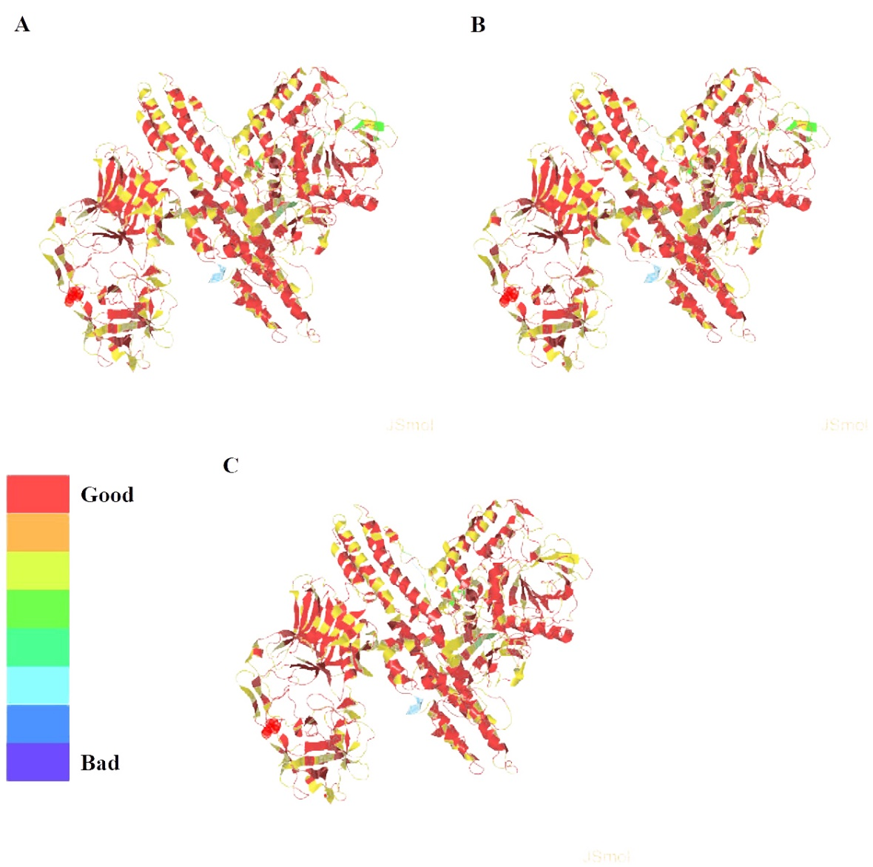

Supplementary Data 2a. Alignment confidence analysis of first option mutein (A), second option mutein (B) and BoNT/A (C)

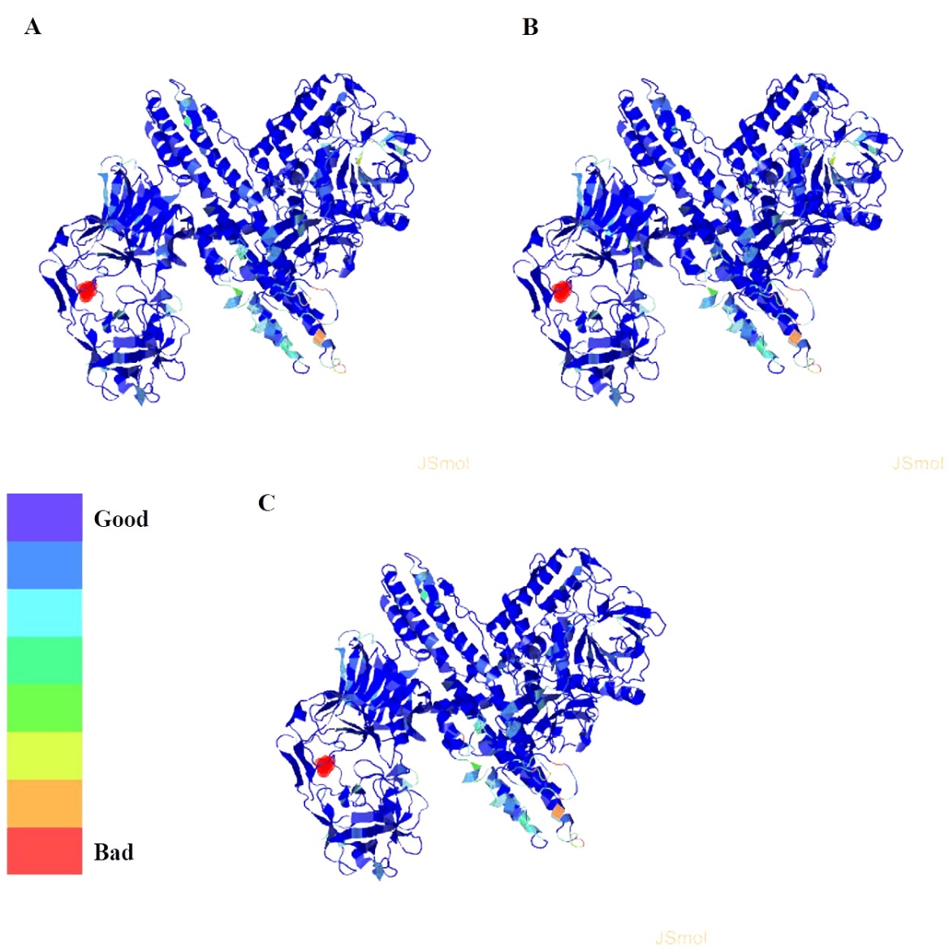

Supplementary Data 2b. Clashes analysis of first option mutein (A), second option mutein (B) and BoNT/A (C)

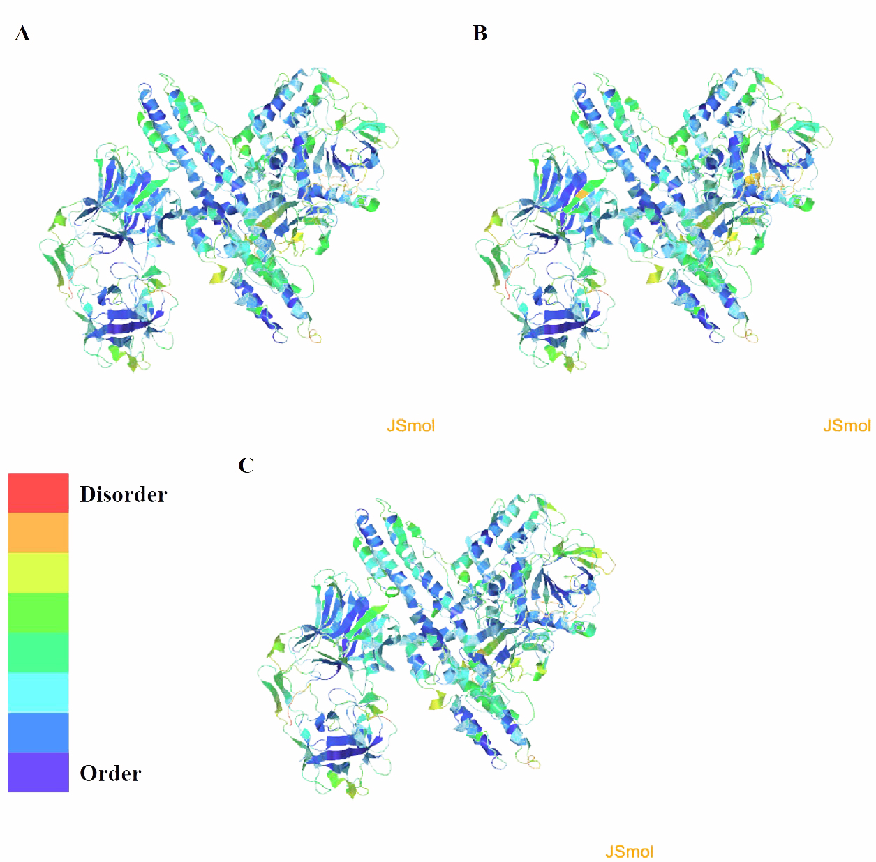

Supplementary Data 2c. Disorder analysis of first option mutein (A), second option mutein (B) and BoNT/A (C)

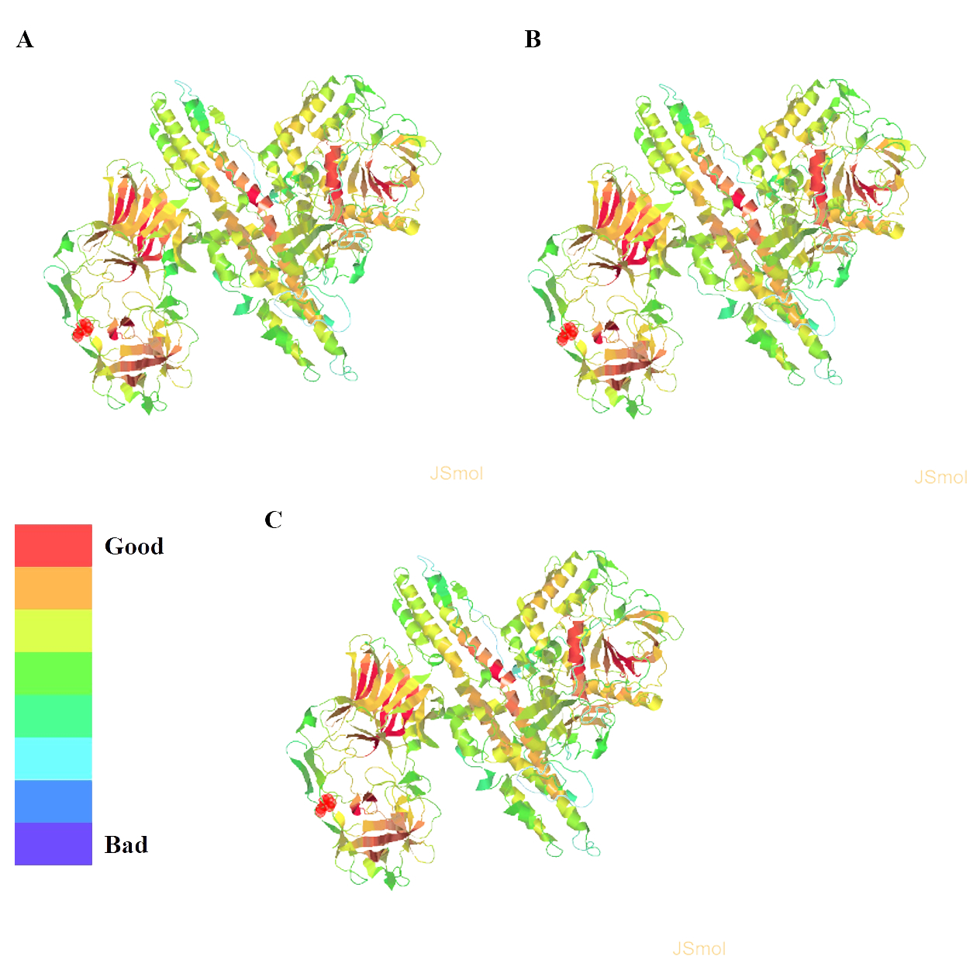

Supplementary Data 2d. ProQ2 analysis of first option mutein (A), second option mutein (B) and BoNT/A (C)

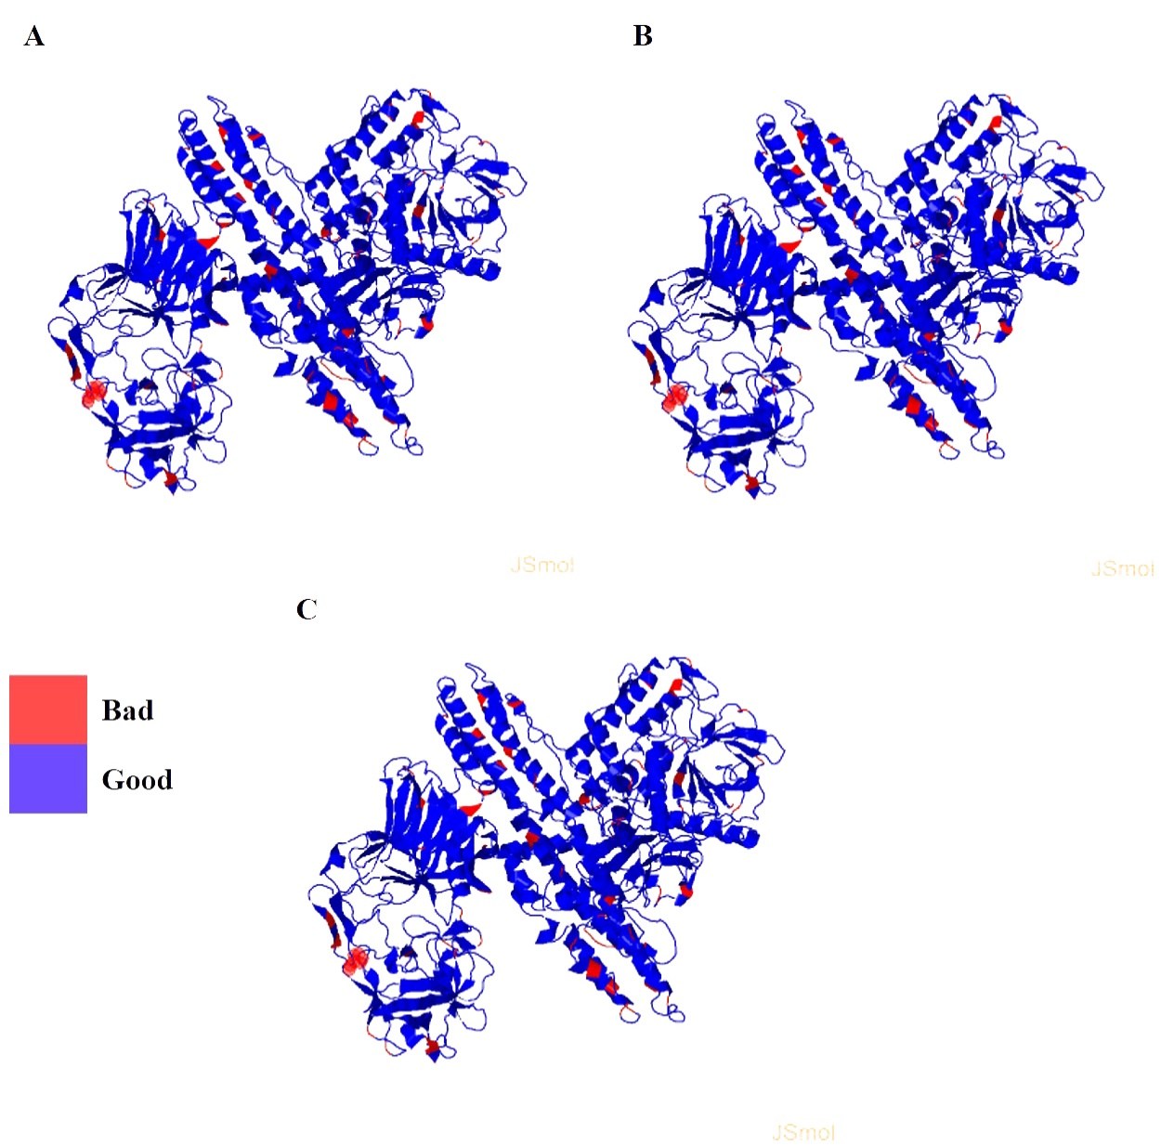

Supplementary Data 2e. Rotamer analysis of first option mutein (A), second option mutein (B) and BoNT/A (C)

Supplementary Data 3. Validation analyses BoNT/A and both mutein 3D structure done in SAVES 5.0 web servers, such as VERIFY3D and ERRAT.

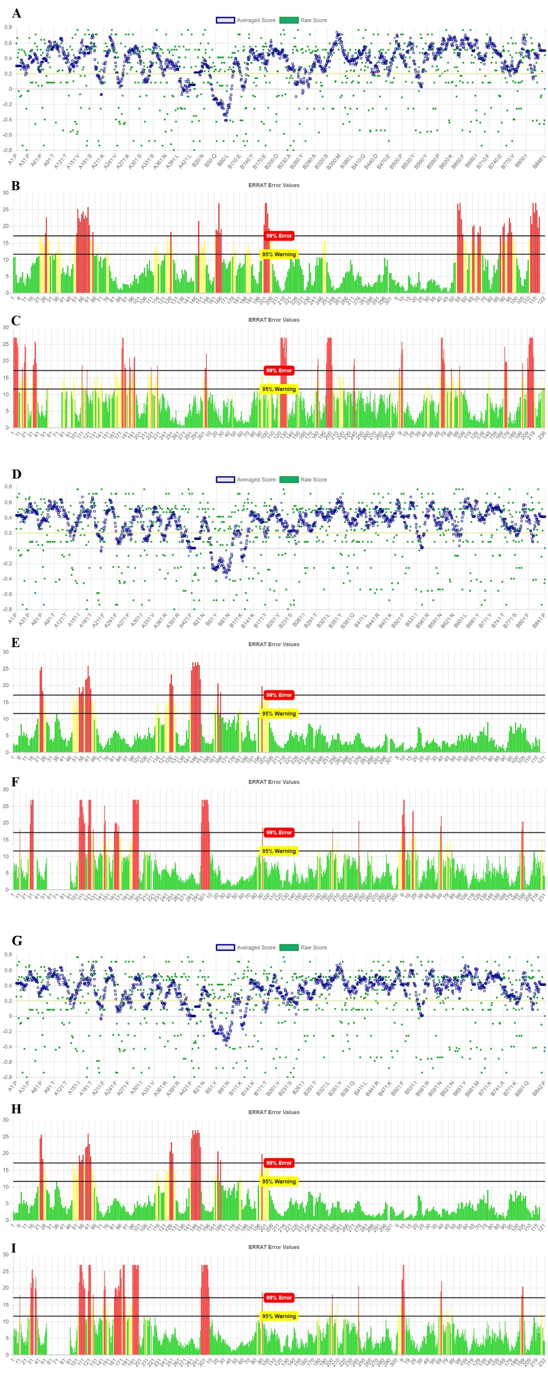

Supplementary Data 3a. Validation analyses BoNT/A using VERIFY3D (A) and ERRAT (B and C).

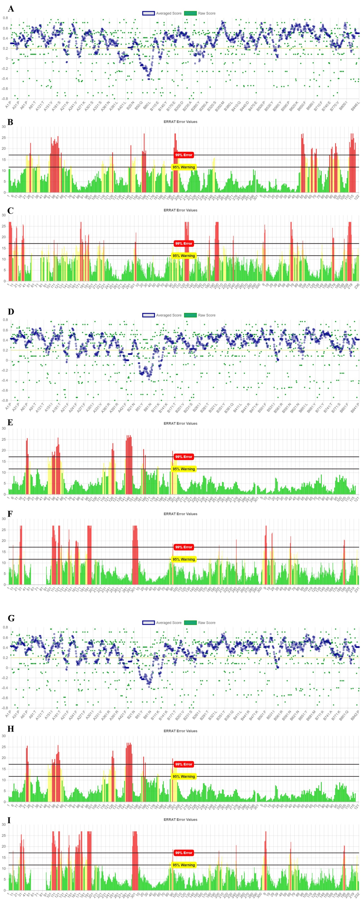

Supplementary Data 3b. Validation analyses first-option BoNT/A mutein using VERIFY3D (D) and ERRAT (E and F).

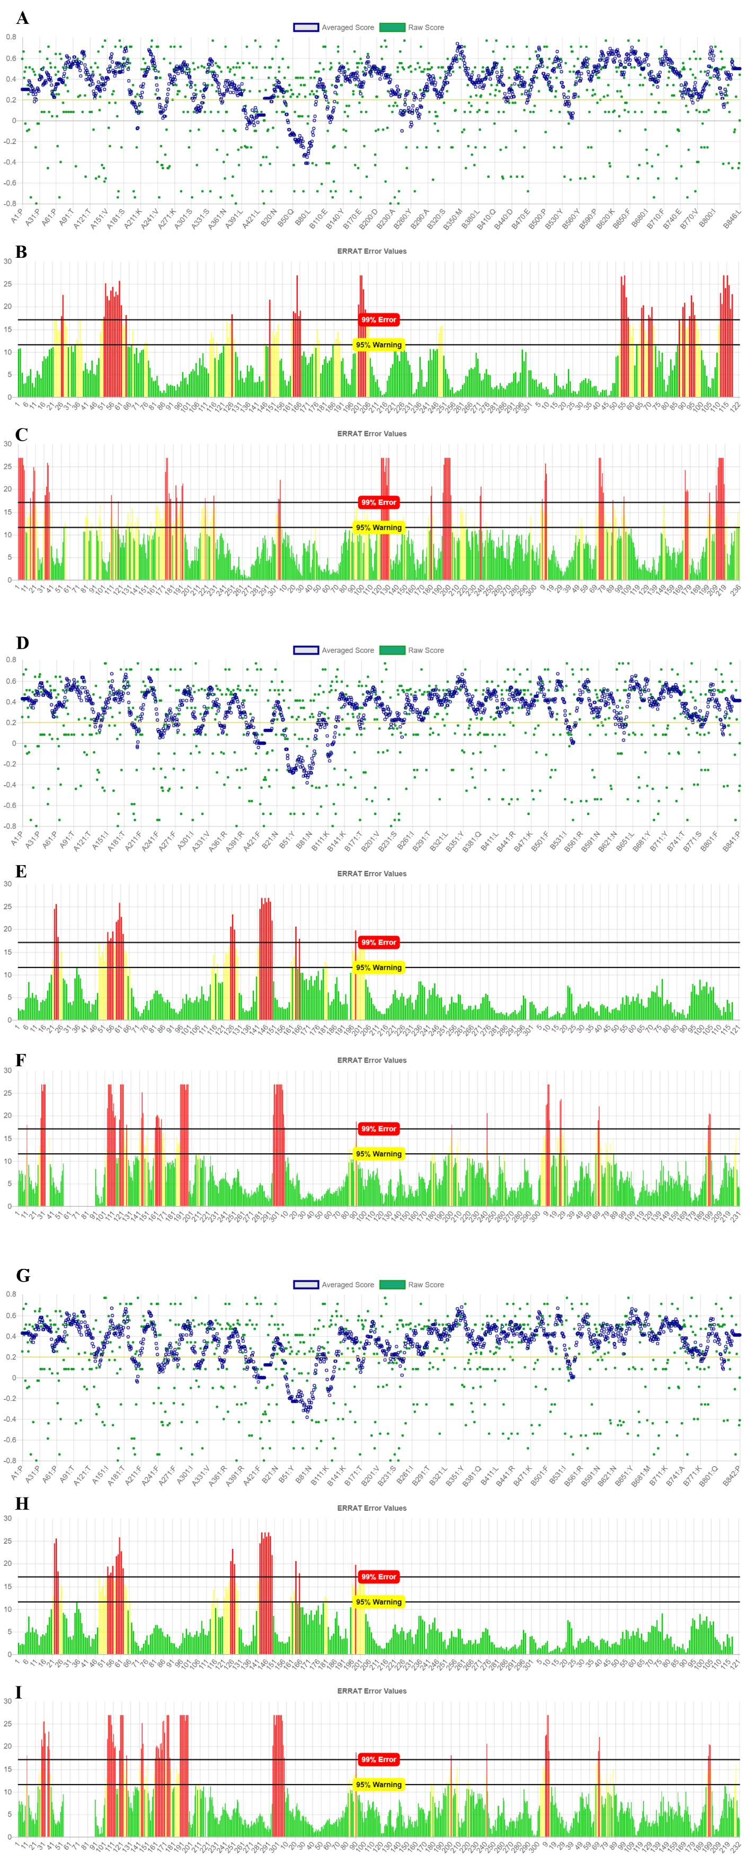

Supplementary Data 3c. Validation analyses second-option BoNT/A mutein using VERIFY3D (G) and ERRAT (H and I).