Supporting Information for

Photogenerated Spin Qubit (Radical) Pairs in DNA Hairpins: Observation of Spin Delocalization and Coherence
Jacob H. Olshansky, Matthew D. Krzyaniak, Ryan M. Young, and Michael R. Wasielewski*
Department of Chemistry and Institute for Sustainability and Energy at Northwestern (ISEN),
Northwestern University, Evanston, IL 60208-3113, USA
*m-wasielewski@northwestern.edu

Contents
Synthesis S2
Structures, UV-Vis, circular dichroism, and MALDI characterization S6
Experimental details S6
NDI-A_{m}G₁ hairpins S8
NDI-A₃G_{n} hairpins S9
NDI-A_{m}-Sd hairpins S10
NDI-A₃G_{n}-Sd hairpins S11
NDI-A₂G_{n}-Sd hairpins S12
Nanosecond Transient Absorption Spectroscopy S13
NDI-A₃-G_{n} hairpins S14
NDI-A_{m}-G₁ hairpins S16
NDI-A_{m}G_{n}-Sd hairpins S17
Predicted values for J and D S21
Spin delocalization fitting parameters S22
Electron g-values for NDI^{•-} and Sd^{•+} S23
Spin-correlated RP simulations and spectral decomposition S24
OOP-ESEEM full spin echos S25
Geometry of Sd end cap from OOP-ESEEM measurements S26
References S27

Synthesis
Materials: Chemicals were purchased as reagent grade and used as received. 1,4,5,8-naphthalenetetracarboxylic acid dianhydride (NDA, TCI, ≥ 97%), 3-amino-1-propanol (3-AMP, Sigma-Aldrich, ≥ 99%), zinc acetate dihydrate (Sigma-Aldrich, ≥ 99%), anhydrous pyridine, 4,4’-dimethoxytrityl chloride (DMT chloride, ChemeGenes), N,N-diisopropylethylamine (DIPEA, Sigma-Aldrich, 99.5%), 2-Cyanoethyl N,N-diisopropylchlorophosphoramidite (Acros, 97%). All DNA synthesis reagents were purchased from Glen Research: oxidizing solution (0.02 M Iodine in Tetrahydrofuran/Water/Pyridine), Cap Mix A (Tetrahydrofuran/Acetic Anhydride), Cap Mix B (10% 1-Methylimidazole in Tetrahydrofuran/Pyridine), Activator (Sublimed 1H-Tetrazole in Anhydrous Acetonitrile), Deblocking Mix (3% Trichloroacetic acid in Dichloromethane), Anhydrous Wash (Acetonitrile, anhydrous), dA-CE Phosphoramidite, dG-CE Phosphoramidite, dT-CE Phosphoramidite, dC-CE Phosphoramidite, and dT or dA CPG.
N,N’-[Bis(3-hydroxypropyl)]-1,4:5,8-naphthalimide
In a typical reaction, NDA (2.0 g, 7.46 mmol), 3-AMP (3.2 g, 29.8 mmol), and zinc acetate dihydrate (2.0 g, 9.32 mmol) were combined with 50 mL of anhydrous pyridine in a 200 mL round-bottomed flask and stirred for 16 hrs at 120 °C under nitrogen. Upon cooling to room temperature, pyridine was removed in vacuo and the product was dry-loaded onto a silica column and eluted with a 50:1 DCM:MeOH solvent mixture. The product was recrystallized from a DCM/MeOH mix to yield pink needle crystals (1.98 g, 69% yield). ¹H NMR (DMSO-d₆) δ = 1.82 (quin, 4H), 3.52 (q, 4H), 4.13 (t, 4H), 4.52 (t, 2H), 8.66 (s, 4H) ppm.
Scheme S1. Synthesis of NDI-diol (N,N’-[Bis(3-hydroxypropyl)]-1,4:5,8-naphthalimide) and conversion of Sd or NDI diol to the DMT and phosphoramidite functionalized reagent used in DNA synthesis.

Dimethoxytrityl (DMT) addition
In a typical reaction the NDI diol was dissolved in 10 mL anhydrous pyridine per mmol of NDI. The Sd diol was dissolved in 3 mL anhydrous pyridine and 12 mL anhydrous DMF per mmol Sd. The reactant mixture had to be heated to 60 °C for an hour to dissolve the diol. Upon cooling to room temperature, DMT chloride (1.25 equivalents) was added and the reaction was stirred 1.5 – 2 hrs under nitrogen. Solvent was removed in vacuo and the crude product was dissolved in a DCM/MeOH mix, washed with saturated aqueous sodium bicarbonate, and dried over sodium sulfate (note that the insoluble diol starting material was partially filtered out in this step). Column chromatography was performed with 1% triethylamine and 1% MeOH in DCM to yield the purified product in a typical yield of 25-33%.
Phosphoramidite addition
In a typical reaction the DMT functionalized NDI or Sd alcohol was dissolved in anhydrous DCM (25 mL per mmol) and placed under nitrogen. The reaction mixture was placed in an ice bath and 5 equivalents of DIPEA and 2 equivalents of 2-cyanoethyl N,N-diisopropylchlorophosphoramidite were added. The reaction was allowed to warm to room temperature over 45 min, at which point the mixture was poured into a solution of 2% triethylamine in ethyl acetate (200 mL per mmol NDI or Sd). The product was washed with saturated aqueous sodium bicarbonate and dried over sodium sulfate. Column chromatography was performed with 2% triethylamine in ethyl acetate to yield the purified product in a typical yield of 70-85%.
DNA Synthesis and purification
A standard 1 µmol DNA synthesis protocol was used with 50 mg of functionalized cpg (dT or dA depending on the sample). The NDI or Sd precursors were loaded onto the DNA synthesizer as 0.15 M solutions in anhydrous acetonitrile. All oligonucleotides were synthesized as their DMT-on derivatives and were stored on CPG in a freezer until purification. The CPG bound oligonucleotides were treated with ammonium hydroxide solution for 36 hours at room temperature to deprotect the bases and remove the DNA from the CPG. After evaporating the ammonia, the DMT-on DNA conjugates were purified by HPLC on a C-18 reverse phase column (4.6 x 250 mm, Phenomenex) with a 2% per minute gradient of acetonitrile in 0.03 M aqueous triethylammonium acetate. The DMT-on product was collected at ~17-20 min and concentrated in vacuo. The DMT group was removed by addition of acetic acid (80%, ~400 uL) for 20 min, followed by addition of sodium acetate and ethanol to precipitate the DMT-off DNA. The DMT-off DNA was purified using the same HPLC protocol, collecting at 13-14 min. A final analytical scale HPLC was performed to ensure purity of the product.

Structures, UV-Vis, circular dichroism, and MALDI characterization

Experimental details
UV-Vis spectroscopy: Absorption spectra were acquired on both a UV-1800 UV/Visible scanning spectrophotometer as well as with the CD spectrometer listed below. DNA hairpins were suspended in buffer for these measurements (10 mM sodium phosphate, 100 mM sodium chloride, pH = 7.2).
Circular Dichroism spectroscopy: CD spectra were acquired on a commercial spectrometer (Jasco, J-815) with a 1 mm cuvette. DNA hairpins were suspended in buffer for these measurements (10 mM sodium phosphate, 100 mM sodium chloride, pH = 7.2).
MALDI-TOF mass spectrometry: A Bruker AutoFlex-III instrument was used in linear negative mode. Masses were calibrated using a quadratic fit based on the known and measured masses of four commercial oligonucleotides purchased from IDT technologies (15T, 18T, Neomycin, and pGEx).
Transient Absorption Spectroscopy: Details of the transient absorption instrumentation have been described previously.¹ Briefly, ~50% of the output of a 1 kHz amplified Ti:sapphire system at 827 nm (1 W, 100 fs, Spitfire, Spectra Physics) is used to pump a non-collinear optical parametric amplifier (TOPAS-White, Light-Conversion, LLC.) tuned to generate the ~60 fs, 355 nm pump pulses. The pump is depolarized to minimize polarization-specific dynamics. In the nsTA experiment, the probe is generated in a separately delayed broadband laser system (EOS, Ultrafast Systems, LLC). The transmitted probe is detected on a commercial spectrometer (customized Helios-EOS, Ultrafast Systems, LLC). Samples were stirred in 2 mm quartz cuvettes during acquisition to minimize the effects of local heating and sample degradation.

NDI-A_{m}G₁ hairpins
Structures:
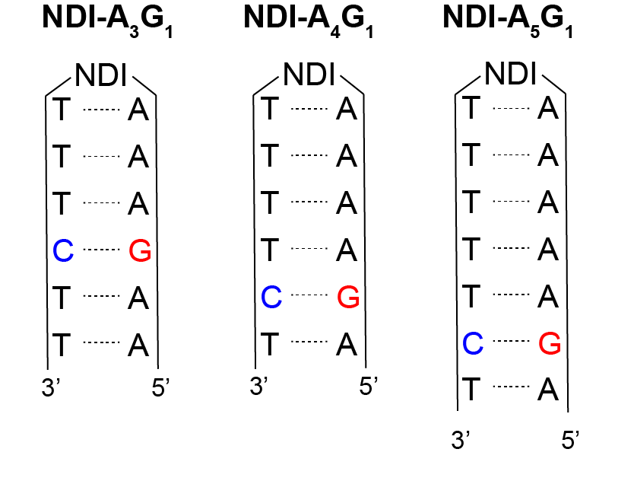
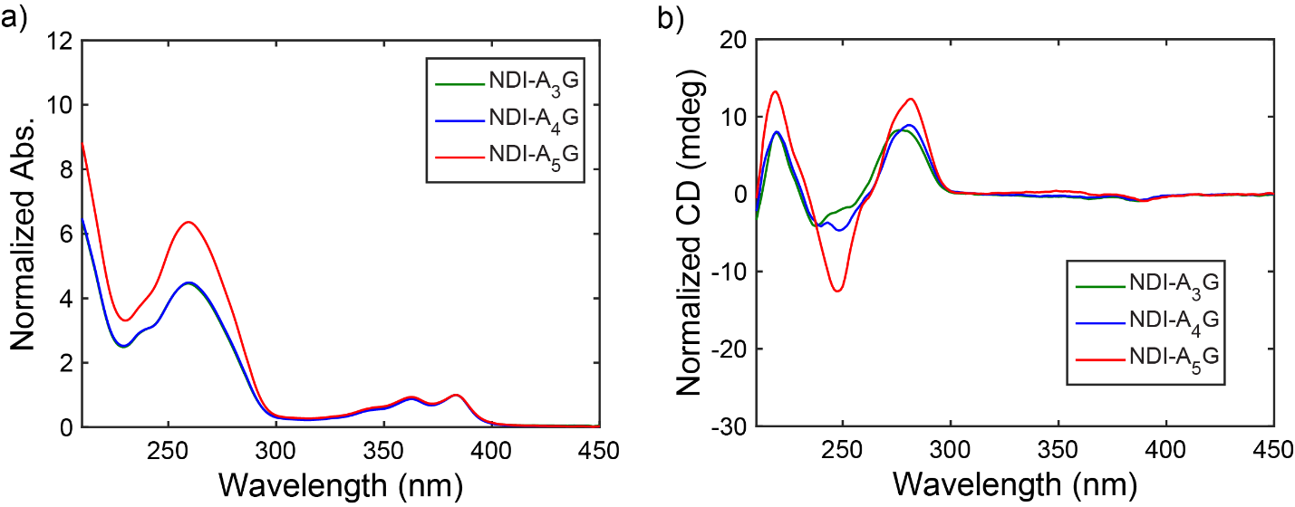
Figure S1. (a) UV-Vis and (b) circular dichroism spectroscopy of NDI-A_{m}G₁ hairpins.

MALDI-TOF mass spectrometry:
Hairpin | Calculated mass (m/|z|) | Experimental mass (m/|z|)
NDI-A₃G₁ | 4087.8 | 4086.0
NDI-A₄G₁ | 4087.8 | 4086.9
NDI-A₅G₁ | 4705.2 | 4704.3

NDI-A₃G_{n} hairpins
Structures:
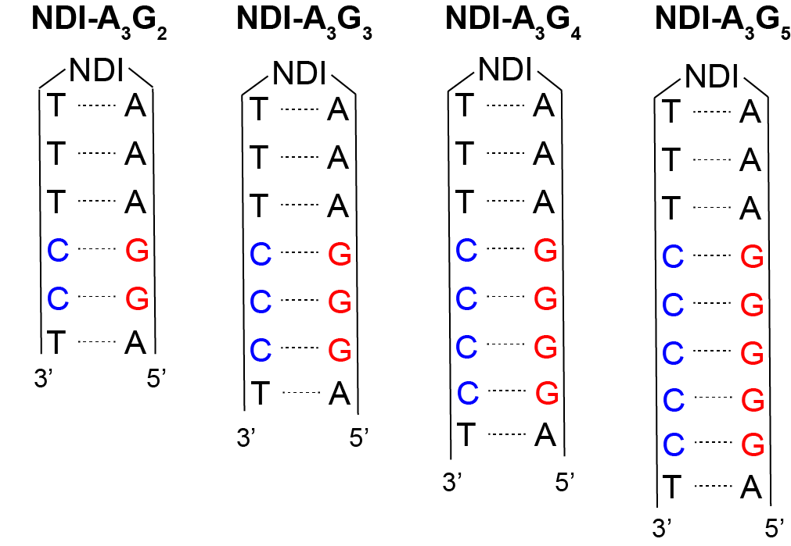
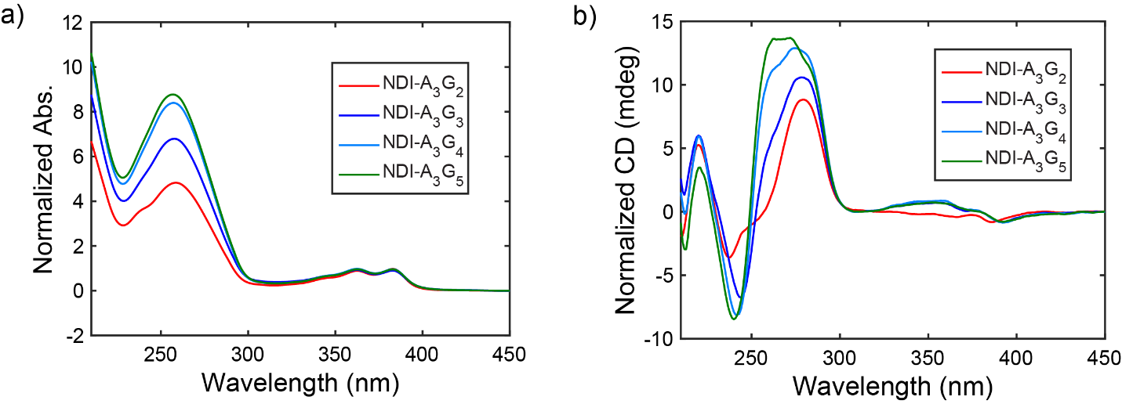
Figure S2. (a) UV-Vis and (b) circular dichroism spectroscopy of NDI-A₃G_{n} hairpins.

MALDI-TOF mass spectrometry:
Hairpin | Calculated mass (m/|z|) | Experimental mass (m/|z|)
NDI-A₃G₂ | 4088.8 | 4084.7
NDI-A₃G₃ | 4707.2 | 4703.4
NDI-A₃G₄ | 5325.6 | 5323.6
NDI-A₃G₅ | 5944.0 | 5937.7

NDI-A_{m}-Sd hairpins
Structures:
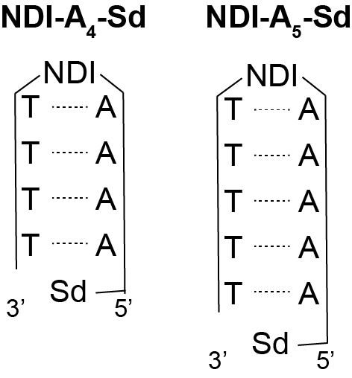
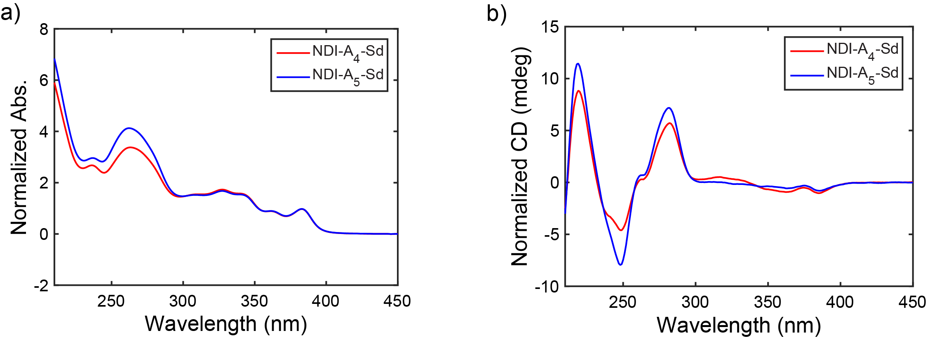
Figure S3. (a) UV-Vis and (b) circular dichroism spectroscopy of NDI-A_{m}-Sd hairpins.

MALDI-TOF mass spectrometry:
Hairpin | Calculated mass (m/|z|) | Experimental mass (m/|z|)
NDI-A₄-Sd | 3214.4 | 3210.5
NDI-A₅-Sd | 3831.8 | 3828.6

NDI-A₃G_{n}-Sd hairpins
Structures:
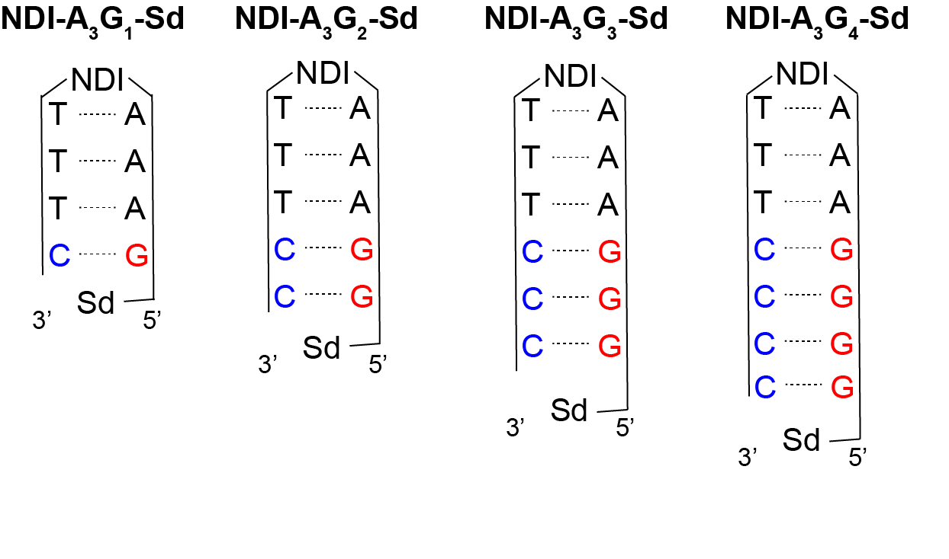
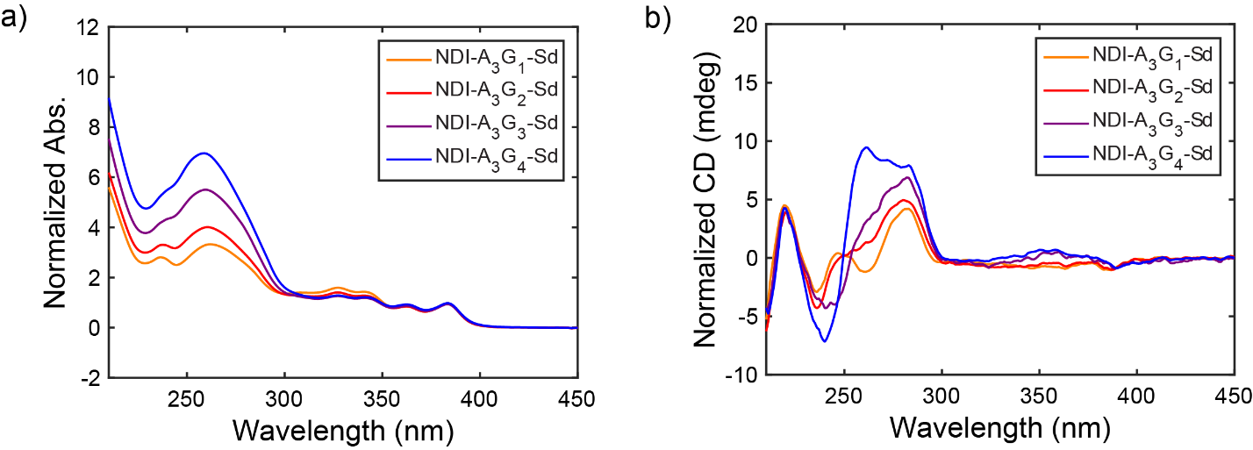
Figure S4. (a) UV-Vis and (b) circular dichroism spectroscopy of NDI-A₃G_{n}-Sd hairpins.

MALDI-TOF mass spectrometry:
Hairpin | Calculated mass (m/|z|) | Experimental mass (m/|z|)
NDI-A₃G₁-Sd | 3215.4 | 3214.3
NDI-A₃G₂-Sd | 3833.8 | 3842.1
NDI-A₃G₃-Sd | 4452.0 | 4453.2
NDI-A₃G₄-Sd | 5070.6 | 5070.0

NDI-A₂G_{n}-Sd hairpins
Structures:
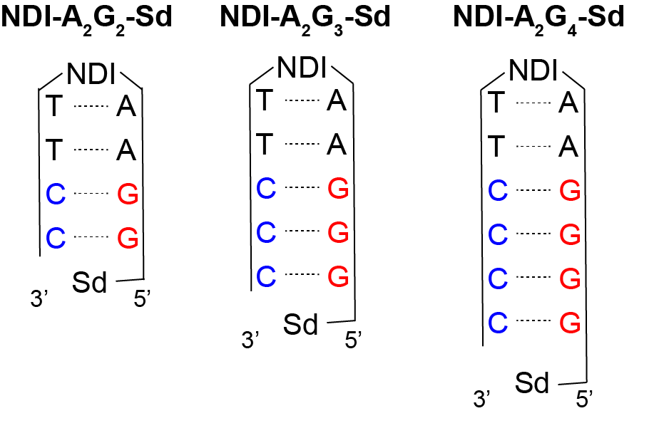
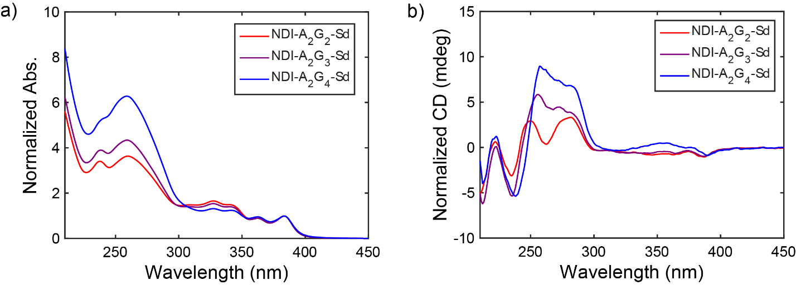
Figure S5. (a) UV-Vis and (b) circular dichroism spectroscopy of NDI-A₂G_{n}-Sd hairpins.

MALDI-TOF mass spectrometry:
Hairpin | Calculated mass (m/|z|) | Experimental mass (m/|z|)
NDI-A₂G₂-Sd | 3216.3 | 3212.6
NDI-A₂G₃-Sd | 3834.7 | 3831.9
NDI-A₂G₄-Sd | 4453.0 | 4451.6

Nanosecond Transient Absorption Spectroscopy
Time-resolved TA spectra are shown for the DNA hairpins studied (Figures S6, S9-S11). As discussed in the main text, the NDI-A_{m}G₁ and NDI-A₃G_{n} structures exhibit spectroscopic features of the NDI^{•-} anion while the NDI-A_{m}G_{n}-Sd structures show, in a 1:1 ratio, spectral features of NDI^{•-} and Sd^{•+}. The recombination of the charge separated states can be monitored by following the decay of these spectral features. Specifically, we have plotted an integrated ΔA from 468-508 nm (around the main NDI^{•-} feature) as a function of time, normalized to the integrated ΔA value at t = 0 (Figures S7, S8, and S12). These plots are analogous to single wavelength traces at 488 nm, with moderately improved signal-to-noise. The TA time traces are therefore a proxy for the relative population of the charge separated state over time. The traces exhibit multiexponential kinetics as a result of the complex nature of charge transfer and recombination in DNA that contains multiple, degenerate, sites on which charges can reside. However, we found that fitting the time traces with biexponential functions (with a baseline) gave reasonable results that can at least approximately quantify the lifetimes of the charge separated states.

NDI-A₃-G_{n} hairpins
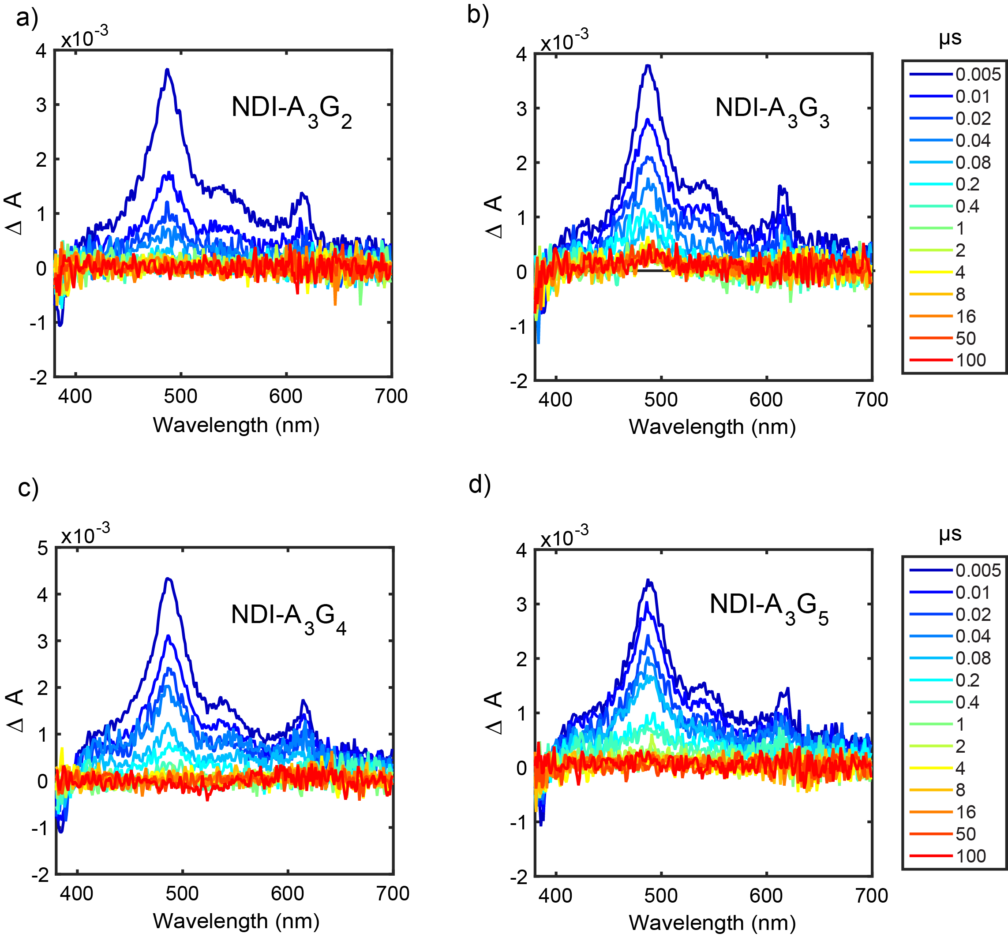
Figure S6. Nanoosecond TA time-resolved spectra of NDI-A₃G_{n} structures following ~60 fs, 355 nm excitation (1.0 μJ/pulse).

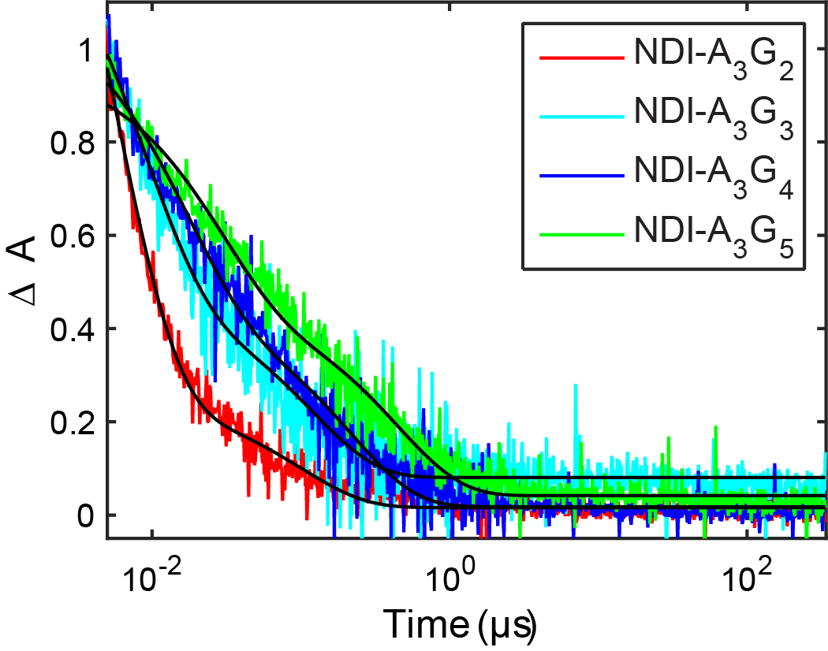
Figure S7. Nanosecond TA traces of NDI-A₃G_{n} hairpins illustrating the dependence of charge recombination on the length of the G-tract.

Time constants (τ_{i}) and amplitudes (α_{i}) extracted from biexponential decays:
hairpin | τ₁ | α₁ | τ₂ | α₂
NDI-A₃-G₂ | 5.4 ns | 0.88 | 100 ns | 0.11
NDI-A₃-G₃ | 8.5 ns | 0.67 | 120 ns | 0.27
NDI-A₃-G₄ | 17 ns | 0.60 | 220 ns | 0.38
NDI-A₃-G₅ | 28 ns | 0.54 | 450 ns | 0.42

NDI-A_{m}-G₁ hairpins
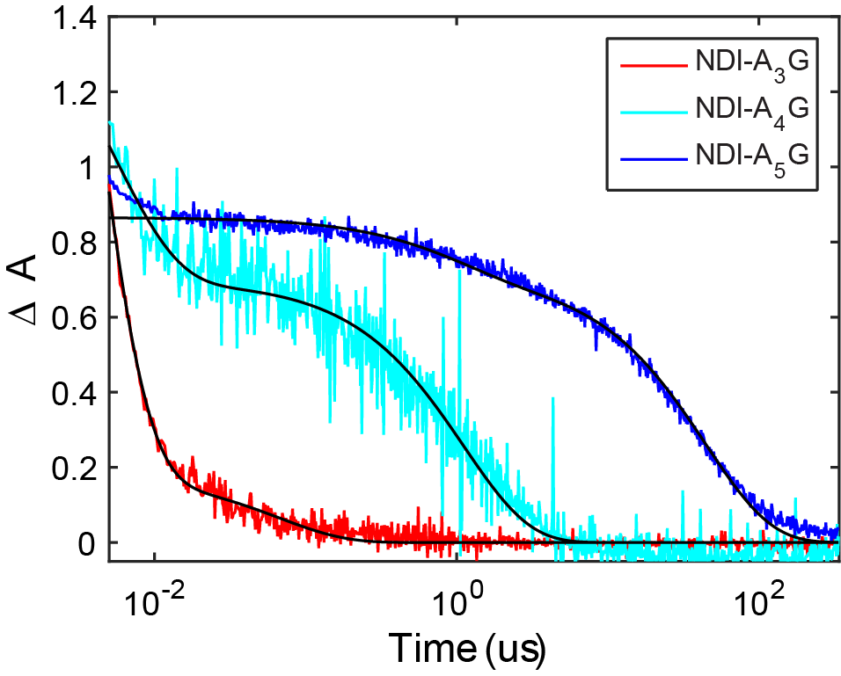
Figure S8. Nanosecond TA traces of NDI-A_{m}-G₁ hairpins illustrating the distance dependence of charge recombination from the NDI^{•-}-G^{•+} state.

Time constants (τ_{i}) and amplitudes (α_{i}) extracted from biexponential decays:
hairpin | τ₁ | α₁ | τ₂ | α₂
NDI-A₃-G₁ | 3.0 ns | 0.96 | 0.067 μs | 0.04
NDI-A₄-G₁ | 5.3 ns | 0.57 | 1.1 μs | 0.43
NDI-A₅-G₁ | n/a | n/a | 44.6 μs | 1.0

NDI-A_{m}G_{n}-Sd hairpins
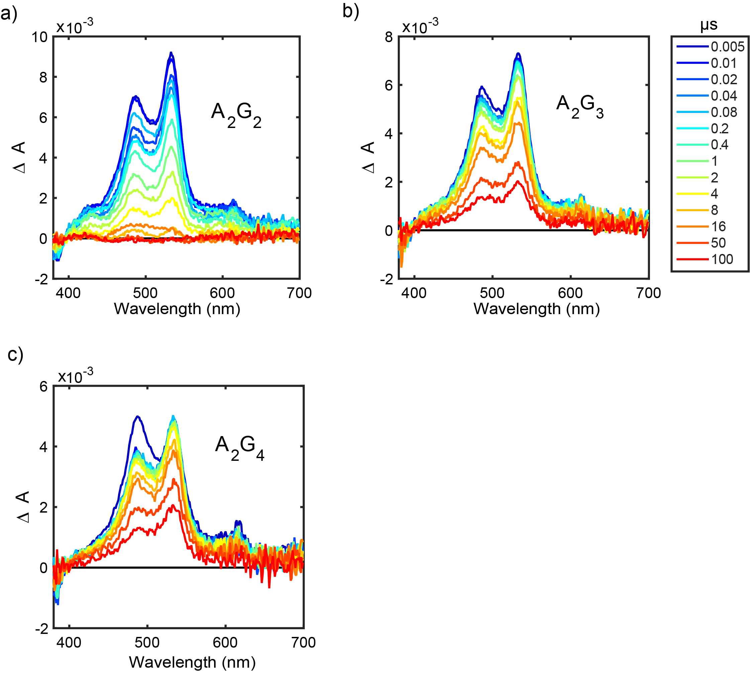
Figure S9. Nanosecond TA time-resolved spectra of NDI-A₂G_{n}-Sd structures following ~60 fs, 355 nm excitation (1.0 μJ/pulse).

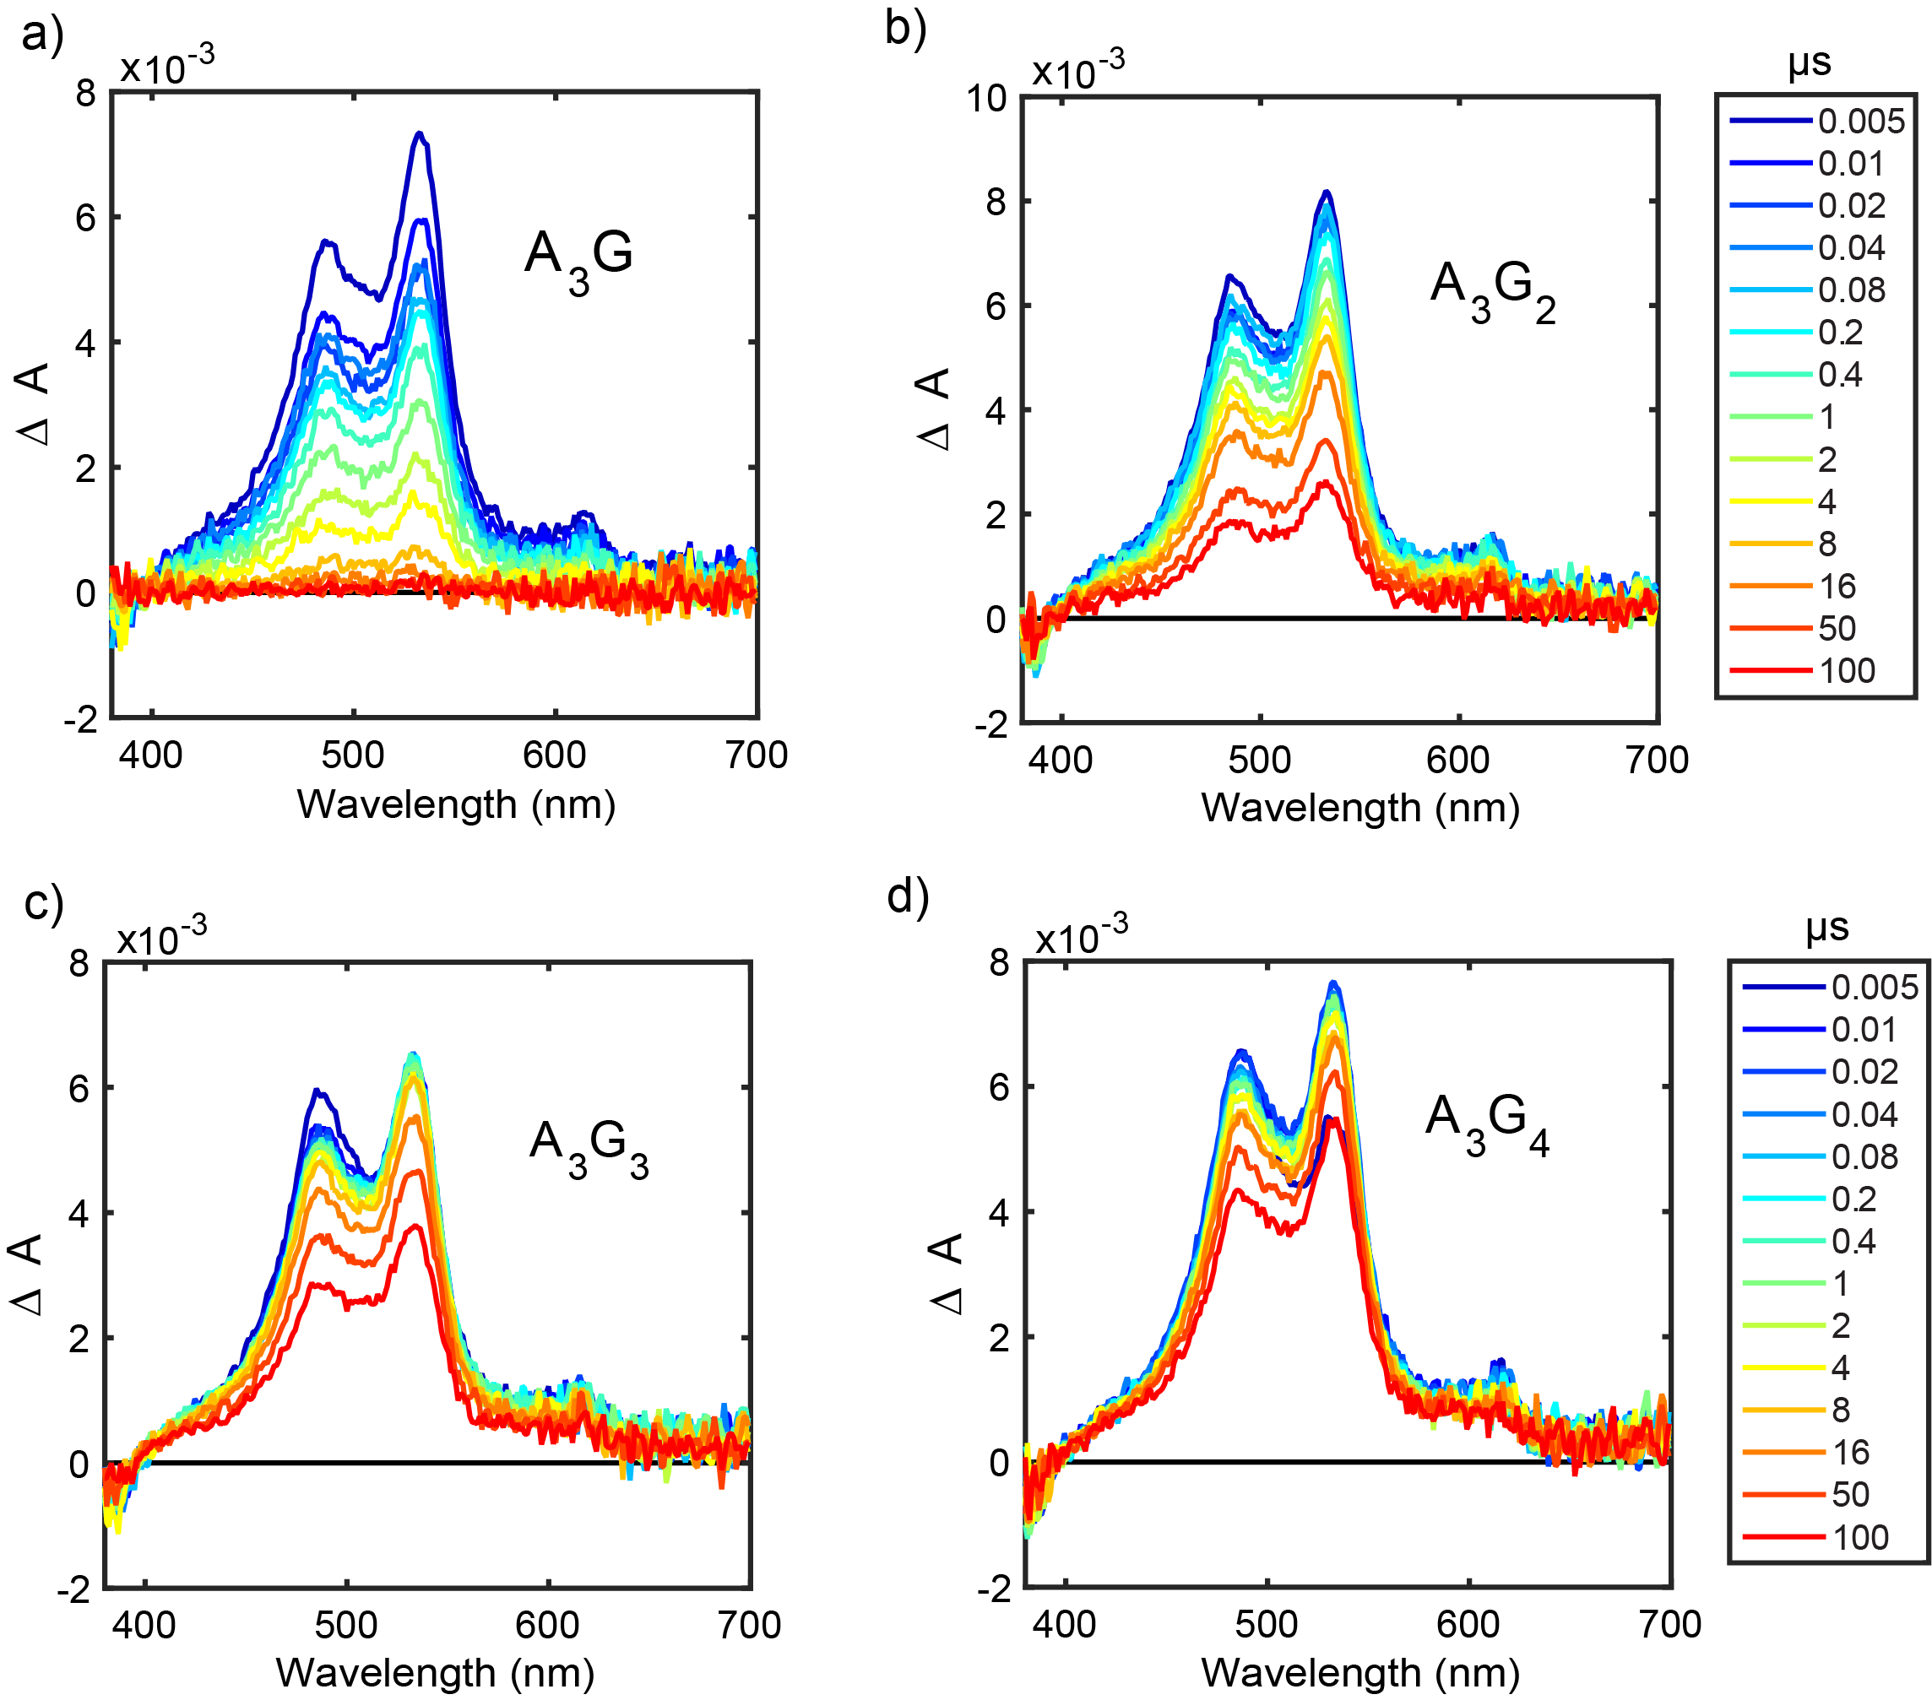
Figure S10. Nanosecond TA time-resolved spectra of NDI-A₃G_{n}-Sd structures following ~60 fs, 355 nm excitation (1.0 μJ/pulse).

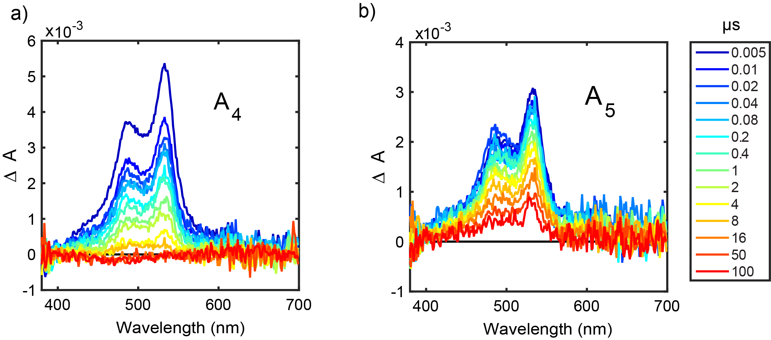
Figure S11. Nanosecond TA time-resolved spectra of NDI-A_{n}-Sd structures following ~60 fs, 355 nm excitation (1.0 μJ/pulse).

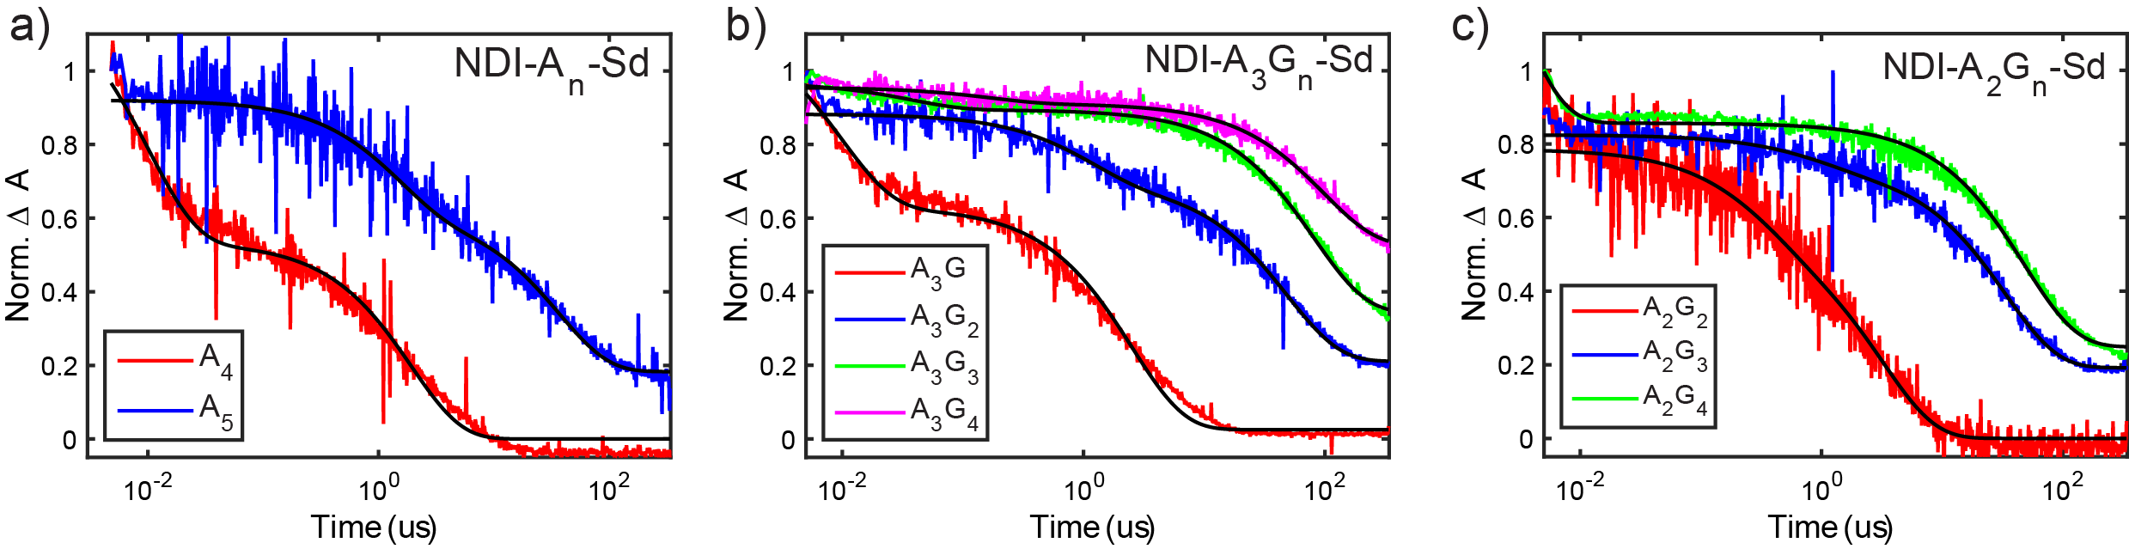
Figure S12. Nanosecond TA traces of a) NDI-A_{m}-Sd, b) NDI-A₃G_{n}-Sd, and c) NDI-A₂G_{n}-Sd hairpins. The hairpins with five or more base pairs do not decay completely within the repetition period of the laser, so extracted recombination time constants are artificially short.

Time constants (τ_{i}) and amplitudes (α_{i}) extracted from biexponential decays:
hairpin | τ₁ | α₁ | τ₂ | α₂
NDI-A₄-Sd | 10 ns | 0.57 | 1.9 μs | 0.43
NDI-A₅-Sd | 1400 ns | 0.33 | 37 μs | 0.47
NDI-A₂G₂-Sd | 320 ns | 0.29 | 3.2 μs | 0.71
NDI-A₂G₃-Sd | 910 ns | 0.11 | 33 μs | 0.66
NDI-A₂G₄-Sd | 2.5 ns | 0.54 | 48 μs | 0.33
NDI-A₃G₁-Sd | 9.7 ns | 0.45 | 2.5 μs | 0.53
NDI-A₃G₂-Sd | 1100 ns | 0.21 | 49 μs | 0.55
NDI-A₃G₃-Sd | 37 ns | 0.08 | 81 μs | 0.57
NDI-A₃G₄-Sd | 167 ns | 0.05 | 98 μs | 0.40

Predicted values for J and D
Distances are computed based on an assumption of 3.4 Å between adjacent base pairs. The point-dipole approximation is used to compute values of D. Values of the exchange coupling were computed from values for the electronic coupling (H_{el}) using the simple relation: $J\left(r\right)= -{H_{el}}^{2}/(λ+ΔG_{CR})$ previously derived by Kobori et al.² Electronic coupling values were derived from the Marcus model described previously.³ It should be noted that these values are quite approximate since the reorganization energy is not accurately known. All structures are assumed to be NDI-Sd hairpins with 4, 5, or 6 base pairs.
Base pairs | distance | D (MHz, mT) | J (MHz, mT)
4 | 17 Å | 16, 0.6 | 0.2, 8 x 10⁻³
5 | 20.4 Å | 9, 0.3 | 5 x 10⁻³, 2 x 10⁻⁴
6 | 23.8 Å | 5.8, 0.2 | 1.4 x 10⁻⁴, 5 x 10⁻⁶

Spin delocalization fitting parameters
The TREPR spectra for NDI-A₃G_{n} (n>1) were fit as linear combinations of the NDI-A_{m}G₁ spectra (m=3-5). The basis spectra were scaled such that a 1:1 ratio of NDI-A₃G₁ and NDI-A₄G₁ reproduced a good fit for the NDI-A₃G₂ spectrum. The NDI-A₄G₁ and NDI-A₅G₁ spectra are quite similar, so using one or the other did not qualitatively change the results. The key parameter is the percentage of NDI-A₃G₁ needed to achieve a fit. This parameter was then compared to expected population at the closest G in the case of full delocalization. See the table below:
 | Fraction of each basis component in the fit |  |  |  | Full delocalization
Structure | NDI-A₃G₁ | NDI-A₄G₁ | NDI-A₅G₁ | A₄G₁+ A₅G₁ | (1/n)
NDI-A₃G₂ | 0.50 | 0.50 | n/a | 0.50 | 0.50
NDI-A₃G₃ | 0.33 | 0.14 | 0.53 | 0.67 | 0.33
NDI-A₃G₄ | 0.17 | 0.11 | 0.72 | 0.83 | 0.25
NDI-A₃G₅ | 0.23 | 0.38 | 0.39 | 0.77 | 0.20

Electron g-values for NDI^{•-} and Sd^{•+}
Electron g-values for NDI^{-•} and Sd^{+•} were computed from geometry optimized structures in ORCA using a 6-31G* basis set. The computed g-values are: for NDI^{•-} g_{x} = 2.0046, g_{y} = 2.0047, g_{z} = 2.0022 and for Sd^{•+} g_{x} = 2.0031, g_{y} = 2.0042, g_{z} = 2.0022.
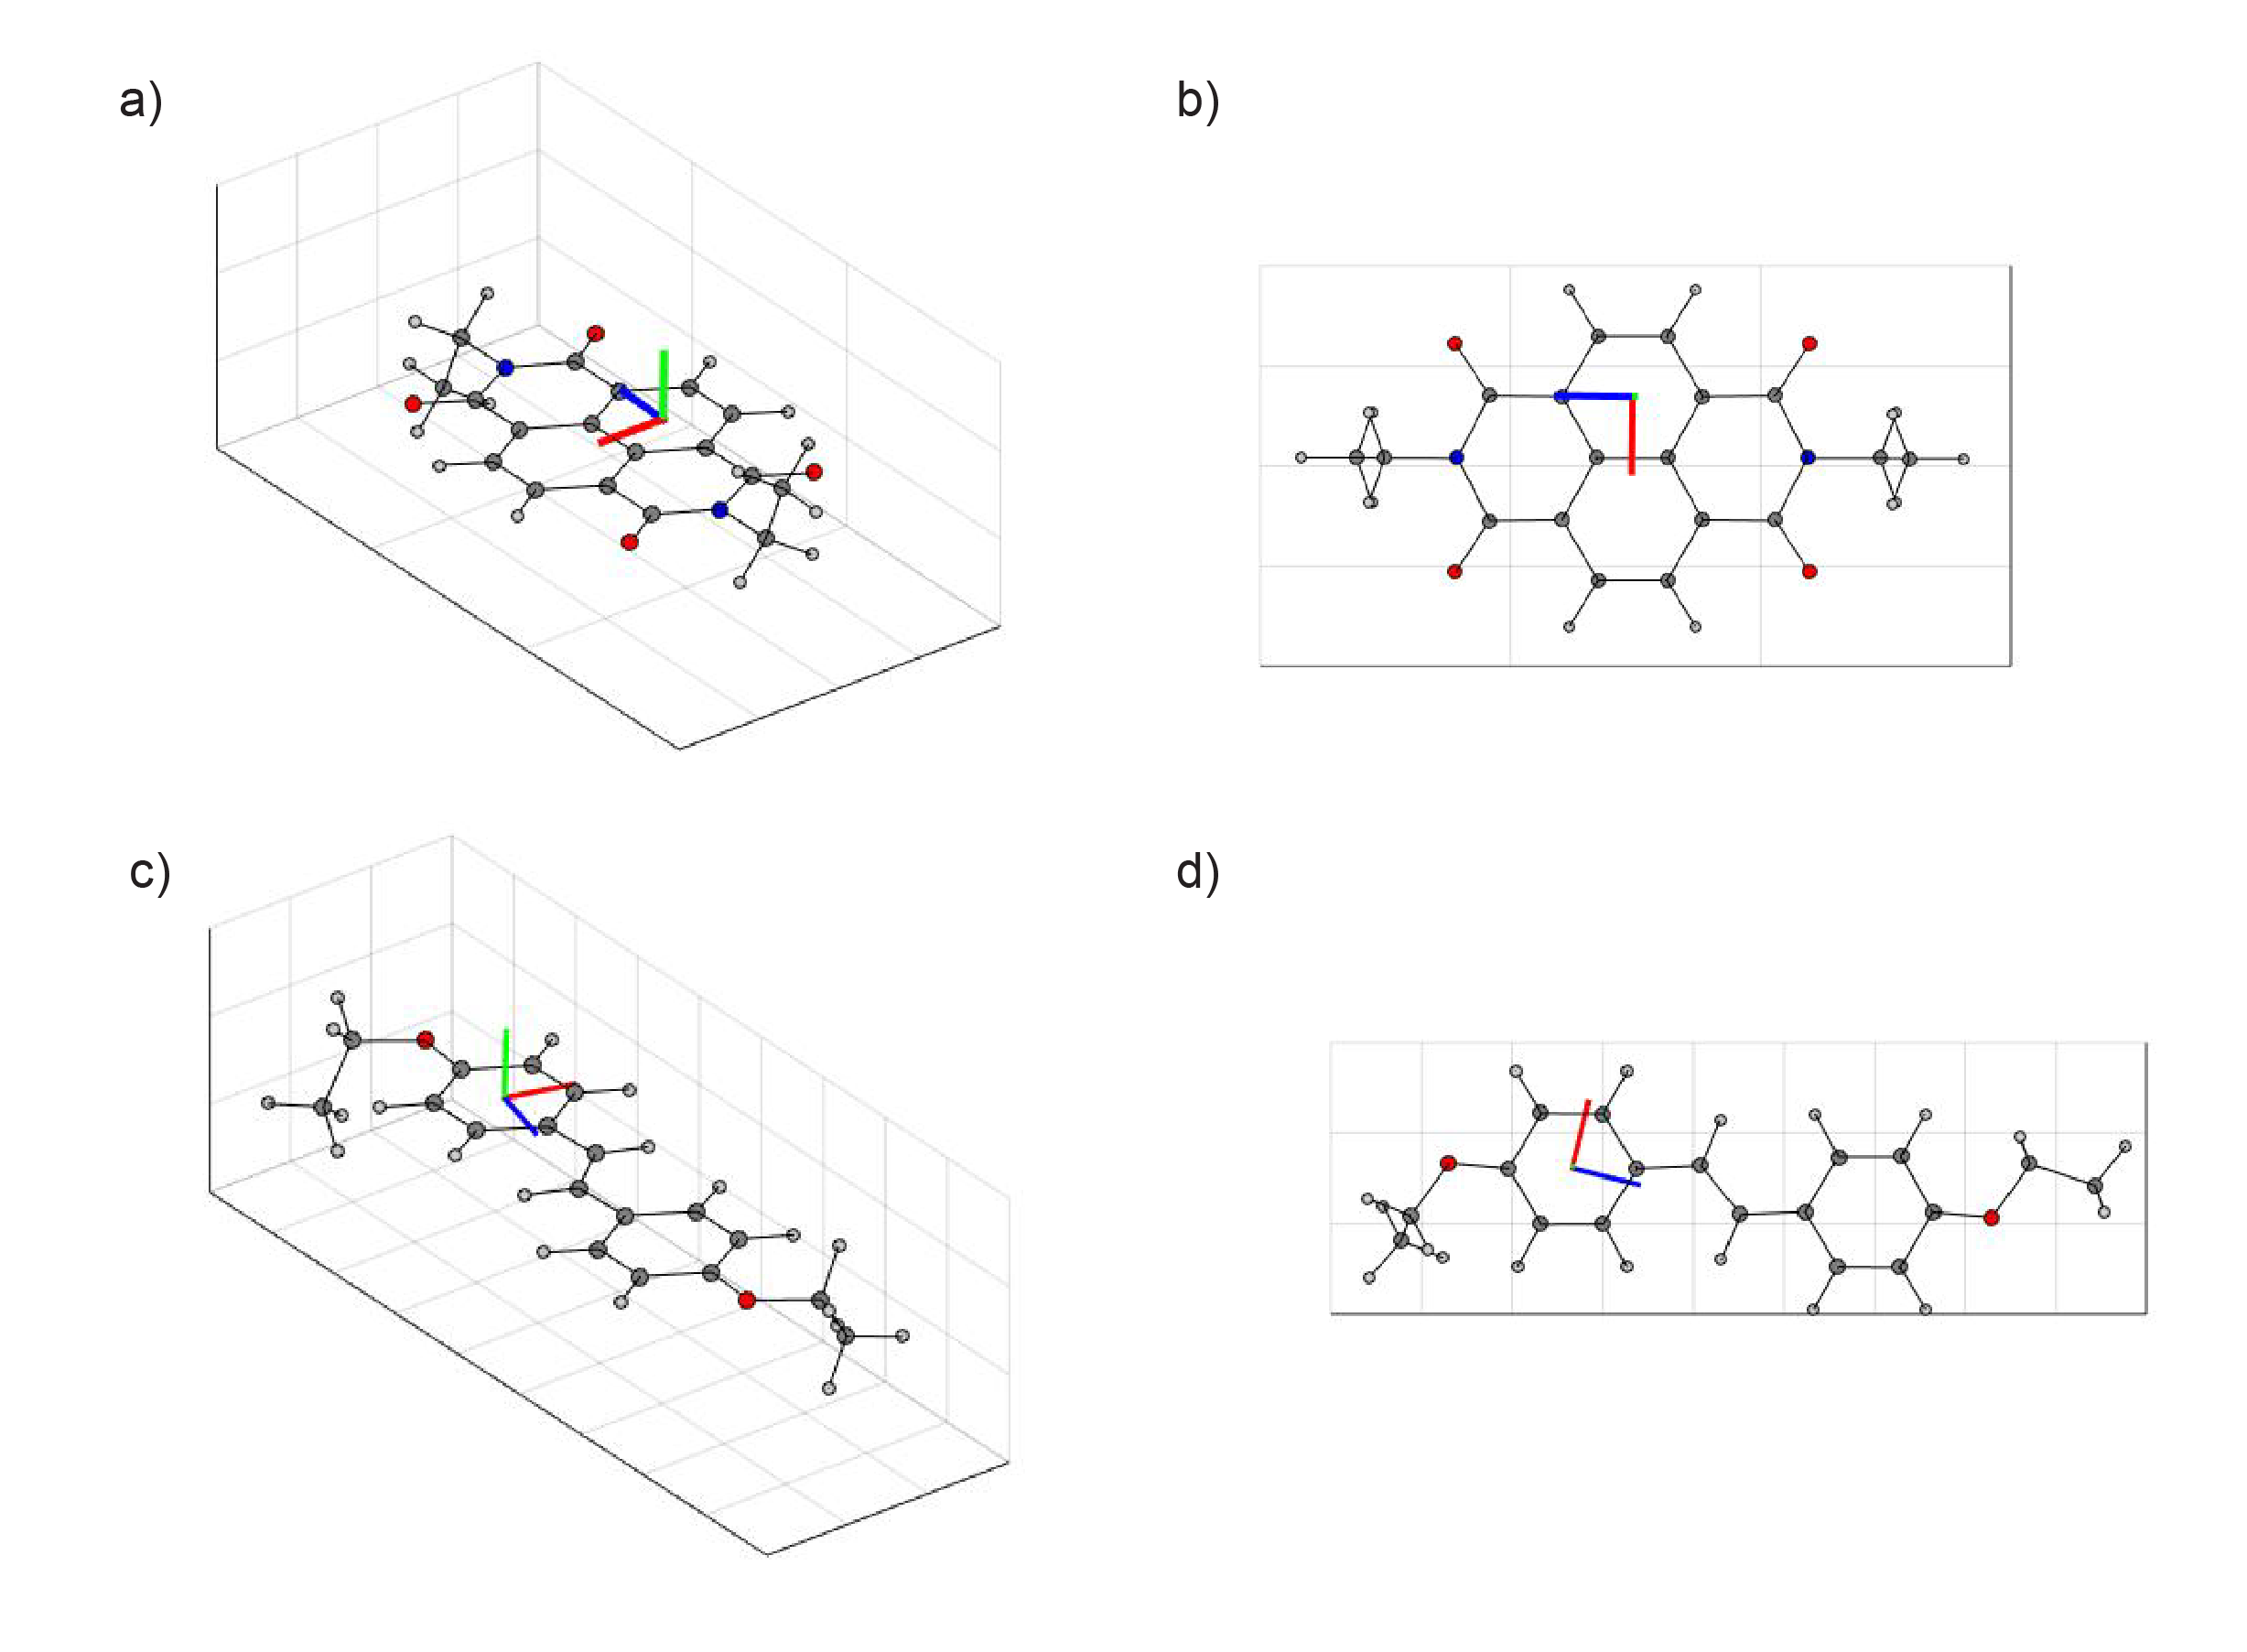
Figure S13. Principal g-axes superimposed on structures for (a,b) NDI^{•-} and (c,d) Sd^{•+}. (blue) x-axis, (red) y-axis, and (green) z-axis are shown.

Spin-correlated RP simulations and spectral decomposition
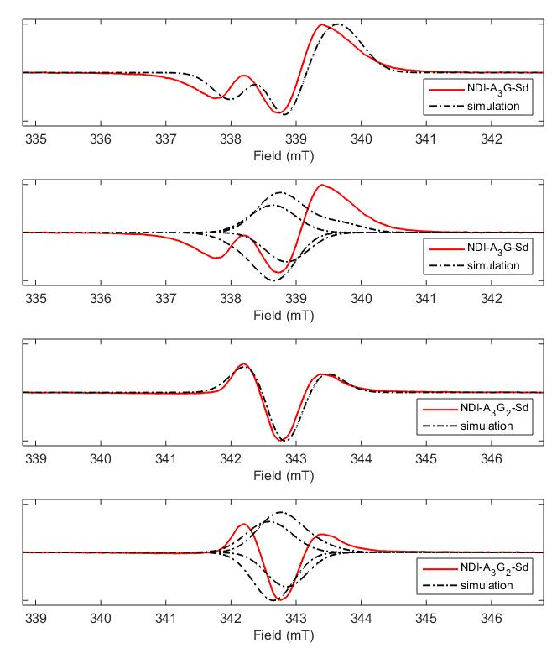
Figure S14. TREPR traces and simulations for two hairpins along with the individual components of the simulations corresponding to the four transitions (two emissive, and two absorptive).

OOP-ESEEM full spin echos
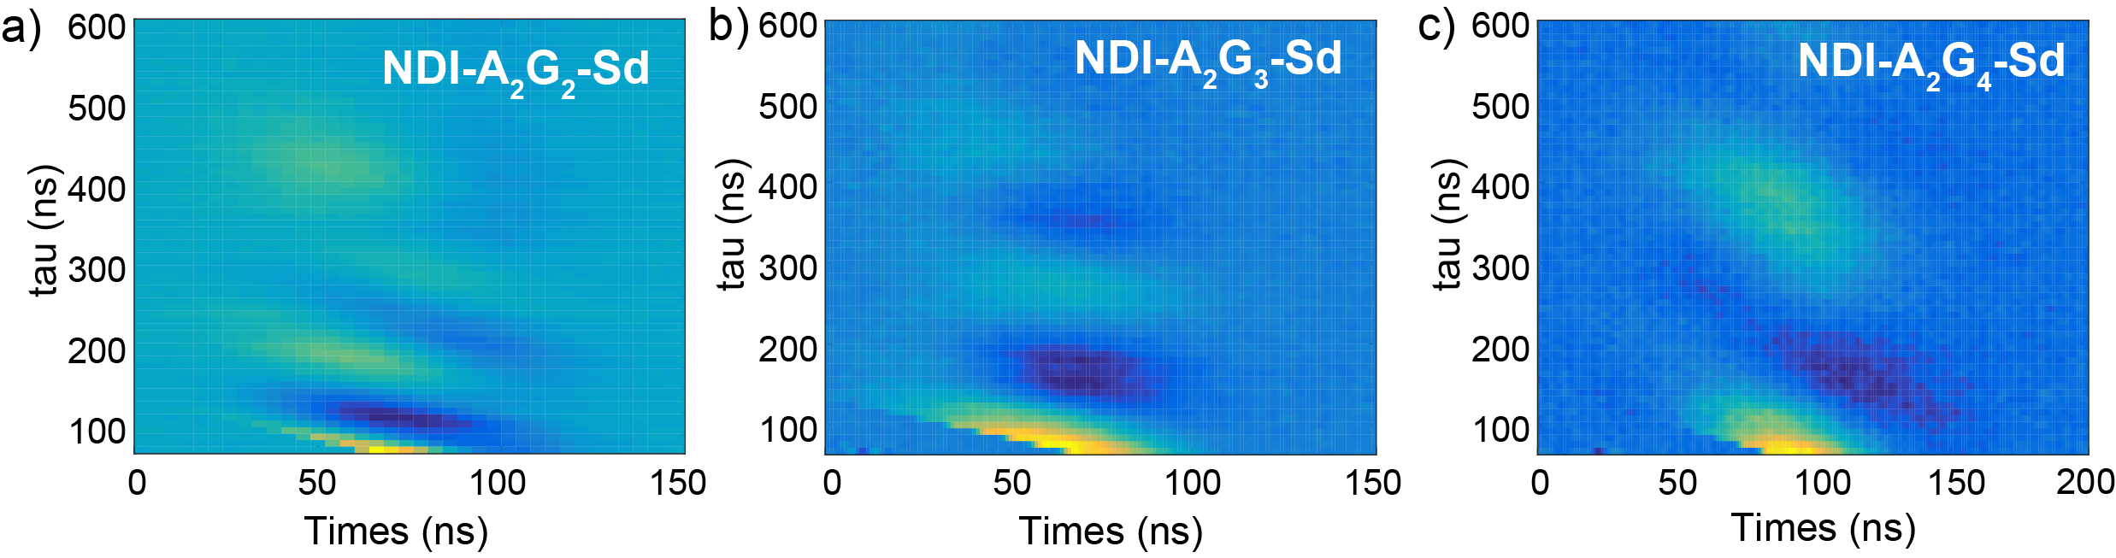
Figure S15. Spin echos for DNA hairpins shown as a function of time after the last microwave pulse (after subtracting tau and adding 72 ns) (horizontal axis). Echos were collected for a series of delay times between microwave pulses (tau, vertical axis).

Geometry of Sd end cap from OOP-ESEEM measurements

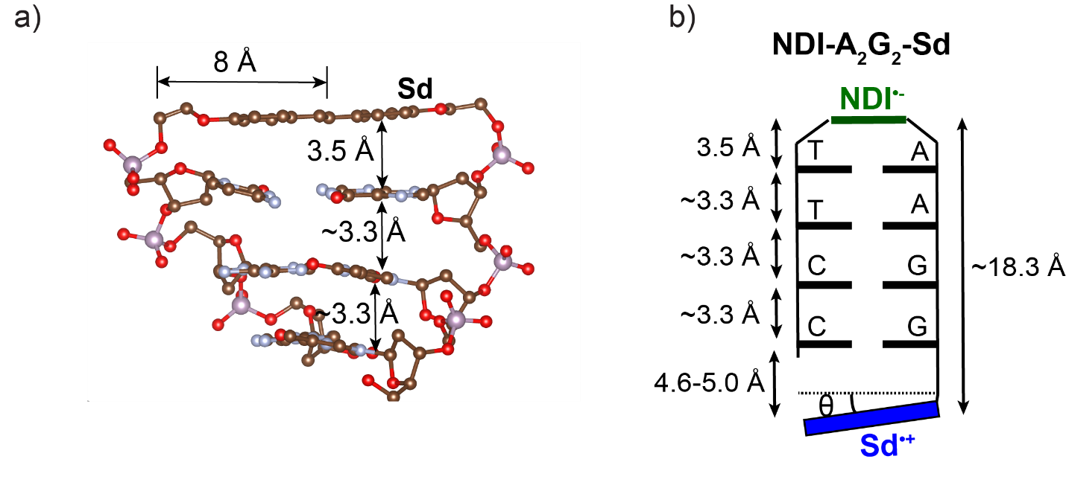
Figure S16. Determination of Sd end cap geometry. a) Sd hairpin linker and first three base pairs from a reported crystal structure.^{4,5} This structure was used to verify distances between base pairs and to determine the 8 Å distance from the end of the Sd molecule to the center. b) Schematic of NDI-A₂G₂-Sd with metrics used to approximate the Sd end cap rotation angle. The range of angles (8-10°) is derived assuming that the center of Sd is 8 Å from the DNA backbone.

References
(1)Young, R. M.; Dyar, S. M.; Barnes, J. C.; Juricek, M.; Stoddart, J. F.; Co, D. T.; Wasielewski, M. R. Ultrafast Conformational Dynamics of Electron Transfer in Exbox⁴⁺⊂Perylene. J. Phys. Chem. A 2013, 117, 12438-12448.
(2)Kobori, Y.; Sekiguchi, S.; Akiyama, K.; Tero-Kubota, S. Chemically Induced Dynamic Electron Polarization Study on the Mechanism of Exchange Interaction in Radical Ion Pairs Generated by Photoinduced Electron Transfer Reactions. J. Phys. Chem. A 1999, 103, 5416-5424.
(3)Lewis, F. D.; Kalgutkar, R. S.; Wu, Y.; Liu, X.; Liu, J.; Hayes, R. T.; Miller, S. E.; Wasielewski, M. R. Driving Force Dependence of Electron Transfer Dynamics in Synthetic DNA Hairpins. J. Am. Chem. Soc. 2000, 122, 12346-12351.
(4)Lewis, F. D.; Liu, X.; Wu, Y.; Miller, S. E.; Wasielewski, M. R.; Letsinger, R. L.; Sanishvili, R.; Joachimiak, A.; Tereshko, V.; Egli, M. Structure and Photoinduced Electron Transfer in Exceptionally Stable Synthetic DNA Hairpins with Stilbenediether Linkers. J. Am. Chem. Soc. 1999, 121, 9905-9906.
(5)Egli, M.; Tereshko, V.; Mushudov, G. N.; Sanishvili, R.; Liu, X.; Lewis, F. D. Face-to-Face and Edge-to-Face π-π Interactions in a Synthetic DNA Hairpin with a Stilbenediether Linker. J. Am. Chem. Soc. 2003, 125, 10842-10849.

