Supplementary information

Biosynthesized Silver Nanoparticle (AgNP) from Pandanus odorifer exhibits Anti-Metastasis and Anti-Biofilm Potentials

Afzal Hussain¹, Mohamed F. Alajmi¹, Meraj A. Khan^{2#}, Syed A. Pervez³, Faheem Ahmed⁴, Samira Amir⁴, Fohad M. Husain⁵, Mohd S. Khan⁶, Gouse M. Shaik⁶, Iftekhar Hassan⁷, Rais A. Khan⁸, Md. Tabish Rehman^{1#}

¹Department of Pharmacognosy, College of Pharmacy, King Saud University, Riyadh-11451, Kingdom of Saudi Arabia.
²Program in Translational Medicine, Peter Gilgan Centre for Research and Learning, The Hospital for Sick Children, Toronto, ON, Canada.
³Helmholtz Institute Ulm, Electrochemical Energy Storage, Helmholtzsteabe, 11, 89081, Ulm, Germany.
⁴Department of Chemistry, College of Science & General Studies, Al Faisal University, Riyadh, Kingdom of Saudi Arabia.
⁵Department of Food Science and Nutrition, College of Food and Agriculture, King Saud University, Riyadh-11451, Kingdom of Saudi Arabia.
⁶Protein Research Chair, Department of Biochemistry, College of Science, King Saud University, Riyadh 11451, Kingdom of Saudi Arabia.
⁷Department of Zoology, College of Science, King Saud University, Riyadh 11451, Kingdom of Saudi Arabia.
⁸Department of Chemistry, College of Science, King Saud University, Riyadh 11451, Kingdom of Saudi Arabia.
Running title: Anti-cancer and anti-biofilm properties of biosynthesized silver nanoparticles.

Key words: Silver nanoparticles (AgNPs), anti-metastasis, anti-biofilm, quorum sensing, molecular docking
#Corresponding authors:

Dr. Meraj Alam Khan
Program in Translational Medicine
The Hospital for Sick Children Research Institute
Peter Gilgan Centre for Research and Learning
686 Bay Street, Toronto, ON, M5G 0A4
Tel: 416-813-7654 ext.303388
Fax: 416-813-5771
Email: meraj.khan@sickkids.ca

Dr. Md Tabish Rehman
Department of Pharmacognosy,
College of Pharmacy,
King Saud University,
Riyadh 11451, Kingdom of Saudi Arabia
Tel: +966556814200, Fax: +96614677245
E-mail: mrehman@ksu.edu.sa,

Table S1. Quality assessment parameters of the predicted RhlR and PqsA models

Name of the Protein | C-Score | Estimated TM-Score | Estimated RMSD (Å)
RhlR | 1.23 | 0.88 ± 0.07 | 4.8 ± 3.1
PqsA | 1.32 | 0.90 ± 0.06 | 3.1 ± 2.2
Table S2. QMEAN assessment parameters for the modeled proteins

Parameters | Rhl R | Z-Score (RhlR) | PqsA | Z-Score (PqsA)
C-beta interaction energy | -80.62 | -0.59 | -116.17 | -0.96
All-atom pairwise energy | -5745.15 | -0.39 | -10496.80 | -0.93
Solvation energy | -30.28 | 0.62 | -41.49 | -0.38
Torsion angle energy | -22.69 | -2.71 | -82.87 | -2.04
Secondary structure agreement | 83.4% | 0.18 | 81.2% | 0.39
Solvent accessibility agreement | 75.5% | -0.80 | 81.0% | -0.04
Total QMEAN-score | 0.603 | -1.79 | 0.708 | -0.70

Fig. S1. UV-Vis absorption spectra of biogenic AgNPs after four months.

Fig. S2. HRTEM images of biogenic AgNPs after four months.

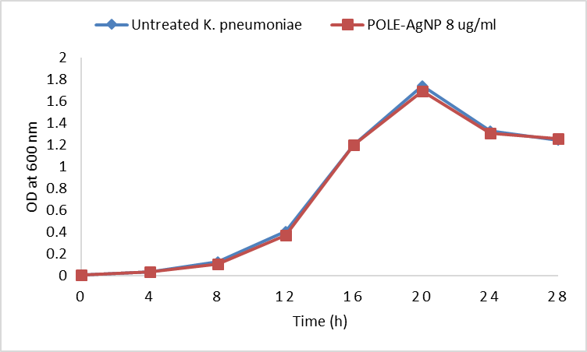
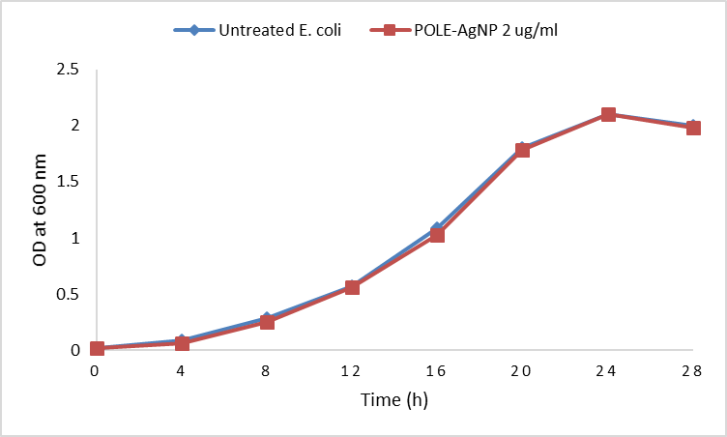
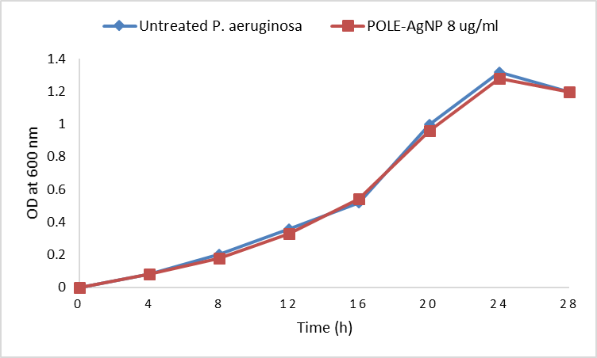
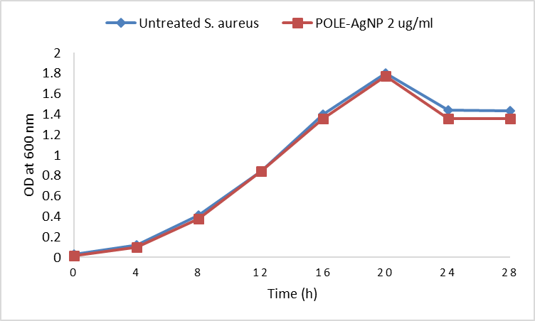
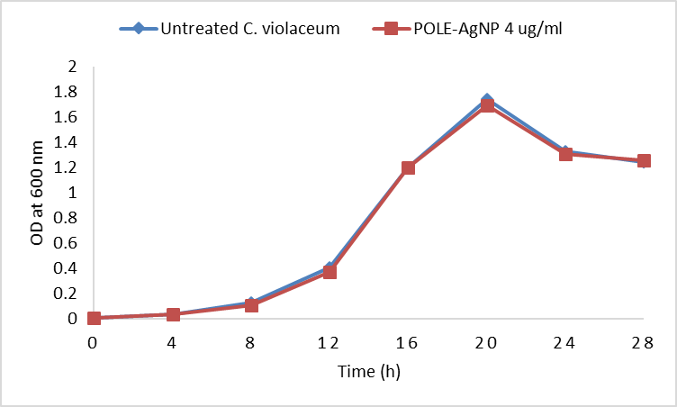

Fig. S3. Growth curve analysis of test pathogens at respective ½ x MIC.

Fig. S4. Log CFU values of test pathogens at ½ x MICs.

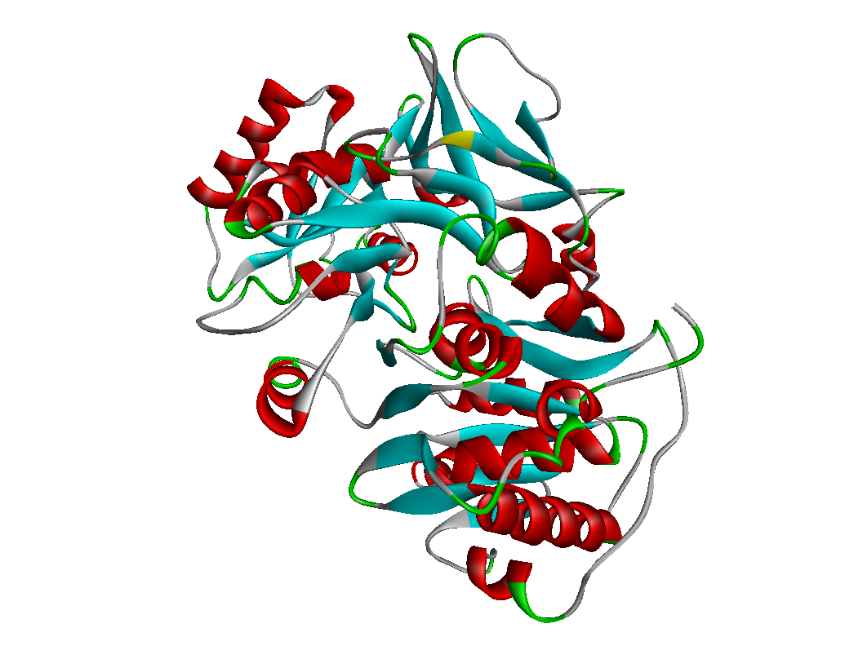
(A) (B)

Fig. S5. Modeled three-dimensional structures of (A) RhlR and (B) PqsA

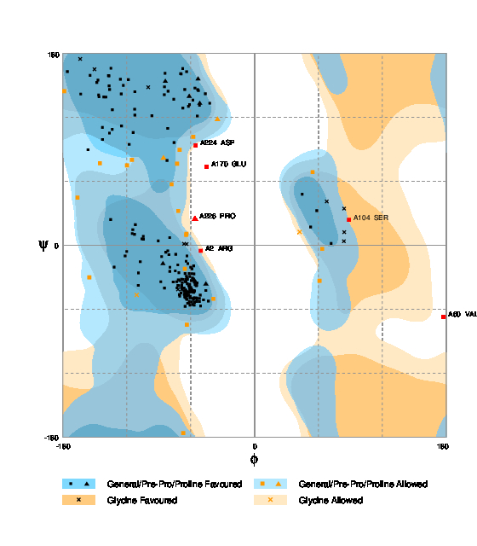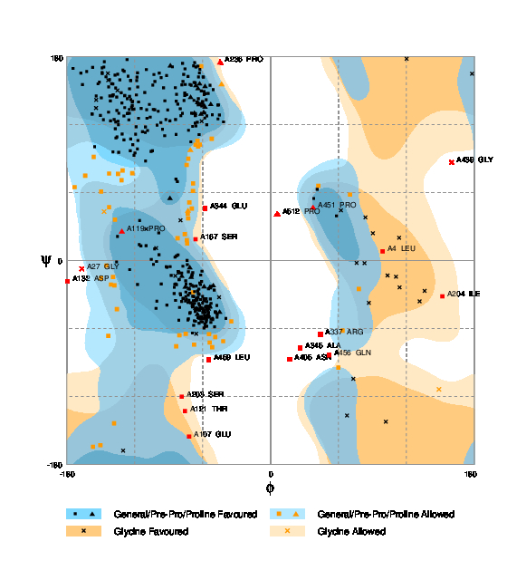
- (B)

Fig. S6. Ramachandran Plot of (A) RhlR and (B) PqsA

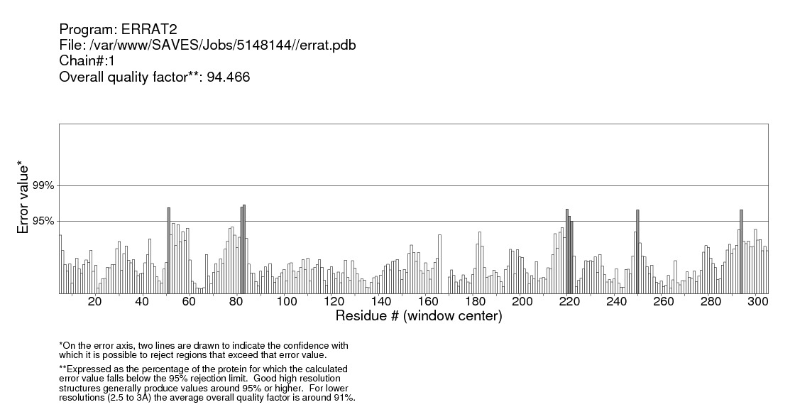
(A)
(B)

Fig. S7. ERRAT plots of (A) RhlR and (B) PqsA

(A)

(B)
Fig. S8. Verify 3D plots of (A) RhlR and (B) PqsA

