Modification of Polyhedral Oligomeric Silsesquioxane Derivatives with Heck Reaction as New Bio-hybrid Materials

**Omer Tahir Gunkara\***

Chemistry Department, Faculty of Science and Arts, Yildiz Technical University, Davutpasa Campus, 34220, Esenler, Istanbul, Turkey

Email: gunkara@yildiz.edu.tr

**Supplemental Materials**

**2-(4-Azabicyclo[2.2.1]hept-8-ene-3-*endo*,5-*endo*-dicarboximide-4-yl) propionyl chloride (3a)1**

Colorless oil; Yield: 95%; IR: ν cm−1 2983, 2942, 2921 and 2873 (Aliphatic CH), 1773, 1736 and 1694 (C=O), 1453, 1377. 1H NMR (500 MHz, CDCl3), δ, ppm (*J*, Hz): 1.39 (3H, d, *J= 7.25*, CH3); 1.52 (1H, d, *J= 8.82*, H10a); 1.72 (1H, d, *J= 8.82*, H10s); 2.89 (1H, s, H1); 2.98 (1H, s, H7); 3.28 (1H, dd, *J= 4.09; 8.51*, H2); 3.38-3.40 (1H, m, H6); 4.59 (1H, q, *J= 7.25*, CH); 6.09 (2H, brs, =CH). 13C NMR (125 MHz, CDCl3), δ, ppm: 14.5 (CH3); 45.2 (CH); 45.7 (CH); 45.9 (CH); 46.2 (CH); 47.5 (CH); 52.2 (CH2); 134.4 (=CH); 134.5 (=CH); 169.7 (C=O); 176.6 (C=O); 176.7 (C=O). HRMS: - Found, m/z: 254.9000 [M+H]+. C12H12ClNO3. Calculated, m/z: 253.0506.

**2-(4-Azabicyclo[2.2.1]hept-8-ene-3-*endo*,5-*endo*-dicarboximide-4-yl)-3-phenyl propionyl chloride (3b)1**

Brown oil; Yield: 98%; IR: ν cm−1 3064 and 3028 (Aromatic CH), 2989, 2942 and 2872 (Aliphatic CH), 1793 and 1703 (C=O), 1497, 1455, 1378, 725. 1H NMR (500 MHz, CDCl3), δ, ppm (*J*, Hz): 1.42 (1H, d, *J*= 8.82 Hz, H10a); 1.59 (1H, d, *J*= 8.82, H10s); 2.95 (1H, s, H1), 3.10 (1H, d, *J*= 4.72, H7); 3.24 (2H, brs, CH2); 3.34 (1H, dd, *J*= 3.15; 14.5, H2), 3.46 (1H, dd, *J*= 5.35; 15.1, H6); 5.01 (1H, dd, *J*= 5.35; 11.6, CH); 5.46 (1H, dd, *J*= 3.15; 5.67, =CH); 5.71 (1H, dd, *J*= 3.15; 5.67, =CH); 7.10-7.14 (2H, m, ArH); 7.24-7.27 (3H, m, ArH). 13C NMR (125 MHz, CDCl3), δ, ppm: 33.65 (CH2); 44.66 (CH); 44.93 (CH); 45.72 (CH); 45.91 (CH); 52.18 (CH2); 52.60 (CH); 126.95 (CAr); 128.44 (CAr x2); 129.09 (CAr x2); 134.31 (=CH); 134.14 (=CH); 136.36 (Cq); 172.72 (C=O); 177.05 (C=O); 177.12 (C=O). HRMS: - Found, m/z: 329.1820 [M]+. C18H16ClNO3. Calculated, m/z: 329.0819.

***N-*[3-(isobutylpolyhedral oligomeric silsesquioxanyl)propyl]-2-(4-Azabicyclo[2.2.1]hept-8-ene-3-*endo*,5-*endo*-dicarboximide-4-yl) propanamide (4a)1**

White solid. m.p.: 167-169 oC. Yield: 80%. IR: ν cm−1 3333 (NH), 2952 and 2870 (Aliphatic CH), 1704 (C=O), 1537 (Si-O-Si), 1463, 1381, 1366, 1085 (O-Si-R). 1H NMR (500 MHz, CDCl3), δ, ppm (*J*, Hz): 0.60 (16H, dd, *J= 1.89; 6.93*, CH2-Si); 0.95 (42H, d, *J= 6.62*, CH3); 1.46 (3H, d, *J= 7.56*, CH3); 1.54-1.57 (3H, m, CH2 and Ha); 1.75 (1H, dt, *J= 1.57; 10.4*, Hs); 1.81-1.87 (7H, m, CH); 3.18-3.23 (2H, m, CH); 3.30 (2H, dd, *J= 4.09; 5.67*, CH); 3.42 (2H, brs, CH); 4.58 (1H, q, *J*= 7.25, CH); 5.86 (1H, brs, NH); 6.14 (2H, brs, =CH). 13C NMR (125 MHz, CDCl3), δ, ppm: 9.49 (CH2); 14.5 (CH3); 22.4 (7xCH2); 22.8 (CH2); 23.8 (7xCH); 25.7 (14xCH3); 42.2 (CH2); 45.1 (CH); 45.2 (CH); 45.6 (CH); 45.7 (CH); 49.8 (CH); 52.3 (CH2); 134.6 (CH); 134.9 (CH); 168.3 (C=O); 177.0 (C=O); 177.1 (C=O). HRMS: - Found, m/z: 1091.300 [M]+. C43H82N2O15Si8. Calculated, m/z: 1090.3869.

***N-*[3-(isobutylpolyhedral oligomeric silsesquioxanyl)propyl]-2-(4-Azabicyclo[2.2.1]hept-8-ene-3-*endo*,5-*endo*-dicarboximide-4-yl)-3-phenyl propanamide (4b)1**

White Solid. m.p.: 139-142 oC. Yield: 80%. IR: ν cm−1 3301 (NH), 2952, 2926, 2906 and 2869 (Aliphatic CH), 1699 (C=O), 1551 (Si-O-Si), 1463, 1383, 1366, 1084 (O-Si-R). 1H NMR (500 MHz, CDCl3), δ, ppm (*J*, Hz): 0.47-0.50 (2H, m, CH2-Si); 0.52 (14H, dd, *J= 3.46; 6.93*, CH2-Si); 0.88 (42H, dd, *J= 1.89; 6.62*, CH3); 1.38 (1H, d, *J= 8.82*, H10a); 1.46-1.52 (4H, m, CH2); 1.58 (1H, d, *J= 8.82*, H10s); 1.75 (7H, hept, *J= 3.46*, CH); 2.95 (1H, dd, *J= 4.41; 7.88*, CH2); 3.06 (1H, dd, *J= 4.41; 7.88*, CH2); 3.14 (2H, t, *J= 7.88*, CH2); 3.28 (1H, brs, H1); 3.21 (1H, brs, H7); 3.29-3.36 (2H, m, H2, H6); 4.77 (1H, dd, *J= 6.30; 10.71*, CH); 5.73 (1H, dd, *J= 2.83; 5.67*, CH); 5.81 (1H, dd, *J= 2.83; 5.67*, CH); 5.88 (1H, brs, NH); 7.05 (2H, d, *J= 7.25*, ArH), 7.11-7.18 (3H, m, ArH). 13C NMR (125 MHz, CDCl3), δ, ppm: 9.5 (CH2); 22.5 (CH2x7); 23.8 (CHx7); 25.7 (CH3x14); 33.9 (CH2); 42.2 (CH2); 44.9 (CH); 45.0 (CH); 45.5 (CH); 52.4 (CH2); 55.8 (CH); 127.0 (CAr); 128.4 (CAr); 128.6 (CAr); 129.0 (CAr); 134.7 (CAr); 136.7 (Cq); 167.8 (C=O); 177.1 (C=O); 177.4 (C=O). HRMS: - Found, m/z: (z=2): 584.2236 [M+2H]++2, 606.6932 [M+2Na]+2. C49H86N2O15Si8. Calculated, m/z: 1166.4182.

**References**

1. Ersoy E. B.; Gunkara O. T.; Ocal N. Synthesis of New Polyhedral Oligomeric Silsesquioxane Derivatives as Some Possible Antimicrobial Agents. *Phosphorus, Sulfur Silicon Relat. Elem.* **2018**, *in press*, DOI: 10.1080/10426507.2018.1539721.

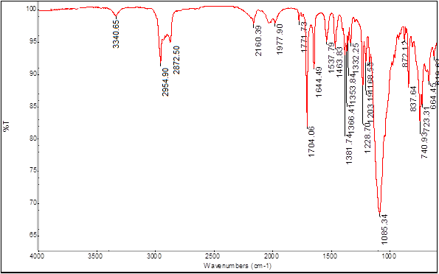

**Figure S 1:** FTIR Spectrum of Compound **5a** (ATR).

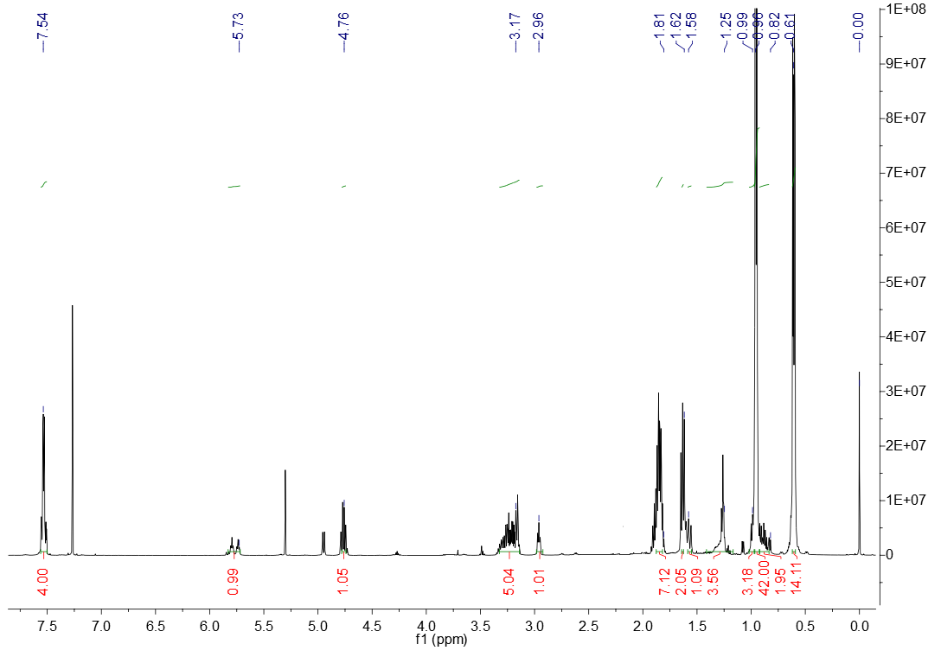

**Figure S 2:** 1H NMR Spectrum of Compound **5a** (CDCl3).

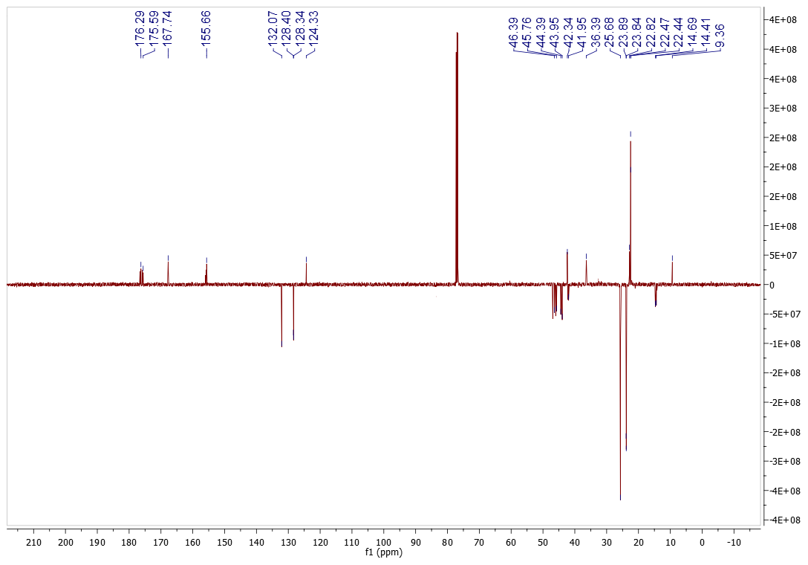

**Figure S 3:** APT Spectrum of Compound **5a** (CDCl3).

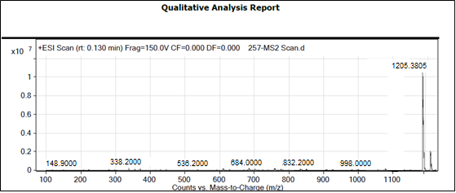

**Figure S 4:** HRMS Spectrum of Compound **5a**



**Figure S 5:** FTIR Spectrum of Compound **5b** (ATR).

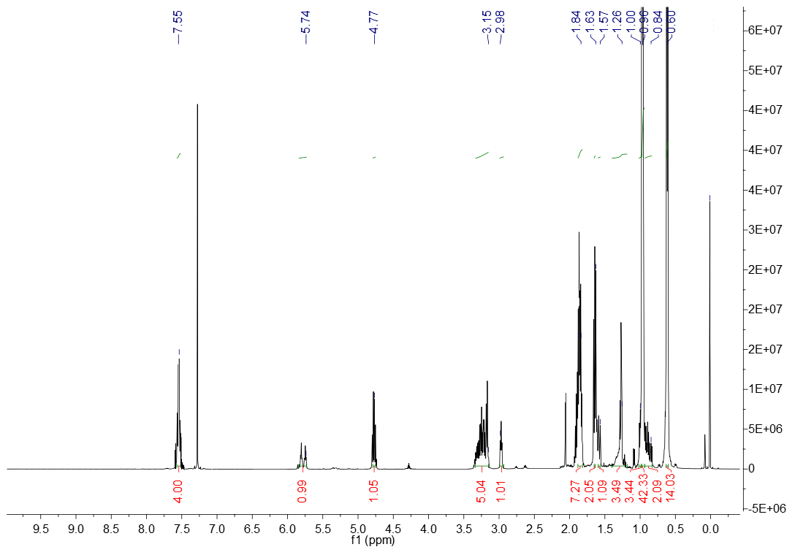

**Figure S 6:** 1H NMR Spectrum of Compound **5b** (CDCl3).

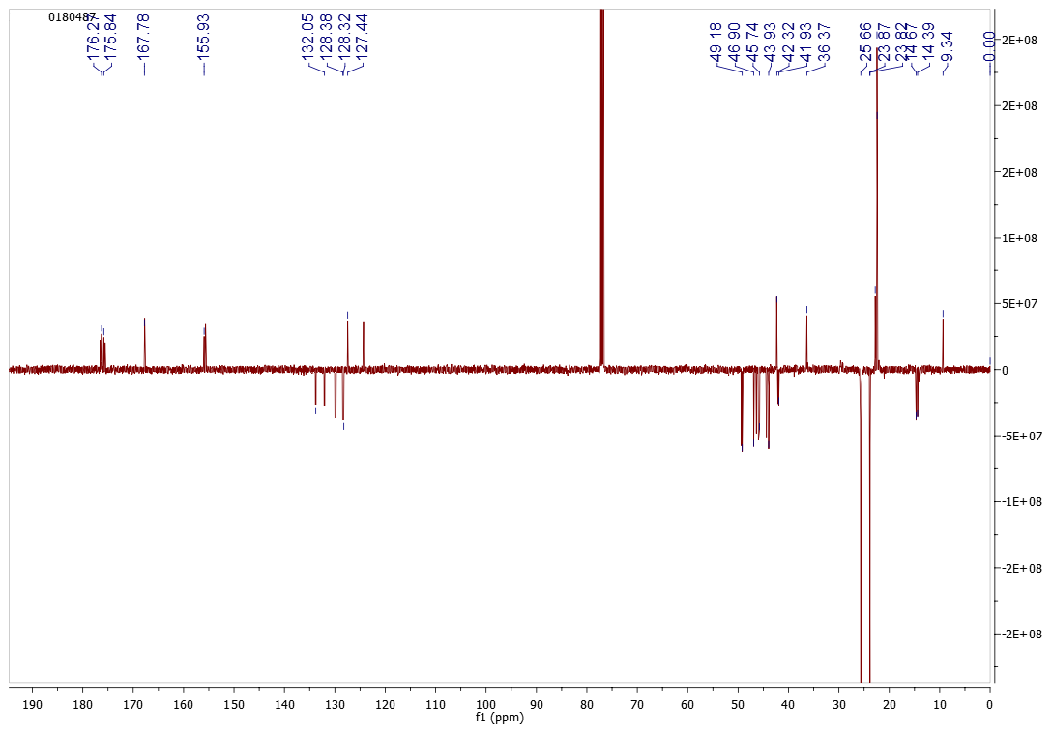

**Figure S 7:** APT Spectrum of Compound **5b** (CDCl3).

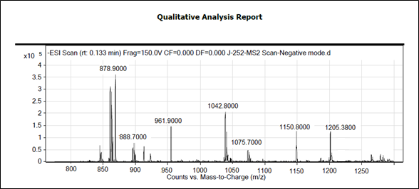

**Figure S 8:** HRMS Spectrum of Compound **5b**



**Figure S 9:** FTIR Spectrum of Compound **5c** (ATR).

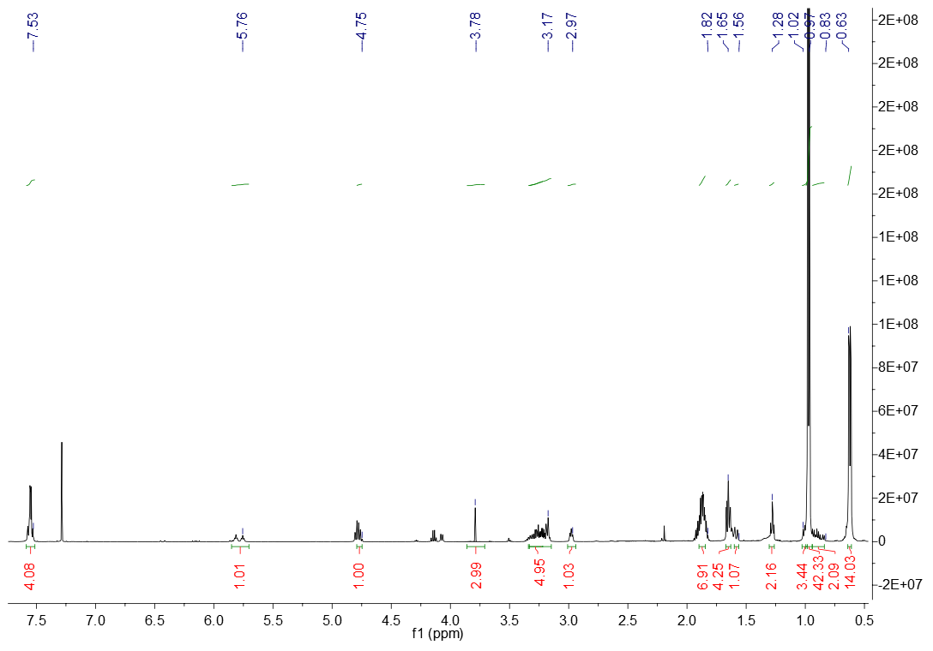

**Figure S 10:** 1H NMR Spectrum of Compound **5c** (CDCl3).

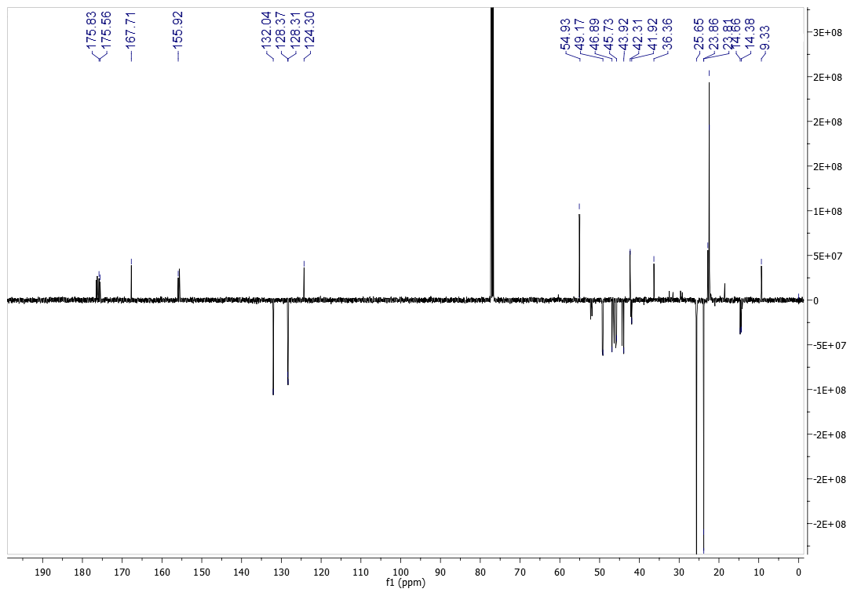

**Figure S 11:** APT Spectrum of Compound **5c** (CDCl3).

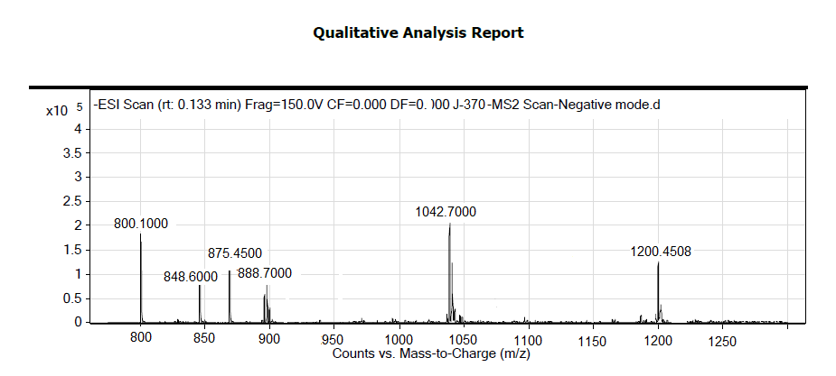

**Figure S 12:** HRMS Spectrum of Compound **5c**



**Figure S 13:** FTIR Spectrum of Compound **6a** (ATR).

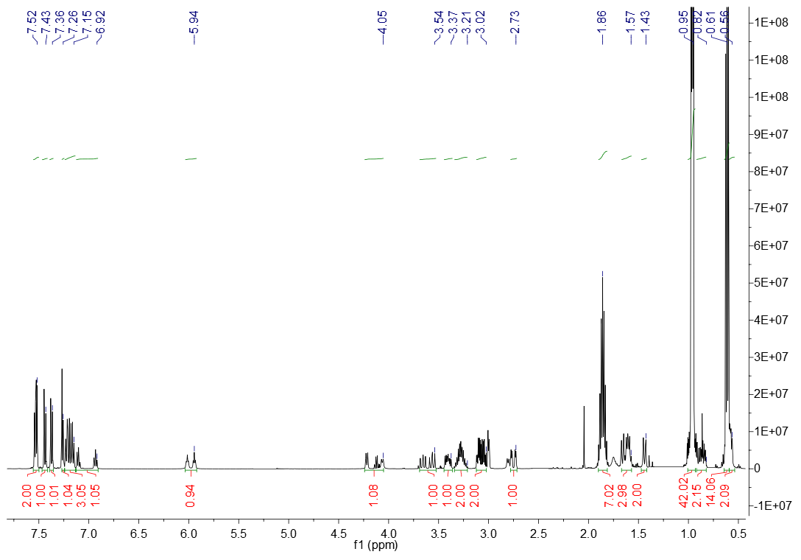

**Figure S 14:** 1H NMR Spectrum of Compound **6a** (CDCl3).

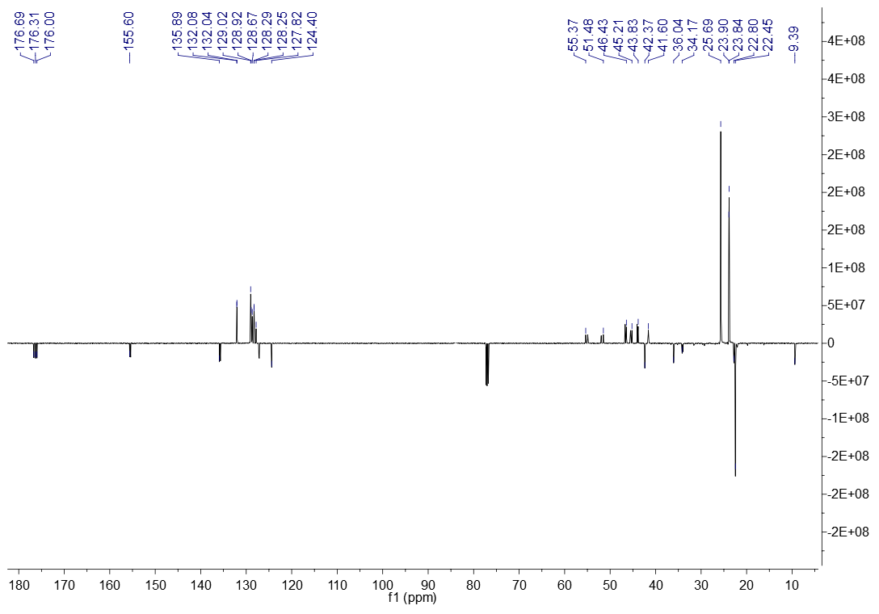

**Figure S 15:** 13C NMR Spectrum of Compound **6a** (CDCl3).

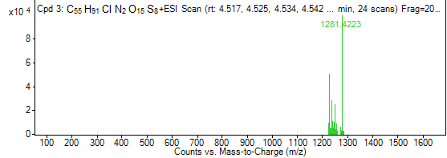

**Figure S 16:** HRMS Spectrum of Compound **6a**



**Figure S 17:** FTIR Spectrum of Compound **6b** (ATR).

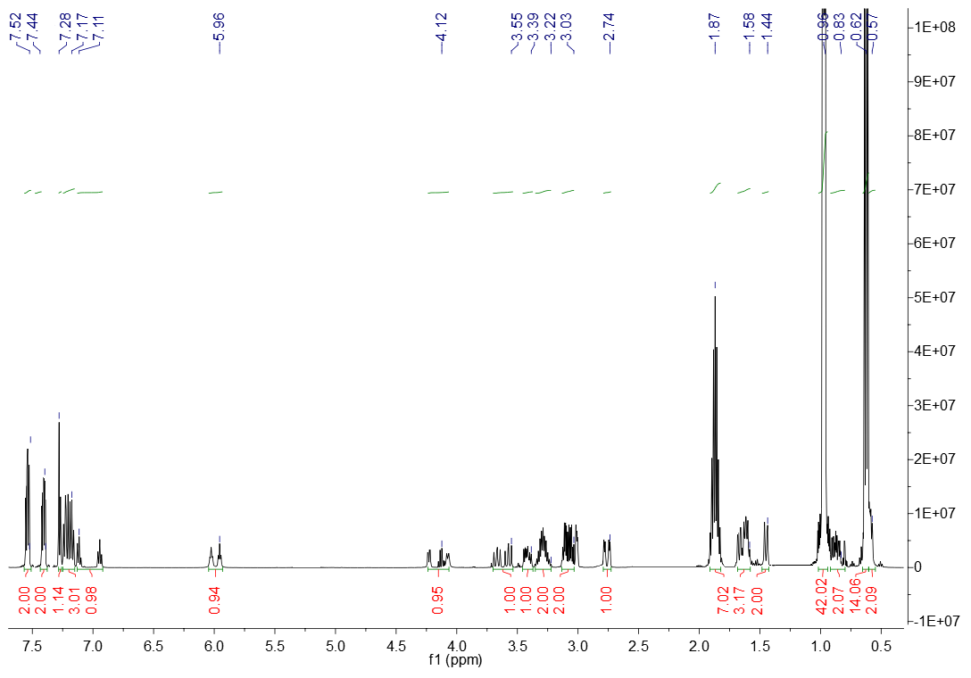

**Figure S 18:** 1H NMR Spectrum of Compound **6b** (CDCl3).

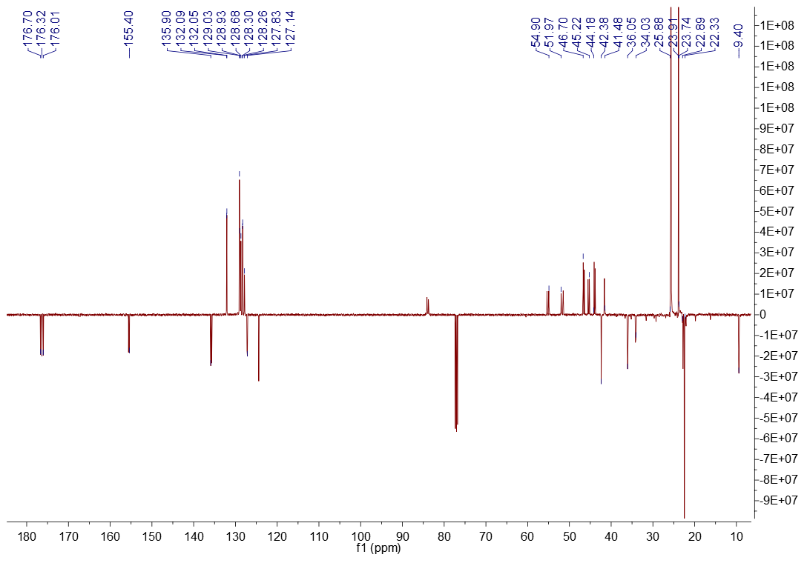

**Figure S 19:** APT Spectrum of Compound **6b** (CDCl3).

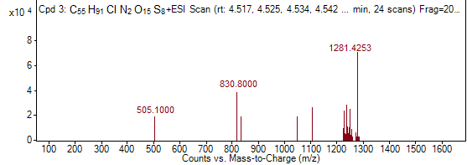

**Figure S 20:** HRMS Spectrum of Compound **6b**



**Figure S 21:** FTIR Spectrum of Compound **6c** (ATR).

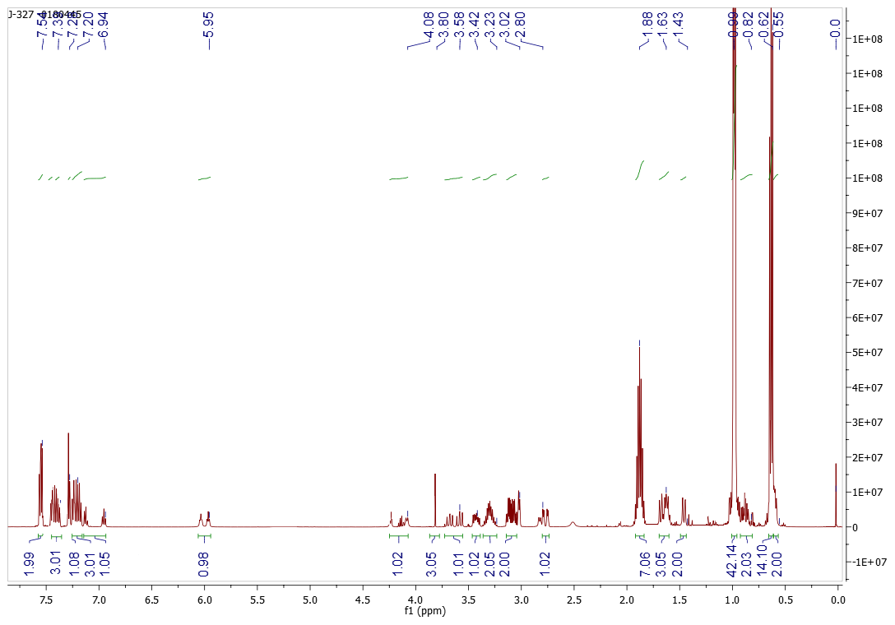

**Figure S 22:** 1H NMR Spectrum of Compound **6c** (CDCl3).

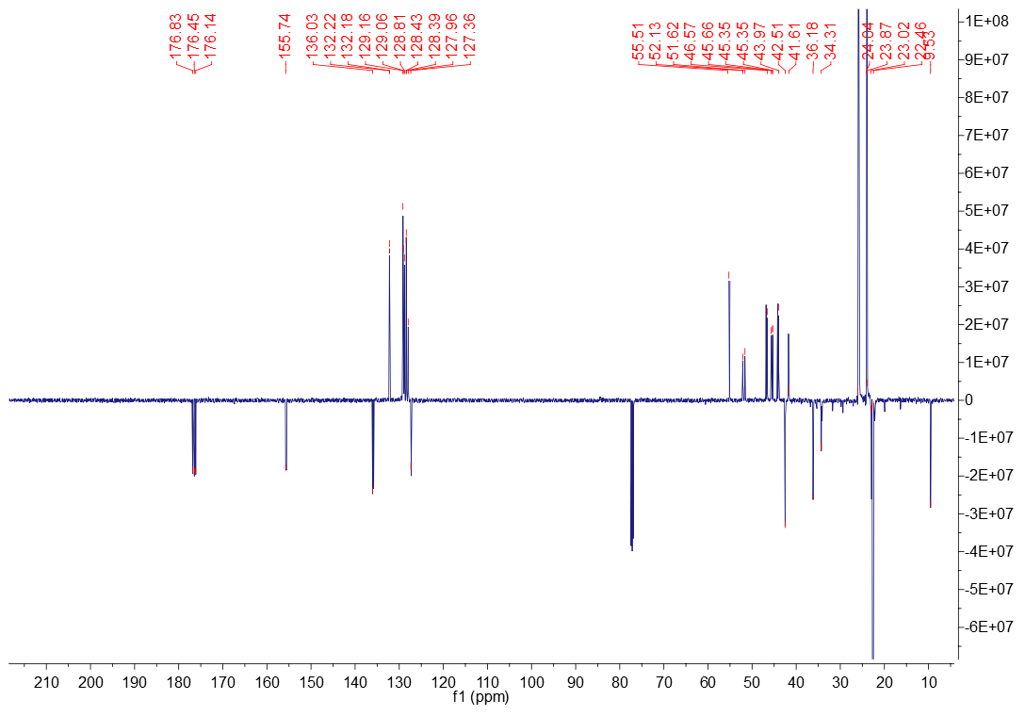

**Figure S 23:** 13C NMR Spectrum of Compound **6c** (CDCl3).

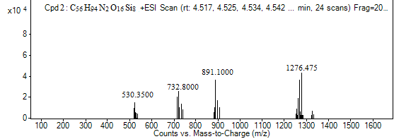

**Figure S 24:** HRMSSpectrum of Compound **6c**



**Figure S 25:** FTIR Spectrum of Compound **7a** (ATR).

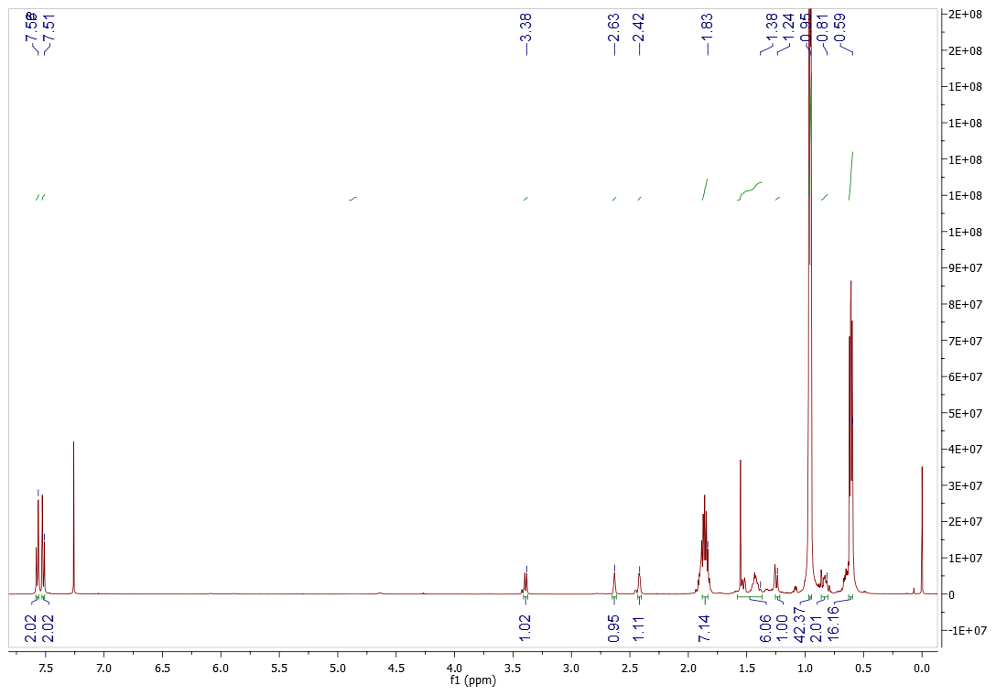

**Figure S 26:** 1H NMR Spectrum of Compound **7a** (CDCl3).

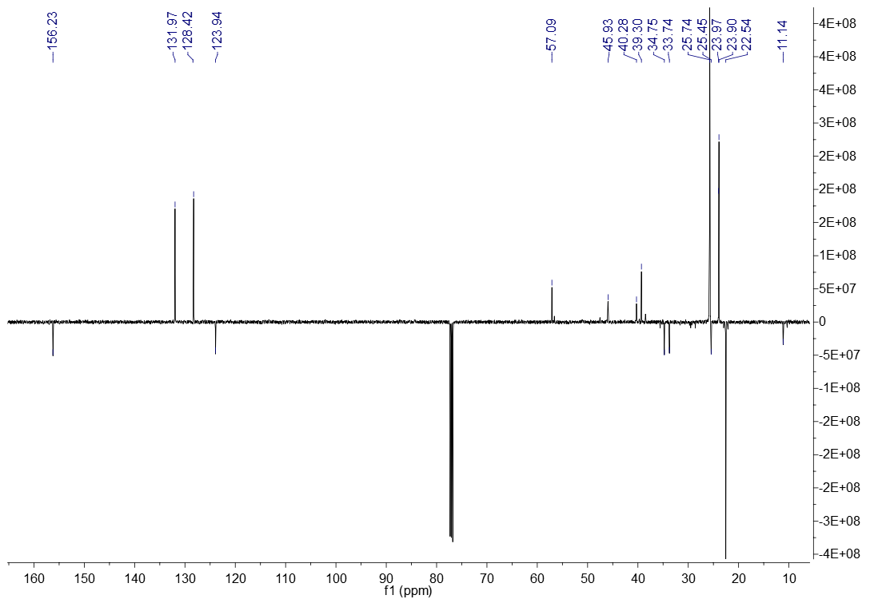

**Figure S 27:** APT Spectrum of Compound **7a** (CDCl3).

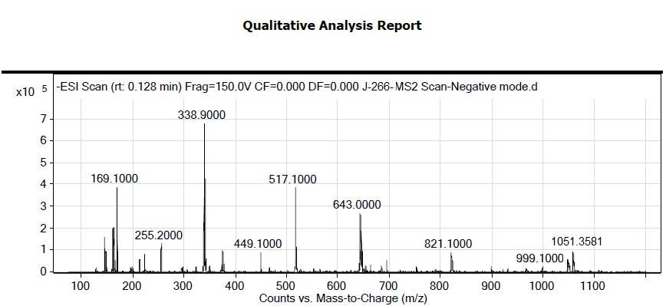

**Figure S 28:** HRMS Spectrum of Compound **7a**



**Figure S 29:** FTIR Spectrum of Compound **7b** (ATR).

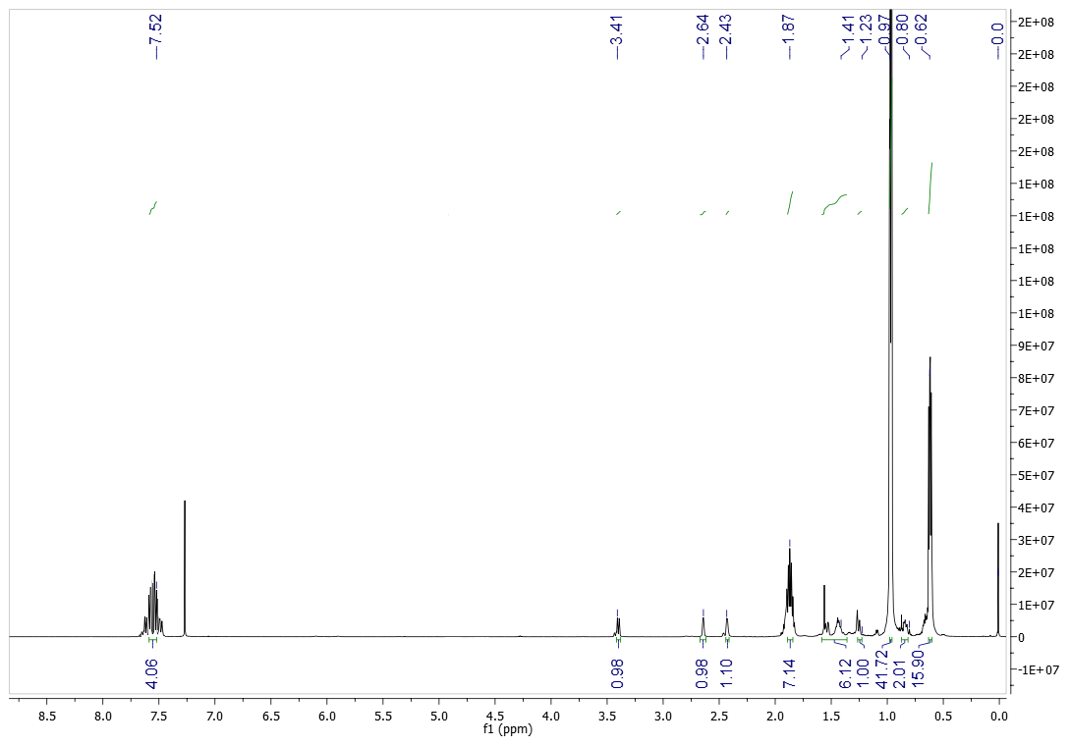

**Figure S 30:** 1H NMR Spectrum of Compound **7b** (CDCl3).

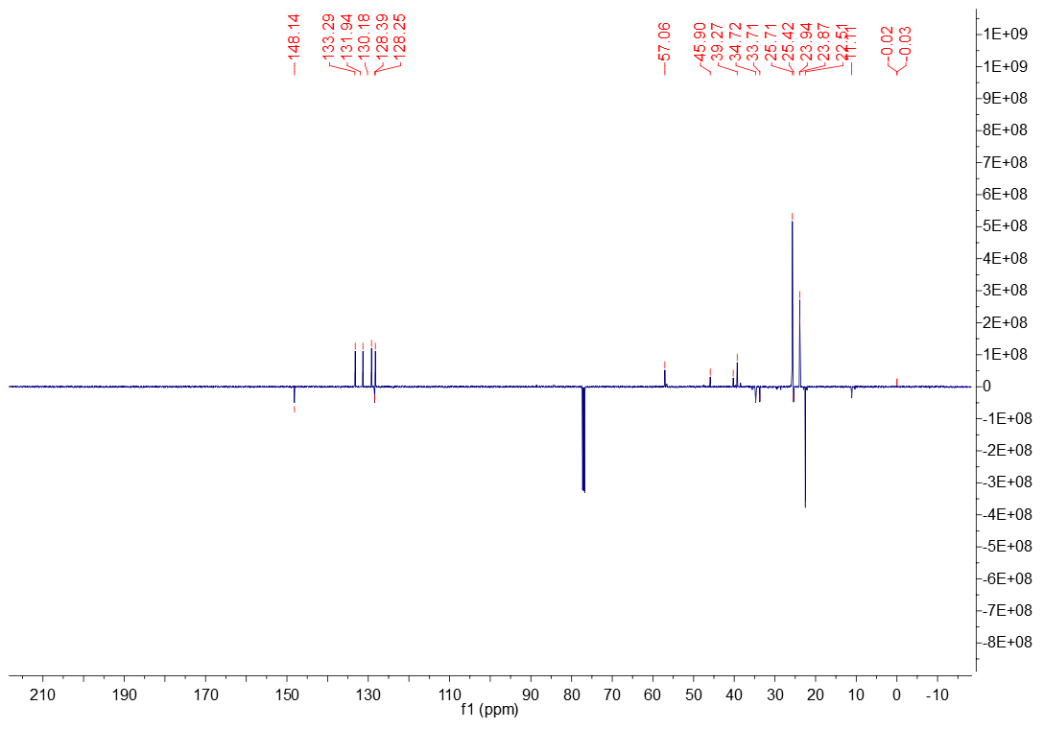

**Figure S 31:** APT Spectrum of Compound **7b** (CDCl3).

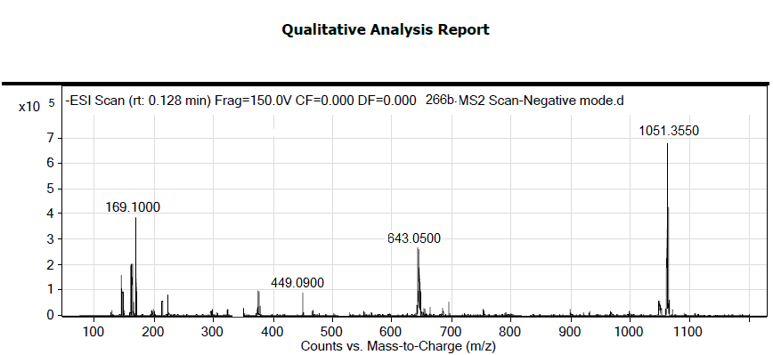

**Figure S 32:** HRMS Spectrum of Compound **7b**



**Figure S 33:** FTIR Spectrum of Compound **7c** (ATR).

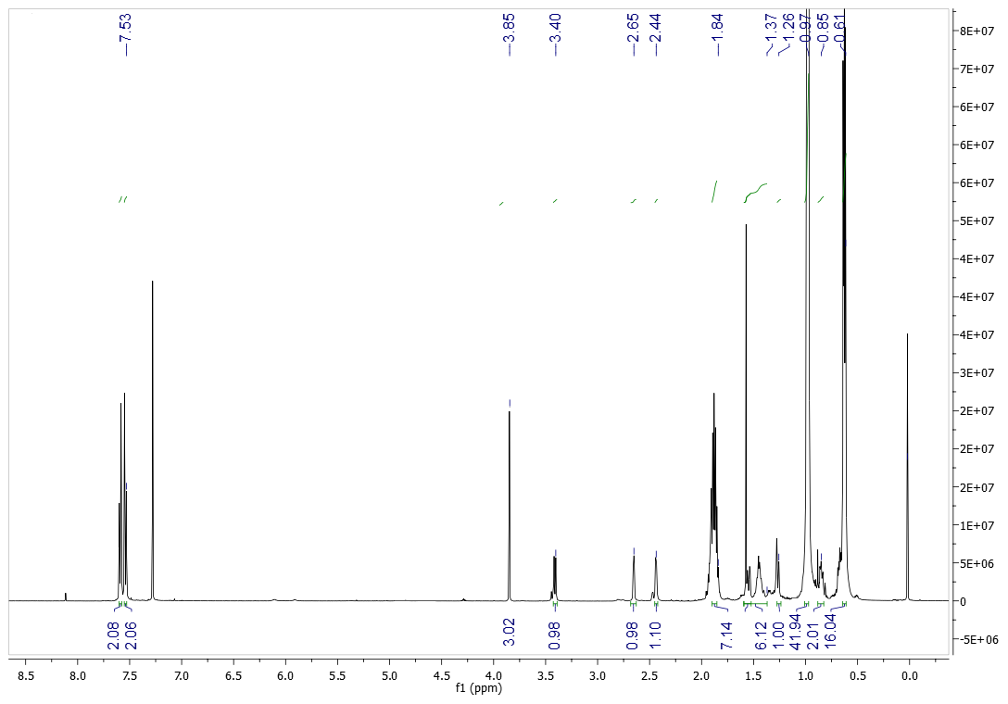

**Figure S 34:** 1H NMR Spectrum of Compound **7c** (CDCl3).

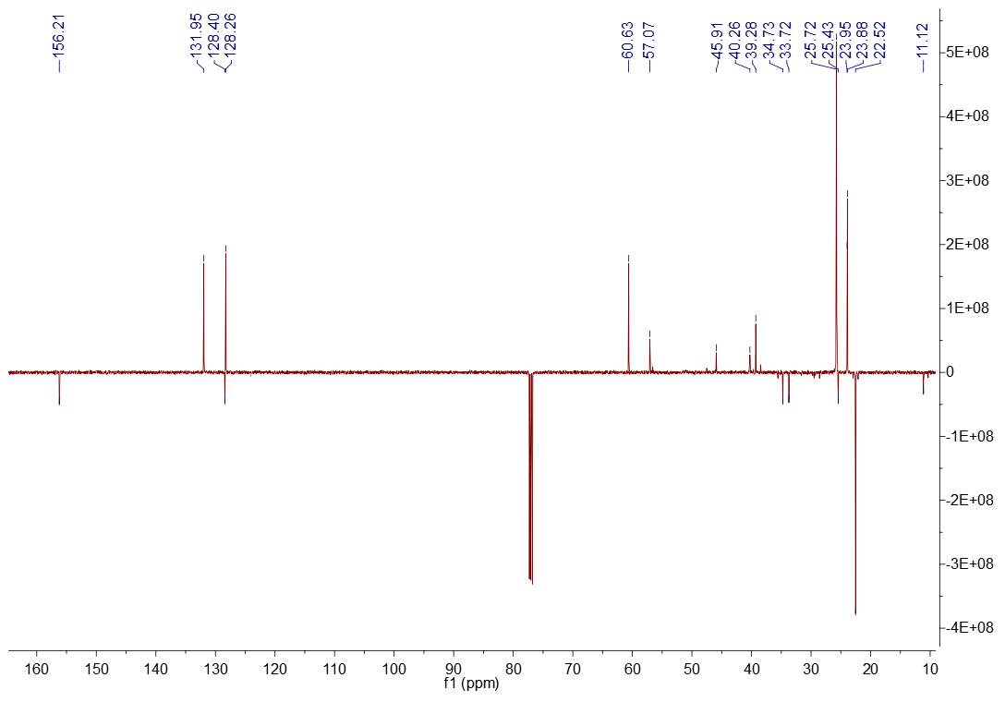

**Figure S 35:** APT Spectrum of Compound **7c** (CDCl3).

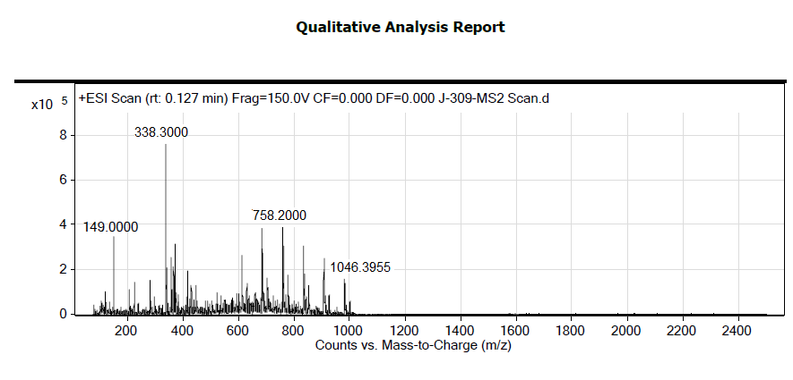

**Figure S 36:** HRMS Spectrum of Compound **7c**