Supporting Information

Supramolecular complexation of homocysteine and cysteine with cucurbit[7]uril

Min Jung Leeª, Nirmal K. Sheeª, Jung-In Sonª, Subramanian Karthikeyan^{b}, Kwang-Hwan Jheeª, Jin Yong Lee^{c}* and Hee-Joon Kimª*

ªDepartment of Applied Chemistry, Kumoh National Institute of Technology, Gumi 39177, Republic of Korea. ^{b}Department of Chemistry, Kalaslingam University, Tamil Nadu 626126, India. ^{c}Department of Chemistry, Sungkyunkwan University, Suwon 16419, Republic of Korea.

*To whom correspondence should be addressed: E-mail: hjk@kumoh.ac.kr; jinylee@skku.edu

Experimental

Materials and Instruments
CB[7], cysteine and homocysteine were purchased from Aldrich. All other reagents were of analytical grade and were used as received. Double-distilled water was used for all experiments. All ¹H NMR spectra, including those for titration experiments, were obtained on a Bruker BIOSPIN/AVANCE III 400 spectrometer at 25 °C. The concentrations of the amino acids were 1-2 mM in the NMR experiments. D₂O was adjusted to pD = 7.0 with sodium phosphate or pD = 2.45 with 1 M DCl. All pD values were verified on a pH meter calibrated with two standard buffer solutions. ESI mass spectra were recorded on a Thermo Finnigan Linear Ion Trap Quadrupole Mass Spectrometer.

Isothermal titration calorimetry measurements
The formation constant and thermodynamic parameters for the complexation of Hcys and Cys with CB[7] were measured by the titration calorimetry using a VP-ITC instrument from MicroCal. A stock solution of cysteine and homocysteine solution (50 mM each) were prepared with 10 mM sodium phosphate (pH 7.0) in distilled H₂O. CB[7] solution was prepared in distilled water of 0.25 mM. Cysteine and homocysteine solution were injected with 40 μl to host solution 250 μl. The heat evolved was recorded at 25 °C. The heat of dilution was corrected for by injecting the cysteine or homocysteine solution into aqueous solution and subtracting this data from that of the host-guest titration. The data were analyzed and fitted by the Origin software (MicroCal).

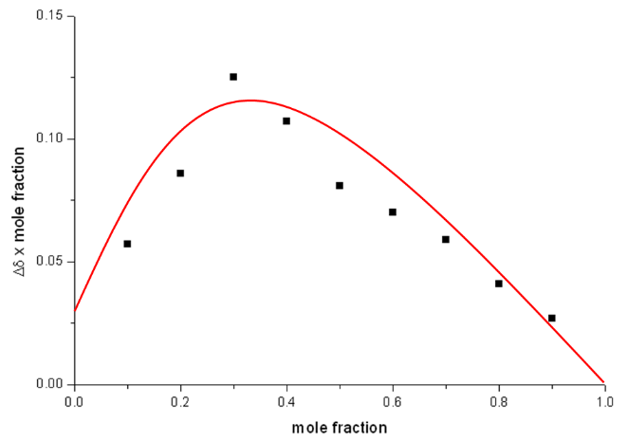
(a) (b)

Figure S1. Job-plots for the supramolecular complexation of (a) Cys and (b) Hcys with CB[7] (observing the α proton resonance shift of amino acids).

Figure S2. ¹H NMR spectra (400 MHz, pD =2.45) of Cys (c = 1 mM) in the absence and in the presence of CB[7]. The asterisk(*) denotes the resonances for CB[7]. S due to residual solvent.

Figure S3. ¹H NMR spectra (400 MHz, pD =2.45) of Hcys (c = 1 mM) in the absence and in the presence of CB[7]. The asterisk(*) denotes the resonances for CB[7]. S due to residual solvent.
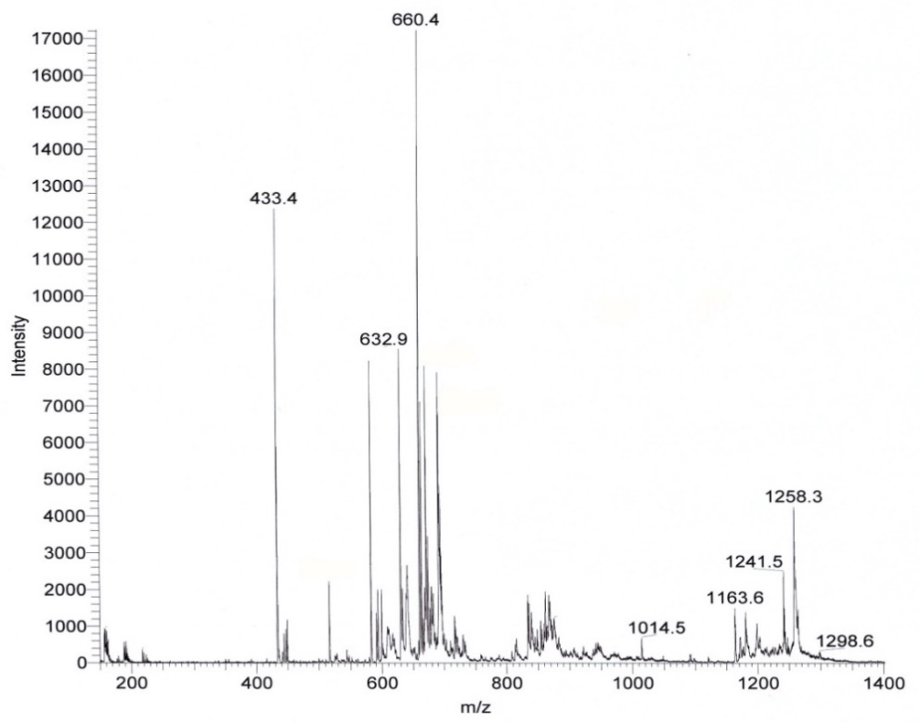

Figure S4. ESI mass spectrum of 1:1 supramolecular complex with Hcys and CB[7] in water.
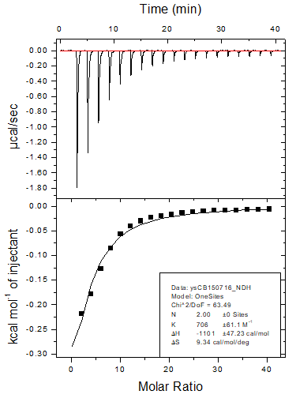
- (b)

Figure S5. ITC titration curves for the supramolecular complexation of CB[7] with (a) Hcys (1:1), (b) Cys (1:2), and (c) Cys (1:1) in aqueous solution.

Figure S6. ¹H NMR titration profiles obtained upon titration of Cys in D₂O with increasing concentration of CB[7] (observing the α proton shift of Cys).
Figure S7. DFT optimized geometries of CB[7], cysteine, homocysteine and their complexes.

Figure S8. Shortest hydrogen bonding interactions in the each optimized geometry for the supramolecular complexes of CB[7] with Cys and Hcys.

