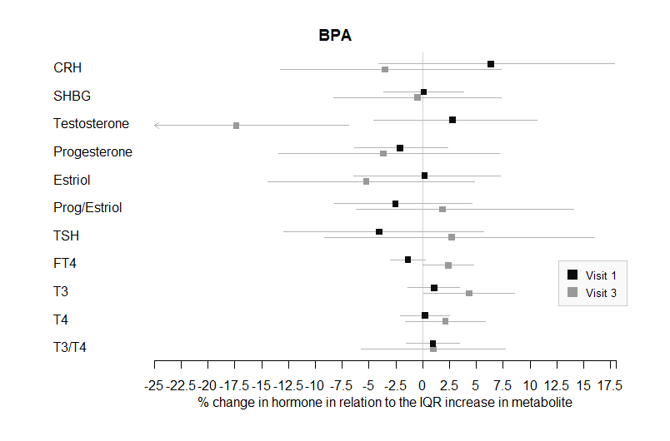
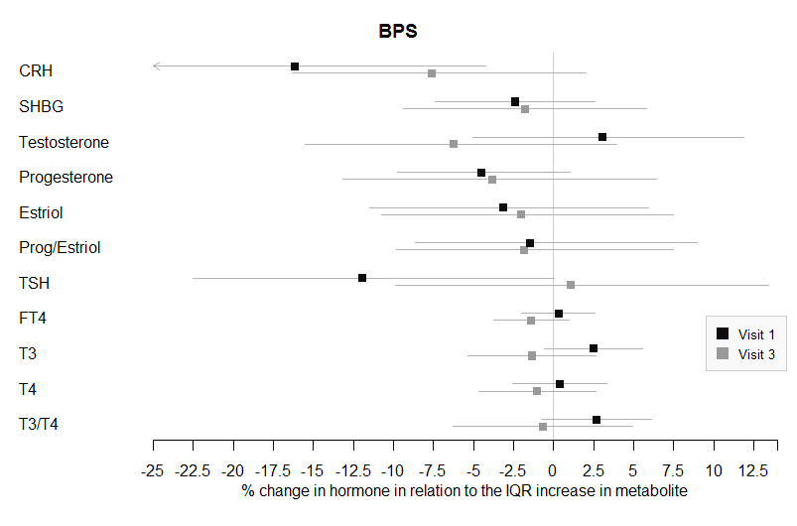
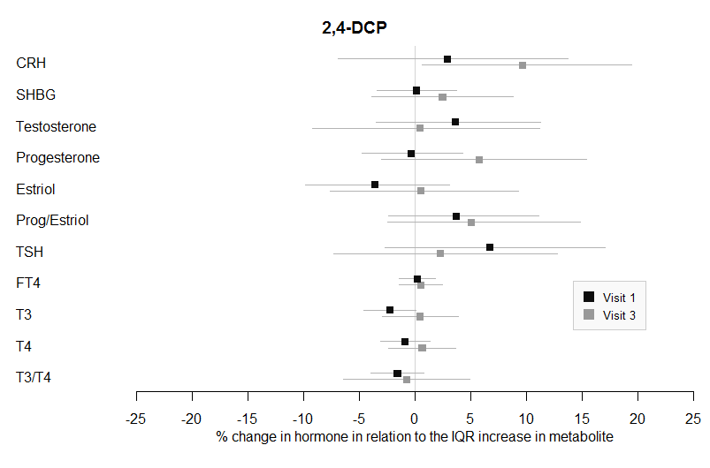
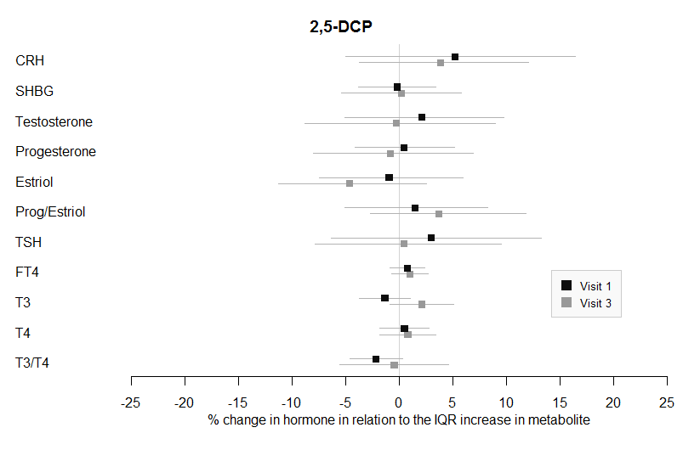
*
*
**
*
**
**

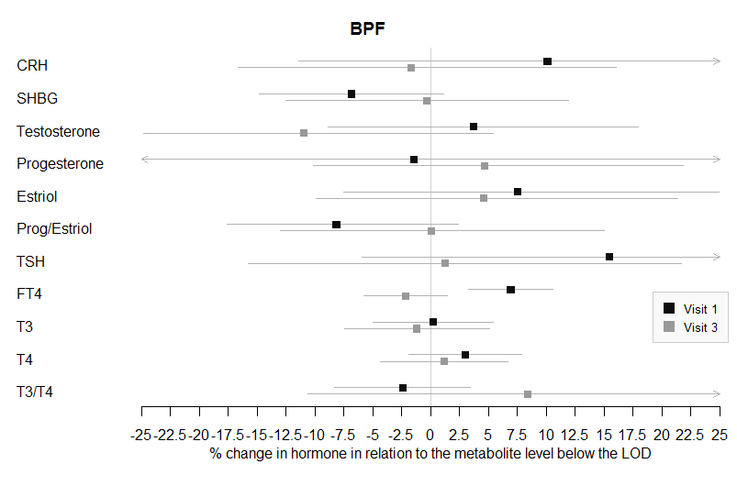
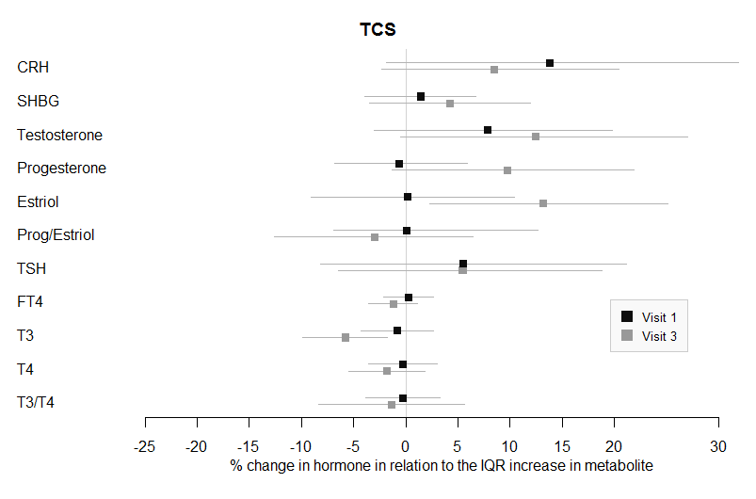
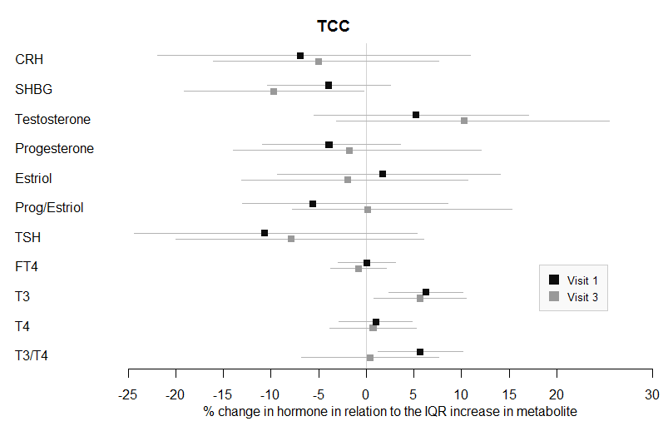
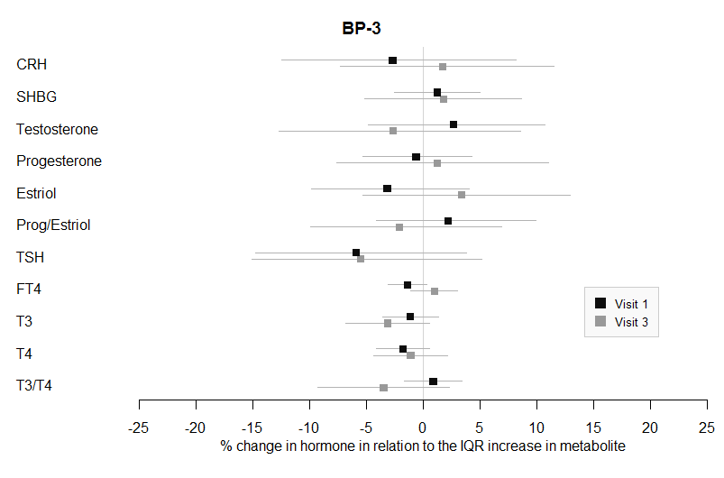
**
*
**
*
**
**
**
**

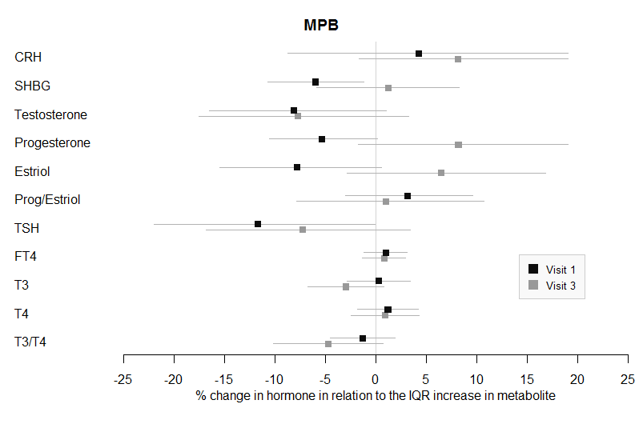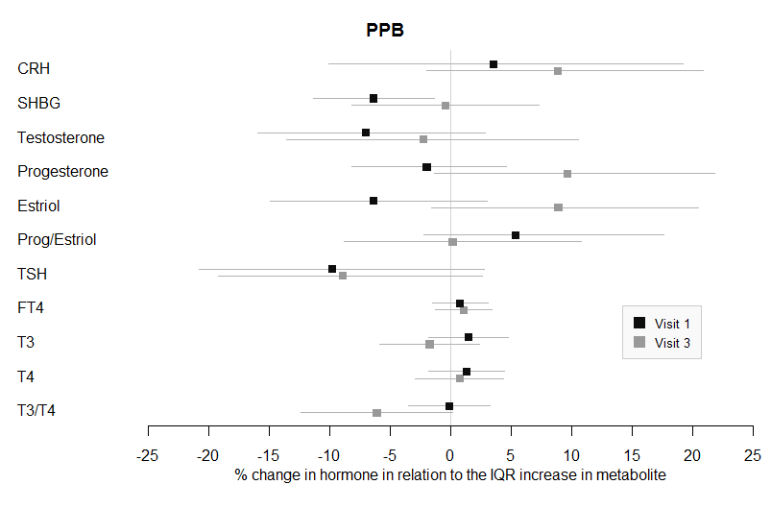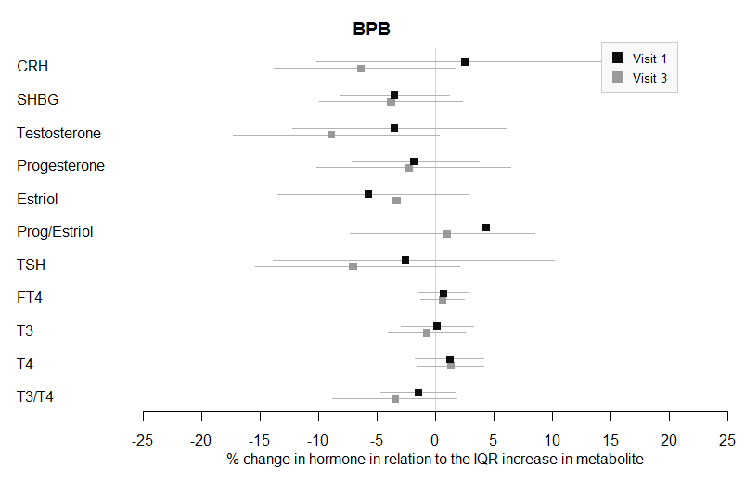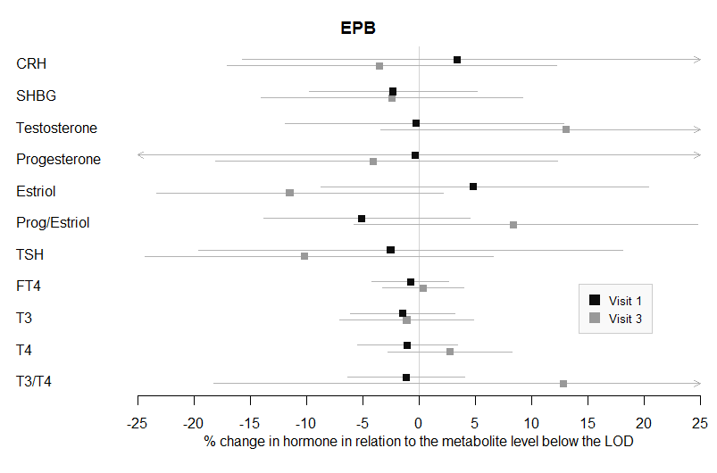
**
**
*
*
*
**
*
*
*
Figure 2: Adjusted multiple linear regressions of hormones versus urinary concentrations of biomarkers stratified by study visit. Visit 1: 16-20 weeks; Visit 3: 24-28 weeks. EPB and BPF are categorical variables. * represents at least one marginal association between the urinary concentration and the hormone across the four time points. ** represents at least one significant association between the urinary biomarker concentration and the hormone across the four time points. BPF and EPB were dichotomous variables. 2,4-DCP: 2,4-dichlorophenol; 2,5-DCP: 2,5-dichlorophenol; BP-3: Benzophenone; TCS: Triclosan; TCC: Triclocarban; EPB: ethylparaben; MPB: Methylparaben; BPB: Butylparaben; PPB: Propylparaben

