SUPPLEMENTARY DATA
Figure S1: Log transformed data plotted over time for all sites in Arabian Gulf (A) and Kuwait Bay (B).

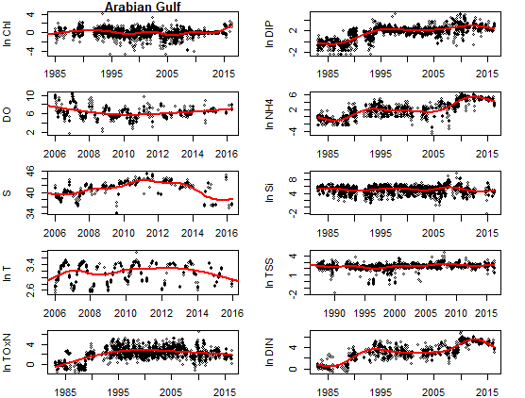

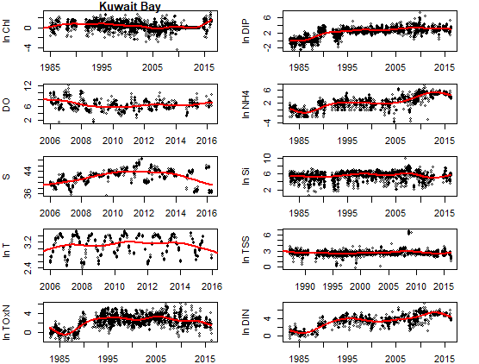

Table S1. List of the most abundant taxa in Kuwait Bay and the Gulf, over the period 2007 - 2016, and associated cell carbon content and references.
Taxon | Cell carbon (pg C cell L⁻¹) | Reference
Asterionellopsis glacialis | 46.2 | Harrison et al. 2015
Bacillaria paxillifer | 177 | Al-Kandari et al. 2009 (size range)  Edler 1979 (shape - parallelepiped)  Menden-Deuer and Lessard 2000 (volume to carbon)
Bacteriastrum delicatulum | 302 | Al-Kandari et al. 2009 (size range)  Edler 1979 (shape - cylinder)  Menden-Deuer and Lessard 2000 (volume to carbon)
Bacteriastrum hyalinum | 536 | Harrison et al. 2015
Ceratium furca | 3046 | Al-Kandari et al. 2009 (size range)  Thomsen 1992 (relationship diameter to volume)  Menden-Deuer and Lessard 2000 (volume to carbon)
Chaetoceros affinis | 161 | Harrison et al. 2015
Chaetoceros atlanticus | 46.2 | Tabassum and Saifullah 2010 (size range)  Edler 1979 (shape - oval cylinder)  Menden-Deuer and Lessard 2000 (volume to carbon)
Chaetoceros brevis | 173 | Harrison et al. 2015
Chaetoceros compressus | 105 | Harrison et al. 2015
Chaetoceros curvisetus | 201 | Harrison et al. 2015
Chaetoceros denticulatus | 460 | Al-Kandari et al. 2009 (size range)  Edler 1979 (shape - oval cylinder)  Menden-Deuer and Lessard 2000 (volume to carbon)
Chaetoceros diversus | 38.7 | Harrison et al. 2015
Chaetoceros laciniosus | 177 | Harrison et al. 2015
Chaetoceros lorenzianum | 389 | Harrison et al. 2015
Chaetoceros pseudocurvisetus | 201 | Harrison et al. 2015 (same as C. curvisetus)
Chaetocerso tortissimum | 95.9 | Harrison et al. 2015
Coscinodiscus spp. | 6983.9 | Harrison et al. 2015 (median volume)  Menden-Deuer and Lessard 2000 (volume to carbon)
Eucampia zodiacus | 441 | Harrison et al. 2015
Guinardia flaccida | 4870 | Harrison et al. 2015
Guinardia striata | 1290 | Harrison et al. 2015
Hemiaulus indicus | 1390 | Tomas 1994 (size range)  Edler 1979 (shape - oval cylinder)  Menden-Deuer and Lessard 2000 (volume to carbon)
Hemiaulus sinensis | 924 | Harrison et al. 2015
Karenia brevis | 432 | Al-Kandari et al. 2009 (size range)  Edler 1979 (shape - flattened ellopsoid)  Menden-Deuer and Lessard 2000 (volume to carbon)
Karenia selliformis | 304 | Al-Kandari et al. 2009 (size range)  Edler 1979 (shape - flattened ellopsoid)  Menden-Deuer and Lessard 2000 (volume to carbon)
Lauderia annulata | 1010 | Harrison et al. 2015
Leptocylindrus danicus | 123 | Harrison et al. 2015
Leptocylindrus minimus | 19.9 | Harrison et al. 2015
Pleurosigma elongatum | 2233 | Al-Kandari et al. 2009 (size range)  Edler 1979 (shape - half parallelepiped)  Menden-Deuer and Lessard 2000 (volume to carbon)
Prorocentrum micans | 1200 | Harrison et al. 2015
Pseudo-nitzschia seriata | 95.9 | Harrison et al. 2015
Rhizosolenia hebetata | 2540 | Harrison et al. 2015
Rhizosolenia imbricata | 1620 | Harrison et al. 2015
Rhizosolenia setigera | 536 | Harrison et al. 2015
Thalassionema fraunfeldii | 106 | Harrison et al. 2015
Thalassionema nitzschioides | 63.4 | Harrison et al. 2015

