Electronic Supplementary material for “How many cubs can a mum nurse? Maternal age and size influence litter size in polar bears” by Dorinda Marie Folio, Jon Aars, Olivier Gimenez, Andrew E. Derocher, Øystein Wiig, Sarah Cubaynes
ESM 1: Age estimation reliability

For cubs (0 to 2 years old), field observation accurately provides their age as the difference in size is considerable, and therefore tooth estimation is not required. For sub-adult and adult bears, two estimates were available: an observational age was provided on the field and an estimation was made using a premolar tooth. The state of the teeth was recorded to determine if the age estimation was more or less accurate (good, mediocre, unreliable and hopeless). Relying on both estimation and individual capture history, we were able to get an age estimation that was reliable. Each year with new captures, all uncertain ages were checked and modified if necessary. In most cases, estimated age using a tooth was within two years of real age. Uncertainty was likely to lead to some noise and might have made it more difficult to show patterns in the data. This being said, because capture rates were high, many bears had an accurate known age based on their first capture as juveniles.

ESM 2: Correlations between explanatory variables

Prior our analyses, we assessed dependence between all explanatory variables using Pearson correlations. Coefficients of correlation are provided in the table below. The covariates of interest here (age and size) were uncorrelated (0.092).

 | Days | Age for analyses | Size (length) | Mass | Body condition
Days | 1.000 | 0.311 | -0.156 | -0.020 | -0.034
Age for analyses | 0.311 | 1.000 | 0.092 | 0.055 | 0.095
Size (length) | -0.156 | 0.092 | 1.000 | 0.381 | 0.034
Mass | -0.020 | 0.055 | 0.381 | 1.000 | 0.539
Body condition | -0.034 | 0.095 | 0.034 | 0.539 | 1.000

ESM 3: Preliminary analyses

We considered female’s identity (ID) as a random effect in preliminary analyses. However, the number of recaptured individuals was too low for convergence to be reached. We also fitted models using age as a factor with either two (young and old) and three (young, prime-aged and old) modalities. We did not find any difference with age considered as a factor, so these effects were not retained.

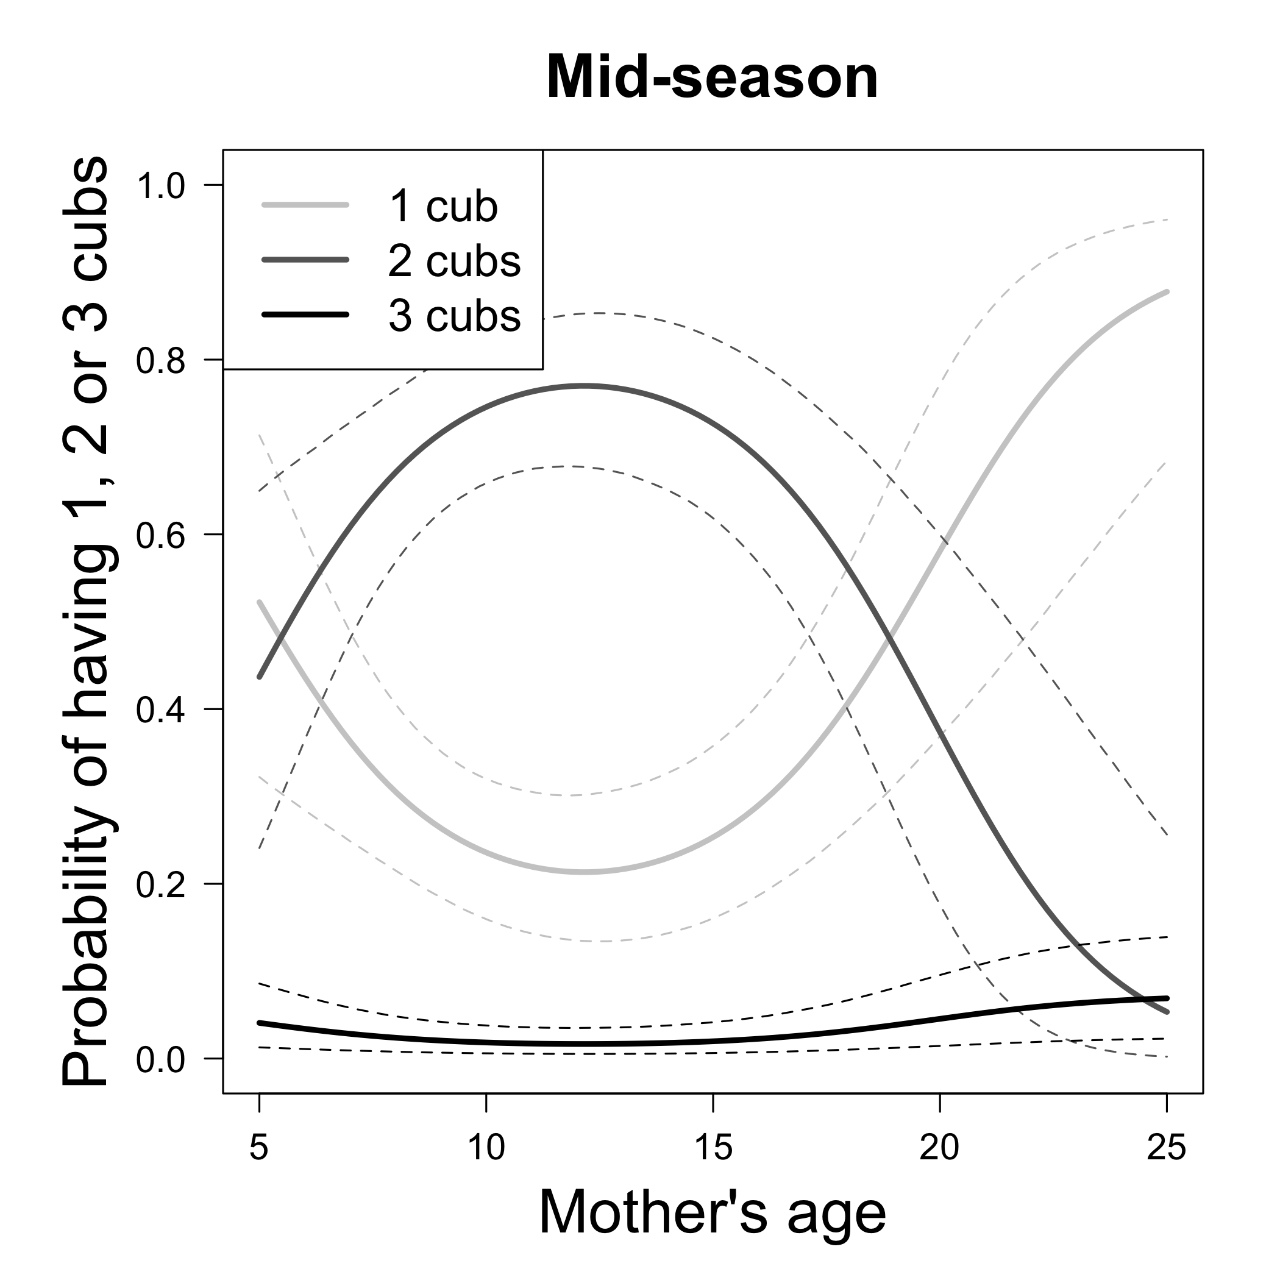

ESM 4: Estimated probability of having 1, 2 or 3 cubs as a function of age (in years) at mid-season (day 105) for a mean maternal size (194.8cm). Predictions were obtained from the best model (model 5.2 in Table 1). Solid lines are posterior means while dotted lines are 95% credible intervals.

