S3 Text. Supplementary figures
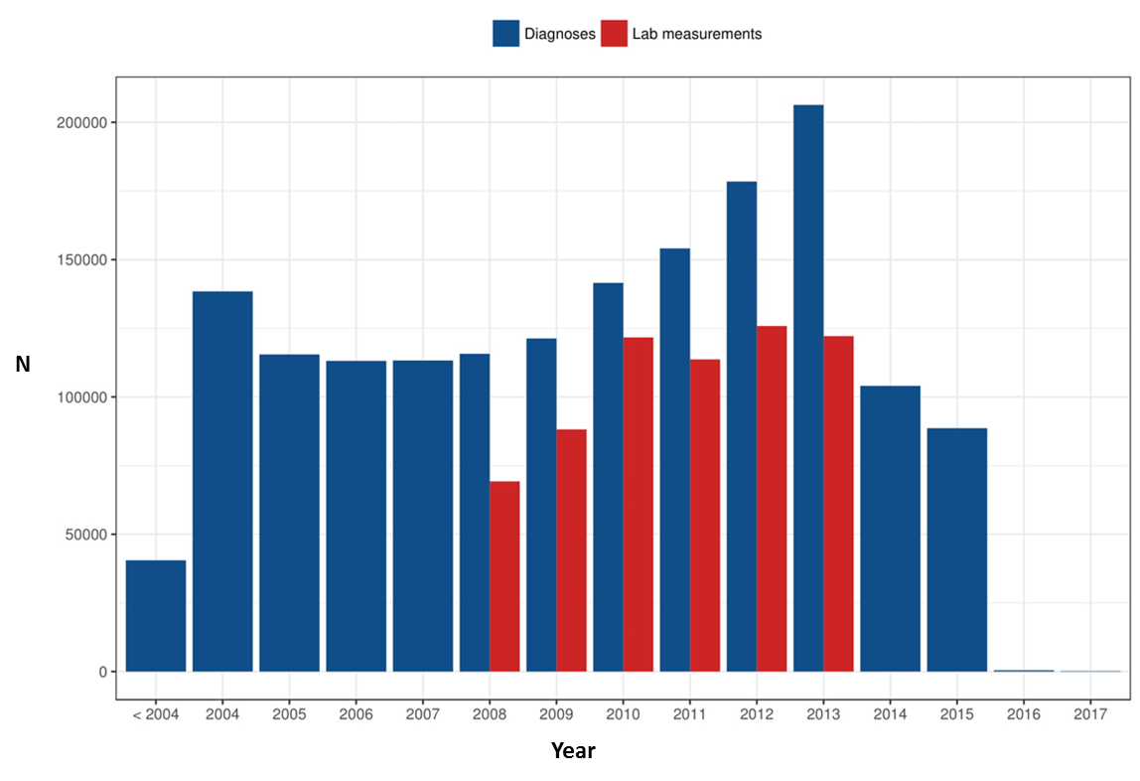
Figure A - Number of disease diagnoses and laboratory/biomarker measurements by year in the Estonian Biobank dataset.
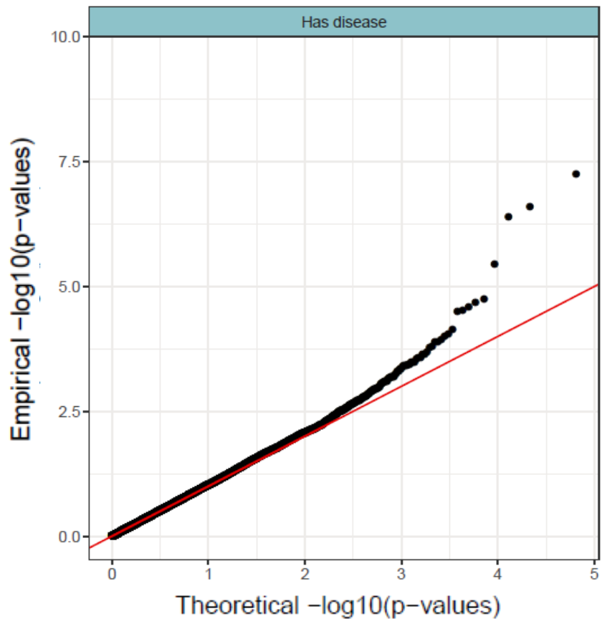
Figure B - QQ-Plot for PheWAS p-value distribution

