Figure S1
Figure S1. Minimal inhibitory concentration of Gentamicin against E. coli ATCC 25922 under NS and HS conditions (means ± s.e.m; n = 4; Mann Whitney test; * p < 0.05).

Figure S2
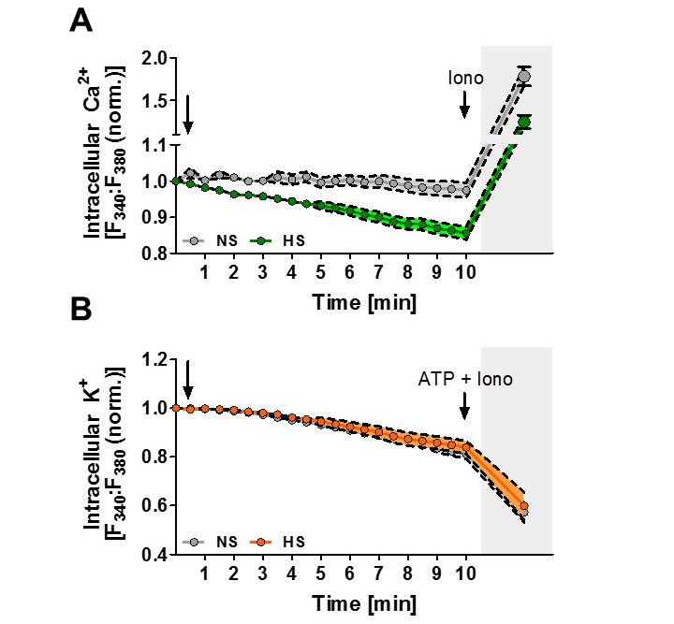

Figure S2. Intracellular Ca²⁺ and K⁺ levels upon HS exposure. (A) Intracellular Ca²⁺ levels were assessed in Fura-2-loaded and E. coli-infected RAW264.7 MΦ by ratiometric live cell imaging. The arrow indicates the addition of 40 mM NaCl to infected cells (means ± s.e.m; n = 6). When indicated, 1 µg/ml Iono (ionomycin) was added to trigger Ca²⁺-efflux as control. (B) As in (A), but K⁺ levels were assessed in PBFI-loaded and E. coli-infected RAW264.7 MΦ (means ± s.e.m; n = 4 - 6). When indicated, ATP + Iono (25 mM ATP + 10 µg/ml ionomycin) was added to induce K⁺-efflux as control.

Figure S3
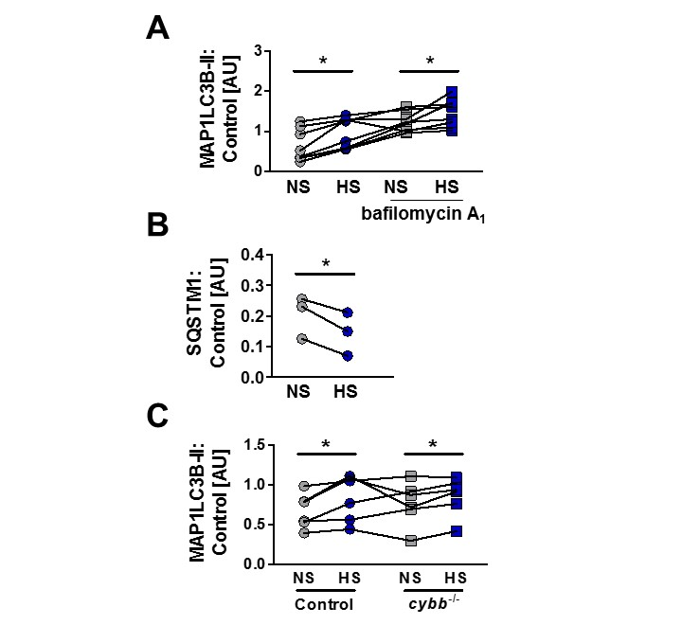
Figure S3. HS increases autophagy in E. coli-infected MΦ. (A) RAW264.7 MΦ were pretreated ± bafilomycin A₁ and infected ± HS for ½ h. Densitometry of immunoblots for MAP1LC3B and loading controls (ACT or HSP90; n = 8; paired Student’s t tests; * p < 0.05). (B) As (A) but for 2 h. Densitometry of immunoblots stained for SQSTM1 and loading controls (ACT or HSP90; n = 3; paired Student’s t test; * p < 0.05). (C) As (A) but WT and cybb^{-/-} BMDM were used. Densitometry of immunoblots stained for MAP1LC3B and loading controls (ACT or HSP90; n = 6; paired Student’s t tests; * p < 0.05).

Figure S4
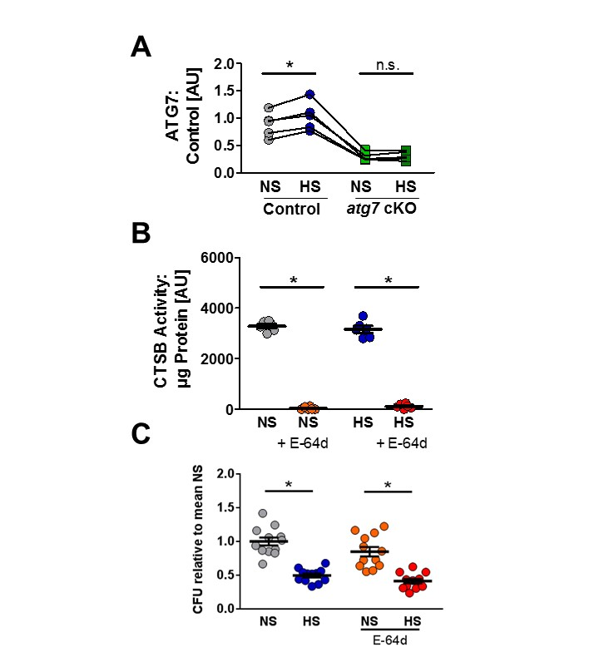

Figure S4. Autophagy and lysosomal acidification are required for high Na⁺-increased antibacterial activity. (A) Infected control and atg7 cKO BMDM were treated ± HS for 2 h. Densitometry of immunoblots stained for ATG7 and loading controls (ACT or HSP90; n = 5; paired Student’s t tests; * p < 0.05). (B) BMDM were infected as described in Fig. 1F. Where indicated, the cathepsin inhibitor E-64d (10 µM) was added prior infection. CTSB activity was measured (means ± s.e.m; Student’s t test + Welch correction and Mann Whitney test; n = 6; * p < 0.05). (C) As in (A), but intracellular E. coli in CFU relative to mean CFU under NS conditions (means ± s.e.m; n = 12; Student’s t test + Welch correction; * p < 0.05).

Figure S5
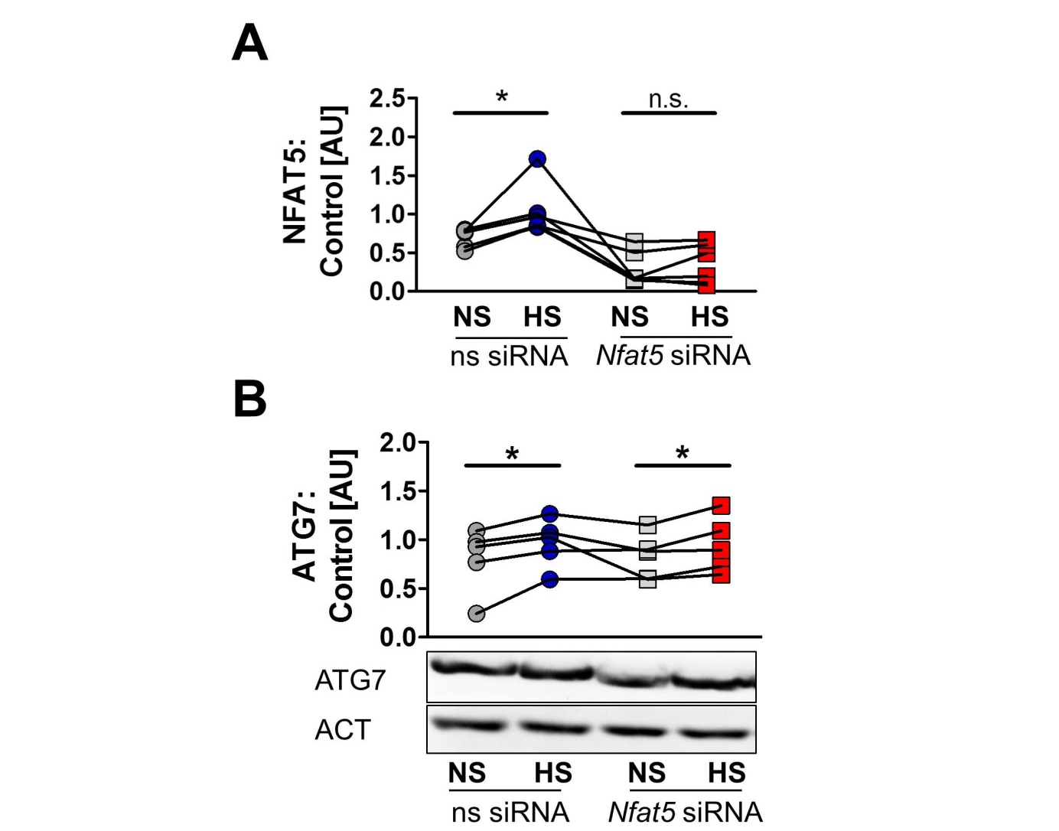

Figure S5. NFAT5 is required for HS-facilitated targeting of intracellular E. coli to autolysosomes. (A) ns siRNA- or Nfat5-specific siRNA-treated RAW264.7 MΦ were infected and stimulated ± HS for ½ h. Densitometry of immunoblots stained for NFAT5 and loading controls (ACT or HSP90; n = 6; Wilcoxon signed rank tests; * p < 0.05). (B) As (A) but for 2 h. One representative blot and densitometry of several immunoblots stained for ATG7 and loading controls (ACT or HSP90; n = 5; paired Student’s t tests; * p < 0.05).

Figure S6
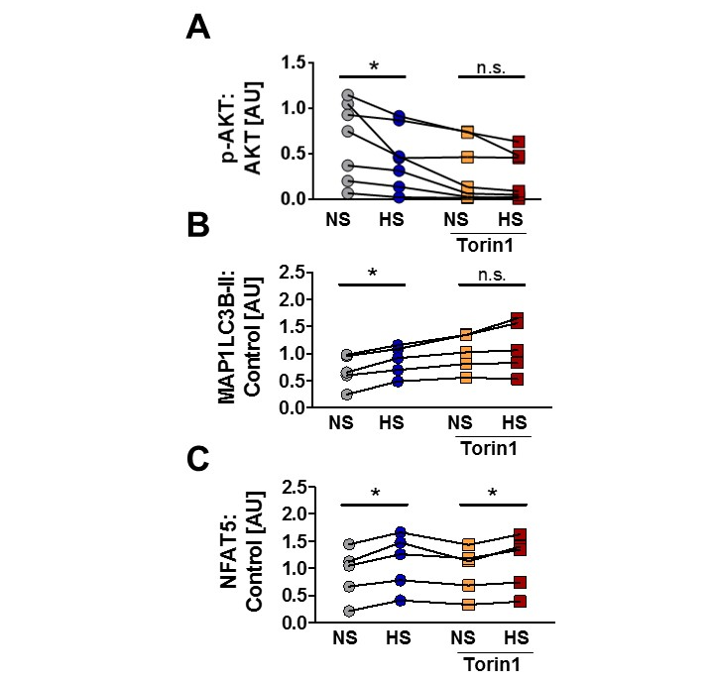

Figure S6. Blunted AKT and MTOR activation does not account for HS-augmented antibacterial activity. (A) RAW264.7 MΦ were pretreated ± Torin1 and infected with E. coli ± HS for ½ h. Densitometry of immunoblots for p-AKT and AKT (n = 7; paired Student’s t tests; * p < 0.05). (B) As (A) but densitometry of immunoblots for MAP1LC3B and loading controls (ACT or HSP90; n = 5; paired Student’s t tests; * p < 0.05). (C) As (A) but for 2 h. Densitometry of immunoblots stained for NFAT5 and loading controls (ACT or HSP90; n = 5; paired Student’s t tests; * p < 0.05).

Figure S7
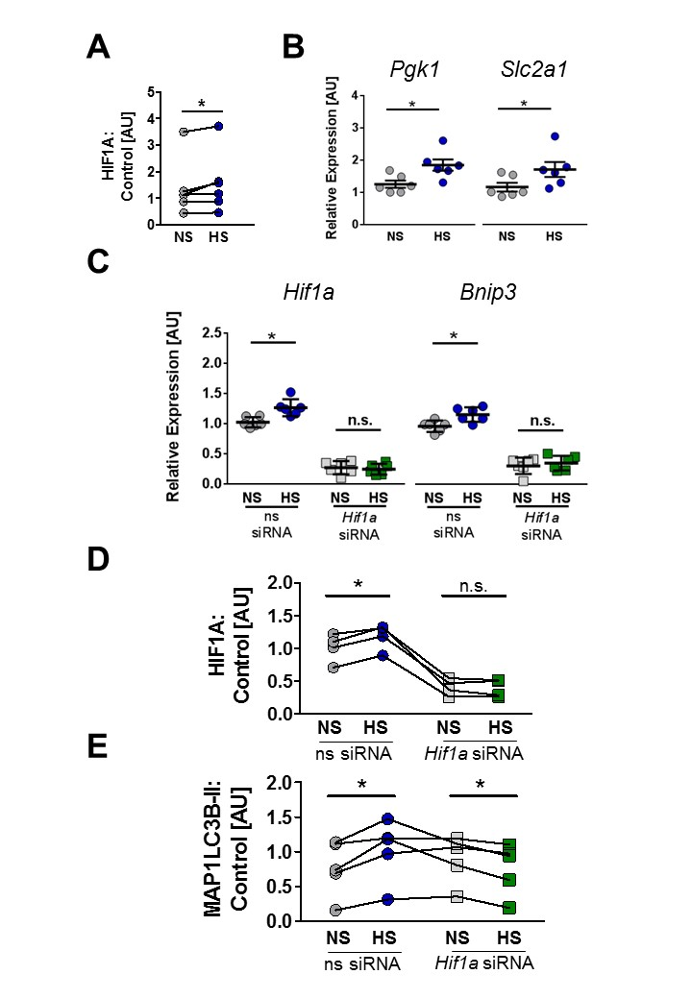
Figure S7. The presence of HIF1A is required for HS-triggered autophagy induction and antibacterial activity. (A) RAW264.7 MΦ were infected and stimulated ± HS for 2 h. Densitometry of immunoblots stained for HIF1A and loading controls (ACT or HSP90; n = 6; Wilcoxon signed rank test; * p < 0.05). (B) As in Fig. 1A, but Pgk1 and Slc2a1 mRNA levels were quantified (means ± s.e.m; n = 6; Student’s t test or Mann Whitney test, * p < 0.05). (C) After treating RAW264.7 MΦ with ns siRNA or Hif1a siRNA, Hif1a and Bnip3 mRNA levels were quantified 2 h after infection ± HS (means ± s.e.m; n = 6; Student’s t test; * p < 0.05). (D) ns siRNA- or Hif1a-specific siRNA-treated RAW264.7 MΦ were infected and stimulated ± HS for 4 h. Densitometry of immunoblots for HIF1A and loading controls (ACT or HSP90; n = 4; paired Student’s t test; * p < 0.05). (E) ns siRNA- or Hif1a-specific siRNA-treated RAW264.7 MΦ were infected and stimulated ± HS for ½ h. Densitometry of immunoblots stained for MAP1LC3B and loading controls (ACT or HSP90; n = 5; paired Student’s t test; * p < 0.05).

Figure S8
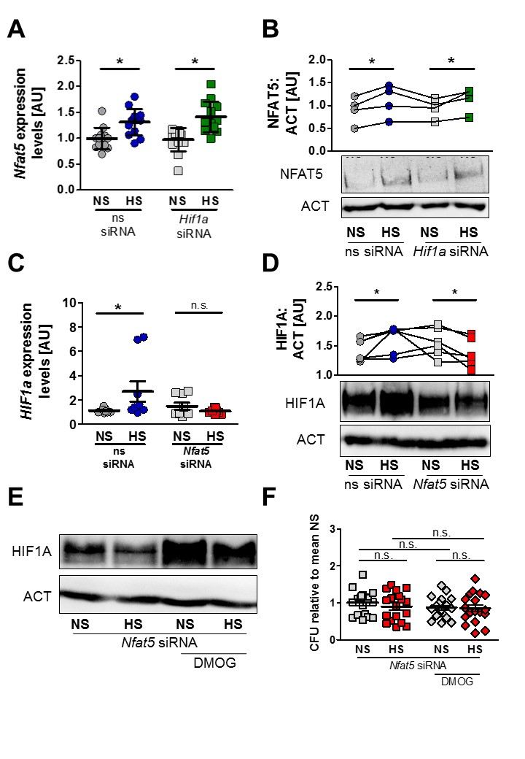
Figure S8. Relationship of HIF1A and NFAT5 upon exposure to HS. (A) Quantification of Nfat5 mRNA levels in E. coli-infected MΦ ± HS, which were either treated with non-silencing (ns) siRNA or Hif1a-specific siRNA at 2 h post infection (n = 13, Student’s t test or Mann-Whitney U test; * p < 0.05). (B) As in (A), but quantification of NFAT5 and ACT protein levels was performed after 4 h (n = 4, paired Student’s t test; * p < 0.05). (C) Quantification of Hif1a mRNA levels in MΦ ± HS at 2 h post E. coli-infection, which were either pretreated with ns siRNA or Nfat5-specific siRNA (n = 9; Mann-Whitney U test, * p < 0.05). (D) Cells were treated as in (C), but quantification of HIF1A protein levels was performed (n = 6; paired Student’s t test or Wilcoxon signed rank test; * p < 0.05. (E) Cells were treated as in (C), but with an additional conditions using 50 µM DMOG. At 4 h post infection, protein levels of HIF1A and ACT were determined. (F) Cells were treated as in (E), but bacterial survival in these cells was analyzed 2 h post infection (n = 18, ANOVA and Bonferroni’s multiple comparison test, * p < 0.05).

