SUPPLEMENTARY MATERIAL

Oxidative stress protective effect of Dracocephalum multicaule essential oil against human cancer cell line
Mohammad Ali Esmaeili^{a,}*, Ali Sonboli^{a,}* and Mohammad Hossein Mirjalili^{b}

ª Department of Biology, Medicinal Plants and Drugs Research Institute, Shahid Beheshti University, G.C., Evin, 1983963113, Tehran, Iran
^{b} Department of Agriculture, Medicinal Plants and Drugs Research Institute, Shahid Beheshti University, G.C., Evin, 1983963113, Tehran, Iran

Abstract
In this study, we report that the antioxidative and protective effect of essential oil of Dracocephalum multicaule on K562 cells. Our results showed that monoterpenoids including oxygenated and hydrocarbons ones with 71.5 and 28.3 %, respectively, were the principal essential oil of D. multicaule. Perilla aldehyde (71.5%) and limonene (28.1%) were identified as the main components. Antioxidant studies based on DPPH assay indicated that the D. multicaule essential oil possesses a marked antioxidant and radical scavenging activity with an IC₅₀ value of 438.2 µg/ml. Pre-treatment with essential oil and main constituents protected K562 cells 49.5% against H₂O₂ induced oxidative damage throughout increasing the activities of antioxidant enzymes and glutathione content in K562 cells. Taken together, D. multicaule essential oil and its main compounds especially in combinatory condition with ratio of 7:3 with high antioxidant properties may be able to protect cells against oxidative stress induced by H₂O₂ through antioxidative mechanisms.

Keywors: Antioxidant activity; Anticancer activity; Dracocephalum multicaule; Essential oil; Perilla aldehyde;

Experimental
Plant material
The aerial parts of D. multicaule were collected from West Azarbaijan province of Iran, in June 3, 2008. A voucher specimen (MPH-1307) has been deposited in Medicinal Plants and Drugs Research Institute Herbarium of Shahid Beheshti University (MPH), Tehran, Iran.
Essential oil isolation and analysis
Air-dried plant material (50g) were hydrodistilled for 2.5 h using a Clevenger type apparatus. The essential oil was dried over anhydrous Na₂SO₄ and then was kept in sealed vials at 4^{ο}C until analysis and tests. GC analysis was carried out on a Thermoquest-Finnigan Trace GC instrument equipped with a capillary DB-5 fused silica column (60 m × 0.25 mm i.d., film thickness 0.25 μm). The details of GC and GC-MS analyses have already been published (Sonboli et al., 2008). The constituents of the oil were identified by calculation of their retention indices under temperature-programmed conditions for n-alkanes (C₆–C₂₄) and the essential oil on DB-5 column. Identification of individual compounds was made by comparison of their mass spectra with those of the internal reference mass spectra library or with authentic compounds and confirmed by comparison of their retention indices with those of reported data in the literature (Adams, 2007).
DPPH and β-Carotene-linoleic acid bleaching assay
The DPPH radicals scavenging activity was determined according to published reference (Blois, 1958). The β-carotene bleaching assay was carried out to determine the antioxidant activity of samples based on Miller's method (Miller 1971)
Cell culture and cell viability
The human leukemia K562 cells were cultured in RPMI-1640 medium supplemented with FBS (10%, v/v), streptomycin (100 µg/ml) and penicillin (100 U/ml). The cells were incubated under 5% CO₂ humidified atmosphere at 37 ºC. Cell viability was estimated using the MTT assay.
Lactate dehydrogenase (LDH) release assay
The LDH activity was assayed spectrophotometrically according to instructions given by the kit's manufacturer (Pars Azmun, Iran).
Assay of intracellular ROS levels
The production of ROS was monitored using 2',7'-dichlorofluorescein diacetate (DCFH-DA) staining regarding the Lebel method (Lebel et al., 1992). Briefly, in the present study, cells were pretreated with various concentrations of essential oil and major compounds and after 24 h; the cells were treated with 10 µM DCFH-DA for 30 min. Then the compound-treated cells were washed twice with PBS to remove the extracellular compounds, and DCFH-DA green fluorescence was detected using flow cytometry (Partec PAS, Germany).
Measurement of antioxidant defense factors
The intracellular GSH content was measured using spectrofluorometer (Osseni et al., 2000). For the assay of the GPx and GR activities, treated cells (10⁵) were suspended in PBS and centrifuged at 300g for 5 min to pellet cells. Cell pellets were resuspended in 20 mM Tris, 5 mM EDTA, and 0.5 mM mercaptoethanol, sonicated, and centrifuged at 3000g for 15 min. the activities of GPx and GR were determined regarding the methods have been previously described (Gunzler et al., 1974; Goldberg and Spooner, 1978).

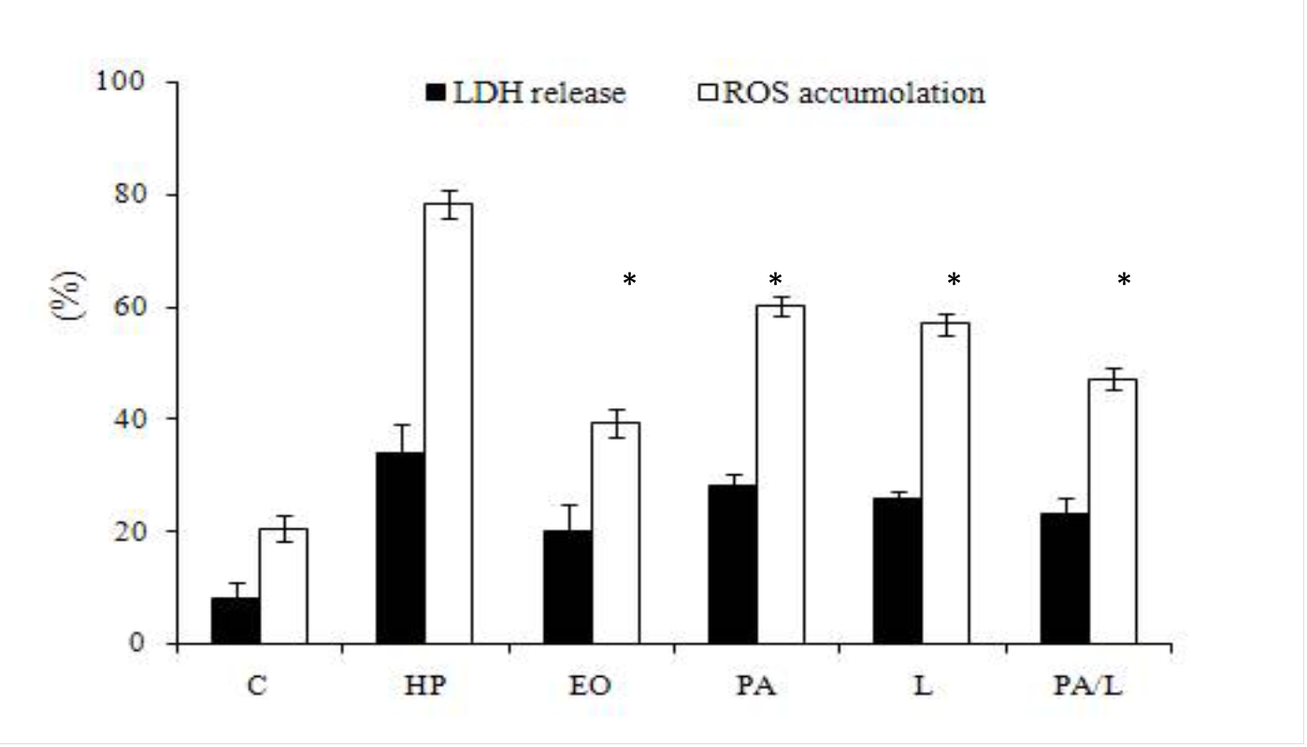
Figure S1. Protective effect of the essential oil and main compounds of Dracocephalum multicaule (single or binary at ratio of 7:3 in mixture) on cellular LDH release () and intracellular ROS generation (). Values are mean ± SD (n=3). Significantly different from H₂O₂-treated cells (P< 0.05); C: Control; HP: Hydrogen peroxide; other abbreviations are presented as in Table S2.

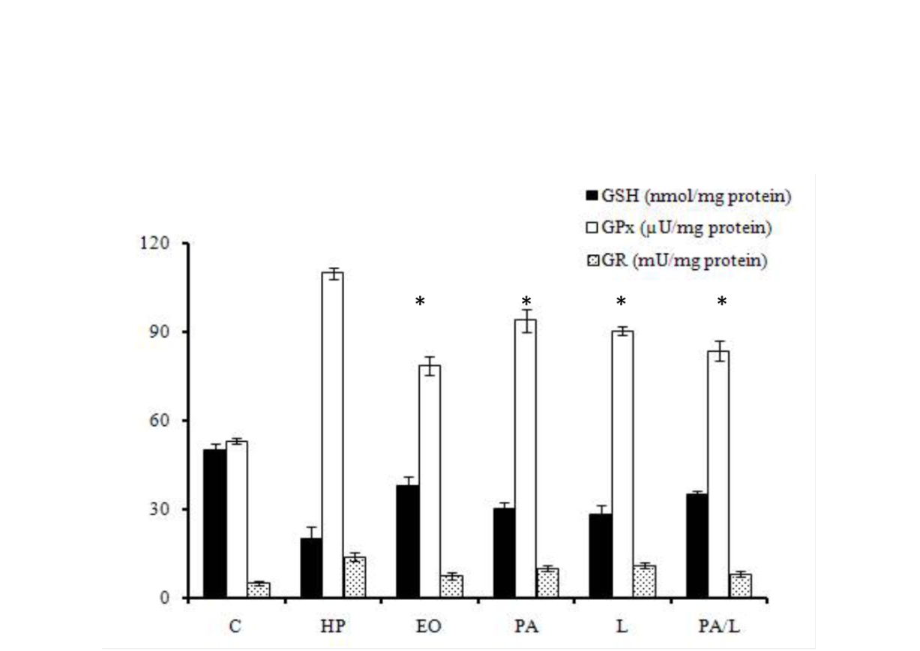

Figure S2. Protective effect of the essential oil and main compounds of Dracocephalum multicaule (L, single or binary at ratio of 7:3 in mixture) on antioxidant defenses: GSH content () and activities of GPx () and GR ( ) in K562 cells. Values are mean ± SD (n=3). Significantly different from H₂O₂-treated cells (P< 0.05), Abbreviations are presented as in Figure S1.

Table S1. Essential oil composition of Dracocephalum multicaule.

Compound | RI | %
β-Pinene | 974 | 0.1
Myrcene | 981 | 0.1
Limonene | 1026 | 28.1
Perilla aldehyde | 1192 | 71.5
Monoterpene hydrocarbons |  | 28.3
Oxygenated monoterpenes |  | 71.5
Total (4 Comps.) |  | 99.8
RI, retention indices relative to C₆ - C₂₄ n-alkanes on the DB-5 column.

Table S2. Antioxidant activities of Dracocephalum multicaule essential oil and its main constituents.

Sample | DPPH (IC50) (μg/ml) | β-carotene bleaching (%)
Essential oil (EO) | 438.2 ±4.5 | 54.2 ± 3.4
Perilla aldehyde (PA) | >1000 | 39.3 ± 1.8
Limonene (L) | 824.1 ± 3.7 | 43.4 ± 2.1
PA/ L (1:1, v/v) | 943.2 ± 1.2 | 41.7 ± 1.7
PA/ L (3:7, v/v) | 741.5 ± 2.5 | 40.5 ± 3.3
PA/ L (7:3, v/v) | 624.7 ± 3.4 | 47.2 ± 2.1
BHT | 21.34 ± 1.4 | 100
Values are given as average ± SD.

References
Adams, R.P. (2007). Identification of essential oil components by gas chromatography
quadropole mass spectroscopy. Carol Stream. Allured Publishing Corporation.
Blois, M.S. (1958). Antioxidant determinations by the use of a stable free radical. Nature, 158, 1199-1200.
Goldberg, D.M., & Spooner, R.J. (1987). Glutathione reductase. In: Methods of Enzymatic Analysis. Bergmeyer H.V. (Ed.), Verlag-Chemie: Weinheim, Germany, pp. 258- 265.
Gunzler, W.A., Kremers, H., & Flohe, L. (1974). An improved coupled test procedure for glutathione peroxidase in blood. Z Klin Chem Klin Biochem,12, 444-448.
Lebel, C.P., Ischiropoulos, H., & Bondy, S.C. (1992). Evaluation of the probe 2',7'-dichlorofluorescin as an indicator of reactive oxygen species formation and oxidative stress. Chemical Research in Toxicology, 5, 227-231.
Miller, H.E. (1971). A simplified method for the evaluation of antioxidants. Journal of American Chemistry Society, 48, 91-94.

