Cytotoxic activity of two natural sesquiterpene lactones, isobutyroylplenolin and arnicolide D, on human colon cancer cell line HT-29

Xuedan Huang ª* ,Yurika Awanoª, Eri Maedaª, Yoshihisa Asada^{b}, Hiroaki Takemotoª ,Takashi Watanabe^{c}, Akiko Kojima-Yuasa^{d}, Yoshinori Kobayashi ª

ªSchool of Pharmaceutical Sciences, Kitasato University, 5-9-1 Shirokane, Minato-ku, Tokyo 108-0086, Japan
^{b}Faculty of Pharmaceutical Sciences, Tokyo University of Science, 2641 Yamazaki, Noda, Chiba 278-8510, Japan
^{c}The Kochi University of Technology, Tosayamada-cho, Kochi 782-8502, Japan
^{d}Department of Food and Human Health Sciences, Graduate School of Human Life Science, Osaka City University, 3-3-138 Sugimoto, Sumiyoshi-ku, Osaka 558-8585, Japan

*Correspondence:
Xuedan Huang
E-mail: kouse@pharm.kitasato-u.ac.jp
Tel.: +81-3-5791-6239
Fax: +81-3-3444-6192

Abstract
In this study, we found that two sesquiterpene lactones, isobutyroylplenolin and arnicolide D, from Centipeda minima L. (Compositae) exerted stronger cytotoxic activity than cisplatin on the human colon carcinoma HT-29 cell line. Furthermore, the cytotoxicity of these two compounds on normal cells was weaker than that of cisplatin. Treatment with isobutyroylplenolin and arnicolide D increased the level of intracellular reactive oxygen species and decreased that of nuclear factor-κB protein, resulting in cell cycle arrest in the G1 phase and apoptosis. We also discussed the difference in structure and activity between these two compounds.
Keywords: word; Centipeda minima L.; isobutyroylplenolin; arnicolide D; cytotoxic; reactive oxygen species; nuclear factor-κB

Experiental:

Reagents
2’,7’-Dichlorodihydrofluorescein diacetate (DCFH-DA) was purchased from Sigma Chemical Co. Ltd. Ribonuclease (RNase) and PI were purchased from Wako Pure Chemical Industries, Ltd. (Osaka, Japan). Fetal bovine serum (FBS) was purchased from Equitech-Bio Inc. (Kerrville, Texas, U.S.). Other chemicals used in this study were special-grade commercial products.

Plant material
C. minima were collected in August 2007 at the mountain hill field of Pohkara, Nepal, and identified by Nobuyuki Tanaka, Ph.D, of The Kochi Prefectural Makino Botanical Garden. A voucher specimen (NPL-SP070811 (004)) has been deposited at The Kochi Prefectural Makino Botanical Garden.

Extraction and isolation
Dried plant materials of C. minima (188 g) were extracted three times with methanol (MeOH). After evaporation in vacuo, the extract was suspended in water and successively partitioned with ethyl acetate (EtOAc) and n-butanol (n-BuOH). The EtOAc extract (18.60 g) was subjected to a silica gel column eluted with a gradient of n-hexane-EtOAc (15:1–0:100) to give eight fractions (A–H). Fraction H (10.86 g) was applied to octadecylsilyl column chromatography, eluting with a gradient of MeOH-H₂O (4:6–0:100) to give nine fractions (H-1–H-9). Fraction H-3 (3.371 g) was purified by preparative reverse phase-HPLC with the mobile phase MeOH-CH₃CN-H₂O (35:28:37) to afford isobutyroylplenolin (0.718 g, 0.3815%) and arnicolide D (0.687 g, 0.3654%). The Mass and NMR Spectrum of isobutyroyplenolin and arnicolide D was showed in figure S6~11. The structures of isobutyroylplenolin and arnicolide D were confirmed by comparing the spectroscopic data with those reported in the literature (Poplawski et al. 1970).

Cell culture
HT-29 and IEC-6 cells (Health science research resources bank, Japan) were cultured in Dulbecco’s modified Eagle’s medium supplemented with 10% FBS in a humidified incubator containing 5% CO₂ in air at 37 °C before use. The cells were washed and cultured again at a concentration of 2 × 10⁴/ml in fresh medium. Isobutyroylplenolin and arnicolide D were dissolved in dimethyl sulfoxide (DMSO; final DMSO concentration < 0.125%). In all the experiments, control cultures comprised the medium, DMSO, and the cells.

Cell viability assay
Cell viability was measured by MTT (3-[4,5-dimethylthiazol-2-yl]-2,5 diphenyl tetrazolium bromide) assay, which is based on the conversion of MTT to formazan crystals by mitochondrial dehydrogenases (Mosmann 1983). Briefly, HT-29 cells were incubated at a density of 2 × 10⁴ cells/well in a 96-well plate. After 24 h, isobutyroylplenolin, arnicolide D, and cisplatin were added to the cells and incubated for 72 h. At the end of the treatment, 10 µl of 5 mg/ml MTT was added to each well for 4 h at 37 °C. The culture medium was then removed, after which 200 µl of DMSO was added to each well to dissolve the formazan that had formed in the reaction. The absorbance of each well was measured at 570 nm using a microplate reader. Viability was calculated as follows: (A₅₇₀-treated cells/A₅₇₀ of appropriate control) × 100% after correction for background absorbance (100% cytotoxicity).

Assay of cell cycle changes
The cell cycle distribution was analyzed by flow cytometry (Beckman Coulter, Coulter® Epics® AltraTM Flow Cytometer) using PI staining. Briefly, after treatment of the concentrations of IC₅₀ values of isobutyroylplenolin (8µM) and arnicolide D (3µM) for 24 hours or 72 hours, the cells were washed twice in PBS and incubated with freshly prepared PI-stained buffer (0.1% Triton X-100 in PBS, 20 µg/ml PI, 200 µg/ml RNase) for 1 h at 37 °C in the dark (Huang et al. 2008).

Assay of ROS production
DCFH-DA was used as the capture reagent of ROS. It was deacetylated by nonspecific esterase intracellularly, and then furthered oxidized by ROS to obtain the fluorescent compound 2,7-dichlorofluorescein (DCF) (Kojima-Yuasa et al. 2005). Cells treated with isobutyroylplenolin (8µM) and arnicolide D (3µM) for 30 min, 1 h, 2 h, 4 h, or 6 h were then incubated with 5 μM DCFH-DA at 37 °C for 15 min. The DCF fluorescence was measured using a flow cytometer at excitation and emission wavelengths of 488 and 525 nm, respectively.

Assay of NF-κB levels
Cytosol protein and nuclear protein were extracted using the ProteoExtract® Subcellular Proteome Extraction Kit (Calbiochem) after 24 h of treatment with isobutyroylplenolin (0.8 and 8µM) and arnicolide D (0.3 and 3µM). The protein concentrations were determined using the BCA protein assay kit (Thermo). Equal amounts of protein were fractionated on 10% SDS-PAGE gels and transferred to 0.45 µm Hybond® (polyvinylidene difluoride (PVDF) membrane; Amersham Pharmacia Biotech). The efficiency of transfer and equal loading of protein were confirmed by staining membranes with Coomassie Brilliant Blue (0.1%) in 5% acetic acid. After overnight blocking in 0.1% Tween-20 and 5% non-fat dry milk in PBS, the blots were incubated with the antibodies of NF-κB for 1 h at room temperature. After washing, the membrane was reincubated with 1:750 diluted biotinylated mouse IgG for 1 h at room temperature. The membrane was then washed several times and incubated with 1:750 diluted horseradish peroxidase-coupled streptavidin for 1 h at room temperature. After several washing steps, the color reaction was developed with tetramethylbenzidine (TMB, Sigma).

8. Statistical analysis
Data are represented as means ± S.D. (standard deviation from the mean). The significance of differences in assay values was evaluated using ANOVA followed by Tukey’s multiple tests. p < 0.05 was used to indicate a statistically significant difference.

References:
Huang X, Kojima-Yuasa A, Xu S, Norikura T, Kennedy DO, Hasuma T, Matsui-Yuasa I. (2008) Green tea extract enhances the selective cytotoxic activity of Zizyphus jujuba extracts in HepG2 cells. Am J Chin Med 36:729–744
Kojima-Yuasa A, Umeda K, Ohkita T, Opare Kennedy D, Nishiguchi S, Matsui-Yuasa I. (2005) Role of reactive oxygen species in zinc deficiency-induced hepatic stellate cell activation. FreeRadic Biol Med 39:631–640
Mosmann T. (1983) Rapid colorimetric assay for cellular growth and survival: application to proliferation and cytotoxicity assays. J Immunol Methods 65:55–63
Poplawski J, Holub M, Samek Z, Herout V. (1970) Arnicolides-sesquiterpenic lactones from the leaves of Arnica montana L. Collect Czech Chem Commun. 36: 2189–2199

Figure S1. Cytotoxic activities of isobutyroylplenolin and arnicolide D on HT-29 cells (a) and IEC-6 cells (b). Cells were cultured in Dulbecco’s modified Eagle’s medium containing 10% FBS for three days, diluted, and incubated again in fresh medium with or without isobutyroylplenolin and arnicolide D. Cell viability was measured 72 h later by the MTT method. Results are representative of three separate determinations. Each point is the mean (± S.D.) of three experiments. *p < 0.05, **p < 0.01 compared to the untreated control.

Figure S2. Effects of isobutyroylplenolin and arnicolide D on the cell cycle in HT-29 cells
Cells were incubated with isobutyroylplenolin and arnicolide D for 72 h, washed twice in PBS, and incubated with freshly prepared PI-stained buffer for 1 h at 37 ℃ in the dark. The staining was analyzed by flow cytometry. Results are representative of three separate determinations. Each point is the mean (± S.D.) of three experiments.**p < 0.01 compared with the same stage of control group.

Figure S3. Effects of isobutyroylplenolin and arnicolide D on ROS levels in HT-29 cells
The intracellular ROS levels were measured by flow cytometry. DCF fluorescence intensity of cells was measured at 30 min, 1 h, 2 h, 4 h, and 6 h after treatment with isobutyroylplenolin and arnicolide D. Data are presented as means ± S.D. *p < 0.05, **p < 0.01 compared with the control group at the same time points.

Figure S4. Effects of isobutyroylplenolin and arnicolide D on NF-κB levels Cells were incubated with isobutyroylplenolin and arnicolide for 24 h. Cell lysis and Western blotting were performed as described in the Materials and methods. Data are representative of at least three independent experiments.

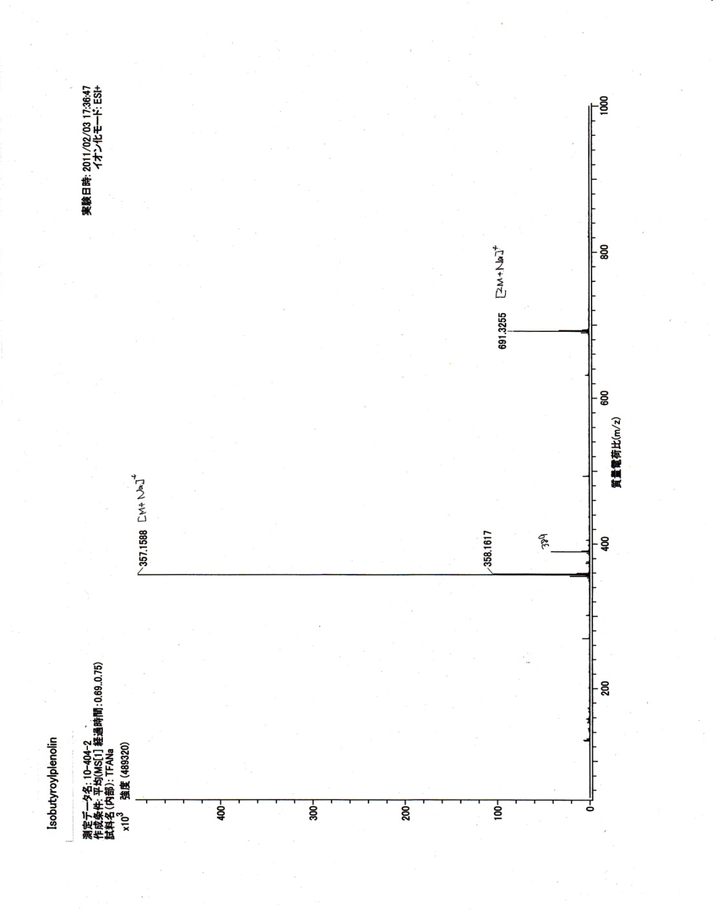
Figure S5. Isobutyroyplenolin ESI-Mass Spectrum

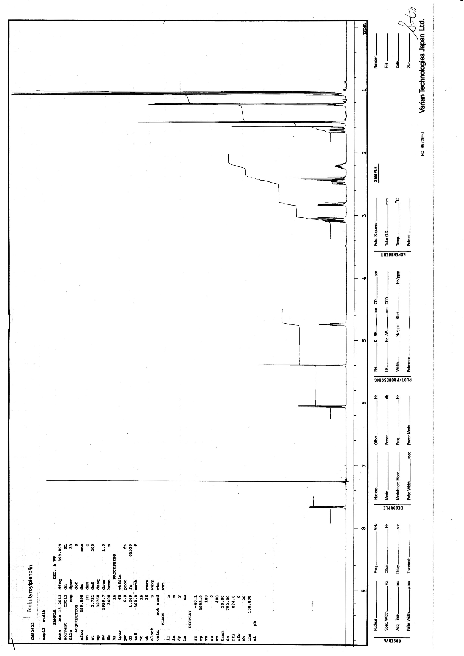
Figure S6. Isobutyroyplenolin 1H-NMR Spectrum

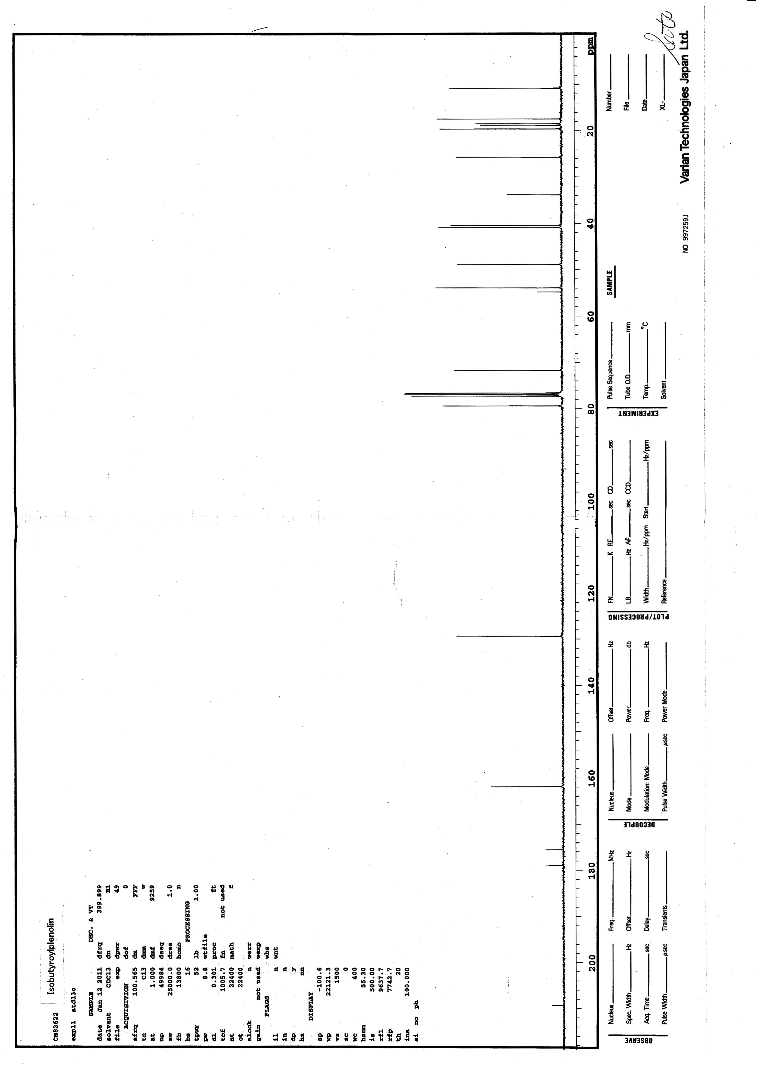
Figure S7. Isobutyroyplenolin 13C-NMR Spectrum

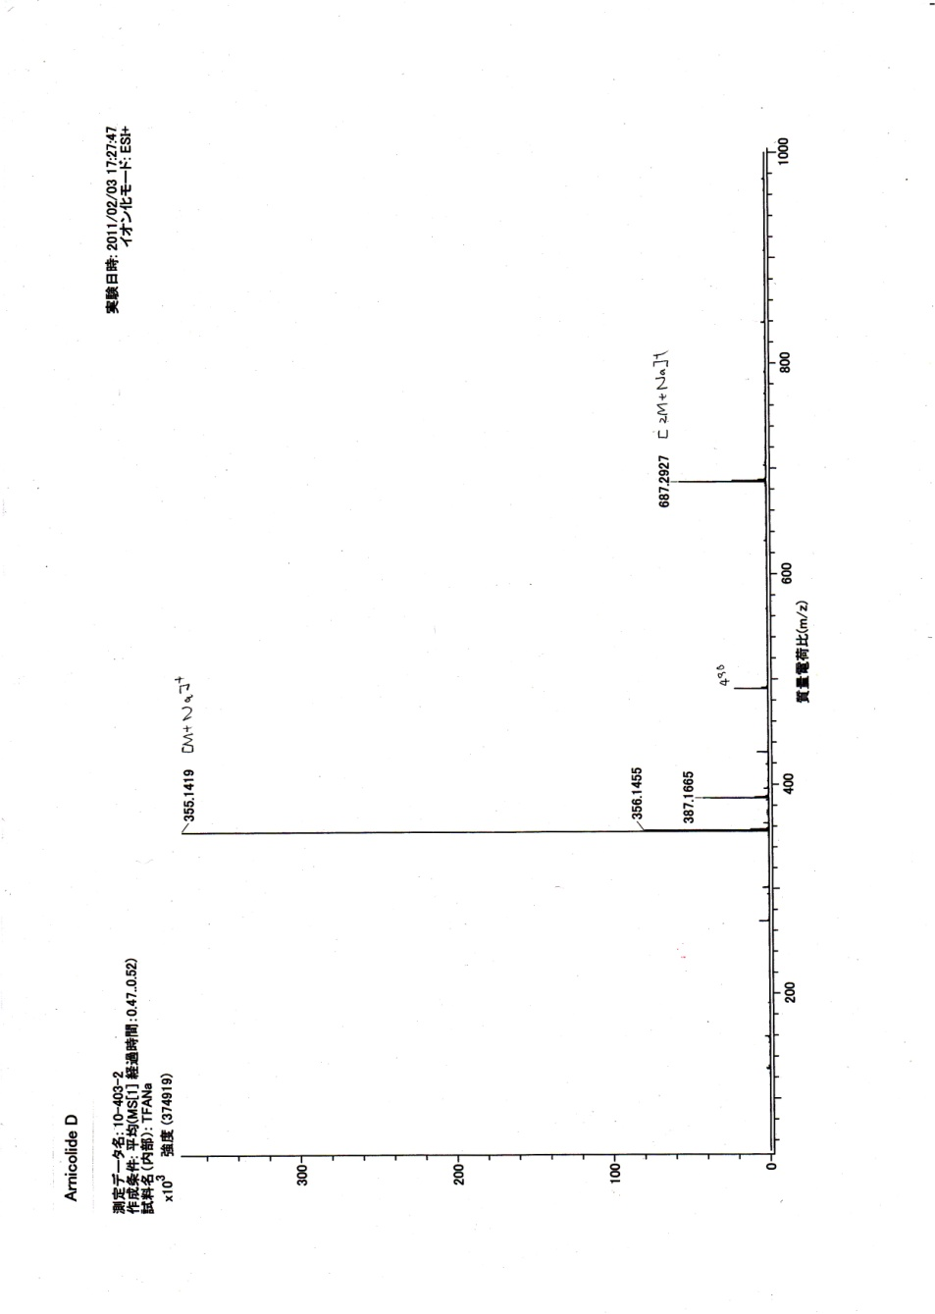
Figure S8. Arnicolide D ESI-Mass Spectrum

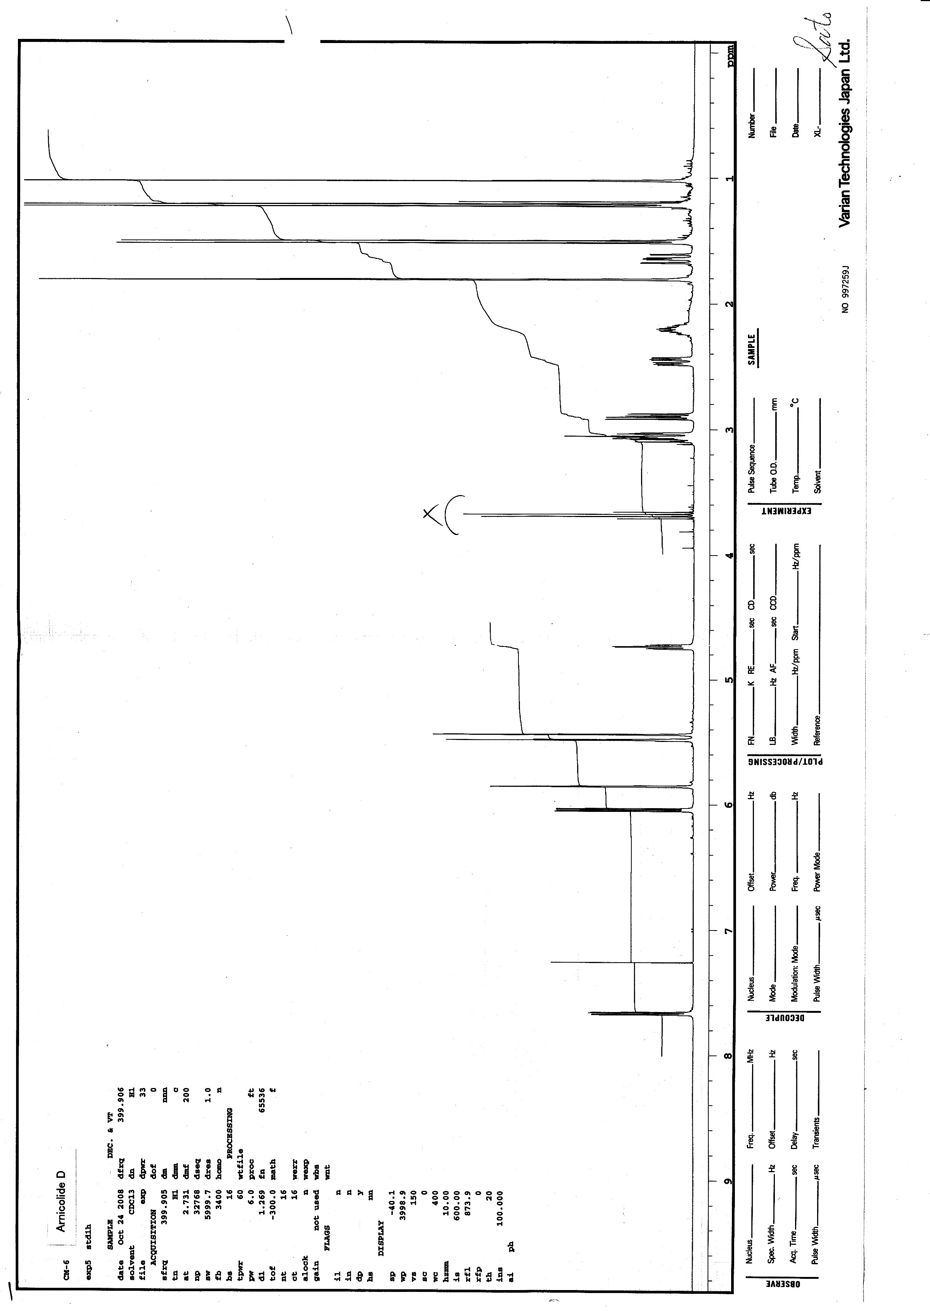
Figure S9. Arnicolide D 1H-NMR Spectrum

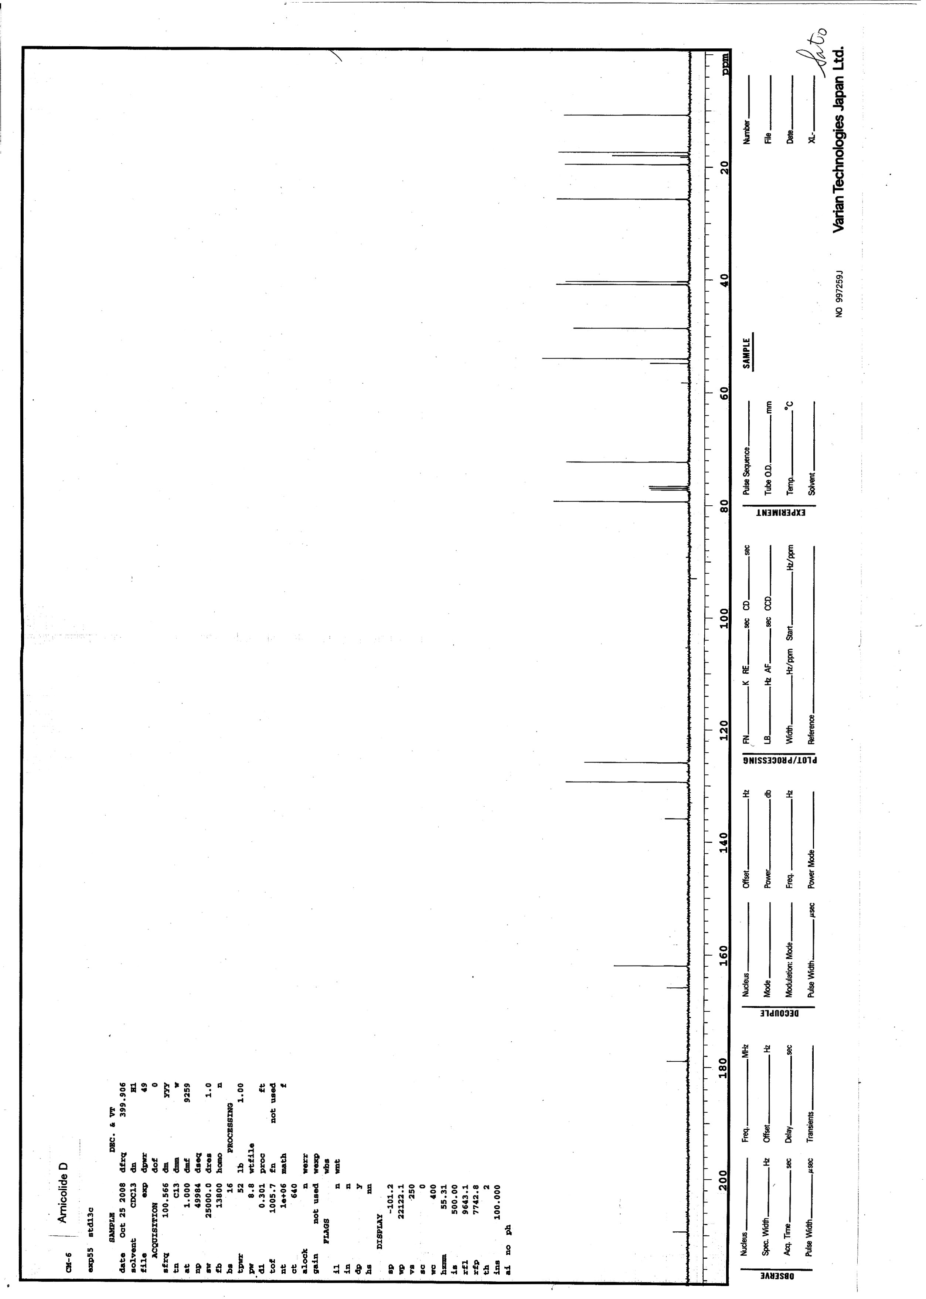
Figure S10. Arnicolide D 13C-NMR Spectrum

