Electronic Supplementary Information

Structural insight into the anion-water cluster: Stabilized by alcohol and carboxylic acid containing tripodal ligand

Md. Najbul Hoque, Arghya Basu and Gopal Das*
Department of Chemistry, Indian Institute of Technology Guwahati,
Assam-781039, India.

Email: gdas@iitg.ernet.in

Figure S1. ORTEP diagram of the complex [LNa₂•6H₂O] (30% probability for thermal ellipsoid) with atom labelling scheme (H-atoms omitted for clarity).
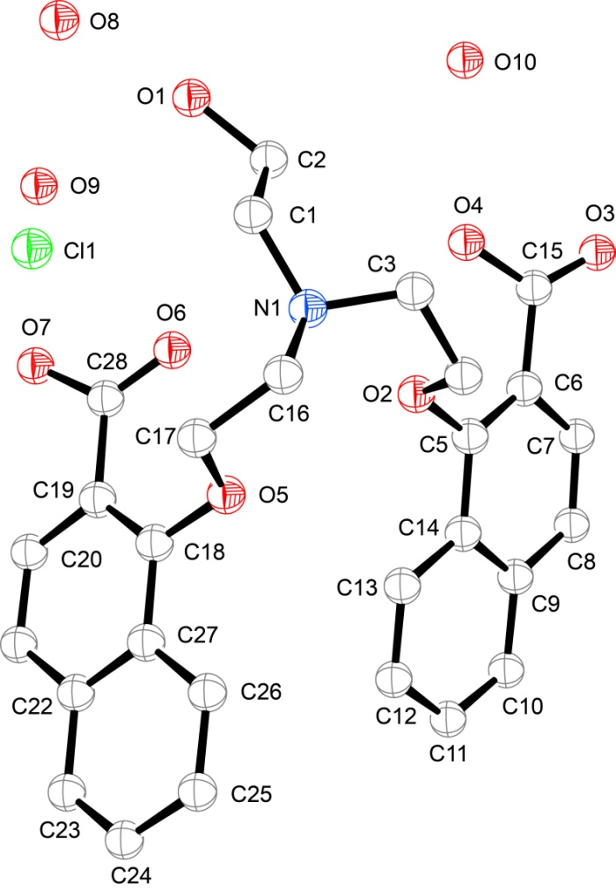
Figure S2. ORTEP diagram of the complex [LH₃•Cl•3H₂O] (30% probability for thermal ellipsoid) with atom labelling scheme (H-atoms omitted for clarity).

Figure S3. ORTEP diagram of the complex [LH₃•Br•2H₂O] (30% probability for thermal ellipsoid) with atom labelling scheme (H-atoms omitted for clarity).

Figure S4. ORTEP diagram of the complex [LH₃•NO₃•2H₂O] (30% probability for thermal ellipsoid) with atom labelling scheme (H-atoms omitted for clarity).

Figure S5. ORTEP diagram of the complex [LH₃•ClO₄•MeOH] (30% probability for thermal ellipsoid) with atom labelling scheme (H-atoms omitted for clarity).
Figure S6. ¹H-NMR (400 MHz) spectra of 1-Hydroxy-naphthalene-2-carboxylic acid methylester II in CDCl₃ at 298 K.
Figure S7. ¹³C-NMR (100 MHz) spectra of 1-Hydroxy-naphthalene-2-carboxylic acid methylester II in CDCl₃ at 298 K.

Figure S8. ¹H-NMR(400 MHz) spectra of tripodal ester III in CDCl₃ at 298 K.

Figure S9. ¹³C-NMR (100 MHz) spectra of tripodal ester III in CDCl₃ at 298 K.

Figure S10. ¹H-NMR(400 MHz) spectra of [LNa₂•6H₂O] in D₂O at 298 K.

Figure S11. ¹H-NMR(400 MHz) spectra of [LH₃•Cl•3H₂O] in CDCl₃ at 298 K.

Figure S12. ¹³C-NMR(100 MHz) spectra of [LH₃•Cl•3H₂O] in CDCl₃ at 298 K.

Figure S13. ¹H-NMR(400 MHz) spectra of [LH₃•Br•2H₂O] in CDCl₃ at 298 K.

Figure S14. ¹H-NMR(400 MHz) spectra of [LH₃•NO₃•2H₂O] in d₆-DMSO at 298 K.

Figure S15. ¹H-NMR(400 MHz) spectra of [LH₃•ClO₄•MeOH] in d₆-DMSO at 298 K.
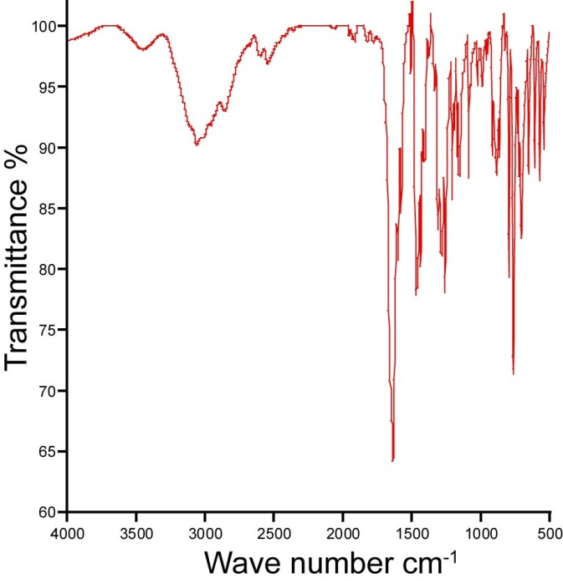
Figure S16. FT-IR spectra of 1-Hydroxy-naphthalene-2-carboxylic acid methylester II (KBr pellet).
Figure S17. FT-IR spectra of tripodal ester III (KBr pellet).

Figure S18. FT-IR spectra of [LNa₂•6H₂O] (KBr pellet).

Figure S19. FT-IR spectra of [LH₃•Cl•3H₂O] (KBr pellet).

Figure S20. FT-IR spectra of [LH₃•Br•2H₂O] (KBr pellet).

Figure S21. FT-IR spectra of [LH₃•NO₃•2H₂O] (KBr pellet).

Figure S22. FT-IR spectra of [LH₃•ClO₄•MeOH] (KBr pellet).

