Supporting information with:
A functional trait approach to identifying life history patterns in stochastic environments
Isabel M. Smallegange^{1,*} and Matty P. Berg^{2,3}

¹ Institute for Biodiversity and Ecosystem Dynamics (IBED), University of Amsterdam, P.O. Box 94240, 1090 GE Amsterdam, The Netherlands
* Corresponding author: i.smallegange@uva.nl

² Department of Ecological Science, Section of Animal Ecology, Vrije Universiteit, Amsterdam, De Boelelaan 1085, 1081 HV Amsterdam, The Netherlands
³ Groningen Institute for Evolutionary Life Sciences, Community and Conservation Ecology Group, Rijksuniversiteit Groningen, Nijenborgh 7, 9747 AG Groningen, The Netherlands;
Email: m.p.berg@vu.nl
Model performance test for O. gammarellus
Methods
We assessed the performance of our model by visually examining to what extend the DEB-IPM is able to reproduce key characteristics of O. gammarellus populations observed in the field. To this end, we used eqn 1 to calculate the population growth rate (λ), lifetime reproductive success (R₀), generation time (T), cohort generation time (T_{c}), and mean body size of juveniles and adults across a range of constant values of expected feeding level: 0.4 ≤ E(Y) ≤ 1 (in increments of 0.01). For each constant feeding level, we discretised the DEB-IPM (Eqn 1) and divided the length domain Ω into 200 very small-width discrete bins, defined as ‘mesh points’ (a higher number of bins did not produce different results). The result is a matrix that maps a vector of 200 size classes from time t to t + 1. The dominant eigenvalue of this matrix equals λ. R₀ was then calculated as the dominant eigenvalue of the matrix $F=V(I-G∙S)^{-1}$, where I is the identity matrix and V = DR, where D is a matrix that approximates the parent-offspring association kernel and R is a matrix that approximates the reproduction kernel (Caswell 2001). G and S are, respectively, the matrix that approximates the growth function and the survival function. Generation time T was approximated as T = log(R₀)/log(λ), which represents the time it takes a population to increase by a factor R₀ (Caswell 2001). Cohort generation time T_{c} was calculated as the mean age of offspring production in a cohort of eggs (Caswell 2009):

$T_{c}=diag{(FNe_{Y})}^{-1} FNUNe_{Y}$, eqn 1

where the vector e_{Y} is a vector with 1 in the first entry (for eggs) and zeros in the other entries and the matrix N is calculated as N = (I – U)⁻¹, where I is the identity matrix and $U=G∙S$.
To assess overall model performance, we compared predicted T, T_{c}, mean body length of juveniles and adults, and overall population growth rate against our field observations. We compared predicted T and T_{c} against the observed value of T_{c} = 8.5 months (T_{c} is defined as the mean age at which adult reproduce and is calculated, very roughly, by taking the mean of the minimum and maximum adult age: (6 + 11)/2 = 8.5 months [Dias and Sprung 2003]). Note that we also compared predicted generation time T against observed T_{c} as no observations on T exist. However, these two measures are often similar (Caswell 2001). Observed body lengths of juveniles and adults were averaged per year across censuses taken between 2015-2017. The observed, monthly population growths of 2017 were used to assess model performance in terms of capturing observed population dynamics over a year. Predicted population growth rates were obtained by used eqn 1 to project a small, starting population forward over an initial period of ten years, after which we plotted the results of year eleven, using the equation$p\left(t+1\right)=M(t)∙p\left(t\right)$. In this equation, the time step equals one month, and $M(t)$ is the discretised DEB-IPM at month t, where we assumed that in the autumn and winter months between October and February, $E(Y)=0.4$ (as then there is no reproduction: see Results Fig. S1A), in spring (March – June), $E(Y)$ is of intermediate value at $E(Y)=0.8$, and in summer, $E(Y)$ is maximal at $E(Y)=1$. All other parameter values are as in Table 1 in the main text. We used the resulting time series of population vectors to calculate population growth per month as ${\sum{p\left(t+1\right)}}/{\sum{p\left(t\right)}}$, and compared the last year of the predicted time series against observations.

Results
Unsurprisingly, both population growth rate λ and lifetime reproductive success R₀ increased with increasing feeding level, whereas both generation time T and cohort generation time T_{c} decreased with increasing feeding level (Fig. S1A-C). Predicted T and T_{c} were similar across all feeding levels, and were very close to the observed generation time at feeding levels of E(Y) > 0.75 (Fig. S1C). Observed mean body lengths of juveniles and adults were very similar across sampling years (Table S1). Taking the 2017 data as representative for all sampling years, shows that the predicted juvenile body length was close to the observed distribution of juvenile body length (Fig. S1D: black solid line [predicted] and shaded area [observed]). The predicted mean body length of adults was mostly within one standard deviation of the observed mean (Fig, S1D: black dashed line [predicted] and shaded area [observed]). Predicted mean body lengths of juveniles first decreased and then increased with increasing feeding level, whereas those of adults slightly increased over the full range of feeding levels (Fig. S1D: black lines). Finally, the observed population growth rates showed the two reproduction peaks in June and August, which was captured by our model predictions (Fig. S1E: solid line [prediction] and open bars [observed]). Our model predictions also match the observed population decline in the autumn and winter months (as population growth rate is lower than unity), but did not predict the very low population growth rate in between reproduction peaks (Fig. S1E).

Model performance check
We assessed the performance of the model by visually comparing predicted and observed key characteristics of O. gammarellus demography. Predicted (cohort) generation time overlapped with the observed generation time at higher feeding levels, and predictions of the mean body lengths of juveniles and adults were for the most part within one standard deviation of the observed mean body lengths. What is more, our simulation of O. gammarellus population dynamics in the field captured the observed two summer reproduction peaks, as well as the observed population declines in autumn and winter. The one aspect of O. gammarellus population dynamics that the model did not capture well, was the drop in population growth immediately following each reproduction peak. This is likely because high population growth due to a reproduction peak can be followed by a steep decline in growth of a juvenile-dominated population if juvenile mortality is high (which it is for many species [Kooijman 2000]). Mortality in our model is constant for all sizes, which could explain why the model did not predict the strong decline in population growth after each reproduction peak. It should be noted that we have only one year of population structure data (2017). However, given that we only found one distinct mismatch between prediction and observation, we are confident to use the model.

Table S1. Average body length (mm), standard deviation (SD) and total number (n) of juveniles and adults measured on field-collected individuals in 2015, 2016, and 2017.
 | 2015 | 2016 | 2017
Juveniles
Average | 5.26 | 5.19 | 5.07
SD | 1.43 | 1.08 | 1.14
n | 305 | 259 | 734
Adults
Average | 10.44 | 10.32 | 9.68
SD | 1.41 | 1.70 | 1.74
n | 548 | 1241 | 1267

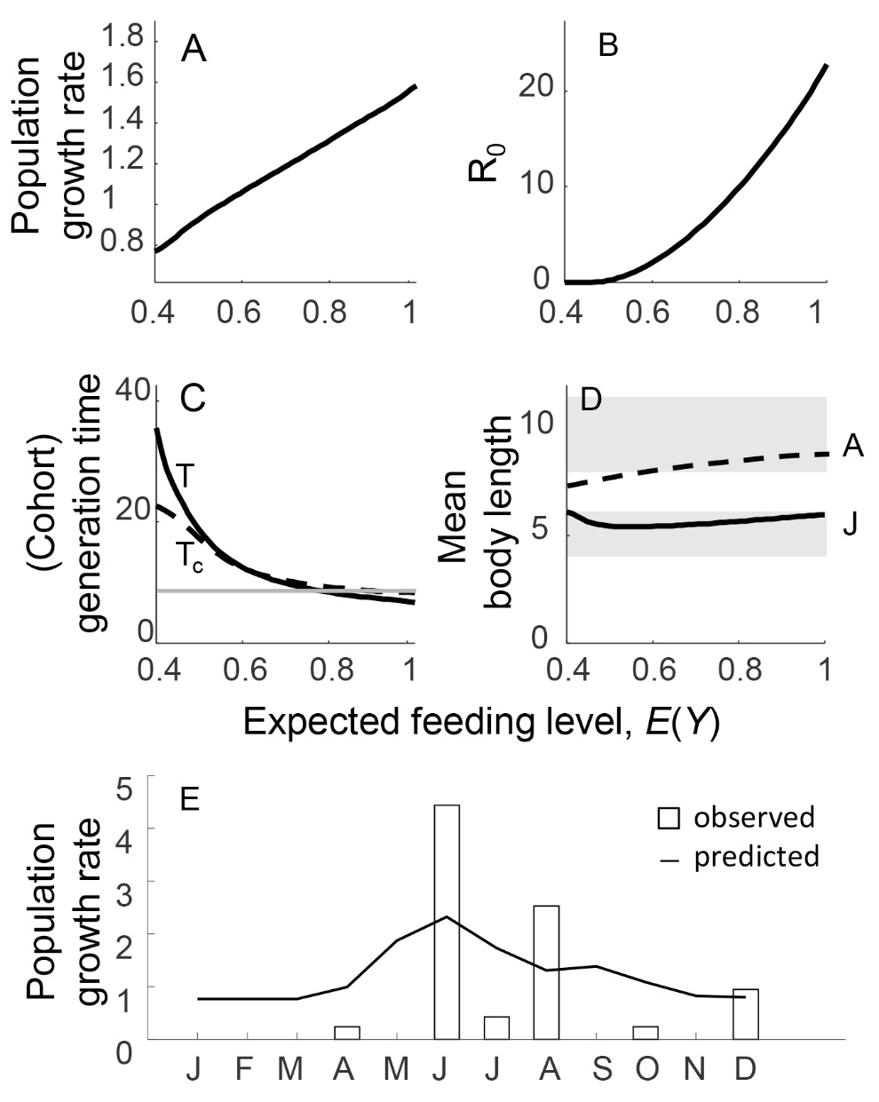
Figure S1. Model performance. Relationship between expected feeding level E(Y) and (A) population growth rate λ, (B) mean lifetime reproductive success R₀, (C) generation time T (solid line) and cohort generation time T_{c} (dashed line), and (D) predicted (black lines) and observed (grey lines) mean body length of juveniles (solid lines) and adults (dashed lines). Shown in (E) are observed (bars) and predicted (line) population growth rates (month⁻¹) . The grey horizontal line in panel (C) is the estimated T_{c} = 8.5 months (see text). Grey shaded areas in (D) denote a 1 standard deviation (SD) band around the observed 2017 mean body length of juveniles (bottom area: ${\overline{L}}_{juveniles}$ = 5.07 mm ± 1.14 SD) and adults (top area: ${\overline{L}}_{adults}$ = 9.68 mm ± 1.74 SD). See Table 1 in the main text for parameter values.

