Appendix

Table A1: Test matrix. NB: PT/LL= pretensioner + load limiter
Test # | Seat Pan | Seat Belt | Upper Anchorage | Seated Posture | Buckle Length
S110460 | Flat | 3-point | Middle | Upright | Normal
S110461 | Flat | 3-point | High and wide | Upright | Normal
S110462 | Flat | 3-point | Low and wide | Upright | Normal
S110463 | Flat | 3-point | High and inboard | Upright | Normal
S110464 | Flat | 3-point | Low and inboard | Upright | Normal
S110465 | Flat | PT/LL | Middle | Upright | Normal
S110466 | Flat | PT/LL | Upper inboard | Upright | Normal
S110473 | Anti-submarining | 3-point | Middle | Upright | Normal
S110475 | Anti-submarining | 3-point | Upper inboard | Upright | Normal
S110477 | Anti-submarining | PT/LL | Middle | Upright | Normal
S110480 | Anti-submarining | PT/LL | Upper inboard | Upright | Normal
S110469 | Flat | 3-point | Middle | Slouched | Normal
S110468 | Flat | PT/LL | Middle | Slouched | Normal
S110470 | Flat | 3-point | Upper inboard | Slouched | Normal
S110467 | Flat | PT/LL | Upper inboard | Slouched | Normal
S110474 | Anti-submarining | 3-point | Middle | Slouched | Normal
S110479 | Anti-submarining | PT/LL | Middle | Slouched | Normal
S110476 | Anti-submarining | 3-point | Upper inboard | Slouched | Normal
S110481 | Anti-submarining | PT/LL | Upper inboard | Slouched | Normal
S110472 | Anti-submarining | 3-point | Middle | Upright | Long
S110477 | Anti-submarining | PT/LL | Middle | Upright | Long

Table A2: Summary of Results. Values above the IARV are highlighted in bold for measures of chest deflection (IARV = 41mm), chest acceleration (IARV = 73g), as well as cases where submarining occurred.
Test # | Head Resultant [3ms] | Nij | Head excursion [mm] | Chest deflection [mm] | Chest acceleration [g] | Viscous Criterion (m/s) | % Risk AIS 3+ chest injury for 65 year old | Femur excursion [mm] | Pelvic Rotation [deg] | Lap belt load [kN] | Sash belt load [kN] | Submarined [yes/no]
S110460 | 80.0 | 0.46 | 441 | 47.7 | 76.8 | 0.7 | 63% | 181 | 7.0 | 6.9 | 6.7 | No
S110461 | 77.0 | 0.44 | 462 | 45.8 | 71.9 | 0.7 | 59% | 172 | 5.6 | 6.5 | 6.8 | No
S110462 | 74.7 | 0.43 | 506 | 54.4 | 74.9 | 0.7 | 75% | 163 | 6.5 | 6.3 | 5.7 | No
S110463 | 76.0 | 0.43 | 443 | 38.6 | 82.8 | 0.5 | 42% | 237 | 5.9 | 6.5 | 6.7 | Yes
S110464 | 78.2 | 0.49 | 417 | 42.6 | 78.9 | 0.5 | 52% | 168 | 7.1 | 6.6 | 6.5 | No
S110465 | 55.2 | 0.23 | 329 | 40.3 | 47.9 | 0.5 | 46% | 82 | 8.2 | 6.1 | 6.0 | No
S110466 | 64.9 | 0.17 | 307 | 33.5 | 39.3 | 0.3 | 30% | 141 | 8.2 | 5.4 | 5.8 | Yes
S110473 | 68.7 | 0.42 | 422 | 38.5 | 56.7 | 0.3 | 42% | 168 | 9.3 | 6.4 | 6.3 | No
S110475 | 69.2 | 0.41 | 409 | 31.4 | 59.5 | 0.3 | 25% | 175 | 8.6 | 6.6 | 6.5 | No
S110477 | 56.4 | 0.20 | 324 | 39.4 | 42.6 | 0.4 | 44% | 83 | 15.7 | 5.5 | 6.6 | No
S110480 | 58.1 | 0.16 | 313 | 26.2 | 39.7 | 0.2 | 15% | 87 | 15.4 | 6.4 | 5.9 | No
S110469 | 305.5 | 0.39 | 402 | 31.3 | 38.5 | 0.3 | 25% | 324 | 13.1 | 7.0 | 5.9 | Yes
S110468 | 190.2 | 0.41 | 268 | 31.3 | 42.1 | 0.4 | 25% | 228 | 13.8 | 7.3 | 5.9 | Yes
S110470 | 188.9 | 0.38 | 394 | 24.0 | 46.5 | 0.3 | 12% | 321 | 12.2 | 8.1 | 6.5 | Yes
S110467 | 140.8 | 0.28 | 281 | 26.6 | 42.9 | 0.2 | 16% | 236 | 9.8 | 7.0 | 6.1 | Yes
S110474 | 94.9 | 0.37 | 413 | 37.5 | 55.7 | 0.3 | 39% | 262 | 7.0 | 6.1 | 5.8 | Yes
S110479 | 68.4 | 0.25 | 303 | 34.7 | 46.0 | 0.3 | 32% | 204 | 11.3 | 5.4 | 5.3 | Yes
S110476 | 165.5 | 0.32 | 398 | 23.3 | 48.9 | 0.2 | 11% | 278 | 7.1 | 7.1 | 5.8 | Yes
S110481 | 161.8 | 0.33 | 284 | 30.8 | 41.7 | 0.3 | 24% | 216 | 8.9 | 5.2 | 6.1 | Yes
S110472 | 70.6 | 0.42 | 424 | 32.6 | 60.2 | 0.3 | 28% | 196 | 8.1 | 5.7 | 6.0 | Yes
S110477 | 56.4 | 0.20 | 324 | 39.4 | 42.6 | 0.4 | 44% | 83 | 15.7 | 5.5 | 6.6 | No

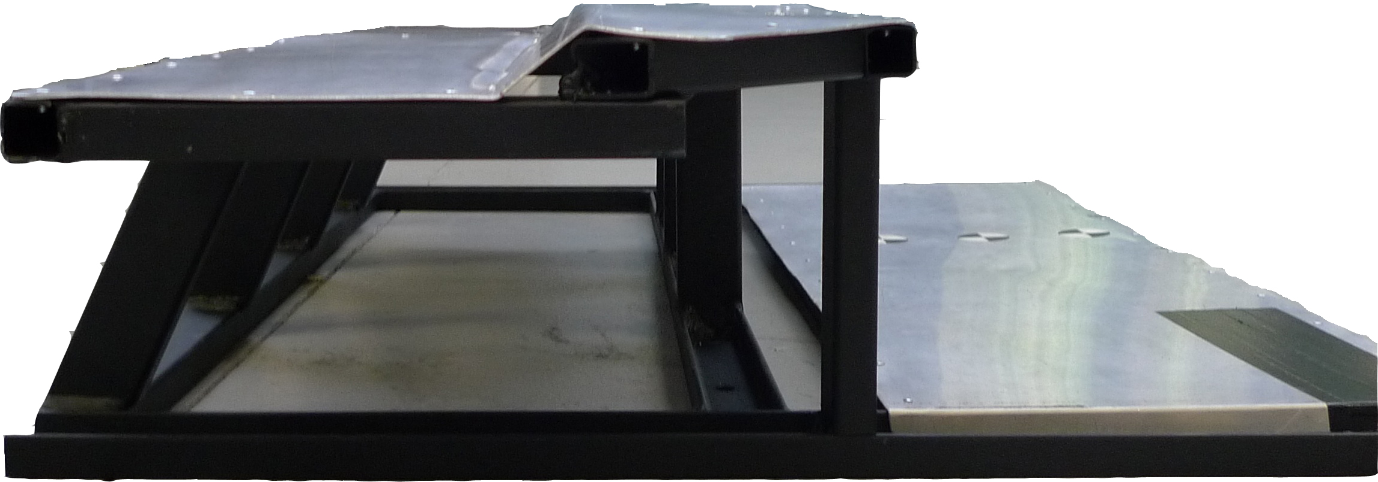
Figure A1: Side profile of the flat seat pan.

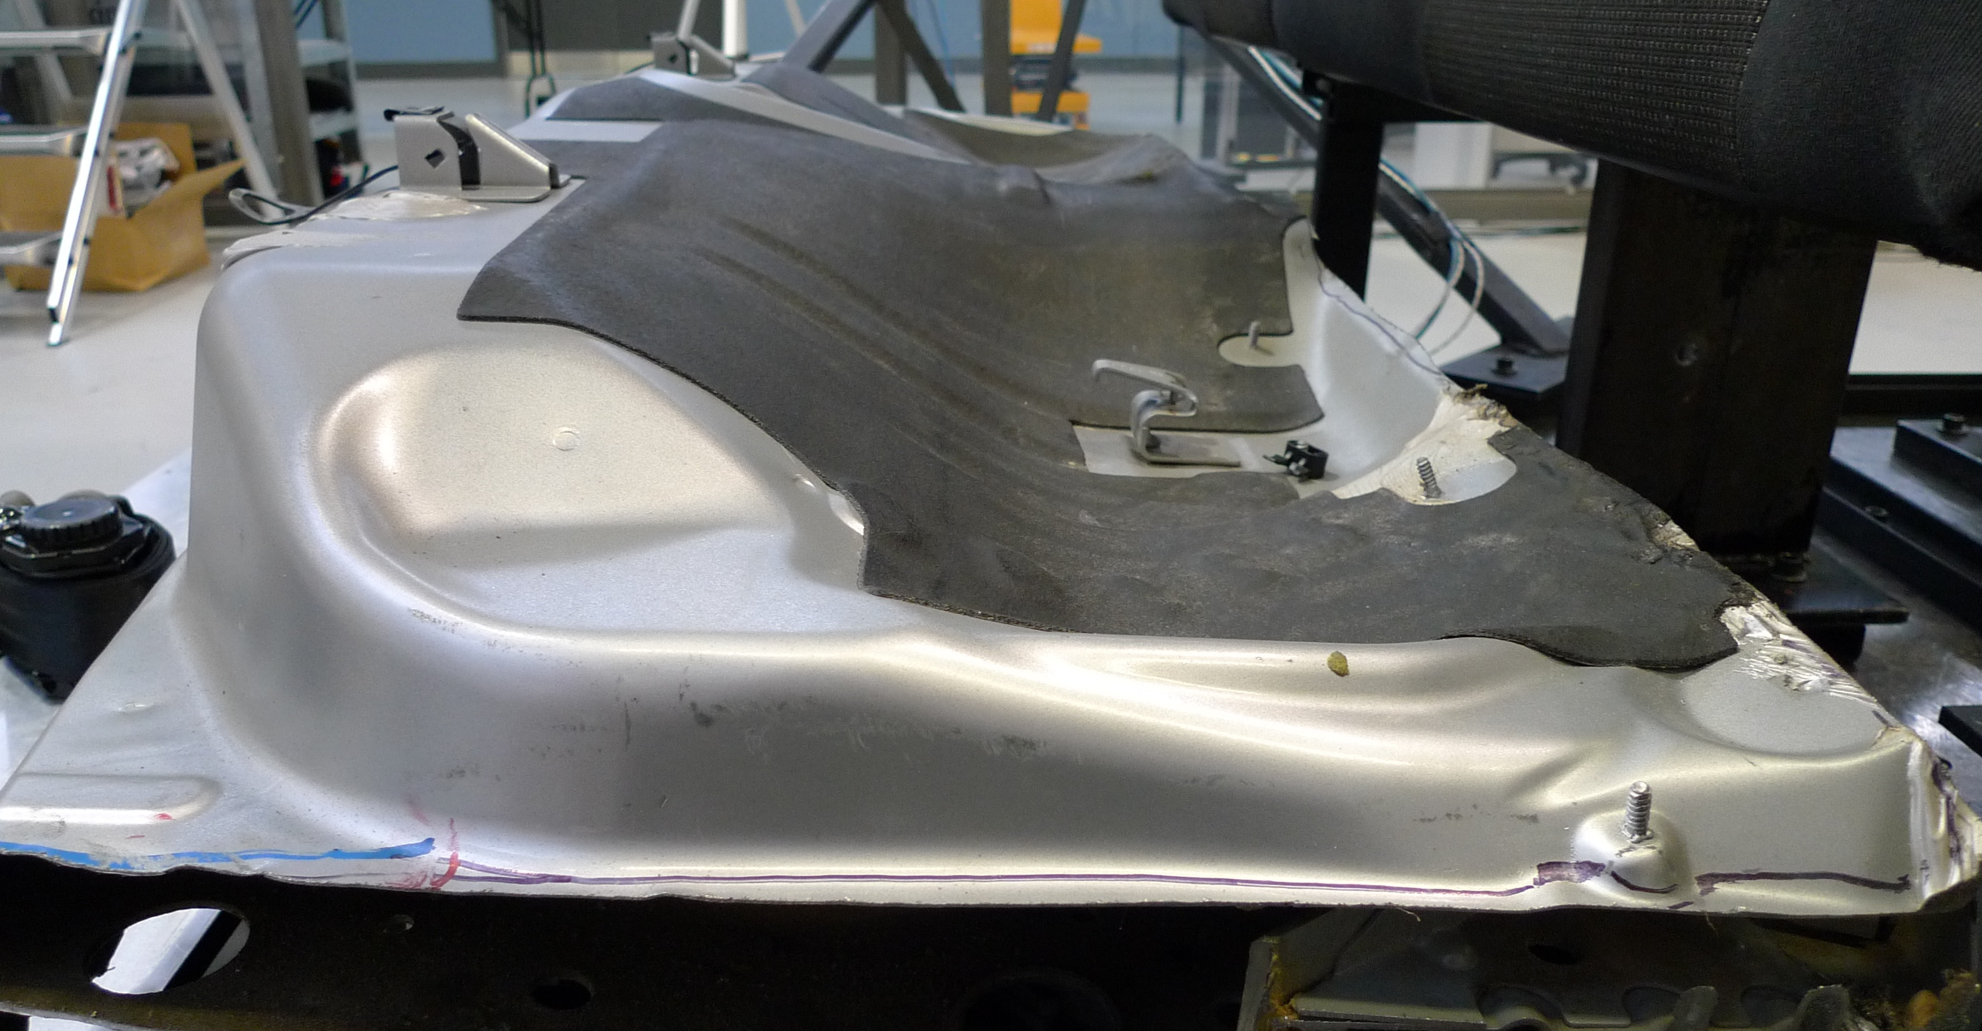
Figure A2: Side profile of the antisubmarining seat pan.

Figure A3: Chest deflection for different upper anchorage locations.

A  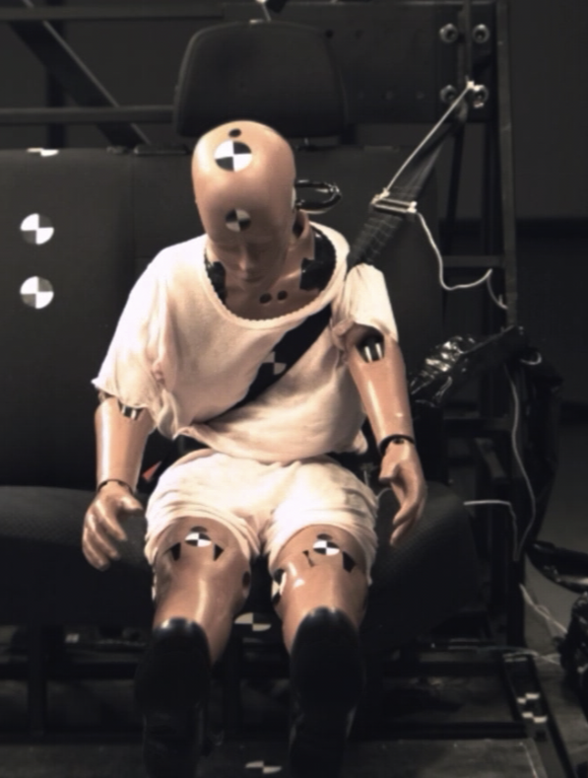 | B  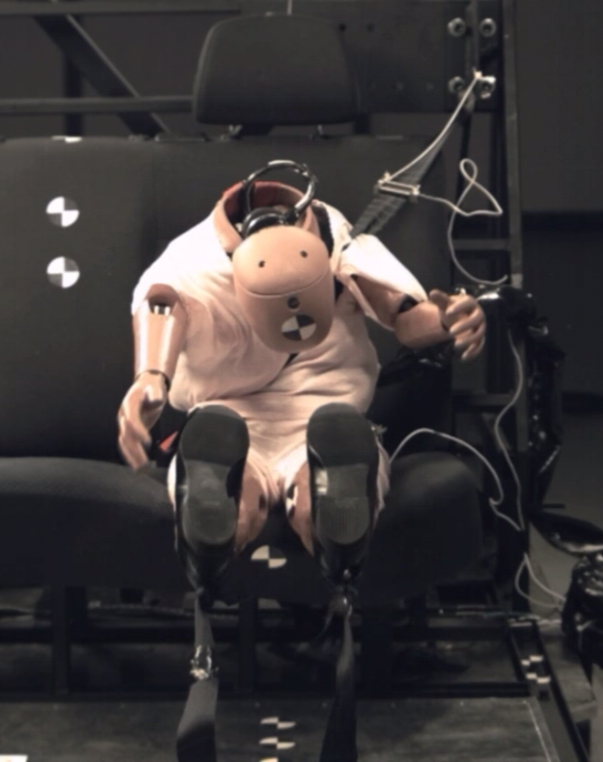
Figure A4: Stills from test S110462 (‘low wide’ anchorage position): (A) at the point at which the belt penetrated the gap between the arm and the shoulder (75ms), and (B) showing the torso rotation (98ms).

A  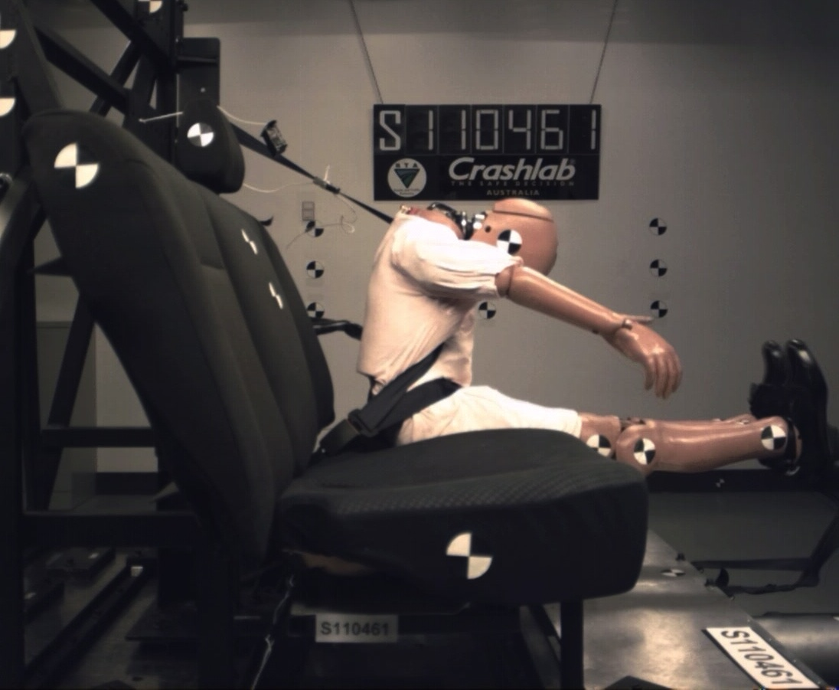 | B  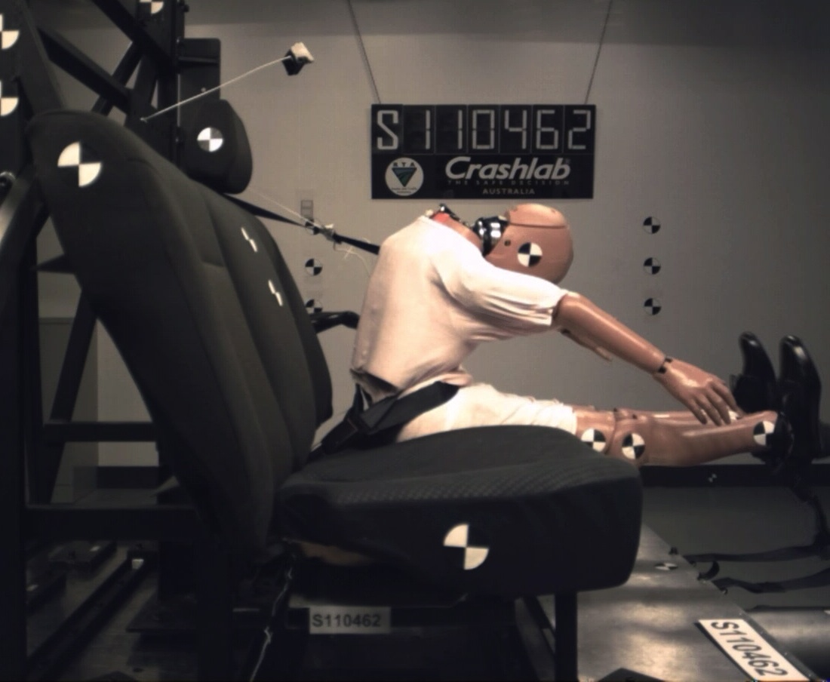
C
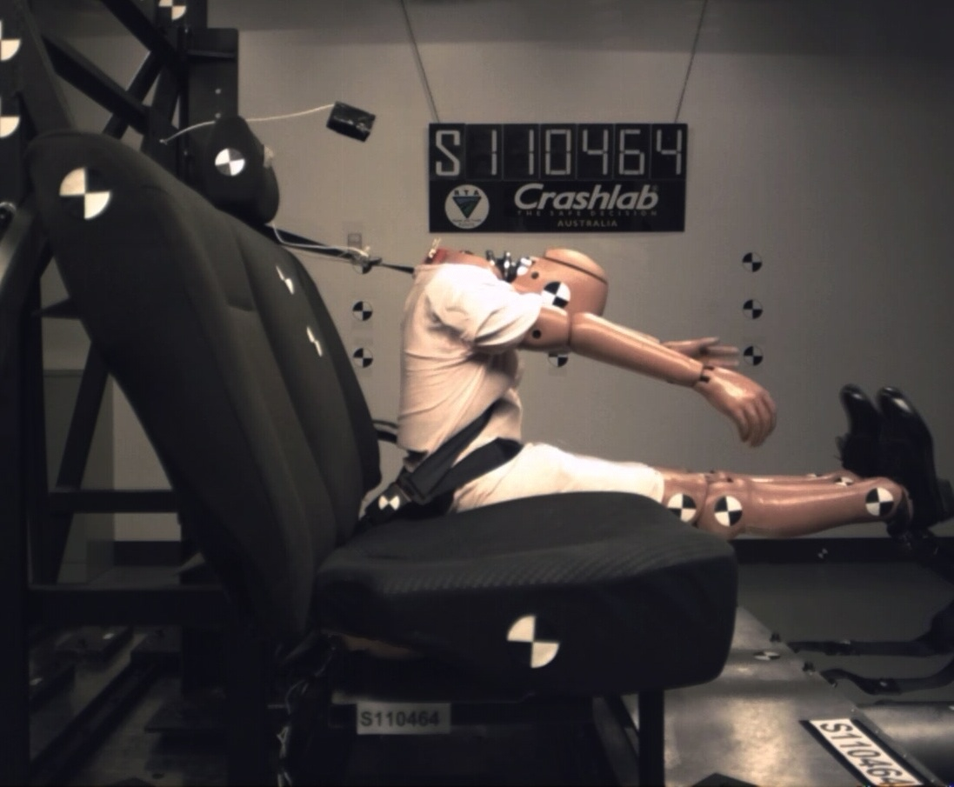
Figure A5: Stills at the point of maximum femur excursion for tests on the flat seat pan with the 3-point seat belt and the dummy in an upright seated posture: (A) Upper anchorage in the high and wide position, (B) Upper anchorage in the low and wide position, and (C) Upper anchorage in the low and inboard position.

A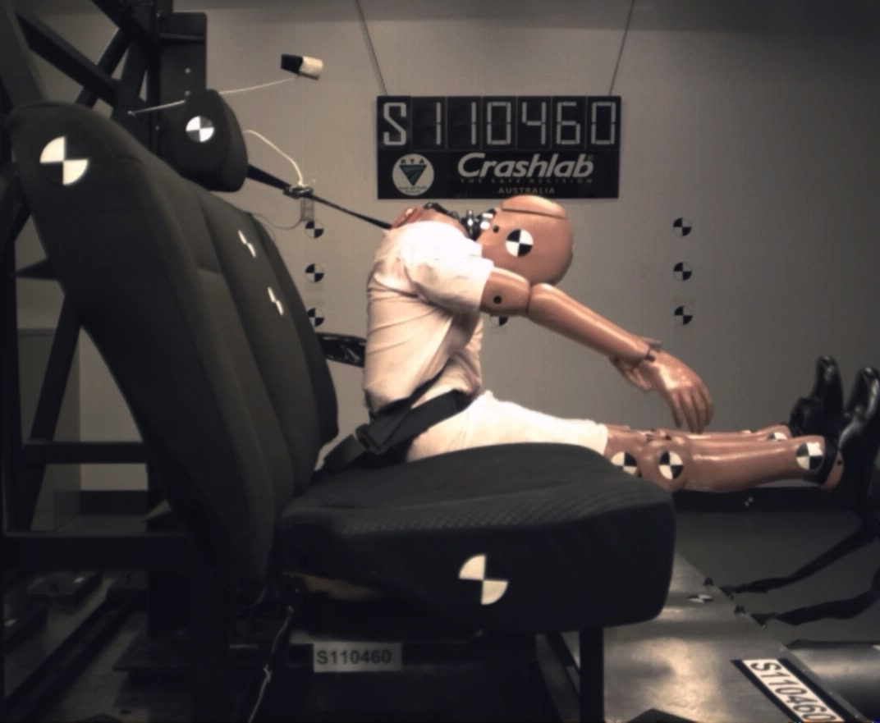 | B  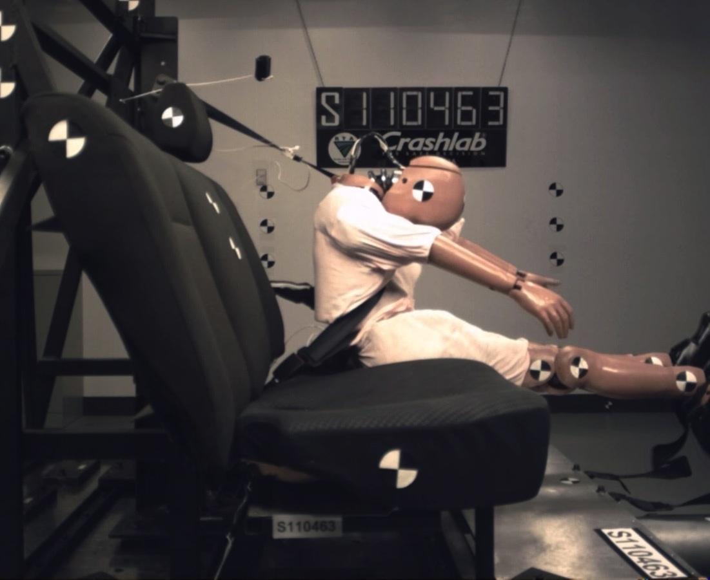
C  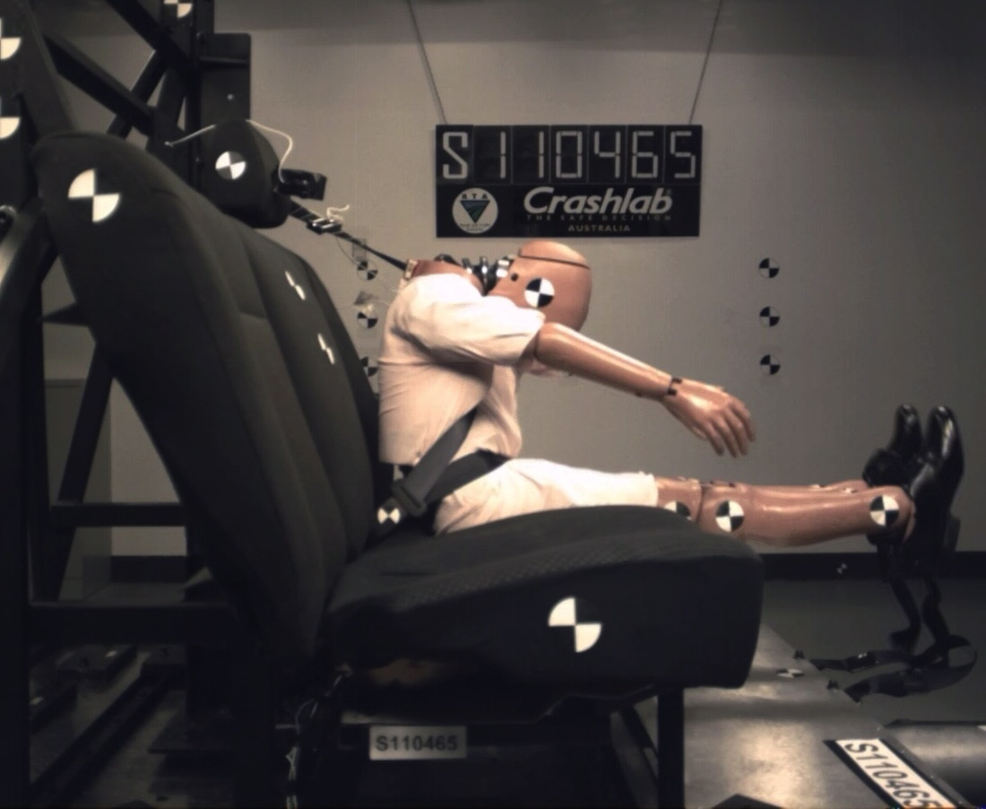 | D  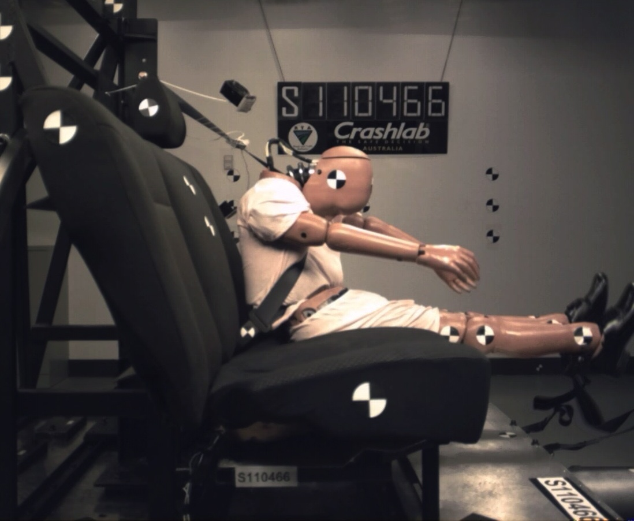
Figure A6: Stills at the point of maximum femur excursion for tests on the flat seat pan with the dummy in an upright seated posture: (A) Upper anchorage in the middle position with the 3-point seat belt, (B) Upper anchorage in the high inboard position with the 3-point seat belt, (C) Upper anchorage in the middle position with the PT/LL seat belt, and (D) Upper anchorage in the high inboard position with the PT/LL seat belt.

A  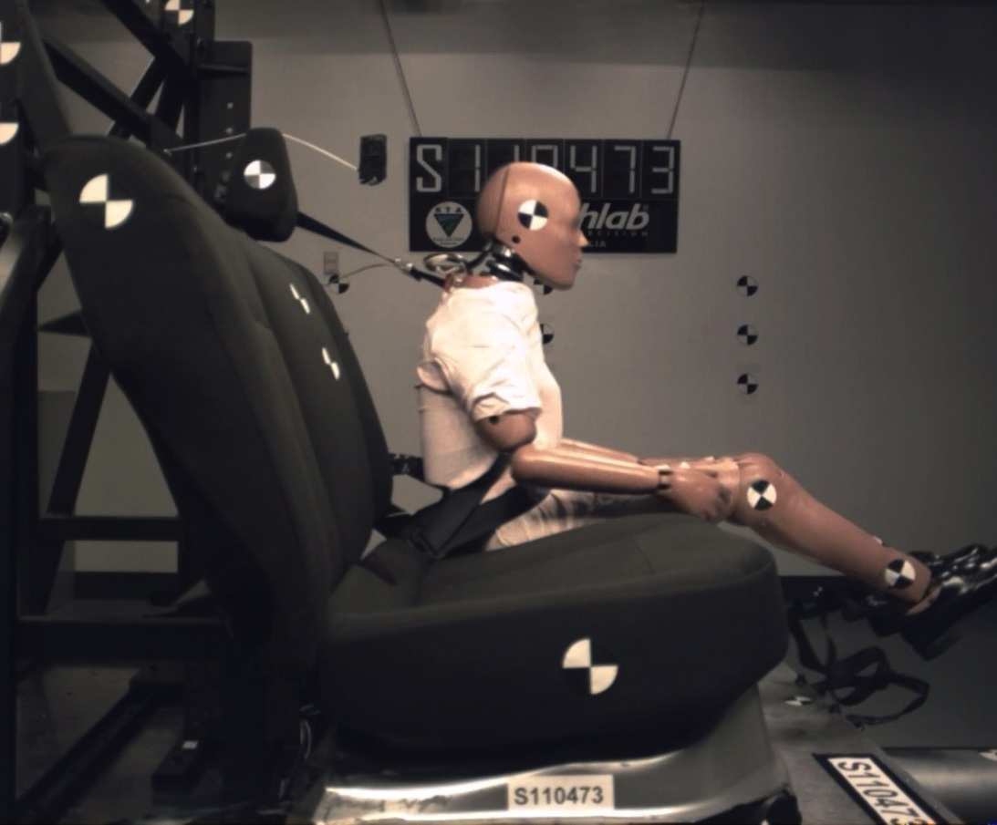 | B  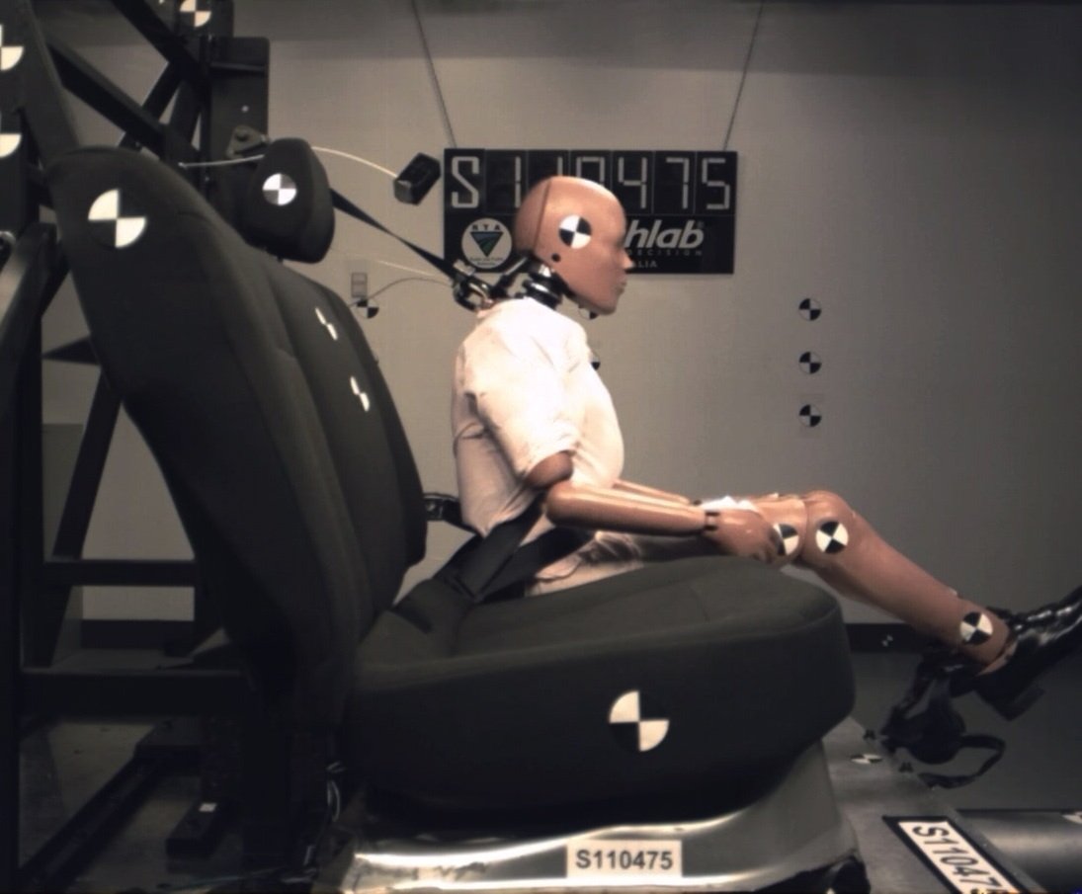
C  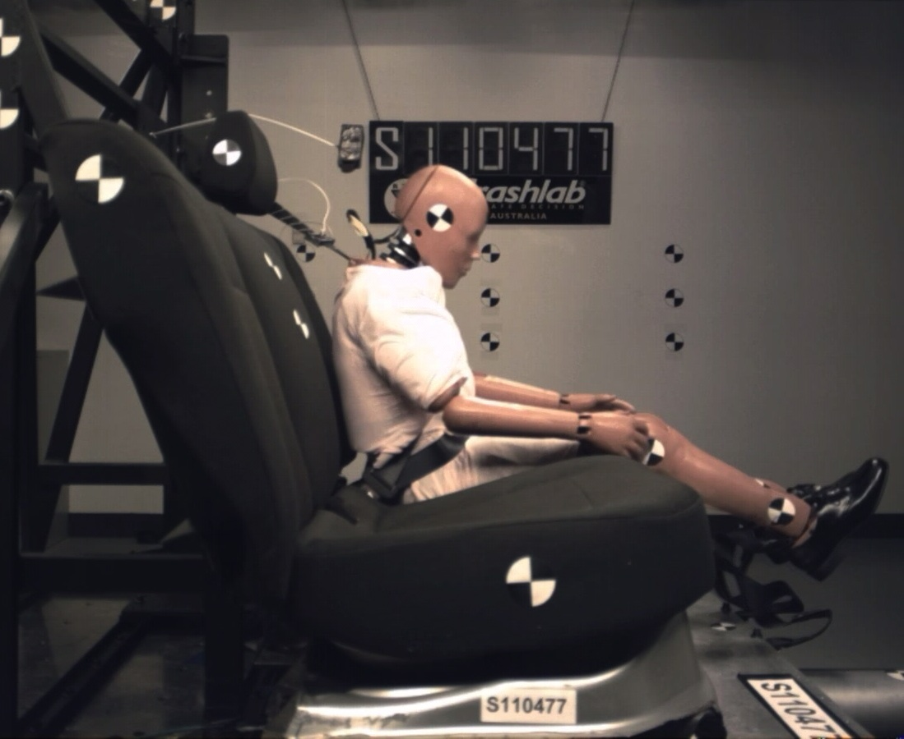 | D
Figure A7: Stills at the point of maximum femur excursion for tests on the anti-submarining seat pan with the dummy in an upright seated posture: (A) Upper anchorage in the middle position with the 3-point seat belt, (B) Upper anchorage in the high inboard position with the 3-point seat belt, (C) Upper anchorage in the middle position with the PT/LL seat belt, and (D) Upper anchorage in the high inboard position with the PT/LL seat belt.

A  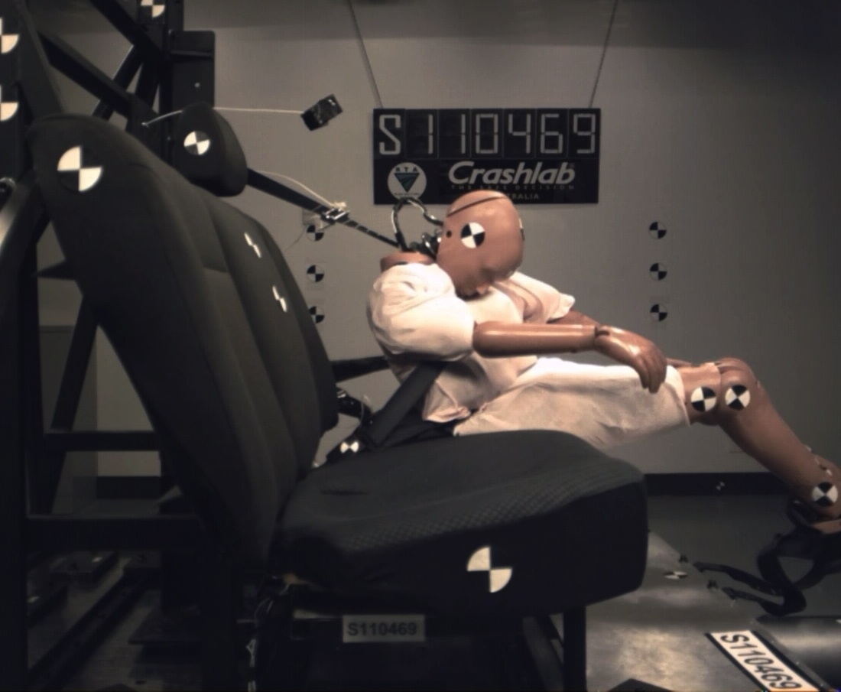 | B  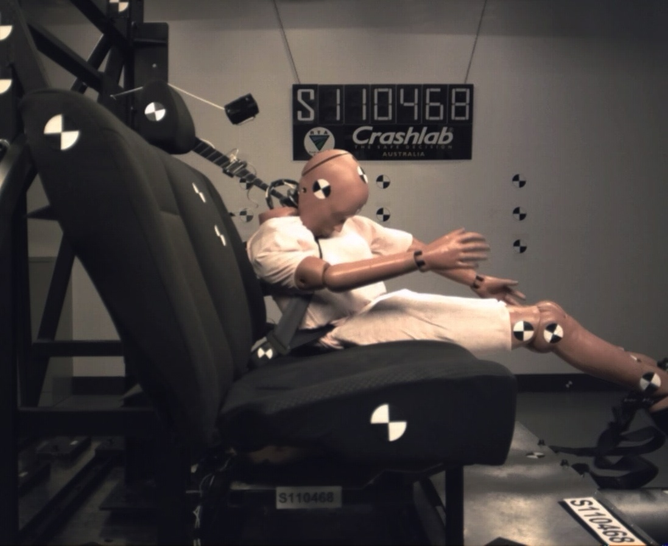
C  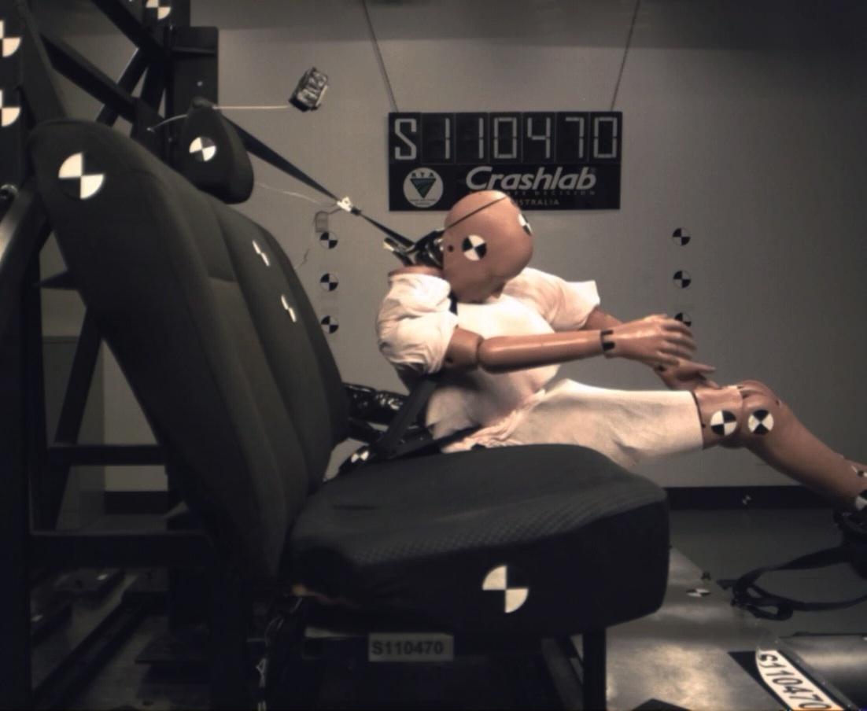 | D  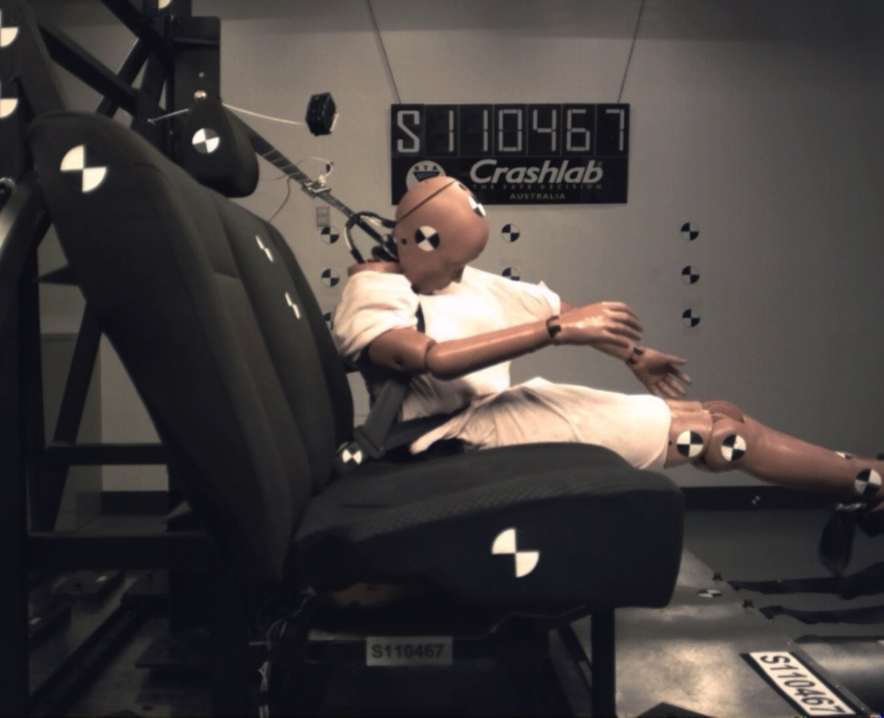
Figure A8: Stills at the point of maximum femur excursion for tests on the flat seat pan with the dummy in a slouched seated posture: (A) Upper anchorage in the middle position with the 3-point seat belt, (B) Upper anchorage in the high inboard position with the 3-point seat belt, (C) Upper anchorage in the middle position with the PT/LL seat belt, and (D) Upper anchorage in the high inboard position with the PT/LL seat belt.

A  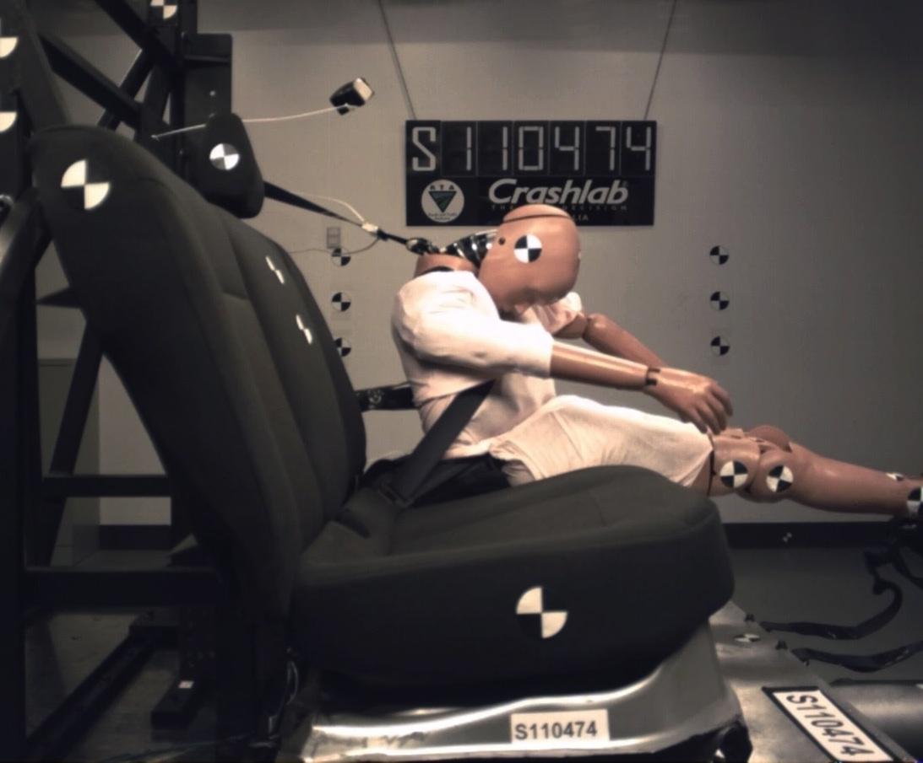 | B  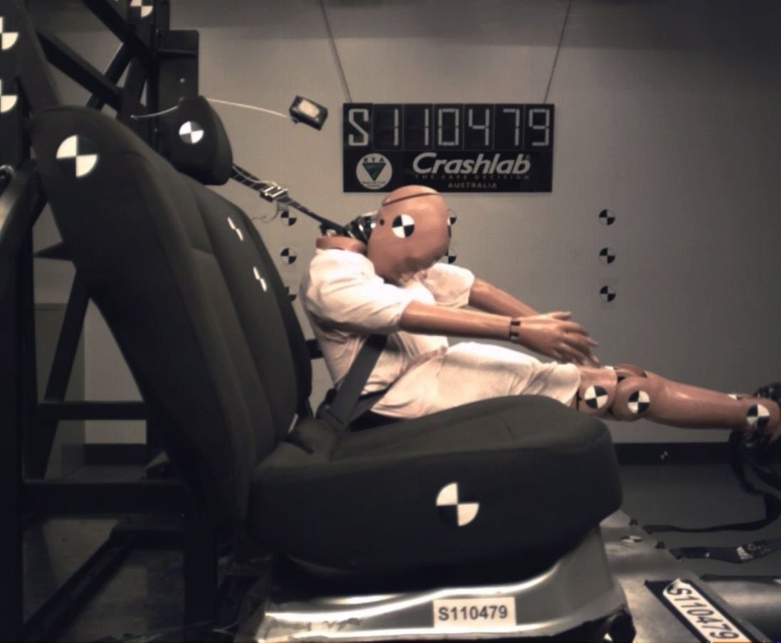
C  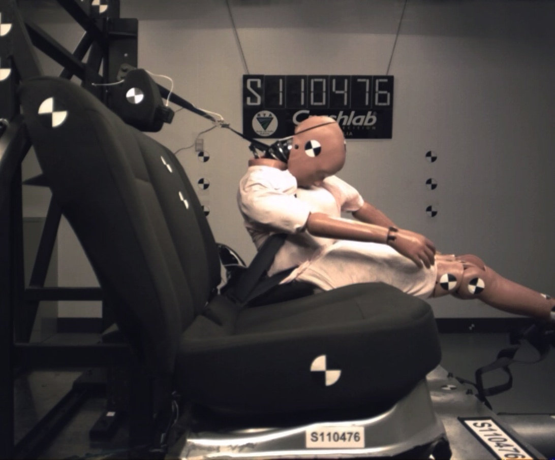 | D  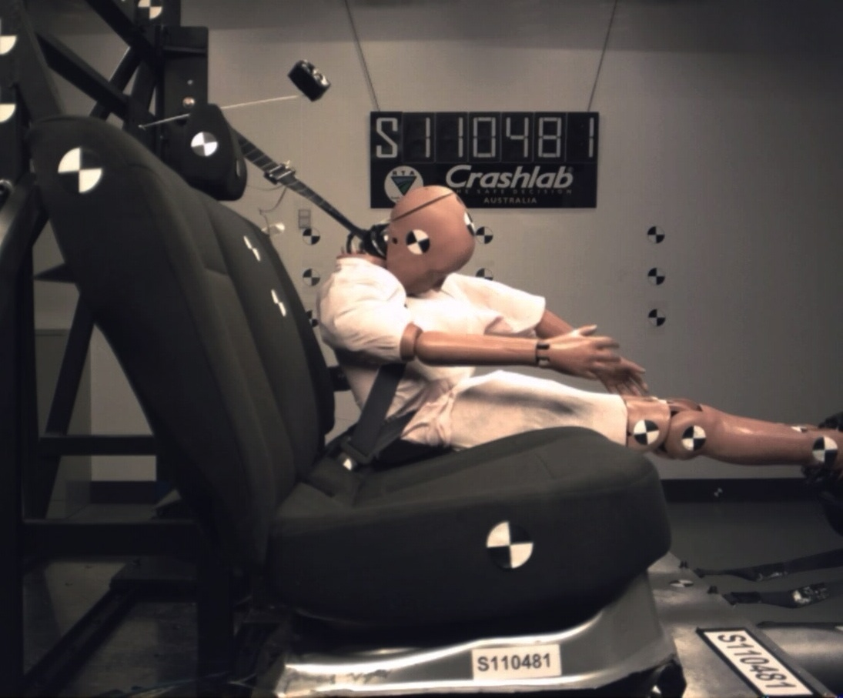
Figure A9: Stills at the point of maximum femur excursion for tests on the anti-submarining seat pan with the dummy in a slouched seated posture: (A) Upper anchorage in the middle position with the 3-point seat belt, (B) Upper anchorage in the high inboard position with the 3-point seat belt, (C) Upper anchorage in the middle position with the PT/LL seat belt, and (D) Upper anchorage in the high inboard position with the PT/LL seat belt.

A  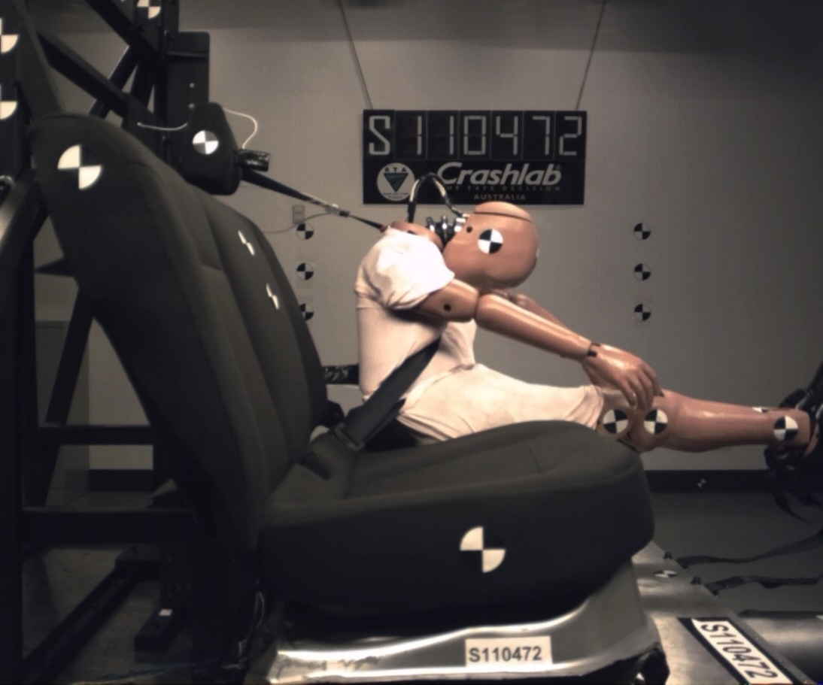 | B
Figure A10: Stills at the point of maximum femur excursion for tests with the longer buckle webbing length on the anti-submarining seat pan, with the upper anchorage in the middle position, and the dummy in an upright seated posture: (A) With the 3-point seat belt, and (B) With the PT/LL seat belt.

