Case study of an Adolescent girl
Dr. Tinni Dutta
Lecturer, Department of Psychology
Asutosh College, Kolkata, India.

A 16 year old School-going child was referred for career counseling associated with deficits in intellectual function confirmed by clinical assessment and intelligence testing. She has difficulties in social emotional reciprocity and restricted repetitive patterns of behaviours and activities. She has expressed persistent anger and irritability between out bursts.

Test Administered : Differential Aptitude test (Verbal) reasoning and (numerical ability)

:Bender Gestalts test (BG)
: Draw A Person test (DAP)
:Rorschach Ink Blot (RIBT)
:Thematic Apperception test (TAT)

Test Behaviour : She was restless, agitated and apprehensive during the test session.

T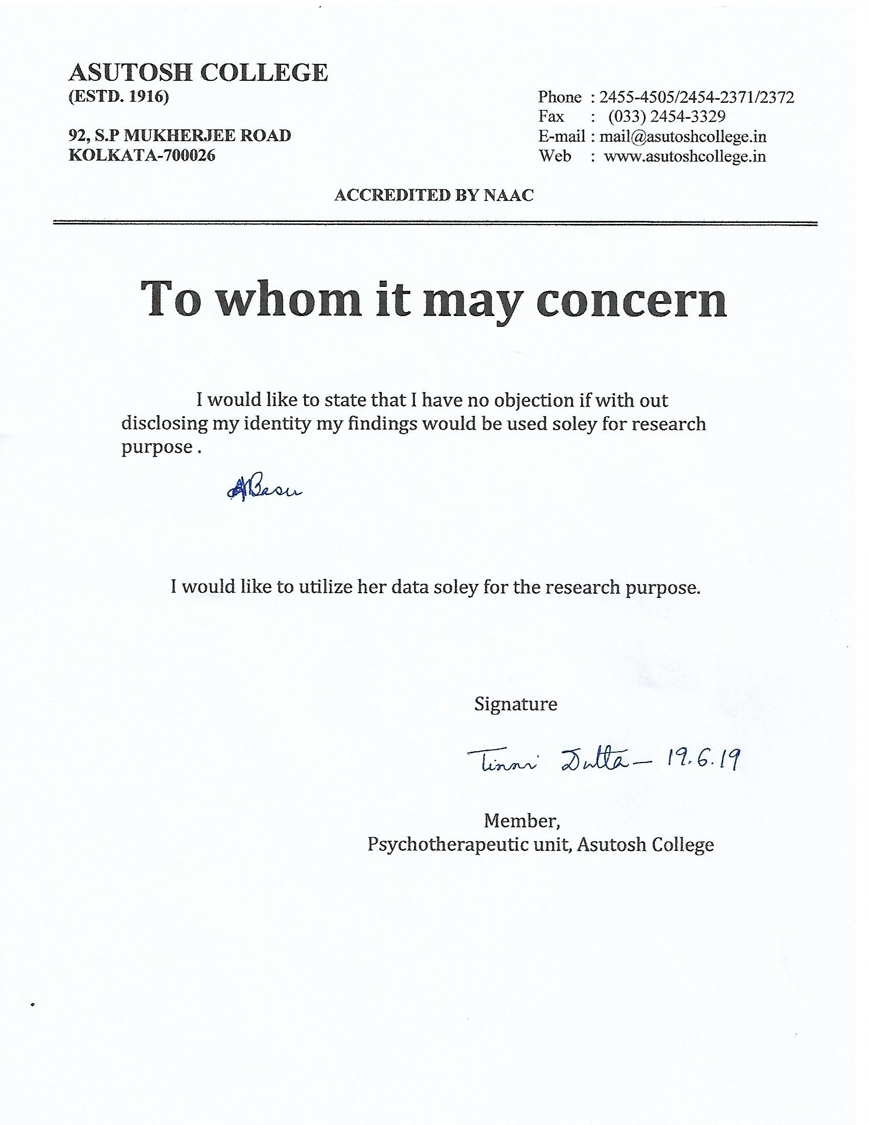
Thus the participant gave the informed consent and it was approved by the ethical committee of the university.
Findings:

In verbal reasoning she has scored 25th percentile which indicates moderately high level of verbal fluency in accordance with her intellectual functioning. .
She would be able to function with manipulation of concept and words to some extent.

On the other hand the percentile in numerical ability is also corroborated with her intellectual functioning . She would not be able to deal with symbols and number , even of day to day life .Scholastic Aptitude (10%) is found to be low but due to her strong effort she has managed well with her intellectual potential.

BG Score of 69 put her in suspect category and is indicative of her slightly impaired visual, motor gestalt functioning . Qualitative analysis reveals unresolved need for maintaining interpersonal relationship, inadequacy, uncertainty and conflict with authority figure.

Analysis of DAP shows fantasy activity rather than reality satisfactions , maternal dependency , emotional out burst with a regressive trend.

RIBT :

There is piled up of instinctual needs without showing proper outlet. She has expressed anxieties stems from inner impulsive desires and conflicts. Psychogram is indicative of introversive balance with a regressive trend .

TAT:

In most of the stories she was unable to form proper emotional bond , even difficulties in identifying with parental figures. She has expressed emotional out burst resulting from anxieties and insecurities.

Impression:

Considering all aspects of case – history, behaviour and findings , it appears she has deficits in intellectual functioning . But due to her strong effort she was able to achieve high despite her lower intellectual potential . But her emotional disturbance affect her intellectual functioning which is to be taken care of .

It was recommended from career counseling she could pursue literary activities with constant supervision.

Therapeutic Intervention :

Constant , unprecedented support is needed to grow her intellectual functioning despite difficulties. Supportive therapy and colour therapy are required to strengthen her emotional equilibrium to function effectively in dealing with the environmental challenges.

Colour therapy was introduced to her. She was instructed to draw with colours . Initially she preferred red and green , especially red , which is indicative of warmth impulsive , and to some extent been violent .

In two phases intervention was done. At the first phase she was asked to use green and blue in her drawings to enhance her internal and external sensitivity and ego strength. It was continued for three months ,twice in a month. After three mouths when she was assessed again frequent emotional outburst was reduced , mentally she was feeling better which was evident in Mental Status Examination.

In the second phase she was asked to draw a picture with colours which depicts positive emotions . she has expressed Blue for empathy, Green for compassion, Orange for faith and Red for gratitude.

Colour therapy was continued for three months , the child felt happier and fuller .

Implication :The girl was able to transform her intellectual deficiency through supportive and colour- therapy .

