**Supplementary Material**

**Regioselective synthesis of new 2,5,6-trisubstituted 5,6-dihydro-2H-pyrazolo[3,4-d]thiazoles from 5-dimethylaminoethylene-thaozolidin-4-thiones**

**Table S1. Z- matrix (X, Y, Z, coordinates of minimized structure) of *2,5,6-triphenyl-5,6-dihydro-2H-pyrazolo[3,4-d]thiazole (4a)***

Row Highlight Display Tag Symbol NA NB NC Bond Angle Dihedral X Y Z

1 No Show 1 S -0.9412460 -1.9680420 -1.9894430

2 No Show 2 C 1 1.9510489 -1.9510170 -0.5915630 -1.0448480

3 No Show 3 N 2 1 1.4774331 106.2887063 -0.9697290 0.4335810 -0.6337980

4 No Show 4 C 3 2 1 1.3957678 112.7921606 -21.6913349 0.3353430 -0.0583190 -0.5791250

5 No Show 5 C 4 3 2 1.4159947 116.7870990 14.2263629 0.5728980 -1.3079670 -1.2012090

6 No Show 6 N 4 3 2 1.3496010 131.4596741 -163.4989028 1.4494580 0.4273060 0.0076790

7 No Show 7 N 6 4 3 1.4003381 103.7375092 -179.6845534 2.4307240 -0.5213940 -0.3054220

8 No Show 8 C 5 4 3 1.3753248 106.7167094 -179.0329129 1.9024720 -1.6006380 -1.0060300

9 No Show 9 H 2 1 5 1.0919870 103.4463451 134.1447536 -2.6095320 -0.1857730 -1.8156450

10 No Show 10 C 2 1 5 1.5086344 111.0084326 -107.3601380 -2.7601950 -1.1898500 0.0791010

11 No Show 11 C 3 2 1 1.4252925 120.4348068 156.4391417 -1.3876570 1.7723630 -0.3799130

12 No Show 12 C 10 2 1 1.4042861 121.6077042 71.7360753 -2.1513210 -1.6688950 1.2503430

13 No Show 13 C 12 10 2 1.3965149 120.3653901 179.6134397 -2.9263010 -2.2104890 2.2781250

14 No Show 14 C 13 12 10 1.4012286 120.3104759 0.3690768 -4.3192620 -2.2884030 2.1476230

15 No Show 15 C 14 13 12 1.3977582 119.7046706 0.0873228 -4.9327810 -1.8226640 0.9812570

16 No Show 16 C 15 14 13 1.3999753 119.9306786 -0.2539251 -4.1551120 -1.2767350 -0.0469080

17 No Show 17 C 11 3 2 1.4093732 120.7089325 -177.4531136 -0.4490350 2.7670490 -0.0394410

18 No Show 18 C 17 11 3 1.3966945 119.8832751 178.0930462 -0.8723930 4.0819690 0.1667360

19 No Show 19 C 18 17 11 1.3991939 121.1842029 0.3661625 -2.2210040 4.4357500 0.0491310

20 No Show 20 C 19 18 17 1.3972383 118.7741578 0.3901587 -3.1509170 3.4438740 -0.2729230

21 No Show 21 C 20 19 18 1.3982738 120.8513237 -0.3903461 -2.7457910 2.1221650 -0.4829890

22 No Show 22 C 7 6 4 1.4254650 119.7126239 177.7057420 3.7761040 -0.3119730 0.1165330

23 No Show 23 C 22 7 6 1.4007957 120.1634444 -164.1674762 4.8167060 -1.0559370 -0.4543380

24 No Show 24 C 23 22 7 1.3982926 119.4789365 -178.9614778 6.1285400 -0.8543570 -0.0142480

25 No Show 25 C 24 23 22 1.3991235 120.4789483 -0.6748589 6.4066450 0.0918380 0.9781830

26 No Show 26 C 25 24 23 1.4002309 119.4538650 -0.0288129 5.3589450 0.8392390 1.5298740

27 No Show 27 C 26 25 24 1.3969329 120.7029488 0.5277920 4.0421700 0.6414270 1.1075050

28 No Show 28 H 8 5 4 1.0761396 131.6845722 178.7976709 2.4979360 -2.4498770 -1.2928960

29 No Show 29 H 12 10 2 1.0849694 119.7790001 -0.3163204 -1.0728910 -1.6166080 1.3571770

30 No Show 30 H 13 12 10 1.0860465 119.7118657 -179.7824776 -2.4446330 -2.5746100 3.1808480

31 No Show 31 H 14 13 12 1.0860012 120.0660038 -179.9616835 -4.9181440 -2.7097520 2.9496230

32 No Show 32 H 15 14 13 1.0860325 120.2539047 179.9023860 -6.0115690 -1.8801760 0.8700120

33 No Show 33 H 16 15 14 1.0875230 119.5893811 179.5314769 -4.6374940 -0.9230640 -0.9551650

34 No Show 34 H 17 11 3 1.0807714 119.8744032 -2.5451144 0.5942370 2.5074480 0.0712730

35 No Show 35 H 18 17 11 1.0867645 118.8099305 -179.7391748 -0.1332360 4.8358410 0.4243810

36 No Show 36 H 19 18 17 1.0852813 120.6422265 179.7601149 -2.5408050 5.4594850 0.2150510

37 No Show 37 H 20 19 18 1.0865256 120.2114589 179.1990639 -4.2058000 3.6901040 -0.3573650

38 No Show 38 H 21 20 19 1.0816355 118.5881876 178.2579211 -3.4998170 1.3783520 -0.7023570

39 No Show 39 H 23 22 7 1.0841940 120.8582555 2.5455158 4.6208890 -1.7673590 -1.2487000

40 No Show 40 H 24 23 22 1.0861176 119.3210387 -179.9210464 6.9335690 -1.4316630 -0.4595540

41 No Show 41 H 25 24 23 1.0853102 120.2304639 -179.7321873 7.4269050 0.2480710 1.3136810

42 No Show 42 H 26 25 24 1.0862078 120.0515988 -179.8406769 5.5641650 1.5782220 2.2990530

43 No Show 43 H 27 26 25 1.0818742 121.6188995 179.6256086 3.2207700 1.2062970 1.5278330

Gaussian Interface: Zero-Point Energy = 214.648851 Kcal/Mol

**Table S2. Z- matrix (X, Y, Z, coordinates of minimized structure) of 1,5,6-triphenyl-5,6-dihydro-1H-pyrazolo[3,4-d]thiazole (*5a)***

Row Highlight Display Tag Symbol NA NB NC Bond Angle Dihedral X Y Z

1 No Show 1 S -2.0248610 -0.803702 -2.3865520

2 No Show 2 C 1 2.0096490 -1.8425850 0.3748070 -0.7689670

3 No Show 3 N 2 1 1.4779988 105.4544904 -0.3967440 0.4037990 -0.4637070

4 No Show 4 C 3 2 1 1.4028156 110.8946750 -24.3739403 0.2441010 -0.7375550 -0.9682070

5 No Show 5 C 1 2 3 1.8183910 86.9107141 18.6651628 -0.3766630 -1.4535580 -1.9770690

6 No Show 6 N 3 2 1 2.5560671 132.1507611 -34.7815850 1.4376160 -1.3631980 -0.6789370

7 No Show 7 N 6 4 5 1.4038434 109.5530007 1.7989015 1.6093810 -2.4649110 1.5318740

8 No Show 8 C 7 6 4 1.3503324 105.5844918 -1.5976152 0.4985060 -2.5069190 -2.2984180

9 No Show 9 H 2 3 4 1.0880606 108.8011360 -136.2314372 -2.1487780 1.3615390 -1.1102610

10 No Show 10 C 2 3 4 1.5029978 115.9232066 98.5348442 -2.7388820 -0.1002740 0.3400650

11 No Show 11 C 6 4 1 1.4264057 131.0901676 -168.9483112 2.3975460 -1.1223000 0.3482610

12 No Show 12 C 3 2 1 1.4421087 116.8908683 121.2064601 0.2440160 1.6957370 -0.4632510

13 No Show 13 C 10 2 3 1.4081322 122.7466486 -40.7104658 -2.4083680 -1.1851440 1.1747230

14 No Show 14 C 13 10 2 1.3939930 120.3458208 -179.7494025 -3.2799980 -1.5870600 2.1856340

15 No Show 15 C 14 13 10 1.4037553 120.4286728 0.0904254 -4.4976760 -0.9169630 2.3825080

16 No Show 16 C 15 14 13 1.3964111 119.7040008 -0.1832621 -4.8345990 0.1614360 1.5618360

17 No Show 17 C 10 2 3 1.4044383 118.4364456 139.3873943 -3.9569530 0.5672180 0.5479220

18 No Show 18 C 3 2 1 2.4459746 95.0599404 143.3546612 -0.3715340 2.7465540 0.2388990

19 No Show 19 C 12 3 2 2.4255532 148.3375695 47.2697699 0.2143780 4.0146820 0.2473290

20 No Show 20 C 19 12 3 1.4002903 90.2721561 -179.9550689 1.4267770 4.2403840 -0.4159660

21 No Show 21 C 12 3 2 2.4226843 151.8196588 -132.9258622 2.0457500 3.1860960 -1.0972730

22 No Show 22 C 3 2 1 2.4855632 133.3493494 92.1123403 1.4579720 1.9179050 -1.1311920

23 No Show 23 C 11 6 7 1.4035648 118.4723494 14.4625207 3.6277340 -1.7951340 0.2856030

24 No Show 24 C 23 11 6 1.3953001 119.5303880 -179.1345169 4.5757720 -1.5897960 1.2885600

25 No Show 25 C 24 23 11 1.4005744 120.6376086 -0.0608878 4.3111400 -0.7194020 2.3534510

26 No Show 26 C 25 24 23 1.3986079 119.4392020 0.4369140 3.0795170 -0.0592580 2.4119210

27 No Show 27 C 11 6 4 1.4042666 121.1815990 10.7128674 2.1159190 -0.2576000 1.4182820

28 No Show 28 H 8 5 4 1.0774435 129.7641508 -179.2609627 0.3984510 -3.2850920 -3.0368760

29 No Show 29 H 13 10 2 1.0846974 119.7584575 -0.2705786 -1.4742200 -1.7154100 1.0238790

30 No Show 30 H 14 13 10 1.0851684 119.6859695 179.8647589 -3.0155360 -2.4259070 2.8212330

31 No Show 31 H 15 16 17 1.0851957 120.3169676 179.8346734 -5.1706700 -1.2358740 3.1718270

32 No Show 32 H 16 17 10 1.0850534 119.7599588 179.8169673 -5.7697820 0.6916990 1.7087880

33 No Show 33 H 17 10 2 1.0881653 119.4527843 -0.7932022 -4.2175370 1.4141560 -0.0836600

34 No Show 34 H 12 3 2 2.1600895 92.5017048 48.7575540 -1.2906080 2.5616660 0.7861820

35 No Show 35 H 19 12 3 1.0852584 149.6239222 0.7577211 -0.2687990 4.8221610 0.7879800

36 No Show 36 H 20 19 12 1.0848155 120.2237665 -179.9013396 1.8850760 5.2234460 -0.3965780

37 No Show 37 H 22 3 2 2.1489272 175.4000900 66.3288396 2.9835330 3.3511230 -1.6174410

38 No Show 38 H 12 3 2 2.1608090 96.0159680 -132.0687859 1.9304000 1.1125630 -1.6819030

39 No Show 39 H 23 11 6 1.0818621 118.9488734 0.5594011 3.8155090 -2.4671860 -0.5411450

40 No Show 40 H 24 23 11 1.0851164 119.3452258 179.9117025 5.5252790 -2.1126220 1.2378950

41 No Show 41 H 25 24 23 1.0850445 120.1671830 -179.7276014 5.0556170 -0.5620020 3.1269500

42 No Show 42 H 26 27 11 1.0848426 119.1061868 179.8098644 2.8584450 0.6121070 3.2348910

43 No Show 43 H 27 11 6 1.0812187 120.6114485 0.3684409 1.1584030 0.2398980 1.4867850

Gaussian Interface: Zero-Point Energy = 215.534266 Kcal/Mol

**2. NMR and Mass spectra of compounds 2, 3, 4 and 6**

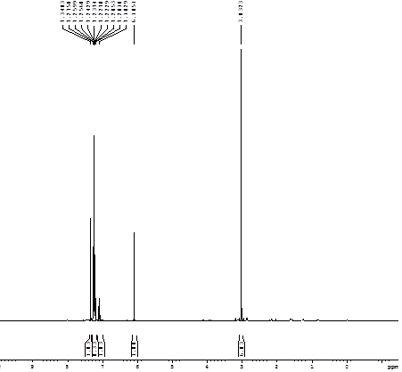



**Fig S1.** 1H NMR spectrum of 2-(4-chlorophenyl)-5-((dimethylamino)methylene)-3-phenylthiazolidin-4-one **(2b)**

m/z

100

150

200

250

300

350

400

450

500

550

600

650

700

750

800

850

900

950

1000

%

0

100

DEEPIKA PM-40 16 (0.297) Cm (3:39)

TOF MS ES+

6.81e4

345.1

68085

274.3

4339

220.1

3757

216.1

2174

347.1

23828

367.1

17290

369.1

5717

540.6

2416



**Fig S2.**Mass spectrum of 2-(4-chlorophenyl)-5-((dimethylamino)methylene)-3-phenylthiazolidin-4-one **(2b)**

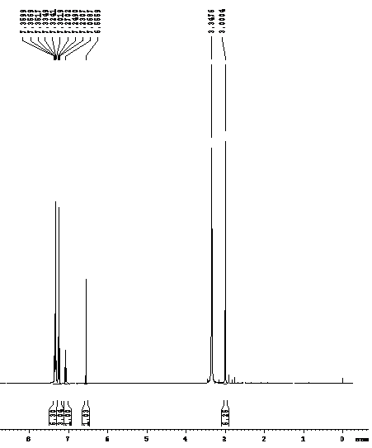



**Fig S3.** 1H NMR spectrum of 2-(4-chlorophenyl)-5-((dimethylamino)methylene)-3-phenylthiazolidine-4-thione **(3b)**



M+H+



**Fig S4.** Mass spectrum of 2-(4-chlorophenyl)-5-((dimethylamino)methylene)-3-phenylthiazolidine-4-thione **(3b)**

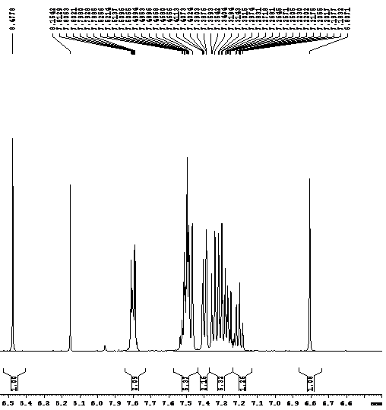



**Fig S5.** 1H NMR spectrum of 2,5,6-triphenyl-5,6-dihydro-1H-pyrazolo[3,4-d]thiazole **(4a)**

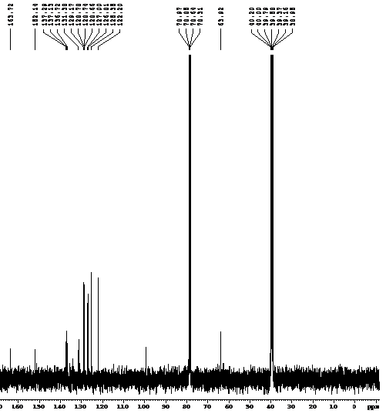



**Fig S6.** 13C NMR spectrum of 2,5,6-triphenyl-5,6-dihydro-1H-pyrazolo[3,4-d]thiazole **(4a)**

M+H+



m/z

100

150

200

250

300

350

400

450

500

550

600

650

700

750

800

850

900

950

1000

%

0

100

TOF MS ES+

6.19e3

378.0

6188

356.1

5418

227.0

1560

226.0

655

185.0

341

355.1

1277

354.1

294

228.0

270

379.0

1088

380.0

340

**Fig S7.**Mass spectrum of 2,5,6-triphenyl-5,6-dihydro-1H-pyrazolo[3,4-d]thiazole **(4a)**

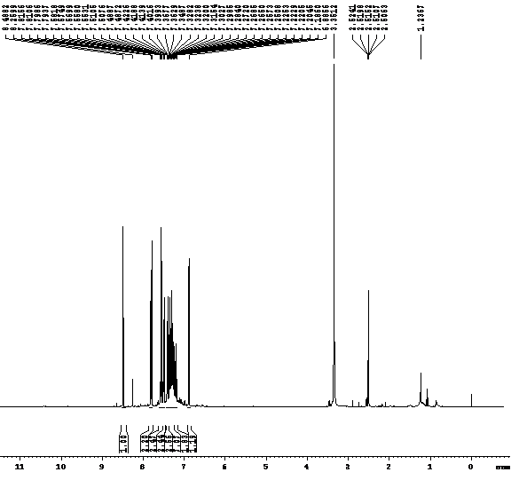



**Fig S8.** 1H NMR spectrum of 2-(4-chlorophenyl)-5,6-diphenyl-5,6-dihydro-2H-pyrazolo[3,4-d]thiazole **(4b)**

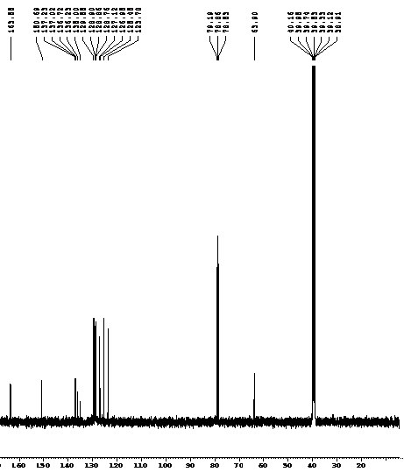



**Fig S9.** 13C NMR spectrum 2-(4-chlorophenyl)-5,6-diphenyl-5,6-dihydro-2H-pyrazolo[3,4-d]thiazole **(4b)**

M+H+



m/z

100

150

200

250

300

350

400

450

500

550

600

650

700

750

800

850

900

950

1000

%

0

100

TOF MS ES+

1.18e3

140.0

1182

131.0

99

245.1

646

158.0

437

181.0

412

220.1

198

199.1

85

257.0

482

390.2

381

275.0

298

293.0

230

298.0

90

339.0

78

359.3

51

475.3

159

412.1

137

453.4

85

414.9

66

476.4

64

701.5

44

**Fig S10.**Mass spectrum of 2-(4-chlorophenyl)-5,6-diphenyl-5,6-dihydro-2H-pyrazolo[3,4-d]thiazole **(4b)**

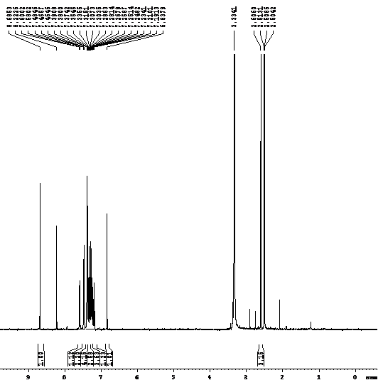



**Fig S11.** 1H NMR spectrum of 5,6-diphenyl-2-(o-tolyl)-5,6-dihydro-2H-pyrazolo[3,4-d]thiazole **(4c)**

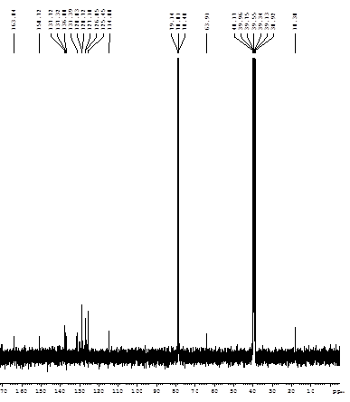



**Fig S12.** 13C NMR spectrum of 5,6-diphenyl-2-(o-tolyl)-5,6-dihydro-2H-pyrazolo[3,4-d]thiazole **(4c)**

M+H+



m/z

100

150

200

250

300

350

400

450

500

550

600

650

700

750

800

850

900

950

1000

%

0

100

TOF MS ES+

1.63e4

370.1

16263

348.1

8898

215.1

2293

91.0

1518

154.1

1230

232.1

1787

371.1

2662

372.1

769

**Fig S13.**Mass spectrum of 5,6-diphenyl-2-(o-tolyl)-5,6-dihydro-2H-pyrazolo[3,4-d]thiazole **(4c)**

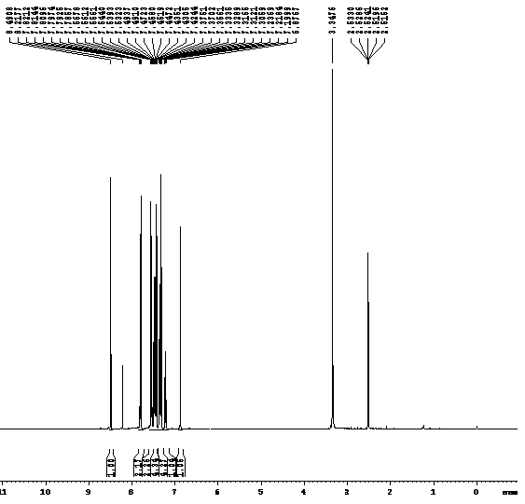



**Fig S14.** 1H NMR spectrum of 2,5-bis(4-chlorophenyl)-6-phenyl-5,6-dihydro-2H-pyrazolo[3,4-d]thiazole **(4e)**

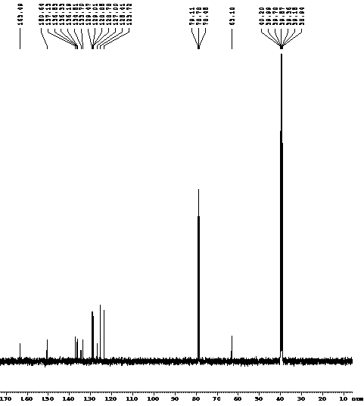



**Fig S15.** 13C NMR spectrum of 2,5-bis(4-chlorophenyl)-6-phenyl-5,6-dihydro-2H-pyrazolo[3,4-d]thiazole **(4e)**



M+H+



**Fig S16.**Mass spectrum of 2,5-bis(4-chlorophenyl)-6-phenyl-5,6-dihydro-2H-pyrazolo[3,4-d]thiazole **(4e)**

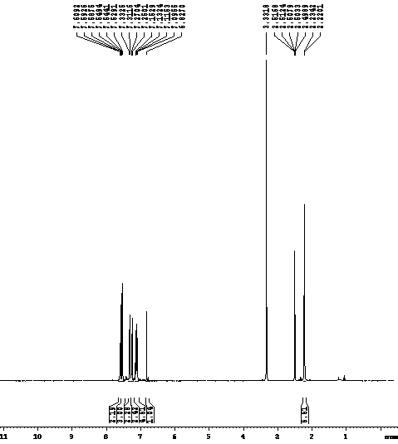



**Fig S17.** 1H NMR spectrum of (E)-5-(4-chlorobenzylidene)-2,3-di-p-tolylthiazolidin-4-one **(6a)**

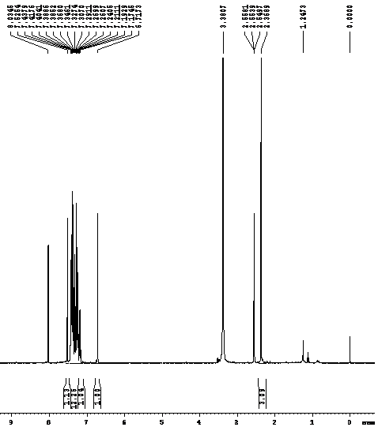



**Fig S18.** 1H NMR spectrum of (E)-2-(4-chlorophenyl)-5-(4-methylbenzylidene)-3-phenylthiazolidin-4-one **(6b)**