Supplementary Material

H₂ kinetic isotope fractionation superimposed by equilibrium isotope fractionation during hydrogenase activity of D. vulgaris strain Miyazaki
Michaela Löffler¹, Steffen Kümmel¹, Carsten Vogt^{1, *}, Hans-Hermann Richnow¹
¹Department Isotope Biogeochemistry, Helmholtz Centre for Environmental Research – UFZ, Leipzig, Germany

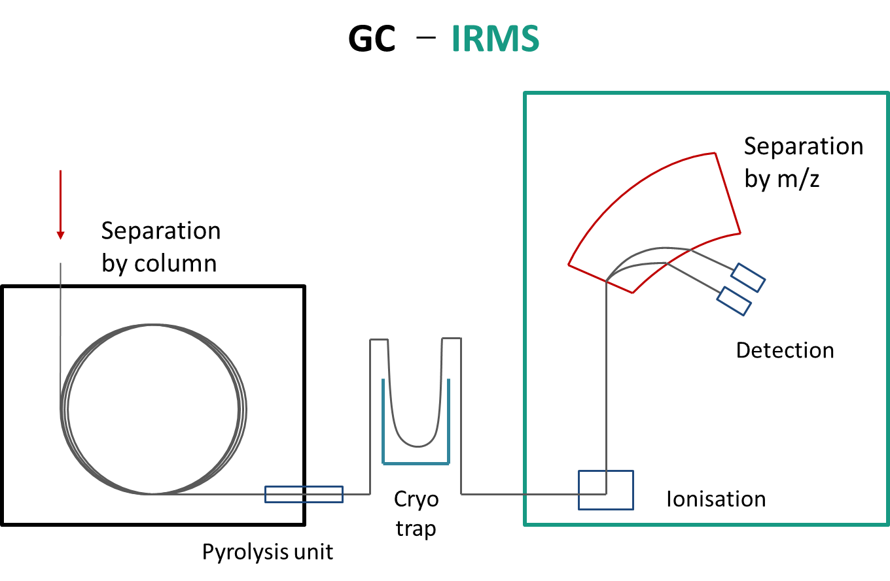Supplementary Figure 1: Scheme of the GC-IRMS system

Supplementary Figure 2: Concentration of H₂ of the abiotic controls of both medium and water. Continuous sampling results in decreasing concentrations from 18 % to 10 % H₂.

