Supplementary Information
For
Overclaiming Knowledge Predicts Anti-Establishment Voting

SI Data characteristics:
The research reported herein was part of a large, multi-wave project in the context of the Dutch Ukraine referendum (4 waves in total), in which multiple researchers (with multiple research projects) participated. In the following we report only those measures that form the basis of the present article. A full overview of the measures in all the waves is available upon request.

SI Methods:
Here we provide the full scales assessed for the present research during Wave 1 of the study. We provide both the English translation as well as the original Dutch wording (in italics).
Self-perceived understanding of the treaty:
To what extent do you agree or disagree with the following statements? (on a scale from 1 = strongly disagree to 5 = strongly agree; 6 = no opinion). (Items 1, 2, and 5 reflect self-efficacy, items 3 and 4 self-perceived knowledge of the treaty)
- I consider myself sufficiently qualified to judge the association treaty between Ukraine and the EU (Ik beschouw mezelf voldoende geschikt om te oordelen over het associatieverdrag tussen Oekraïne en de EU).
- My judgment of the association treaty between Ukraine and the EU is the only right one (Mijn oordeel over het associatieverdrag tussen Oekraïne en de EU is het enige juiste).
- I know better than the average Dutch citizen what the association treaty between Ukraine and the EU is about exactly (Ik weet beter dan de gemiddelde Nederlander waar het associatieverdrag tussen Oekraïne en de EU precies over gaat).
- I am well-informed about the contents of the association treaty between Ukraine and the EU (Ik ben goed geïnformeerd over de inhoud van het associatieverdrag tussen Oekraïne en de EU).
- I am, more than the average Dutch citizen, aware of how important this referendum is (Ik ben meer dan de gemiddelde Nederlander ervan bewust hoe belangrijk dit referendum is).
Actual knowledge of the treaty:
Are the following propositions about the association treaty true or false? (to be answered with true / false / do not know; below we give the correct answers together with a clarification).
- This treaty ensures that Ukrainian citizens eventually can travel to all EU member states without a Visa (Dit verdrag regelt dat inwoners van Oekraïne op termijn zonder visum kunnen reizen naar alle EU-lidstaten) (Correct answer: False. In June 2017, rules allowing free travel between EU and Ukraine without a Visa for a stay of maximum 90 days did become effective; however, the visa negotiations took place separately from the negotiations about the association treaty, and therefore these visa rules are not part of the association treaty. In fact, the association treaty became effective on 1 September 2017—which is three months after the visa liberalization already became effective).
- Ukrainian employees get the opportunity to work in EU countries without a permit (Oekraïense werknemers krijgen de mogelijkheid in EU landen te gaan werken zonder werkvergunning) (Correct answer: False. This is currently not possible, and certainly not part of the treaty. Also the new Visa rules referred to under the first question do not include the right to work in EU member states without a permit).
- Within ten years, an economic free trade zone will be formed between the EU and Ukraine (Binnen tien jaar wordt een economische vrijhandelszone gevormd tussen de EU en Oekraïne) (Correct answer: True. The DCFTA [“Deep and Comprehensive Free Trade Area”] is a central part of the treaty, and includes the progressive elimination of custom duties by the EU over a transition period of 10 years).
- Ukraine will be a partner in reducing migration and fighting terrorism (Oekraïne wordt een partner bij de beperking van migratiestromen en het bestrijden van terrorisme) (Correct answer: True. The treaty includes provisions about cooperation between the EU and Ukraine in migration and border management, as well as cooperation in the fight against terrorism).
- The government is legally compelled to follow the result of the referendum (De regering is wettelijk verplicht zich te houden aan de uitslag van het referendum) (Correct answer: False. At the time the referendum was held [6 April 2016], referenda in the Netherlands were explicitly “advisory”. This was the first advisory referendum after introduction of this political tool in 2015. The Dutch government was compelled to discuss the referendum result in parliament, and in case the result deviated from the government’s original decision, it had to be re-approved by both parliament and the senate. But the referendum was still “advisory” and the government was not compelled to follow the result. Since 2018, advisory referenda are no longer possible in the Netherlands).
- Parliament has already voted about the association treaty (De tweede kamer heeft al over het associatieverdrag gestemd) (Correct answer: True. In fact, advisory referenda in the Netherlands were only possible about laws that already were accepted by both parliament and the senate).
- In order to reach the goals of the association treaty, Ukraine can get financial support from the EU (Om de doelen van het associatieverdrag te realiseren kan Oekraïne financiële steun van de EU krijgen) (Correct answer: True. The treaty includes explicit provisions about a financial support package from the EU for Ukraine to reach the political and economic goals of the treaty).
- Because of the treaty, companies from Ukraine can freely settle in all EU countries (Door het verdrag kunnen bedrijven uit Oekraïne zich vrij vestigen in alle EU landen). (Correct answer: False. The treaty makes it easier for companies from Ukraine to export to the EU, but it does not stipulate that companies from Ukraine can freely settle in the EU).
Anti-establishment sentiments:
Could you tell me to what extent you agree or disagree with the following statements? (on a scale from 1 = strongly disagree to 5 = strongly agree; 6 = do not know / no opinion).
- Voting is useless, political parties do what they want anyway (Gaan stemmen heeft geen zin, de partijen doen toch wat ze willen)
- Political parties are only interested in my vote, not in my opinion (De politieke partijen zijn alleen maar geïnteresseerd in mijn stem en niet in mijn mening)
- Politicians talk a lot, but they do nothing to address the real problems (Politici praten wel veel, maar doen niets aan de échte problemen)
- As of the moment they are elected, most politicians feel superior towards people like me (Vanaf het moment dat ze gekozen zijn, voelen de meeste politici zich te goed voor mensen zoals ik)
General overclaiming:
Could you indicate to what extent you are familiar with the following persons, objects, ideas, or places? (on a scale ranging from 1 = Never heard of, to 5 = Very familiar) (original Dutch words displayed; English translation provided in italics, only if the English translation differs. * = foil).
- Houdini
- Charlotte Brontë
- Meta-toxides*
- Mythe (Myth)
- Antigone
- Chlorarine*
- Alliteratie (Alliteration)
- Barend de Witte
- Koningin Shattuck (Queen Shattuck)*
- Lewis Carroll
- Vrije wil (Free will)
- Max Weber
- Murphy’s laatste wens (Murphy’s last wish)*
- Stigma zinnen (Stigma sentences)*
- Varkensbaai (Bay of Pigs)
- Hyperbool (Hyperbole)
- De Aeneis (The Aeneis)
- Eufemisme (Euphemism)
- Equivociteit (Equivocity)
- Consumenten appareil (Consumer appareil)*
- Blank vers (Blank verse)
- Shunt-woord (Shunt word)*
- Art deco
- Artemis
- A capella
SI Additional Analyses:
Predictors of attrition between waves
We conducted a logistic regression analysis in which we analyzed what Wave 1 variables would predict attrition in Wave 2 (coded as 1 = participated in Wave 2; 0 = did not participate in Wave 2). Given that we had no a priori prediction about this, we simply entered all the control and independent variables of Wave 1 at once in the regression model (i.e., gender, age, education, anti-establishment sentiments, self-perceived understanding, actual knowledge, general overclaiming, and political ideology). As with all other analyses, we set the alpha level of significance at p < .001. Together these variables significantly predicted participation in Wave 2, χ²(8) = 779.57, p < .001 (Nagelkerke R² = .08). Increased likelihood of participation was associated with older age, B = 0.03, SE = .001; Wald = 571.21; p < .001; Exp(B) = 1.03; higher self-perceived understanding, B = 0.15, SE = .02; Wald = 44.12; p < .001; Exp(B) = 1.16; increased actual knowledge, B = 0.03, SE = .008; Wald = 16.12; p < .001; Exp(B) = 1.03; and decreased general overclaiming, B = -0.22, SE = .03; Wald = 45.99; p < .001; Exp(B) = 0.81. The other variables were not significant (ps > .01).
Furthermore, we conducted the two-lines test with participation in Wave 2 as dependent variable and political ideology as independent variable, while controlling for gender, age, and political orientation. The linear slopes were nonsignificant at both the left (z = -2.80, p = .005) and right of the political spectrum (z = 1.82, p = .07).
Overconfidence to judge the treaty as difference score.
We also calculated an index of participants’ overconfidence to judge the treaty by first standardizing the self-perceived understanding and actual knowledge indicators, and then subtracting the standardized actual knowledge index from the standardized self-perceived understanding index (such that higher scores reflect stronger overconfidence, operationalized as the difference between self-perceived understanding and actual knowledge of the treaty). Given the psychometric problems associated with difference scores in psychology (Furr, 2011) we analyze the underlying constituent variables in the main manuscript, yet for full disclosure also report the analyses of difference scores in the supplemental materials.
We entered both overconfidence to judge the treaty, and general overclaiming, as predictors in a logistic regression analysis, after entering the control variables. Step 2 (containing the overconfidence and overclaiming measures) added significantly to the regression model, χ²(2) = 302.17, p < .001; total model χ²(5) = 776.10, p < .001 (Nagelkerke R² = .18). Both overconfidence to judge the treaty and general overclaiming predicted an increased likelihood of an anti-establishment vote: For overconfidence to judge the treaty, B = 0.39, SE = .03; Wald = 240.73; p < .001; Exp(B) = 1.48 (pro-establishment vote M = -0.10, SD = 1.15; anti-establishment vote M = 0.53, SD = 1.33); for general overclaiming, B = 0.25, SE = .06; Wald = 20.28; p < .001; Exp(B) = 1.28 (pro-establishment vote M = 1.47, SD = 0.52; anti-establishment vote M = 1.57, SD = 0.57). The chance for an anti-establishment vote was 1.48 times more likely per measurement point increase of overconfidence to judge the treaty, and 1.28 times more likely per measurement point of general overclaiming. These results are consistent with the results reported in the main manuscript, and further support the idea that both overconfidence to judge the treaty and a general tendency to overclaim knowledge predict anti-establishment voting in elections.

Voting abstention
In Wave 2, there were a total of 2044 participants who indicated to not have voted during the referendum, and had also participated in Wave 1 (1467 men, 485 women, 92 not indicated). Here, we explored whether (a) anti-establishment sentiments, and (b) self-perceived understanding of the treaty, actual knowledge of the treaty, and general overclaiming were stronger among respondents who voted against the treaty as opposed to voters who did not vote at all. In a first logistic regression analysis, we included the control variables gender, age, and education in Step 1 and anti-establishment sentiments in Step 2. Step 1 was significant, χ²(3) = 234.69, p < .001 (Nagelkerke R² = .07). Results revealed that as compared to not voting, anti-establishment voting was weaker among women, B = -0.26, SE = .08; Wald = 11.86; p = .001, Exp(B) = 0.77; and among the higher educated, B = -0.37, SE = .03; Wald = 205.87; p < .001, Exp(B) = 0.69. The effect of age was not significant, B = -0.003, SE = .002; Wald = 1.26; p = .26, Exp(B) = 1.00. Step 2 was also significant, χ²(1) = 703.12, p < .001 (Nagelkerke R² = .27). The results revealed that anti-establishment sentiments were stronger among participants who voted against the establishment (M = 3.66, SD = 0.95) than among participants who abstained from voting (M = 2.73, SD = 0.96), B = 0.91, SE = .04; Wald = 585.77; p < .001, Exp(B) = 2.47. The odds ratio indicates that per measurement point of anti-establishment sentiments, the chance of anti-establishment voting (as compared to not voting) became 2.47 times more likely.
In a second analysis, we included self-perceived understanding of the treaty, actual knowledge of the treaty, and general overclaiming in Step 2. This step was also significant χ²(3) = 414.42, p < .001 (Nagelkerke R² = .19), as were the effects of self-perceived understanding, B = 0.75, SE = .04; Wald = 311.66; p < .001, Exp(B) = 2.11; and actual knowledge of the treaty, B = -0.13, SE = .02; Wald = 70.93; p < .001, Exp(B) = 0.88. The effect of general overclaiming was marginal, B = 0.18, SE = .06; Wald = 7.66; p = .006, Exp(B) = 1.19. The chance of an anti-establishment vote (as opposed to a non-vote) was 2.11 times more likely per measurement point increase of self-perceived understanding, and 1.19 times more likely per measurement point increase of general overclaiming. Moreover, it was 0.88 times more likely per measurement point of actual knowledge of the treaty (a value lower than 1, indicating a decreased likelihood per measurement point of actual knowledge). In sum, as compared with voting abstention, anti-establishment voting was associated with increased anti-establishment sentiments, increased self-perceived understanding of the treaty, decreased actual knowledge of the treaty, and marginally increased general knowledge overclaiming.

References:
Furr, R. (2011). Scale construction and psychometrics for social and personality psychology.
London, UK: Sage.

Figures two-lines tests
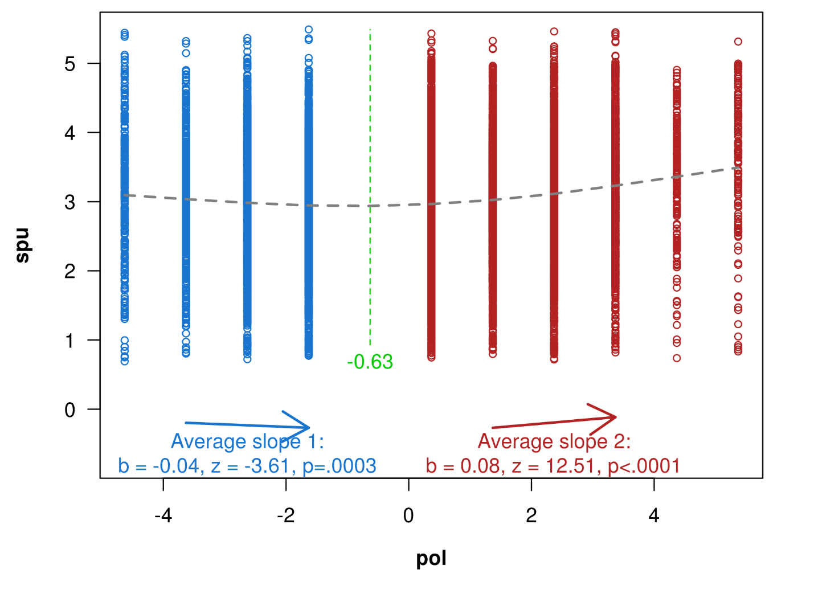Figure S1 – Self-perceived understanding of the treaty as a function of political ideology.

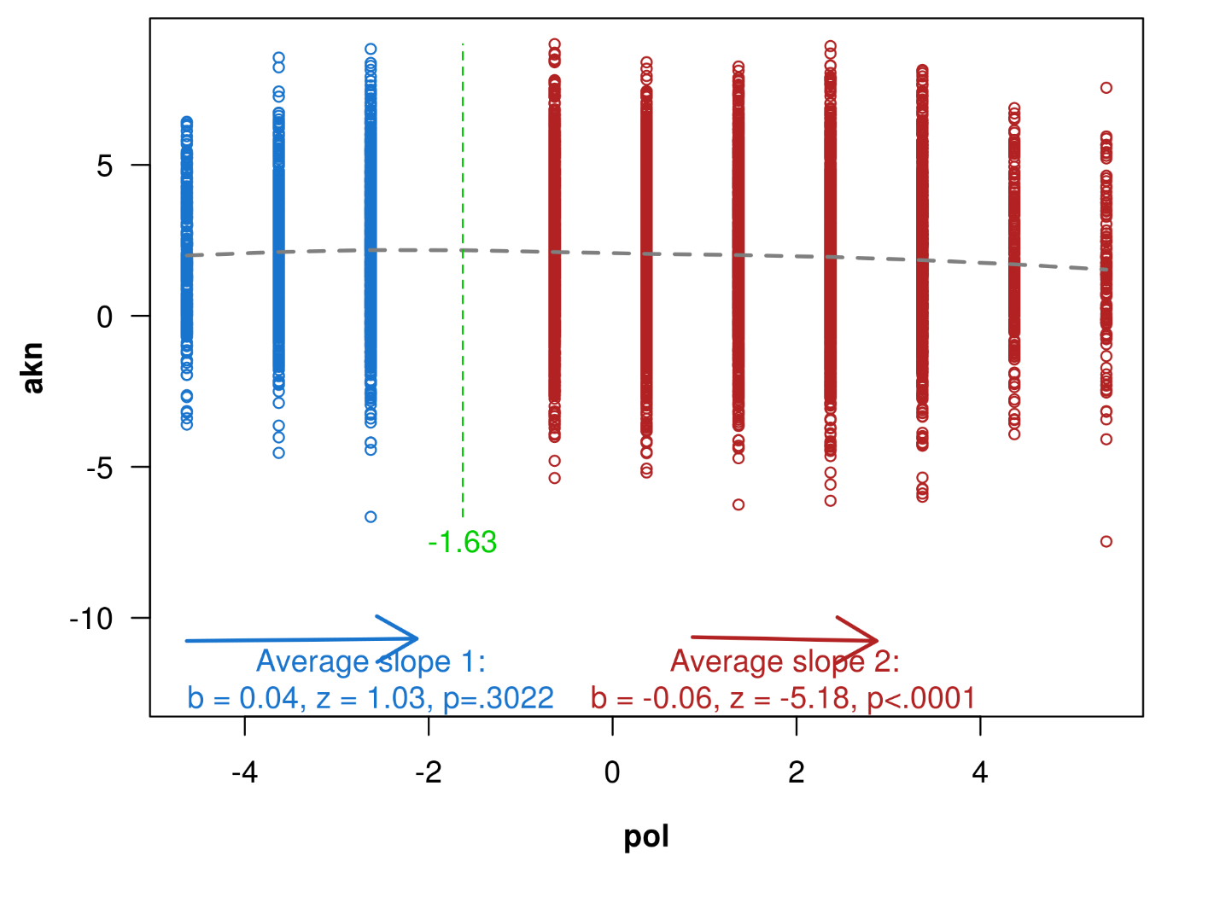Figure S2 – Actual knowledge of the treaty as a function of political ideology.

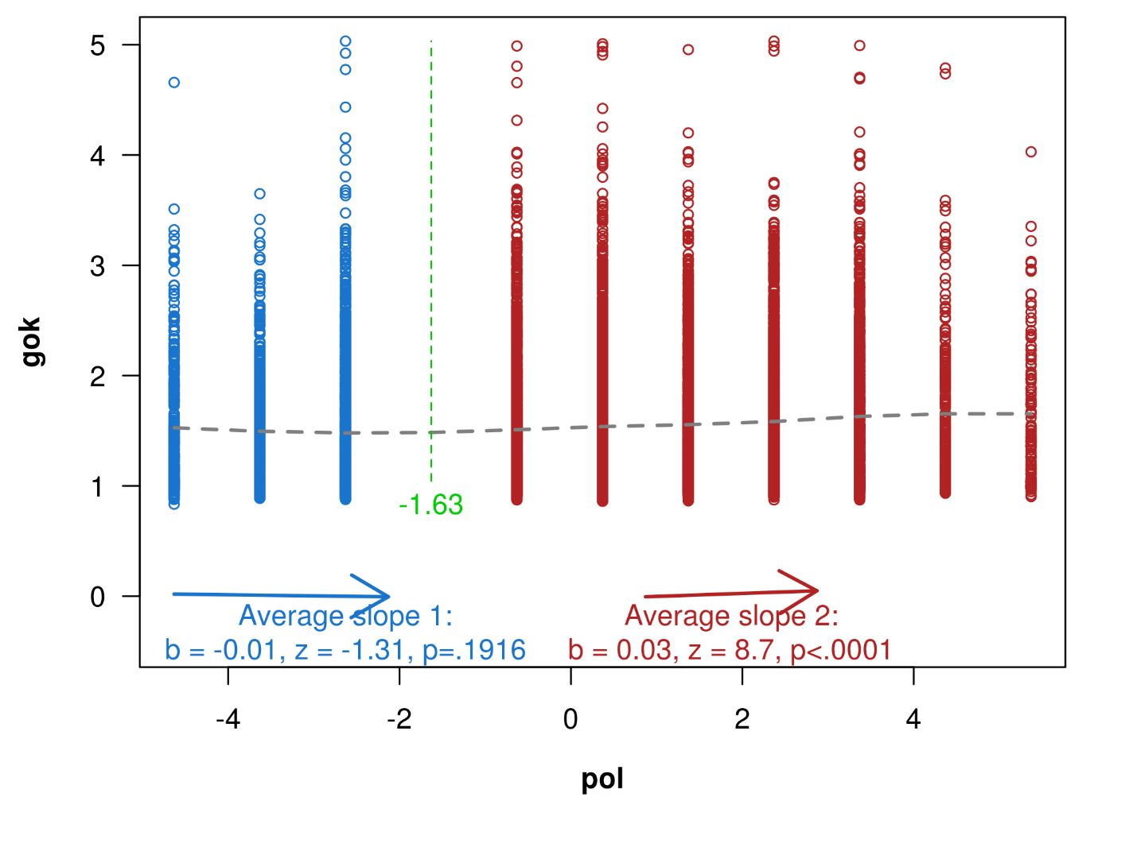Figure S3. General overclaiming as a function of political ideology.

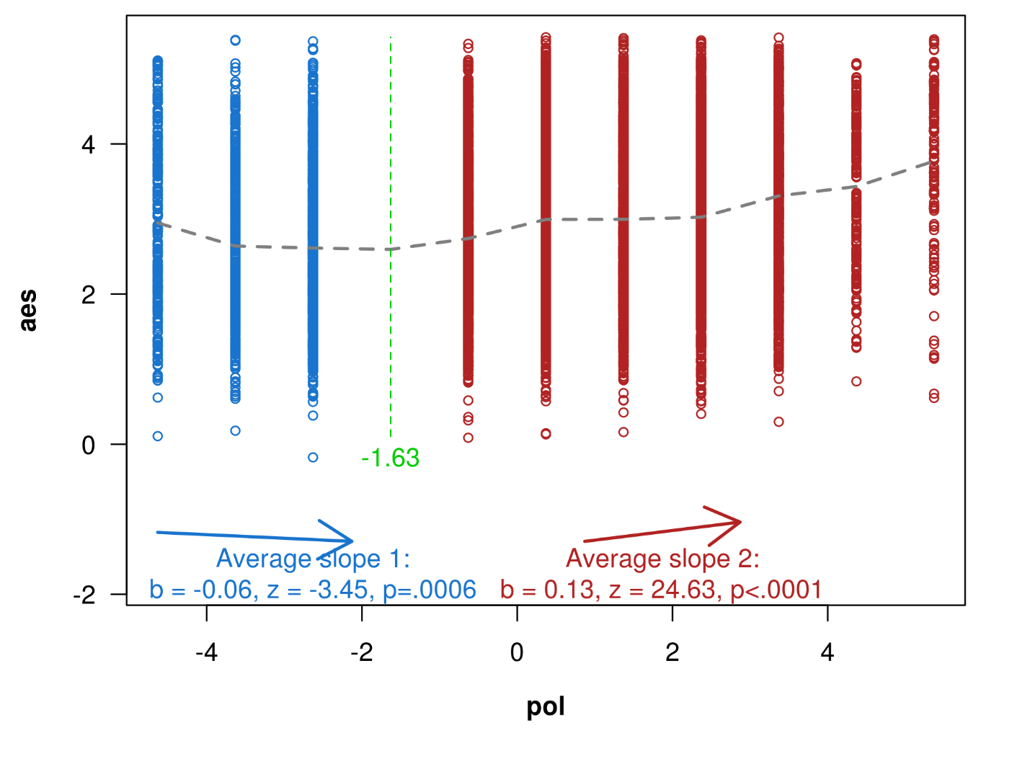Figure S4. Anti-establishment sentiments as a function of political ideology.

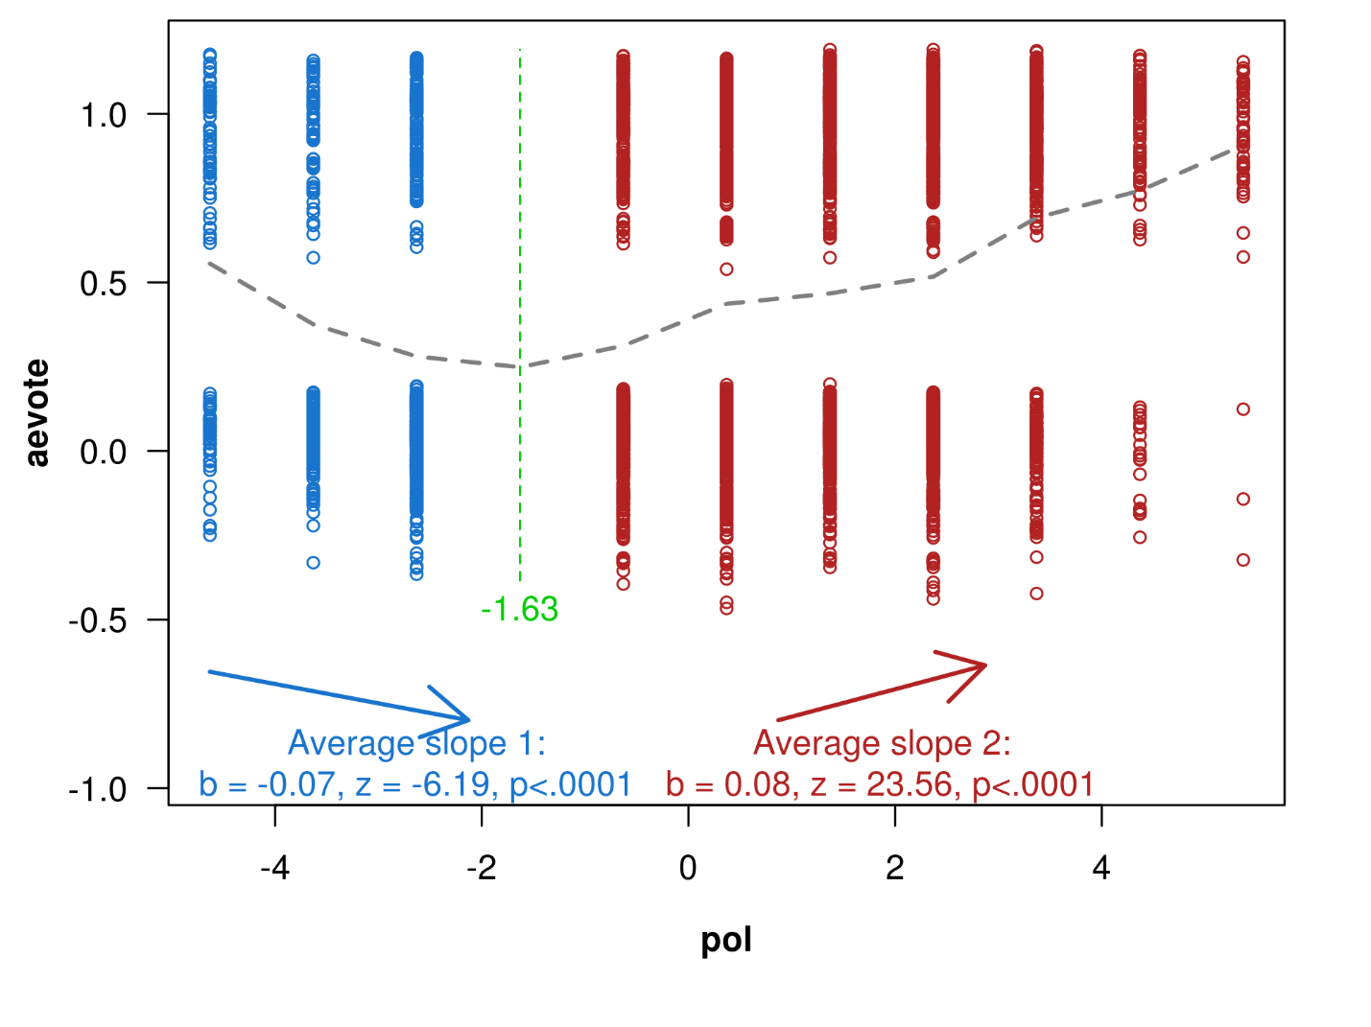Figure S5 – Anti-establishment voting as a function of political ideology. 1 = anti-establishment vote (i.e., against the treaty), 0 = pro-establishment vote (i.e., in favor of the treaty).

