**SUPPORTING INFORMATION**

**Reversible pH-responsive hydrogels of Softwood kraft lignin and poly[(2-dimethylamino)ethyl methacrylate]-based polymers**

Guangzheng Gao, William Z. Xu, and John F. Kadla*

University of British Columbia, Vancouver, BC, Canada V6T 1Z4

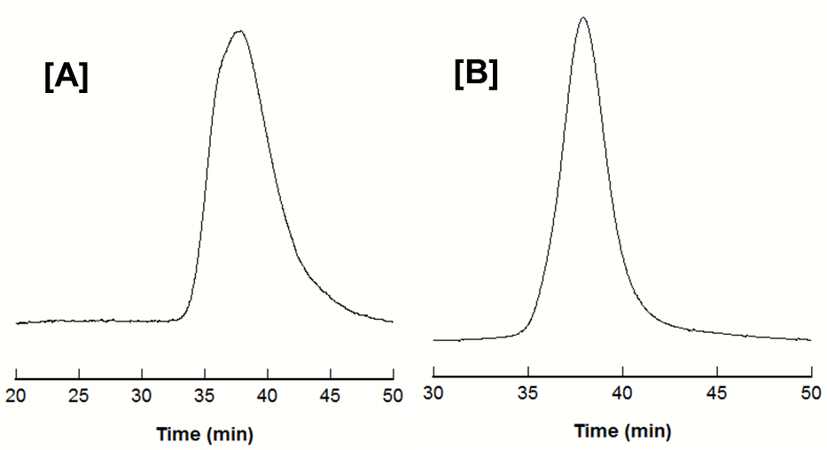

**Figure S1.** GPC traces of **[A]** PDMAEMA and **[B]** PbP with THF as eluent.

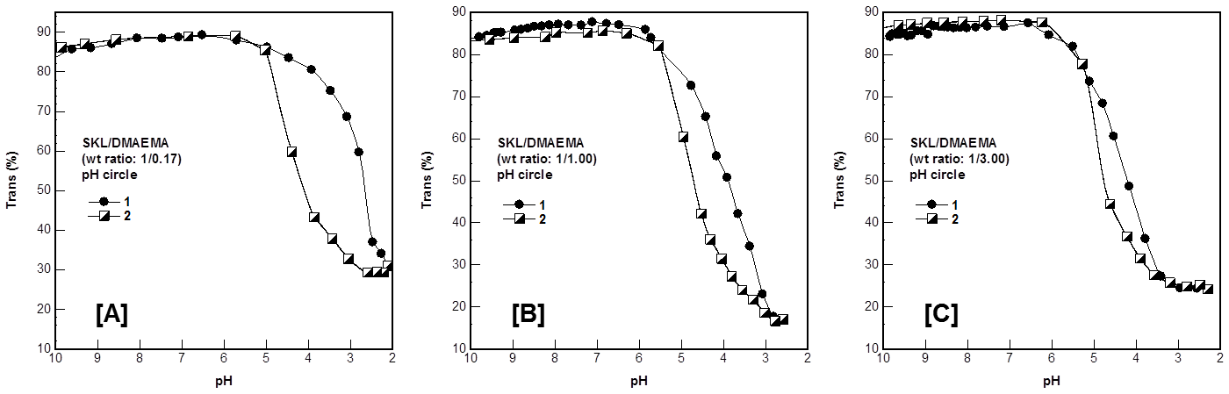

**Figure S2. SKL/DMAEMA (monomer) control samples**:pH induced SKL/DMAEMA assembly in aqueous solution of various weight ratios. Reversible pH induced SKL/DMAEMA assembly of weight ratio **[A]** 1/0.17, **[B]** 1/1.00 and **[C]** 1/3.00. **1.** Titrated by 0.1 M HCl solution. **2.** Titrated by 0.1 M NaOH solution. Lignin concentration = 1.0 mg/mL. There is S-I phenomenon in lignin/DMAEMA systems and no S-I-S phenomenon appears in this systems, indicating that the PDMAEMA polymer dominates the S-I-S phenomena (**Scheme 2**).

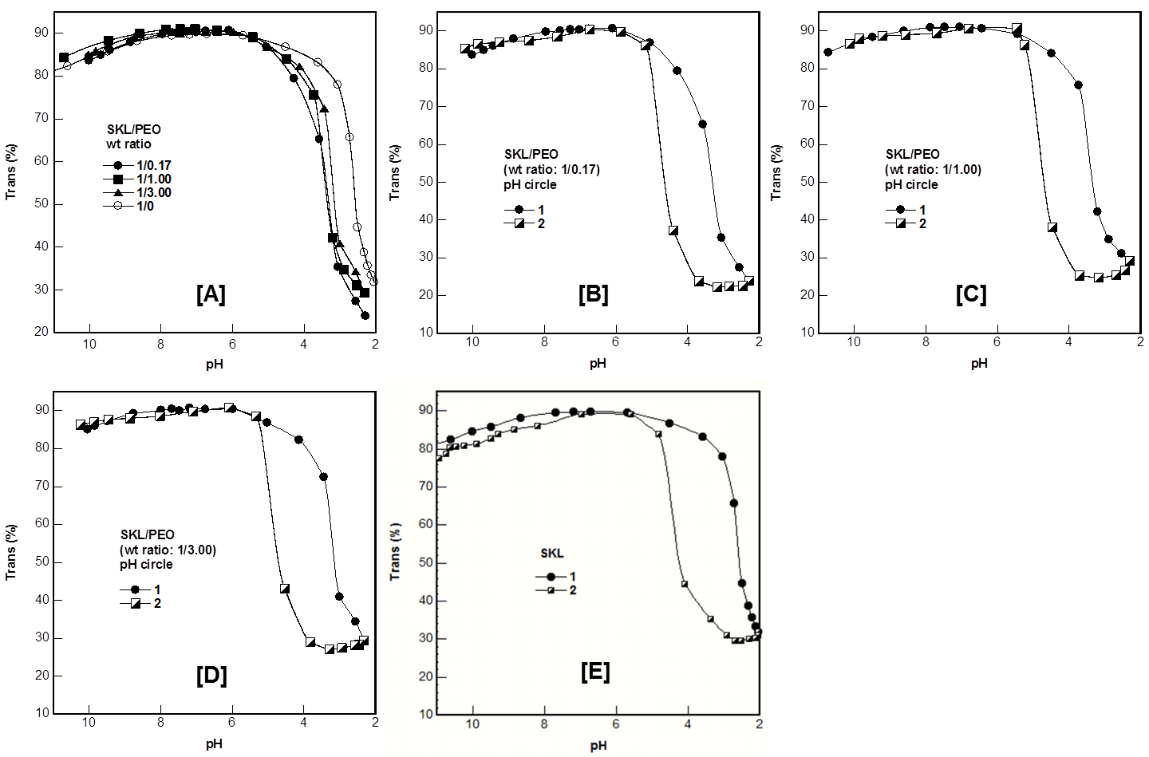

**Figure S3. SKL/PEO control samples**: **[A]** pH induced SKL/PEO assembly in aqueous solution of various weight ratios. Reversible pH induced SKL/PEO assembly of weight ratio **[B]** 1/0.17, **[C]** 1/1.00, **[D]** 1/3.00 and **[E]** 1/0. **1.** Titrated by 0.1 M HCl solution. **2.** Titrated by 0.1 M NaOH solution. Lignin concentration = 1.0 mg/mL.

|  |  |  |
| --- | --- | --- |
| **[A]** | **[B]** | **[C]** |

**Figure S4.** The *ν*OH region of the FTIR spectra of **[A]** SKL/PEO, **[B]** SKL/PDMAEMA and **[C]** SKL/PDMAEMA-*co*-PEO-*co*-PDMAEMA blends. SKL/polymer (PEO, PDMAEMA and PbP) weight ratio: 1/1.00. Solid line: SKL, dot line: SKL/polymer (PEO, PDMAEMA and PbP) blends.

|  |  |  |
| --- | --- | --- |
| **[A]** | **[B]** | **[C]** |

**Figure S5.** Effect of blend ratio on the glass transition temperatures **(***T*g) of SKL/polymer (PEO, PDMAEMA, and PDMAEMA-*co*-PEO-*co*-PDMAEMA) blends. **[A]** SKL/PEO blends. **[B]** SKL/PDMAEMA blends. **[C]** SKL/PDMAEMA-*b*-PEO-*b*-PDMAEMA blends.



**Figure S6.** pH responsive SKL/polymer (PDMAEMA and PbP) assembly at weight ratio of 1/0.33 in aqueous solution with various SKL concentrations. **[A]** and **[B]** SKL/PDMAEMA mixtures; **[C]** and **[D]** SKL/PbP mixtures.

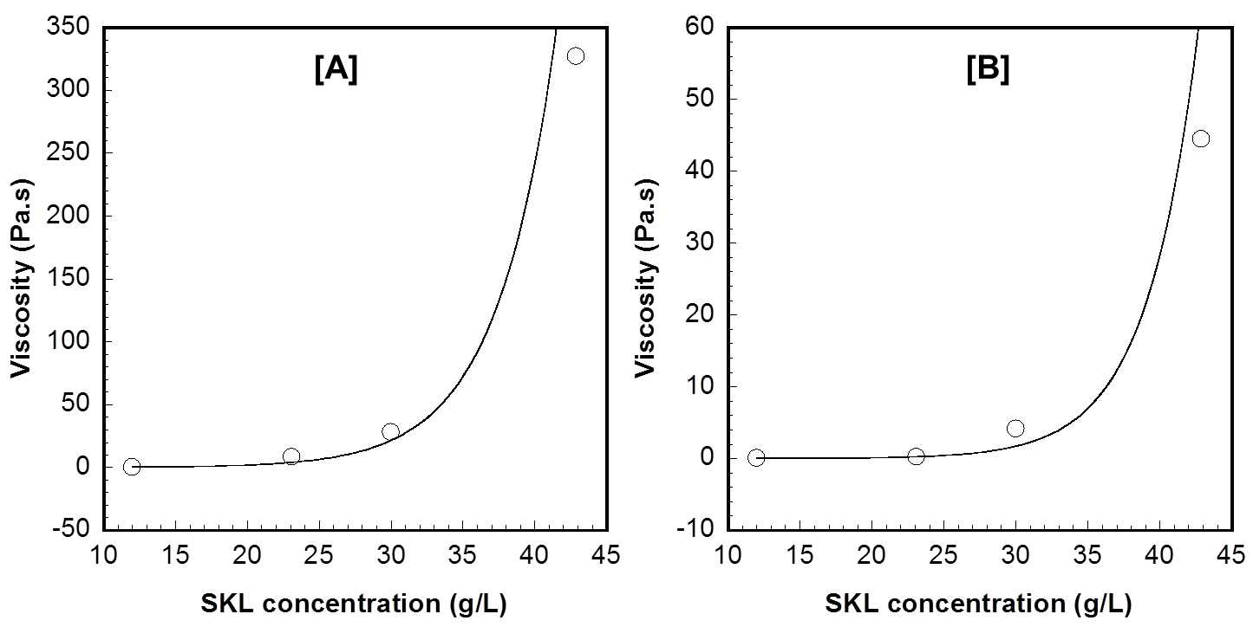

**Figure S7.** Effect of SKL concentration on the steady-shear viscosity obtained for **[A]** SKL/PDMAEMA and **[B]** SKL/PDMAEMA-*co*-PEO-*co*-PDMAEMA systems. SKL/polymer weight ratio = 1/0.33; shear rate = 1 s-1.

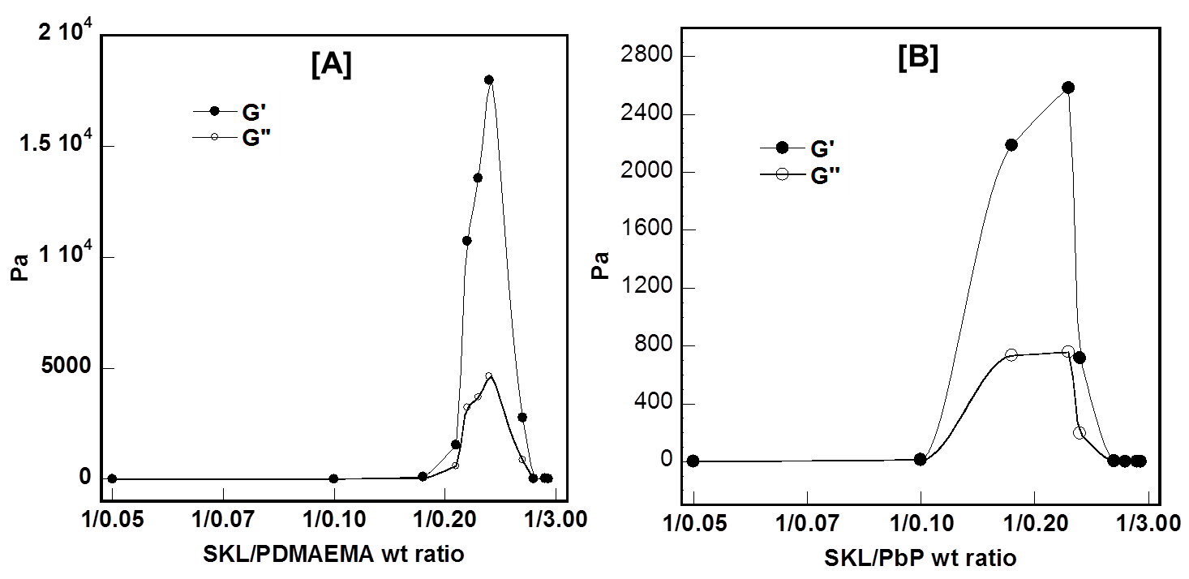**Figure S8.** Relationship between the elastic (G’) and viscous (G”) moduli vs the weight ratio of [A] SKL/PDMAEMA and [B] SKL/PDMAEMA-*co*-PEO-*co*-PDMAEMA systems.