Supplementary Figure S1: Position of facial landmarks.
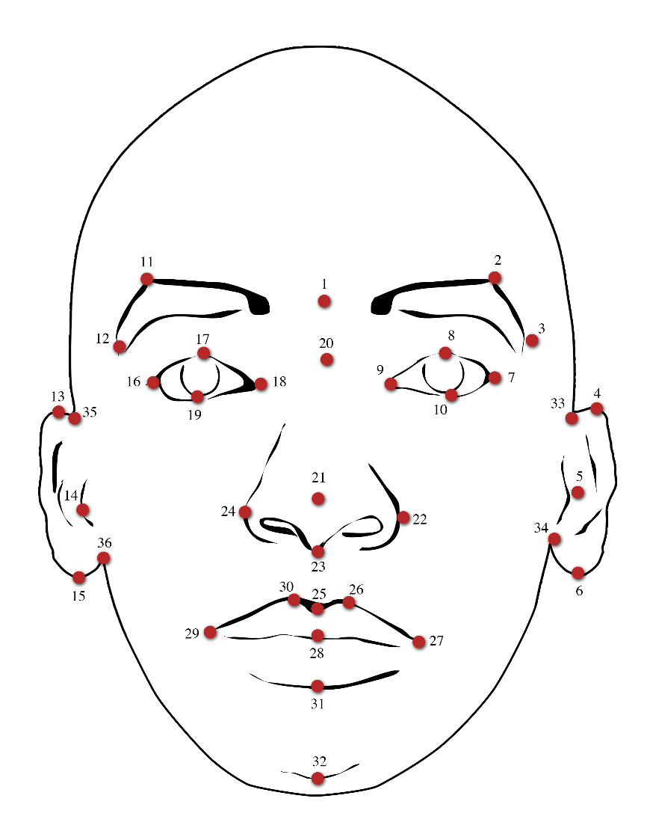

Landmarks:  - Glabella  - Superciliare (left)  - Frontotemporale (left)  - Superaurale (left)  - Superior lateral tragion (left)  - Subaurale (left)  - Exocanthion (left)  - Palpebrale superiorus (left)  - Endocanthion (left)  - Palpebrale inferiorus (left)  - Superciliare (right)  - Frontotemporale (right)  - Superaurale (right)  - Superior lateral tragion (right)  - Subaurale (right)  - Exocanthion (right) | - Palpebrale superiorus (right)  - Endocanthion (right)  - Palpebrale inferiorus (right)  - Sellion  - Infrapronasale  - Alare (left)  - Subnasale  - Alare (right)  - Labiale superiorus (sagital)  - Labiale superiorus (left)  - Cheilion (left)  - Stomion  - Cheilion (right)  - Labiale superiorus (right)  - Labiale inferiorus  - Pogonion  - Otobasion superiorious (left)  - Otobasion inferiorous (left)  - Otobasion superiorious (right)  - Otobasion inferiorous (right)

