Supporting information for the manuscript TENT-2014-0295

Internal carbon source from sludge pretreated by microwave-H₂O₂ for nutrient removal in A²/O-MBRs
Rongle Xu, Qing Zhang, Juan Tong, Yuansong Wei, Yaobo Fan *
Research Center for Eco-Environmental Sciences, Chinese Academy of Sciences, Beijing 100085
*Corresponding author. E-mail: ybfan@rcees.ac.cn

Introduction
Table S1 Comparison of the sludge pretreatment for internal carbon sources carbon sources
Sludge pretreatment |  | Parameters | Carbon source type | Configuration | Conclusion | Reference
Physical | ultrasonic | 1L sludge sonicated under 600W for 1h once a day, returned to MBR tank | Solubilized sludge | MBR,8.5L | Sludge reduction, effluent quality slightly deteriorated. | [1]
 | Mechanically disintegration | Disintegrated with a deflaker, 2300-6200kJkg⁻¹TSS for 2-5min. | Solubilized sludge | —— | Higher denitrification rate and more phosphate release | [2]
Chemical | Alkaline and ozonation | Fix pH of 11 for 3h, ozone treatment with 0.02gO₃g⁻¹SS for 26.6-35.5min ozone sludge 1.44Ld⁻¹ | Solubilized sludge | MBR, 28L. | Sludge reduction, no significant deterioration in effluent quality. | [3]
 | Thermo chemical digestion | Fix pH of 11(NaOH), temperature of 75℃for 3 h | Supernatant to anoxic; digested sludge to anaerobic basin | A²/O-MBR, 83.4L | Sludge reduction, no improvement or deterioration in nutrient removal | [4]
Biochemical | 2-step alkaline fermentation | Fix pH of 10, 25℃ for 72h, 2.5 days SRT for fermentation at 23-35℃ | Fermentation liquids recycled into anaerobic basin, wastewater into anoxic basin. | A²/O, 115L | Improved TN,TP removal efficiency 11% and 16%, respectively | [5]
 | Alkaline hydrolysis and gamma-ray | pH 10, gamma-ray irradiation of 20kGy | Solubilized sludge | A/O, 30L | TN removal efficiency improved 36.8 | [6]
 | Alkaline fermentation | pH 10, 20℃ for 8 days | Supernatant after recovery phosphorus and nitrogen by MAP | SBR, 4L | Improved TN,TP removal efficiency 19.9% and 48.9%, respectively | [7, 8]

Results and discussions

COD removal
Figure S1 shows the COD concentration of influent and effluent during the period of operation. The variation of COD in influent was evident and sometimes influent COD was very low. The low concentration of influent COD may drop the MLSS concentration and weaken nitrogen removal. It was observed that the effluent COD in Reactor 2 was higher than that in Reactor 1 during Stage 2 and Stage 3. A t-test analysis showed that the differences between Reactor 1 and Reactor 2 at Stage 2 are not statistically significant. However, at Stage 3, the differences between Reactor 2 and Reactor 1 were significant (p<0.05). Meanwhile, the sCOD in the aerobic basin were in the range of 18-45 mg/L and 42-82mg/L, and the effluent were fluctuated among 9-25 and 12.5-45 mg/L in Reactor 1 and Reactor 2, respectively. The result indicated that the membrane separation played an important role in producing high quality effluent, and the effluent quality was slightly deteriorated due to addition of internal carbon source, which agreed with that presented in some reports for study on sludge pretreatment [1, 9].
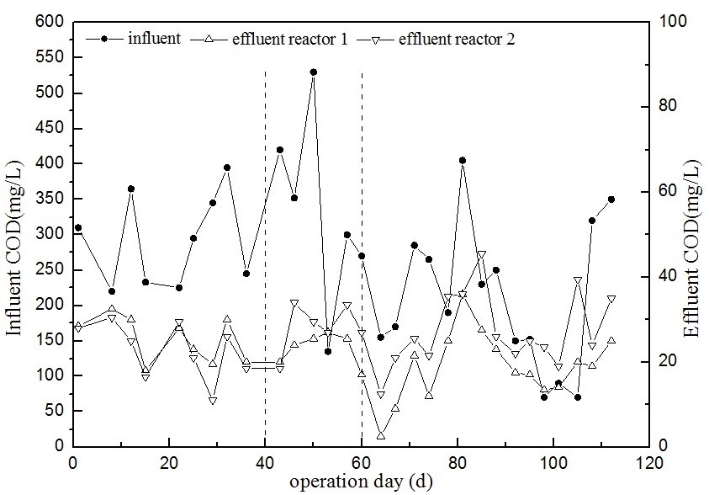
Figure S1. Variation of COD in influent and effluent of two reactors during operation time.

MLSS
Figure S2 shows MLSS and sludge yield during the operational period of Reactor 1 and 2. At Stage 1 (day 1-20) without adding internal carbon source from MHP, MLSS concentration decreased because of the unsteady influent, and then from day 20- 40, it reached to the steady state at around 8000mg/L in two reactors. During Stage 2, the MLSS concentration was maintained around 7500mg/L in Reactor 1, while that was higher and more fluctuated in Reactor 2 because of the addition of internal carbon source. At Stage 3, the MLSS concentration of Reactor 1 was decreased from 8000mg/L to 4000mg/L because of the endogenesis respiration of microorganisms in the shortage of substrate from influent [10]. While in Reactor 2, with addition of internal carbon source from MHP, the MLSS concentration was maintained around 8000mg/L. During Stage 3, the ratio of MLSS/MLVSS in two reactors were maintained at 0.79 and 0. 77, respectively, which indicated that there was slightly accumulation of inorganic matter caused by sludge pretreatment, similar to the previous study of Ventura [11].
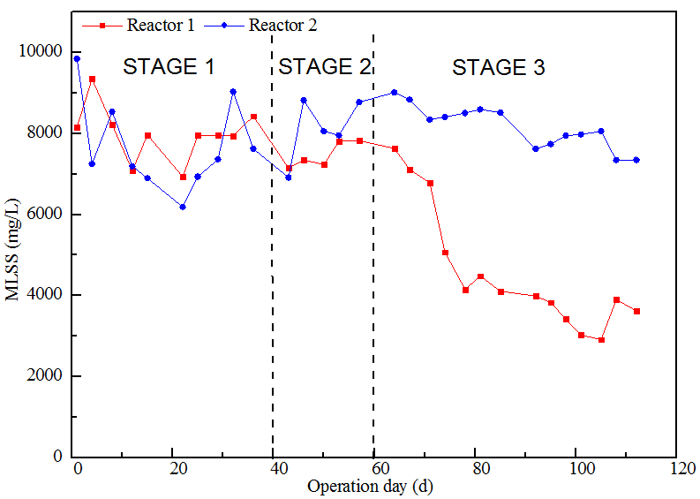
Figure S2. MLSS profile during the period of study.

Mass balance calculation
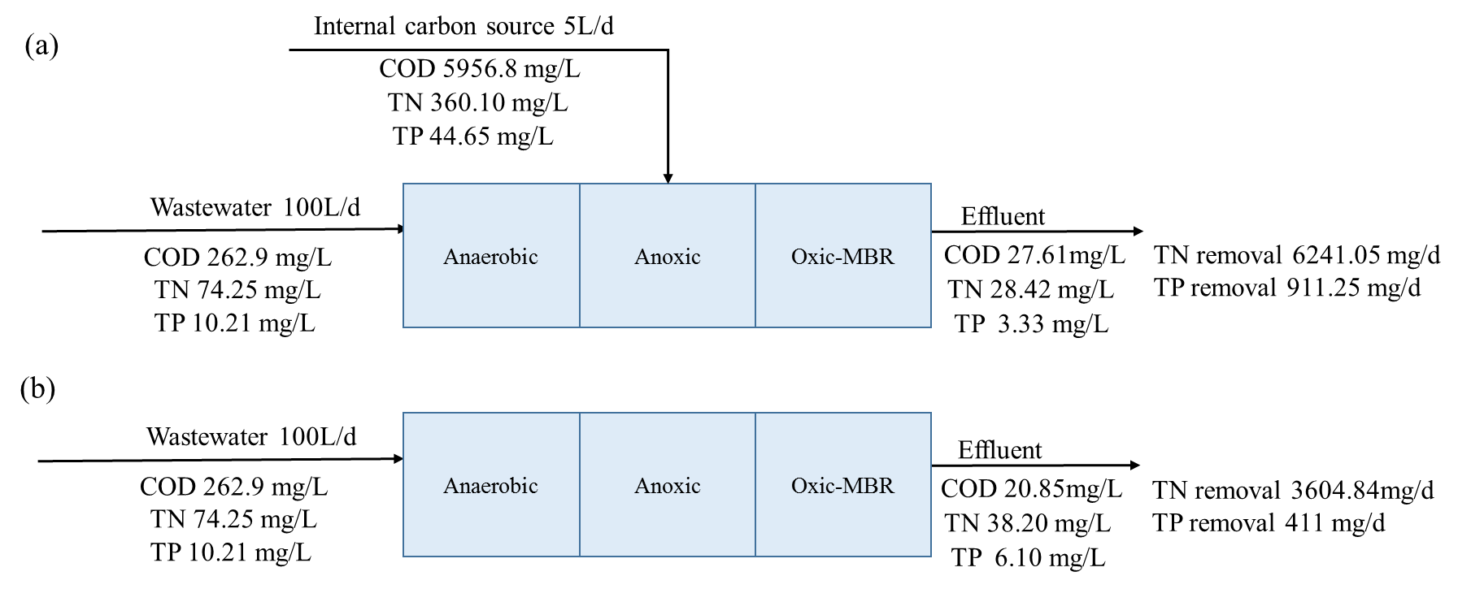
Figure S3. Mass balances of nitrogen and phosphorus in (a) A²/O-MBR-MHP, (b) A²/O-MBR
The mean value in Stage 3 was used to calculate the mass balance in two reactors.

References
[1] S.-H. Yoon, H.-S. Kim, and S. Lee, Incorporation of ultrasonic cell disintegration into a membrane bioreactor for zero sludge production, in Process Biochemistry, 2004, pp. 1923-1929.
[2] P. Kampas, S.A. Parsons, P. Pearce, S. Ledoux, P. Vale, E. Cartmell, and A. Soares, An internal carbon source for improving biological nutrient removal, in Bioresource Technology, 2009, pp. 149-154.
[3] Y.K. Oh, K.R. Lee, K.B. Ko, and I.T. Yeom, Effects of chemical sludge disintegration on the performances of wastewater treatment by membrane bioreactor, in Water Res, 2007, pp. 2665-71.
[4] J. Rajesh Banu, D.K. Uan, and I.-T. Yeom, Nutrient removal in an A²O-MBR reactor with sludge reduction, in Bioresource Technology, 2009, pp. 3820-3824.
[5] Y. Gao, Y. Peng, J. Zhang, S. Wang, J. Guo, and L. Ye, Biological sludge reduction and enhanced nutrient removal in a pilot-scale system with 2-step sludge alkaline fermentation and A2O process, in Bioresource Technology, 2011, pp. 4091-4097.
[6] T.-H. Kim, Y.-K. Nam, C. Park, and M. Lee, Carbon source recovery from waste activated sludge by alkaline hydrolysis and gamma-ray irradiation for biological denitrification, in Bioresource technology, 2009, pp. 5694-5699.
[7] H. Yuan, Y. Chen, H. Zhang, S. Jiang, Q. Zhou, and G. Gu, Improved bioproduction of short-chain fatty acids (SCFAs) from excess sludge under alkaline conditions, in Environmental science & technology, 2006, pp. 2025-2029.
[8] J. Tong, and Y. Chen, Recovery of nitrogen and phosphorus from alkaline fermentation liquid of waste activated sludge and application of the fermentation liquid to promote biological municipal wastewater treatment, in Water Research, 2009, pp. 2969-76.
[9] Y. Sakai, T. Fukase, H. Yasui, and M. Shibata, An activated sludge process without excess sludge production, in Water Science and Technology, 1997, pp. 163-170.
[10] S. Xia, J. Guo, and R. Wang, Performance of a pilot-scale submerged membrane bioreactor (MBR) in treating bathing wastewater, in Bioresource technology, 2008, pp. 6834-6843.
[11] J.S. Ventura, S. Seo, I. Chung, I. Yeom, H. Kim, Y. Oh, and D. Jahng, Enhanced reduction of excess sludge and nutrient removal in a pilot-scale A2O-MBR-TAD system, in Water Science & Technology, 2011, pp. 1547.

