Supporting Information

Transmembrane Anion Transport Mediated by Adamantyl-functionalized Imidazolium Salts

Julien Gravel and Andreea R. Schmitzer
Département de Chimie, Université de Montréal, Montréal, Canada
Université de Montréal, 2900 Edouard Montpetit, CP 6128, succ. Centre ville, Montréal, Québec, Canada. E-mail: ar.schmitzer@umontreal.ca

Table of content
General procedures 3
Synthesis 3
Lucigenin-based fluorescence assays 11
Preparation of EYPC liposomes for lucigenin-based fluorescence assays 11
Preparation of EYPC:Cholesterol liposomes for lucigenin-based fluorescence assays 11
Preparation of DPPC liposomes for lucigenin-based fluorescence assays 11
Lucigenin-based fluorescence assays with EYPC liposomes 11
Lucigenin-based fluorescence assays with EYPC:Cholesterol liposomes 12
Lucigenin-based fluorescence assays with DPPC liposomes 12
Tranport in EYPC:Cholesterol liposomes 12
Transport in DPPC liposomes 13
NMR Job’s plots 14
NMR Titrations 17
HPTS-based fluorescence assays 22
Preparation of EYPC liposomes for HPTS-based fluorescence assays 22
HPTS-based fluorescence assays with EYPC liposomes 23
U-tube experiments 23
References 24

Experimental

General procedures
All chemicals were purchased from Aldrich Chemicals and used without further purification. CDCl₃ were purchased from CDN Isoptopes. NMR experiments were recorded on Bruker Avance 300, Bruker Avance 400 and Bruker Avance 500. Mass spectral data were obtained by the Université de Montréal Mass Spectrometry Facility and were recorded on a Mass spectrometer TSQ Quantum Ultra (Thermo Scientific) with accurate mass options instrument. Fluorimetric studies were performed on a Varian Cary Eclipse Fluorescence spectrophotometer equipped with a temperature controller.

Synthesis
1,3-bis(adamantan-1-yl)imidazolium bromide (1a):
Adamantylamine (2 g, 13.2 mmol, 1 eq.) is solubilized in 20 mL of MeOH with formaldehyde 37% (1.04 mL, 14 mmol, 1.1 eq.) and agitated for 30 minutes at room temperature. Solubilized adamantylamine (2 g, 13.2 mmol, 1 eq.) in 20 mL of MeOH is slowly added over 1 hour. During this time, a solution of 20% HBr (3.84 mL, 14 mmol, 1.1 eq.) was cooled in the ice bath. Cold HBr 20% is added dropwise and the mixture is agitated 2 hours at room temperature. Glyoxal 40% (1.6 mL, 14 mmol, 1.1 eq.) is added dropwise and the reaction mixture is agitated overnight at reflux. The solvent are evaporated and the crude product is triturated with 20 mL of AcOEt and the precipitated solid is filtrated. The product is then treated with 250 mL of saturated NaHCO₃ and extracted with 3 portions of 200 mL of dichloromethane. The product is concentrated and purified by chromatography column using a 90%/10% dichloromethane/MeOH eluent. Combined fractions of the product were evaporated and triturated with 20 mL of AcOEt. The precipitate was filtrated and rinsed with 2 portions of 20 mL of AcOEt and dried to yield a white solid (1.1 g, 19%).
¹H NMR (CDCl₃, 500MHz): δ = 10.32 (t, J=1.7 Hz, 1 H), 7.44 (d, J=1.8 Hz, 2 H), 2.32 - 2.38 (m, 18 H), 1.84 - 1.89 (m, 6 H), 1.76 - 1.81 ppm (m, 6 H)
¹³C NMR (CDCl₃, 126MHz): δ = 134.3, 117.7, 61.2, 42.9, 35.3, 29.6 ppm
HRMS (ESI) for C₂₃H₃₃N₂: Calc. (m/z): 337.2648; found (m/z): 337.2648.

1,3-bis(adamantan-1-yl)imidazolium bis(trifluoromethylsulfonyl)imide (1b):
1,3-bis(adamantan-1-yl)imidazolium bromide (200 mg, 0.48 mmol, 1 eq.) was solubilized in a minimum amount of MeOH and an excess of LiNTf₂ (413mg, 1.44 mmol, 3 eq.) is added. The solution is heated to 50°C overnight. Solvent is evaporated and triturated in 50 mL of water. The precipitate is filtered to yield a white solid (223mg, 75%).
1H NMR (CDCl₃, 300MHz): δ = 8.59 (t, J=1.7 Hz, 1 H), 7.54 (d, J=1.7 Hz, 2 H), 2.32 (br. s., 6 H), 2.17 (d, J=2.9 Hz, 12 H), 1.80 ppm (d, J=2.9 Hz, 12 H)
13C NMR (CDCl₃, 75MHz): δ = 129.8, 119.9, 119.2, 60.9, 42.6, 35.2, 29.4 ppm
HRMS (ESI) for C₂₃H₃₃N₂: Calc. (m/z): 337.2638; found (m/z): 337.2648.
HRMS (ESI) for C₂F₆NO₄S₂: Calc. (m/z): 279.9178; found (m/z): 279.9176.

1-(bromomethyl)adamantane (2):
Adamantanemethanol (2 g, 12 mmol, 1 eq.) was introduced in 30 mL of concentrated hydrobromic acid and refluxed for 12 hours. The reaction mixture was cooled down to room temperature and was then diluted with 50 mL of distillated water. The aqueous layer is then extracted with dichloromethane (75 mL × 3). The combined organic extracts were washed with 100 mL of a saturated NaHCO₃ solution, with 100 mL of distillated water, with 100 mL of Brine. The organic extracts were dried over MgSO₄, filtered, and concentrated to yield a white powder (2.59 g, 94 %).
Characterization data are in accordance with literature.(1)
1-(2-bromoethyl)adamantane (3):

Adamantaneethanol (2 g, 11 mmol, 1 eq.) was introduced in 30 mL of concentrated hydrobromic acid and refluxed for 12 hours. The solution was cooled down to room temperature and was then diluted with 50 mL of distillated water. The aqueous layer is then extracted with dichloromethane (75 mL × 3). The combined organic extracts were washed with 100 mL of a saturated NaHCO3 solution, with 100 mL of distillated water and with 100 mL of Brine. The organic extracts were dried over MgSO4, filtered and concentrated to yield a white powder (2.45 g, 91 %).
Characterization data are in accordance with literature.(2)

1-(2-(adamantan-1-yl)methyl)imidazole (4):

Sodium hydroxide (312 mg, 7.8 mmol, 3 eq.) and imidazole were suspended in 20 mL of dry DMF and stirred for 2 hours under nitrogen atmosphere at room temperature. The resulting solution is added on 1-(bromomethyl)adamantane (600 mg, 2.6 mmol, 1 eq.) via a syringe and heated to 100°C overnight. The reaction mixture was cooled down to room temperature and quenched with methanol. Solvents were evaporated and the crude product was transferred in an Erlenmeyer using 100 mL of DCM and 150 mL of distillated water. The heterogeneous mixture was vigorously stirred for 20 min. and the organic layer was decanted, washed with 100 mL of Brine, dried over MgSO₄, and concentrated to yield a white solid (429 mg, 76 %).
¹H NMR (CDCl₃, 400MHz): δ = 7.39 (s, 1 H), 7.05 (s, 1 H), 6.84 (s, 1 H), 3.59 (s, 2 H), 2.01 (br. s., 3 H), 1.67 - 1.78 (m, 3 H), 1.56 - 1.64 (m, 3 H), 1.50 ppm (d, J=2.2 Hz, 6 H)
¹³C NMR (CDCl₃, 126MHz): δ = 138.3, 128.4, 120.6, 59.7, 40.3, 36.6, 34.1, 28.1 ppm
HRMS (ESI) for C₁₄H₂₁N₂: Calc. (m/z): 217.1699; found (m/z): 217.1689.
1-(2-(adamantan-1-yl)ethyl)imidazole (5):
Sodium hydroxide (493 mg, 12.3 mmol, 3 eq.) and imidazole were suspended in 20 mL of dry DMF and stirred for 2 hours under nitrogen atmosphere at room temperature. The resulting solution is added on 1-(2-bromoethyl)adamantane (1 g, 4.1 mmol, 1 eq.) via a syringe and heated to 40°C overnight. The reaction mixture was cooled down to room temperature and quenched with methanol. Solvents were evaporated and the crude product was transferred in an Erlenmeyer using 100 mL of DCM and 150 mL of distillated water. The heterogeneous mixture was vigorously stirred for 20 min. and the organic layer was decanted, washed with 100 mL of Brine, dried over MgSO₄, and concentrated to yield a pale yellow solid (850 mg, 89 %).
¹H NMR (CDCl₃, 400MHz): δ = 7.49 (s, 1 H), 7.07 (s, 1 H), 6.93 (s, 1 H), 3.92 - 3.99 (m, 2 H), 2.01 (br. s., 3 H), 1.71 - 1.80 (m, 3 H), 1.58 - 1.71 (m, 5 H), 1.56 ppm (br. s., 6 H)
¹³C NMR (CDCl₃, 101MHz): δ = 136.5, 128.9, 118.3, 45.0, 41.8, 41.7, 36.5, 31.5, 28.0 ppm
HRMS (ESI) for C₁₅H₂₃N₂: Calc. (m/z): 231.1856; found (m/z): 231.1856.
1-(2-(adamantan-1-yl)methyl)-2-methylimidazole (6):

Sodium hydroxide (260 mg, 6.5 mmol, 3 eq.) and 2-methylimidazole (536 mg, 6.5 mmol, 3 eq.) were suspended in 20 mL of dry DMF and stirred for 2 hours under nitrogen atmosphere at room temperature. The resulting solution is added on 1-(bromomethyl)adamantane (500 mg, 2.2 mmol, 1 eq.) via a syringe and heated to 100°C overnight. The reaction mixture was cooled down to room temperature and quenched with methanol. Solvents were evaporated and the crude product was transferred in an Erlenmeyer using 100 mL of DCM and 150 mL of distillated water. The heterogeneous mixture was vigorously stirred for 20 min. and the organic layer was decanted, washed with 100 mL of Brine, dried over MgSO₄, and concentrated to yield a white solid (443 mg, 88 %).
¹H NMR (CDCl₃, 300MHz): δ = 6.88 (s, 1 H), 6.74 (s, 1 H), 3.49 (s, 2 H), 2.36 (s, 3 H), 1.99 (br. s., 3 H), 1.65 - 1.76 (m, 3 H), 1.54 - 1.64 (m, 3 H), 1.51 ppm (d, J=2.0 Hz, 6 H)
¹³C NMR (CDCl₃, 75MHz): δ = 145.3, 126.2, 121.2, 58.2, 40.6, 36.6, 35.2, 28.1, 13.7 ppm
HRMS (ESI) for C₁₅H₂₃N₂: Calc. (m/z): 231.1856; found (m/z): 231.1866.
1-(2-(adamantan-1-yl)ethyl)-2-methylimidazole (7):

Sodium hydroxide (100 mg, 2.5 mmol, 3 eq.) and 2-methylimidazole (205 mg, 2.5 mmol, 3 eq.) were suspended in 15 mL of dry DMF and stirred for 2 hours under nitrogen atmosphere at room temperature. The resulting solution is added on 1-(2-bromoethyl)adamantane (205 mg, 0.82 mmol, 1 eq.) via a syringe and heated to 40°C overnight. The reaction mixture was cooled down to room temperature and quenched with methanol. Solvents were evaporated and the crude product was transferred in an Erlenmeyer using 100 mL of DCM and 150 mL of distillated water. The heterogeneous mixture was vigorously stirred for 20 min. and the organic layer was decanted, washed with 100 mL of Brine, dried over MgSO₄, and concentrated to yield a pale brown solid (161 mg, 81 %).
¹H NMR (CDCl₃, 400MHz): δ = 6.92 (s, 1 H), 6.82 (s, 1 H), 3.77 - 3.89 (m, 2 H), 2.39 (s, 3 H), 2.02 (br. s., 3 H), 1.75 - 1.78 (m, 3 H), 1.64 - 1.71 (m, 3 H), 1.58 (d, J=2.0 Hz, 6 H), 1.47 - 1.54 ppm (m, 2 H)
¹³C NMR (CDCl₃, 126MHz): δ = 127.1, 118.8, 45.1, 42.2, 41.1, 37.0, 31.9, 28.5, 29.6 13.0 ppm
HRMS (ESI) for C₁₆H₂₅N₂: Calc. (m/z): 245.2012; found (m/z): 245.2003.
1,3-bis(2-(adamantan-1-yl)methyl)imidazolium bromide (8a):

1-(2-(adamantan-1-yl)methyl)imidazole (500 mg, 2.3 mmol, 1 eq.) is solubilized with 1-(2-bromomethyl)adamantane (583 mg, 2.5 mmol, 1.1 eq.) in 5 mL of NMP in a sealed vial and were heated using a Biotage® Initiator Classic Microwave Synthesizer at 200°C for 2 hours. The NMP is evaporated and the crude mixture is triturated with 20 mL AcOEt. The precipitate is filtrated and dried to yield a white solid (717 mg, 70 %).
¹H NMR (CDCl₃, 500MHz): δ = 10.51 (s, 1 H), 7.21 (d, J=1.5 Hz, 2 H), 4.11 (s, 4 H), 2.05 (br. s., 6 H), 1.70 – 1.78 (m, 6 H), 1.58 - 1.64 (m, 6 H), 1.57 ppm (d, J=2.6 Hz, 12 H)
¹³C NMR (CDCl₃, 126MHz): δ = 139.0, 122.6, 61.4, 39.8, 36.3, 34.1, 27.9 ppm
HRMS (ESI) for C₂₅H₃₇N₂: Calc. (m/z): 365.2951; found (m/z): 365.2944.

1,3-bis(2-(adamantan-1-yl)methyl)imidazolium bis(trifluorometylsulfonyl)imide (8b):
1,3-bis(2-(adamantan-1-yl)ethyl)imidazolium bromide (150mg, 0.34 mmol, 1 eq.) is solubilized in a minimum amount of MeOH and an excess of LiNTf₂ (290mg, 1.01 mmol, 3 eq.) is added. The solution is heated to 50°C overnight. Solvent is evaporated and triturated in 50 mL of water. The precipitate is filtered to yield a white solid (196mg, 90%).
¹H NMR (CDCl₃, 300MHz): δ = 8.75 (s, 1 H), 7.11 (d, J=1.7 Hz, 2 H), 3.93 (s, 4 H), 2.06 (br. s., 6 H), 1.69 - 1.81 (m, 6 H), 1.55 - 1.66 (m, 6 H), 1.50 ppm (d, J=2.7 Hz, 12 H)
¹³C NMR (CDCl₃, 101MHz): δ = 137.2, 123.1, 119.8, 61.7, 39.7, 36.3, 34.0, 27.9 ppm
¹⁹F NMR (CDCl₃, 282MHz): δ = -80.2 ppm
HRMS (ESI) for C₂₅H₃₇N₂: Calc. (m/z): 365.2951; found (m/z): 365.2943.
HRMS (ESI) for C₂F₆NO₄S₂: Calc. (m/z): 279.9178; found (m/z): 279.9183.
1,3-bis(2-(adamantan-1-yl)ethyl)imidazolium bromide (9a):
1-(2-(adamantan-1-yl)ethyl)imidazole (500 mg, 2.2 mmol, 1 eq.) is solubilized with 1-(2-bromoethyl)adamantane (792 mg, 3.3 mmol, 1.5 eq.) in 20 mL of acetonitrile and were heated to reflux during 72 hours. The solvent is evaporated and the crude mixture is triturated with 20 mL AcOEt. The precipitate is filtrated, rinsed with 2 portions of 20 mL of AcOEt, and dried to yield a white solid (722 mg, 70 %).
¹H NMR (CDCl₃, 400MHz): δ = 10.80 (s, 1 H), 7.27 (s, 2 H), 4.33 - 4.43 (m, 4 H), 2.00 (br. s., 6 H), 1.56 - 1.78 ppm (m, 28 H)
¹³C NMR (CDCl₃, 400MHz): δ = 213.1, 208.9, 189.9, 189.6, 189.0, 187.6, 186.5, 185.5 ppm
HRMS (ESI) for C₂₇H₄₁N₂: Calc. (m/z): 393.3264; found (m/z): 393.3269.

1,3-bis(2-(adamantan-1-yl)ethyl)imidazolium tetrafluoroboride (9b):
1,3-bis(2-(adamantan-1-yl)ethyl)imidazolium bromide (50 mg, 0.11 mmol, 1 eq.) is solubilized in a minimum amount of MeOH and an excess of NaBF₄ (35 mg, 0.32 mmol, 3 eq.) is added. The solution is heated to 50°C overnight. Solvents are evaporated and triturated in 50 mL of water. The precipitate is filtered to yield a white solid (47 mg, 89%).
¹H NMR (CDCl₃, 400MHz): δ = 8.98 (br. s., 1 H), 7.33 (s, 2 H), 4.15 - 4.30 (m, 4 H), 1.99 (br. s., 6 H), 1.53 - 1.80 ppm (m, 28 H)
¹³C NMR (CDCl₃, 101MHz): δ = 135.7, 121.6, 45.4, 43.9, 41.6, 36.4, 31.7, 28.0 ppm
¹⁹F NMR (CDCl₃, 282MHz): δ = -151.3 ppm
HRMS (ESI) for C₂₇H₄₁N₂: Calc. (m/z): 393.3264; found (m/z): 393.3269.

1,3-bis(2-(adamantan-1-yl)ethyl)imidazolium hexafluorophosphate (9c):
1,3-bis(2-(adamantan-1-yl)ethyl)imidazolium bromide (50 mg, 0.11 mmol, 1 eq.) is solubilized in a minimum amount of MeOH and an excess of KPF₆ (59mg, 0.32 mmol, 3 eq.) is added. The solution is heated to 50°C overnight. Solvent is evaporated and triturated in 50 mL of water. The precipitate is filtered to yield a white solid (54 mg, 92%).
¹H NMR (CDCl₃, 400MHz): δ = 9.08 (br. s., 1 H), 7.25 (br. s., 2 H), 4.23 (br. s., 4 H), 2.01 (br. s., 6 H), 1.50 - 1.81 ppm (m, 28 H)
¹³C NMR (CDCl₃, 126MHz): δ = 135.7, 122.1, 45.8, 44.2, 41.9, 36.8, 32.0, 28.4 ppm
¹⁹F NMR (CDCl₃, 282MHz): δ = -71.0, -73.5 ppm
³¹P NMR (CDCl₃, 162MHz): δ = -143 ppm.
HRMS (ESI) for C₂₇H₄₁N₂ : Calc. (m/z): 393.3264; found (m/z): 393.3267.
HRMS (ESI) for F₆P: Calc. (m/z): 144.9647; found (m/z): 144.9647.

1,3-bis(2-(adamantan-1-yl)ethyl)imidazolium bis(trifluorometylsulfonyl)imide (9d):

1,3-bis(2-(adamantan-1-yl)ethyl)imidazolium bromide (50 mg, 0.11 mmol, 1 eq.) is solubilized in a minimum amount of MeOH and an excess of LiNTf₂ (92mg, 0.32 mmol, 3 eq.) is added. The solution is heated to 50°C overnight. Solvent is evaporated and triturated in 50 mL of water. The precipitate is filtered to yield a white solid (67 mg, 91%).
¹H NMR (CDCl₃, 400MHz): δ = 9.02 (s, 1 H), 7.22 (s, 2 H), 4.22 - 4.29 (m, 4 H), 2.02 (br. s., 6 H), 1.72 - 1.79 (m, 6 H), 1.64 - 1.71 (m, 10 H), 1.57 ppm (s, 10 H)
¹³C NMR (CDCl₃, 126MHz): δ = 135.5, 122.2, 119.8, 45.9, 44.2, 41.9, 36.7, 32.0, 28.4 ppm
¹⁹F NMR (CDCl₃, 282MHz): δ = -78.8 ppm
HRMS (ESI) for C₂₇H₄₁N₂: Calc. (m/z): 393.3264; found (m/z): 393.3270.
HRMS (ESI) for C₂F₆NO₄S₂: Calc. (m/z): 279.9178; found (m/z): 279.9182.
1,3-bis(2-(adamantan-1-yl)methyl)-2-methylimidazolium bromide (10a):
1-(2-(adamantan-1-yl)methyl)-2-methylimidazole (80mg, 0.35 mmol, 1 eq.) is solubilized with 1-(2-bromomethyl)adamantane (160 mg, 2.5 mmol, 2 eq.) in 2 mL of NMP in a sealed vial and were heated using a Biotage® Initiator Classic Microwave Synthesizer at 200°C for 2 hours. The NMP is evaporated and the crude mixture is triturated with 20 mL AcOEt. The precipitate is filtrated and dried to yield a white solid (116 mg, 71 %).
¹H NMR (CDCl₃, 400MHz): δ = 7.38 (s, 2 H), 4.01 (s, 4 H), 2.81 (s, 3 H), 2.07 (br. s., 6 H), 1.72 - 1.80 (m, 6 H), 1.61 - 1.68 (m, 6 H), 1.59 ppm (s, 12 H)
¹³C NMR (CDCl₃, 101MHz): δ = 144.9, 122.8, 60.6, 40.4, 36.3, 35.4, 27.9, 12.5 ppm
HRMS (ESI) for C₂₆H₃₉N₂: Calc. (m/z): 379.3108; found (m/z): 379.3118.

1,3-bis(2-(adamantan-1-yl)methyl)-2-methylimidazolium bis(trifluorometylsulfonyl)imide (10b):
1,3-bis(2-(adamantan-1-yl)methyl)-2-methylimidazolium bromide (115mg, 0.25 mmol, 1 eq.) is solubilized in a minimum amount of MeOH and an excess of LiNTf₂ (215mg, 0.75 mmol, 3 eq.) is added. The solution is heated to 50°C overnight. Solvent is evaporated and triturated in 50 mL of water. The precipitate is filtered to yield a white solid (143mg, 87%).
¹H NMR (CDCl₃, 300MHz): δ = 7.13 (s, 2 H), 3.83 (s, 4 H), 2.63 (s, 3 H), 2.07 (br. s., 6 H), 1.72 - 1.80 (m, 6 H), 1.58 - 1.66 (m, 6 H), 1.54 ppm (d, J=2.4 Hz, 12 H)
¹³C NMR (CDCl₃, 101MHz): δ = 144.6, 122.6, 120.0, 60.4, 40.2, 36.2, 35.3, 27.8, 11.3 ppm
¹⁹F NMR (CDCl₃, 282MHz): δ = -80.1 ppm
HRMS (ESI) for C₂₆H₃₉N₂: Calc. (m/z): 379.3108; found (m/z): 379.3108
HRMS (ESI) for C₂F₆NO₄S₂: Calc. (m/z): 279.9178; found (m/z): 279.9175.

1,3-bis(2-(adamantan-1-yl)ethyl)-2-methylimidazolium bromide (11a):

1-(2-(adamantan-1-yl)ethyl)-2-methylimidazole (500mg, 2.1 mmol, 1 eq.) is solubilized with 1-(2-bromoethyl)adamantane (747 mg, 3.1 mmol, 1.5 eq.) in 20 mL of acetonitrile and were heated to reflux 72 hours. The solvent is evaporated and the crude mixture is triturated with 20 mL AcOEt. The precipitate is filtrated, rinsed with 2 portions of 20 mL of AcOEt, and dried to yield a white solid (804 mg, 67 %).
¹H NMR (CDCl₃, 500MHz): δ = 7.52 (s, 2 H), 4.20 - 4.25 (m, 4 H), 2.79 (s, 3 H), 2.01 (br. s., 6 H), 1.71 - 1.77 (m, 6 H), 1.63 - 1.68 (m, 6 H), 1.55 - 1.61 ppm (m, 16 H)
¹³C NMR (CDCl₃, 126MHz): δ = 142.8, 121.5, 44.6, 44.1, 42.1, 36.7, 32.1, 28.4, 11.0 ppm
HRMS (ESI) for C₂₈H₄₃N₂: Calc. (m/z): 407.3421; found (m/z): 407.3418.

1,3-bis(2-(adamantan-1-yl)ethyl)-2-methylimidazolium bis(trifluorometylsulfonyl)imide (11b):
1,3-bis(2-(adamantan-1-yl)ethyl)-2-methylimidazolium bromide (200 mg, 0.41 mmol, 1 eq.) is solubilized in a minimum amount of MeOH and an excess of LiNTf₂ (353mg, 1.23 mmol, 3 eq.) is added. The solution is heated to 50°C overnight. Solvent is evaporated and triturated in 50 mL of water. The precipitate is filtered to yield a white solid (246mg, 87%).
¹H NMR (CDCl₃, 300MHz): δ = 7.19 (s, 2 H), 4.04 - 4.12 (m, 4 H), 2.60 - 2.64 (m, 3 H), 2.02 (br. s., 6 H), 1.71 - 1.81 (m, 6 H), 1.62 - 1.71 (m, 6 H), 1.50 - 1.61 ppm (m, 16 H)
¹³C NMR (CDCl₃, 101MHz): δ = 142.8, 121.0, 120.0, 44.4, 43.8, 42.0, 36.7, 32.0, 28.4, 9.7 ppm
¹⁹F NMR (CDCl₃, 282MHz): δ = -80.1 ppm
HRMS (ESI) for C₂₈H₄₃N₂: Calc. (m/z): 407.3421; found (m/z): 407.3435
HRMS (ESI) for C₂F₆NO₄S₂: Calc. (m/z): 279.9178; found (m/z): 279.9171.

Lucigenin-based fluorescence assays

Preparation of EYPC liposomes for lucigenin-based fluorescence assays
A lipid film was formed by evaporating a chloroform solution containing 50 mg or 25 mg of EYPC lipids (Egg Yolk Phosphatidyl Choline) under reduced pressure at 25°C for at least 2 hours. The lipid film was then hydrated with 500 μL of a 2 mM lucigenin solution containing 100 mM NaCl and 10 mM NaH₂PO₄/Na₂HPO₄ buffer (pH = 6.2). The resulting suspension was then subjected to at least 10 freeze/thaw cycles (1 minute at -78°C followed by 1 minute at 35°C) and vortexed for 30 seconds between each cycles. The suspension is then extruded through a 100 nm polycarbonate membrane 21 times. The liposomes are purified through a Sephadex G-25 column to remove the extravesicular lucigenin dye using a 100 mM NaNO₃ and 10 mM NaH₂PO₄/Na₂HPO₄ buffer (pH = 6.2) eluent. The isolated liposomes were diluted to 10 mM (50 mg of EYPC) or 5 mM (25 mg of EYPC) relative to the lipid, assuming all EYPC was conserved through manipulations.

Preparation of EYPC:Cholesterol liposomes for lucigenin-based fluorescence assays
The procedures are the same as the Preparation of EYPC liposomes for lucigenin-based fluorescence assays, except that cholesterol was added in proportion of 7:3 EYPC:Cholesterol in the chloroform solution.

Preparation of DPPC liposomes for lucigenin-based fluorescence assays
The procedures are the same as the Preparation of EYPC liposomes for lucigenin-based fluorescence assays, except that EYPC is replaced by Dipalmitoylphosphatidylcholine (DPPC).

Lucigenin-based fluorescence assays with EYPC liposomes
A 50 μL (10 mM EYPC liposomes stock solution) or 100 μL (5 mM EYPC liposomes stock solution) aliquot of liposomes solution was added to a 2.5 mL solution containing 10 mM NaH₂PO₄/Na₂HPO₄ buffer (pH = 6.2) and 100 mM salt (salt = NaCl, NaNO₃, NaHCO₃, Na₂SO₄, NaClO₄). The lucigenin fluorescence was monitored by excitation at λ_{ex} = 372 nm and the emission was recorded at λ_{em} = 503 nm. At t = 50 s, 50 μL of solution of transporter at different concentrations in MeOH were added, and at t = 300 s, 100 μL of a Triton-X 5% (V/V) solution were added in order to lyse the liposomes and observe maximal lucigenin fluorescence in solution. The temperature was set to 25°C. Experiments were repeated in triplicate and all traces reported are the average of the three trials.

Lucigenin-based fluorescence assays with EYPC:Cholesterol liposomes
The procedures are the same as the Lucigenin-based fluorescence assays with EYPC liposomes, except that it was a EYPC:Cholesterol 7:3 liposomes stock solution.

Lucigenin-based fluorescence assays with DPPC liposomes
The procedures are the same as the Lucigenin-based fluorescence assays with EYPC liposomes, except that it was a DPPC liposomes stock solution with the temperature set to 30°C or 40°C.

Tranport in EYPC:Cholesterol liposomes
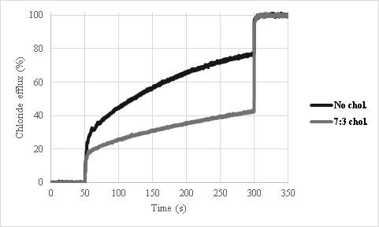
Figure S1. Relative chloride transport activity of imidazolium salt 9a at 20 mol% relative to EYPC or EYPC:Cholesterol (7:3). Intravesicular: 2 mM lucigenin, 100 mM NaCl, 10 mM phosphate buffer (pH=6.2). Extravesicular: 100 mM NaNO3, 10 mM phosphate buffer (pH=6.2).
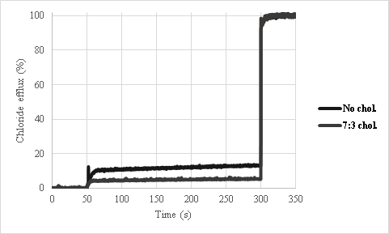
Figure S2. Relative chloride transport activity of imidazolium salt 11b at 20 mol% relative to EYPC or EYPC:Cholesterol (7:3). Intravesicular: 2 mM lucigenin, 100 mM NaCl, 10 mM phosphate buffer (pH=6.2). Extravesicular: 100 mM NaNO₃, 10 mM phosphate buffer (pH=6.2).

Transport in DPPC liposomes
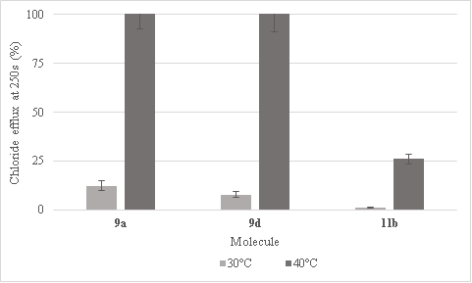
Figure S3. Relative chloride transport activity of imidazolium salts at 15 mol% relative to DPPC. Intravesicular: 2 mM lucigenin, 100 mM NaCl, 10 mM phosphate buffer (pH=6.2). Extravesicular: 100 mM NaNO₃, 10 mM phosphate buffer (pH=6.2).

NMR Job’s plots
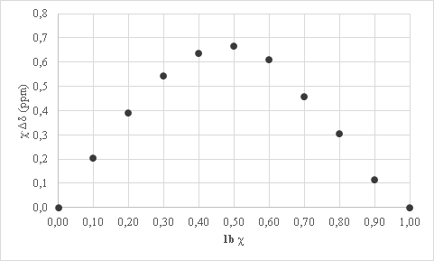
Figure S4. 1b NMR Job’s plot with TBAC salt in CDCl₃. Total concentration = 12,5mM. Effect on H2 proton signal.
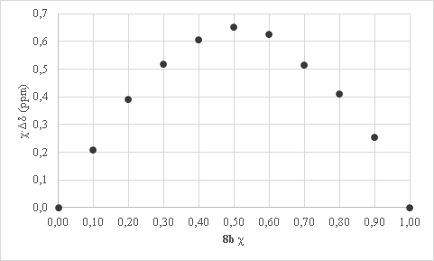
Figure S5. 8b NMR Job’s plot with TBAC salt in CDCl₃. Total concentration = 12,5mM. Effect on H2 proton signal.
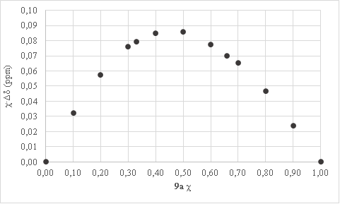
Figure S6. 9a NMR Job’s plot with TBAC salt in CDCl₃. Total concentration = 12.5mM (effect on the H2 proton).

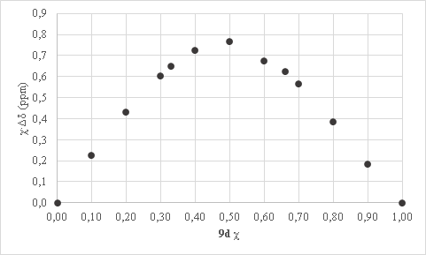
Figure S7. 9d NMR Job’s plot with TBAC salt in CDCl₃. Total concentration = 12.5mM (effect on the H2 proton).
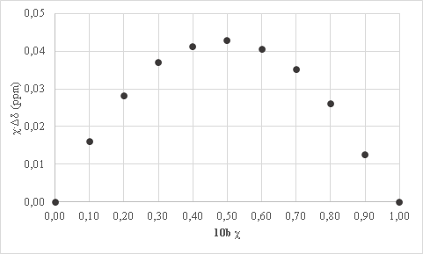
Figure S8. 10b NMR Job’s plot with TBAC salt in CDCl₃. Total concentration = 12.5mM (effect on the H2 proton).
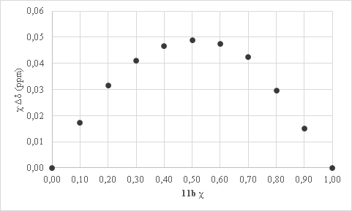
Figure S9. 11b NMR Job’s plot with TBAC salt in CDCl₃. Total concentration = 12.5mM (effect on the H2 proton).

NMR Titrations
A)
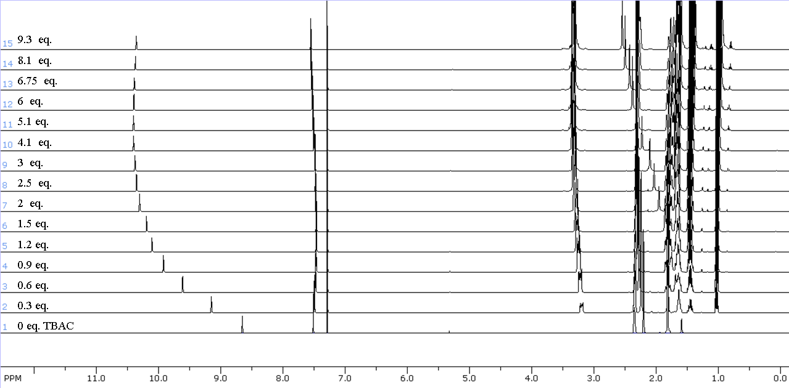
B)
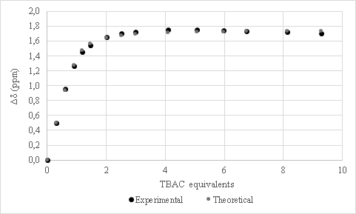
Figure S10. Stacked 1H NMR spectra (A) and titration curves (B) of [1b] = 12.5mM with TBAC (400 MHz, CDCl₃, 298 K).

A)
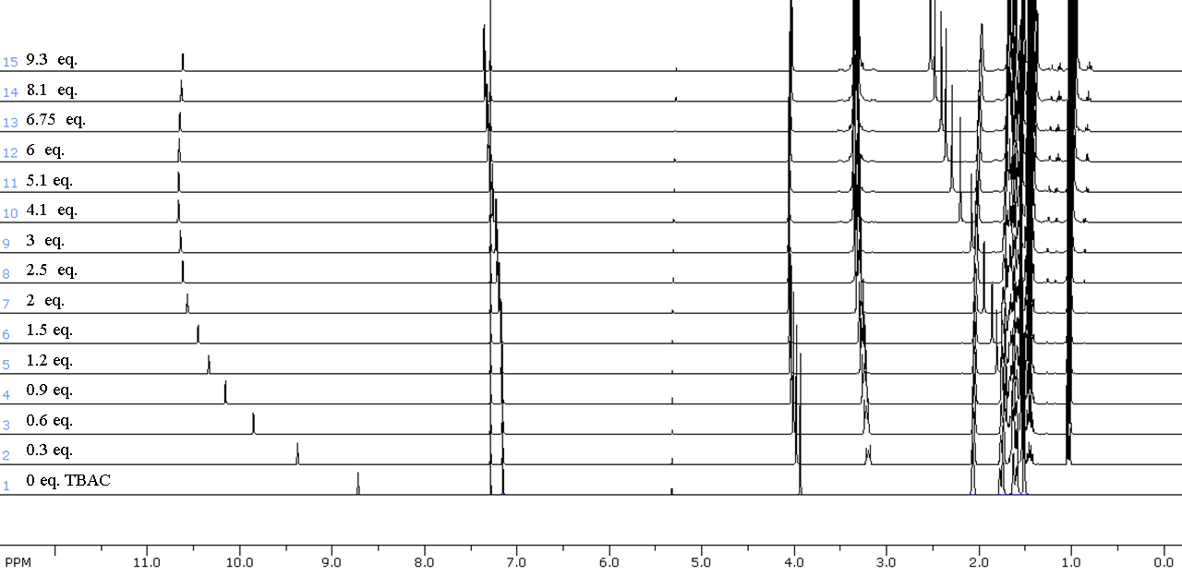
B)
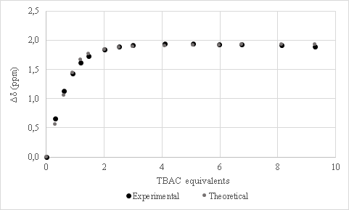
Figure S11. Stacked 1H NMR spectra (A) and titration curves (B) of [8b] = 12.5mM with TBAC (400 MHz, CDCl₃, 298 K).

A)
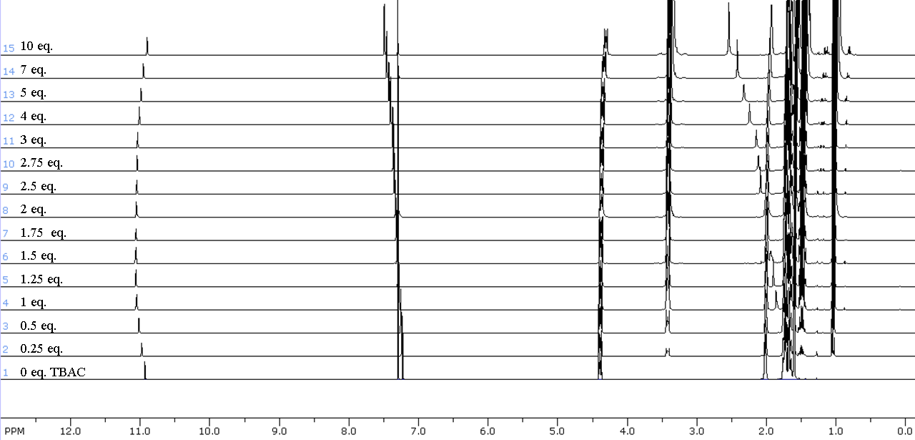
B)
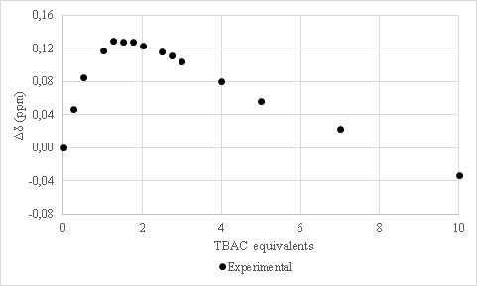
Figure S12. Stacked 1H NMR spectra (A) and titration curves (B) of [9a] = 12.5mM with TBAC (400 MHz, CDCl₃, 298 K).

A)
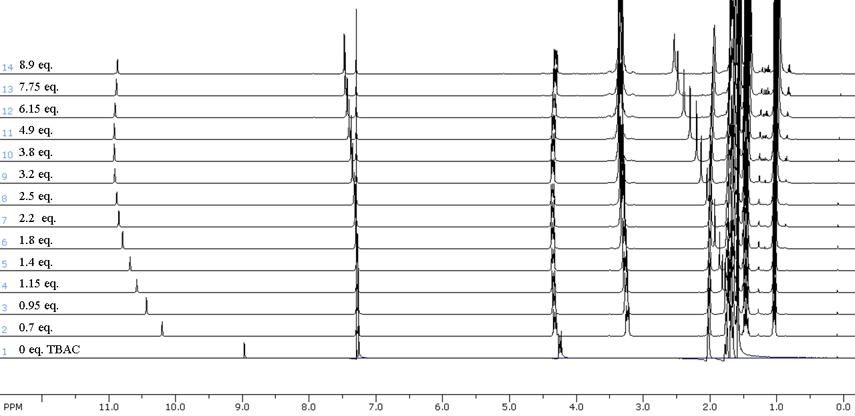
B)
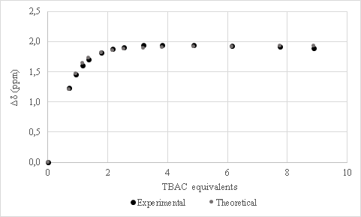
Figure S13. Stacked 1H NMR spectra (A) and titration curves (B) of [9d] = 12.5mM with TBAC (400 MHz, CDCl₃, 298 K).

A)
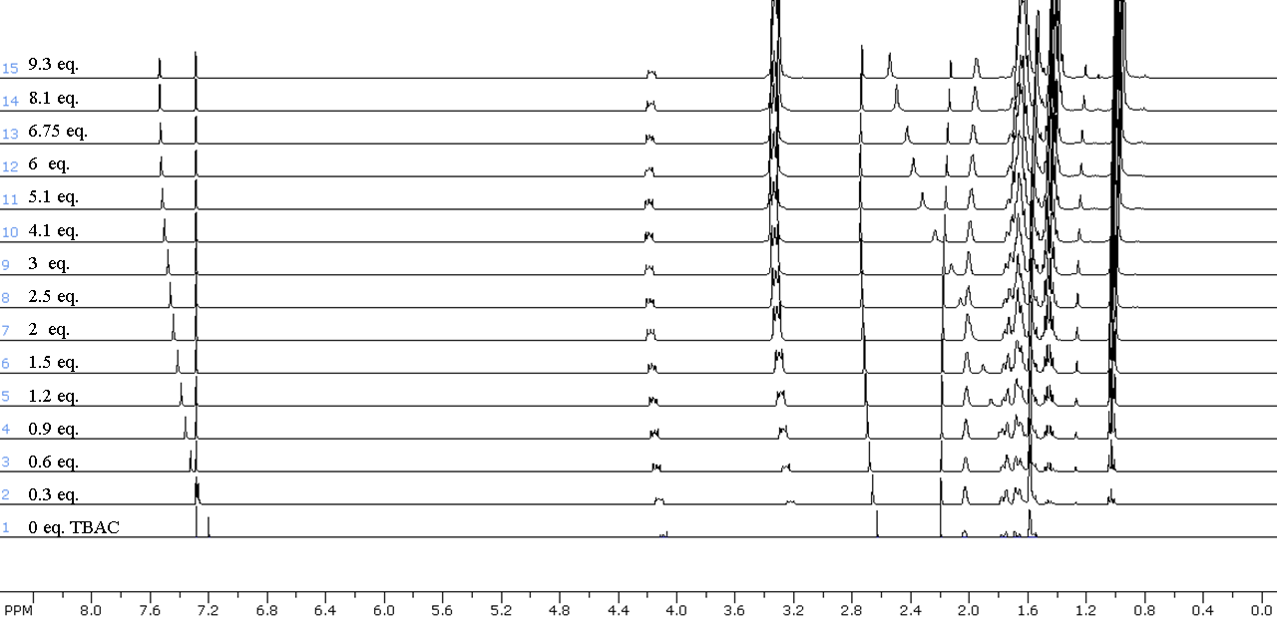
B)
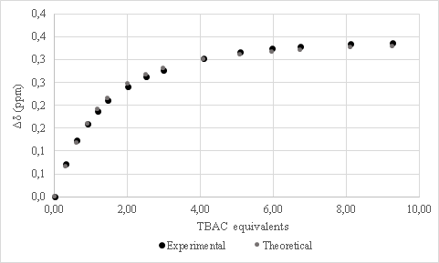
Figure S14. Stacked 1H NMR spectra (A) and titration curves (B) of [10b] = 12.5mM with TBAC (400 MHz, CDCl₃, 298 K).

A)
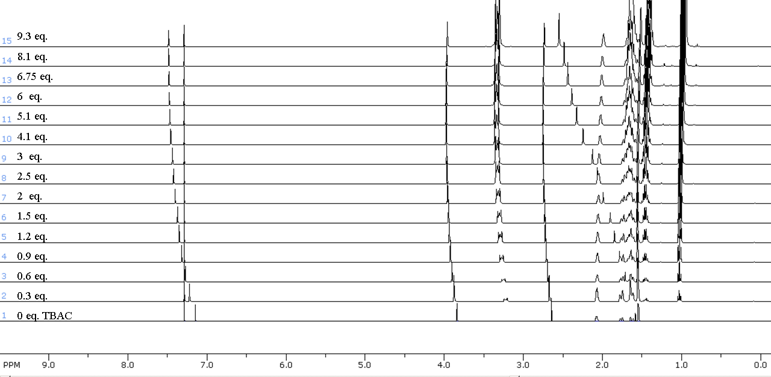
B)
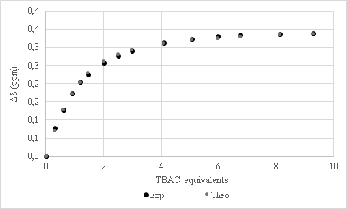
Figure S15. Stacked 1H NMR spectra (A) and titration curves (B) of [_{11b}] = 12.5mM with TBAC (400 MHz, CDCl₃, 298 K).

HPTS-based fluorescence assays

Preparation of EYPC liposomes for HPTS-based fluorescence assays
The procedures are the same as the Preparation of EYPC liposomes for lucigenin-based fluorescence assays, except that the lucigenin is replaced by a HPTS solution of 0.1 mM containing 100 mM of NaCl or NaClO₄.

HPTS-based fluorescence assays with EYPC liposomes
The procedures are the same as the Lucigenin-based fluorescence assays with EYPC liposomes, except that it was with the liposomes containing the HPTS probe.
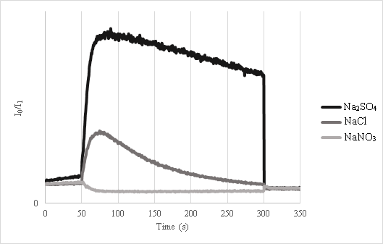
Figure S16. HPTS-based transport assay of imidazolium salt 9d at 15 mol% relative to EYPC. Intravesicular: 0.1 HPTS, 100 mM NaOCl₄, 10 mM phosphate buffer (pH=6.2). Extravesicular: 100 mM NaX or Na2X, 10 mM phosphate buffer (pH=6.2).

U-tube experiments
U-tube experiment is performed in a U-shaped glass tube in which two aqueous phases are separated by a bulk hydrophobic solvent, such as chloroform (Figure S17).(3) U-tube experiment was performed with transporter 9d in order to confirm the carrier transport mechanism.
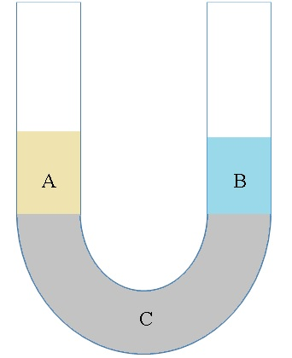
Figure S17. U-tube experiment scheme. A: Aqueous phase containing 0.1 mM Lucigenin (water, 5 mL). B: Receiving phase (water, 5 mL). C: Bulk organic phase (CHCl₃, 10 mL) with transporter 9d (1mM) or without.
If transporter 9d is able to carry NO₃⁻ anions that are paired with the lucigenin dication across the bulk organic solvent, fluorescence should increase over time.
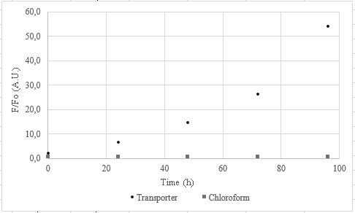
Figure S18. U-tube experiment results. Experiment conditions are shown in Figure S17.
U-tube experiments are conclusive with compound 9d transporting NO₃⁻ using a carrier mechanism. Paired with EYPC:Cholesterol and DPPC studies, we believe it is strong evidence that molecule 9d transport anion following a carrier mechanism.

References
(1) Shahane, S.; Toupet, L.; Fischmeister, C.; Bruneau, C. Eur. J. Inorg. Chem. 2013, 54.
(2) Belser, T.; Stöhr, M.; Pfaltz, A. J. Am. Chem. Soc. 2005, 127, 8720.
(3) Gokel, G. W.; Daschbach, M. M. Coord. Chem. Rev. 2008, 252, 886.

