The reactions of non-gem-hexanedioxytetrachlorocyclotriphosphazene with 2-(2-hydroxyethyl)thiophene, benzyl alcohol and 1,1,3,3-tetramethylguanidine. Spectroscopic studies of the derived products.
Sedat Ture*¹ and Özge Kücük¹
¹Faculty of Arts & Sciences, University of Bilecik, Seyh Edabali, Bilecik, Turkey
Department of Natural & Environmental Sciences, Chemistry, Southampton University, UK.

E-mail: s.ture@yahoo.com
Supplemental Materials
Synthesis of 2,4,6,6-tetrachloro-2,4-(hexane-1,6-dioxy)cyclotriphosphazatriene, N₃P₃Cl₄[O(CH₂)₆O] (1):
Compound 1 was synthesized and evaluated using conventional methods according to the literature [32, 43]. Cyclochlorotriphosphazene, N₃P₃Cl₆, (8 g, 22.99 mmol) was dissolved in THF (150 mL) and placed in a 500 mL three-necked round-bottomed flask. The reaction mixture was cooled in an ice-bath and to the stirred solution, pyridine (7.27 g, 91.95 mmol) in dry THF (20 mL) was quickly added under an argon atmosphere. Solid 1,6-hexane-diol (5.42 g., 45.98 mmol) in dry THF (25 mL) was then added dropwise to the reaction mixture whiles stirring at room temperature (1 h). Then the reaction mixture was left stirring for a further 36 h and the reaction was followed on TLC silica gel plates using benzene/diethyl ether (3:1). After attaining room temperature, the pyridine hydrochloride and the other insoluble materials were filtered off and the filtrate was concentrated (25 mL). TLC revealed the formation of the two major and two minor compounds. Separation of these compounds was achieved by using column chromatography (240 g, silica gel, and a solvent system of benzene: diethyl ether (4:1) as the eluent. Fractions containing the major compounds were collected, taken to dryness, and then the residue recrystallized from light petroleum (b.p. 40-60 ⁰C) containing a few drops of benzene. (i) The first cyclophosphazene derivative was identified as the isomeric mono spiro derivative, N₃P₃Cl₄[O(CH₂)₆O] (3.2%). (ii) The second compound was identified as single-bridged derivative, N₃P₃Cl₅[O(CH₂)₆O]₂N₃P₃Cl₅ (6.4%). (iii) The third compound was identified as the mono-ansa compound, N₃P₃Cl₄[O(CH₂)₆O], 2,4,6,6-tetrachloro-2,4-(hexane-1,6-dioxy)cyclotriphosphazatriene (1), an oil, yield 1.16 g (25.3%). Anal. Cal. for C₆H₁₂O₂N₃P₃Cl₄ (M, 392.9); C, 18.34: H, 3.08; N, 10.69%. Found: C, 18.37; H, 3.13; N, 10.68%; [M+H]⁺, 393.7. ¹H NMR, 298 K (CDCl₃); δPOCH₂: 4.32/4.15, δPOCCH₂: 1.70, δPOCCCH₂:1.57/1.38 ³J(PH): 21.0/22.70 Hz. ³¹P NMR, (CDCl₃), δPCl₂: 26.90, δP(OR)Cl: 19.92, ²J[PCl₂–P(OR)Cl]: 67.3 Hz.
(iv) The fourth compound was identified as the double-bridged derivative, N₃P₃Cl₄[O(CH₂)₆O]₂N₃P₃Cl₄ derivatives (48%). (v) The fifth compound was identified as tri-bridged, N₃P₃Cl₃[O(CH₂)₆O]₃N₃P₃Cl₃ derivative (17.1%).

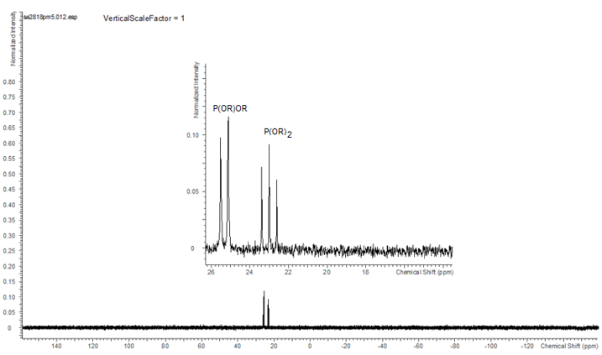
Figure S 1. {³¹P-¹H} decoupled NMR spectrum of compound 6, in CDCl₃ at 162.00 MHz, (room temperature), referenced to external 85% H₃PO₄.

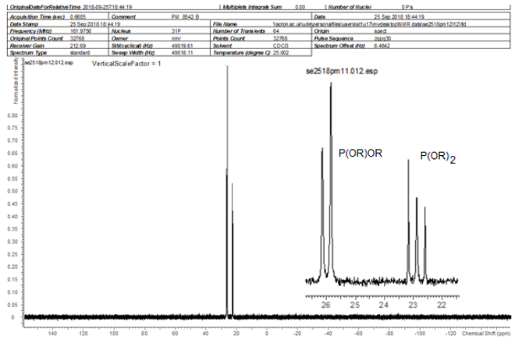
Figure S 2. {³¹P-¹H} decoupled NMR spectrum of compound 8, in CDCl₃ at 162.00 MHz, (room temperature), referenced to external 85% H₃PO₄.

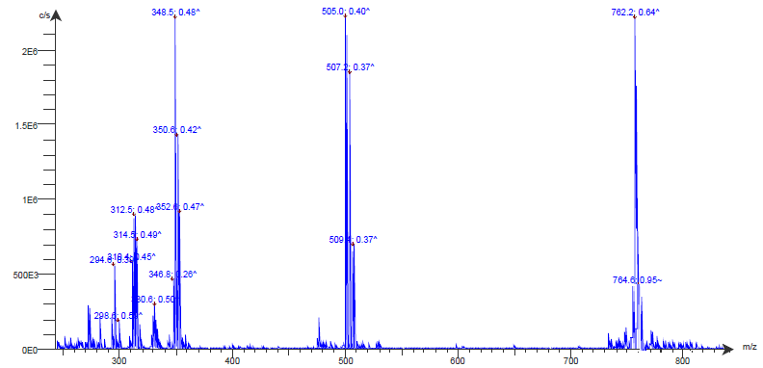
Figure S 3: TLC-MS spectrum of compound 6.

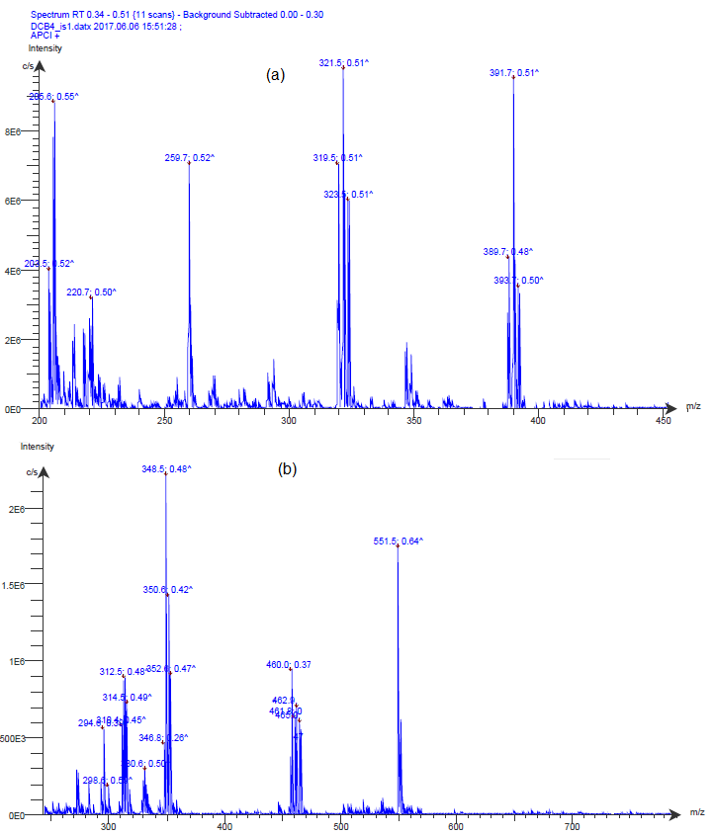
Figure S 4: TLC-MS spectra of compounds (a) 1 and (b) 9.

