Pilot-scale evaluation of anammox based main-stream nitrogen removal from municipal wastewater

T. Lotti^{a,} , R. Kleerebezemª, Z. Hu^{b}, B. Kartal^{b}, M.K. de Kreuk^{d, *}, C. van Erp Taalman Kip^{d}, J. Kruit ^{e, **}, T.L.G. Hendrickx ^{e}, M.C.M. van Loosdrecht^{a, 2}
ª Department of Biotechnology, Delft University of Technology, Delft, The Netherlands
^{b} Department of Microbiology, IWWR, Radboud University Nijmegen, Nijmegen, The Netherlands
^{d} Waterschap Hollandse Delta, Ridderkerk, The Netherlands
^{e} Paques b.v., Balk, The Netherlands
* Present address: Department of Civil Engineering, Delft University of Technology, Stevinweg 1, Delft 2628 CN, the Netherlands
** Present address: Orgaworld b.v., PO Box 5076, Pettelaarpark 100, ‘S-Hertegenbosch 5216 PR, the Netherlands

APPENDIX. Additional supporting material

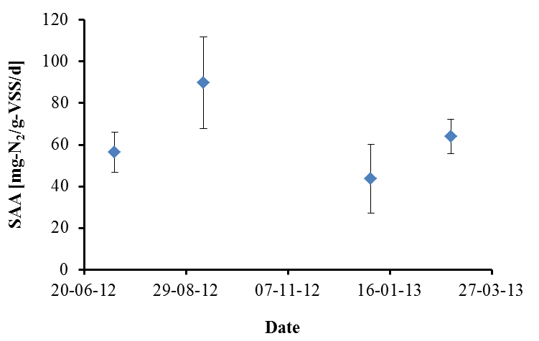
Figure S1. Biomass specific maximum anammox activity (SAA, mg-N₂ g-VSS⁻¹ d⁻¹) as measured during anoxic ex-situ manometric batch tests conducted in triplicates.

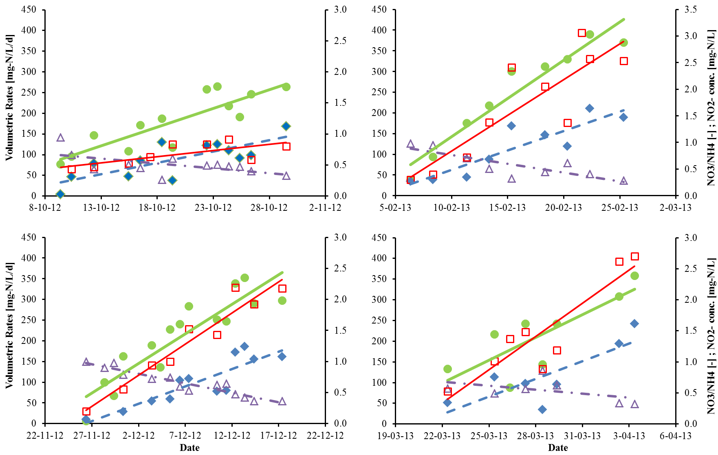
Figure S2. Change in volumetric ammonium conversion rate (green circles) and total nitrogen removal rate (blue diamonds) [left y-axis], NO3/NH4-conversion ratio (purple triangles) and nitrite effluent concentration (red squares) [right y-axis] during four distinct periods of increasing performances (i.e. positive trend of total nitrogen removal rate). The DO was constant (1.5±0.2 mgO₂ L⁻¹) during these four periods.

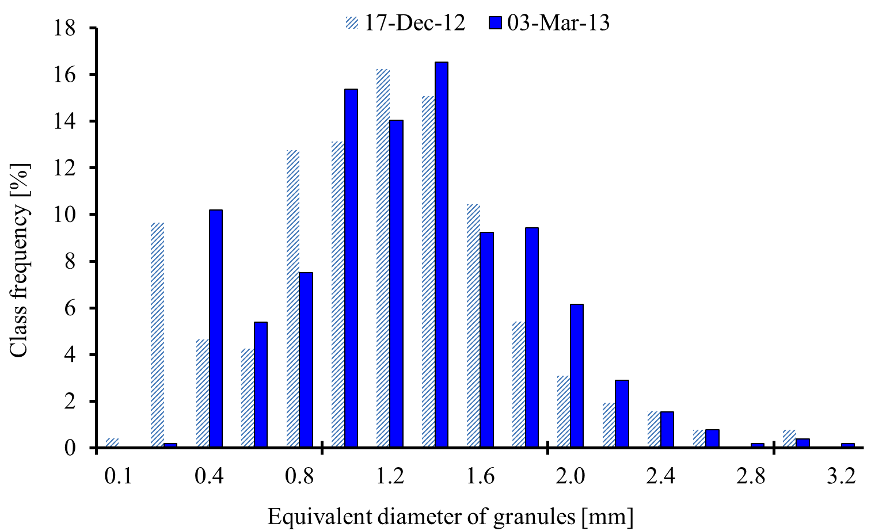
Figure S3. Size distribution of granular biomass. More than 1000 particles analyzed. Analysis was conducted on December the 17th 2012 (light blue bars) and on March the 13th 2013 (dark blue bars).

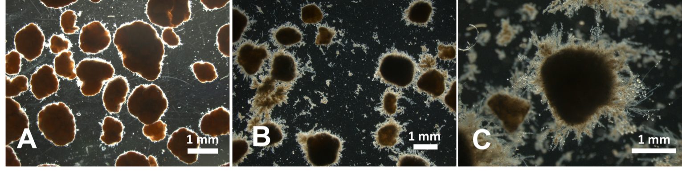
Figure S4. Black background picture of granules during normal operations (A) and during the episode of vorticella-like protozoa blooming (B and C).

¹ Corresponding author, Tommaso Lotti, E-mail: T.Lotti@tudelft.nl; Tommaso.Lotti@polimi.it ² Additional corresponding author, Mark van Loosdrecht, E-mail: M.C.M.vanLoosdrecht@tudelft.nl

