Additional Details of the Revision

Figure

Figure S1. Optical efficiency of concentrating system with SOE slope (𝛼) 65°, obtained from ray-tracing simulation.

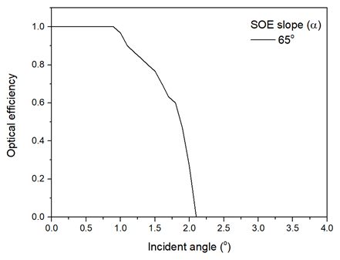

Equation

R1: The ratio of diffuse radiation within the utilizable range (excluding the angle less than 0.5°) of the CPV with SOE to the diffuse sky radiation on horizontal surface (x_{d}) was calculated by Eq. (R1)

$x_{d}= \frac{\int{\int{\left(θ\right)I\left(ϕ,γ\right)\sin{ϕ}dϕdγ}}}{\int{\int{I\left(ϕ,γ\right)\cos{ϕ}sin{ϕ}dϕdγ}}}$ (R1)

where ϕ is zenith angle, γ is azimuth angle, I(ϕ,γ) is diffuse radiation from a sky element at (ϕ,γ), η(θ) is optical efficiency of the system at θ incident angle (which is considered as 0 for θ < 0.5), and θ is angular distance from lens normal to a sky element (assuming that lens point at the sun). The distribution of diffuse radiation I(ϕ,γ) was based on sky radiation distribution studied by Chirarattananon and Chaiwiwatworakul (2007).

R2: The diffuse radiation on the PV cell of the CPV with SOE (I_{pv}) was calculated from Eq. (R2).

$I_{pv}= C_{g}x_{d}I_{d}$ (R2)

where C_{g} is concentration ration of CPV and I_{d} is diffuse radiation.

