**Supplementary material**

**Figure S1.** Map of the binary plasmid *pIRDJB-EIN4as* used for Arabidopsis and tomato transformation with the *CcEIN4* cds in antisense orientation. The plasmid carries the *hpt* gene, under the control of a doubled 35S promoter, as selectable marker.

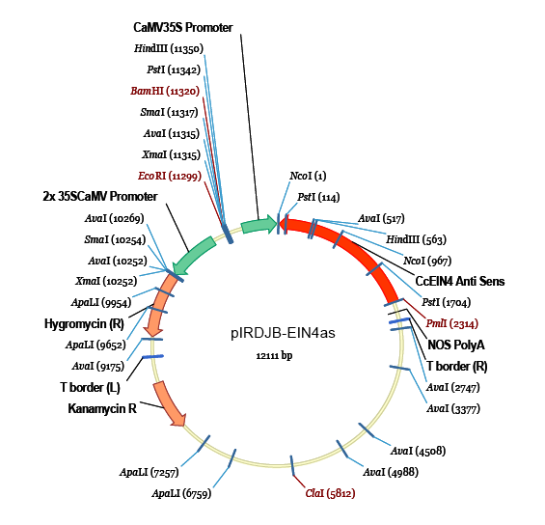

**Figure S2.** Aspects of wild type and transgenic tomato plants (cv. Wva 106) cultivated under salinity (200 mM NaCl).

