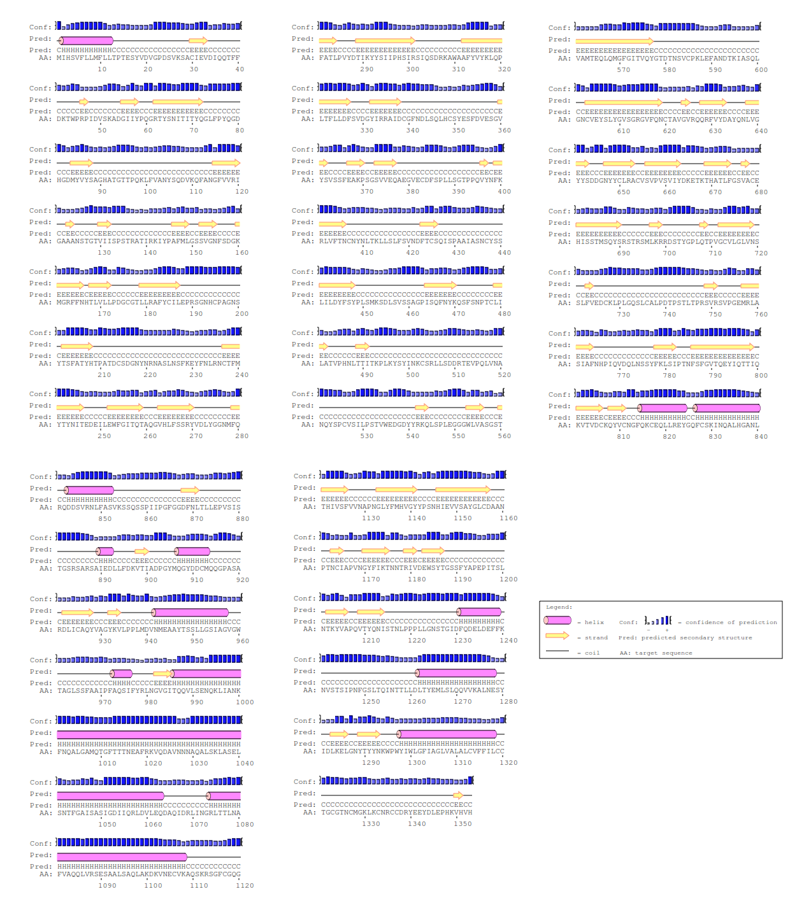
Figure S1. PSIPRED analysis of the MERS-COV S protein. Helixes are cylindrical and coloured pink, beta-strands are shown as arrows and coloured yellow, and random coil regions are black.

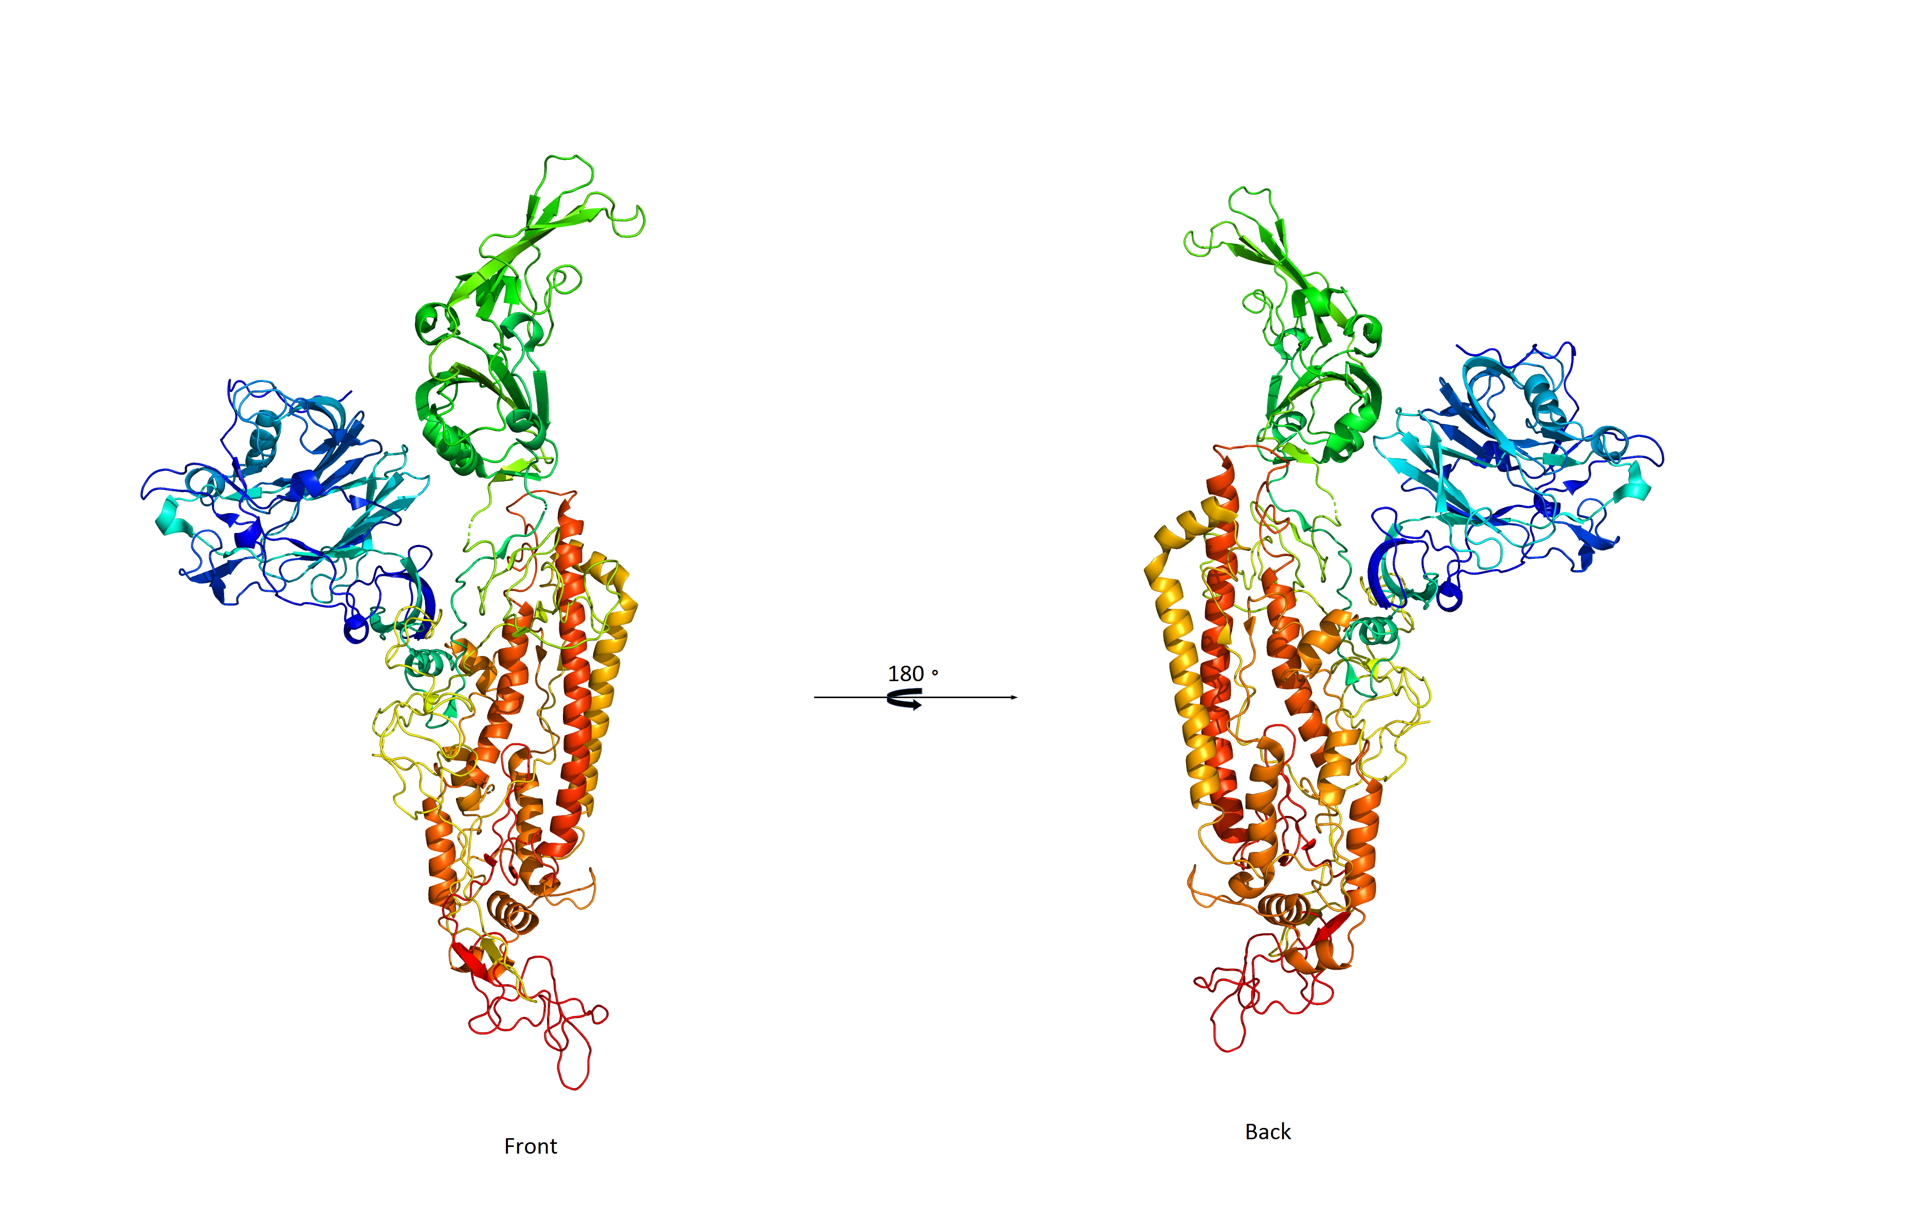
Figure S2. The 3D structure of the MERS-COV S protein (front and back conformations).

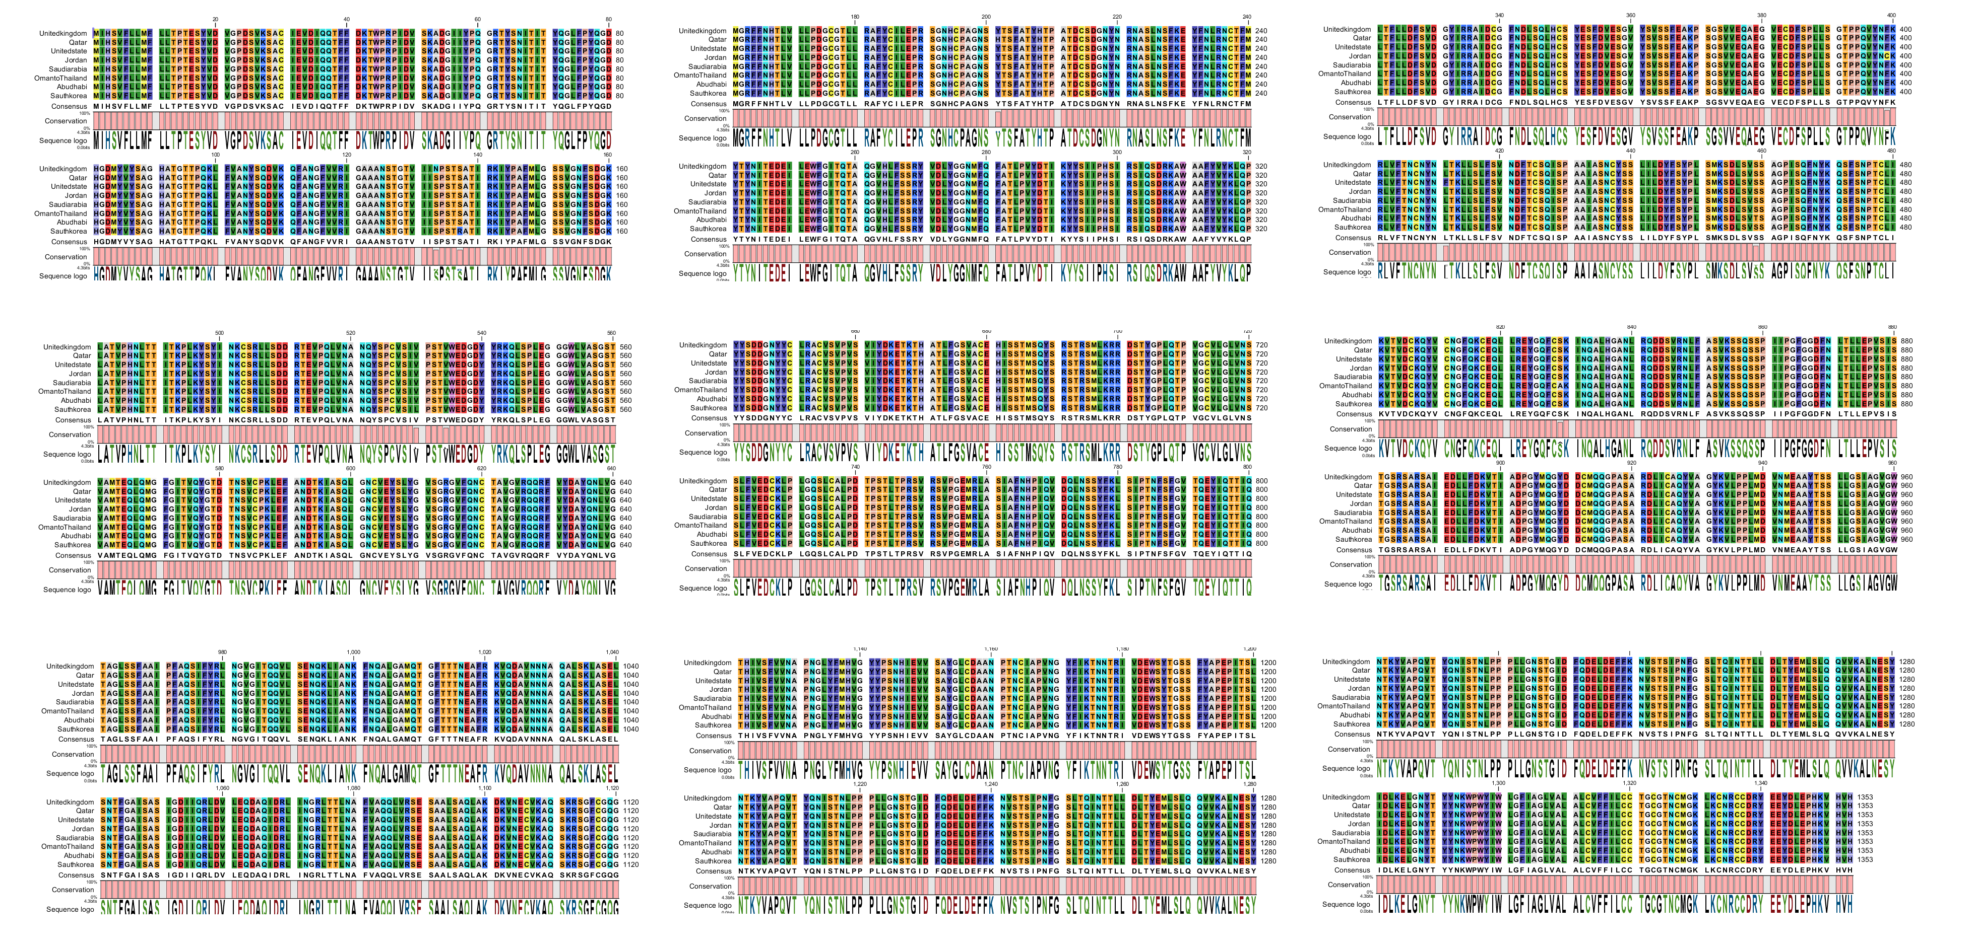
Figure S3. Multiple sequence alignment showing conservation of the S protein of MERS-COV isolated from eight different countries.

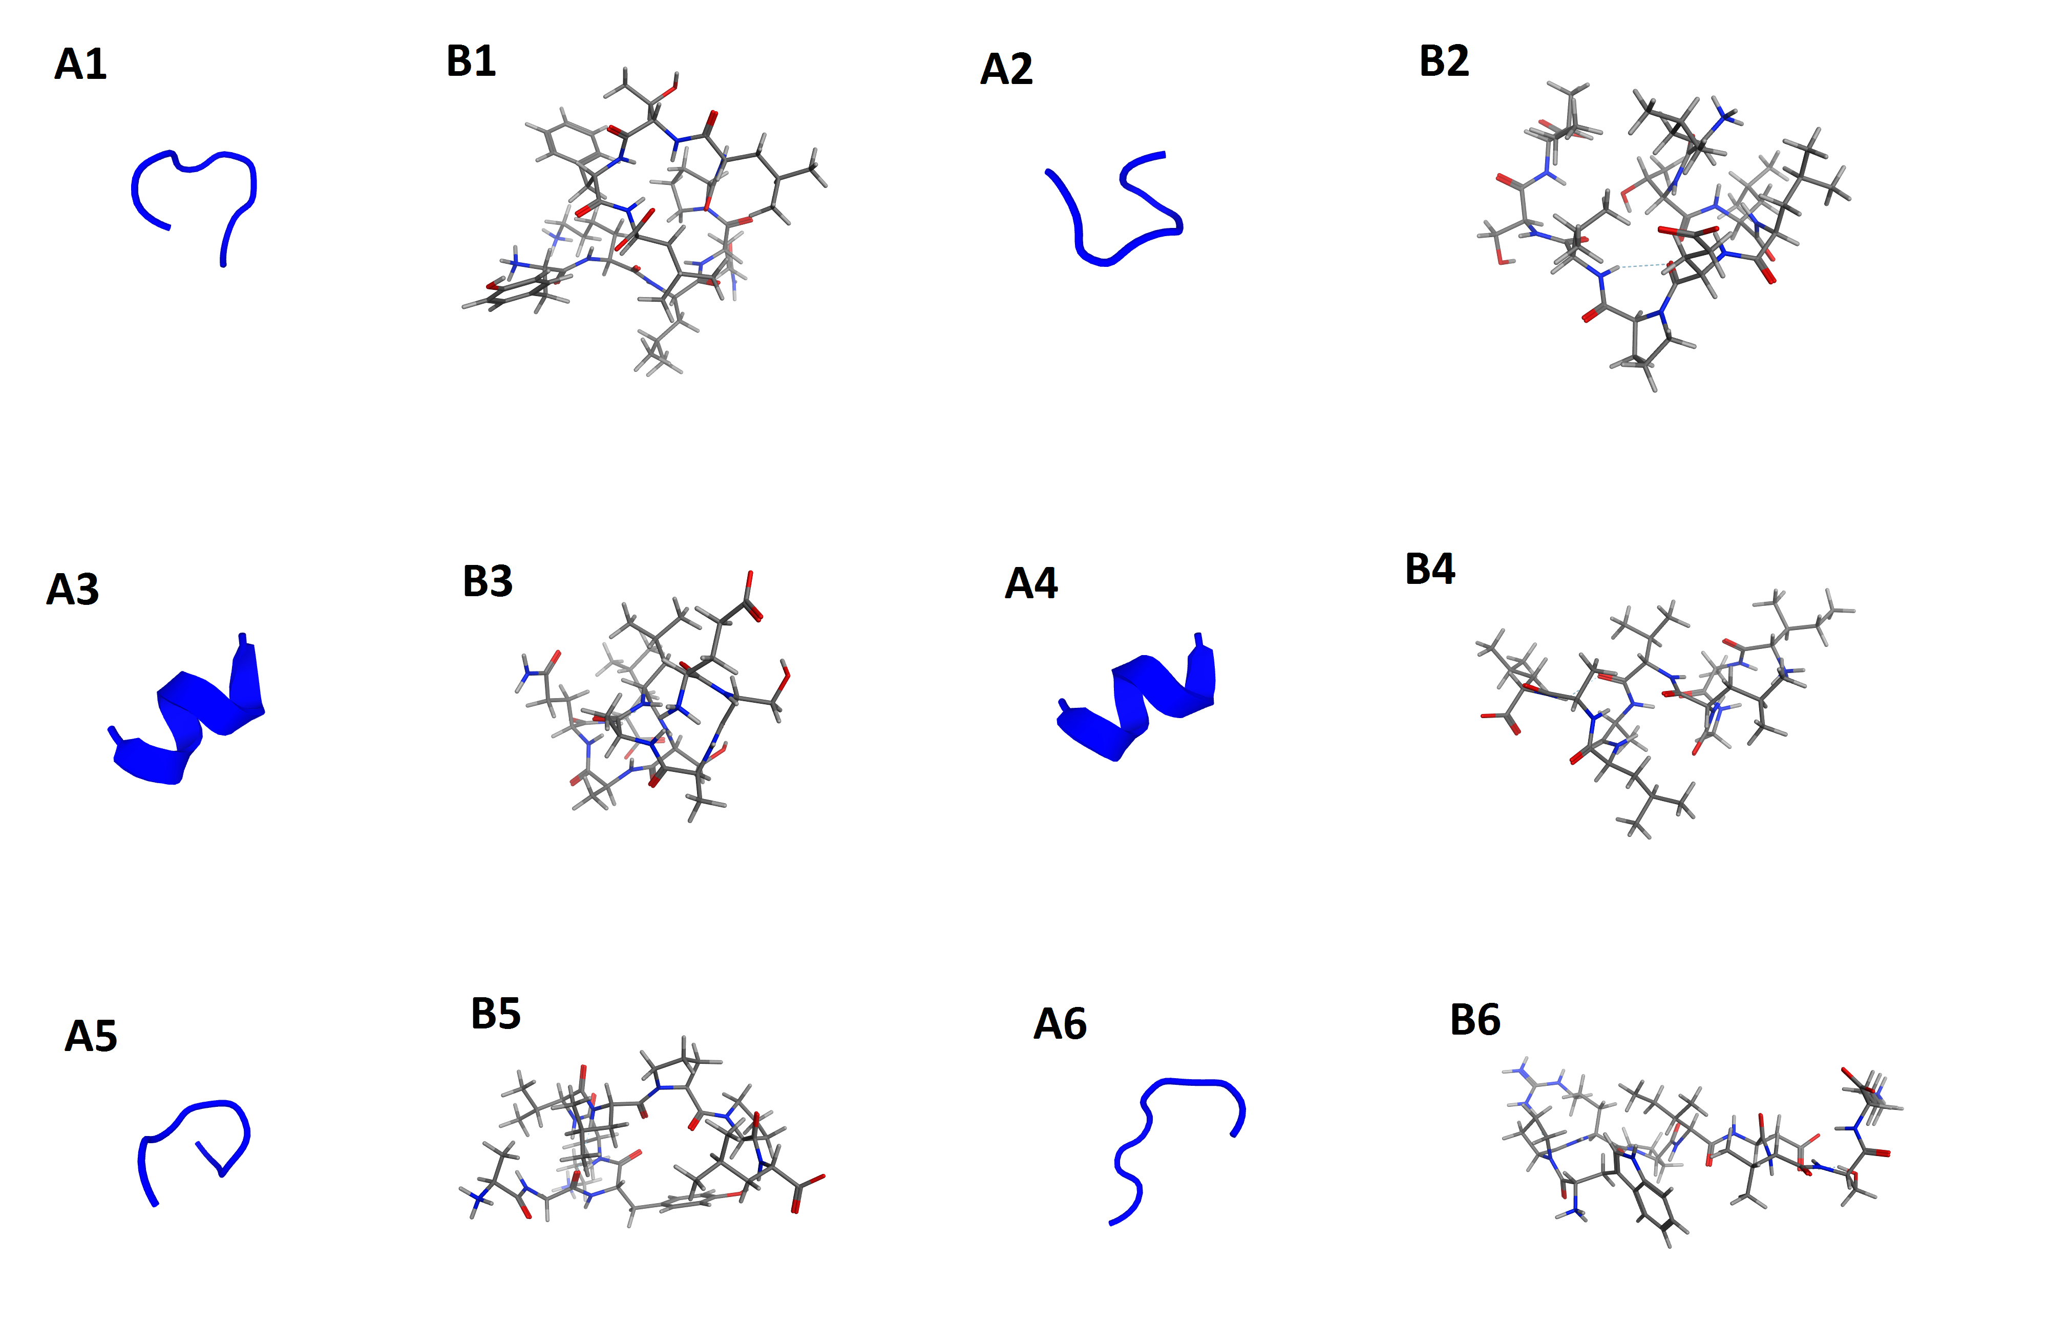
Figure S4. 3D (A1-6) and stick structures (B1-6) representation of selected MHC class-I alleles binding peptides. The figure is in symmetry with the information provided in Table 3.

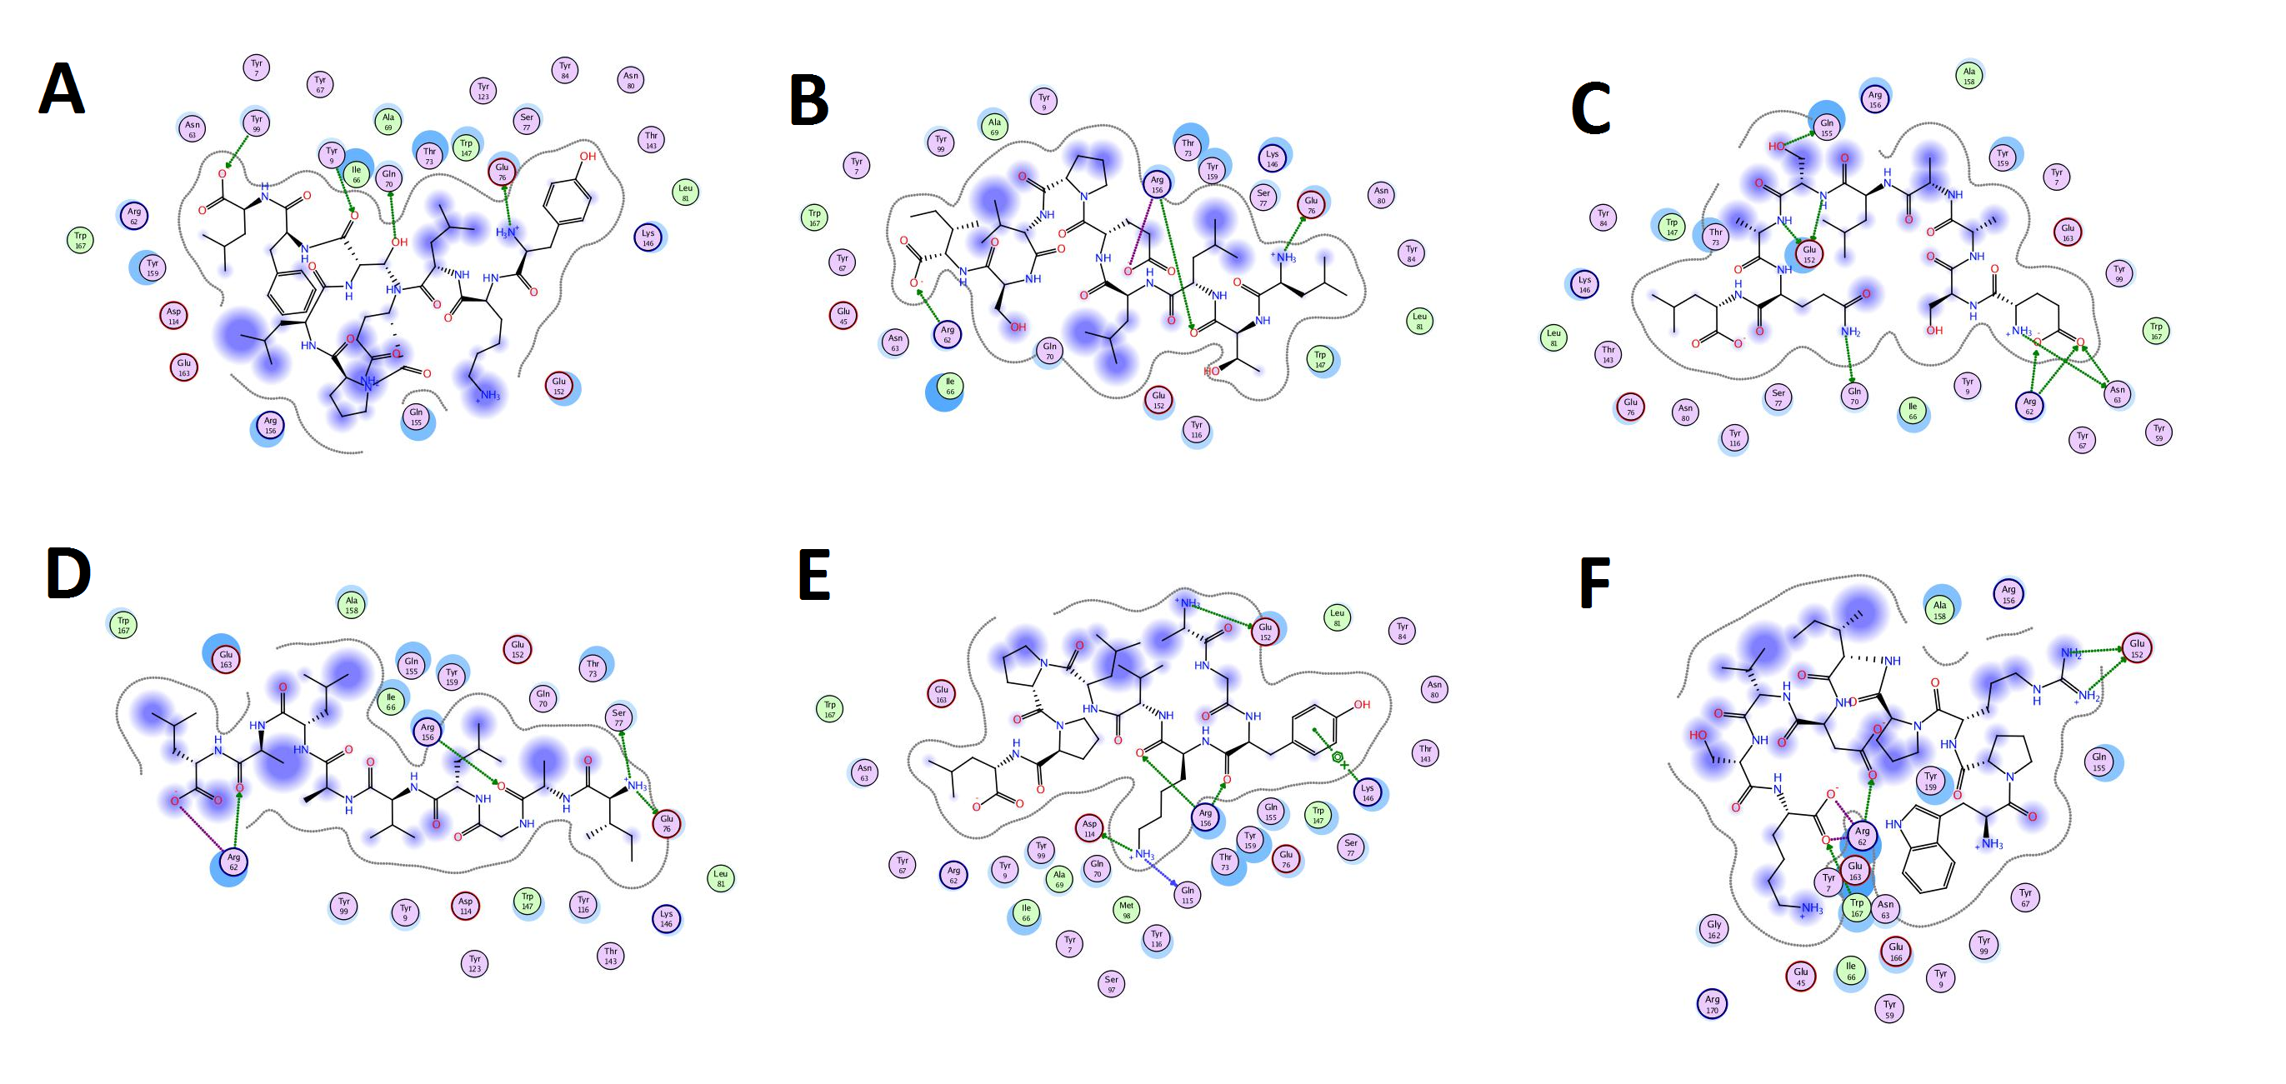
Figure S5. 2D graphical representation of interaction analyses between human HLA-B7 protein and MHC class-I alleles binding peptides. The figure is in symmetry with the information provided in Table 6 and Figure 6 and showing the residues interacting with strong hydrogen bonding.

