Appendix 1: Supporting Tables
Table 1: Test Matrix with vehicle mass scale factors and occupant length scale factors. The occupant length scale was applied to the occupant model length along the X, Y, and Z axis equally to achieve the target height. The vehicles were scaled by using the mass scale function in LS-DYNA.
CIREN Vehicles | Male/ Female | Striking Vehicle Wt. (kg) | Struck Vehicle Wt. (kg) | PDOF | Striking Vehicle Mass Scale | Struck Vehicle Mass Scale
2004 Taurus vs. 1997 Lumina | Male | 1500 | 1532 | 320 | 0.92 | 0.94
1993 Taurus vs. 1999 Sephia | Male | 1430 | 1124 | 300 | 0.87 | 0.69
2004 Trailblazer vs. 2000 Focus | Female | 2165 | 1160 | 80 | 0.97 | 0.71
1996 Explorer vs. 1998 Altima | Female | 1631 | 1304 | 280 | 0.73 | 0.80
2004 4Runner vs. 2002 Jetta | Female | 2000 | 1330 | 280 | 0.89 | 0.81
2004 Ranger vs. 2002 Grand Am | Female | 1625 | 1460 | 280 | 0.73 | 0.89
1998 Rodeo vs. 1998 Civic | Male | 1810 | 1064 | 280 | 0.81 | 0.65
2002 Trailblazer vs. 2003 Galant | Female | 2099 | 1375 | 290 | 0.94 | 0.84
2002 Envoy vs. 2004 Neon | Female | 2099 | 1171 | 290 | 0.94 | 0.72
1993 Blazer vs. 2004 Impala | Male | 1720 | 1617 | 100 | 0.77 | 0.99
2004 RAV4 vs. 2003 Aerio | Female | 1361 | 1175 | 70 | 0.61 | 0.72
1998 F150 vs. 2002 Taurus | Female | 1968 | 1603 | 290 | 0.85 | 0.98
1984 GMC Pickup vs. 2002 Forester | Female | 1901 | 1489 | 290 | 0.84 | 0.91
1989 F250 vs. 2004 Aveo | Male | 1742 | 1075 | 280 | 0.77 | 0.66
1996 F250 vs. 2001 Cavalier | Male | 2390 | 1214 | 280 | 1.05 | 0.74

Table 2: Simulation matrix with the resulting maximum crush as compared to the measured values in the database.
Sim Type | CIREN Vehicles | Sim # | Max Crush (cm) | Sim Max Crush (cm) | Crush Difference  (cm) | Crush Difference (% of CIREN)
Taurus vs Taurus | 2004 Taurus vs.  1997 Lumina | 1 | 33 | 33.33 | 0.33 | 1.00%
Taurus vs Taurus | 1993 Taurus vs.  1999 Sephia | 2 | 33 | 33.46 | 0.46 | 1.39%
SUV vs Taurus | 2004 Trailblazer vs. 2000 Focus | 3 | 41 | 42.12 | 1.12 | 2.73%
SUV vs Taurus | 1996 Explorer vs. 1998 Altima | 4 | 24 | 24.85 | 0.85 | 3.54%
SUV vs Taurus | 2004 4Runner vs. 2002 Jetta | 5 | 30 | 30.14 | 0.14 | 0.47%
SUV vs Taurus | 2004 Ranger vs. 2002 Grand Am | 6 | 64 | 60.01 | 3.99 | 6.23%
SUV vs Taurus | 1998 Rodeo vs. 1998 Civic | 7 | 34 | 33.24 | 0.76 | 2.24%
SUV vs Taurus | 2002 Trailblazer vs. 2003 Galant | 8 | 62 | 58.53 | 3.47 | 5.60%
SUV vs Taurus | 2002 Envoy vs. 2004 Neon | 9 | 60 | 61.04 | 1.04 | 1.73%
SUV vs Taurus | 1993 Blazer vs. 2004 Impala | 10 | 67 | 63.41 | 3.59 | 5.36%
SUV vs Taurus | 2004 RAV4 vs. 2003 Aerio | 11 | 49 | 48.3 | 0.7 | 1.43%
Truck vs Taurus | 1998 F150 vs. 2002 Taurus | 12 | 59 | 58.28 | 0.72 | 1.22%
Truck vs Taurus | 1984 GMC Pickup vs. 2002 Forester | 13 | 45 | 43.87 | 1.13 | 2.51%
Truck vs Taurus | 1989 F250 vs. 2004 Aveo | 14 | 29 | 29.97 | 0.97 | 3.34%
Truck vs Taurus | 1996 F250 vs. 2001 Cavalier | 15 | 58 | 55.86 | 2.14 | 3.69%
Crush Difference Statistics
Mean (cm) |  | 1.43 | STDev (cm) | 1.26 | CV | 0.88

Table 3: Simulation metric threshold analysis results.
Strain metric | Mean  Threshold | Minimum  Value | Maximum  Value | Standard  Deviation | Coefficient  of Variance
1st Principal  Strain | 0.60 | 0.31 | 0.93 | 0.17 | 0.29
Maximum Shear  Strain | 0.64 | 0.32 | 1.00 | 0.19 | 0.30
First Principal  Strain Rate (1/s⁻¹) | 43.93 | 21.17 | 71.60 | 15.74 | 0.36
Maximum Shear  Rate (1/s⁻¹) | 47.28 | 20.48 | 75.61 | 17.52 | 0.37
First Principal  Strain x Rate (1/s⁻¹) | 18.69 | 4.32 | 39.01 | 10.56 | 0.56
Shear Strain x  Rate (1/s⁻¹) | 22.26 | 4.81 | 46.28 | 13.13 | 0.59

Appendix 2: CIREN to simulation crush picture and profile comparison. The location of measured maximum crush in the CIREN case (♦) and simulation (●) are marked on all plots.
Case 1: 2004 Taurus vs. 1997 Lumina, Maximum Crush 33 cm
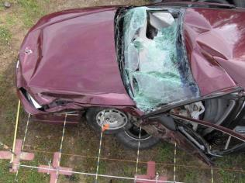
CIREN Results
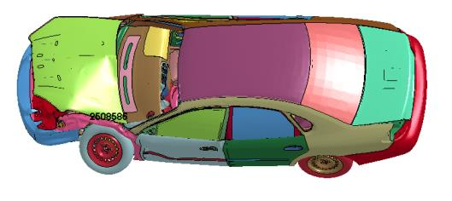
Simulation Results
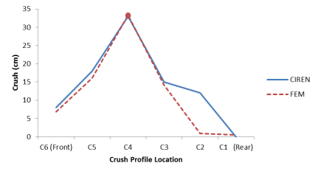
Crush Profile Plots

Case 2: 1993 Taurus vs. 1999 Sephia, Maximum Crush 33 cm
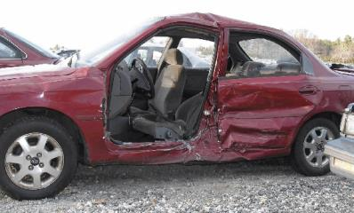
CIREN Results
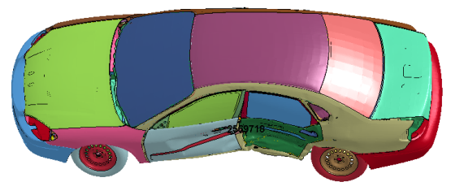
Simulation Results
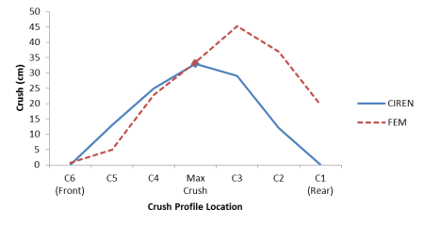
Crush Profile Plots

Case 3: 2004 Trailblazer vs. 2000 Focus, Maximum Crush 41 cm
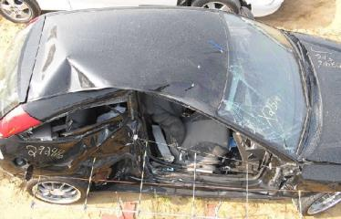
CIREN Results
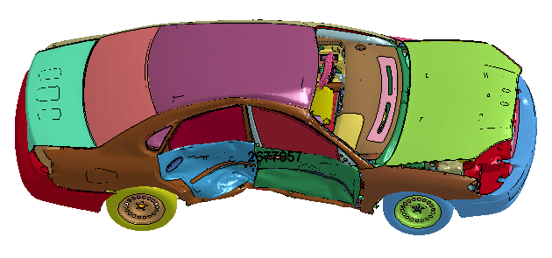
Simulation Results
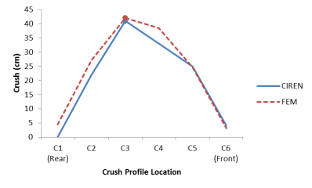
Crush Profile Plots

Case 4: 1996 Explorer vs. 1998 Altima, Maximum Crush 24 cm
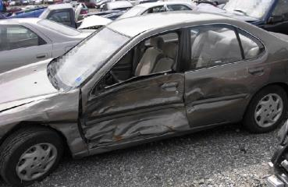
CIREN Results
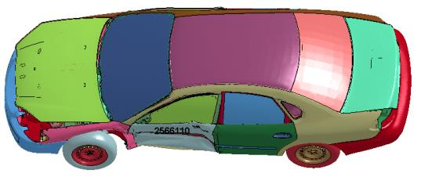
Simulation Results
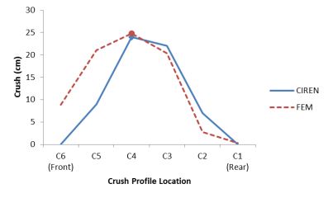
Crush Profile Plots

Case 5: 2004 4Runner vs. 2002 Jetta, Maximum Crush 30 cm
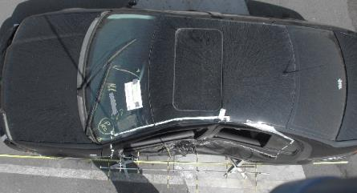
CIREN Results
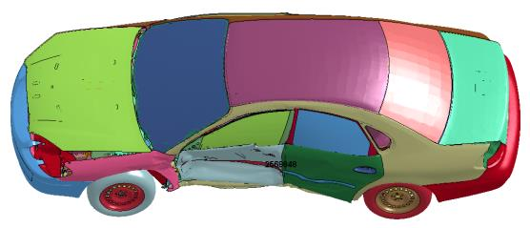
Simulation Results
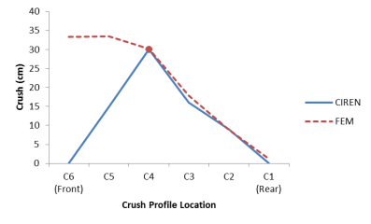
Crush Profile Plots

Case 6: 2004 Ranger vs. 2002 Grand Am, Maximum Crush 64 cm
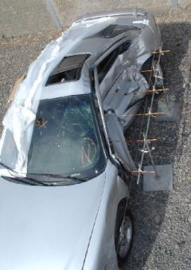
CIREN Results
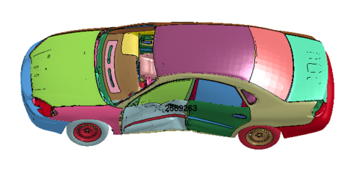
Simulation Results
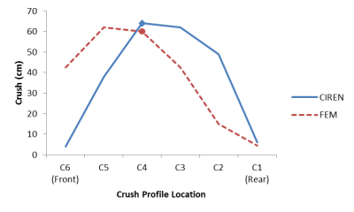
Crush Profile Plots

Case 7: 1998 Rodeo vs. 1998 Civic, Maximum Crush 34 cm
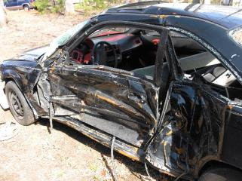
CIREN Results
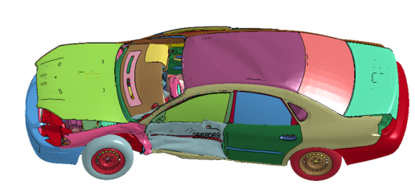
Simulation Results
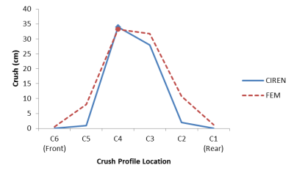
Crush Profile Plots

Case 8: 2002 Trailblazer vs. 2003 Galant, Maximum Crush 62 cm
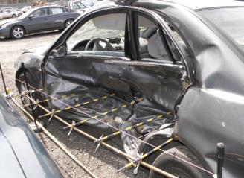
CIREN Results
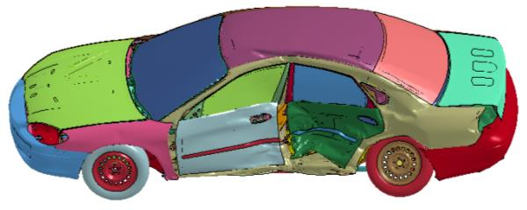
Simulation Results
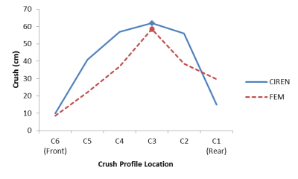
Crush Profile Plots

Case 9: 2002 Envoy vs. 2004 Neon, Maximum Crush 60 cm
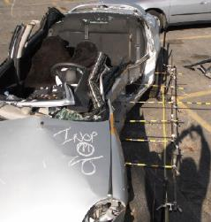
CIREN Results
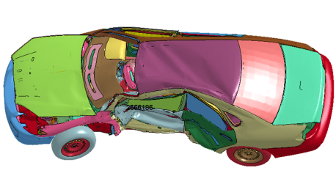
Simulation Results
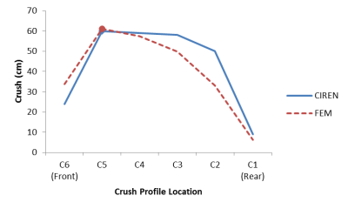
Crush Profile Plots

Case 10: 1993 Blazer vs. 2004 Impala, Maximum Crush 67 cm
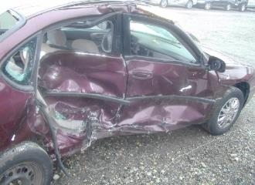
CIREN Results
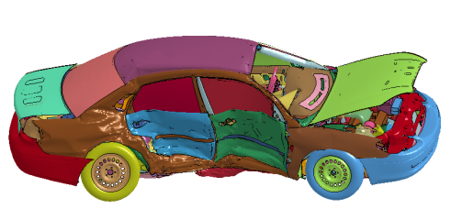
Simulation Results
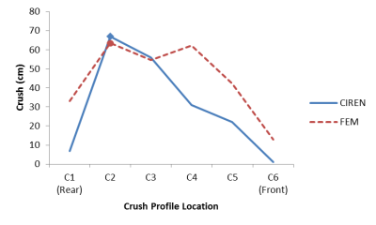
Crush Profile Plots

Case 11: 2004 RAV4 vs. 2003 Aerio, Maximum Crush 49 cm
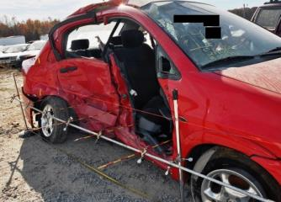
CIREN Results
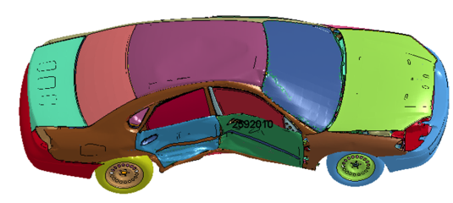
Simulation Results
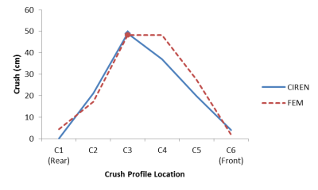
Crush Profile Plots

Case 12: 1998 F150 vs. 2002 Taurus, Maximum Crush 59 cm
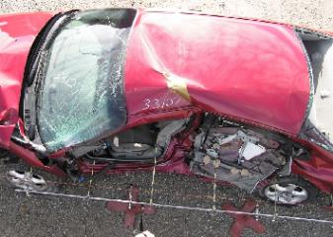
CIREN Results
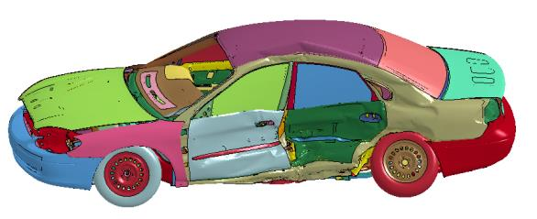
Simulation Results
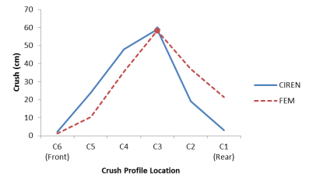
Crush Profile Plots

Case 13: 1984 GMC Pickup vs. 2002 Forester, Maximum Crush 45 cm
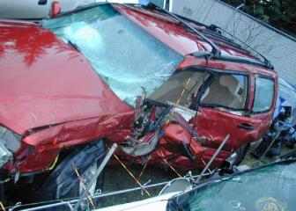
CIREN Results
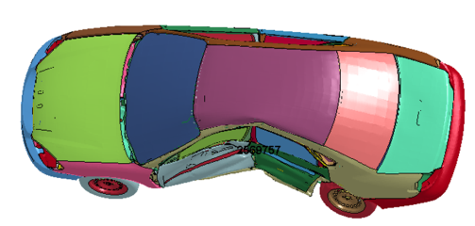
Simulation Results
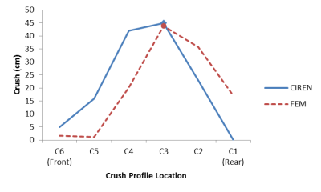
Crush Profile Plots

Case 14: 1989 F250 vs. 2004 Aveo, Maximum Crush 29 cm
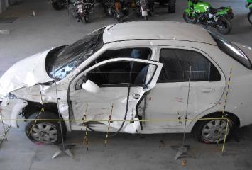
CIREN Results
Simulation Results
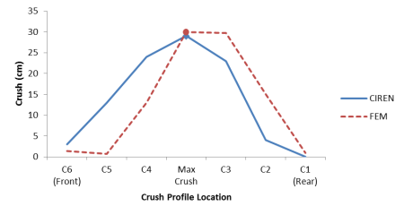
Crush Profile Plots

Case 15: 1996 F250 vs. 2001 Cavalier, Maximum Crush 58 cm
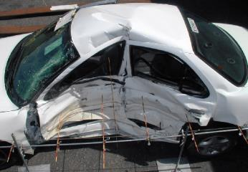
CIREN Results
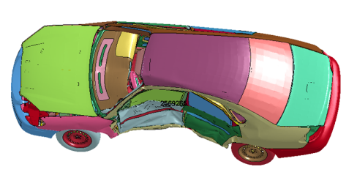
Simulation Results
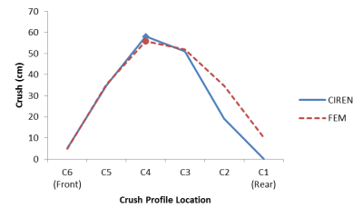
Appendix 3: Pulmonary contusion segmentation results
Pulmonary contusion segmentation results from the case occupants and high strain locations, first principal strain only, from the simulated cases. In cases without isolated PC, high attenuation volume is shown instead. These cases are annotated with “high attenuation” immediately following the case number. In the images, black areas are the location of PC, high attenuation, or high strain. The yellow areas are the uninjured or lower strain areas.
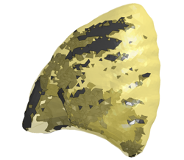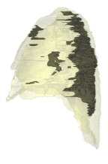
Case 1 element distribution for 5.42% volume, side view, simulation (left) and occupant (right) view.
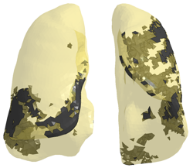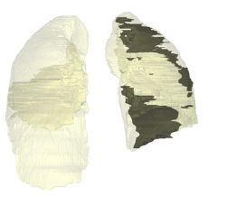
Case 1 element distribution for 5.42% volume, front view, Simulation (left) and Occupant (right) view.
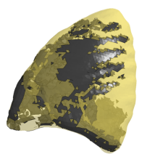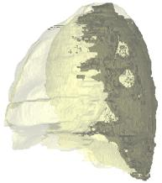
Case 2 high attenuation element distribution for 9.64% volume, side view, simulation (left) and occupant (right) view.
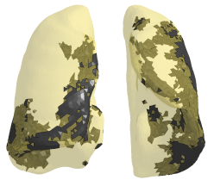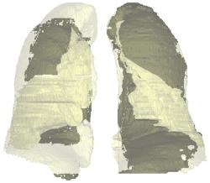
Case 2 high attenuation element distribution for 9.64% volume, front view, Simulation (left) and Occupant (right) view.

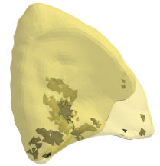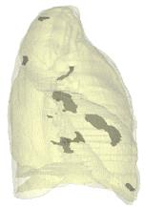
Case 3 element distribution for 0.77% volume, side view, simulation (left) and occupant (right) view.
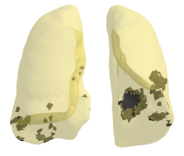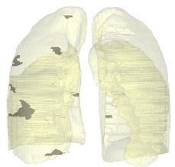
Case 3 element distribution for 0.77% volume, front view, Simulation (left) and Occupant (right) view.

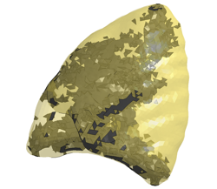
Case 4 element distribution for 7.85% volume, side view, simulation (left) and occupant (right) view.
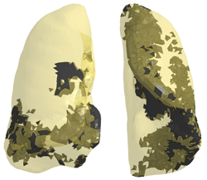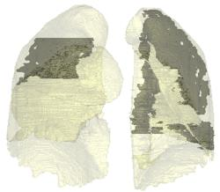
Case 4 element distribution for 7.85% volume, front view, Simulation (left) and Occupant (right) view.

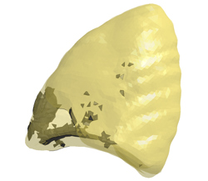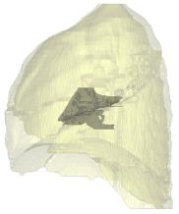
Case 5 element distribution for 1.03% volume, side view, simulation (left) and occupant (right) view.
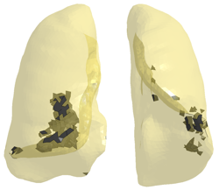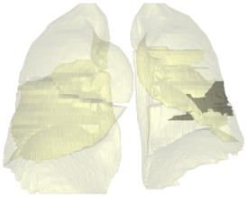
Case 5 element distribution for 1.03% volume, front view, Simulation (left) and Occupant (right) view.

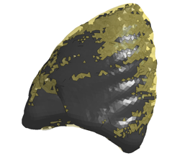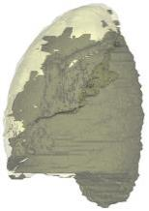
Case 6 high attenuation element distribution for 65.98% volume, side view, simulation (left) and occupant (right) view.
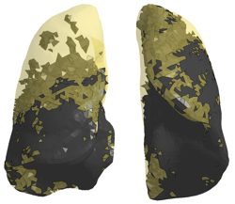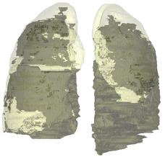
Case 6 high attenuation element distribution for 65.98% volume, front view, Simulation (left) and Occupant (right) view.

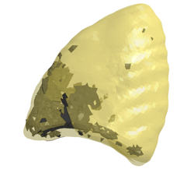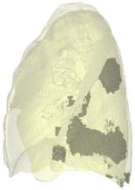
Case 7 element distribution for 3.13% volume, side view, simulation (left) and occupant (right) view.
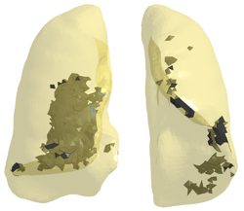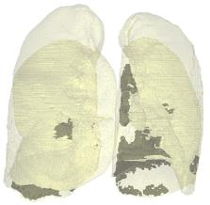
Case 7 element distribution for 3.13% volume, front view, Simulation (left) and Occupant (right) view.

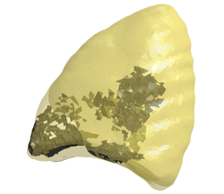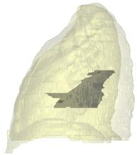
Case 8 element distribution for 1.91% volume, side view, simulation (left) and occupant (right) view.
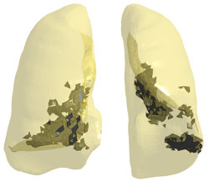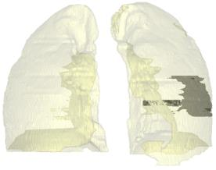
Case 8 element distribution for 1.91% volume, front view, Simulation (left) and Occupant (right) view.
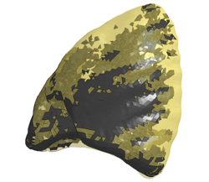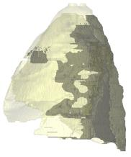
Case 9 element distribution for 21.23% volume, side view, simulation (left) and occupant (right) view.
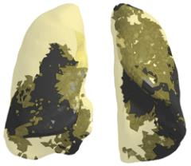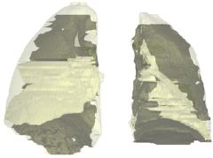
Case 9 element distribution for 21.23% volume, front view, Simulation (left) and Occupant (right) view.

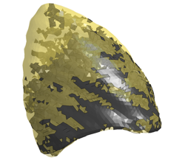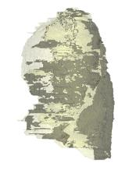
Case 10 high attenuation element distribution for 39.55% volume, side view, simulation (left) and occupant (right) view.
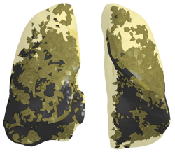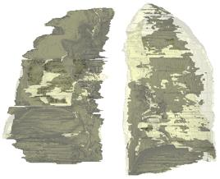
Case 10 high attenuation element distribution for 39.55% volume, front view, Simulation (left) and Occupant (right) view.

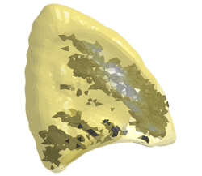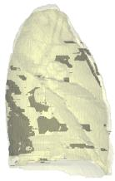
Case 11 high attenuation element distribution for 3.39% volume, side view, simulation (left) and occupant (right) view.
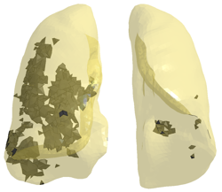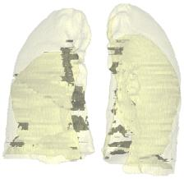
Case 11 high attenuation element distribution for 3.39% volume, front view, Simulation (left) and Occupant (right) view.

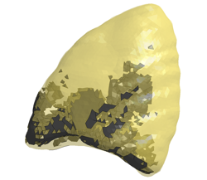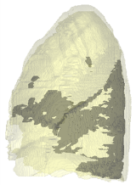
Case 12 element distribution for 4.96% volume, side view, simulation (left) and occupant (right) view.
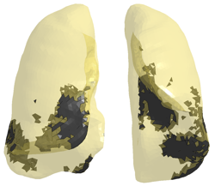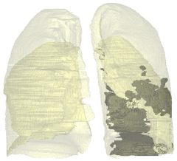
Case 12 element distribution for 4.96% volume, front view, Simulation (left) and Occupant (right) view.

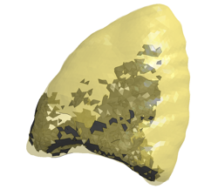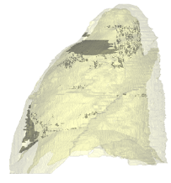
Case 13 element distribution for 6.17% volume, side view, simulation (left) and occupant (right) view.
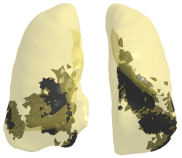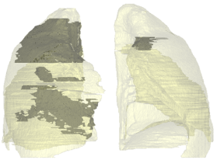
Case 13 element distribution for 6.17% volume, front view, Simulation (left) and Occupant (right) view.
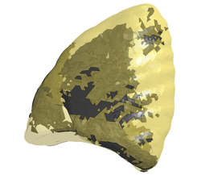
Case 14 high attenuation element distribution for 9.46% volume, side view, simulation (left) and occupant (right) view.
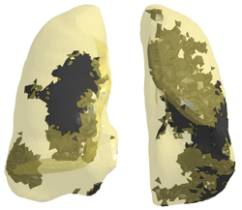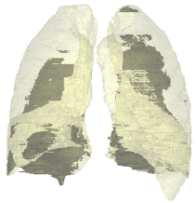
Case 14 high attenuation element distribution for 9.46% volume, front view, Simulation (left) and Occupant (right) view.

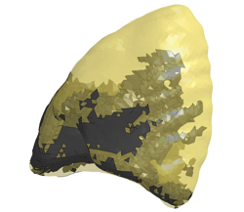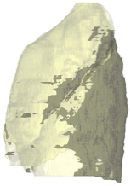
Case 15 high attenuation element distribution for 16.97% volume, side view, simulation (left) and occupant (right) view.
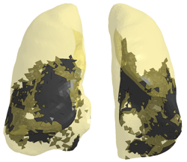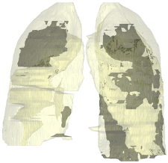
Case 15 high attenuation element distribution for 16.97% volume, front view, Simulation (left) and Occupant (right) view.

Appendix 4: Comparison between the Taurus FEM and crash test data for FMVSS 214 test number 3263.
