Simultaneous Delivery of BMP-2 Factor and Anti-osteoporotic Drugs Using Hyaluronan-assembled Nanocomposite for Synergistic Regulation on the Behaviors of Osteoblasts and Osteoclasts in Vitro
Yarong Zhang, Yan Hu*, Zhong Luo, Xinkun Shen, Caiyun Mu and Kaiyong Cai*
Key Laboratory of Biorheological Science and Technology (Chongqing University), Ministry of Education, College of Bioengineering, Chongqing University, Chongqing 400044, P. R. China Department
Corresponding author: Prof. Dr. Yan Hu,
College of Bioengineering, Chongqing University, Chongqing 400044, P. R. China
Tel: +86-23-65126127 Fax: +86-23-65126127
E-mail: huyan303@cqu.edu.cn

Corresponding author: Prof. Dr. Kaiyong Cai
College of Bioengineering, Chongqing University, Chongqing 400044, P. R. China
Tel: +86-23-65102507 Fax: +86-23-65102877
E-mail: kaiyong_cai@cqu.edu.cn

Cell culture
Osteoblasts were firstly isolated from the cranial bones of newborn mice (1 or 2 days), which were supplied by the animal experimental center of Chongqing Medical University (Chongqing, China). Then, the obtained cells were incubated in high glucose Dulbecco’s Modified Eagle’s Medium (DMEM, Gibco) supplemented with bovine serum (10 vol%), penicillin (100 U mL⁻¹) and streptomycin(100 μg mL⁻¹) at 37 °C under 5% CO₂ atmosphere. Cell culture medium was further changed every two days. When the cells covered nearly 90% of the culture flask, they were detached with 0.25% trypsin in 1 mM tetrasodium EDTA and reseeded in the new culture flasks. Osteoblasts populations after the 3rd generation were used in the following study. RAW264.7 cells were provided from Chongqing Medical University (Chongqing, China) and cultured in a high glucose DMEM medium with 10% of fetal bovine serum (Gibco, Invitrogen Co.) at 37 °C under 5% CO₂ atmosphere. The culture medium was replaced every 2 days in this study.

Cell viability assay
After the osteoblasts were treated with free BMP-2, HA/BMP-2 and HA-Aln/BMP-2 nanocomposites for 48 h, the cells were rinsed with PBS and changed to 180 μL of fresh culture medium. And the cells without any treatment were used as the control groups. Then, 20μL of MTT solution (5 mg mL⁻¹) was added into each well and the medium was incubated at 37 °C for another 4 h. Subsequently, the medium containing MTT was removed and 200 μL of dimethyl sulfoxide (DMSO) was added into each well to dissolve the formazan crystals generated. Optical density of the mixture was measured by a microplate reader (Bio-Rad 680, USA) at the wavelength of 490 nm.

Cell morphologies observation
The osteoblasts morphologies were observed by using CLSM after treatment with free BMP-2, HA/BMP-2 and HA-Aln/BMP-2 nanocomposites for 48 h. And the cells without any treatment were used as the control groups. Then, all samples were fixed with glutaraldehyde, and permeabilized with Triton X-100 (0.1 %). Subsequently, the specimens were stained with rhodamine-phalloidin (5 U mL⁻¹) at 4 °C for overnight and further stained with Hoechst 33258 (10 μg mL⁻¹) at room temperature for another 10 minutes. Finally, the obtained samples were mounted with 95% of glycerinum and observed with CLSM (TCS SP5, Leica, Germany).

Transwell assay
To further investigate the cell migration, the transwell migration assay was performed. Briefly, osteoblasts (seeding density at 2×10⁴ cells per well) were firstly cultured onto a transwell insert chambers with a pore size of 8 µm (Corning, NY, USA). Then, the chambers were introduced into a 24-well tissue culture plate. Each well was filled with 1 mL of cell culture medium. And 40 μL of free BMP-2, HA/BMP-2 or HA-Aln/BMP-2 nanocomposites was added into each well, respectively. After incubation for another 12 h at 37°C, cells in the upper chambers were removed by wiping with a cotton swab. Subsequently, the cells that migrated to the lower surface of the chambers were treated with 4% glutaraldehyde for 30 min and then stained with 0.2% crystal violet for 10 min. Finally, the migrated cells were observed using an optical microscope (MVX10, Olympus), while the crystal violet in cells was dissolved with acetic acid (10%, v/v). The optical density of mixture was measured at 570 nm using a microplate reader (Bio-Rad 680).
Table S1. Real-time polymerase chain reaction (RT-PCR) primers used in this study.
Target Gene | Gene Bank (Accession no.) | Primers | products  size (bp)
Runx2 | NM_053470.2 | GCCGTAGAGAGCAGGGAAGAC CTGGCTTGGATTAGGGAGTCAC | 150
Osterix | NM_181374.2 | CGGCAAGGCTTCGCATCTG GGAGCAGAGCAGACAGGTGAACT | 166
ALP | NM_013059 | AGCGACACGGACAAGAAGC GGCAAAGACCGCCACATC | 183
Col I | NM_053304.1 | CCTGAGCCAGCAGATTGA TCCGCTCTTCCAGTCAG | 106
OC | M11777 | GAGGGCAGTAAGGTGGTGAA CGTCCTGGAAGCCAATGTG | 154
OPN | M99252 | GACAGCAACGGGAAGACC CAGGCTGGCTTTGGAACT | 216
β-actin | NM_031144.2 | GGAGATTACTGCCCTGGCTCCTA GACTCATCGTACTCCTGCTTGCTG | 150

Table S2. Zeta-potential results of HA-Aln molecule and HA-Aln/BMP-2 nanocomposites.
Materials | ζ–potential (mV)
HA-Aln | -24.1±6.0
HA-Aln | -16.4±5.0

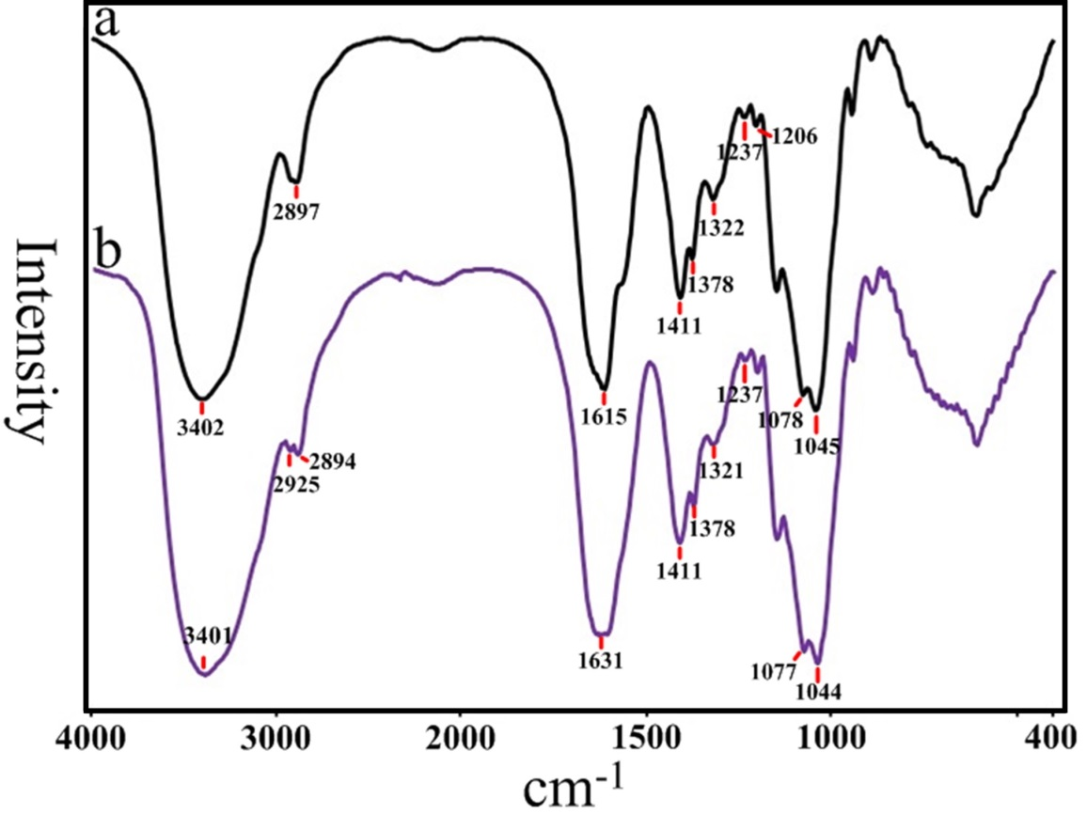
Figure S1. FTIR spectra of sodium hyaluronate (a, HA), and alendronate-grafted- hyaluronate (b, HA-Aln).

For the free HA specimen (Figure S1a), the peak of 3402 cm⁻¹ and 2894 cm⁻¹ were respectively assigned to the association of hydroxyl (–OH) groups and the stretching vibration of methine (–CH–) groups in HA, while that of 1615 cm⁻¹ and 1411 cm⁻¹ were attributed to the stretching vibration of amide I bonds and –C–N bonds, respectively. And the peaks of 1378 cm⁻¹ and 1322 cm⁻¹ were ascribed to the symmetrical stretching vibration of carboxylate (–COONa) groups in HA, while that of 1237 cm⁻¹ and 1206 cm⁻¹ were assigned to the stretching vibration of ester linkages. The peaks of 1045 cm⁻¹ and 1078 cm⁻¹ were attributed to the stretching vibration of primary alcohol (–CH₂OH) and secondary alcohol (–CHOH–), respectively

a.
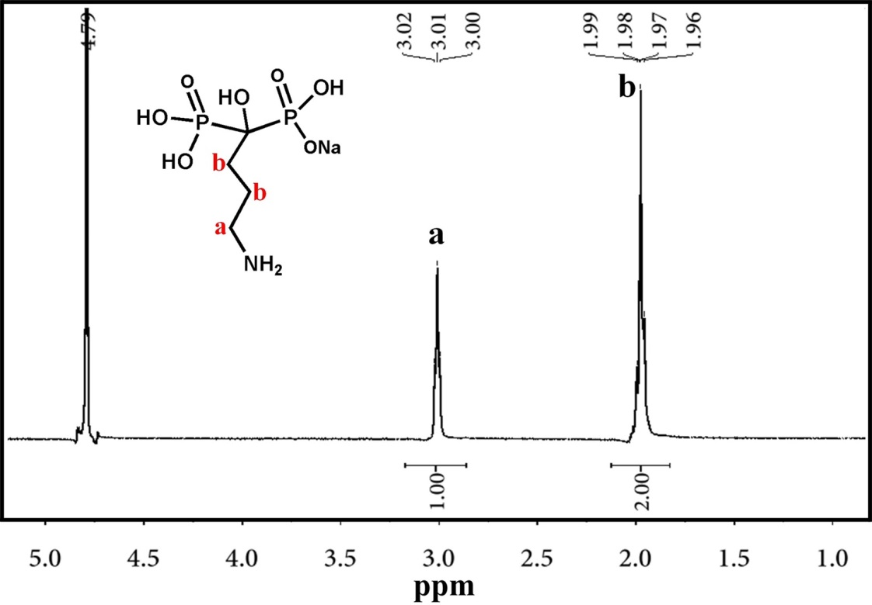

b.
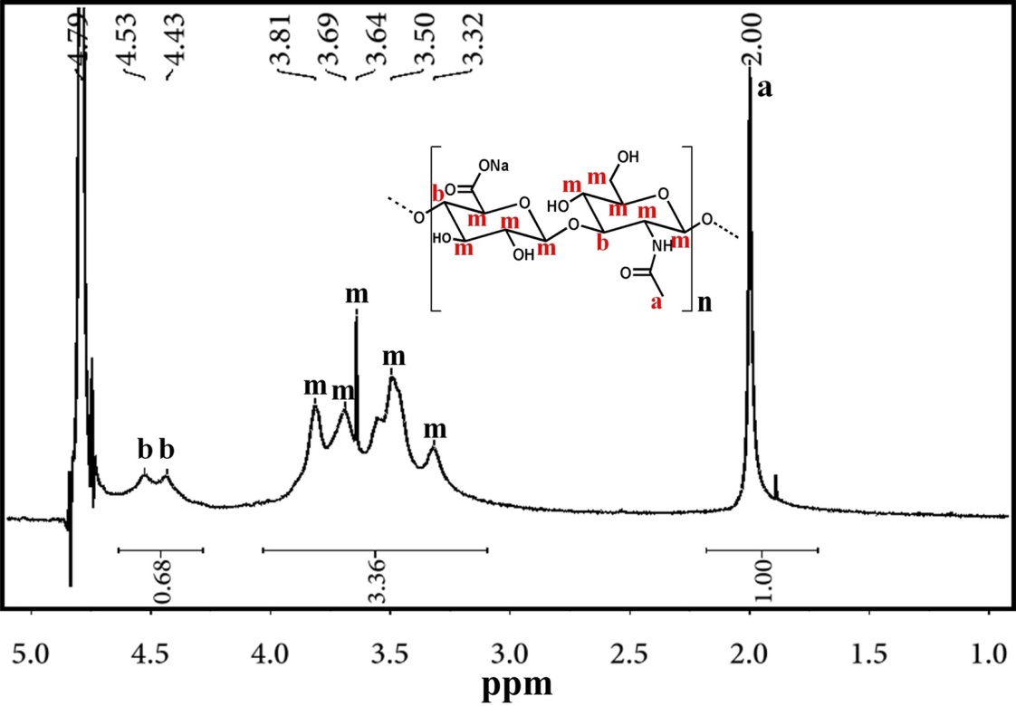

c.
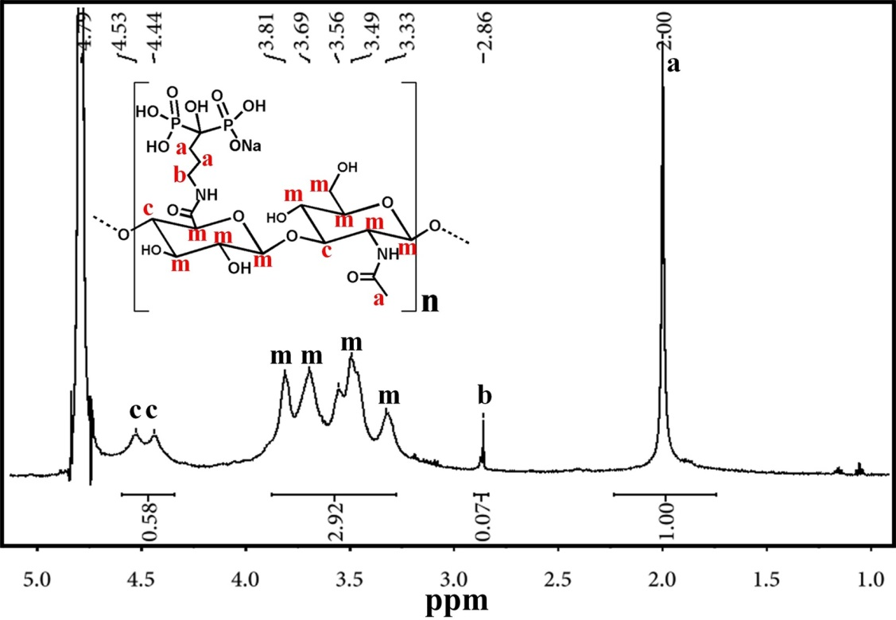
Figure S2. ¹H NMR spectra (D₂O, 400 MHz, 298 K) of (a) alendronate (Aln), (b) sodium hyaluronate (HA), and (c) alendronate-grafted- hyaluronate (HA-Aln).

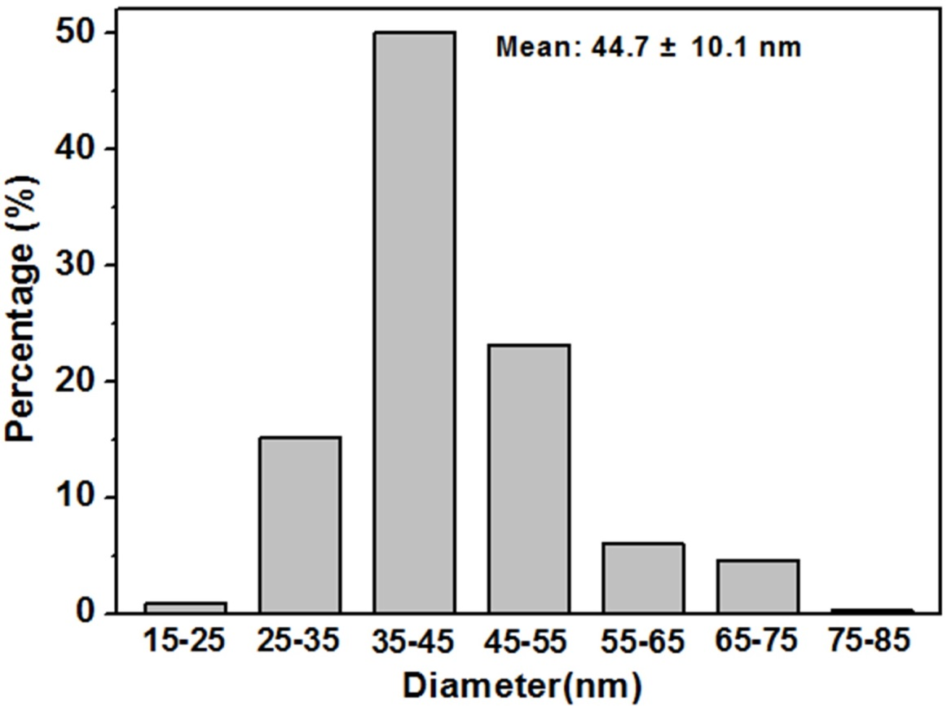
Figure S3. The analysis for the size distribution of the prepared HA-Aln/BMP-2 nanocpmposites based on TEM images. Scale bar: nm, means ±SD for n=350.

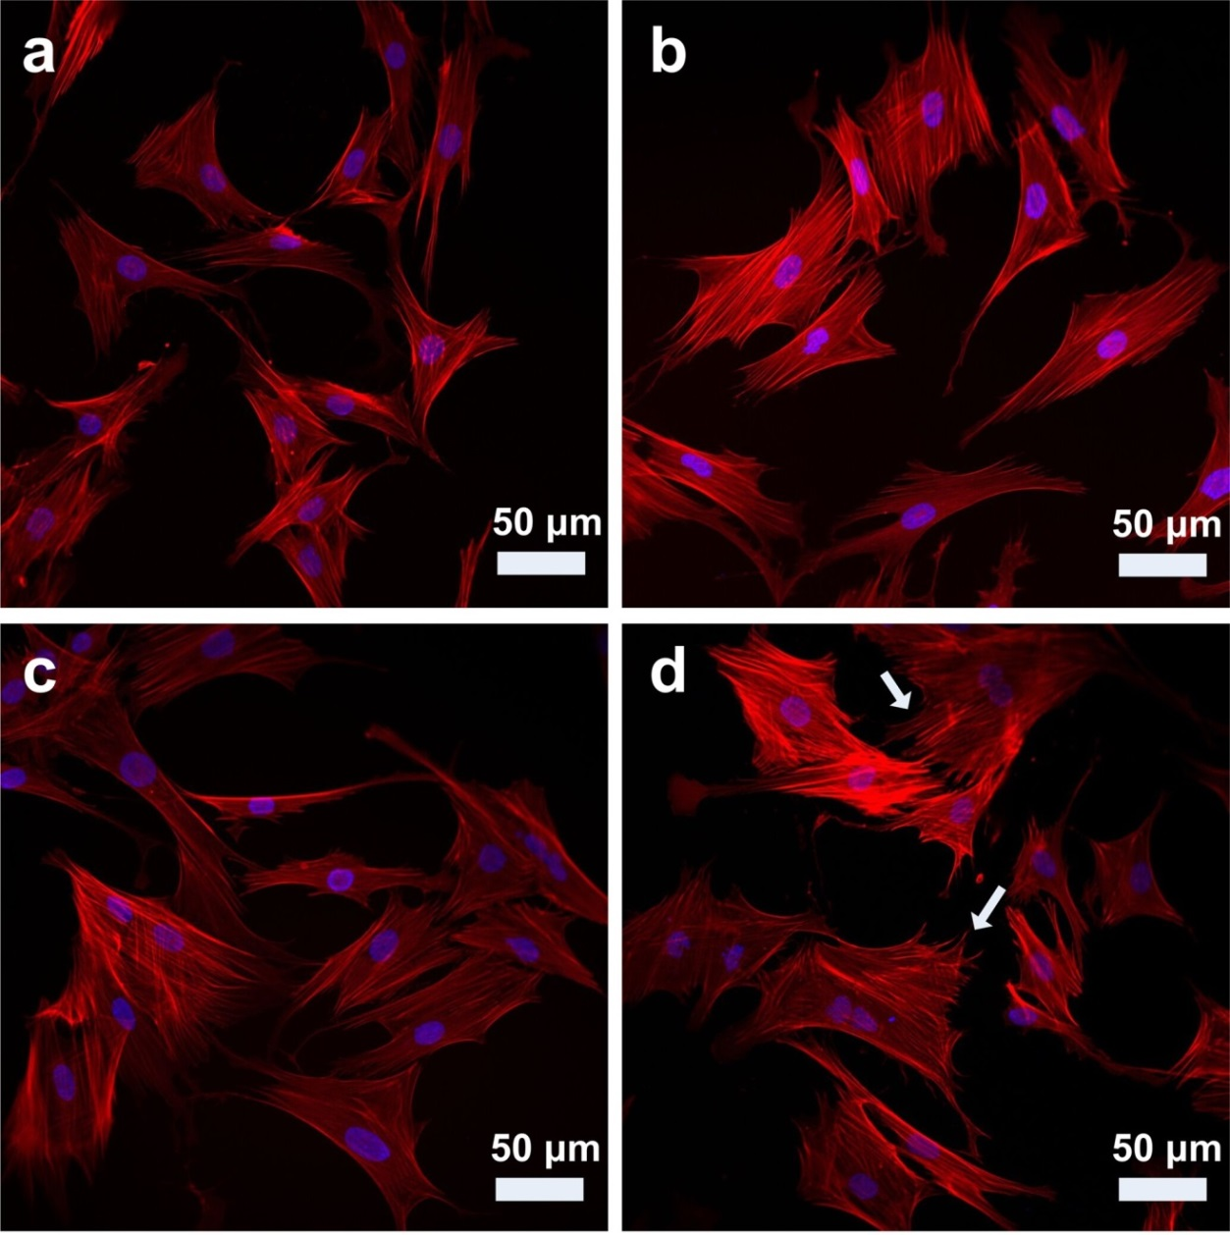
Figure S4. Representative CLSM images of the osteoblasts morphologies after treatment with TCPS (control group) (a), free BMP-2 (b), HA/BMP-2 (c) and HA-Aln/BMP-2 (d) nanocomposites for 48 h, respectively. (Red: cytoskeleton, blue: cell nuclei. Scale bar: 50 μm).

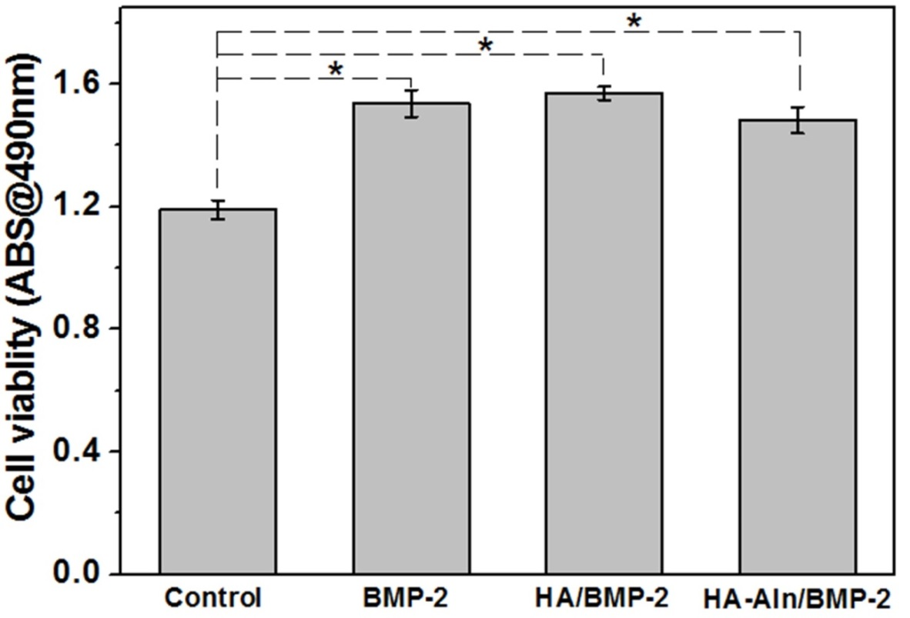
Figure S5. The analysis of osteoblasts cyto-compatibility using MTT method after incubation with TCPS (control group), free BMP-2, HA/BMP-2 and HA-Aln/BMP-2 nanocomposites for 48h. Error bars represent means ±SD for n=5, *p<0.05.

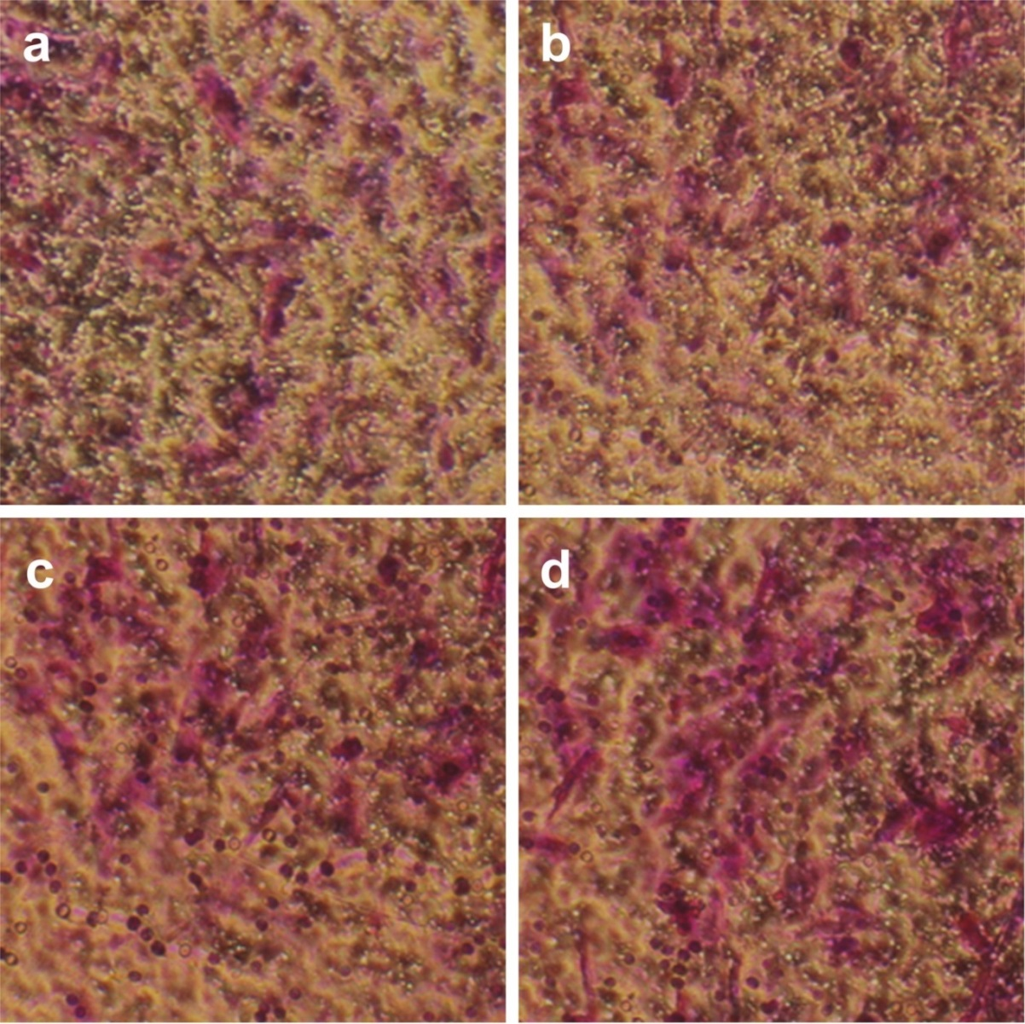
Figure S6. Representative microscope observation showing the osteoblasts migration in a transwell assay after treatment with TCPS (a, control group), free BMP-2 (b), HA/BMP-2 (c) and HA-Aln/BMP-2(d) nanocomposites for 12 h.

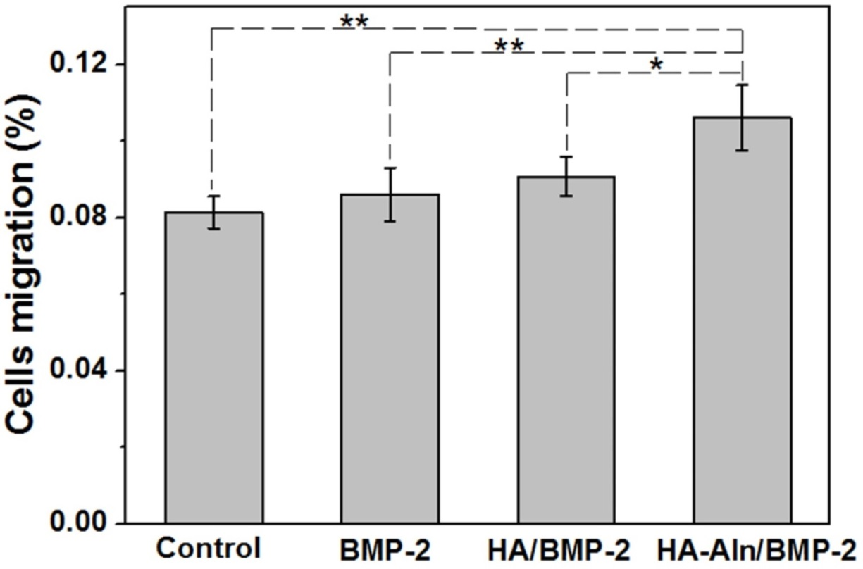
Figure S7. Quantitative transwell analysis showing the osteoblasts migration ability after incubation with TCPS (control group), free BMP-2, HA/BMP-2 and HA-Aln/BMP-2 nanocomposites for 12h, respectively. Error bars represents means ±SD (**p<0.01,*p<0.05).

Figure S8. Representative western blotting images (a) and quantitative protein production analysis of phosphorylated smad 1/5 protein in osteoblasts after being treated with TCPS (I, control group), free BMP-2 (II), HA/BMP-2 (III) and HA-Aln/BMP-2 (IV) for 12 hours, respectively. Error bars represent means ± SD for n=3,**p<0.01.

