SUPPLEMENTARY MATERIAL
Two New Eudesmane-Type Glucopyranosides from the Fruits of
Daucus carota L.
Jin-ke Xu ^{#, a, b}, Xiang-hong Lu ^{#, c}, Wei Zhu^{d}, Bingxian Yang^{d}, Lin Zhang^{d}, Jing-kui Tian^{*, d}
ª Shandong Center For Disease Control and Prevention; Jinan 250014, China: ^{b} School of Pharmaceutical Sciences, Shandong University; Jinan 250012, China: ^{c} Lishui People’s Hospital; Lishui 32300, China: and ^{d} The Key Laboratory of Biomedical Engineering, Ministry of Education, China, Department of Biomedical Engineering, Zhejiang University; Hangzhou 310027, China

# These authors have contributed equally to this work.
* To whom correspondence should be addressed. E-mail: tjk@zju.edu.cn
Tel.: +86-571-88208454; Fax: +86-571-87951091
Address: College of Biomedical Engineering & Instrument Science, Zhejiang University, 38 Zheda Road, Hangzhou, Zhejiang, China.

Two new eudesmane-type glucopyranosides have been isolated from the fruits of Daucus carota L. On the basis of their spectroscopic and chemical evidence, the new compounds were elucidated as daucucarotol-10-O-β-D-glucopyranoside (1) and decahydro-7-[(2-O-β-D-glucopyranosyl)-isopropyl]-1β, 4aα-dimethyl-(1α, 4α, 8aβ)-naphthalenetriol (2). Compounds 1 and 2 showed moderate antitumor activity against human ECA-109 and gave IC₅₀ values of 23.22 µM/mL and 26.76 µM/mL, respectively.

Keywords: Daucus carota L.; eudesmane type sesquiterpene glycoside; antitumor activity
Table S1 ¹H and ¹³C NMR chemical shifts of compounds 1 and 2 (in C₅D₅N)
Figure S1. The ¹H-¹H COSY (─), key HMBC correlations (H→C) (a), and key NOESY correlations (H H ) (b) of 1.
Figure S2. The ¹H-¹H COSY (─), key HMBC correlations (H→C) (a), and key NOESY correlations (H H ) (b) of 2.
Figure S3. ¹H NMR spectrum of compound 1 in Pyridine-D₅
Figure S4. ¹³C NMR spectrum of compound 1 in Pyridine-D₅
Figure S5. HMQC spectrum of compound 1 in Pyridine-D₅
Figure S6. HMBC spectrum of compound 1 in Pyridine-D₅
Figure S7. H-H COSY spectrum of compound 1 in Pyridine-D₅
Figure S8. NOE spectrum of compound 1 in Pyridine-D₅
Figure S9. ¹H NMR spectrum of compound 2 in Pyridine-D₅
Figure S10. ¹³C NMR spectrum of compound 2 in Pyridine-D₅
Figure S11. HMQC spectrum of compound 2 in Pyridine-D₅
Figure S12.HMBC spectrum of compound 2 in Pyridine-D₅
Figure S13. H-H COSY spectrum of compound 2 in Pyridine-D₅
Figure S14. NOE spectrum of compound 2 in Pyridine-D₅

Table S1 ¹H and ¹³C NMR chemical shifts of compounds 1 and 2 (in C₅D₅N )
Position | 1 |  | 2
 | δ_{H}(J in Hz) | δ_{C} | δ_{H}(J in Hz) | δ_{C}
1 | 2.17 (1H, m) | 47.8 |  | 72.4
2 | 1.72 (1H, m) | 30.1 | 2.04 (1H, m) | 48.8
 | 1.39 (1H, m) |  | 1.78 (1H, m)
3 | 1.74(1H, m) | 27.9 | 2.44 (1H, m) | 33.0
 | 1.63(1H, m) |  | 1.81(1H, m)
4 | 1.72(1H, m) | 22.1 | 4.26(1H,dd, 7.5,7.5) | 80.1
 | 1.55(1H, m)
4a | 1.66(1H, m) | 54.9 |  | 48.2
5 |  | 72.3 | 1.93 (2H,t, 7.0) | 45.8
6 | 1.88(1H, m) | 46.9 | 1.72 (1H, m) | 28.3
 | 1.45(1H, m) |  | 1.69 (1H, m)
7 | 1.82(1H, m) | 47.9 | 2.02 (1H, m) | 48.3
8 | 1.60(1H, m) | 29.4 | 1.98 (2H, d, 7.0) | 23.6
 | 1.49(1H, m)
8a | 2.70(1H, m) | 36.8 |  | 81.9
9 | 1.10(3H, s) | 31.5 | 1.15(3H, s) | 25.4
10 |  | 81.9 | 1.28(3H, s) | 22.9
11 | 1.23(3H, s) | 25.0 |  | 82.1
12 | 1.13(3H, s) | 23.2 | 1.19(3H, s) | 22.7
13 | 3.73(1H, dd,10.5,7.0) | 63.4 | 1.12(3H, s) | 17.5
 | 3.46(1H, dd,10.5,7.0)
Glc-1’ | 4.80 (1H,d, 7.5) | 98.9 | 4.79 (1H,d, 7.5)k | 99.1
2’ | 4.25 (1H,t, 7.5) | 75.8 | 4.11 (1H,t, 7.5) | 75.8
3’ | 3.97 (1H,t, 7.5) | 78.4 | 3.72 (1H,t, 7.5) | 78.6
4’ | 4.05 (1H,t, 7.5) | 71.7 | 3.96 (1H,t, 7.5) | 74.4
5’ | 4.18 (1H,q, 7.5) | 79.2 | 4.08 (1H,q, 7.5) | 79.4
6’ | 4.60 (1H,dd, 12.0, 7.5)  4.35 (1H,dd, 12.0, 7.5) | 63.3 | 4.24 (1H,dd, 12.0, 7.5)  4.00 (1H,dd, 12.0, 7.5) | 63.5

Figure S1. The ¹H-¹H COSY (─), key HMBC correlations (H→C) (a), and key NOESY correlations (H H ) (b) of 1.

Figure S2. The ¹H-¹H COSY (─), key HMBC correlations (H→C) (a), and key NOESY correlations (H H ) (b) of 2.

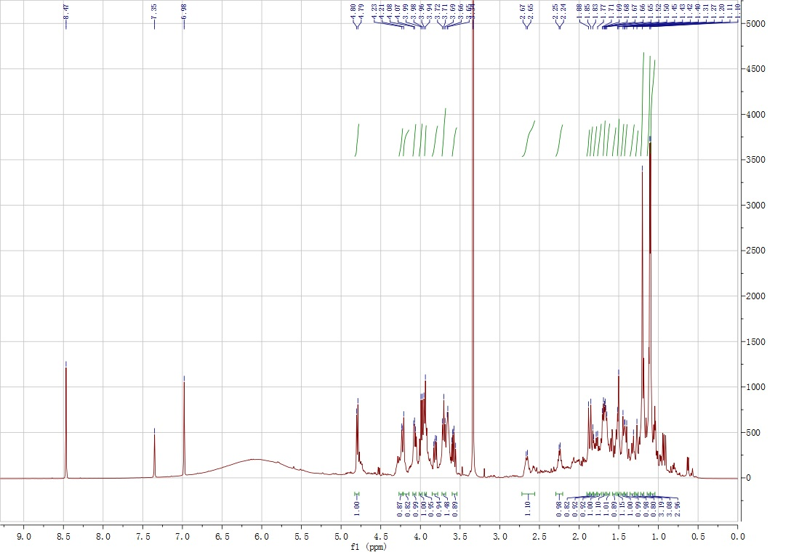
Figure S3. ¹H NMR spectrum of compound 1 in Pyridine-D₅

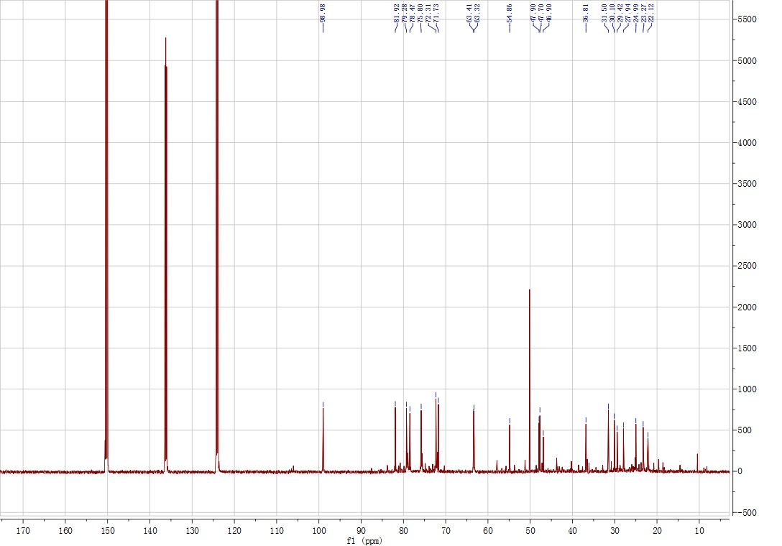
Figure S4. ¹³C NMR spectrum of compound 1 in Pyridine-D₅

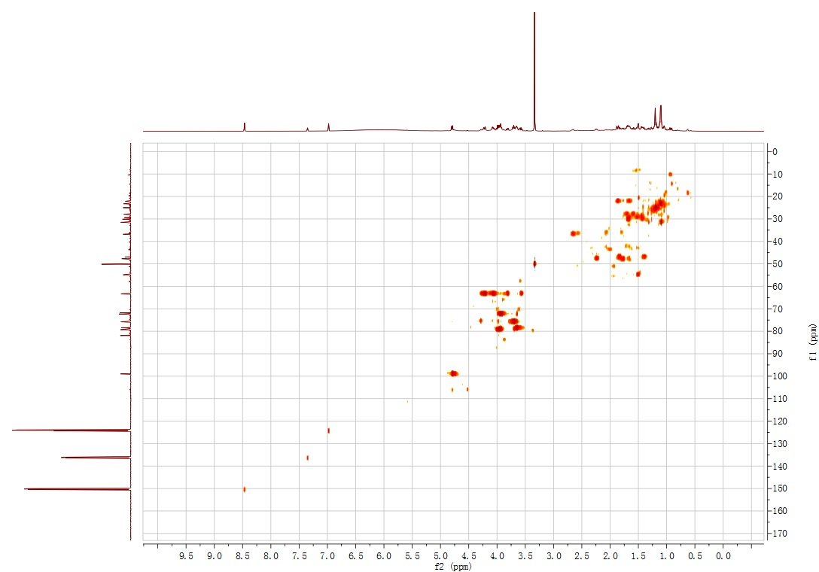
Figure S5. HMQC spectrum of compound 1 in Pyridine-D₅

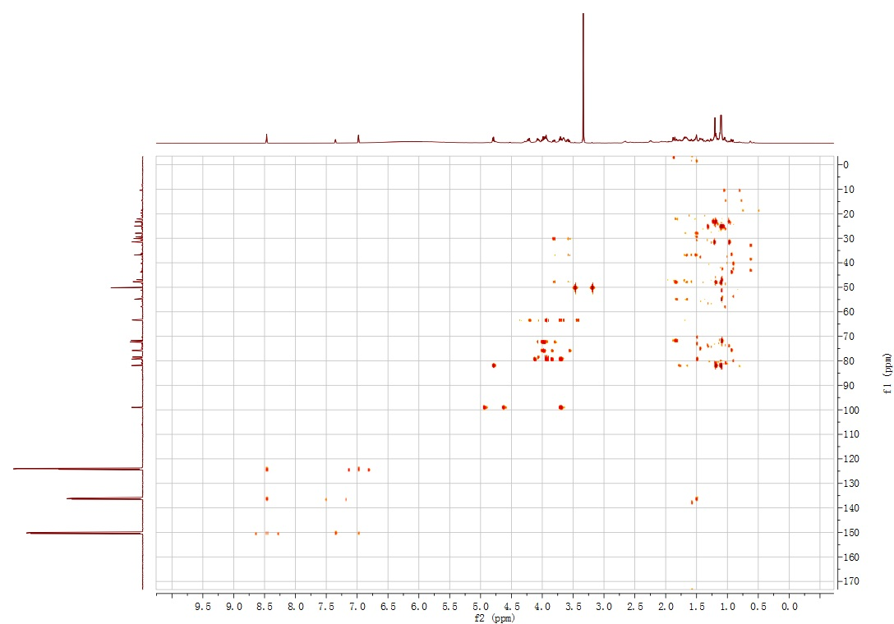
Figure S6. HMBC spectrum of compound 1 in Pyridine-D₅

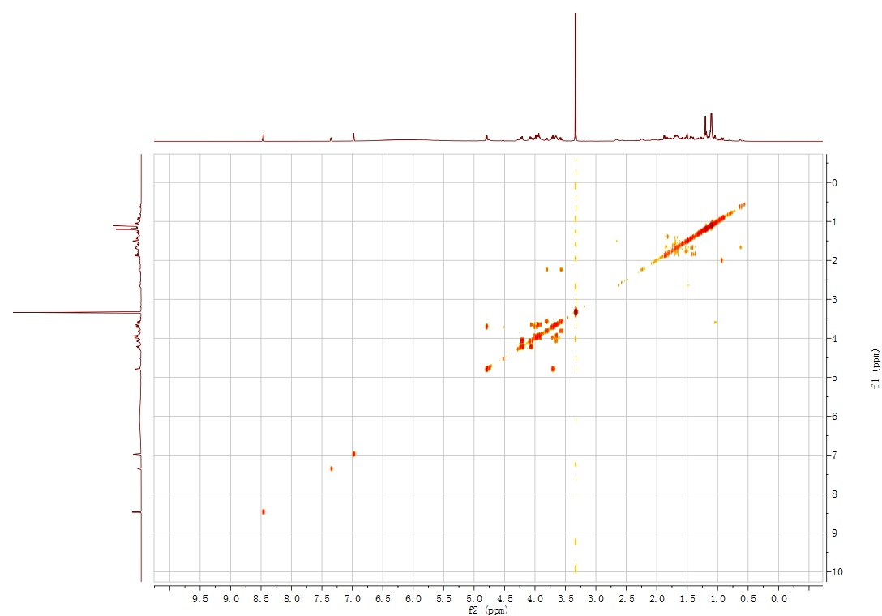
Figure S7. H-H COSY spectrum of compound 1 in Pyridine-D₅

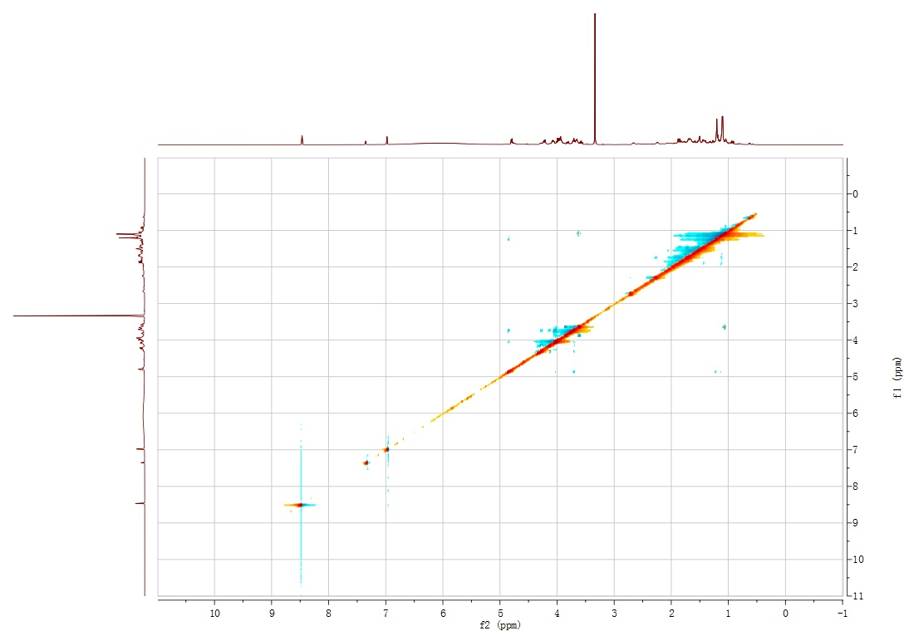
Figure S8. NOESY spectrum of compound 1 in Pyridine-D₅

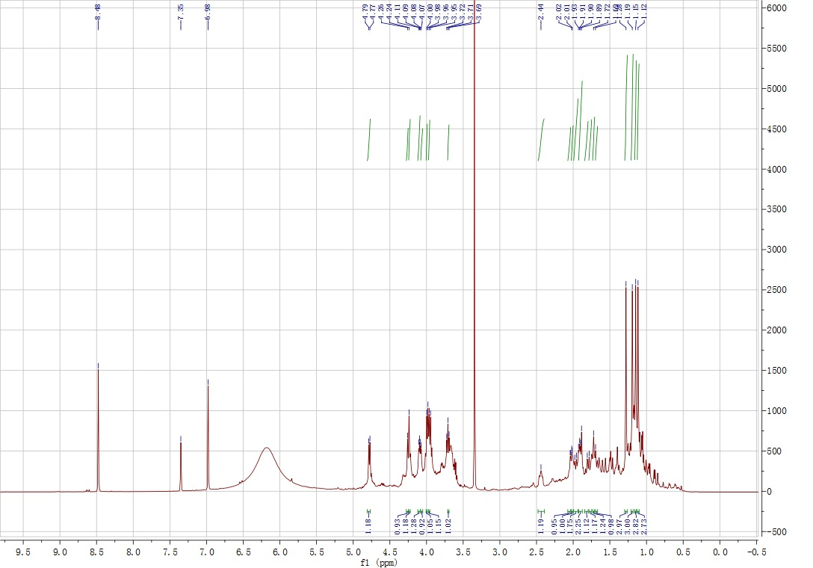
Figure S9. ¹H NMR spectrum of compound 2 in Pyridine-D₅

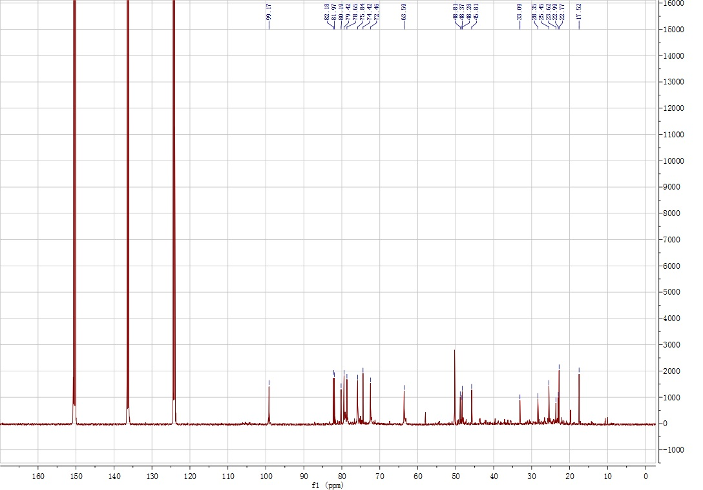
Figure S10. ¹³C NMR spectrum of compound 2 in Pyridine-D₅

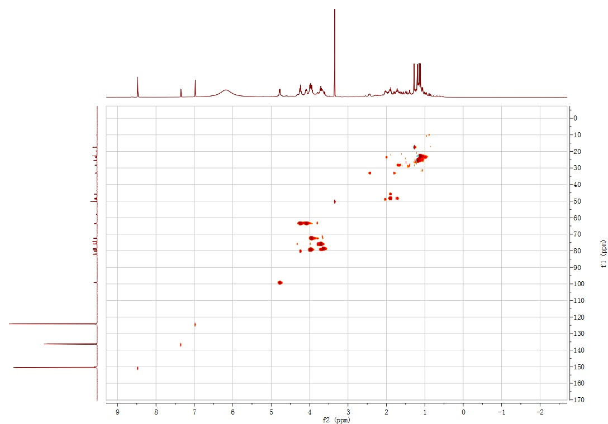
Figure S11. HMQC spectrum of compound 2 in Pyridine-D₅

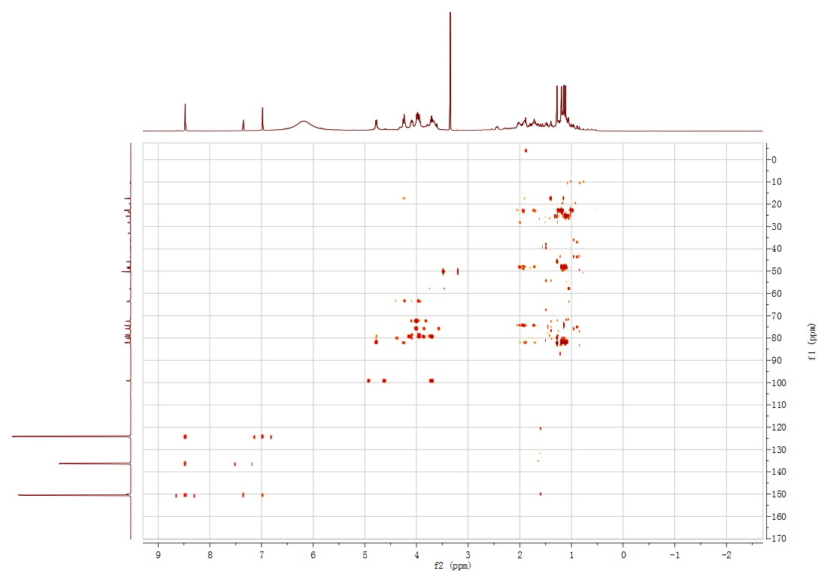
Figure S12.HMBC spectrum of compound 2 in Pyridine-D₅

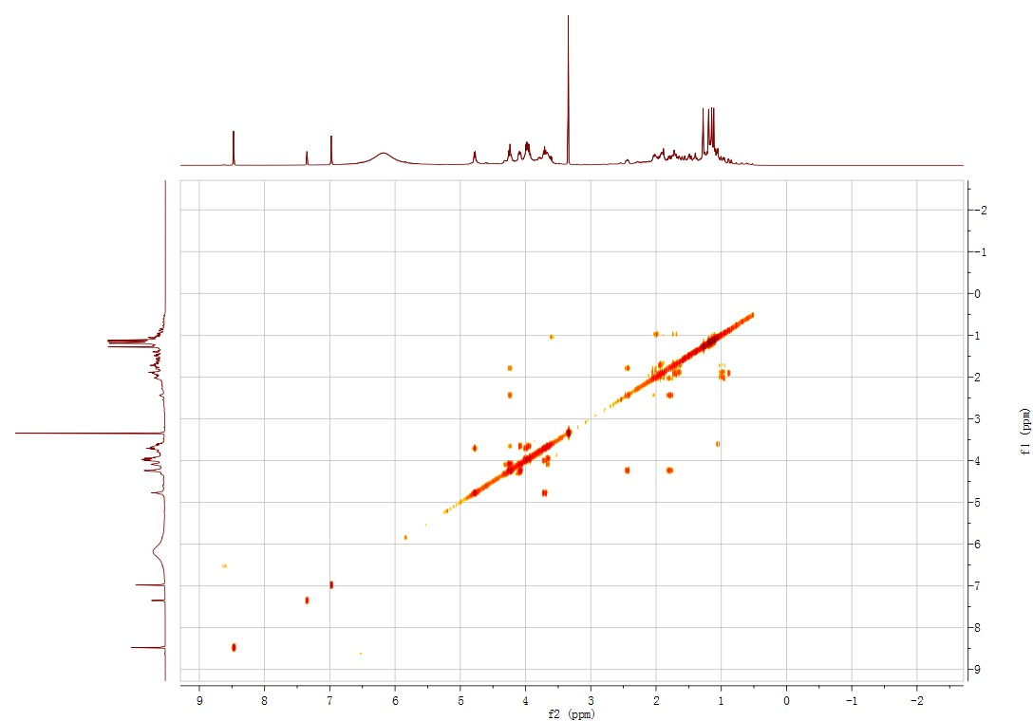
Figure S13. H-H COSY spectrum of compound 2 in Pyridine-D₅

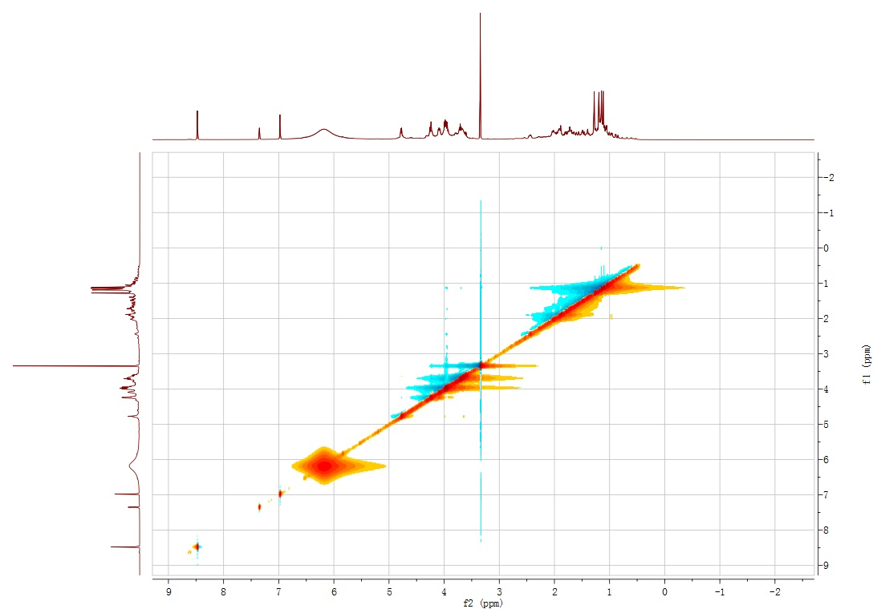
Figure S14. NOESY spectrum of compound 2 in Pyridine-D₅

