Supplemental Information

Application Of A Simple Method To Study Single Particle Bioaerosols Including Preferential Aerosolization
N. Groulx, N. Turgeon and C. Duchaine

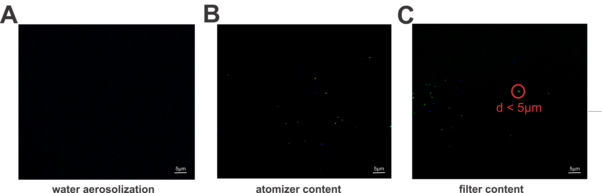

Figure S1: Single particle distribution of E. coli (blue) and P. fluorescens (green) (ratio 1:1) after aerosolization and impaction on a black filter. (A) aerosolization of water showed no fluorescence. (B) The atomizer media was diluted, filtered and the occurrence of the different species were tracked over the fields of view. (C) Single particles of E. coli (blue) and P. fluorescens (green) were observed on a black filter and were spatially distinct.

