Supporting information
Table S1: Analysis of variance
Source | P
Regression | 0,000
Linear | 0,000
Square | 0,153
Interaction | 0,000

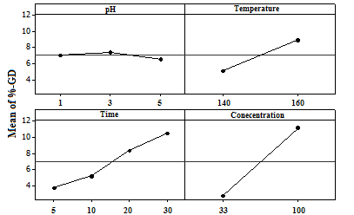

Figure S2: Analysis of main effects plot

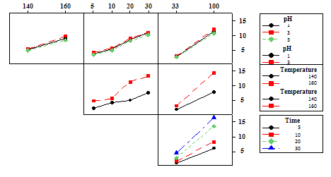

Figure S3: Analysis of interaction plot

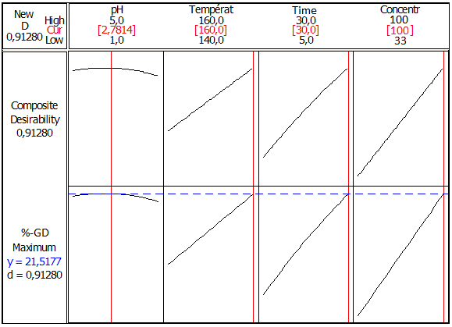

Figure S4: Response optimization of the grafting process

