## Supplementary Information

Experimental DNA demethylation associates with changes in growth and gene expression of oak tree seedlings

Luke Browne *,†, Alayna Mead*, Courtney Horn*, Kevin Chang*, Zeynep Celikkol*, Claudia Henriquez*, Feiyang Ma‡,§, Eric Beraut*, Rachel Meyer*, Victoria L. Sork*,**

**Affiliations**:

* Department of Ecology and Evolutionary Biology, Box 957239, Los Angeles, CA, 90095-7239, USA

† UCLA La Kretz Center for California Conservation Science, Institute of the Environment and Sustainability, University of California, Los Angeles, CA, 90095-1496 USA

‡ Molecular Biology Institute, University of California, Los Angeles, Los Angeles, CA 90095-1496 USA

§ Department of Molecular, Cellular, and Developmental Biology, University of California, Los Angeles, Los Angeles, CA 90095-7246

** Institute of the Environment and Sustainability, University of California, Los Angeles, CA, 90095-1496 USA

**Contents:**

**Figure S1. Photographs of leaves of individuals used for low coverage whole-genome bisulfite sequencing**

**Figure S2. Average methylation level in the CG, CHG, and CHH sequence context for *Q. lobata* seedlings**

**Figure S3. Mean new growth in treated and untreated seedlings of *Q. lobat*a seedlings by family.**

**Figure S4. Leaf fluctuating asymmetry in treated and untreated seedlings of *Q. lobat*a seedlings by family.**

**Figure S5. PCA of gene expression for sequenced samples of 6 paired treated and 6 untreated half-sib seedlings of *Q. lobota.***

**Figure S6. 16S Alpha diversity soil microbiome results*.***

**Figure S7. ITS Alpha diversity soil microbiome results*.***

**Figure S8. Community composition soil microbiome results*.***

**Table S1. Sampling information for the 12 *Q. lobata* maternal source trees sampled for acorns in this study**

**Table S2. Mapping statistics of Whole Genome Bisulfite Sequencing (WGBS) samples**

**Table S3. List of Gene Ontology (GO) term enrichment across treated and untreated seedlings of *Q. lobat*a seedlings**

### Figure S1

Photographs of leaves of individuals sampled for low coverage whole-genome bisulfite sequencing.

### Figure S2

Average methylation level (ranging from 0 – 1.00) in the CG, CHG, and CHH sequence context in 1,000,000 bp bins across 12 *Q. lobata* chromosomes for seedlings treated with the demethylating agent 5-Azacytidine and controls.

### Figure S3

Mean total new growth (cm) in *Quercus lobata* seedlings treated with 5-Azacytidine vs. control by family.

### Figure S4

Leaf fluctuating asymmetry indices (FA1 not scaling by size, FA2 scaling by size) in *Quercus lobata* seedlings treated with 5-Azacytidine vs. control by family.  
  
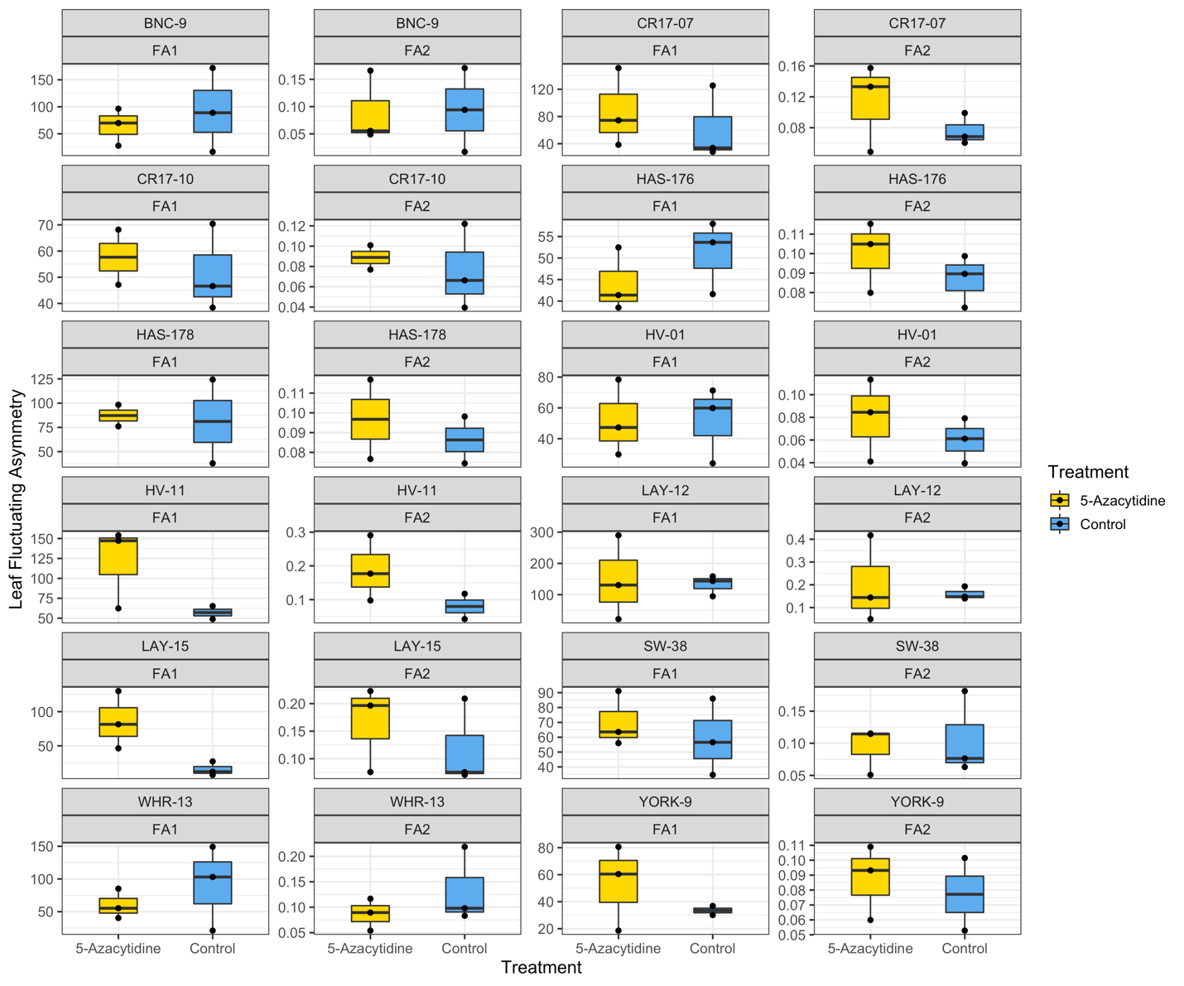

### Figure S5

PCA of gene expression for sequenced samples of 6 paired treated and 6 untreated half-sib seedlings of *Q. lobata* for **(a)** only genes differentially expressed across 5-Azacytidine treatment and **(b**) all genes*.* Gene expression was normalized using the DESeq2 “varianceStabilizingTransformation” function and the PCA was done using R’s “prcomp”   
function.

### Figure S6

Estimates of 16S (bacteria and archaea) alpha diversity showing observed richness, and the Chao, Shannon, and Simpson diversity indices for *Quercus lobata* seedlings treated with 5-Azacytidine vs. controls. Treatment with 5-Azacytidine was not associated with any differences in alpha diversity for 16S for any estimator.



### Figure S7

Estimates of ITS (fungi) alpha diversity showing observed richness, and the Chao, Shannon, and Simpson diversity indices for *Quercus lobata* seedlings treated with 5-Azacytidine vs. controls. Treatment with 5-Azacytidine was not associated with any differences in alpha diversity for ITS for any estimator.



### Figure S8

Ordination by principle coordinate analysis (PcoA) using Bray, Jaccard, or Chao methods on 16S (bacteria and archaea) and ITS (fungi) primers in the soil microbiome of *Quercus lobata* seedlings treated with 5-Azacytidine vs. controls. Treatment with 5-Azacytidine was not associated with differences in community composition for either 16S or ITS. Locality was significantly associated with community composition for 16S but not ITS across the Bray, Jaccard, and Chao methods. 

### Table S1

Sampling information for the 12 *Q. lobata* maternal source trees sampled for acorns in this study. Locality ID shows abbreviation for the population (map in Figure 1), Family ID is the unique family name, along with latitude, longitude and elevation. The remaining columns shows the sample size of seedlings within each family used for whole-genome bisulfite sequencing (WGBS), total new growth measurements, leaf fluctuating asymmetry (FA) measurements, RNA-seq, and microbiome analysis.

|  |  |  |  |  |  |  |  |  |  |
| --- | --- | --- | --- | --- | --- | --- | --- | --- | --- |
| Locality ID | Family ID | Latitude | Longitude | Elevation (m) | WGBS N | New Growth N | FA N | RNA-seq N | Microbiome N |
| BNC | BNC-09 | 35.257800 | -118.67188 | 585 | - | 3 | 6 | - | 2 |
| CR17 | CR17-07 | 34.987227 | -118.61983 | 1753 | - | 6 | 6 | - | 2 |
| CR17 | CR17-10 | 34.987544 | -118.61902 | 1753 | - | 6 | 5 | - | - |
| HAS | HAS-176 | 36.420923 | -121.61240 | 339 | - | 6 | 6 | - | - |
| HAS | HAS-178 | 36.399515 | -121.57673 | 485 | - | 6 | 4 | - | - |
| HV | HV-01 | 34.143117 | -118.89999 | 305 | - | 6 | 6 | - | 2 |
| HV | HV-11 | 34.156342 | -118.91834 | 343 | 2 | 6 | 5 | 4 | - |
| LAY | LAY-12 | 39.690220 | -123.48292 | 504 | - | 6 | 6 | - | - |
| LAY | LAY-15 | 39.688360 | -123.49007 | 492 | 2 | 6 | 6 | 4 | 2 |
| SW | SW-38 | 34.702907 | -120.04074 | 351 | - | 2 | 6 | - | 2 |
| WHR | WHR-13 | 35.839200 | -118.97216 | 190 | - | 6 | 6 | - | - |
| YORK | YORK-09 | 35.55643 | -120.77023 | 293 | - | 4 | 5 | 4 | 2 |

### Table S2

Read numbers and mapping statistics for whole genome bisulfite sequencing (WGBS) samples

|  |  |  |  |  |  |
| --- | --- | --- | --- | --- | --- |
| Sample ID | Family ID | Treatment | Number of raw reads | Number of uniquely aligned reads | Mapping rate |
| HV.11.33 | HV.11 | 5-Azacytidine | 36,297,561 | 18,065,083 | 49.8% |
| LAY.15.34 | LAY.15 | 5-Azacytidine | 41,412,816 | 19,632,238 | 47.4% |
| HV.11.5 | HV.11 | Control | 40,048,867 | 19,507,117 | 48.7% |
| LAY.15.30 | LAY.15 | Control | 38,385,343 | 19,089,286 | 49.7% |