Facilitator orientation (180 minutes)
Pre-event work | - Pre-reading: van Es, E. A., Tunney, J., Goldsmith, L. T., & Seago, N. (2014). A Framework for the Facilitation of Teachers’ Analysis of Video. Journal of Teacher Education, 65(4), 340-356.  - Canvass the facilitators in advance for any influences on their facilitation style; especially formal frameworks.  - Share the relevant video-clip in advance with each facilitator.  - Facilitators to think about any concerns, issues, and questions that they have in advance to share early on in the session.  - Send out ME Plain Language Statements and consent forms and ask them to bring them with them on the day.
Broad aims | - Support facilitators’ preparedness in leading the video-club meetings.  - Address facilitators’ concerns, issues, and questions.  - Discuss underpinning ideas that align our thoughts about teaching and learning, professional development, video-clubs, and the role of the facilitator.  - Provide clarity about the structuring of the video-clubs and the commitments and expectation of the participants.  - Run and reflect on a simulated on-line and face-to-face video club.  - Provide clarity about the next steps as we move towards running the video-clubs.
Indicative time | Cumulative time | Content and facilitator activity | Lead | Participant activity and resources
4 | 4 | Welcome and introductions.  - Brief introductions to participants who do not know one another. | TC | Participants introduce themselves to people they do not know.  Resources: Laptop and screen. All participants to have access to laptop or PC.
5 | 9 | Structure of the morning and the objectives we are hoping to achieve.  - See handout with listed objectives (see above).  Key point: tried to design this event in a way that mirrors how we see the video-clubs working.  - Brief question to facilitators’ to list questions that they think may not be covered. (Aim is to list, not answer or discuss.) | EM | Resource: Handout that lists the key activities and key times.  An invitation to Medical Educator (ME) facilitators to raise questions that they think will not be covered by the espoused objectives.
5 | 14 | Monthly video-clubs: Mapping the terrain.  - Handout. To provide facilitators with clarity about the design, people’s roles, and expectations.  - Completion of ME consent forms.  - Clarify what is required about post-video-club self-reflections (guided interview) | TC | Resource: This slide as handout.  ME facilitators have an opportunity to ask questions about the design and any issues with the consent form.
5 | 19 | Recruitment update.  - To share where we are in relation to recruiting supervisors for the two video-clubs. | TC
5 | 24 | Research timeframe.  - Handout. To lead a discussion about the key dates. To set some provisional date for the first video-clubs, given leave and recruitment issues. | TC | ME facilitators to contribute to setting of provisional dates.  Resource: Calendar of key dates.
5 | 29 | Underpinning ideas  - Handout. (Slide available at end of this document.) Share the thinking that underpins the thinking about professional development, the design of the video-club as a professional development activity, and the role of the facilitator. A discussion about three of the four quadrants.  What we are aiming for is a congruence between a set of overlapping ideas. The facilitator has a key role in maintaining the congruence of the educational design.  - Ideas about teaching and learning  - Key principles about professional development  - Aims of the video-clubs  (Preference is to stick with the handout, rather than the slide, primarily to avoid the ‘lecture’ feel. Run through these three ‘quadrants’ quickly and then link them to the later discussion about the facilitator’s role.) | TC/EM | Discussion between the research team and ME facilitators, with research team leading on the influencing ideas.
2 | 31 | The strengths of video.  Key point. The video is the content or primary focus of the video-club. (Not what might have happened, but what did happen.)  What we are proposing is unusual for teachers, to look at teaching in the micro-level. | DH | Discussion between the research team and ME facilitators, with research team leading.  Both ME facilitators will have experience of using video, particularly in relation to recording and viewing consultations. They will probably need little convincing, and I suspect that it why they have joined. Perhaps ask them to share their views about the strengths of videos?
5 | 36. | Handout. Selecting video extracts.  A discussion of the process and the move away from the original conceptualisation to provide more flexibility. | DH | Discussion between the research team and ME facilitators
20 | 56 | The role of the facilitator: A discussion  - Discussion and ‘clarification’ of the role of the facilitator  - What is the roles?  - How do the two facilitators see their role?  - Do they draw on any frameworks to inform their practice?  Key idea: The aforementioned underpinning ideas suggest a facilitator role that is aligned with these ideas. | EM/TC | Resources: Master slide; 4th quadrant – Ideas about the role of the facilitator; Van Es paper; handout with Heron’s categories of intervention; modes of authority and power.  Discussion between research team and ME facilitators.  I think a way into this discussion is to use the van Es paper. They will have received it with some guidance about how to use it. If we parallel the way we are going to use the videos, perhaps start with a question, ‘What stood out for you in relation to your role?’ We can link in the discussion to the other resources.
9 | 65 | Handout: Ideas for promoting the Videos as Teaching and learning resources. (Slide represented at end.)  Wrapping-up the first-session. Tie up of the discussion and to anchor back to some ideas in the literature regarding the role of video in triggering learning/insights. | TC/EM | Resource: Handout of this slide.  Discussion between research team and ME facilitators.
10 | 75 | Break
5 | 80 | The role of the researcher: A discussion.  - Researcher as participant.  - Other roles outside of meetings (preparation) | TC | Questions from ME facilitators.
10 | 90 | Proposed structure and content of the video-clubs.  - Address the core content and the unique content to first and last meetings. | TC | Resource: Handout of this slide.  Discussion between research team and ME facilitators. Aim for facilitators to say that they know what they are doing, especially in the first meeting.
10 | 100 | Proposed process for sharing video-extracts in video-club meetings. | TC | Resource: Handout of this slide.  Discussion between research team and ME facilitators.
20 | 120 | Simulated video-club: Face-to-face.  Enact the ‘proposed process’ and add-in ‘What I’ve learnt today and whether there are implications for practice’. | DH/ME facilitator | Resource: Video-clip and associated text.  Video-camera and audio-recorder to record meeting.
10 | 130 | Reflections on simulated face-to-face video club. | DH | Discussion between research team and ME facilitators  Primarily and opportunity for KD to reflect on the process with the group.
5 | 135 | The challenges of on-line video-conferencing. | TC | Discussion between research team and ME facilitators.  An opportunity for ME facilitator(s) to flag or to have flagged with him some of the different challenges that he will face.
5 | 140 | Break and setting-up IT connections/places for the video-club.
20 | 160 | Simulated video-club: on-line. | TC/ME facilitator | Resource: Video-clip and associated text.  Everyone to have access to laptop/PC.
10 | 170 | Reflections on simulated on-line video club. | TC | Discussion between research team and ME facilitators.  Primarily and opportunity for ME facilitator(s) to reflect on the process with the group.
10 | 180 | Wrap-up: Looking back over the day and looking forward to the next steps and beyond.  List key actions.  Key questions:  - Are the facilitators prepared for the first meeting?  - If no, what do we need to do?  - Has what we have done and learnt today raised any issues for our preparedness for the video-club roll-out?  - Have we addressed the facilitators’ questions listed at the start? | TC/EM | Discussion between research team and ME facilitators.

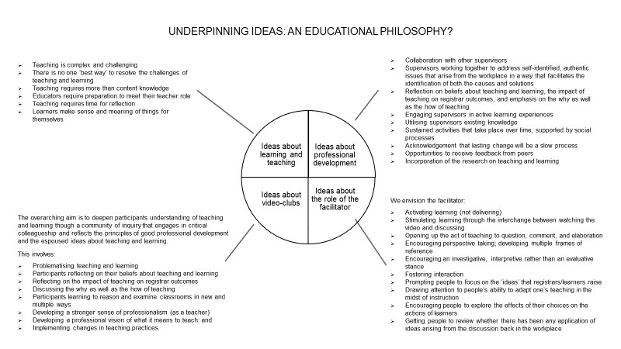

If we were to run this orientation again, we would lengthen it to include more time for reflection on the simulated video-clubs. Some of the research content could be removed. An extra hour would be realistic.

