Suppl. Appendix 1.
Forest plots for the meta-analyses and results of “fill and trim” analysis
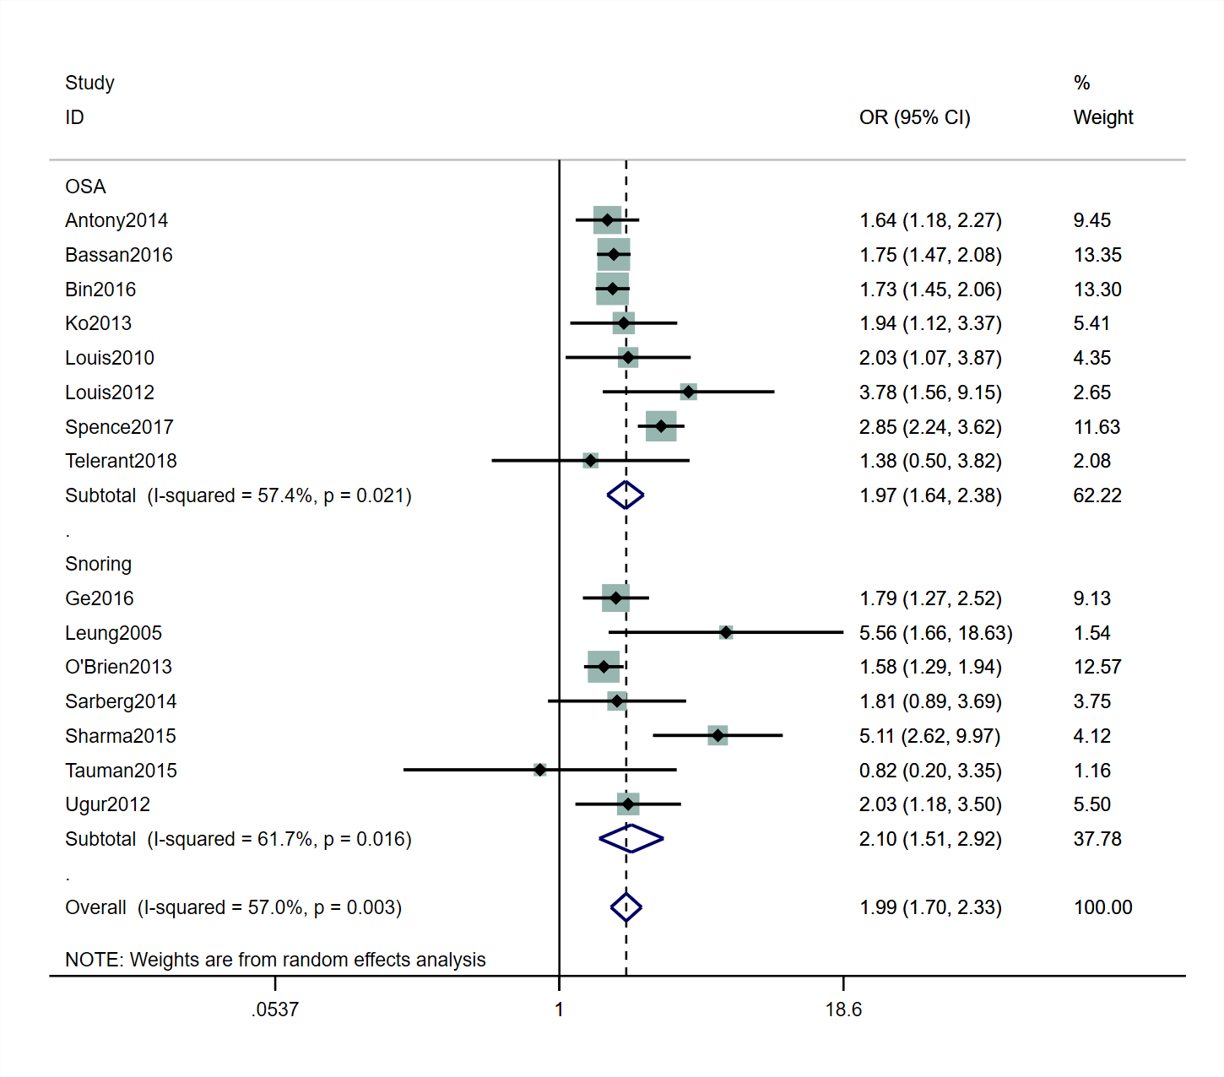
Forest plots for the meta-analyses of the association between sleep disturbances and cesarean delivery
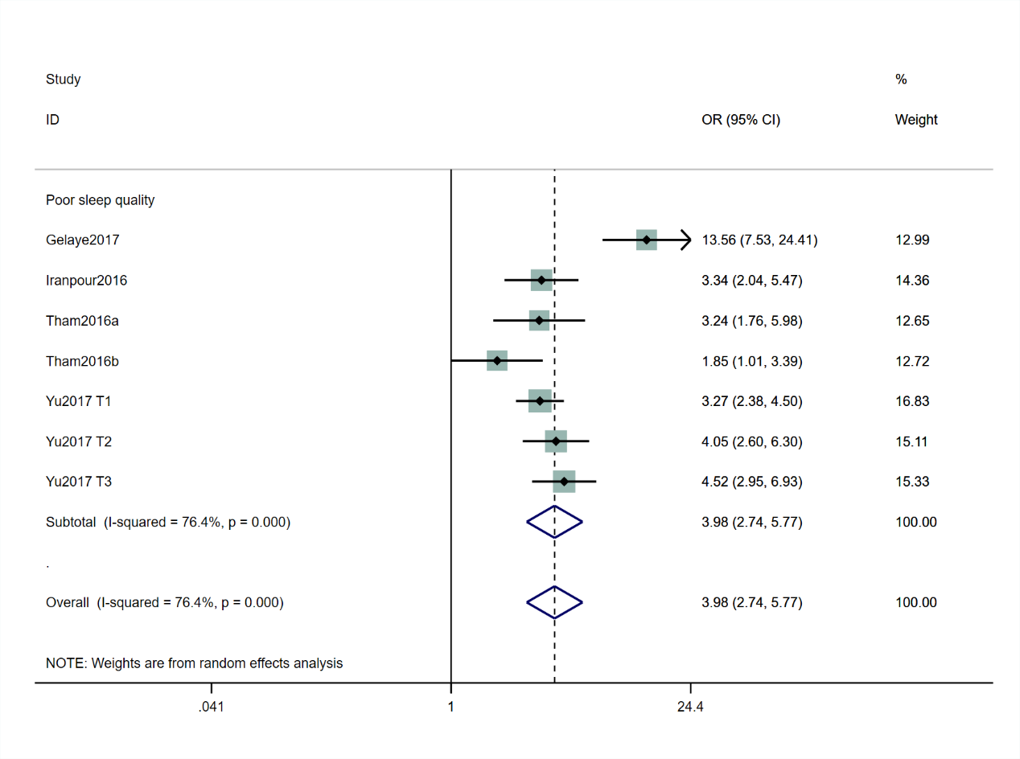
Forest plots for the meta-analyses of the association between sleep disturbances and depression
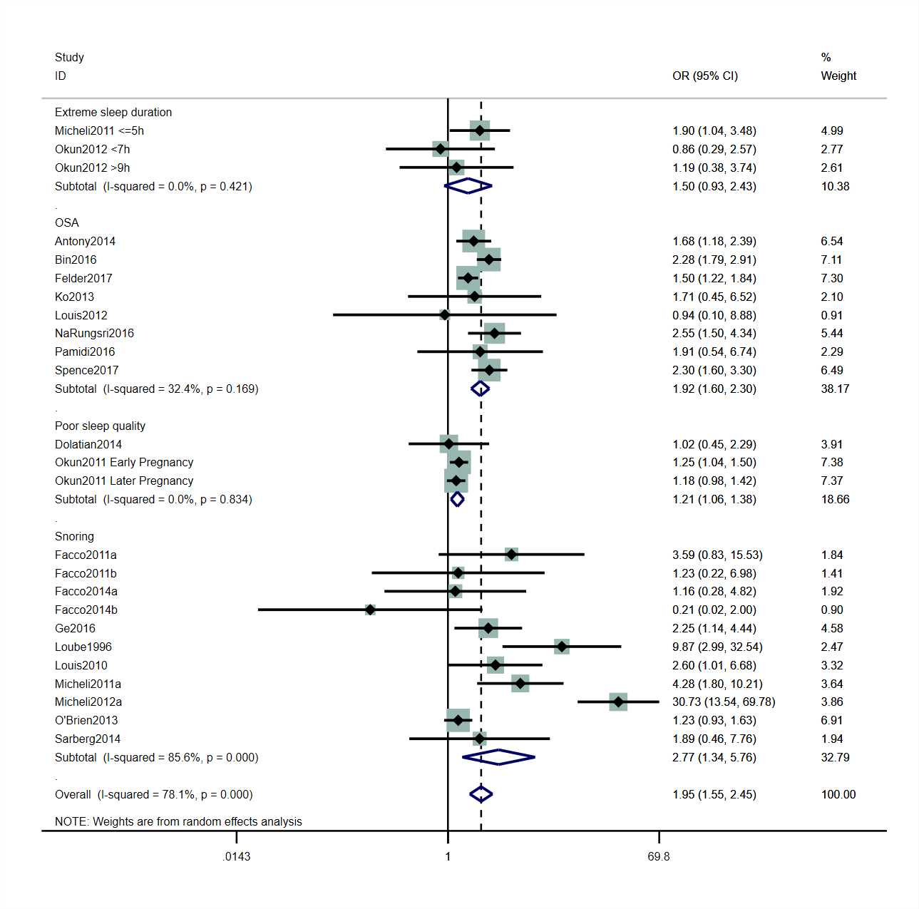
Forest plots for the meta-analyses of the association between sleep disturbances and preterm birth
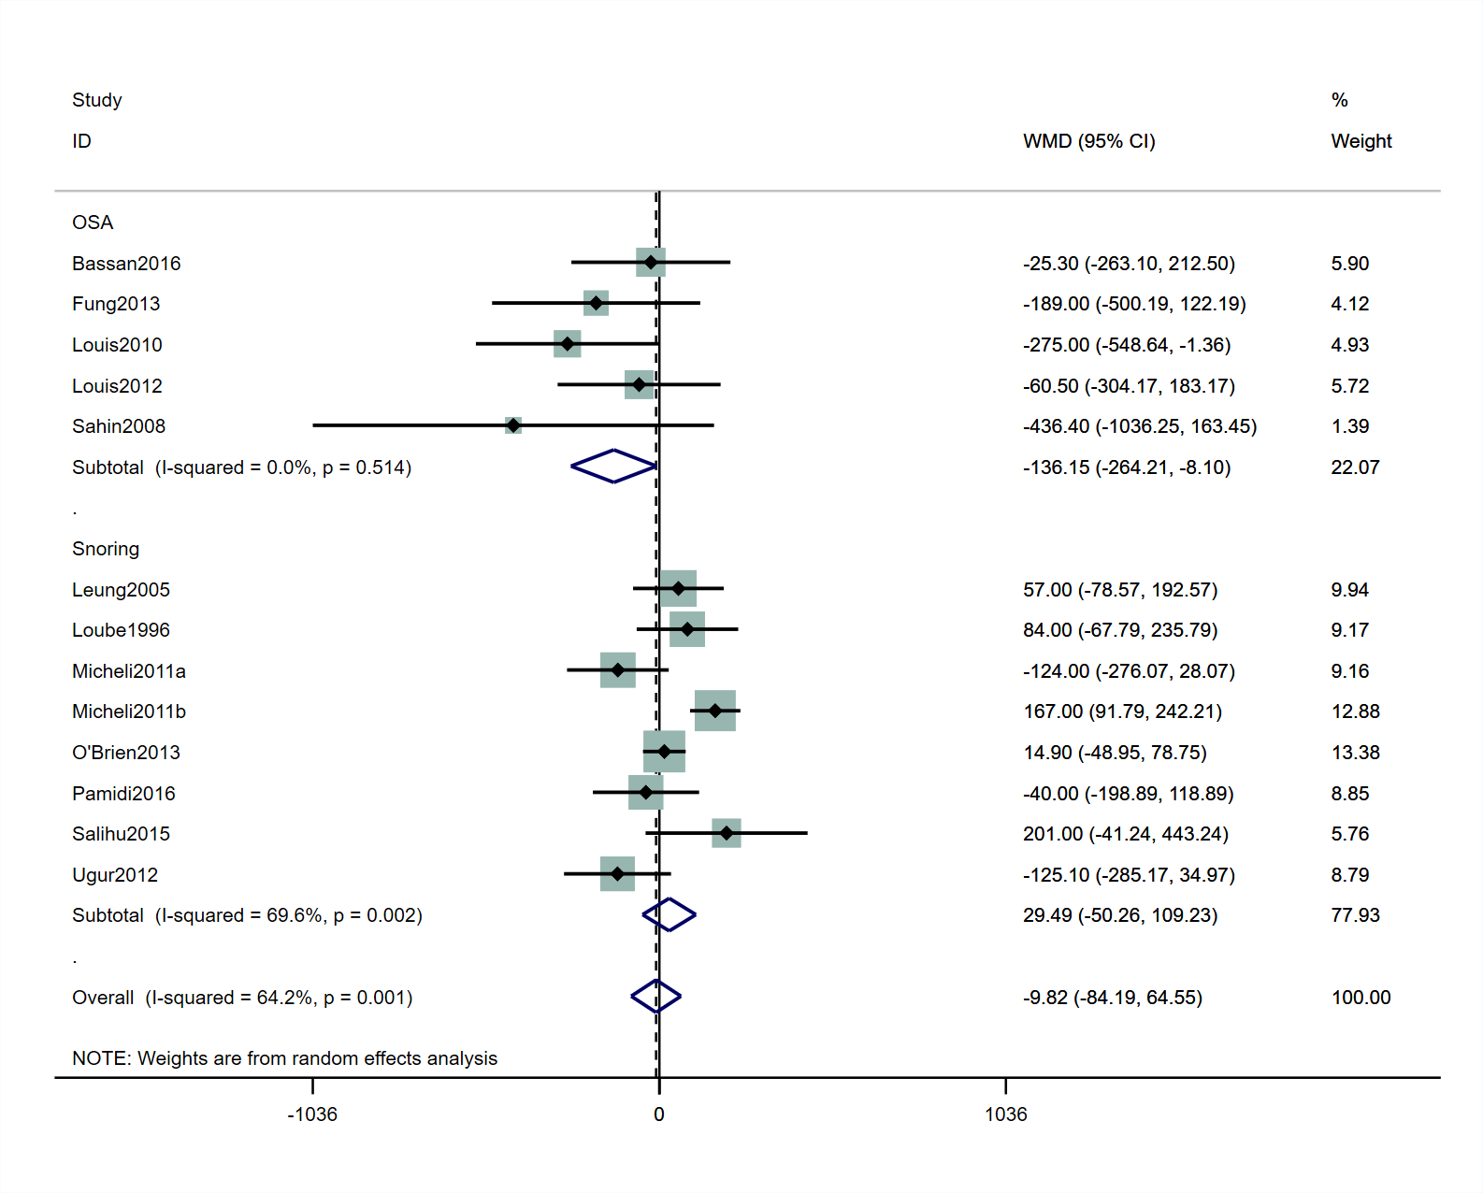
Forest plots for the meta-analyses of the association between sleep disturbances and birthweight
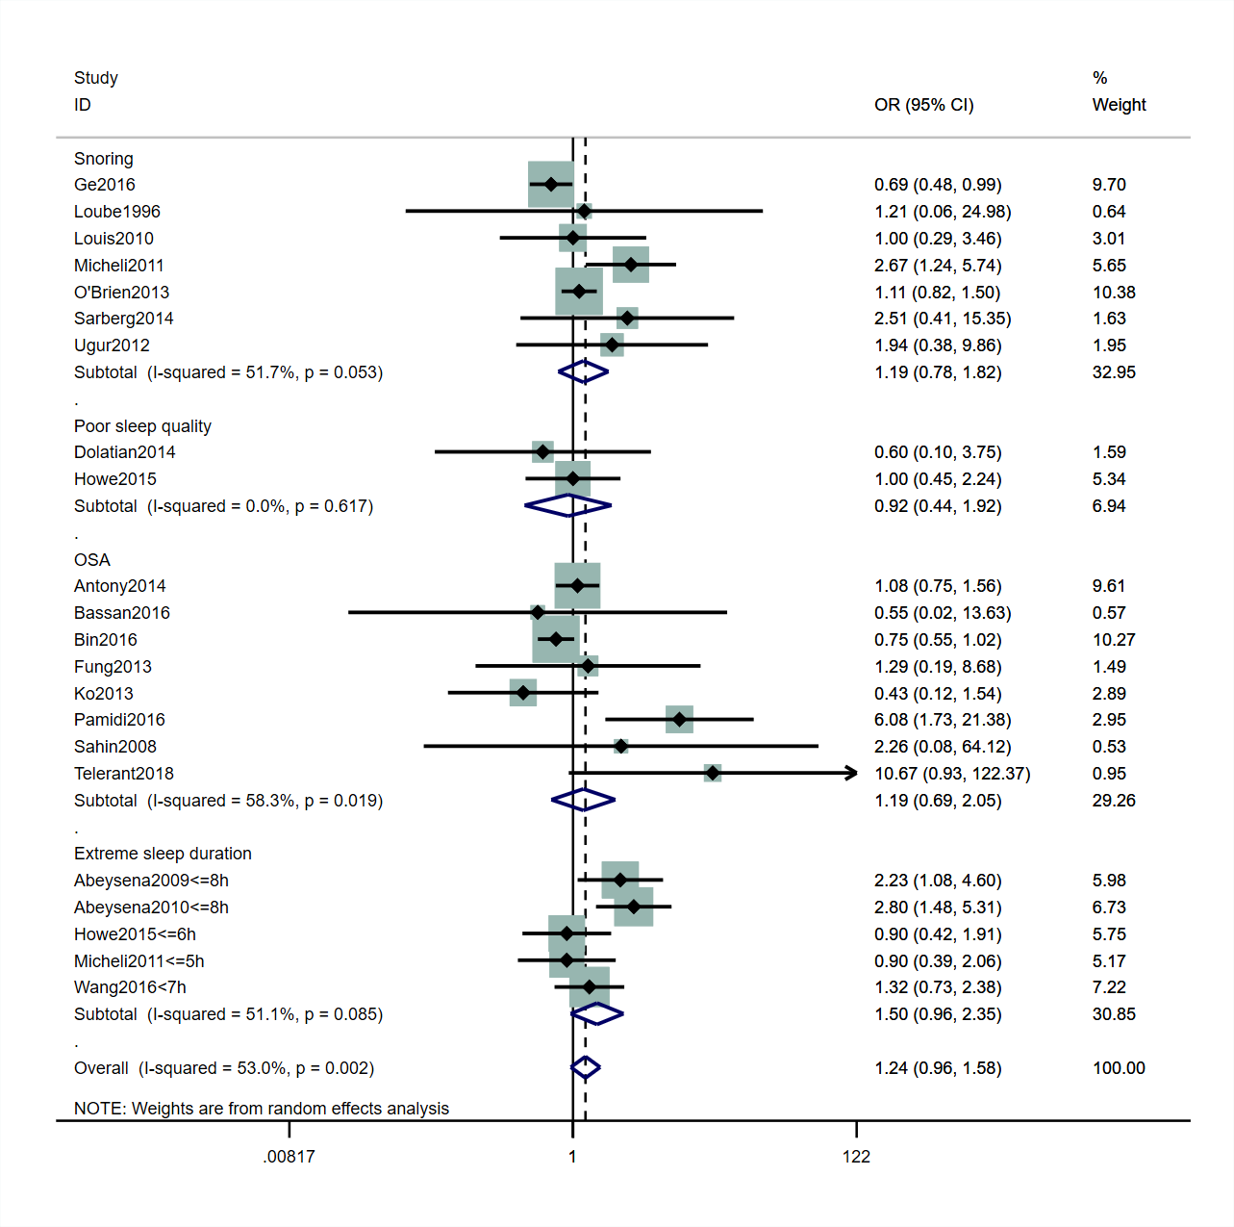
Forest plots for the meta-analyses of the association between sleep disturbances and SGA

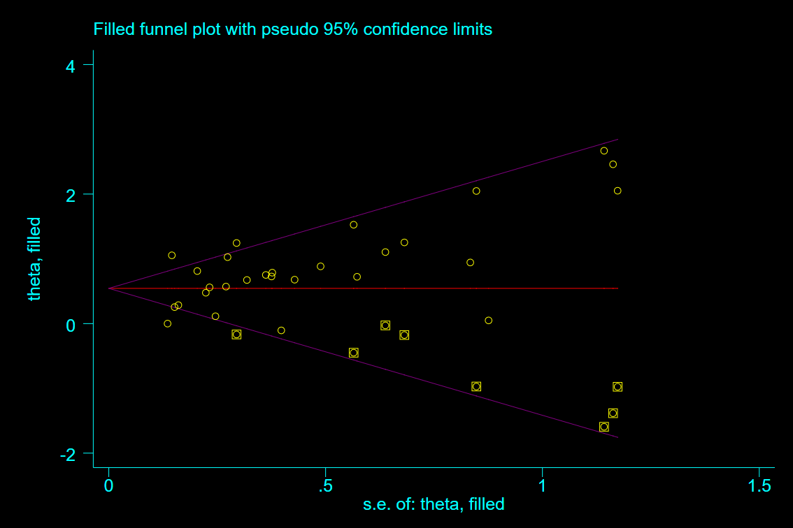
Results of “fill and trim” analysis

