

**Fisheries Manual**

**February 2020**

**Authors:** Sara Miñarro*, Petra Benyei, André Braga Junqueira, Joao Campos-Silva, Victoria Reyes-García.

* Correspondence: sara.minarro@uab.cat



**This project has received funding from the European Research Council**

**(ERC) under the European Union’s Horizon 2020 research and**

**innovation programme (grant agreement No 682602 and No 771056).**

***Definitions***

*Fisher*: people who consider their main activity to be fishing and identify themselves as fishers. Ensure that participants go fishing regularly in the fishing grounds associated with the study site.

*Aquatic species*: animal or plant that lives in the water (freshwater, brackish waters or marine waters) most or all of its lifetime.

*Target species*: aquatic species targeted by fishing, either for selling, for consumption or for other purposes (please record what they are used for).

*Fishing ground*: defined area where local people fish; often fishing grounds have particular names to designate and to distinguish them from one another.

*Fishing technique*: method used for catching fish or other aquatic animals such as mollusks (shellfish, squid, octopus) and marine invertebrates. Fishing techniques include hand-gathering, spearfishing, netting, angling and trapping. Please describe in detail how fishing is conducted and be specific with fishing technique descriptions including: number of people involved, whether it uses boats (what type and how many), gear used, target species, habitat or habitats where it is used, etc.

*Gear*: the tool or group of tools used for fishing. Try to be specific when doing gear description, e.g. size, mesh size for nets, type of nets (bagnet, gillnet, etc.), hook type and size, etc.

You can check some gear descriptions below:

Nets: <https://www.fish.gov.au/fishing-methods/nets>

Hook and line: <https://www.fish.gov.au/fishing-methods/hook-and-line>

Traps: <https://www.fish.gov.au/fishing-methods/traps-and-pots>

Diving/spearfishing: <https://www.fish.gov.au/fishing-methods/diving>

*Habitat*: the type of natural environment in which a particular species of organism lives or dwells, characterized by both physical and biological features. A species’ habitat includes places where it can find food, shelter, protection and mates for reproduction. The habitat can be specific to each particular site. Please take into account local peoples classification and describe each type of habitat according to its distinct biophysical characteristics (depth, substrate, whether marine, brackish or freshwater, structural organisms (e.g. coral, seagrass), etc.).

For instance, in the Solomon Islands site the habitats are: mangrove, coral reef, drop-off, sandbank, seagrass, deep pelagic, and passage or channels between inner lagoon and outer lagoon.**Protocol for capturing local climate change impacts and adaptations in fisheries**

***Goals***: i. To obtain a list of aquatic species commonly found in the field site, ii. to document changes in species abundance, location, temporality and size, iii. to identify the main factors driving these changes, iv. to assess the adaptations made by the fishing community in response to those changes, v) to quantify changes in catch composition, and vi) to quantify changes in diet composition.

The fisheries protocol follows the same methods and sampling design as described in the qualitative part of the core LICCI protocol (i.e. semi-structured interviews and FGDs) and should be conducted as an extension of this part of the LICCI protocol.

Specifically, the fisheries protocol expands the content of the qualitative part (at the **village level**) of the LICCI methods as follows:

(A) The ***semi-structured interviews*** aim at assessing the diversity of **fishing grounds, fishing techniques (**and the **target species** they are used for**)** and **aquatic species** present in the village area. A description of the typical local diet and the perceived reasons for any changes in local diets should also be provided at this level.

Partners should follow the standard LICCI protocol to **document the local observations of changes, with a special focus on changes in aquatic species and habitats** over time, as well as any **adaptations** the community members are implementing in response to those changes.

Finally, two additional pebble games should be carried out with the aim of capturing changes in a) catch composition and b) diet composition with respect to 10 years into the past.

(B) The ***focus group discussions*** aim at assessing **observations of changes in aquatic species and habitats** more in depth, including:i) experienced fishers’ observations concerning changes in aquatic species abundance, size, distribution and behavior, and ii) experienced fishers’ observations about changes in the aquatic environment. The main addition to the LICCI protocol is bringing the adaptations related to aquatic environments for discussion, aiming at documenting any existing changes in fishing gear, habitat, target species and/or timing of fishing or gathering practices. It is recommended that one of the 2-4 focus groups envisioned in the LICCI protocol is specifically dedicated to discussing aquatic changes and adaptations.

Before starting to conduct the interviews, you should make sure you have clarified a “glossary” with the interview terminology. If possible, run 3-5 pilot interviews to check how the concepts work and train your translator. Examples of tricky concepts are “fishing ground”, “gear”, “habitat” (see definitions).

***Material recommended:*** If possible, a booklet with the picture and scientific names of all the aquatic species expected to be present in the study area should be printed before going on the field (including algae, mangrove species, and other aquatic plants). This booklet will be a reference for the village surveys and can be adapted by adding species that were not included initially. The picture should be clear and display the whole organism (preferably in their habitat), as well as details relevant for its identification. When possible, choosing pictures representing the diversity of the subspecies/different life stages observed in the area is recommended.

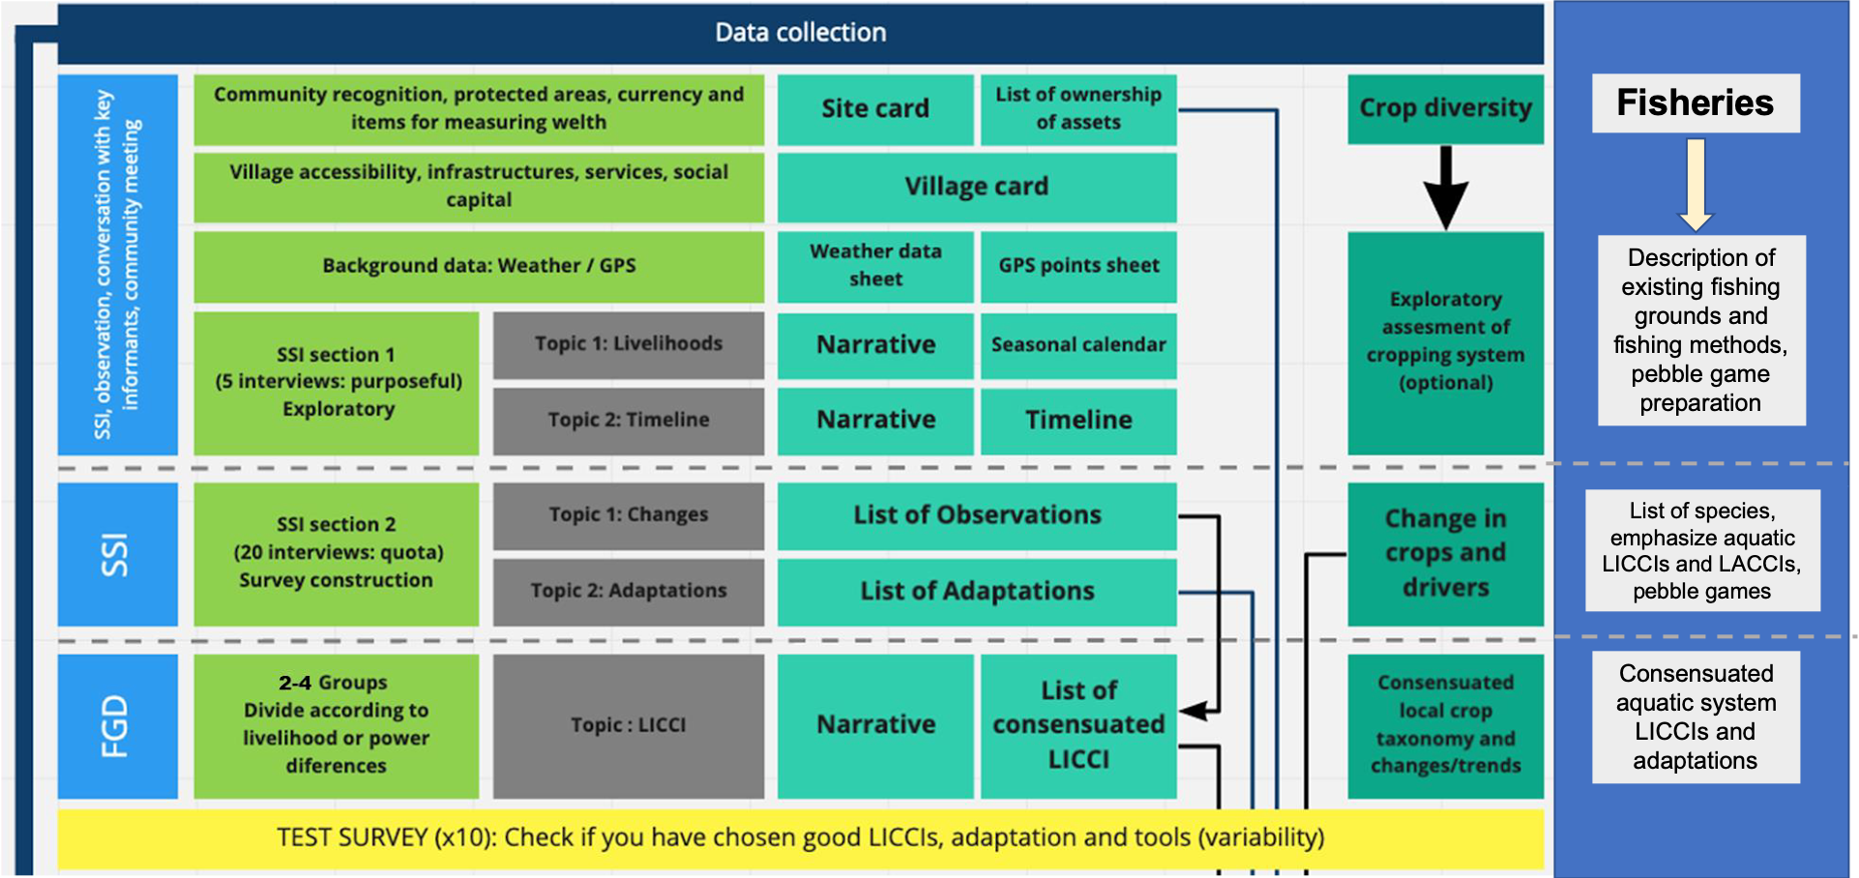

Figure 1. Scheme of how the fisheries data collection flow is integrated in the LICCI protocol.

1. **Village level, semi-structured interviews**
2. **Local livelihoods semi-structured interviews**(SSI section 1 of LICCI protocol)

During the local livelihoods semi-structured interviews (comprising 3-5 in-depth interviews with knowledgeable members of the community), partners should gather all the contextual information needed to carry out the fisheries protocol effectively. This includes assessing the diversity of fishing grounds and fishing techniques, and getting a comprehensive idea of what are the types of fisheries operating in the village and which groups are involved in each kind of fishery. For example, in the Solomon Islands, men are involved in spearfishing and fishing in the pelagic areas, while women are involved in gleaning (gathering of shells in the mangroves) and fishing in the coral reefs. During these interviews, it may be helpful to start filling up the species table with the most commonly mentioned aquatic species.

This phase should also serve as preparation for the pebble games you will run in section 2 of the SSIs. For that, you should inquire about the typical diet, i.e. what are the main food sources and ingredients (e.g. bread, potatoes, cabbage, sardines, etc.) in the site, nowadays as well as in the past, and record participants’ explanations of any changes in their local food sources. At this point, you should already have a good idea of the catch composition for each type of fishing after having filled the fishing techniques table.

***Expected outputs:*** Partners should produce a description of all the fishing techniques employed by fishers in the village, and a description of the different fishing grounds that fishers visit.

1. **A** **description of the different fishing grounds** and their characteristics. If a fishing ground is shared between villages, information should be entered only once.
2. Partners should *fill the table* (*refer to the output manual table 1*) as follows: Establish the **list of fishing grounds** that people distinguish and name using their local names. Indicate the main target species per fishing ground. Provide: i) a brief description of the **biophysical characteristics** of each fishing ground (e.g., habitat type, distance to village, approximate surface area), ii) the **main target species** associated with each fishing ground, and iii) **management rules** (if they have formal or informal rules in place regulating the harvesting in that particular area).
3. Provide a *brief narrative* with a general description of fishing techniques used and provide any useful complementary information about the fishing ground, especially concerning their respective importance in livelihood strategies, their temporal dynamics, local cultural importance, etc. Specify if the fishing activities are subsistence-oriented or market oriented, what are the main value chains, what are the main constraints, and what have been the major changes observed in that area. Submit as text.
4. **A list of fishing techniques with descriptions** (*refer to the output manual table 2*). Please include: the gear they employ (list of gear and where fishers can get it from), habitat and species they target, whether it is performed from a boat/canoe or from shore, roughly how many people use it, and what is the typical catch composition (including bycatch) for each fishing method. Then, a short narrative detailing the fishing process should be submitted as text.
5. Lists of the **categories to be used in each of the pebble games**: a **list of the main target species** for each of the main fishing techniques (e.g. Trolling: wahoo, bonito, barracuda, shark, trevally; Netting: sardine, anchovy, turtle), and a **list of the main food items** (e.g. bread, potatoes, cabbage, sardines, wild boar, etc.) in the area.

**B. Changes and adaptations semi-structured interviews** (SSI section 2 of LICCI protocol)

During the ***changes and adaptations*** (20 interviews) semi-structured interviews of the LICCI protocol, partners should ask participants for a free listing of all aquatic species known to them (this involves a free listing until the participant appears to become tired, or more than 15 min have been invested). When doing the species list, please follow the local name as a guide, but bear in mind that sometimes local people distinguish two or more “types” of the same species, depending on their life stage (e.g. they have one name for juvenile fish and a different name for adult fish), physical features, behavior, culinary use, etc. In this case you should list both local “subspecies” in two separate rows (noting their common name in English and scientific name whenever possible) and record any reported changes for each subspecies separately.

While administering the normal LICCI protocol, ask specifically about any changes they may have observed in these species and in the aquatic environment as a whole. Inquire about adaptations to the observed changes, and about changes in fishing behavior (changes in frequency of fishing in general, frequency visiting certain fishing grounds, changes in gear or target species, etc.). Please note that taking up fishing as a novel livelihood activity can be an adaptation too, e.g., to a decrease in agriculture productivity; in this case, record all the available information on the target species, gear and fishing grounds, and on how fishing was adopted (temporality, who were the early starters in the community, etc.).

As with the core LICCI protocol, the purpose of this phase is to gather all the possible information needed about changes and adaptations, which will be verified and consensuated in the focus group discussions.

**Pebble game - Catch and diet composition changes:** this exercise aims at quantitatively documenting changes in (1) the average catch composition (species typically caught and their abundance) for each type of fishing technique, and (2) the average daily diet composition of participants. The pebble game should be done for the catch and diet composition today and for the typical catch and diet 10 years ago. If participants in your site find it difficult to relate to the 10 years mark, you can mention remarkable events that happened at that time as reference (e.g. when the bridge fell from a storm, when your son was married).

Some guiding questions can be:

* What is the average catch that you can get after going on a fishing trip/session, in the current season, nowadays? (for a certain fishing technique)
* What is the average catch that you used to get after going on a fishing trip/session, in the current season, 10 years ago? (for a certain fishing technique)
* What is the approximate amount of these food items you typically eat, in the current season, in a day?
* What is the approximate amount of these food items you would typically eat, in the current season, in a day 10 years ago?

The categories of target species and food items offered to participants should be based on the information gathered in section 1, and no more than 10 options should be offered. It is recommended that 100 pebbles are used in each game.

*For the catch composition*: If more than two fishing methods are common in the study site, partners should select a **maximum of three fishing techniques** for the pebble game to ensure enough representativity of the data collected. To assess the catch composition, the most common species reported for the participants’ main fishing methods should be provided (e.g. as pictures or drawings), and if they note that some species are missing, they should be noted, and their percentage of the catch accounted for.

*For the diet composition*: record the relative importance of the food sources for the typical diet today and 10 years ago. If aquatic food sources are mentioned, please specify the species name of the fish/other aquatic sources.

The catch and diet composition pebble games are an optional, standalone study, although partners are encouraged to do them in order to capitalize on the data collected on species, changes and adaptations. It can take place at the end of the semi-structured interviews or (if the SSI is taking too long) by recruiting participants independently. At least 20-25 participants should be surveyed. Additionally, for each participant, please record: age, gender, years living in this site, fishing technique, and fishing grounds usually visited.

***Expected outputs:*** (using the standard LICCI protocol) list of observed changes in aquatic species, changes in the aquatic environment, and list of adaptations including changes in fishing behavior.

1. **A** **list of known aquatic species in the area** *(refer to the Output manual table 3).* Fill the output table by establishing a list with the correspondence between the local species name and the scientific name of the aquatic species (Use the species pictures booklet as a reference).

Indicate:

* Species habitat and fishing ground names where the species is present.
* What are the main target species in the village, i.e. the fish or invertebrate species fished the most frequently for consumption, sale or other purposes (please specify their main use).
* For target species, please specify how many people fish for them (give as a percentage).

1. **A table of pebble game participants information** *(refer to the Output manual table 4).*
2. **A table of catch composition** separated by fishing technique*(refer to the Output manual table 5)* summarizing the results from the pebble game for today and 10 years ago*.* Please include a small narrative with any relevant points raised during the focus group discussions with regard to the reasons for any changes in the catch.
3. **A table of diet composition** *(refer to the Output manual table 6)* summarizing the results from the pebble game for today and 10 years ago*.* Please include a small narrative with any relevant points raised during the focus group discussions with regard to the reasons for any changes in diet.
4. **Village level, focus group discussions**

***Sampling recommendations***: at least one group interview should be conducted in each village. Each group should include between **5 and 10 people**. The procedure for sampling will be the same as for the Focus Group Discussion in the main LICCI protocol but targeting only people involved in fishing as their main livelihood activity. When applicable, we will use quota-sampling to capture fisher variability within the local communities in terms of gender and age. If the partners feel that power relationships may impede some specific group to express their viewpoint freely, or if more than one fisher collective exist that employ different fishing techniques or target different species/fishing grounds, more than one focus group discussion should be completed per village to include all the relevant groups. Informants selected for the fisheries protocol may need to be selected independently from those selected for the core LICCI FGD. Partners can choose to do these group interviews together with the FGD conducted in the core protocol or independently. In any case, bear in mind time constraints, and if the general LICCI FGD is too long, try to do the fisheries FGD separately.

***Content:*** In the group interviews we will explore five main topics: (1) document fishers’ observations concerning changes in aquatic species size, distribution and abundance, and the main drivers of such changes (focusing on the impacts of climate change but recording all drivers); (2) document community adaptations with regard to the aquatic environment, including changes in fishing behavior (target species, fishing grounds, timing, etc.) and changes in fish/aquatic organisms consumption.

***Expected Outputs*:**

Researchers should note any extra information and as many details as possible about reported changes in the aquatic environment and species, as well as a table of consensuated adaptations in terms of fishing and/or seafood gathering.

From the data gathered in the app, we expect to produce:

1. **A table of perceived changes for aquatic species by species*****ID***. (Please make a new row in table 2 for each observed change, repeating the species local name as many times as needed, including the direction of change, driver(s) and classification in the LICCI tree.)
2. **A table of perceived changes in the aquatic environment by habitat**. (Please make a new row in table 4 for each observed change, repeating the habitat name as many times as needed, including the direction of change, driver(s) and classification in the LICCI tree.)
3. **A table of adaptations to changes in the aquatic environment,** similar to the LICCI core protocol table. For changes that have to do with fishing behavior please also include changes regarding the frequency of fishing, frequency visiting certain fishing grounds, changes in gear and changes in target species.

1. **Output manual**

Researchers should not submit raw data but should keep it for a period of 3 years, as it might be required for clarifications. Raw data includes transcripts or recordings of the interviews, field notes, etc.

**Table 1- List of fishing grounds**

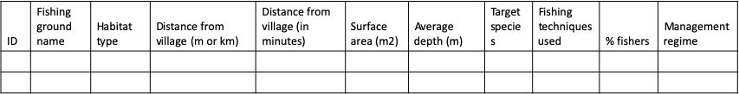

**Table 2- Fishing techniques**

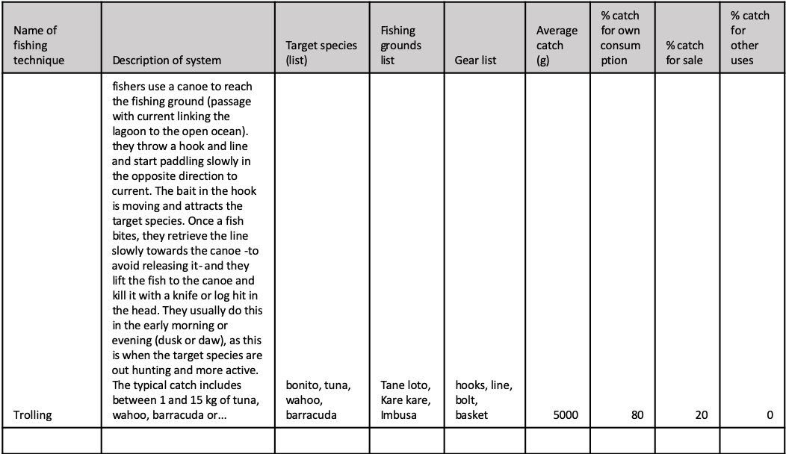

**Table 3- Species list**

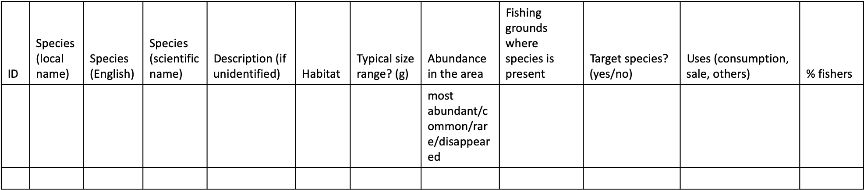

**Table 4- Pebble game participants information**

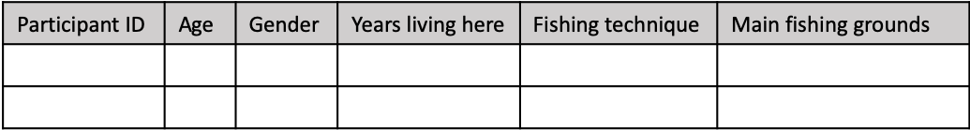

**Table 5- Catch composition**

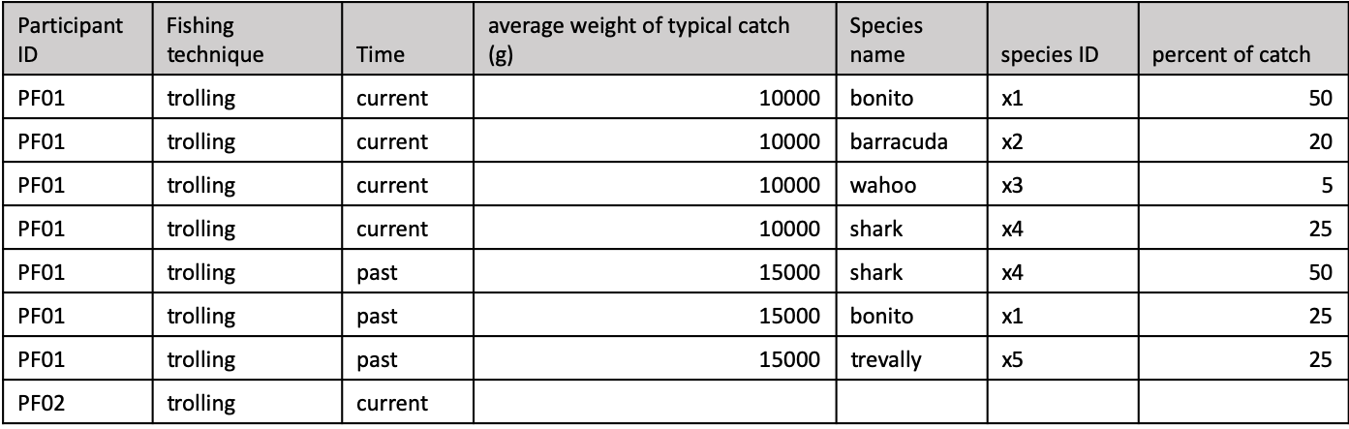

**Table 6- Diet composition**

