Supplemental online material for:
False memory for pictorial scripted material: the role of distinctiveness and negative emotion

Table S1
Means (and standard deviations) of the ratings of valence, arousal, and distinctiveness, provided by 28 independent judges on the endings of the stories used as the encoding material in the experiment.
 | Scale
Type of story ending | Valence | Arousal | Distinctiveness
 | (9-point rating scale;  1 = negative, 9 = positive) | (9-point rating scale;  1 = low, 9 = high) | (5-point Likert scale;  1 = low, 5 = high)
Neutral | 5.30 (1.29) | 2.38 (1.75) | 1.87 (1.18)
Negative | 2.59 (1.41) | 5.63 (2.19) | 3.36 (1.14)
Distinctive | 5.56 (1.45) | 3.47 (2.23) | 3.63 (1.40)

Table S2
Means and standard deviations of the (informed) prior and posterior distributions for the fixed effects of Causal errors, Gap-filling errors, and Hits in the final models (see Table S3 for details on the model selection).
Response variable / Model coefficient |  | Prior distributions (weakly informed) |  |  | Posterior distributions |  |  | Posterior distributions (using default priors)
 |  | M | SD |  | M | SD |  | M | SD
Causal errors
 | Intercept (familiar) | -.82 | 1.00 |  | -1.06 | .18 |  | -1.07 | .19
 | B - Type of ending: Negative (familiar) | -.53 | 1.00 |  | -.11 | .22 |  | -.09 | .23
 | B - Type ending: Distinctive (familiar) | -.53 | 1.00 |  | -.53 | .23 |  | -.51 | .24
 | B - STAI-Y z-score (familiar) | .00 | 10.00 |  | .23 | .13 |  | .23 | .13
 | Intercept (remember) | -1.52 | 1.00 |  | -1.77 | .25 |  | -.1.78 | .27
 | B - Type of ending: negative (remember) | -.53 | 1.00 |  | -.98 | .31 |  | -1.01 | .34
 | B - Type ending: distinctive (remember) | -.53 | 1.00 |  | -.67 | .29 |  | -.69 | .31
 | B - STAI-Y z-score (remember) | .00 | 10.00 |  | .25 | .19 |  | .26 | .20
Gap-filling errors
 | Intercept (familiar) | -1.72 | 1.00 |  | -1.95 | .11 |  | -1.95 | .11
 | B – STAI-Y z-score (familiar) | .00 | 10.00 |  | .17 | .10 |  | .17 | .10
 | Intercept (remember) | -2.42 | 1.00 |  | -3.41 | .20 |  | -3.45 | .21
 | B - STAI-Y z-score (remember) | .00 | 10.00 |  | .07 | .17 |  | .07 | .18
Hits
 | Intercept (familiar) | .34 | 1.00 |  | .19 | .10 |  | .19 | .10
 | B - STAI-Y z-score (familiar) | .00 | 10.00 |  | -.06 | .10 |  | -.06 | .10
 | Intercept (remember) | 1.04 | 1.00 |  | 1.01 | .11 |  | 1.01 | .11
 | B - STA-Y I z-score (remember) | .00 | 10.00 |  | .04 | .11 |  | .04 | .11
Note. Prior and posterior distributions follow the Gaussian distribution of probability. The M can be interpreted as the estimate of a model coefficient, with SD being its standard error. All model coefficients are on a logit scale because they multinomial regressions were used.

Table S3
WAIC and WAIC weights (as % probability of a model being the best model within the set for its response variable) of each alternative model for each response variable. Trait Anxiety was measured by STAI-Y z-score, and it was retained in the models as a control variable independently of its relevance as a predictor.
Response variable | Model (fixed predictors) | WAIC | WAIC weight (%)
Causal errors | Intercept | 1197.10 | 0%
 | Intercept + Trait Anxiety | 1193.90 | 1%
 | Intercept + Type of Ending | 1188.54 | 20%
 | Intercept + Trait Anxiety + Type of Ending (final model) | 1186.10 | 68%
 | Intercept + Trait Anxiety x Type of Ending | 1189.91 | 10%
Gap-filling errors | Intercept | 2420.73 | 49%
 | Intercept + Trait Anxiety (final model) | 2421.19 | 39%
 | Intercept + Type of Ending | 2424.71 | 7%
 | Intercept + Trait Anxiety + Type of Ending | 2425.24 | 5%
 | Intercept + Trait Anxiety x Type of Ending | 2431.72 | 0%
Hits | Intercept | 5406.17 | 63%
 | Intercept + Trait Anxiety (final model) | 5407.50 | 32%
 | Intercept + Type of Ending | 5412.76 | 2%
 | Intercept + Trait Anxiety + Type of Ending | 5412.97 | 2%
 | Intercept + Trait Anxiety x Type of Ending | 5417.84 | 0%
Note. For WAIC weights, see the identical procedure for the calculation of AIC weights in a non-Bayesian setting by Wagenmakers and Farrell (2004) (doi:10.3758/BF03206482).

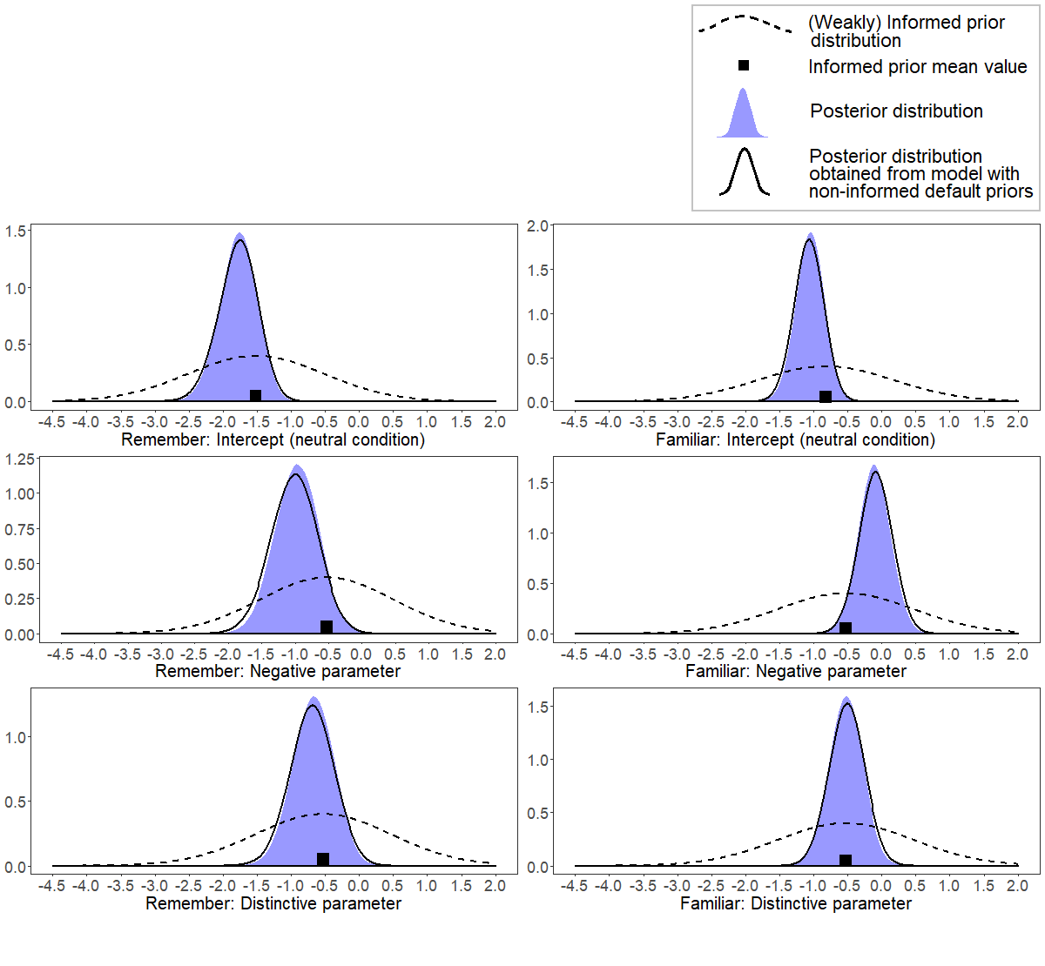
Figure S1. Prior and posterior distributions for the effect of Type of ending on causal errors (final model).

Additional analyses
The distinction between gap-filling and causal-antecedent errors is theoretically motivated by the existing literature. Nonetheless, gap-filling and causal errors may also differ in terms of how they are located within the script. Specifically, gap-filling errors are related to lures that are logically located before the critical lures of causal errors. In addition, gap-filling errors may be located at the beginning of the script, in the middle, or close to the ending.
An additional analysis was conducted on temporal order (as a discrete quantitative variable indicating the logical order of distractors within the script) as a predictor of false memory. The analysis suggested that temporal order was a relevant predictor of gap-filling errors (ΔWAIC = -6.6 when added to the final model). I.e., gap-filling located later in the script were more likely to occur than those located earlier in the script; for gap-filling errors associated with “familiar” responses: B = .23, 95% BCI (.08, .39); for gap-filling errors associated with “remember” responses: B = .26, 95% BCI (.00, .52). However, this main effect was not qualified by an interaction with “type of ending”, ΔWAIC = +10.6 (when the interaction was added to the model), thus suggesting that such a steady increase in errors was not related with increasing proximity with emotional or distinctive stimuli rather than neutral stimuli.
There was a corresponding tendency also for hits but supported by weak evidence (ΔWAIC = -1.0 when temporal order was added to the final model). For hits associated with “familiar” responses: B = .12, 95% BCI (.02, .22); for hits associated with “remember” responses: B = .04, 95% BCI (-.05, .13), once again not qualified by an interaction with “type of ending”, ΔWAIC = +11.9 (when the interaction was added to the model).

