Supplementary Material

Supplementary Figures
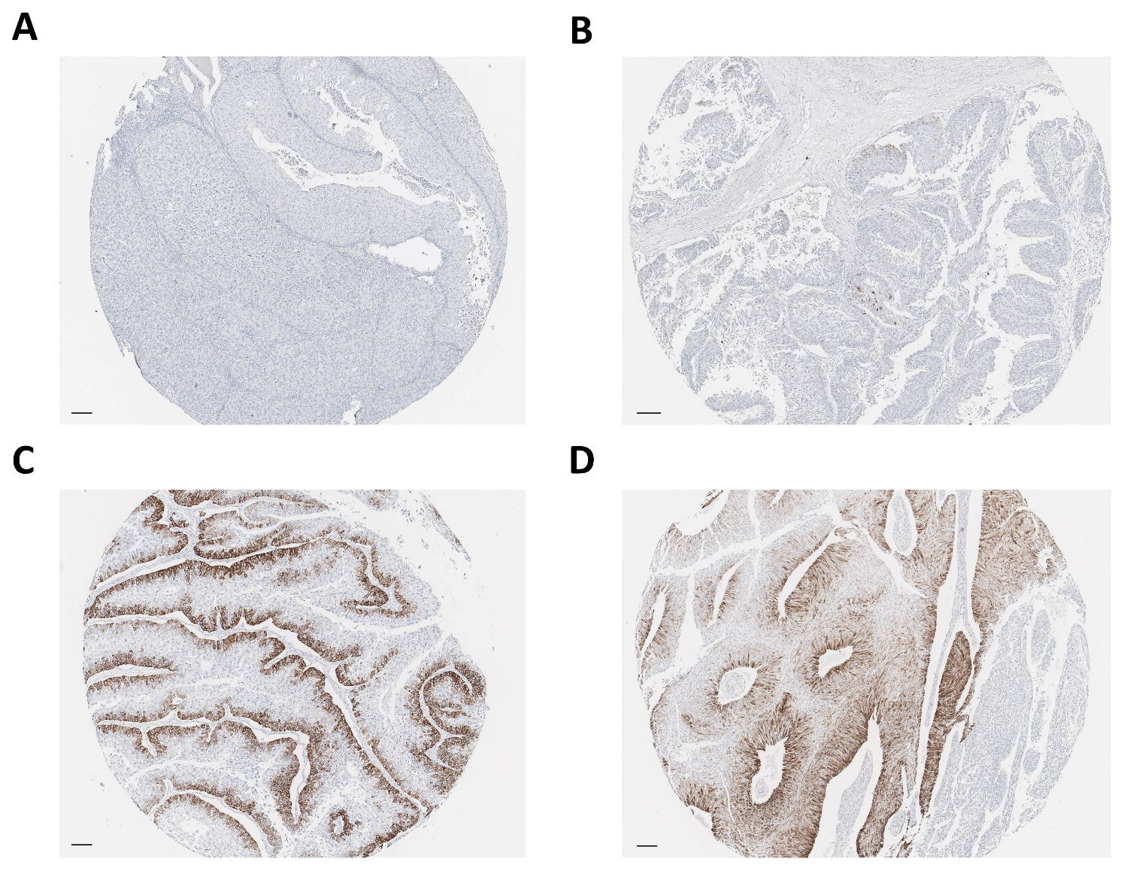
Supplementary Figure 1. CK14 IHC staining is observed variously: absent (0%) (A), stained in a few tumor cells (0-1%) (B), confined to the basal layer (>1%) (C), and diffusely reactive with occasional accentuation in the basal layer (>1%) (D). scale bar = 100 μm

Supplementary Figure 2. A 0% group (0% CK14 staining in all TMA cores; n = 139) showed distinctly poor PFS than a >1% group (>1% staining in all TMA cores; n = 10) or the remaining specimens (0-1% staining in any TMA cores; n = 55), which were similarly observed in survival analyses for CSS and OS. Therefore, the cutoff value of CK14 positivity was determined as >0%. (Visualization: http://web-r.org/)

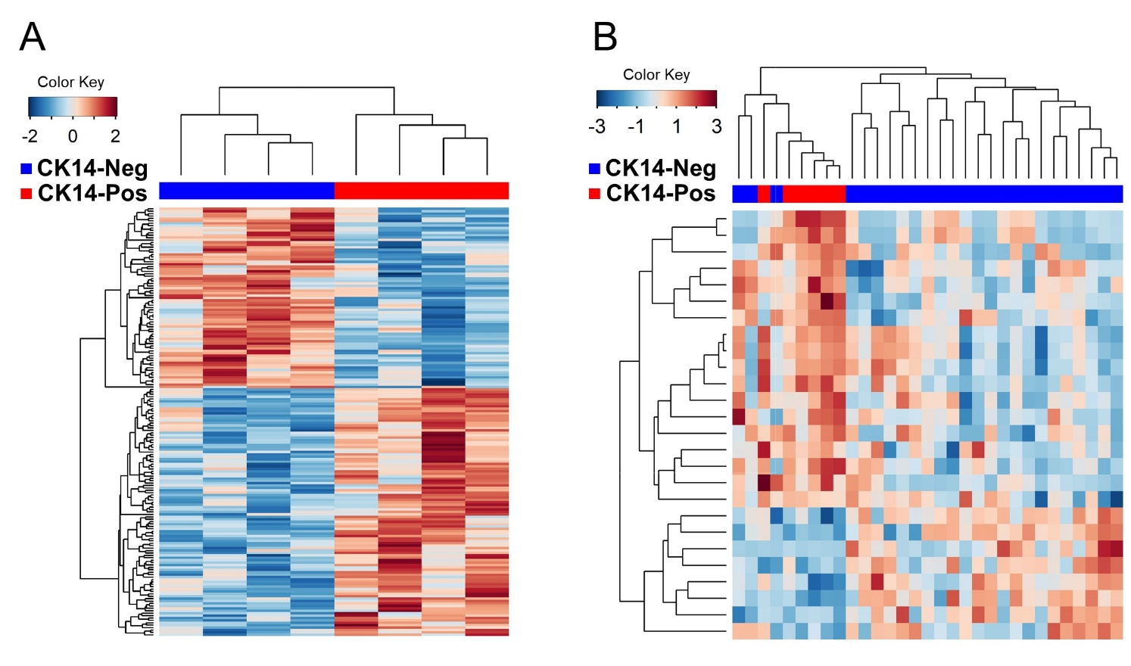
Supplementary Figure 3. Unsupervised clustering analysis of DEGs between CK14-positive and CK14-negative tumors in the high-grade GEP cohort and (A) the low-grade NMIBC cohort (B).

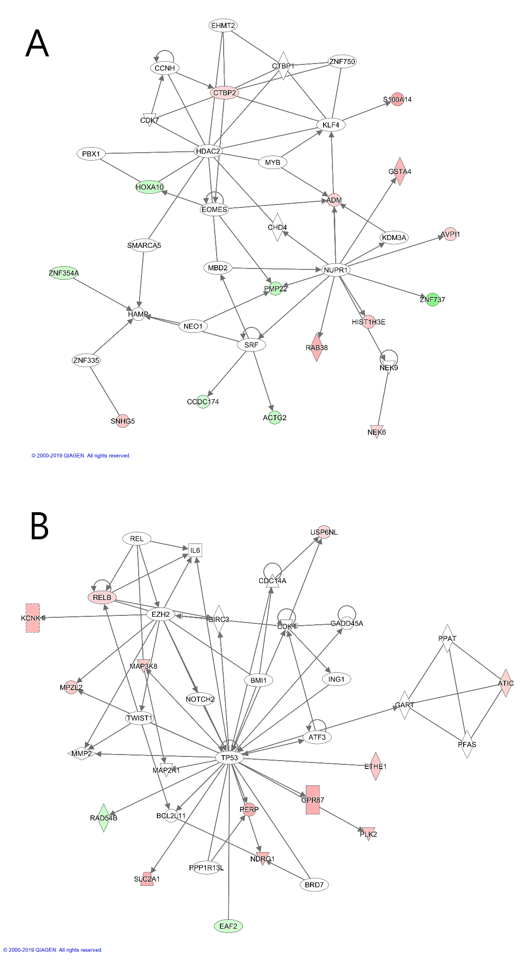
Supplementary Figure 4. Cellular growth and proliferation, cellular development, gene expression network (A) and cellular growth and proliferation, connective tissue development and function, tissue development network (B) are differentiating between CK14-positive and CK14-negative papillary NMIUTUC.

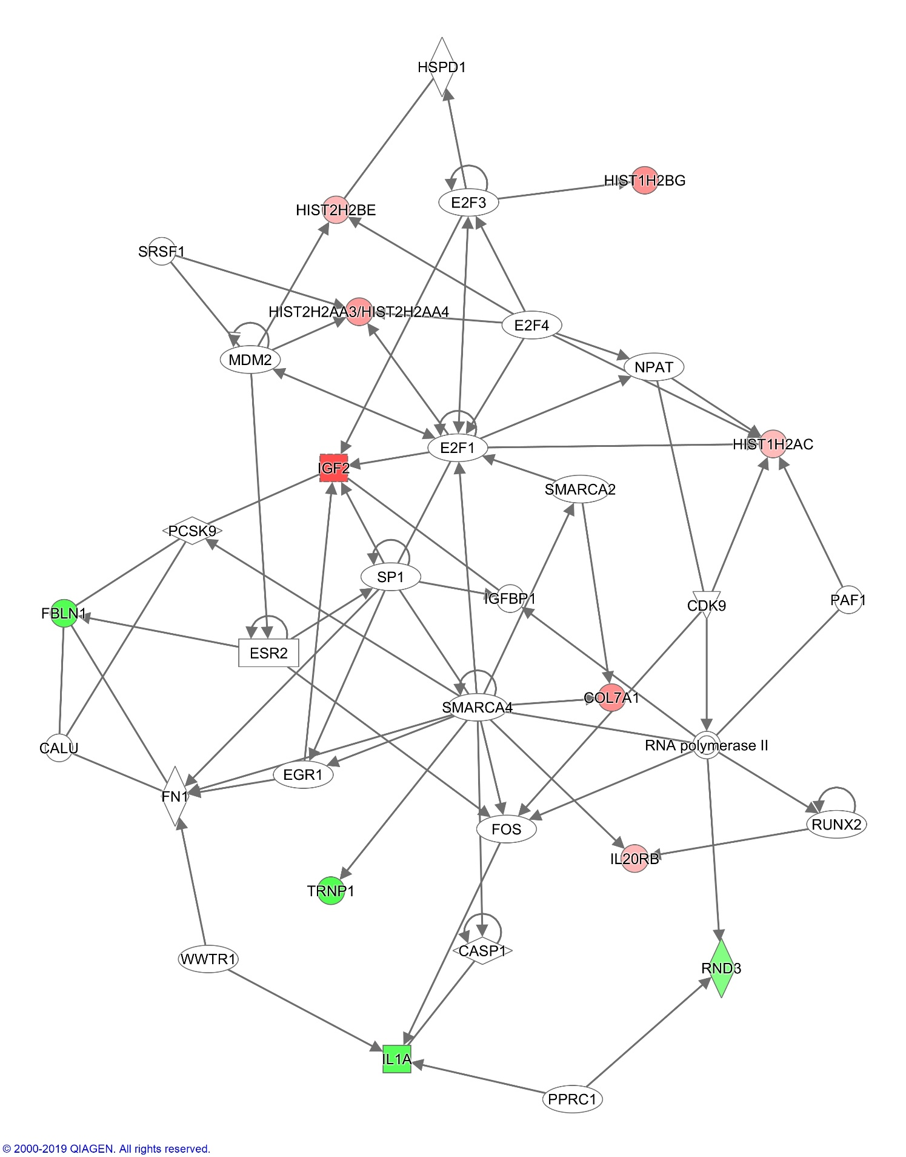
Supplementary Figure 5. Cellular growth and proliferation, cell cycle, cellular development is the top network affected by CK14 IHC staining in papillary NMIBC.

Supplementary Tables

Supplementary Table 1. Clinicopathological characteristics and molecular subtypes of the low-grade NMIBC cohort
Variables | CK14-negative (n = 25, %) | CK14-positive (n = 6, %) | Total (N = 31, %) | P
Age |  |  |  | 0.587
<68 | 11 (44.0%) | 4 (66.7%) | 15 (48.4%)
≥68 | 14 (56.0%) | 2 (33.3%) | 16 (51.6%)
Sex |  |  |  | 1.000
Female | 10 (40.0%) | 3 (50.0%) | 13 (41.9%)
Male | 15 (60.0%) | 3 (50.0%) | 18 (58.1%)
T stage |  |  |  | n.a.
0 | 25 (100.0%) | 6 (100.0%) | 31 (100.0%)
1 | 0 (0.0%) | 0 (0.0%) | 0 (0.0%)
WHO grade |  |  |  | n.a.
G1 | 25 (100.0%) | 6 (100.0%) | 31 (100.0%)
G2 or 3 | 0 (0.0%) | 0 (0.0%) | 0 (0.0%)
CK14 (median TCS) | 0.0 | 0.5 | 0.0 | <0.001
Lund molecular subtype |  |  |  | 0.470
MS1a | 10 (40.0%) | 4 (66.7%) | 14 (45.2%)
MS1b | 15 (60.0%) | 2 (33.3%) | 17 (54.8%)
Abbreviation: WHO, World Health Organization; TCS, tumor cell score

Supplementary Table 2. Top 5 gene ontology (GO) and Kyoto encyclopedia of genes and genomes (KEGG) terms
Category | High-grade GEP cohort |  | Low-grade NMIBC cohort
 | Terms (ID) | FDR | Terms (ID) | FDR
GO-BP | Cellular process (GO:9987) | 1.36728x10⁻³³ | Cellular component organization (GO:0016043) | 0.00962
 | Biological regulation (GO:65007) | 4.71759x10⁻²⁸ | Cellular process (GO:0009987) | 0.00962
 | Single-organism process (GO:44699) | 7.54751x10⁻²⁷ | Cellular component organization or biogenesis (GO:0071840) | 0.01095
 | Regulation of biological process (GO:50789) | 5.01092x10⁻²⁴ | Single-organism process (GO:0044699) | 0.01097
 | Regulation of cellular process (GO:50794) | 5.23257x10⁻²³ | Regulation of gene expression, epigenetic (GO:0040029) | 0.01109
GO-CC | Cell part (GO:44464) | 1.23237x10⁻³⁶ | Extracellular region (GO:0005576) | 0.00000
 | Cell (GO:5623) | 1.23237x10⁻³⁶ | Membrane-bounded vesicle (GO:0031988) | 0.00001
 | Organelle (GO:43226) | 2.86317x10⁻³² | Vesicle (GO:0031982) | 0.00001
 | Intracellular (GO:5622) | 2.55996x10⁻³⁰ | Extracellular region part (GO:0044421) | 0.00001
 | Membrane-bounded organelle (GO:43227) | 1.87623x10⁻²⁸ | Extracellular membrane-bounded organelle (GO:0065010) | 0.00003
GO-MF | Binding (GO:5488) | 5.62653x10⁻³¹ | Binding (GO:0005488) | 0.00004
 | Protein binding (GO:5515) | 3.46704x10⁻²¹ | Protein heterodimerization activity (GO:0046982) | 0.00021
 | Ion binding (GO:43167) | 7.58821x10⁻¹³ | Protein binding (GO:0005515) | 0.00395
 | Heterocyclic compound binding (GO:1901363) | 3.28961x10⁻¹⁰ | Protein dimerization activity (GO:0046983) | 0.00860
 | Organic cyclic compound binding (GO:97159) | 5.17409x10⁻¹⁰ | n.a. | n.a.
KEGG | Pathways in cancer (5200) | 0.00032 | Systemic lupus erythematosus (5322) | 0.00000
 | Vascular smooth muscle contraction (4270) | 0.00032 | Alcoholism (5034) | 0.00000
 | Herpes simplex virus 1 infection (5168) | 0.00123 | Necroptosis (4217) | 0.00011
 | Metabolic pathways (1100) | 0.00123 | n.a. | n.a.
 | Human T-cell leukemia virus 1 infection (5166) | 0.01921 | n.a. | n.a.
Abbreviation: GEP, gene expression profile; ID, identification; FDR, false discovery rate; GO, gene ontology; BP, biologic process; CC, cellular component; MF, molecular function; n.a., not available; KEGG, Kyoto encyclopedia of genes and genomes

