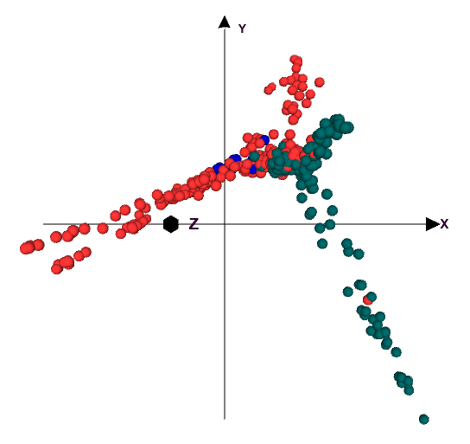
Supplementary Figure S1. Principal component analysis for 411 individuals with 182,252 GBS SNP markers. Lines were grouped based on adaptation as highland (blue color), mid-altitude level (orange color) and low land (green color) maize lines.

Supplementary Figure S2. Kinship heatmap generated for 411 inbred lines from 182,252 GBS SNP markers
Supplementary Figure S3. Genome-wide and chromosome specific LD decay plots at two cutoff points (green line, r²=0.2 (arbitrary r² value) and orange line, r²=0.34 (Calculated r² value))

