Supplementary material
The Supplement contains 2 supplementary figures and 5 supplementary tables.

Figures
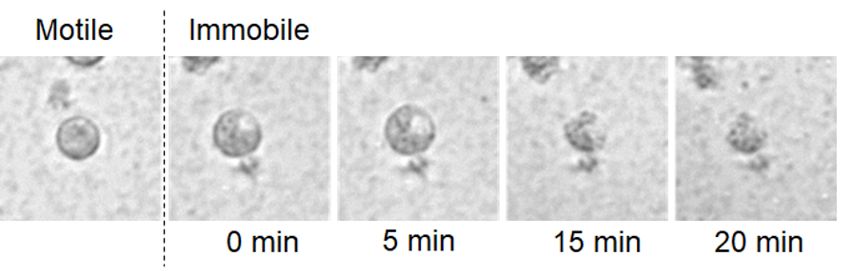
Figure S1 Time lapse images of the immobilization and degradation of a zoospore exposed to R32 in a bacterial suspension. Pictures were taken every 5 minutes using a Cytation5 plate reader (Biotek, United States).

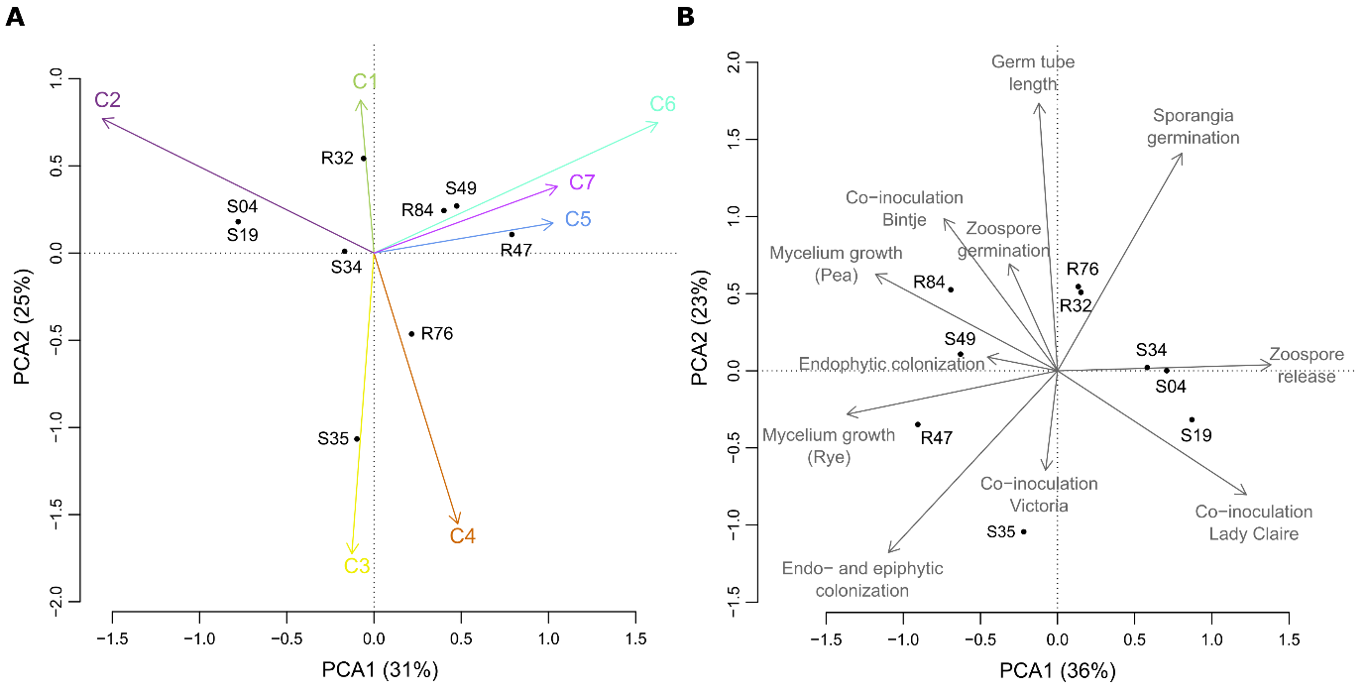
Figure S2 (A) PCA analysis on the clusters of co-occurring genes. (B) PCA analysis on the phenotypic data of the in vitro experiments, plant colonization experiments and co-inoculation experiments.

Tables

Table S1: NCBI data submission information. Bioproject, Biosample, SRA and Genbank accession are given for each strain.
Strain | Bioproject | Biosample | SRA acc.# | GenBank acc. #
PspR32 | PRJNA355625 | SAMN06234845 | SRS1925888 | CP019396
PchlR47 | PRJNA355625 | SAMN06241861 | SRS1929209 | CP019399
PspR76 | PRJNA355625 | SAMN06242059 | SRS1932041 | CP019428
PspR84 | PRJNA355625 | SAMN06242059 | SRS1932279 | CP019426
PspS04 | PRJNA355625 | SAMN06246385 | SRS1932352 | CP019427
PspS19 | PRJNA355625 | SAMN06234846 | SRS1925892 | CP019397
PspS34 | PRJNA355625 | SAMN06241450 | SRS1929109 | CP019398
PspS35 | PRJNA355625 | SAMN06241957 | SRS1932016 | CP019431
PspS49 | PRJNA355625 | SAMN06245871 | SRS1932214 | CP019432

Table S2: Strains used for construction of the phylogenetic tree and their accession numbers
No. | Strain | Accession
1. | Pseudomonas aeruginosa PA7 | NC_009656
2. | Pseudomonas aeruginosa PACS2 | NZ_AAQW01000001
3. | Pseudomonas aeruginosa PAO1 | NC_002516
4. | Pseudomonas alkylphenolia strain KL28 | CP009048
5. | Pseudomonas antarctica strain PAMC 27494 | CP015600
6. | Pseudomonas azotoformans strain S4 | CP014546
7. | Pseudomonas brassicacearum subsp. brassicacearum NFM421 | NC_015379
8. | Pseudomonas brenneri strain BS2771 | NZ_LT629800
9. | Pseudomonas chlororaphis subsp. aurantiaca strain JD37 | NZ_CP009290
10. | Pseudomonas chlororaphis subsp. aureofaciens 30-84 | NZ_CM001559
11. | Pseudomonas chlororaphis O6 | NZ_CM001490
12. | Pseudomonas chlororaphis strain PA23 | NZ_CP008696
13. | Pseudomonas chlororaphis strain PCL1606 | NZ_CP011110
14. | Pseudomonas corrugata strain RM1-1-4 | NZ_CP014262
15. | Pseudomonas fluorescens A506 | NC_017911
16. | Pseudomonas fluorescens BBc6R8 | NZ_AKXH00000000
17. | Pseudomonas fluorescens strain DSM 50090 | LHVP01000000
18. | Pseudomonas fluorescens F113 | CP003150
19. | Pseudomonas fluorescens Pf0-1 | NC_007492
20. | Pseudomonas fluorescens SBW25 | AM181176
21. | Pseudomonas fluorescens SS101 | NZ_CM001513
22. | Pseudomonas fluorescens strain UK4 | NZ_CP008896
23. | Pseudomonas granadensis strain LMG 27940 | LT629778
24. | Pseudomonas koreensis strain D26 | CP014947
25. | Pseudomonas lini strain BS3782 | LT629746
26. | Pseudomonas mandelii 36MFCvi | NZ_KB906353
27. | Pseudomonas mandelii JR-1 | CP005960
28. | Pseudomonas moraviensis strain BS3668 | LT629788
29. | Pseudomonas poae RE*1-1-14 | NC_020209
30. | Pseudomonas protegens CHA0 | CP003190
31. | Pseudomonas protegens Pf-5 | NC_004129
32. | Pseudomonas psychrophila strain BS3667 | NZ_LT629795
33. | Pseudomonas putida BIRD-1 | NC_017530
34. | Pseudomonas putida H8234 | NC_021491
35. | Pseudomonas putida KT2440 | NC_002947
36. | Pseudomonas putida ND6 | NC_017986
37. | Pseudomonas putida S16 | NC_015733
38. | Pseudomonas putida W619 | NC_010501
39. | Pseudomonas reinekei strain BS3776 | NZ_LT629709
40. | Pseudomonas sp. 20_BN | NZ_CCSF01000001
41. | Pseudomonas sp. A3 | CP014870
42. | Pseudomonas sp. CMR5c | NZ_LHUY00000000
43. | Pseudomonas sp. UW4 | NC_019670
44. | Pseudomonas sp. Z003-0.4C(8344-21) | LT629756
45. | Pseudomonas stutzeri A1501 | NC_009434
46. | Pseudomonas syringae pv. syringae B728a | NC_007005
47. | Pseudomonas syringae pv. tomato str. DC3000 | NC_004578
48. | Pseudomonas veronii 1YdBTEX2 | LT599583
49. | Azotobacter vinelandii DJ | NC_012560.1

Tables S3 to S5, please see separate Excel files
Table S3: The list of genes from each of the nine genomes including their annotation obtained from NCBI, and COG categories, additional functional annotation information from interproscan and eggnog.

Table S4: The first table contains to the list of genes and corresponding reference protein sequences and locus_tags of the homologs found in the nine Pseudomonas strains. The reference protein sequences were searched against the genomes of the nine Pseudomonas strains using blastp (v 2.2.30+) (Altschul et al., 1990). Only the best matching hit satisfying certain threshold parameters (e-value ≤ 1e-5, percentage identity ≥ 50% and query coverage ≥ 50%) was taken as homolog in each of the nine Pseudomonas strains. The second table contains the genes belonging to putative R-pyocins found between the mutS and cinA genes for each strain.

Table S5: List of genes and corresponding locus tags positively correlated to mycelial growth inhibition, plant colonization and inhibition of sporangia germination. For mycelial growth inhibition, all genes present in at least four of the five active strains (R32, R47, R84, S35 and S49) or present in all five active strains and R76 or S34 are listed.

Reference

Altschul, S.F., Gish, W., Miller, W., Myers, E.W., and Lipman, D.J. (1990) Basic local alignment search tool. J. Mol. Biol. 215: 403–410.

