Supplementary Information
Structural Insights into the Zika Virus NS1 Protein Inhibition Using a Computational Approach.
Nasir Ahmad¹; Syed Lal Badshah^{1,*}; Mohammad Junaid²; Ashfaq Ur Rehman²; Akhtar Muhammad¹, Khalid Khan^{1,*}
¹Department of Chemistry, Islamia College University, Peshawar 25120, Pakistan.
²State Key Laboratory of Microbial Metabolism, Department of Bioinformatics and Biostatistics, National Experimental Teaching Center for Life Sciences and Biotechnology, College of Life Sciences and Biotechnology, Shanghai Jiao Tong University, Shanghai, 200240, China.
*Corresponding Authors email address: shahbiochemist@gmail.com and drkhalidchem@yahoo.com
Supplementary figure 1. Structures of flavonoid derivatives from F1 to F10.

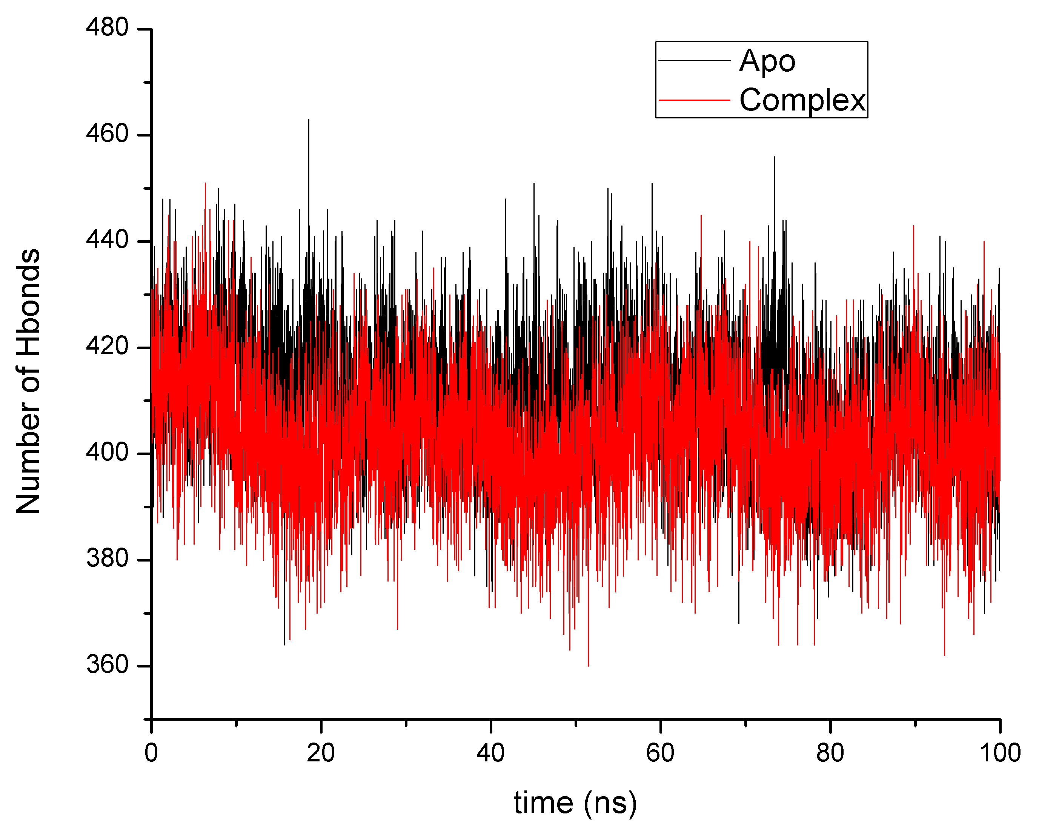
Supplementary figure 2. The number of hydrogen bonds in Apo (black) and complex (red) during 100 ns simulation.

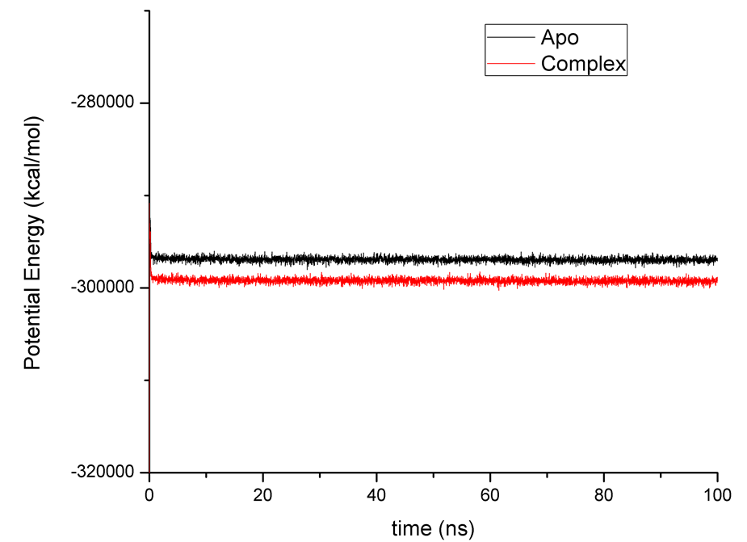
Supplementary figure 3. Potential energy of Apo (back) and complex (red) over a period of 100 ns simulation time.

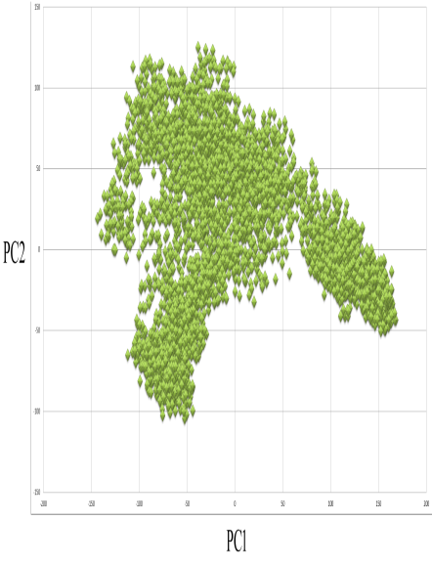  Apo | 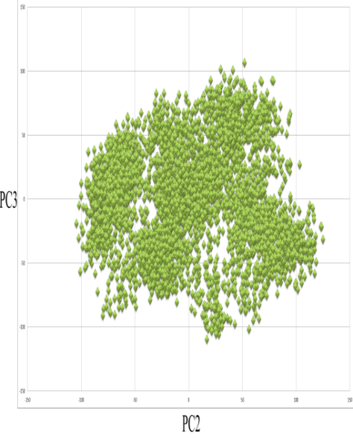  Apo | 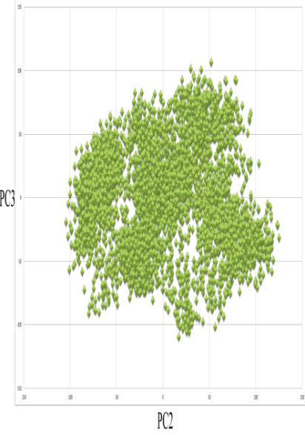  Apo
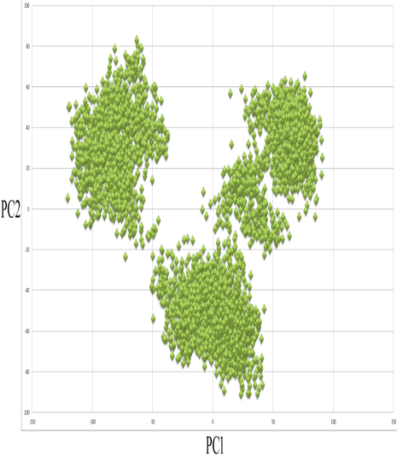  Complex | 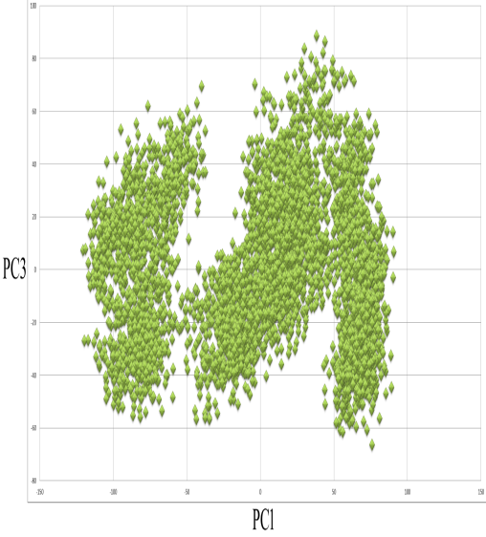  Complex | 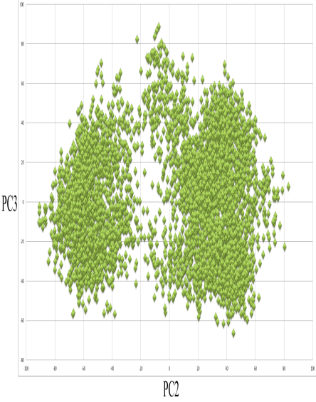  Complex

Supplementary figure 4. Principal component (PC) analysis of apo-protein of NS1 and NS1-flavonoid complex during100 ns simulation for three components PC1, PC2, PC3.

