Supplementary Figure S1. Measurement of erythrocyte aggregation using the modified erythrocyte sedimentation rate method.
A: Snap shots with a digital camera at intervals of five minutes for three hours;
B: Regression analysis with three fitted parameters (α: initial value, β: fitting constant, λ: characteristic time).
RBC, Red blood cell.
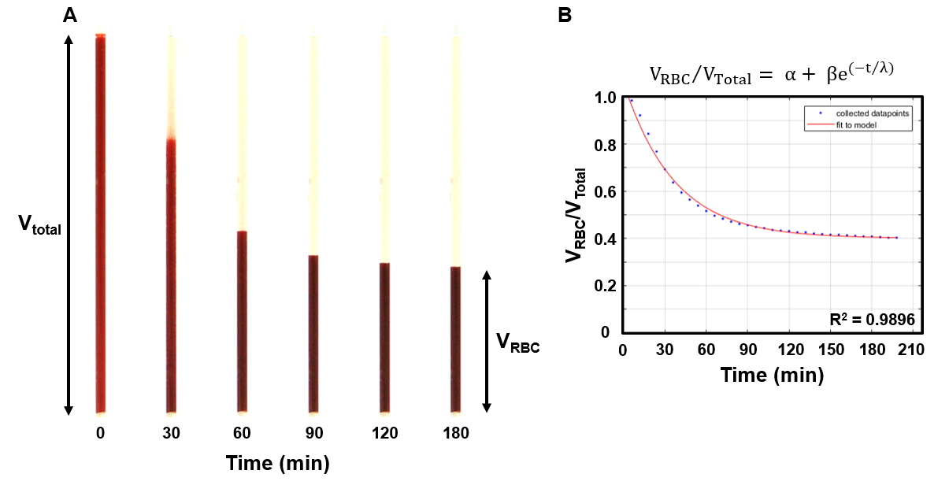

Supplementary Figure S2. Holotomographic images of erythrocytes according to group.
A: 2D membrane height maps of erythrocytes;
B: Reconstructed 3D images of erythrocytes.
DPP-4 inhibitor, dipeptidyl peptidase 4 inhibitor; SGLT-2 inhibitor, sodium-glucose cotransporter 2 inhibitor.
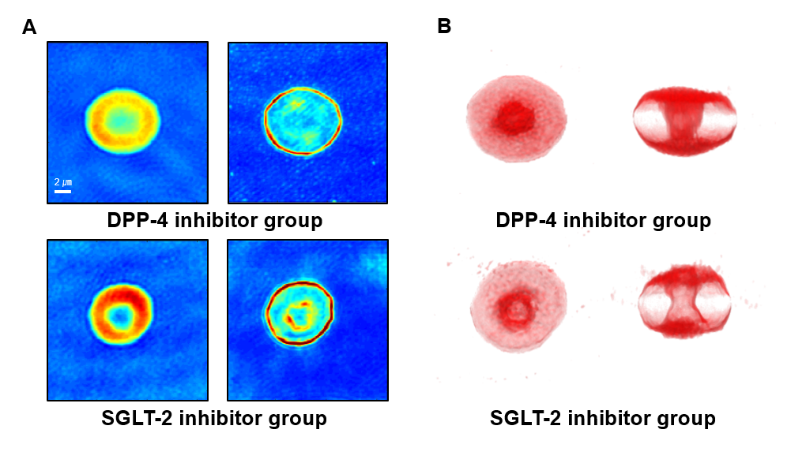
Supplementary Figure S3. Distribution of propensity scores.
Treatment group: SGLT-2 inhibitor group;
Control group: DPP-4 inhibitor group.
SGLT-2 inhibitor, sodium-glucose cotransporter 2 inhibitor; DPP-4 inhibitor, dipeptidyl peptidase 4 inhibitor.
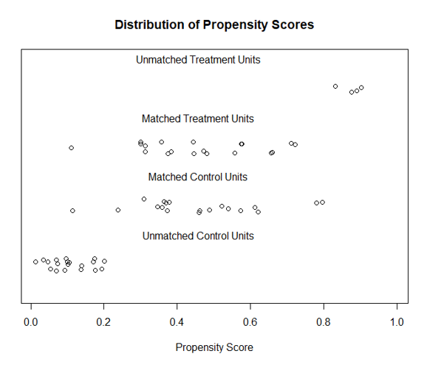

Supplementary Table S1. Medical treatment at baseline.
 | Before propensity score matching |  |  | After propensity score matching
Total  (n = 63) | DPP-4 inhibitor  (n = 38) | SGLT-2 inhibitor  (n = 25) | p-value | DPP-4 inhibitor  (n = 19) | SGLT-2 inhibitor  (n = 19) | p-value
HMG-CoA reductase inhibitor | 30 (78.9) | 19 (76.0) | 0.783 | 13 (68.4) | 16 (84.2) | 0.447
Ezetimibe | 3 (7.9) | 2 (8.0) | 1.000 | 1 (5.3) | 2 (10.5) | 1.000
Fenofibrate | 5 (13.2) | 1 (4.0) | 0.389 | 3 (15.8) | 1 (5.3) | 0.604
Omega-3-acid ethyl ester 90 | 1 (2.6) | 1 (4.0) | 1.000 | 1 (5.3) | 1 (5.3) | 1.000
RAS blockade | 17 (44.7) | 9 (36.0) | 0.491 | 8 (42.1) | 6 (31.6) | 0.501
Calcium channel blocker | 8 (21.1) | 4 (16.0) | 0.749 | 4 (21.1) | 2 (10.5) | 0.660
β-blocker | 4 (10.5) | 0 (0.0) | 0.145 | 3 (15.8) | 0 (0.0) | 0.230
Thiazide | 1 (2.6) | 2 (8.0) | 0.557 | 0 (0.0) | 0 (0.0) | -
Aspirin | 7 (18.4) | 2 (8.0) | 0.298 | 5 (26.3) | 2 (10.5) | 0.405
ADP receptor inhibitor | 1 (2.6) | 0 (0.0) | 1.000 | 1 (5.3) | 0 (0.0) | 1.000

Data are expressed as the number with (percentage).
DPP-4 inhibitor, dipeptidyl peptidase 4 inhibitor; SGLT-2 inhibitor, sodium-glucose cotransporter 2 inhibitor;
HMG-CoA inhibitor, 3-hydroxy-3-methyl coenzyme A reductase inhibitor;
RAS blockade, renin-angiotensin system blockade;
ADP receptor inhibitor, adenosine diphosphate receptor inhibitor.
Supplementary Table S2. Standardized difference before and after propensity score matching.
 | Standardized difference
Variables | Before propensity score matching | After propensity score matching
Age (years) | -4.783 | 1.469
Sex (male) | -0.120 | 0
Body mass index (kg/m²) | 13.521 | -0.599
Systolic blood pressure (mmHg) | 0.626 | -0.104
Diastolic blood pressure (mmHg) | 0.987 | -1.3623
HbA1c (%) | 77.382 | 4.111
Total cholesterol (mg/dL) | 1.660 | -0.327
High density lipoprotein (mg/dL) | 1.251 | -0.068
Low density lipoprotein (mg/dL) | 1.746 | -0.379
Triglycerides (mg/dL) | 0.472 | -0.044
Disease duration (years) | -9.643 | 1.790
Current smoker | -0.255 | 0

