Supplementary figure 1
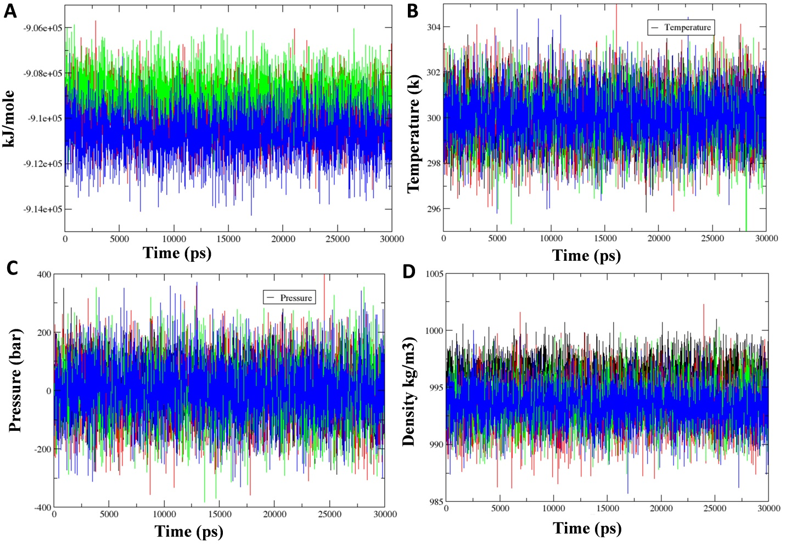
Supplementary figure 1. Energy, temperature and pressure of the unbound protein, protein-ligand complex C1, C2, and, lopinavir during the 30 ns simulation. (A) Energy of the protein and protein-ligand complex C1, C2 and lopinavir. (B) Temperature of the protein and protein-ligand complex C1, C2 and lopinavir. (C) Pressure of the protein and protein-ligand complex C1, C2 and lopinavir. (C) Pressure of the protein and protein-ligand complex C1, C2 and lopinavir. Unbound protein parameters are depicted in black color. Protein-ligand complex C1 and C2 parameters are shown in green and blue color respectively. Protein-lopinavir complex is shown in red color.

Supplementary figure 2
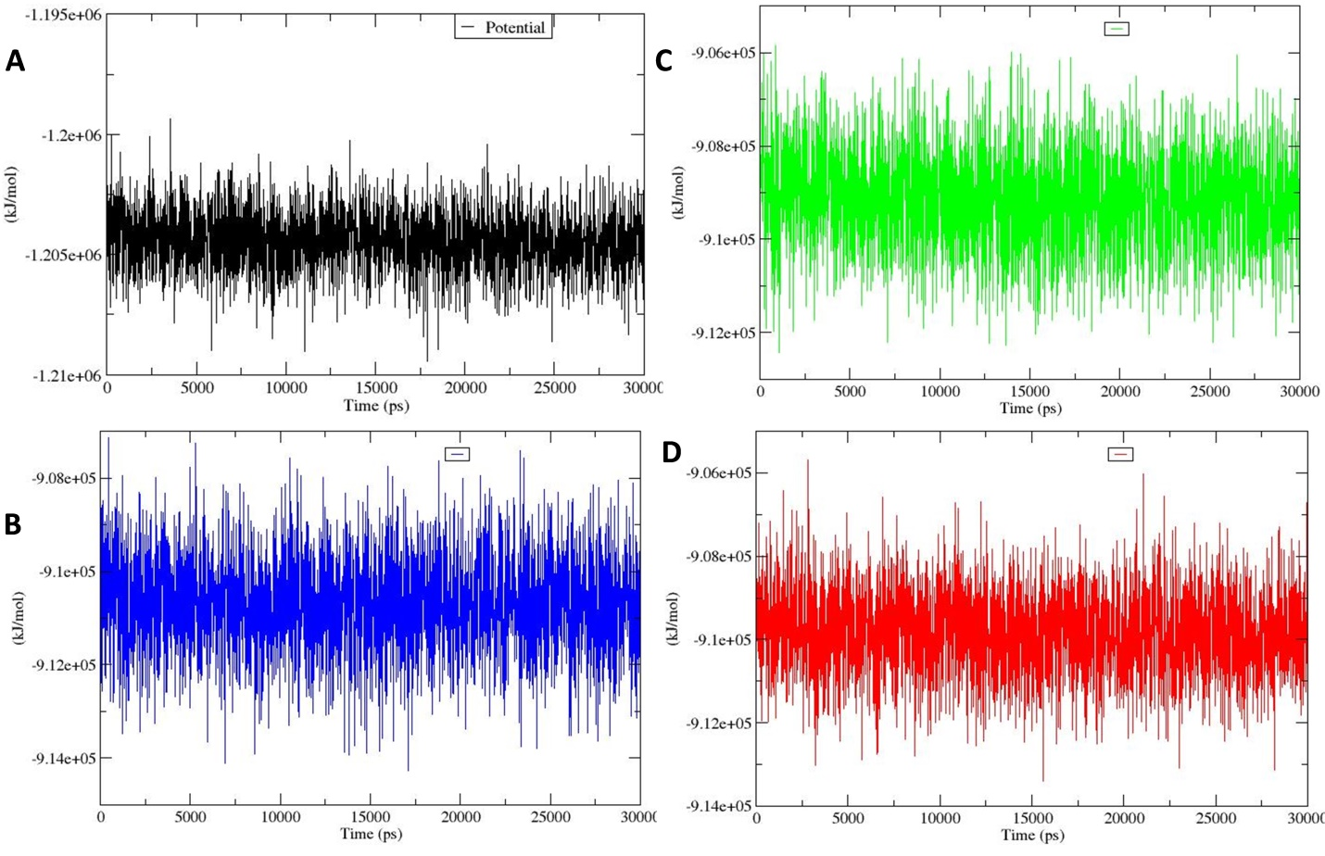
Supplementary figure 2. Free energy of (A) unbound protein, (B) and (C) protein-ligand complex C1 and C2 respectively, and (D) protein-lopinavir during the 30 ns simulation.

Supplementary figure 3
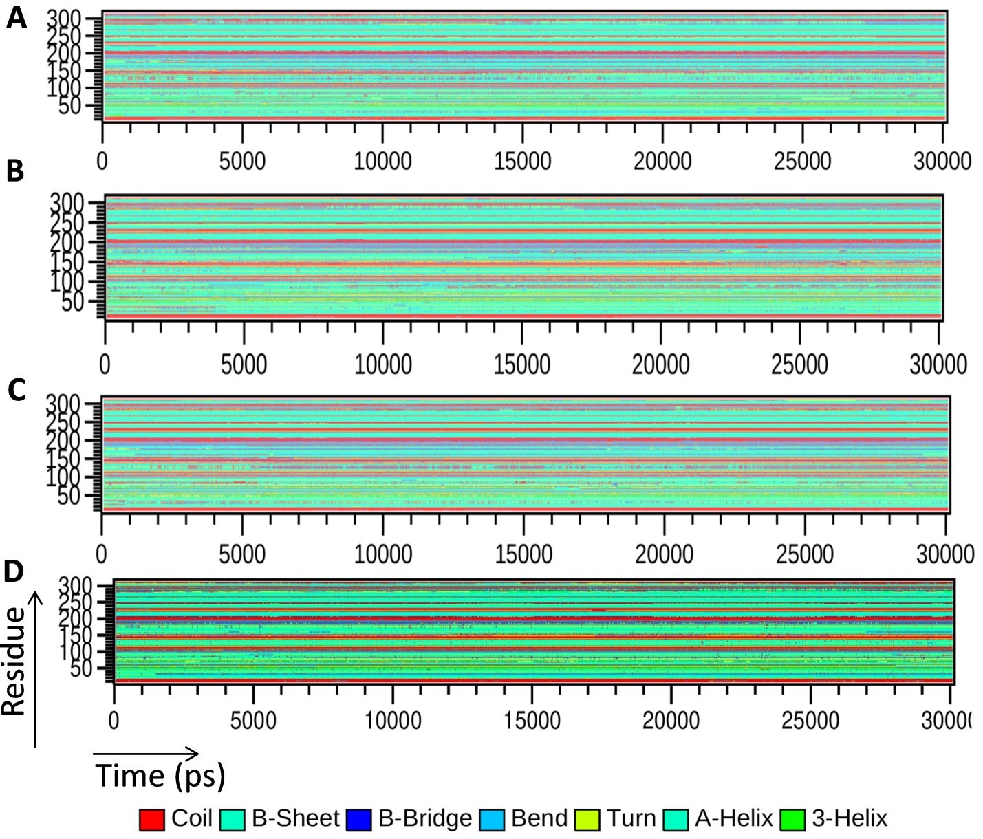
Supplementary figure 3. Change in secondary structure of the (A) unbound protein, (B) and (C) protein-ligand complex C1 and C2 respectively, and (D) protein-lopinavir during the 30 ns simulation.

Supplementary table 1. List of Curcuma longa phytochemicals involved in binding with COVID-19 M^{pro} protein having binding energy -5.00< kcal/mole cutoff value.
CN | Compound name | Structure | Compound structure in SMILES format | MW (g/mol)
1 | (1E,6E)-1,2,6,7-tetrahydroxy-1,7-bis(4-hydroxy-3-methoxyphenyl)hepta-1,6-diene-3,5-dione) |  | COC1=C(C=CC(=C1)/C(=C(\O)/C(=O)CC(=O)/C(=C(\O)/C2=CC(=C(C=C2)O)OC)/O)/O)O | 432.4
2 | (4Z,6E)‐1,5‐dihydroxy‐1,7‐bis(4‐hydroxyphenyl)hepta‐4,6‐dien‐3‐one |  | [H]C1=CC(\C=C\C(\O)=C\C(=O)CC(O)C2=CC([H])=C(O)C=C2)=CC=C1O | 326.3
3 | (4Z,6E)‐1,5‐dihydroxy‐7‐(4‐hydroxy‐3‐methoxyphenyl)‐1‐(4‐hydroxyphenyl)hepta‐4,6‐dien‐3‐one |  | [H]C1=C(O)C=CC(=C1)C(O)CC(=O)\C=C(/O)\C=C\C1=CC=C(O)C(OC)=C1 | 356.3
4 | (6E)‐3‐hydroxy‐1,7‐bis(4‐hydroxyphenyl)hept‐6‐ene‐1,5‐dione |  | OC(CC(=O)\C=C\C1=CC=C(O)C=C1)CC(=O)C1=CC=C(O)C=C1 | 326.3
5 | (4Z,6E)‐1,5‐dihydroxy‐1‐(4‐hydroxy‐3‐methoxyphenyl)‐7‐(4‐hydroxyphenyl)hepta‐4,6‐dien‐3‐one |  | [H]C1=CC(\C=C\C(\O)=C\C(=O)CC(O)C2=CC(OC)=C(O)C=C2)=CC=C1O | 356.3
6 | (4Z,6E)‐1,5‐dihydroxy‐1,7‐bis(4‐hydroxy‐3‐methoxyphenyl)hepta‐4,6‐dien‐3‐one |  | COC1=CC(\C=C\C(\O)=C\C(=O)CC(O)C2=CC(OC)=C(O)C=C2)=CC=C1O | 386.4
7 | (1E)‐1,7‐bis(4‐hydroxy‐3‐methoxyphenyl)hept‐1‐ene‐3,5‐dione |  | [H]C1=CC(CCC(=O)CC(=O)\C=C\C2=CC(OC)=C(O)C=C2)=CC=C1O | 370.4
8 | (1E)‐1‐(4‐hydroxy‐3‐methoxyphenyl)‐7‐(4‐hydroxyphenyl)hept‐1‐ene‐3,5‐dione |  | COC1=CC(CCC(=O)CC(=O)\C=C\C2=CC(OC)=C(O)C=C2)=CC=C1O | 340.3
9 | Curcumin |  | COC1=C(C=CC(=C1)/C=C/C(=O)CC(=O)/C=C/C2=CC(=C(C=C2)O)OC)O | 368.4
10 | 1,6-Heptadiene-3,5-dione, 1,7-bis(4-hydroxy-3-methoxyphenyl) |  | COC1=C(C=CC(=C1)C=CC(=O)CC(=O)C=CC2=CC(=C(C=C2)O)OC)O | 368.4
11 | (1E,6E)‐1‐(3,4‐dihydroxyphenyl)‐7‐(4‐hydroxyphenyl)hepta‐1,6‐diene‐3,5‐dione |  | OC1=CC=C(\C=C\C(=O)CC(=O)\C=C\C2=CC=C(O)C(O)=C2)C=C1 | 324.3
12 | Calebin A |  | COC1=C(C=CC(=C1)/C=C/C(=O)COC(=O)/C=C/C2=CC(=C(C=C2)O)OC)O | 384.4
13 | (1E,4E)‐1,5‐bis(4‐hydroxy‐3‐methoxyphenyl)penta‐1,4‐dien‐3‐one |  | COC1=CC(\C=C\C(=O)\C=C\C2=CC(OC)=C(O)C=C2)=CC=C1O | 326.3
14 | Curcumin D6 |  | [2H]C(OC1=C(C=CC(=C1)/C=C/C(=O)CC(=O)/C=C/C2=CC(=C(C=C2)O)OC([2H])([2H])[2H])O)([2H])[2H] | 374.4
15 | 5‐hydroxy‐6‐(3‐hydroxy‐4‐methylphenyl)‐2‐methylhept‐2‐en‐4‐one |  | CC(C(O)C(=O)C=C(C)C)C1=CC(O)=C(C)C=C1 | 248.3
16 | Bisacurone B |  | CC(CC(=O)C=C(C)C)C1CC(C(C=C1)(C)O)O | 252.3
17 | (1E)‐7‐(4‐hydroxy‐3‐methoxyphenyl)‐1‐(4‐hydroxyphenyl)hept‐1‐ene‐3,5‐dione |  | [H]C1=C(O)C=CC(\C=C\C(=O)CC(=O)CCC2=CC=C(O)C(OC)=C2)=C1 | 340.3

Supplementary table 2. List of amino residue involved in interaction with lopinavir and Curcuma longa phytochemicals with -5.00 < cutoff value.
Ligand | Hydrogen interacting residues | Hydrophobic interacting residues
Lopinavir | Cys145, Glu166 | Met165, Gln189, Arg188, His41, Thr26, Gly143, Thr24, Cys44, Thr25, Thr45, Ser46, Leu141, Asn142
C1 | Thr190, Glu166, Thr25 | Cys44, Cys145, Met165, Pro168, Ser46, Thr45
C2 | Thr190, Glu166, Thr25 | Cys44, Cys145, Met165, Pro168, Ser46, Thr45
C3 | Glu166, Thr190, Gln189 | Pro168, Leu167, Met165, Gln192, Ala191, Hie41, Cys44, Thr45, Ser46, Met49, Thr25, Thr24
C4 | Thr190, Glu166, Asn142, Gly143, Hie41 | Gln192, Ala191, Hie41*, Gln189, Arg188, Pro168, Met165, Met49, Ser46, Cys44, Val42, Leu27, Thr25, Cys145
C5 | Glu166, Thr190, Thr25 | Pro168, Leu167, Met165, Gln192, Ala191, Gln189, Arg188, Met49, Ser46, Thr45, Cys44, Thr24, Hie41
C6 | Thr190, Hie41, Thr26 | Pro168, Glu166, Met165, Gln192, Ala191, Gln189, Arg188, Met49, Ser46, Cys44, Val42, Thr25, Leu27, Cys145, Gly143, Asn142
C7 | Thr190, Glu166, Cys44 | Gln192, Ala191, Gln189, Arg188, Cys145, Asn142, Hie41, Thr45, Ser46, Met49, Thr26, Thr25, Hie164, Met165, Leu167, Pro168
C8 | Glu166, Gln189, Gly143 | Leu167, Met165, Hie164, Met49, Ser46, Cys44, Val42, Hie41, Thr25, Thr26, Leu27, Asn142, Ser144, Cys145
C9 | Cys44, Thr26 | Met49, Ser46, Thr45, Hie41, Glu166, Met165, Hie164, His163, Leu141, Asn142, Gly143, Ser144, Cys145, Thr25, Leu27
C10 | Cys44, Thr26 | Met49, Ser46, Thr45, Hie41, Glu166, Met165, Hie164, His163, Leu141, Asn142, Gly143, Ser144, Cys145, Thr25, Leu27
C11 | Thr190, Gln189, Glu166, Thr25 | Pro168, Leu167, Met165, Gln192, Ala191, Hie41, Thr24, Cys44, Thr45, Ser46, Met49
C12 | Gly143 | Cys145, Ser144, Asn142, Leu141, Phe140, His163, Hie164, Met165, Glu166, Leu167, Pro168, Thr190, Gln189, Arg188, Asp187, Met49, Ser46, Thr45, Cys44, Hie41, Thr24, Thr25, Thr26
C13 | Gly143, Glu166, Thr25 | Leu141, Asn142, Ser144, Cys145, His163, Hie164, Met165, Leu167, Arg188, Gln189, Met49, Asp48, Ser46, Thr45, Cys44, Hie41, Thr24
C14 | Glu166, Thr26 | Met165, Hie164, His163, Hie41, Cys44, Thr45, Ser46, Met49, Cys145, Gly143, Asn142, Leu27, Thr25
C15 | Glu166, Hie164 | Gln189, Arg188, Asp187, Met49, Hie41, Tyr54, Phe181, His163, Met165, Leu167, Phe140, Leu141, Asn142, Cys145
C16 | Glu166 | Hie164, Met165, Leu167, Gln189, Met49, Ser46, Cys44, Val42, Hie41, Gly143, Cys145, Leu27, Thr26, Thr25
C17 | Thr26 | Met49, Ser46, Thr45, Cys44, Hie41, Gln189, Hie164, Met165, Glu166, Leu27, Thr25, Cys145, Gly143, Asn142, Leu141
*=pi-pi stacking, Hie=His with ε-nitrogen protonated; C=compound

Supplementary Table 3: MM-GBSA analysis of the SARS-CoV-2 Mpro protein and protein-standard inhibitor/lead molecule complex
Parameter | Protein | Protein-ligand complex
 | M^{pro} | Lopinavir_M^{pro} | Lead 1_M^{pro} | Lead 2_M^{pro}
Energy | -12755.75386 | -2831.225208 | -12663.6882 | -12903.45873
Coulomb | -10166.91011 | -10251.06003 | -10016.57602 | -10315.43631
Covalent | 1100.70167 | 8198.979825 | 1162.440578 | 1111.064421
Hbond | -182.9188239 | -184.0748691 | -184.2680508 | -185.2130454
Lipo | -735.2815705 | -772.6030553 | -744.0377879 | -753.2242905
Packing | -28.37586074 | -28.39803508 | -28.70024255 | -28.38640755
SelfCont | -57.4738776 | -57.4738776 | -57.4738776 | -57.4738776
Solv_GB | -1102.938584 | -1081.902994 | -1223.883799 | -1086.101863
vdW | -1582.556699 | 1345.307829 | -1571.189003 | -1588.687357
Lead 1-(1E,6E)-1,2,6,7-tetrahydroxy-1,7-bis(4-hydroxy-3-methoxyphenyl)hepta-1,6-diene-3,5-dione), Lead 2-(4Z,6E)‐1,5‐dihydroxy‐1,7‐bis(4‐hydroxyphenyl)hepta‐4,6‐dien‐3‐one as lead agents
All the numerical values are shown in the table are given in kcal/mole.

