Table 1.Several important human pathogenic viruses with bats as storage hosts（Data source: https://m.51daifu.com/news/detail/tid/732958.shtml）
Virus | Cause disease | Host
Rabies virus | Rabies | Variety of Bats
Marburg virus | Marburg haemorrhagic fever | Egyptian fruit bat
Ebola virus | Ebola hemorrhagic fever | Hammerhead fruit bat  Shoulder fruit bat
SARS-CoV | Severe acute respiratory syndrome | Chrysanthemum
HeV, NiV | Encephalitis | Flying fox
Sosuga virus | Severe acute febrile disease | Fruit bat
MERS virus | Middle East Respiratory Syndrome | Tomb bat

Table 2. Expression of wild animals on pottery
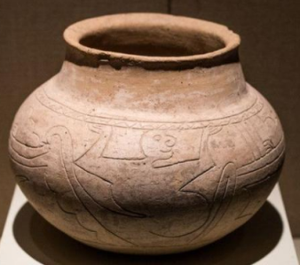  1 | 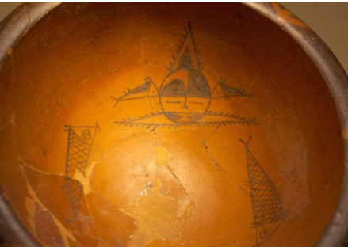  2 | 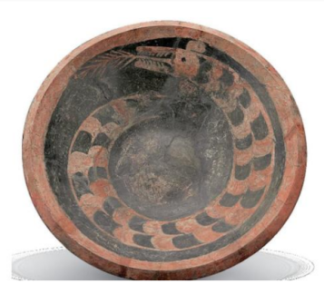  3
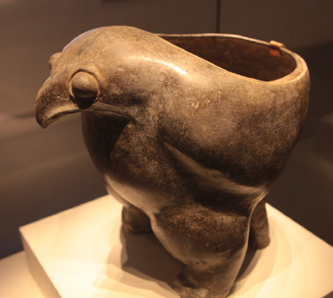  4 | 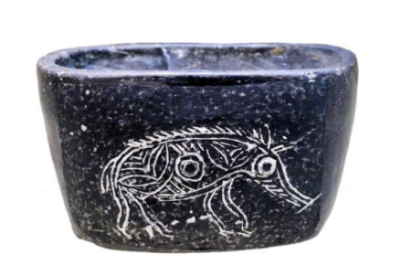  5 | 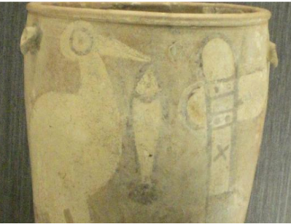  6
Fig source:
- http://blog.sina.com.cn/s/blog_50935f370102vd0n.html.
2、4、6.National Museum of China.
3. Zhang Yuanshan. The way of Fuxi. Hunan: Yuelu press, 2015.
5. Zhejiang Provincial Museum.

Table 3. The pattern of deer and crane
The pattern of sea and white crane bowl with green color on Yellow ground | Deer pattern in flat bottle with double ear | Blue and white and deer and crane pattern in Calabash bottle
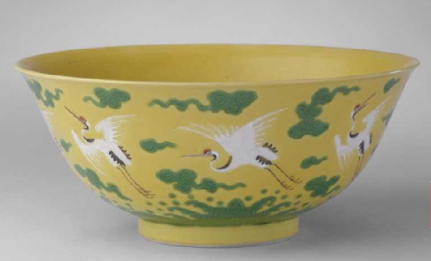  1 | 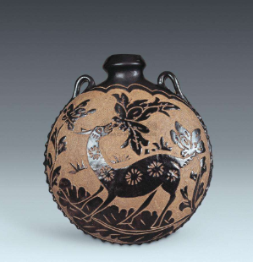  2 | 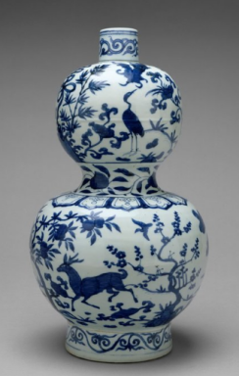  3
Fig source:
- China National Palace Museum
- Deze Ceramic Museum, Luohe City, Henan Province
- American Metropolitan Museum

