**Supplemental Information for**

**Design and Performance Test of a Lab-Made Single-Stage Low-Pressure Impactor for Morphology Analysis of Diesel Exhaust Particles**

Junho Hyun1, Ali Mohamadi Nasr2, Nak-Kyoung Choi3, Dongho Park4, and Jungho Hwang1,2,*

1Graduate Program in Clean Technology, Yonsei University, 134 Shinchon-dong, Seodaemoon-gu, Seoul, 120-749, Korea

2Department of Mechanical Engineering, Yonsei University, 134 Shinchon-dong, Seodaemoon-gu, Seoul, 120-749, Korea

3RAC Product Development, LG Electronics, 76 Seongsan-dong, Seongsan-gu, Changwon, 642-713, Korea

4Korea Institute of Industrial Technology, 35-3 Hongcheon-ri, Ipjang-myeon, Seobuk-gu, Cheonan, 331-825, Korea

**\*Author to whom correspondence should be addressed.**

**Fax: +82-2-312-2821**

**E-mail:** [**hwangjh@yonsei.ac.kr**](mailto:hwangjh@yonsei.ac.kr)

In this supplemental information, we describe the design of the impactor and the numerical calculation of the designed impactor in greater details. Also we explain how uncertaintiesy for experimental results were determined.

1. **Design of the impactor**

The cutoff characteristic of an impactor stage is expressed in terms of a Stokes number, which is defined as

, (S1)

where  is the relaxation time, *U* is the flow velocity, *W* is the nozzle diameter, and *μ* is the dynamic viscosity of air.

Assuming that the fluid is an ideal gas with isentropic flow, the flow velocity is derived as

, (S2)

where *m* is the mass flow rate, *k* is the specific heat ratio of air, *A* is the nozzle area, *Nn* is the number of nozzles, *Ru* is the universal gas constant, *M* is the molar weight of the air, and *p* is the static pressure. Additionally, , , and  are the stagnation pressure, temperature, and density, respectively.

Then, the static density, pressure, and temperature are calculated as follows.

 (S3)

 (S4)

 (S5)

To determine the cutoff diameter, Eq. (S1) can be rearranged as follows to give the cutoff diameter in terms of *Stk50*, which is the Stokes number at a collection efficiency of 50%:

, (S6)

where the cutoff diameter of the impactor stage (*d50*) is defined as the aerodynamic diameter where the collection efficiency is 50%. In the case of a circular nozzle impactor, the value of  is recommended to be 0.49 (Hinds, 1999). To satisfy this value of  and to achieve a sharp collection efficiency curve, it has been reported that the ratio of the jet-to-plate distance (*S*) to the nozzle diameter (*W*) should be higher than 1.0 (Marple and Liu, 1974).

1. **Numerical calculation of the impactor**

Using ANSYS FLUENT 14.0, the flow field distribution was calculated by solving the following steady-state mass, momentum, and energy conservation equations:

 (S7)

 (S8)

, (S9)

where *E* is the total energy,  is the effective conductivity, *T* is the temperature, $h_{j}$ is the enthalpy of species *j*,  is the diffusion flux of species *j*, and  is the viscous stress tensor. The shear-stress transport (SST) k–ω model was utilized as the turbulence model because it can accurately predict separation under a pressure gradient. A density-based solver based on the coupled-implicit formulation with second-order discretization was chosen to simulate the flow. After the flow field  was obtained, particle trajectories were calculated by means of a Lagrangian approach using the discrete phase model that is included in FLUENT. After the particles entered the inlet and followed the flow, some of them collided with the collection plate while others escaped from the impactor. In this study, we assumed that the particles were be inert water droplets. The equation of motion of a single particle is expressed as

, (S10)

where  is the particle velocity. The initial velocity was assumed to be the same as the flow velocity. The following formulation of the Cunningham slip correction factor was used (Hinds, 1999).

 (S11)

In this study, the collection efficiency of the impactor was determined by using the method introduced by Kim and Yook (2011), in which the collection efficiency is calculated as the ratio of the ring-shaped areas of trapped particles to the nozzle inlet area. The flow rate passing through the ring-shaped areas, Qcaptured (i.e., the captured particles), and the total flow rate, Qtotal (i.e., the total number of particles) are expressed as follows.

 (S12)

 (S13)

The collection efficiency of the impactor was expressed as

, (S14)

where Uin is the inlet velocity,  is the gap spacing between particles, Rin is the radius of the impactor inlet and ri is the radial position of the *i*th particle. Additionally, fi is the fate of the *i*th particle, which is 1 if the particle was captured or 0 if the particle escaped from the impactor.

The computational geometry of the impactor is shown in Fig. S1. The grid was generated using the FLUENT preprocessor GAMBIT. The dimensionless wall coordinate y+, which is equal to one, was kept at every wall as demanded by the advanced wall treatment. For the inlet flow, the following equation was used,

 (S15)

where $Δy$ is the distance from the wall to the centroid of the first fluid cell, dh is the hydraulic diameter, and Redh is the Reynolds number based on the hydraulic diameter. A mesh study was also carried out to ensure that the results were independent of the mesh used.

Boundary conditions were set as follows. For boundary #1 (the inlet boundary), the standard atmospheric pressure was used. For boundary #2 (the outlet boundary), the pressure was set to the measured value. For boundary #3 (the collection plate) and boundary #4 (the wall), the no-slip flow condition and the particle trap condition were used. For boundary #5, axisymmetric conditions were used. For boundary #6, the wall was extended to avoid reverse flow, but its boundary was considered as an escape. A turbulent intensity of 1% was applied for the turbulent boundary conditions at boundaries #1, #2 and #6.

Additionally, the measured pressure drop at the exit (44.2 kPa) was used in the calculation as a boundary condition. Fig. S2 shows the numerically calculated spatial distributions of the flow velocity, pressure, and temperature inside the impactor. The area-weighted average flow velocity at the exit of the nozzle was 307 m/s (Fig. S2a), which was a little lower than the design velocity (348 m/s). The temperature dropped to 233 K at the nozzle outlet (Fig. S2b), which is very close to the design temperature (232 K). The static pressures at the axis changed significantly across the jet area near the collection plate; after the nozzle, flow developed in the radial direction and the pressure at the axis increased to the stagnation pressure (Fig. S2c).

1. **Uncertainty estimation for parameters**

When *q* is a function of *x, …, z* which are measured with uncertainties of $δx$*, …, $δz$* , the uncertainty in *q* is expressed as follows,

, (S16)

assuming that these uncertainties are independent and random (Taylor, 1982).

Since the collection efficiency of the impactor is calculated with Eq. (4),

, (4)

then the uncertainty in impactor efficiency will be:

 (S17)  (S18)

where $δI_{up}=δI_{down}$ = 2 fA.

From the fitting equation of our impactor

, (7)

the following equation is transformed as a function of collection efficiency.

 (S19)

Using Eq.(S16), the uncertainty in aerodynamic diameter can be written as

. (S20)

The effective density can be determined using Eq.(1),

. (1)

Using Eq.(16) again, the uncertainty for effective density can be expressed as

 (S21)

where ${δd_{m}}/{d_{m}}$ = 3% (Kinney et al., 1991) and $({δC_{a}}/{C_{a}})$ = $\left({δC_{m}}/{C_{m}}\right)=2.1\%$ (Tavakoli & Olfert, 2014, Allen and Raabe, 1985).

**References**

Allen, M.D. and Raabe, O.G. (1985). Slip correction measurements of spherical solid aerosol particles in an improved Millikan apparatus, Aerosol Sci. Technol., 4: 269-286.

Hinds, W.C. (1999). Aerosol technology: properties, behavior, and measurement of airborne particles, 2nd ed., Wiley, New York.

Kim, Y.-J. and Yook, S.-J. (2011). Enhancement of collection efficiency of inertial impactors using elliptical concave impaction plates, J. Aerosol Sci., 42: 898-908.

Kinney, P.D., Pui, D.Y.H., Mulholland, G.W. and Bryner, N.P. (1991). Use of the electrical classification method to size 0.1μm SRM particles―a feasibility study, J. Res. Natl. Inst. Stand. Technol., 96: 147-17.

Marple, V.A. and Liu, Y.H. (1974). Characteristics of laminar jet impactors, Engineering Science & Technology, 8: 648-654.

Tavakoli, F. and Olfert, J. S. (2014) Determination of particle mass, effective density, mass-mobility exponent, and dynamic shape factor using an aerodynamic aerosol classifier and a differential mobility analyzer in tandem, J. Aerosol Sci., 75: 35-42.

Taylor, J. R. (1982) An introduction to error analysis, University Science Books.

**List of Figures**

Fig. S1. Geometry and calculation domain of the proposed impactor

Fig. S2. Numerical results for (a) velocity [m/s], (b) static temperature [K], and (c) static pressure [kPa]

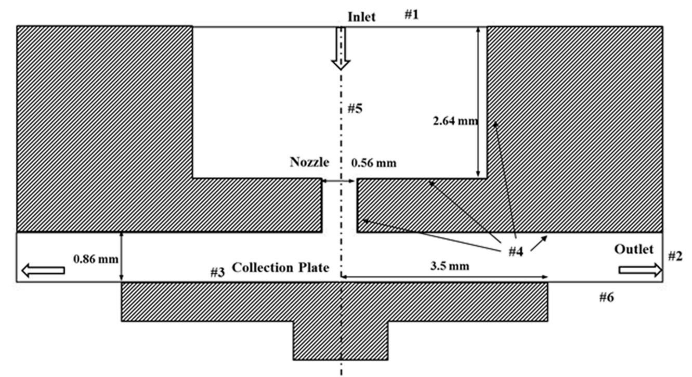

**Outlet**

**#2**

Fig. S1. Geometry and calculation domain of the proposed impactor







Fig. S2. Numerical results for (a) velocity [m/s], (b) static temperature [K], and (c) static pressure [kPa]