Supplementary material for Proudfoot M. et al. Eye-tracking in amyotrophic lateral sclerosis: A longitudinal study of saccadic and cognitive tasks. Amyotroph Lateral Scler Frontotemporal Degener. 2015; doi: 10.3109/21678421.2015.1054292.
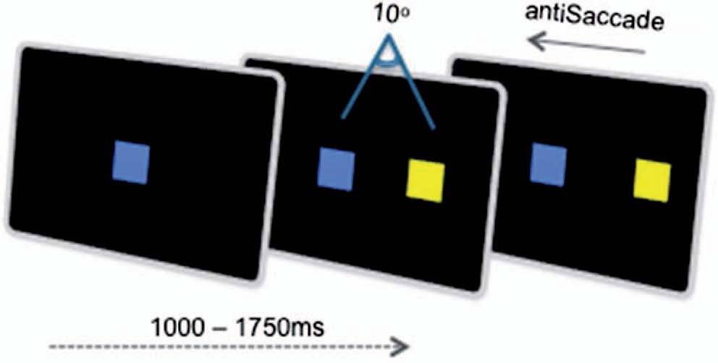
Supplementary Figure 1. The anti-saccade task requires suppression of a reflexive pro-saccade in favour of a voluntary saccade in the opposite direction.
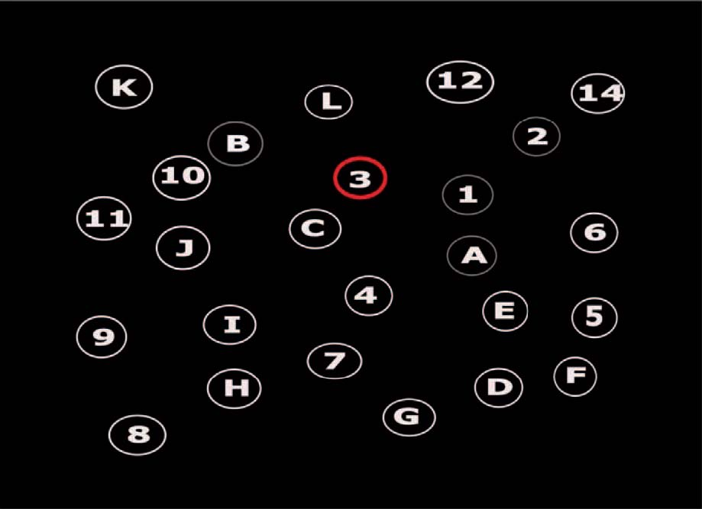
Supplementary Figure 2. The eye-tracking version of the TMT. Item B has been selected by gaze contingency. Items 1 A and 2 were previously selected and their circles turn to grey.
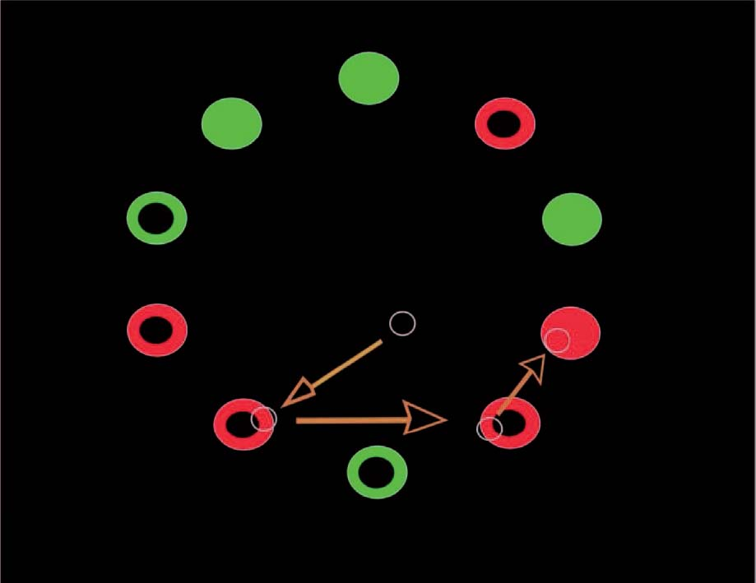
Supplementary Figure 3. Visual search task with arrows indicating the directions of saccades from the initial central cue, and blue circles indicating fixations until the red disc is located and selected by fixation.
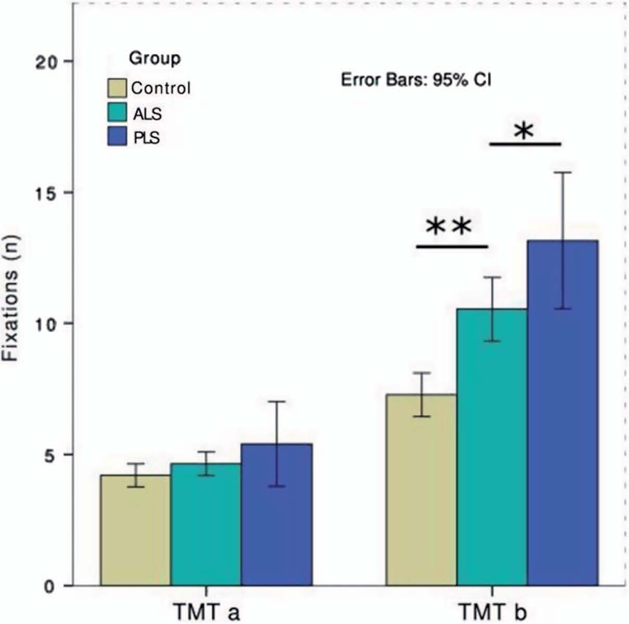
Supplementary Figure 4. Group performance at ﬁrst time-point on the eye-tracker TMT as measured by number of excess ﬁxations produced during the trail.

