School Belonging Visual Measure

Contact: drkellyallen@gmail.com

How to cite this questionnaire:

Allen, K-A. (2020). School Belonging Visual Measure. Figshare. doi: [insert doi]

COPYRIGHT NOTICE:
Please note that the School Belonging Visual Measure is subject to copyright and licensing agreements. As such, the scale may not be modified in any way (e.g. changing the wording of items or adding items). This is to ensure that the research integrity of the School Belonging Visual Measure.

School Belonging Visual Measure may be downloaded and photocopied for non-commercial research or use by practitioners.

Users are not permitted to distribute or translate the School Belonging Visual Measure into another language without prior permission from the leading author, Dr Kelly Allen drkellyallen@gmail.com

Version 1: School Belonging Visual Measure- Full Colour (Preschool/Pre-reading)

Instructions: Point to the picture of the child and say, “This is you”. Then, point to the picture of the building and say, “And this is your school*” (*or use another appropriate term for the child e.g., kinder)

Instructions: Say to the child, “which one of these best shows how you feel about school*? Do you feel like you belong a little (point to the first picture) or belong a lot? (point to the last picture) or do you feel somewhere in between?” (*or use another appropriate term for the child e.g., kinder)

Say to the child, “point to the two circles that shows how you feel about school*?” (*or use another appropriate term for the child e.g., kinder).

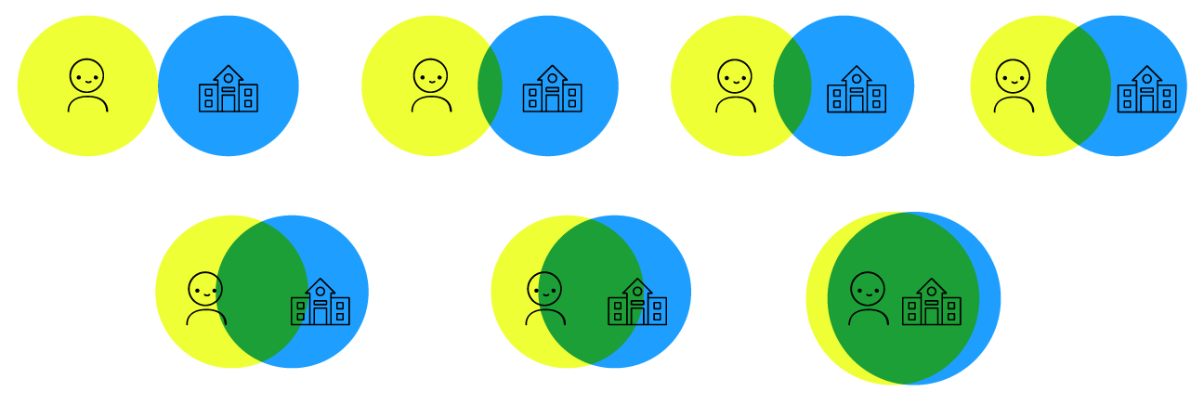

Version 2: School Belonging Visual Measure- Black and White (Preschool/Pre-reading)

Instructions: Point to the picture of the child and say, “This is you”. Then, point to the picture of the building and say, “And this is your school*” (*or use another appropriate term for the child e.g., kinder)

Instructions: Say to the child, “which one of these best shows how you feel about school*? Do you feel like you belong a little (point to the first picture) or belong a lot? (point to the last picture) or do you feel somewhere in between?” (*or use another appropriate term for the child e.g., kinder)

Say to the child, “point to the two circles that shows how you feel about school*?” (*or use another appropriate term for the child e.g., kinder).

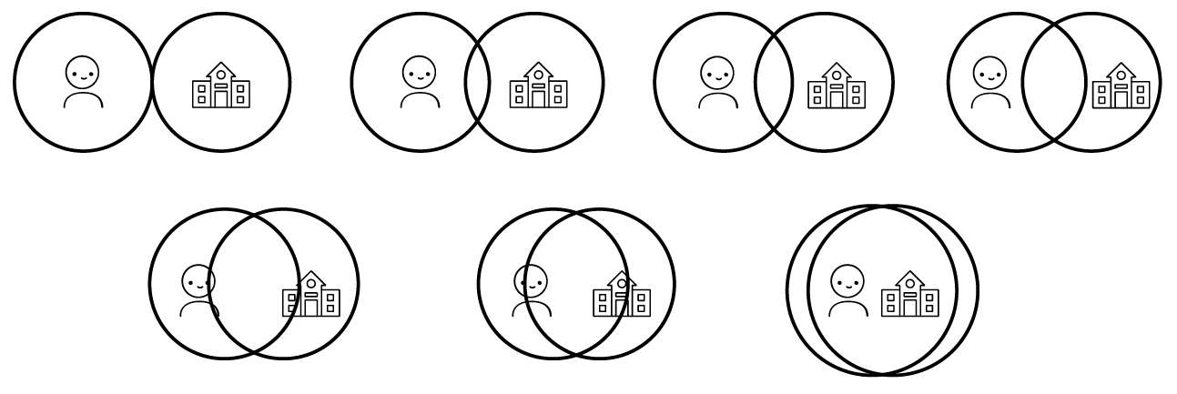

Version 3: School Belonging Visual Measure- Coloured Outlines (Preschool/Pre-reading)

Instructions: Point to the picture of the child and say, “This is you”. Then, point to the picture of the building and say, “And this is your school*” (*or use another appropriate term for the child e.g., kinder)

Instructions: Say to the child, “which one of these best shows how you feel about school*? Do you feel like you belong a little (point to the first picture) or belong a lot? (point to the last picture) or do you feel somewhere in between?” (*or use another appropriate term for the child e.g., kinder)

Say to the child, “point to the two circles that shows how you feel about school*?” (*or use another appropriate term for the child e.g., kinder).

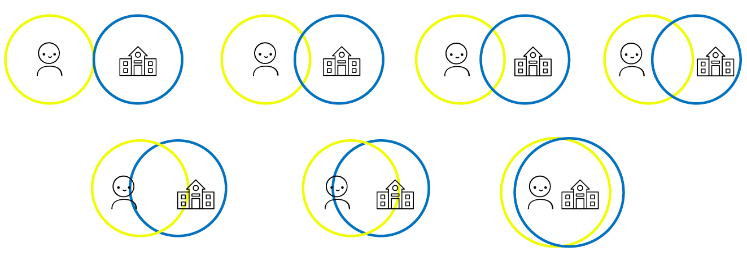

Version 4: School Belonging Visual Measure- Brief Black and White (Preschool/Pre-reading)

Instructions: Point to the picture of the child and say, “This is you”. Then, point to the picture of the building and say, “And this is your school*” (*or use another appropriate term for the child e.g., kinder)

Instructions: Say to the child, “which one of these best shows how you feel about school*? Do you feel like you belong a little (point to the first picture) or belong a lot? (point to the last picture) or do you feel somewhere in between?” (*or use another appropriate term for the child e.g., kinder)

Say to the child, “point to the two circles that shows how you feel about school*?” (*or use another appropriate term for the child e.g., kinder).
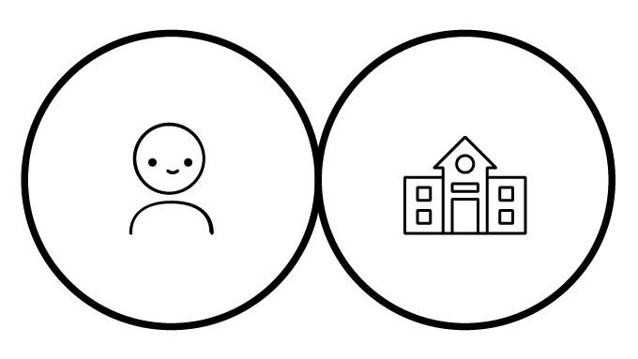
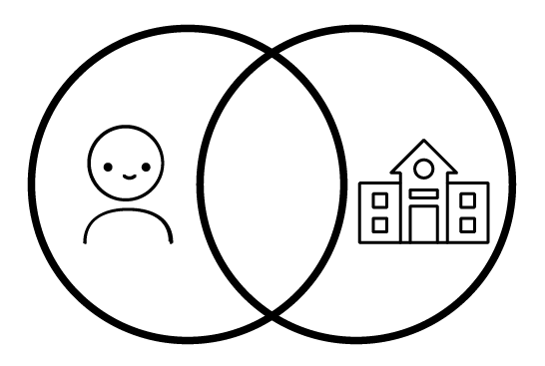

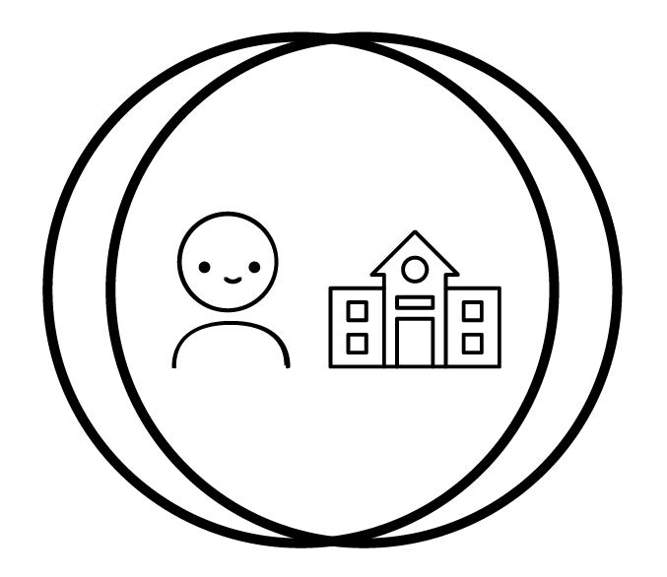

Version 5: School Belonging Visual Measure- Brief Full Colour (Preschool/Pre-reading)

Instructions: Point to the picture of the child and say, “This is you”. Then, point to the picture of the building and say, “And this is your school*” (*or use another appropriate term for the child e.g., kinder)

Instructions: Say to the child, “which one of these best shows how you feel about school*? Do you feel like you belong a little (point to the first picture) or belong a lot? (point to the last picture) or do you feel somewhere in between?” (*or use another appropriate term for the child e.g., kinder)

Say to the child, “point to the two circles that shows how you feel about school*?” (*or use another appropriate term for the child e.g., kinder).
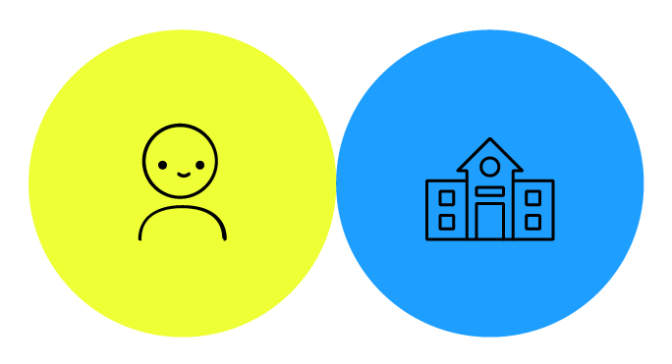
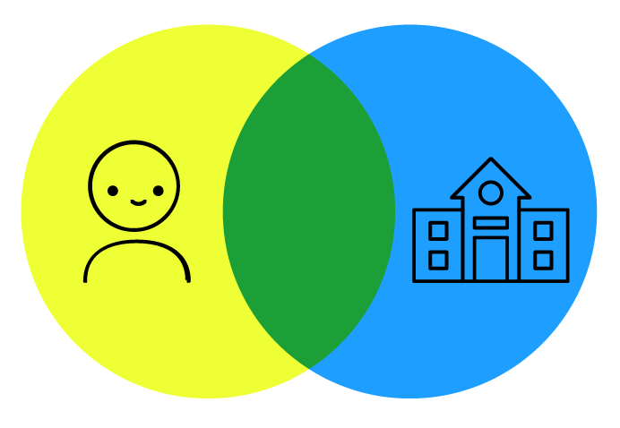

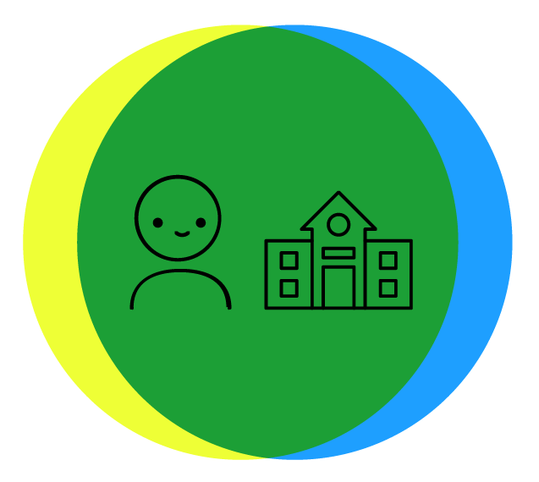

Version 6: School Belonging Visual Measure- Brief Coloured Outlines (Preschool/Pre-reading)

Instructions: Point to the picture of the child and say, “This is you”. Then, point to the picture of the building and say, “And this is your school*” (*or use another appropriate term for the child e.g., kinder)

Instructions: Say to the child, “which one of these best shows how you feel about school*? Do you feel like you belong a little (point to the first picture) or belong a lot? (point to the last picture) or do you feel somewhere in between?” (*or use another appropriate term for the child e.g., kinder)

Say to the child, “point to the two circles that shows how you feel about school*?” (*or use another appropriate term for the child e.g., kinder).

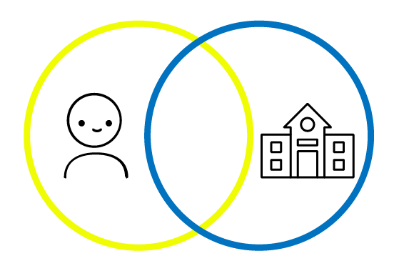
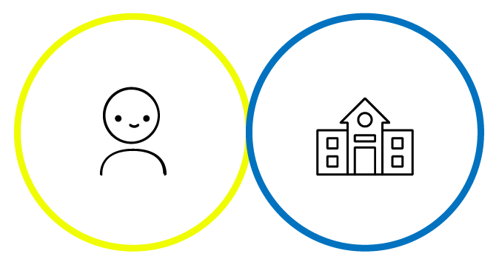

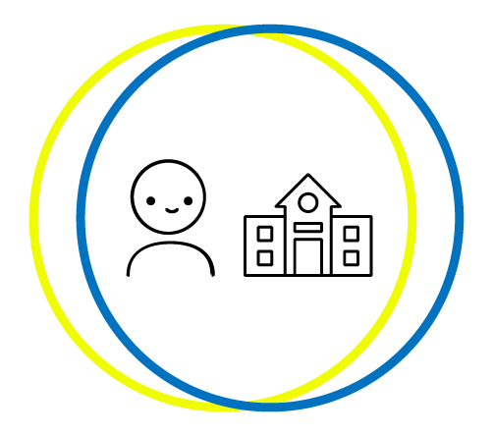

Version 7: School Belonging Visual Measure- Black and White (Older Child of reading age /Adolescent/Adult Version)

This is you And this is your school

Instructions:

Feeling a sense of belonging to school is when you feel respect, accepted, and safe at school.

Which one of these best shows how you feel about school? Do you feel like you belong a little (the first picture) or belong a lot? (the last picture) or do you feel like you belonging to school somewhere in between?”

Underline the two circles that best show how much you feel like you belong to school.

Version 8: School Belonging Visual Measure- Full Colour (Older Child of reading age /Adolescent/Adult Version)

This is you And this is your school

Instructions:

Feeling a sense of belonging to school is when you feel respect, accepted, and safe at school.

Which one of these best shows how you feel about school? Do you feel like you belong a little (the first picture) or belong a lot? (the last picture) or do you feel like you belonging to school somewhere in between?”

Underline the two circles that best show how much you feel like you belong to school.

Version 9: School Belonging Visual Measure- Coloured Outlines (Older Child of reading age /Adolescent/Adult Version)

This is you And this is your school

Instructions:

Feeling a sense of belonging to school is when you feel respect, accepted, and safe at school.

Which one of these best shows how you feel about school? Do you feel like you belong a little (the first picture) or belong a lot? (the last picture) or do you feel like you belonging to school somewhere in between?”

Underline the two circles that best show how much you feel like you belong to school.

Scoring

Children choose a pair of with different degrees of overlap. 1 = no overlap; 2 = little overlap; 3 = some overlap; 4 = equal overlap; 5 = strong overlap; 6 = very strong overlap; 7 = most overlap.

1 = low school belonging
7= high school belonging

This measure has been adapted from:

Aron, A., Aron, E. N., & Smollan, D. (1992). Inclusion of other in the self-scale and the structure of interpersonal closeness. Journal of Personality and Social Psychology, 63(4), 596-612.

http://sparqtools.org/mobility-measure/inclusion-of-other-in-the-self-ios-scale/

